Github.com :

Github is acquired by Microsoft .Earlier it was an open source. Github is a centralised hosting server which provides a number of services/utilities like git , bit bucket, bit rise ,code versioning systems ,bug management tool and other services available.

It is a website which provides different web services like wiki pages , task management activities, bug tracking tool, hosting services for Git repo.

Github is just a simple site which provides some space to the GIT tool.



GIT is a tool where activities like check in , checkout, versioning control, push,pull, creating the branches etc all things happen here.

Git is code versioning or code management tool.

Linus Torvalds is the founder of the GIT who was also the founder o the Linux kernel(chk in and chkout)

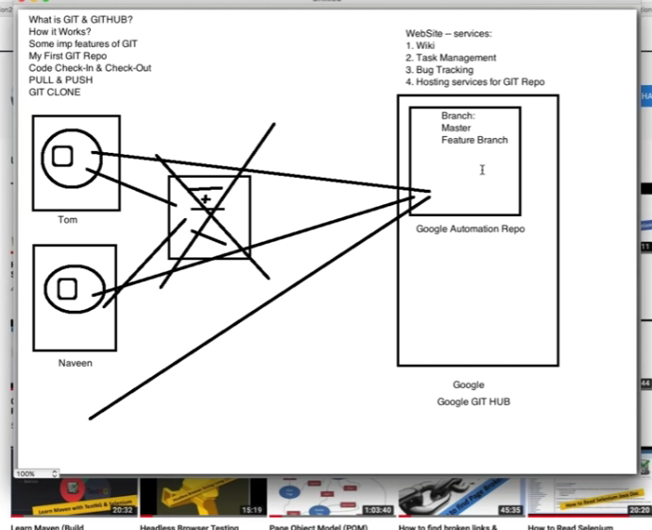

Lets say first version is created : V1

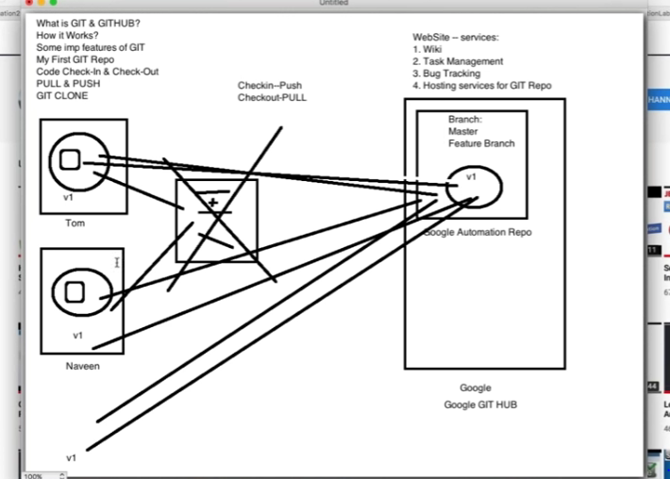

Then after sometime another version v2 is pushed by one person , so everyone sjould have the same code.

Push the code into repo- chkin

Pull the code from the repo- chkout.

The centralized repository where all the version of the code is pushed and pulled is called the GIT repository.

This GIT repo is hosted over Git HUB.

This hub is a hosting server where number of companies have registered and they have created their own repos over here.

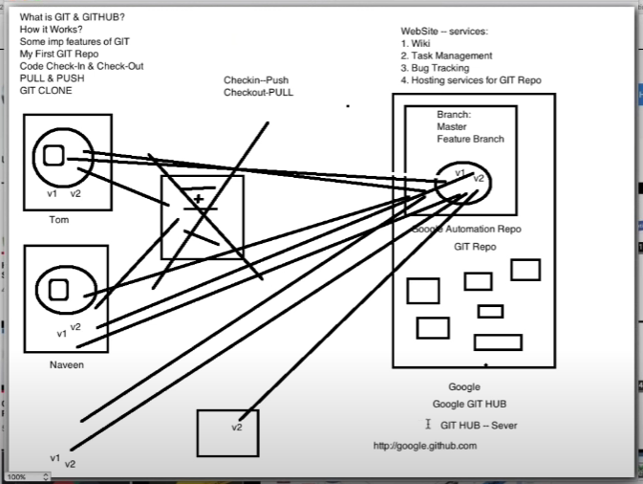

There are some GITHUB where they provide other services like wiki pages, tack management

SCM- source control management

Git is one of the best SCM tool.

Other tools are Bitbucket, SVN(sub version control), FS(Team foundation server)by Microsoft, VSTS,VSS(virsual source safe by MS).

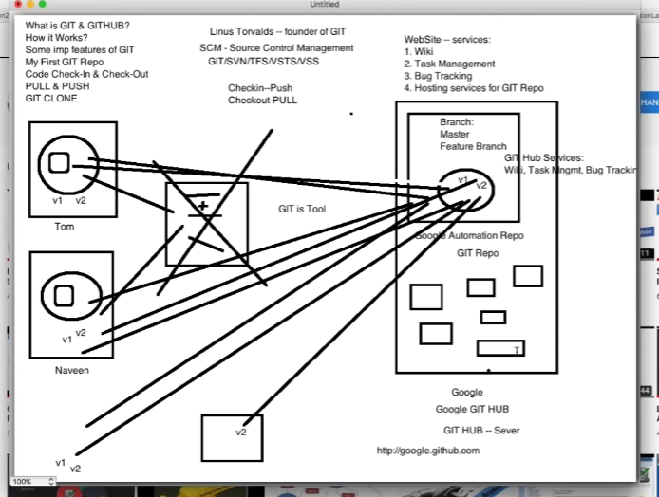

<https://www.youtube.com/watch?v=iJNuZw0ur2E>