Selenium+Jenkins Integration : Page Object Model (POM) Design With Selenium - Part -6

<https://www.youtube.com/watch?v=lPxrPqSyCo8&list=PLFGoYjJG_fqo4oVsa6l_V-_7-tzBnlulT&index=35>

Install the laytest version of Jenkins dform <https://updates.jenkins-ci.org/download/war/>

Copy the Jenkins war files to some other location : C:\Jenkins

Goto the cmd prompt and run:

java -jar Jenkins.war

2020-07-10 21:50:33.709+0000 [id=39] INFO o.s.b.f.s.DefaultListableBeanFactory#preInstantiateSingletons: Pre-instantiating singletons in org.springframework.beans.factory.support.DefaultListableBeanFactory@45dcfe53: defining beans [filter,legacy]; root of factory hierarchy

2020-07-10 21:50:34.091+0000 [id=39] INFO jenkins.install.SetupWizard#init:

*************************************************************

*************************************************************

*************************************************************

Jenkins initial setup is required. An admin user has been created and a password generated.

Please use the following password to proceed to installation:

9594a38d270b4396851e7d7870f5461f

This may also be found at: C:\Users\Innu\.jenkins\secrets\initialAdminPassword

*************************************************************

*************************************************************

*************************************************************

Whenever we want to stafrt Jenkins we need to go to the locarionof the Jenkins war file and start from the command promt and then start by the command :

Java -jar Jenkins.war

And then open the browser and typr in localhost:8080 and wait for the Jenkins to appear.

At the initial set up it swill be asking to give the password we provided above for the firsttime and then set up our own id and password

Then we can create our normal project or maven projects.

For maven projects we need to install some maven plugins from the manage Jenkins🡪manage plug-ins🡪active search 🡪Maven.

And for the testing we need to have the trstNG plugin from the same location.

# Selenium+Jenkins Integration : Page Object Model (POM) Design With Selenium - Part -6

<https://www.youtube.com/watch?v=lPxrPqSyCo8&list=PLFGoYjJG_fqo4oVsa6l_V-_7-tzBnlulT&index=35>

# Selenium + Jenkins + GIT Integration : Run your Test Cases from GIT Hub using Jenkins

<https://www.youtube.com/watch?v=rb5OL-QQPw4&list=PLFGoYjJG_fqo4oVsa6l_V-_7-tzBnlulT&index=36>

For the Maven projects we set up the project and give all the details:

There are two ways :

1. One for the normal project from our desktop local directory
2. Another from the git repo

For the project from the git repo: we need to give the git location and the POM.xml file ;

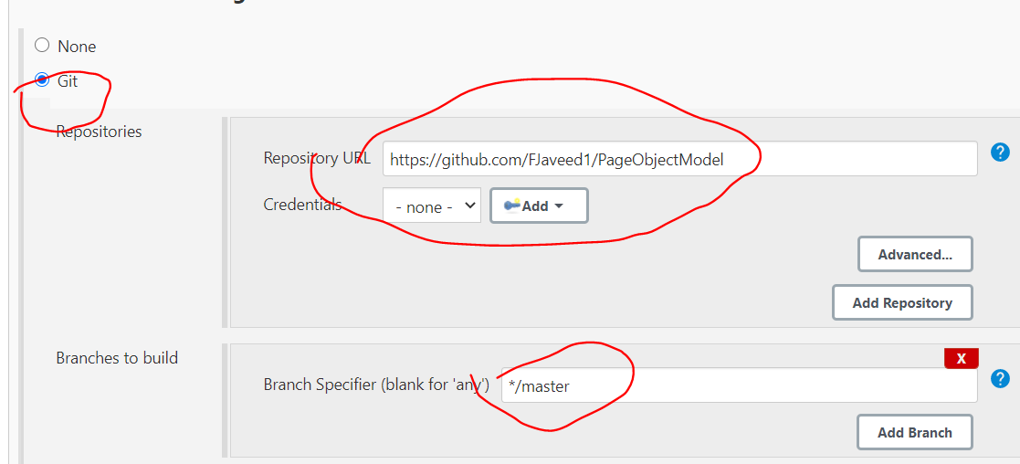

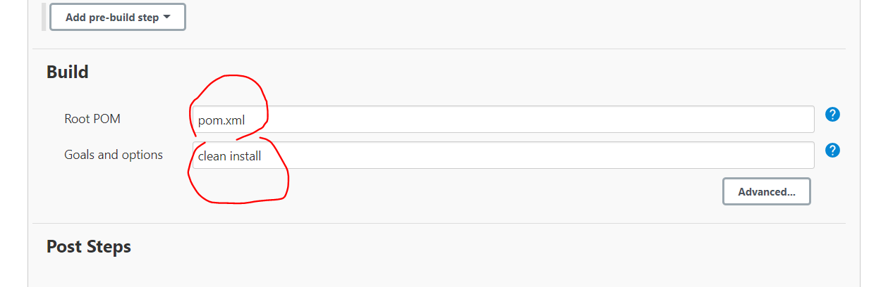

And in post build we need to select TestNG reports and then save and apply.

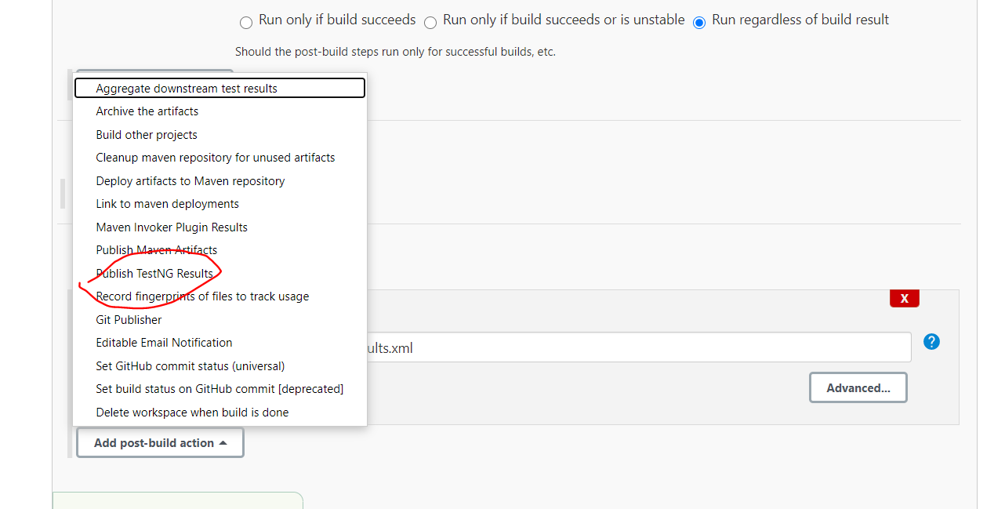

After that we need to build and can view the results from the ouput console:

A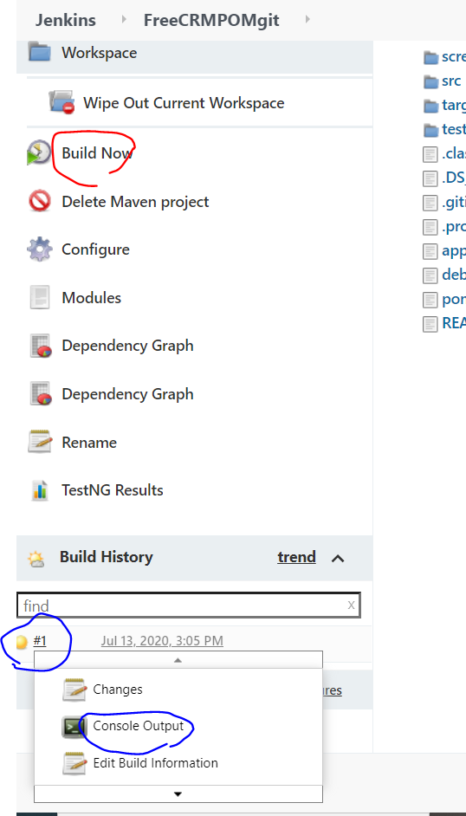

Now from the output we can see its taking from the git rpo: 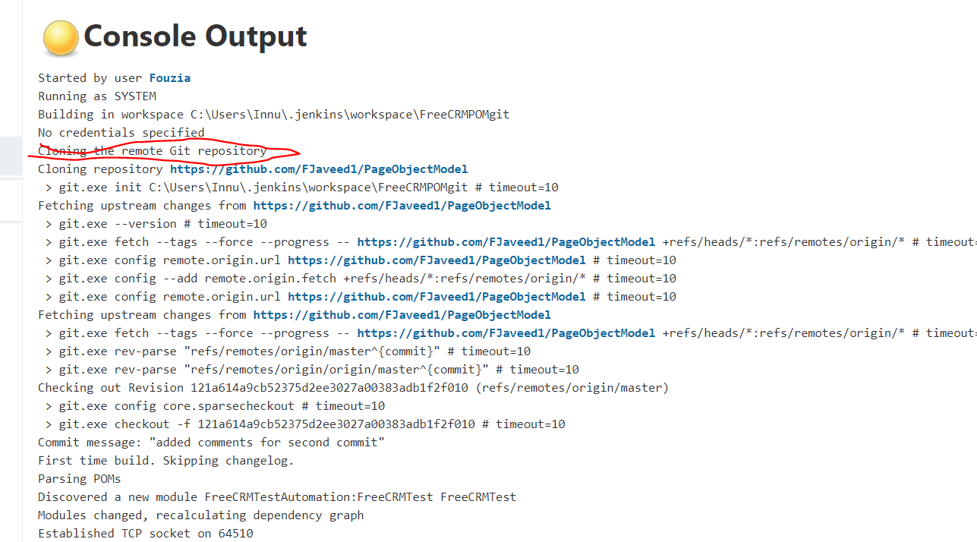

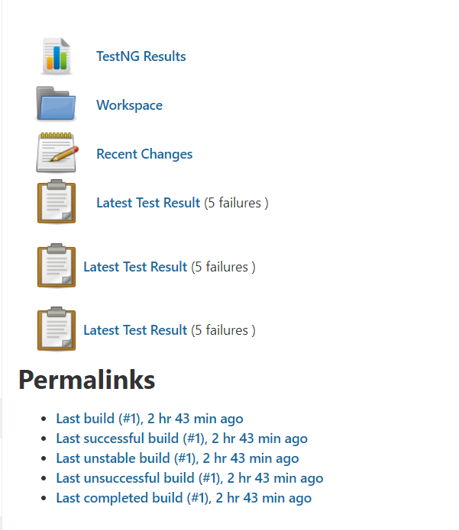

WE can see the testing results and the workspace from the above structure

Thhis workspace is same as the eclipse folder structure:

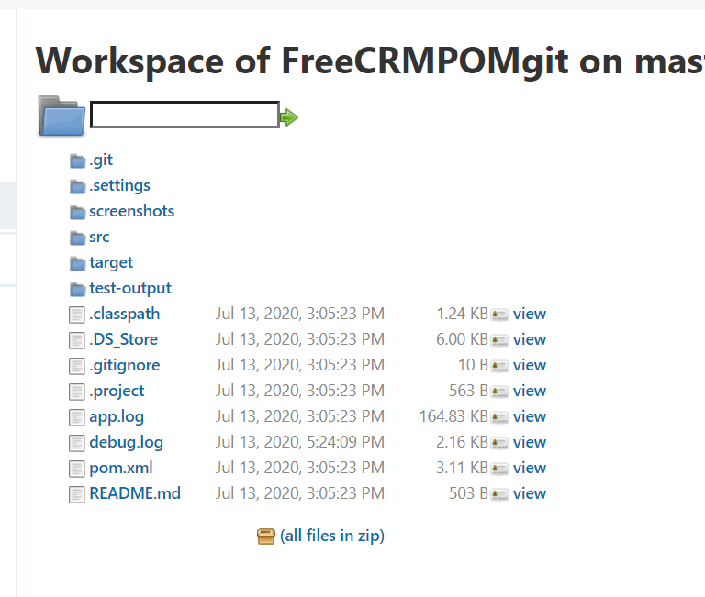

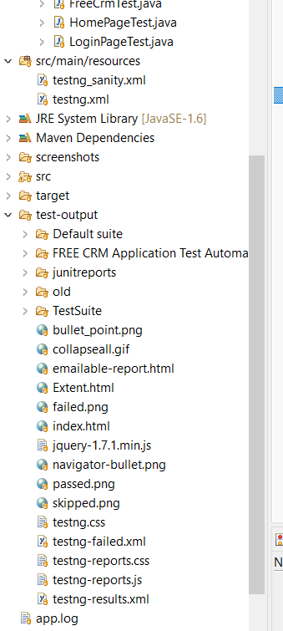

WE can see from the above structure there is extent.html but in Jenkins also we need to have the html report.So for this we need to download the html plugin firt to generate the report.

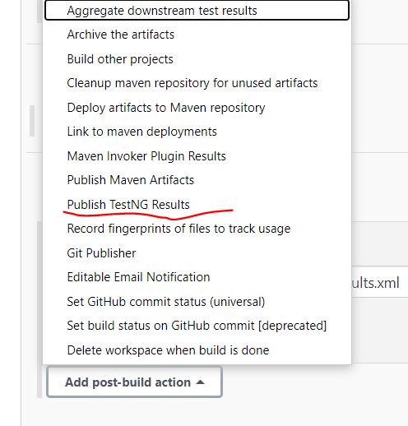

There is no options for the publish html reports.For this we need to donload the plugin :

After installing the plugin and rebooting the jankins(by terminating .Ctrl C) and restafrting again we can now see the plug in option :

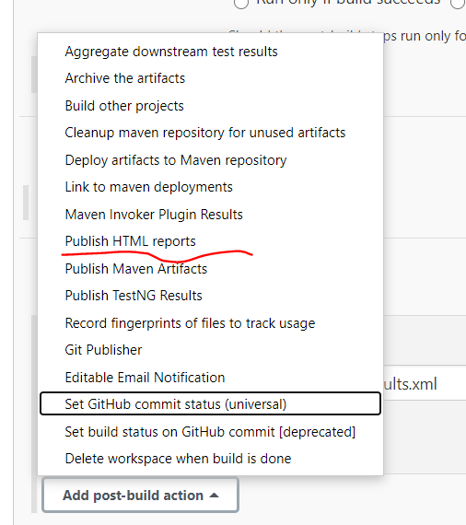

Now we need to update all the fields as below :

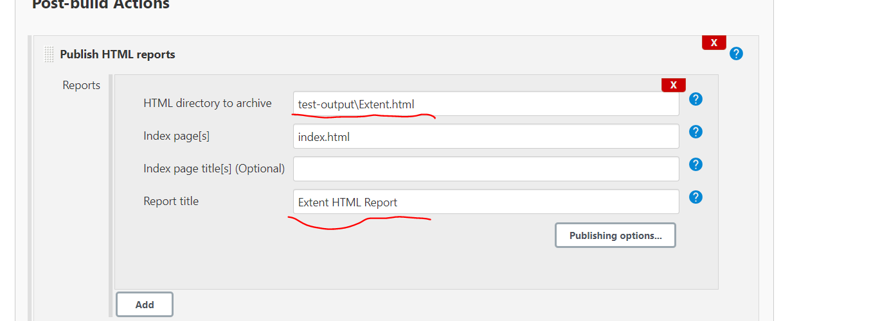



And again build now :

Now we can see the html reports :

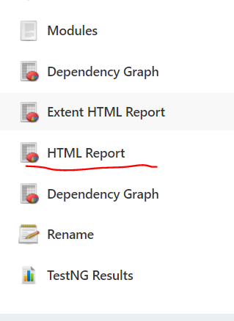

We get the following html report in jenkins:

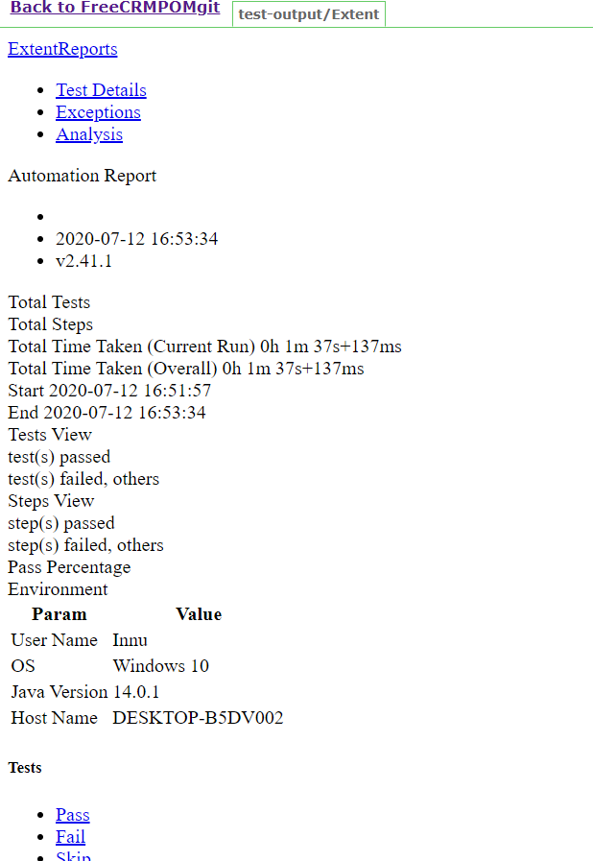

But the html reports are not coming in the graphic mode as we get in the eclipse :

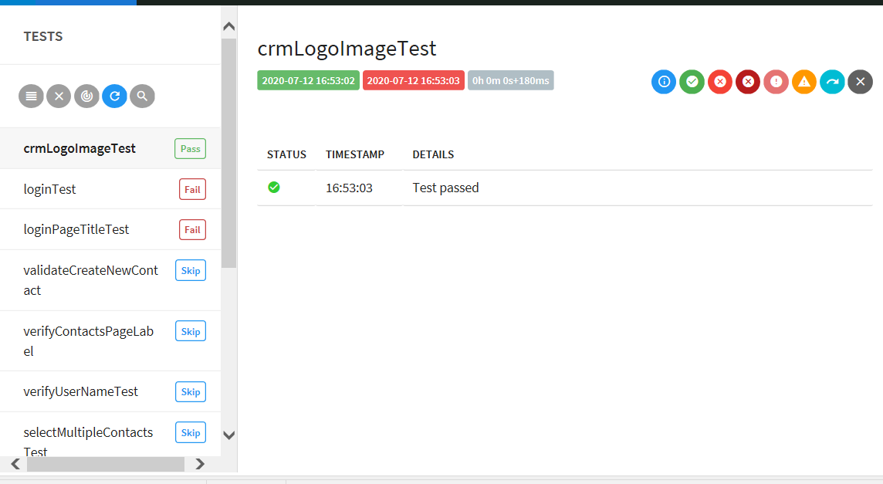

To solve this problem we need to go to the manage Jenkins🡪 script console

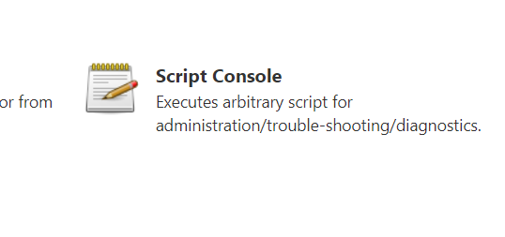

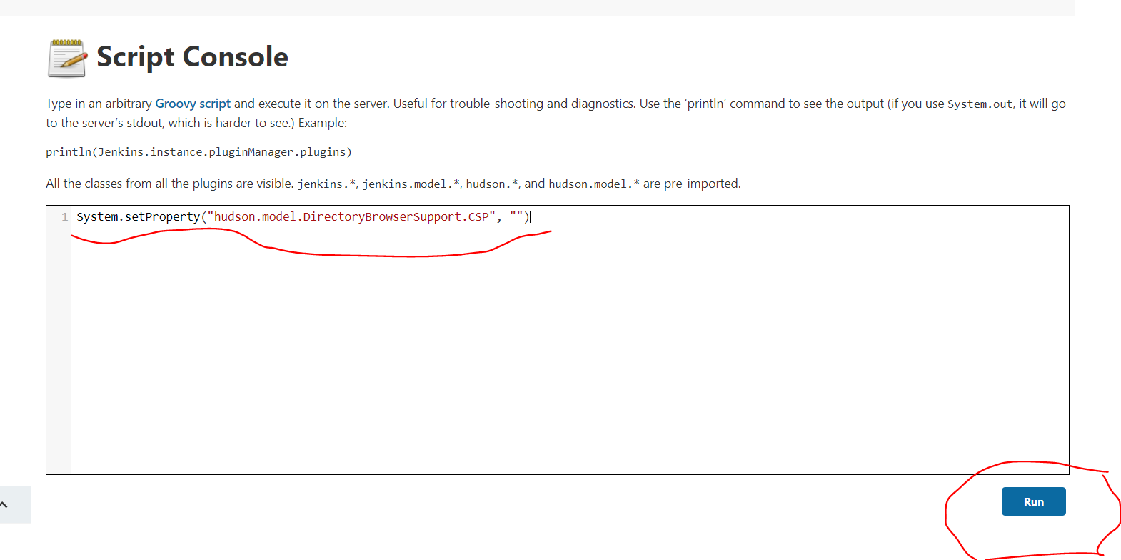

**To generate proper Extent/HTML Report in Jenkins, use following script in Script Console of Jenkins: System.setProperty("hudson.model.DirectoryBrowserSupport.CSP", "")

So we need to get the Result : below like this :it means this si working fine

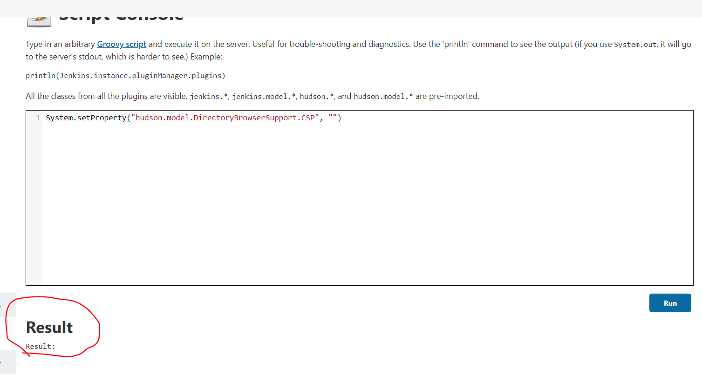

Now go back to the project and see the html report , stillwe can see the same .

SO now we need to build again fopr this extent report to take place and come in proper.