# REPUBLIC OF THE PHILIPPINES PROVINCE OF CAVITE MUNICIPALITY OF TANZA

BARANGAY TRES CRUSES

OFFICE OF THE PUNONG BARANGAY

1 X 1

PICTURE

BARANGAY CLEARANCE

TO WHOM IT MAY CONCERN :

# EDUARD G. TOLEDO

This is to certify that

**{{FULL_NAME}}** Filipino,

PUNONG BARANGAY {{AGE}} years of age, {{@STATS}} , born on {{BORN}} and whose

## JOSEFINA G. TACUS

BARANGAY KAGAWAD LORENZO C. PROFETA BARANGAY KAGAWAD FIDEL B. ARNES

BARANGAY KAGAWAD

signature and thumb mark appears below, is a bonafide resident of

### {{HOUSE_ADDRESS}} BRGY.TRES CRUSES,TANZA, CAVITE and has NO CRIMINAL AMBIGOUS record in this community that may damage his / her good moral character.

This certification is being issued in accordance to the implementation of the Provision of the

### NEW LOCAL GOVERNMENT CODE OF 1991 and for {{PUOSE}} purposes only.

NORMAN R. ABUTIN

BARANGAY KAGAWAD

## SILVERIO I. TOLEDO

BARANGAY KAGAWAD ROLANDO B. GATDULA BARANGAY KAGAWAD GERRY F. BARIAS

BARANGAY KAGAWAD

## JAMES ANDREI T. INOCANDO

SK CHAIRMAN

## KENETH O. PROFETA

KALIHIM

## JHOANNA S. JOCSON

INGAT YAMAN

Done and signed this **{{CURRENT_DAY}}** day of **{{CURRENT_MONTH}} {{CURRENT_YEAR}} at the Office of the Punong Barangay of**

### TRES CRUSES, TANZA, CAVITE.

RIGHT THUMBMARK

***Applicant’s Signature Over Printed Name***

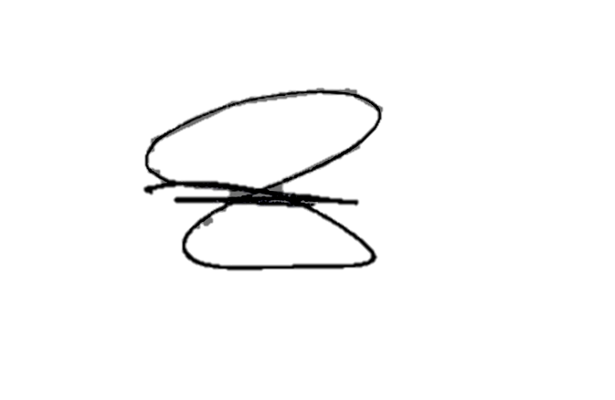

Certified by:

**HON. EDUARD G. TOLEDO**

*PUNONG BARANGAY*

***NOT VALID WITHOUT***

***BARANGAY OFFICIAL DRY SEAL***

***VALID ONLY FOR THREE MONTHS UPON ISSUANCE***

***CONTROL NO : 2024_ 09-***