# REPUBLIC OF THE PHILIPPINES PROVINCE OF CAVITE MUNICIPALITY OF TANZA

BARANGAY TRES CRUSES

OFFICE OF THE PUNONG BARANGAY

**CERTIFICATE OF INDIGENCY**

# EDUARD G. TOLEDO

PUNONG BARANGAY

JOSEFINA G. TACUS

BARANGAY KAGAWAD LORENZO C. PROFETA BARANGAY KAGAWAD FIDEL B. ARNES

BARANGAY KAGAWAD NORMAN R. ABUTIN BARANGAY KAGAWAD SILVERIO I. TOLEDO BARANGAY KAGAWAD

ROLANDO B. GATDULA BARANGAY KAGAWAD GERRY F. BARIAS

BARANGAY KAGAWAD

JAMES ANDREI T. INOCANDO

SK CHAIRMAN

To whom it may concern,

*This is to certify that* ***{{FULL_NAME}}*** *years of age, and a Filipino Citizen is a bonafide resident of {{HOUSE_ADDRESS}}****, Brgy. Tres Cruses, Tanza, Cavite.***

And I do certify that {{FULL_NAME}} belongs to many indigent families in our barangay Their family income is barely enough for the daily needs of their family.

That I am issuing this certification only of above named person for

**{{PUROSE}}** purpose only.

*Given this* ***{{CURRENT_DAY}}*** *of* ***{{CURRENT_MONTH}} {{CURRENT_YEAR}}***

KENETH O. PROFETA

KALIHIM

JHOANNA S. JOCSON

INGAT YAMAN

Certified by:

**HON. EDUARD G. TOLEDO**

*Punong Barangay*

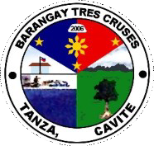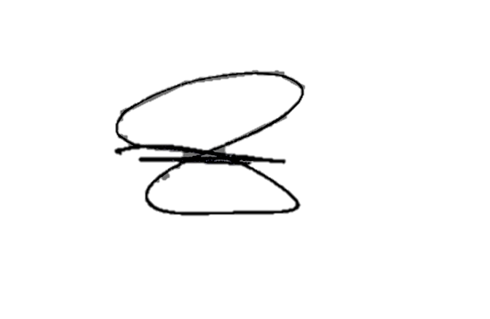

***NOT VALID WITHOUT BARANGAY OFFICIAL DRY SEAL***