# REPUBLIC OF THE PHILIPPINES PROVINCE OF CAVITE MUNICIPALITY OF TANZA

BARANGAY TRES CRUSES

OFFICE OF THE PUNONG BARANGAY

**CERTIFICATE OF RESIDENCY**

# EDUARD G. TOLEDO

PUNONG BARANGAY

JOSEFINA G. TACUS

BARANGAY KAGAWAD LORENZO C. PROFETA BARANGAY KAGAWAD FIDEL B. ARNES

BARANGAY KAGAWAD NORMAN R. ABUTIN BARANGAY KAGAWAD SILVERIO I. TOLEDO BARANGAY KAGAWAD

ROLANDO B. GATDULA BARANGAY KAGAWAD GERRY F. BARIAS

BARANGAY KAGAWAD

JAMES ANDREI T. INOCANDO

SK CHAIRMAN

KENETH O. PROFETA

KALIHIM

JHOANNA S. JOCSON

INGAT YAMAN

To whom it may concern,

*This is to certify that {{FULL_NAME}} of legal age and a Filipino citizen is a bonafide resident of {{HOUSE_ADDRESS}}****, Brgy. Tres Cruses, Tanza, Cavite.***

And I do certify that {{FULL_NAME}} lives in our barangay since {{DATESS}} up to **{{CURRENT_MONTH}} {{CIR}} {{CURRENT_YEAR}}.**

That I am issuing this certification upon the request of above named person for {{PURPOSE}} purposes only.

*Given this* ***{{CURRENT_DAY}}*** *day of* ***{{CURRENT_MONTH}} {{CURRENT_YEAR}}.***

**HON. EDUARD G. TOLEDO**

*Punong Barangay*

Certified by:

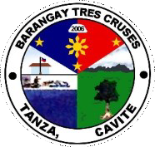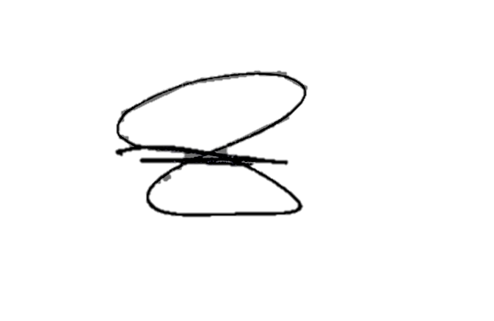

***NOT VALID WITHOUT BARANGAY OFFICIAL DRY SEAL***