**Schaffer-collateral-evoked EPSCs**

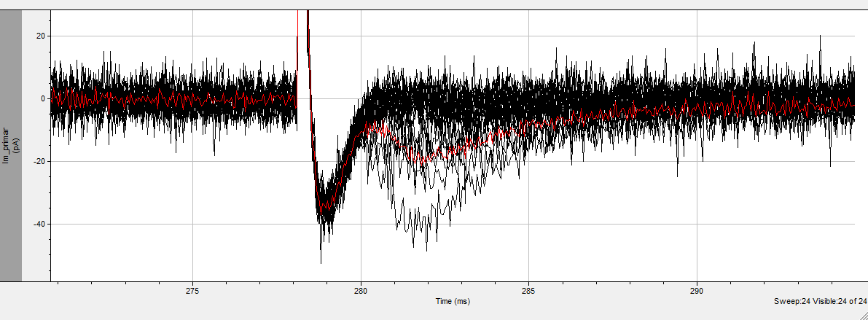

Artefact Response Failure Red trace: average

This example fulfills the criteria for minimal stimulation, since it contains both failures and EPSCs. Unfortunately, the width of the artefact obscures the rise of the response, precluding us from properly looking at rise kinetics.

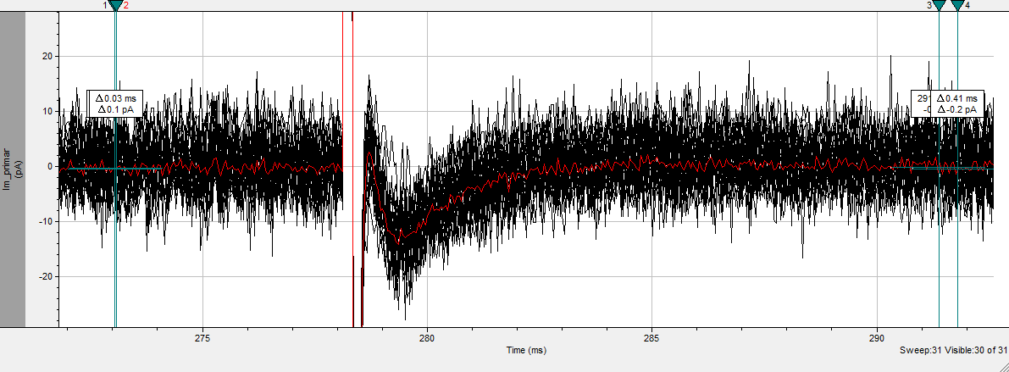

This example unfortunately doesn’t contain any failure, although it should be noted that stimulating with a lower stimulation intensity didn’t elicit any response, so it should be very close to minimal. On the other hand, the trace comes back fully to the baseline between the artefact and the response, allowing us to look at the rise kinetics. Hence why we’re sending both examples.

**Miniatures**

We make long recordings (multiple minutes) of the cell held at -70mV in the presence of TTX.

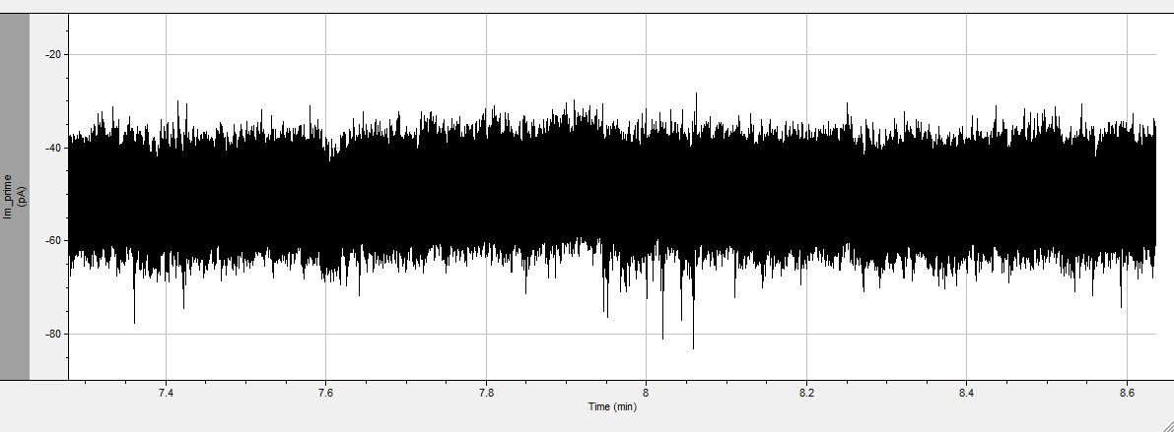

Then we extract EPSCs from the trace using Clampfit’s template search option, after which we filter out unsuitable events manually to obtain a set of comparable, aligned events.

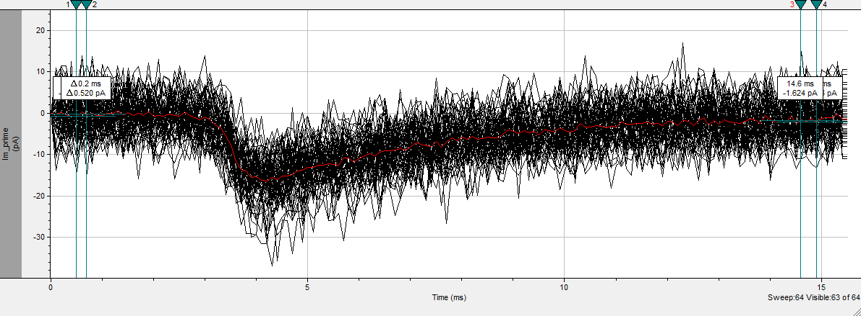

We then average those events to extract physiologically relevant data.