**Simulations with Single Spike, Layer-Specific Inputs**

Like previous simulations, I simulate single spikes at different points along the dendritic arbour of the top models until a somatic spike is recorded. Axon initial segment sections are not tested. Note that I also used a smaller spatial resolution.

*Parameters for Schaffer Collateral Stimulation:*

-For synapses at dendritic locations lesser than 300um away from the soma

-Rise Time: 0.45 ms

-Decay Time: 2.175 ms

-Reversal Potential: 10 mV

*Parameters for Perforant Path Simulations:*

-For synapses at dendritic locations greater than 300um away from the soma

-Rise Time: 1.71 ms

-Decay Time: 5.04 ms

-Reversal Potential: 30 mV

It appears that by adjusting the parameters of synaptic inputs past a certain distance from the soma, we can see more effective initiation of spikes at the soma.

**Notes about graphs**:

***Red dashed line*** = synaptic weight threshold to elicit a spike at the soma (0.5 uS)

***Blue dashed line*** = The distance border point (i.e. RAD/LM border) at which the synaptic parameters (i.e. rise time, decay time and reversal potential) change from the experimentally measured values for radiatum layer stimulation to the experimentally measured values for lacunosum-moleculare layer stimulation. I chose 300um as an approximate location of the stratum border, but by having it at this far a distance, it also shows that the RAD layer parameters become inefficient at generating somatic spikes past a certain distance (i.e. increase in weight past 0.5 uS - red dashed line), and that by changing the parameters to LM layer parameters, somatic spikes can once again be initiated with <0.5 uS weights.

Case 7 Top Model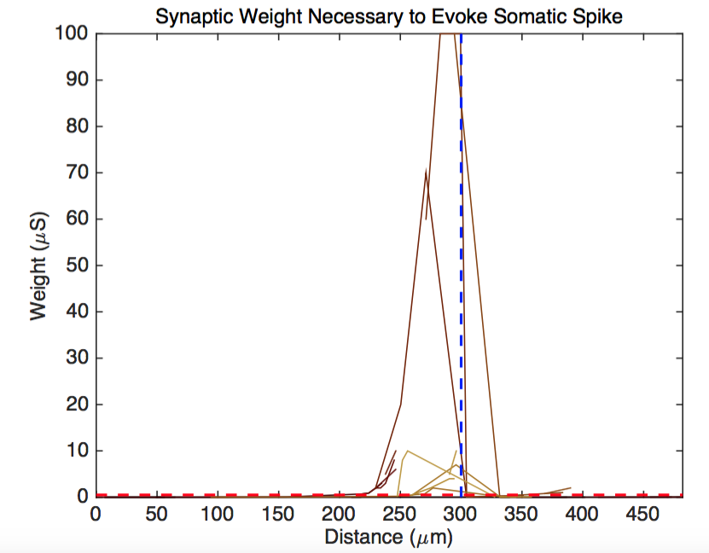

Case 8 Top Model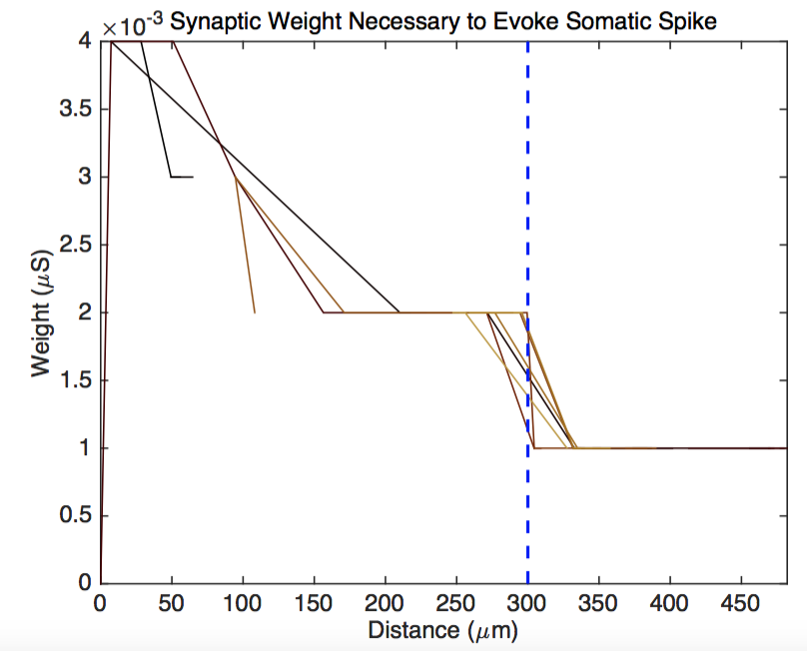

Case 8 Star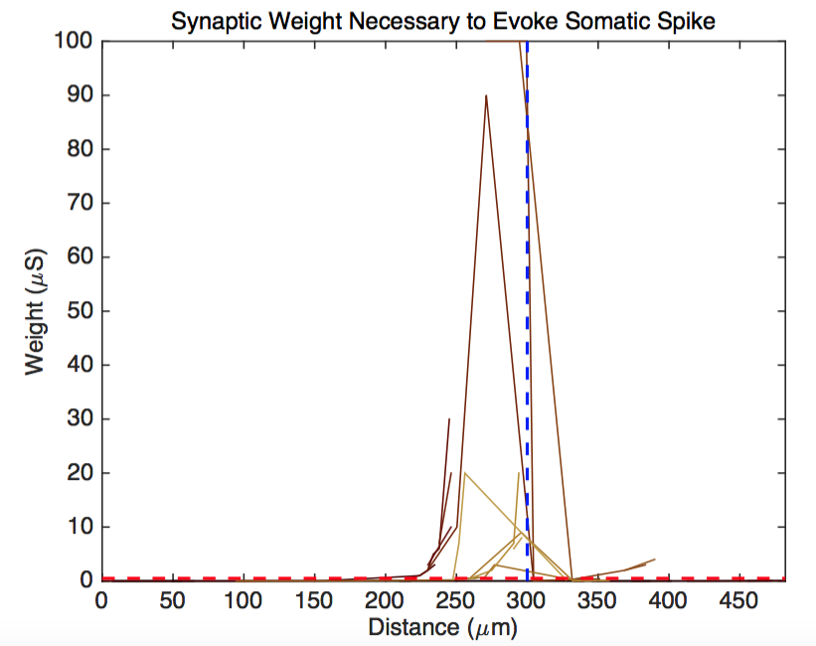

Case 9 Star