PROG3185

Programming Mobile Applications I

Yash Shah

April 14, 2019

By

Fatima Kharodia

project charter

# Project name

*Makeup Reviews*

# business purpose

*The purpose of this project is to showcase reviews written by customers. Reviews are an important business piece at it can decided weather or not a consumer buys a product based on reviews they have read.*

# project roles/responsibilities

*This was and individual project, and I have done all aspects of this project alone, with help from resources on econestoga, as well as in class demonstrations.*

# Technical architecture

*The technical architecture that would be in consideration for this project would be Visual Studio Code, as well as possibly MySql, for the tables used in the project.*

events table

|  |  |  |  |  |
| --- | --- | --- | --- | --- |
| Event | source | use  case# | response | destination |
| User Adds a Review | User | UC01 | Review added to database | User |
| User looks at review | User | UC02 | Reviews that have been added are listed | User |
| User updates review | User | UC03 | Review modified and saved to database | User |
| User deletes review | User | UC04 | Review removed from database | User |

Table 1: Events Table

use case diagram

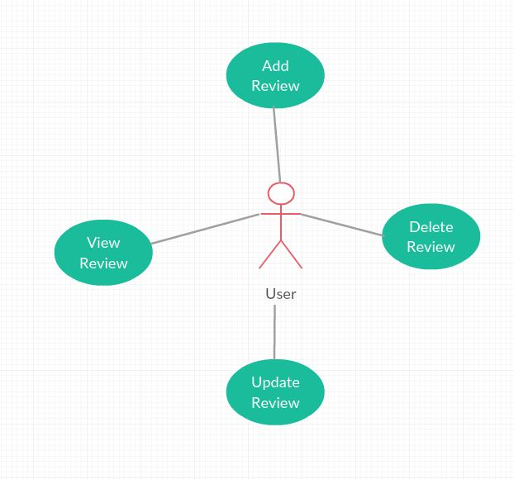

Figure 1UML

use case description

|  |  |  |  |  |
| --- | --- | --- | --- | --- |
| Use case # | UC01 | | | |
| Use case name | User Adds a Review | | | |
| Scenario | User uses the mobile app to add a review for a makeup product | | | |
| Triggering event | User clicks on add review tab | | | |
| Brief description | The user clicks on the add review tab, and enters the information required | | | |
| Actors | User | | | |
| Related use cases | View review, update/delete review | | | |
| Pre-conditions | User has app loaded onto phone | | | |
| Post-conditions | User has to have added a review to view/update or delete a review | | | |
| Flow of events | Actor | | System | |
| 1. | User clicks app icon on phone | 2. | System loads app |
| 3. | User clicks add review | 4. | System loads add review form |
| 5. | User adds valid and required information and clicks save | 6. | System adds review to reviews page, saves to database, and a confirmation alert is shown |
| Exceptions | N/A | | | |

Table 1: UC01-Add Review

|  |  |  |  |  |
| --- | --- | --- | --- | --- |
| Use case # | UC02 | | | |
| Use case name | User Views a Review | | | |
| Scenario | User uses the mobile app to view a review for a makeup product | | | |
| Triggering event | User clicks on reviews tab | | | |
| Brief description | The user clicks on the review tab, and views the information | | | |
| Actors | User | | | |
| Related use cases | Add review, update/delete review | | | |
| Pre-conditions | User has app loaded onto phone | | | |
| Post-conditions | Reviews have to have been posted in order to view reviews | | | |
| Flow of events | Actor | | System | |
| 1. | User clicks app icon on phone | 2. | System loads app |
| 3. | User clicks review | 4. | System loads review page |
| 5. | User views the information displayed | 6. |  |
| Exceptions | No reviews added | | | |

Table 2: UC02-View Review

|  |  |  |  |  |
| --- | --- | --- | --- | --- |
| Use case # | UC03 | | | |
| Use case name | User Updates Review | | | |
| Scenario | User uses the mobile app to update a review for a makeup product | | | |
| Triggering event | User clicks on review | | | |
| Brief description | The user clicks on the review, and edits the information | | | |
| Actors | User | | | |
| Related use cases | Add review, view review, delete review | | | |
| Pre-conditions | User has app loaded onto phone | | | |
| Post-conditions | Reviews have to have been posted in order to update reviews | | | |
| Flow of events | Actor | | System | |
| 1. | User clicks app icon on phone | 2. | System loads app |
| 3. | User clicks review | 4. | System loads review page |
| 5. | User updates the desired input fields | 6. | System updates review |
| Exceptions | No reviews added | | | |

Table 3: UC03-Update Review

|  |  |  |  |  |
| --- | --- | --- | --- | --- |
| Use case # | UC04 | | | |
| Use case name | User Deletes Review | | | |
| Scenario | User uses the mobile app to delete a review for a makeup product | | | |
| Triggering event | User clicks on review | | | |
| Brief description | The user clicks on the review, and clicks the delete button | | | |
| Actors | User | | | |
| Related use cases | Add review, view review, update review | | | |
| Pre-conditions | User has app loaded onto phone | | | |
| Post-conditions | Reviews have to have been posted in order to delete reviews | | | |
| Flow of events | Actor | | System | |
| 1. | User clicks app icon on phone | 2. | System loads app |
| 3. | User clicks review | 4. | System loads review page |
| 5. | User clicks the delete button | 6. | System deletes review from the database |
| Exceptions | No reviews added | | | |

Table 4: UC04-Delete Review

user interface prototype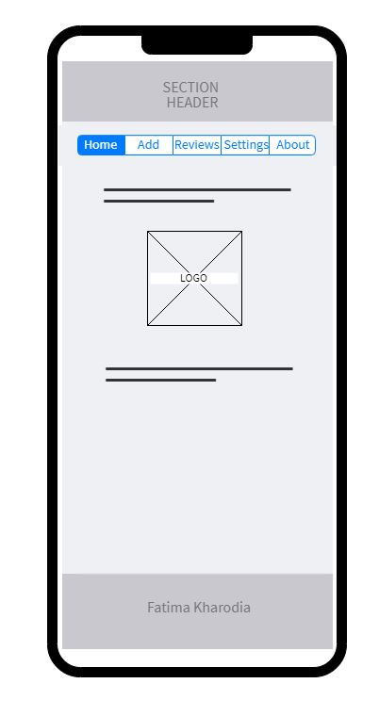

Figure 2 Home Screen

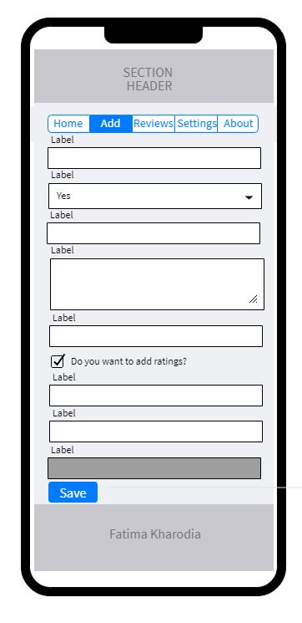

Figure 3 Add Review Screen

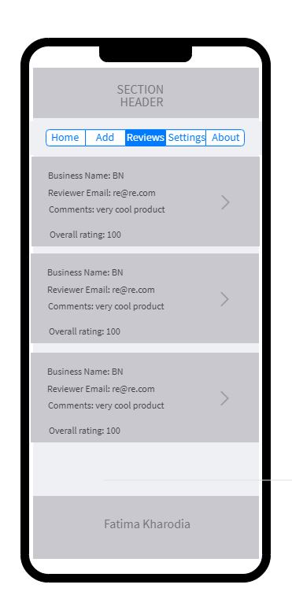

Figure 4 Reviews Screen

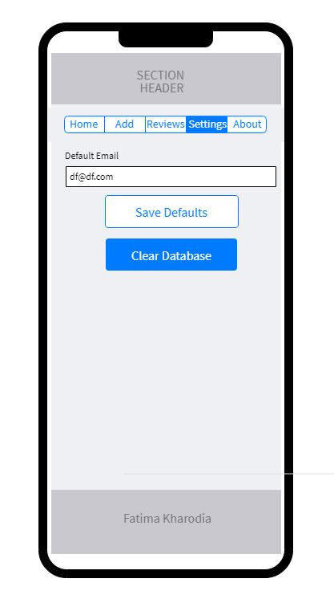

Figure 5 Settings Page

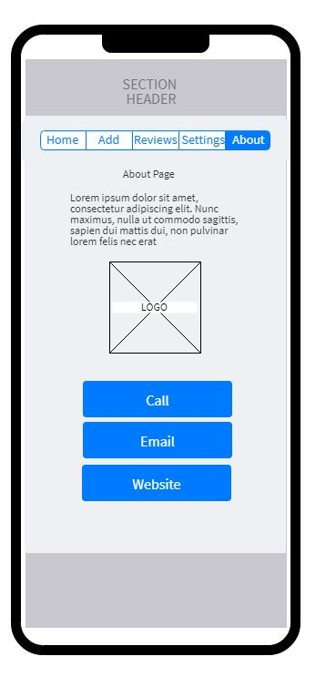

Figure 6 About Screen

entity relationship diagram (ERD)

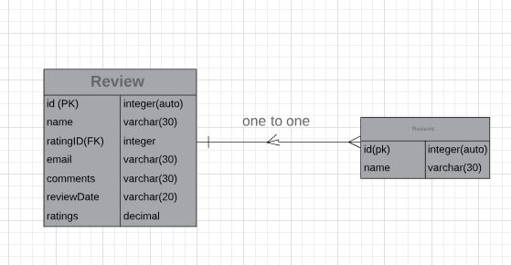

Figure 7: Entity Relationship Diagram (ERD) for FKFinal

User documentation – help system

# Description

This project is intended for users to add, view, update and delete reviews about makeup products they have used or are interested in trying a makeup product but would like to read reviews on the product before purchasing it.

# How to use

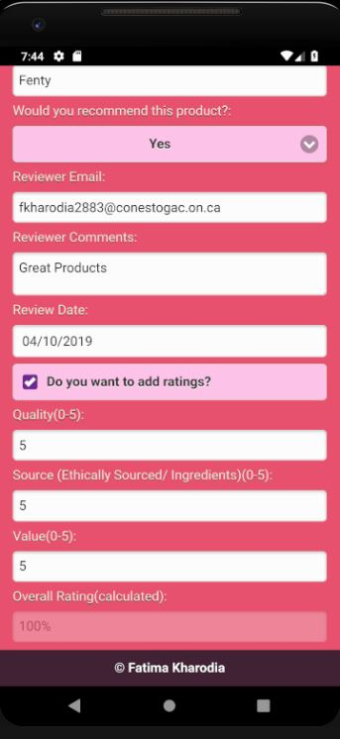

This is where the user can add a review

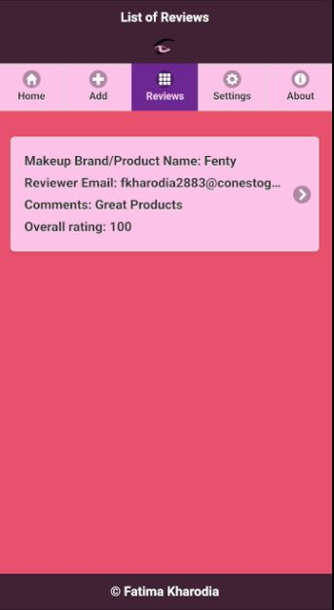

Once the user adds a review they can view it on the reviews screen

# About the programmers

Fatima Kharodia, 2nd year ITID student at Conestoga College

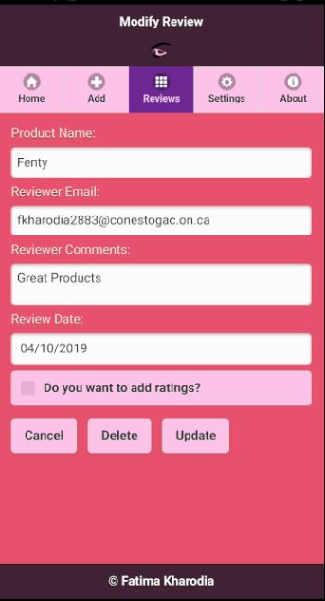

Once the user clicks the review, they

have the option to update or delete the review

Refrences

1. jQuery Mobile : <https://jquerymobile.com/>
2. econestoga PROG3185 AvengersDBIteration