# C# 项目 csproj 文件格式的本质和编译流程

Link Url: <https://blog.csdn.net/WPwalter/article/details/80371271>

# How is Roslyn related to MSBuild?

MSbuild is the build system for Visual Studio. It calls the C# compiler to compile C# projects. Roslyn is the C# compiler (and the VB compiler). **So msbuild uses Roslyn**.

However, Roslyn also includes more things than just the compiler. It also includes a VS plug in that gives you IDE features (completion lists, colorization, code fixes, etc).

In addition, Roslyn is also an API for analyzing source code, that you can use from your own app. For this last scenario is has an API known as MSBuildWorkspace that you can use to open a project or solution for analysis. This workspace uses MSBuild to figure out all the pieces of the projects and solution. So this part of **Roslyn uses MSBuild**.

# .csproj File

“.csproj ” is a Visual Studio .NET C# Project file extension. This file will have information about the file includes in that project, assemblies used in that project, project GUID and project version etc. This file is related to your project. It will be automatically generated when we create.

# Visual Studio Load Project

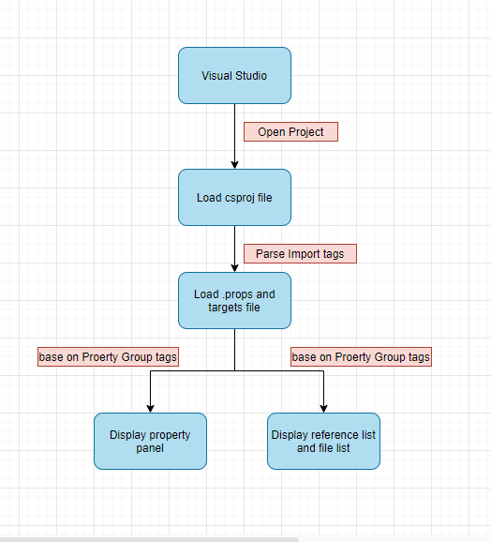

# .sln File

“.sln” is structure for organizing project in Visual Studio. It contains the state information for project in .sln(text-based, shared). We can add multiple project inside one solution.

# MSBuild

Links url: <https://docs.microsoft.com/en-us/visualstudio/msbuild/msbuild?view=vs-2019>

# Both .targets and .props files are MSBuild project file

They can be imported into your project in several ways. They can define project properties like product name or targets definitions. I’ll try to show you various examples of usage.

## .props File

Declare properties that be use during build project.

## .targets File

<https://docs.microsoft.com/en-us/visualstudio/msbuild/msbuild-targets?view=vs-2019>