Social Search Posts Analysis
  - A descriptive review of 77 social media posts collected through SUGAR
Measure | Value | Meaning
Posts | 77 | 77 unique post IDs
Impressions | 777,508 | Across sampled posts
Total engagement | 48,587 | Likes, replies, reposts, quotes, bookmarks
Weighted rate | 6.2% | Engagement divided by impressions

Executive summary
- The dataset contains 77 posts spanning 2026-08-21 to 2026-09-01.
- en is the most frequently detected language (21 posts).
- Engagement is concentrated: the leading post contributes 23% of recorded engagement.
- The most common inferred location is United States (14 posts).
- Geography remains provisional: median location confidence is 0.42, and 16 posts have confidence of at least 0.80.

Bottom line
This report describes the collected sample, not the full population of online discussion. Query design, language filters, date boundaries, result ordering, and per-query caps all shape what appears in the workbook.

1 Dataset and collection design
The file contains 77 records observed from 2026-08-21 through 2026-09-01. The table below shows the contribution of each stored query.
Query term | Posts | Observed date range UTC
democracy | 10 | 2026-09-01 to 2026-09-01
communism | 10 | 2026-09-01 to 2026-09-01
 | 10 | 2026-09-01 to 2026-09-01
الديمقراطية | 10 | 2026-09-01 to 2026-09-01
الشيوعية | 10 | 2026-09-01 to 2026-09-01
 | 9 | 2026-08-31 to 2026-09-01
 | 9 | 2026-09-01 to 2026-09-01
 | 9 | 2026-08-21 to 2026-09-01

Sampling caveat
Counts reflect the retrieved sample. They should not be interpreted as the total volume of matching discussion unless the collection exhausted every available result page.

2 Language and geography
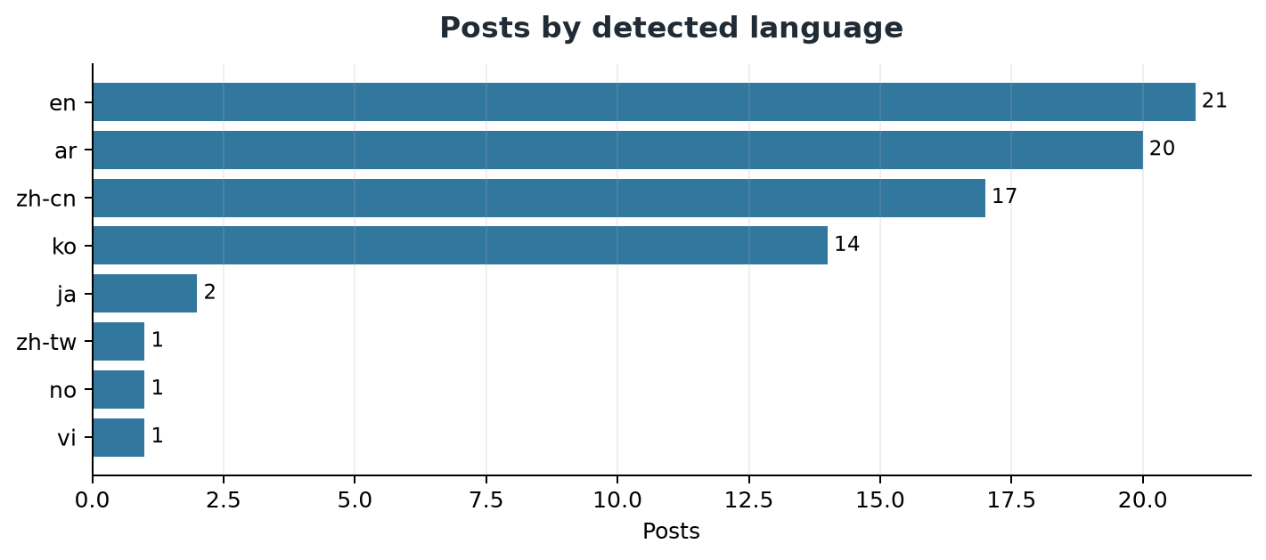
Language | Posts | Impressions | Engagement | Weighted rate
en | 21 | 612,498 | 46,792 | 7.6%
ar | 20 | 58,230 | 646 | 1.1%
zh-cn | 17 | 71,493 | 1,063 | 1.5%
ko | 14 | 34,935 | 80 | 0.2%
ja | 2 | 318 | 5 | 1.6%
vi | 1 | 11 | 0 | 0.0%
no | 1 | 12 | 0 | 0.0%
zh-tw | 1 | 11 | 1 | 9.1%

Geographic distribution
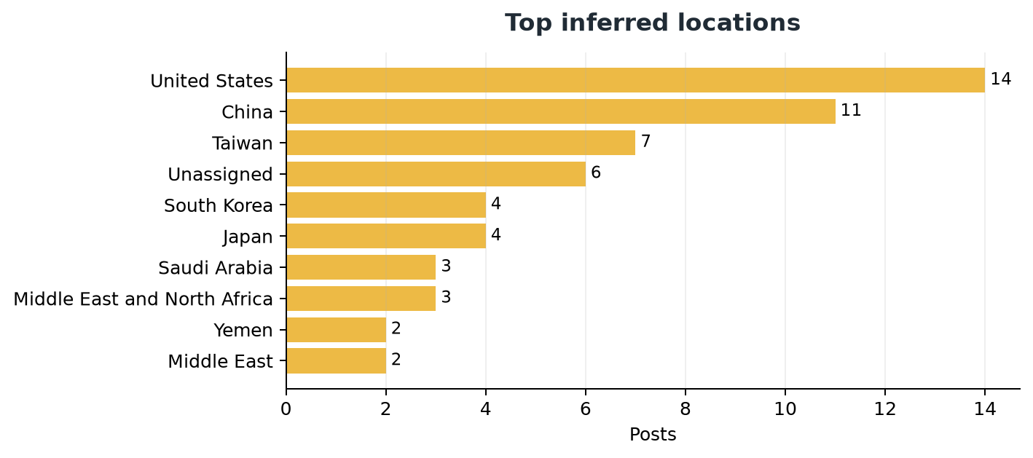

Location confidence and meaning
SUGAR locations may be inferred from profile information or post content and are not verified geotags. Treat the map as exploratory. Distinguish author location from places discussed before making claims about geographic origin.

3 Engagement and discourse
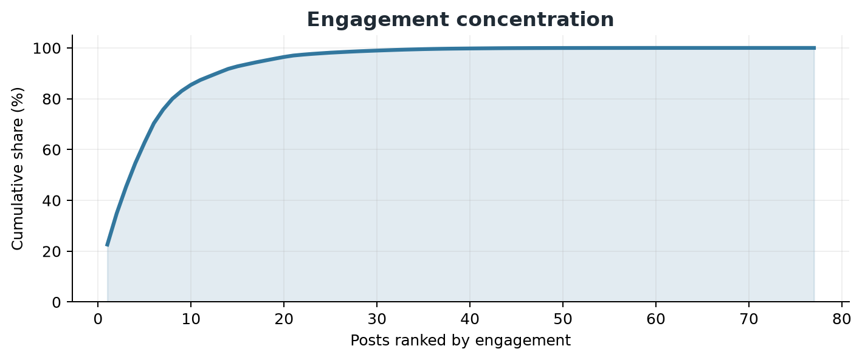
Account | Query | Impressions | Engagement | Rate
MAGAVoice | communism | 88,776 | 10,989 | 12.4%
BolsonaroSP | democracy | 41,065 | 5,942 | 14.5%
SaraAbrams1990 | democracy | 100,775 | 5,054 | 5.0%
Sassafrass_84 | democracy | 32,118 | 4,542 | 14.1%
waltermasterson | communism | 23,284 | 3,970 | 17.1%
marceelias | democracy | 79,063 | 3,680 | 4.7%
RyanAFournier | communism | 24,554 | 2,620 | 10.7%
texasdemocrats | democracy | 16,538 | 2,079 | 12.6%
AAGDhillon | democracy | 22,475 | 1,491 | 6.6%
IbaraEleven | communism | 9,579 | 1,176 | 12.3%

Recurring vocabulary
communism (27), democracy (26), communist (22), people (20), party (18), socialism (17), democratic (16), china (14), country (10), house (10), capitalism (10), president (9)
These are descriptive word counts, not validated themes or stance classifications. Review posts in context before assigning qualitative codes.

4 Recommendations for the next collection
- Increase depth and stratify long date ranges into daily or weekly intervals.
- Record requested count, returned count, pagination status, and collection time for every query.
- Store platform language and independent language detection separately.
- Separate author location, place discussed, and geocoding evidence into distinct fields.
- Report medians and concentration measures alongside totals and weighted engagement rates.
- Deduplicate near-identical narratives as well as post identifiers.

Method notes
Engagement is calculated as likes, replies, reposts or retweets, quotes, and bookmarks. Weighted engagement rate is total engagement divided by total recorded impressions. The analysis does not independently verify post content, identity, translation, or location.

Source
social_search_posts_20260909_144336.xlsx (77 data rows).

