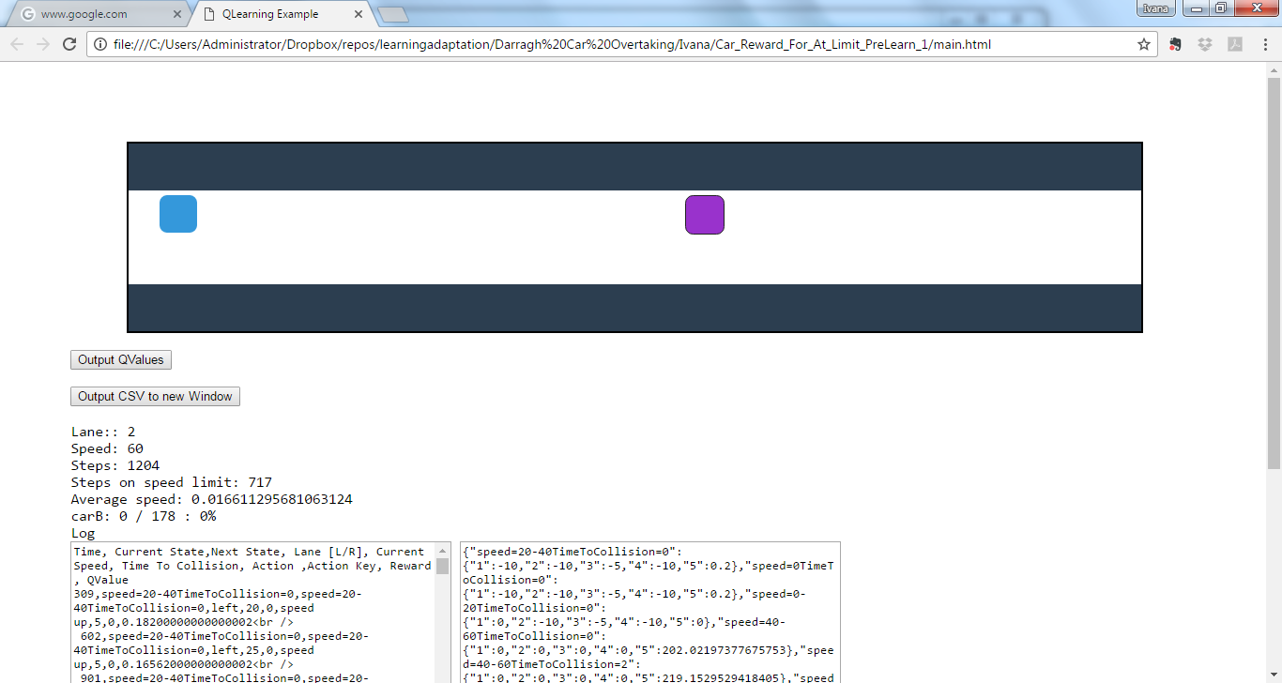

Perfect, 0 collision, 60% speed limit