Tyler Wiggins

This is my own work

CST-247

Bill Hughes

Figure : ViewBag that passes a message from the controller to the view.

Figure : Screenshot of effective debugging. I stepped into the program and it displayed the message in the ViewBags.Message

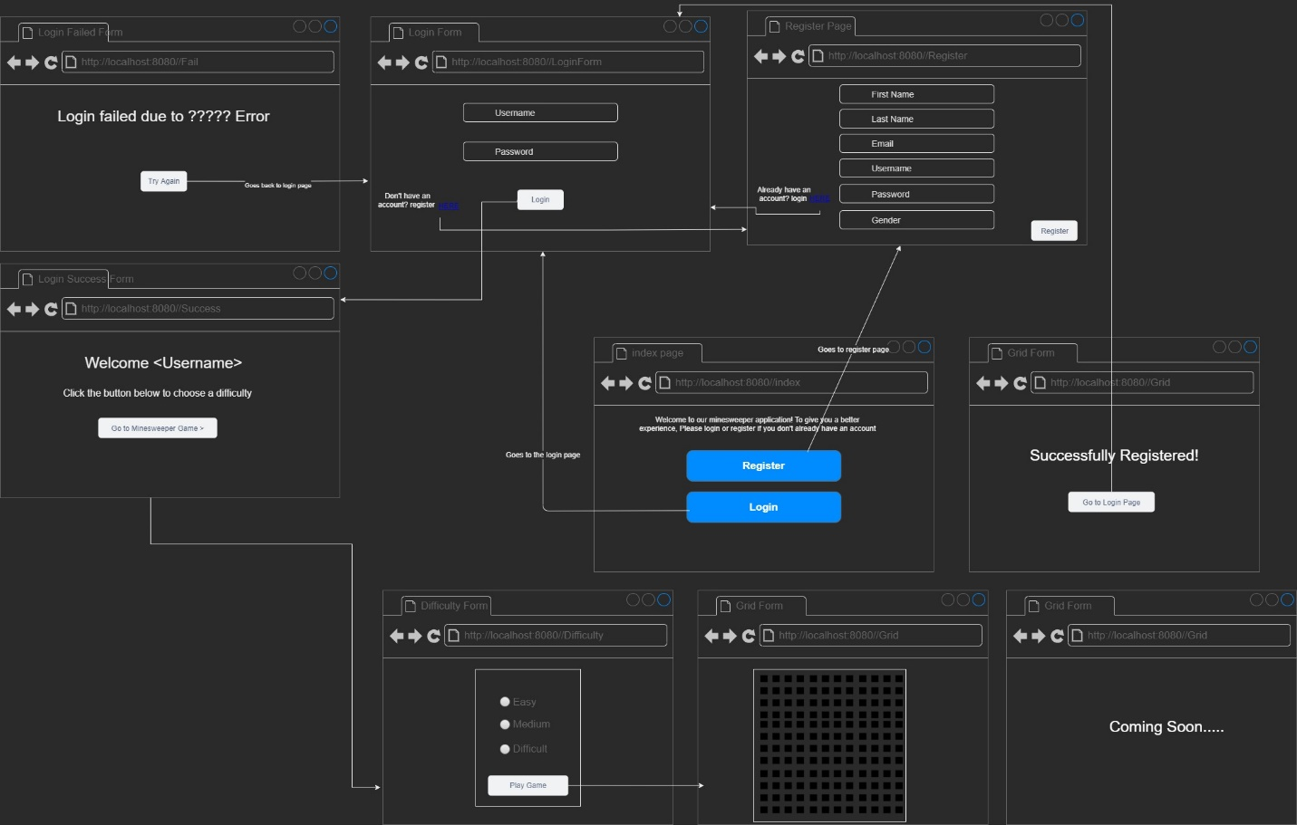

Figure : Wireframe for Minesweeper Application.

Figure : Sitemap for Minesweeper Application.

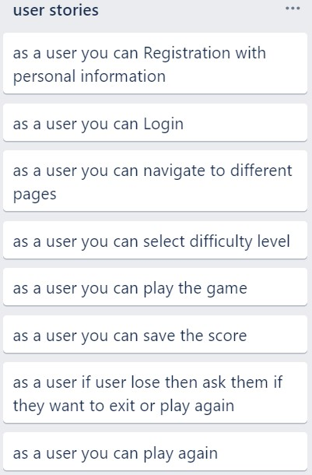

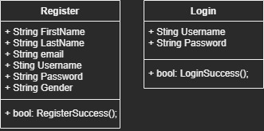

Figure : Started the UML for the login and register page.

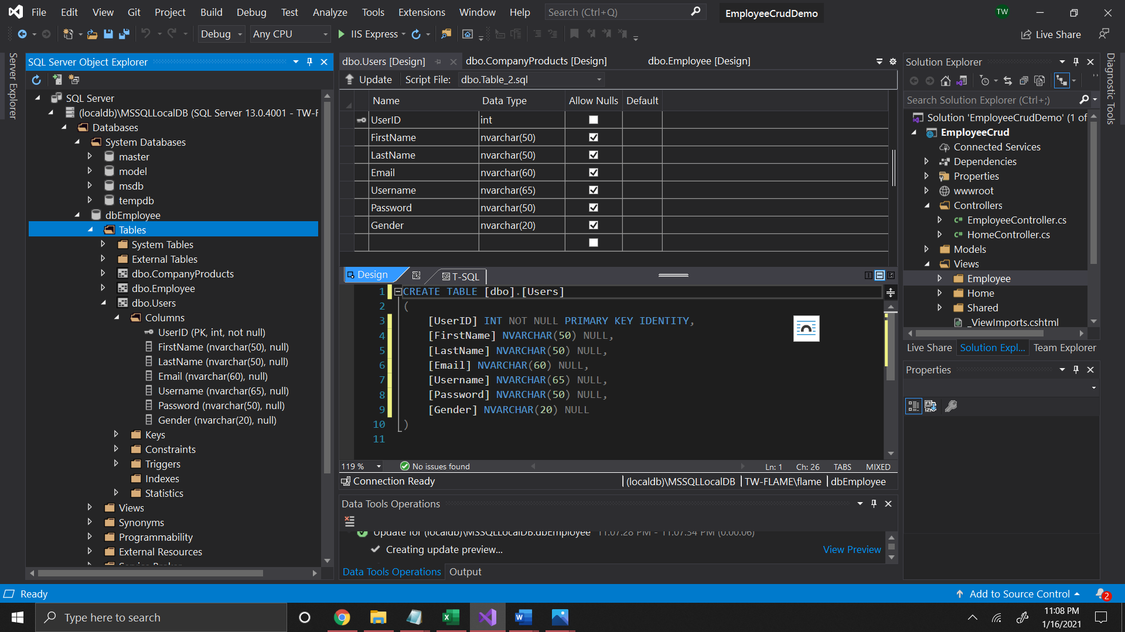

Figure : Database table to store the users information.