Tyler Wiggins

This is my own work

2/14/2021

Bill Hughes

CST-247

Activity 2

Link to activity github: https://github.com/FLAME270/Activities_For_CST-247.git

Figure : running controller and View from <http://localhost:30822/products>

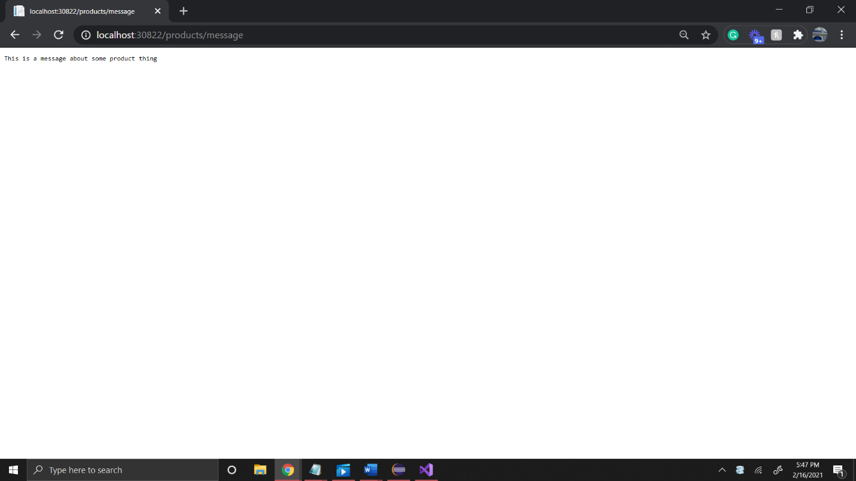

Figure : message function in the controller being ran from <http://localhost:30822/products/message>

Figure : testing view with a new controller.

Figure : ViewBag passed from the controller.

PART 2:

Figure : Login view created using the userModel class

Figure 6: Testing new login page at <https://localhost:44366/Login>

Figure 7: login sucessful with one user login ran at <https://localhost:44366/Login/ProcessLogin>

Figure 8: Login failed for single user login

Figure 9: Login fail with multiple users in business layer

Figure 10: login success with multiple users in business layer

Figure 11: Login success when adding database functionality

Figure 12: Login failed with database functionality

Figure : form with data validation

Figure : challenge screenshot of added address, email, and phone to the form