Tyler Wiggins

Cst-247

Bill Hughes

Midterm Assessment

GitHub Link: <https://github.com/FLAME270/CST-247_Midterm_Assessment.git>

Figure : View of Menu form

Figure : View of menu form after you click the menu button, with a returned viewbag message

Figure :Food controller that communicates with the BusinessService and view

Figure :foodModel that stores all the variables

Figure : BusinessService that takes the two ingrediences and reverses them and returns it to the controller

Figure : Menu view that shows the textboxes, with data validation

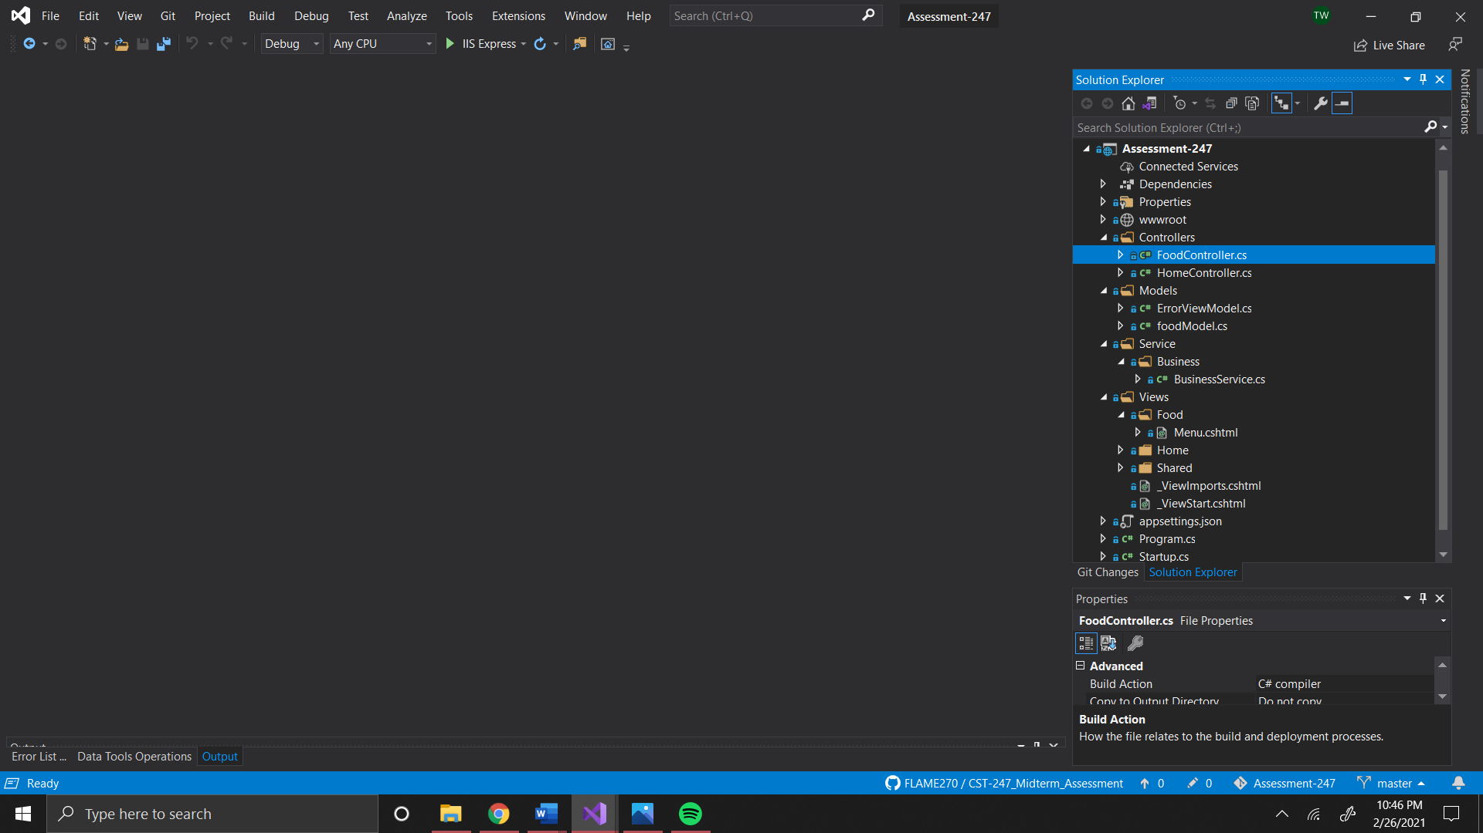

Figure : Folder structure