Tyler Wiggins and Vrijesh Patel

This is our own work

Cst-247

Bill Hughes

Milestone 3

Loudcloud did not let us upload the zip file, so its here in github

GitHub repo with entire application: https://github.com/FLAME270/CST-247_Milestone-3.git

Link to our loom video: <https://www.loom.com/share/e0d956d8fca94595964bb02a73905df6>

Part 2: <https://www.loom.com/share/5f0a8cef05e24e5c80ba731f2f5b6195>

Figure 5: wireframe for program.

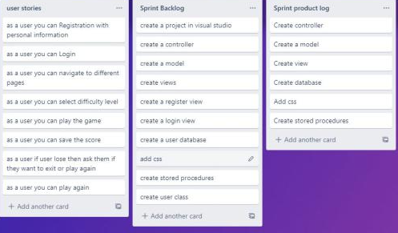



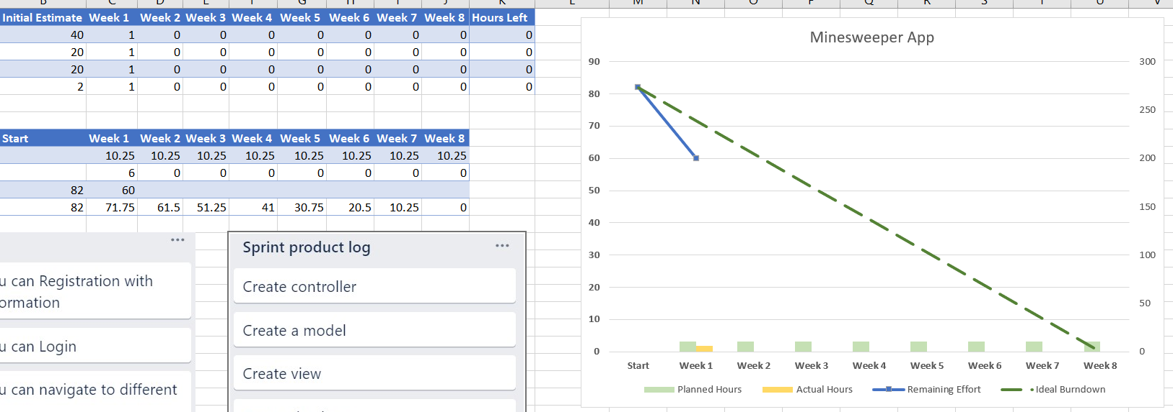



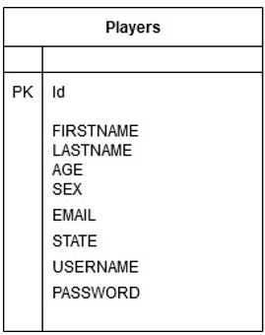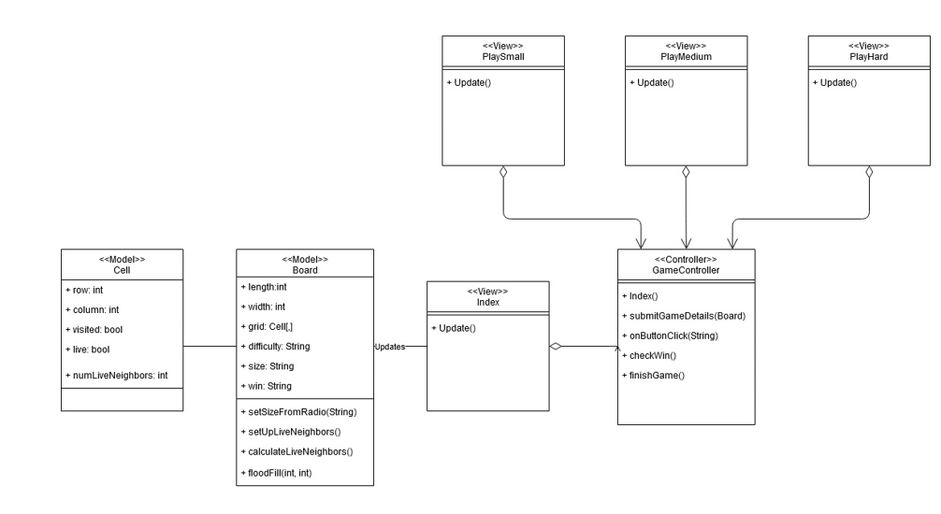

Tyler and Vrijesh

Er Diagram

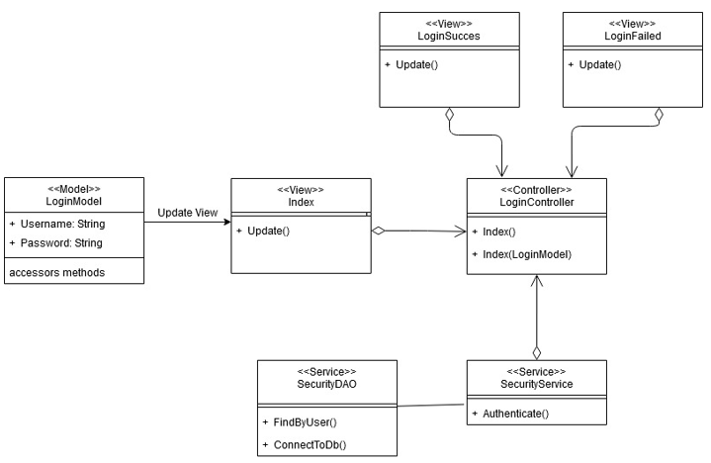

Database SQL

CREATE TABLE [dbo].[Player] (

[Id] INT IDENTITY (1, 1) NOT NULL,

[FIRSTNAME] NVARCHAR (50) NULL,

[LASTNAME] NVARCHAR (MAX) NULL,

[USERNAME] NVARCHAR (100) NULL,

[PASSWORD] NVARCHAR (100) NULL,

[SEX] NVARCHAR (100) NULL,

[AGE] INT NULL,

[STATE] NVARCHAR (100) NULL,

[EMAIL] NVARCHAR (100) NULL,

PRIMARY KEY CLUSTERED ([Id] ASC)

);

Procedures:

CREATE PROCEDURE [dbo].[AddPlayer]

@FIRSTNAME NVARCHAR(50),

@LASTNAME NVARCHAR(50),

@SEX NVARCHAR(20),

@AGE int,

@STATE NVARCHAR(20),

@EMAIL NVARCHAR(50),

@USERNAME NVARCHAR(50),

@PASSWORD NVARCHAR(50)

AS

BEGIN

Insert into Player(FIRSTNAME, LASTNAME, USERNAME, PASSWORD,SEX, AGE, STATE, EMAIL)

values(@FIRSTNAME, @LASTNAME, @USERNAME, @PASSWORD, @SEX, @AGE, @STATE, @EMAIL)

end

RETURN 0