List of Some Issue

1. Header and Footer Should seprate and load one time no need to write all pages
it will increase length of our code and also loading time.

2. Data Base Connection Need to make once time no need to make in all query execution to write separte code for connection we can inculede only time, it will reduse our code length and time

3. Need to provide Option Value
<option value =”Government”>Government</option>

4. If Foulder Not Creted for Uplad file it gives Error
So first check folder and if it not there create it

5. There is no filemove saving code

6. We can changes data type for some index we can user varchar and we can avoid text which taking more space in SQL server

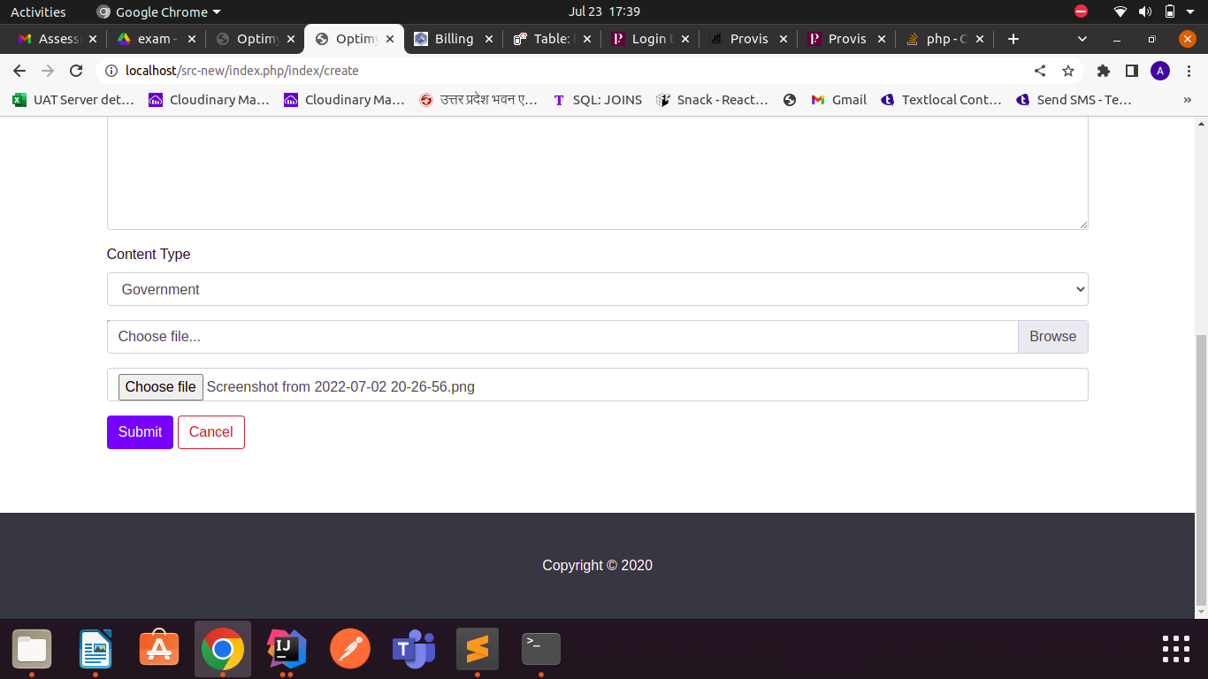
7. If file selected by user but in file text field user can not see

8. Need to add pagination and limit and more data there it will take time for loading
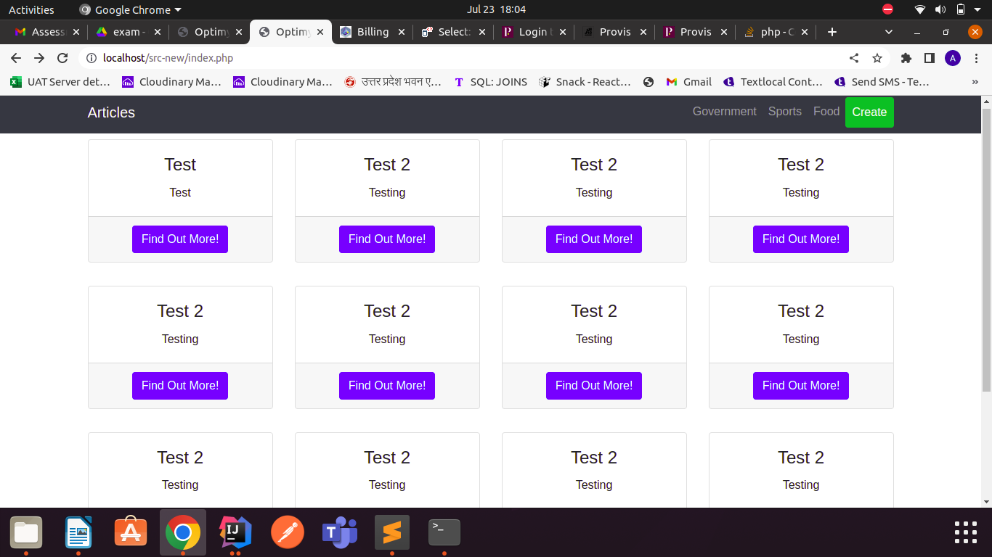

9. There is no any details page and its hyperlink

10. Image is not showing

12. In footer year should dynamic

11. Success Message after adding blog
