|  |  |
| --- | --- |
|  | **SR UNIVERSITY**  **Campus Warangal** |
| **Program:** II - B.Tech (CS& AI) |
| **Professor(a):** Dr. Venkataramana Veeramsetty, Professor |
| **Department:** Computer Science and AI **Semester:** I |
| **AI Assisted Coding - Lab Test 1 - Set B** |
| Instructions:   1. Use AI Tools like VScode+Github Copilot and Cursor AI for code generation 2. This Assignment will be evaluated for 15 Marks (10 Marks for Tasks and 5 Marks for viva based on regular lab activities) 3. Students need to submit assignment through canvas before due date 4. Students who are absent for lab will receive 0 Marks | |

1. Create a Python function that converts an amount from one currency to another using exchange rates stored in a dictionary. Use GitHub Copilot along with VS Code. Use Few shot prompting.  
     
   prompt:-  
    # Few-shot examples for Copilot:
2. # Example 1:
3. # input: amount=100, from_currency="USD", to_currency="EUR"
4. # exchange_rates={"USD": 1.0, "EUR": 0.85, "INR": 74.5}
5. # output: 85.0
6. # Example 2:
7. # input: amount=200, from_currency="INR", to_currency="USD"
8. # exchange_rates={"USD": 1.0, "EUR": 0.85, "INR": 74.5}
9. # output: 2.684563758389262
10. # Example 3:
11. # input: amount=50, from_currency="EUR", to_currency="INR"
12. # exchange_rates={"USD": 1.0, "EUR": 0.85, "INR": 74.5}
13. # output: 4382.352941176471
14. # Now write a function convert_currency(amount, from_currency, to_currency, exchange_rates)
15. # that uses the exchange rates dictionary to perform the conversion.  
      
    A screenshot of a computer program

    AI-generated content may be incorrect.  
      
    output:-  
    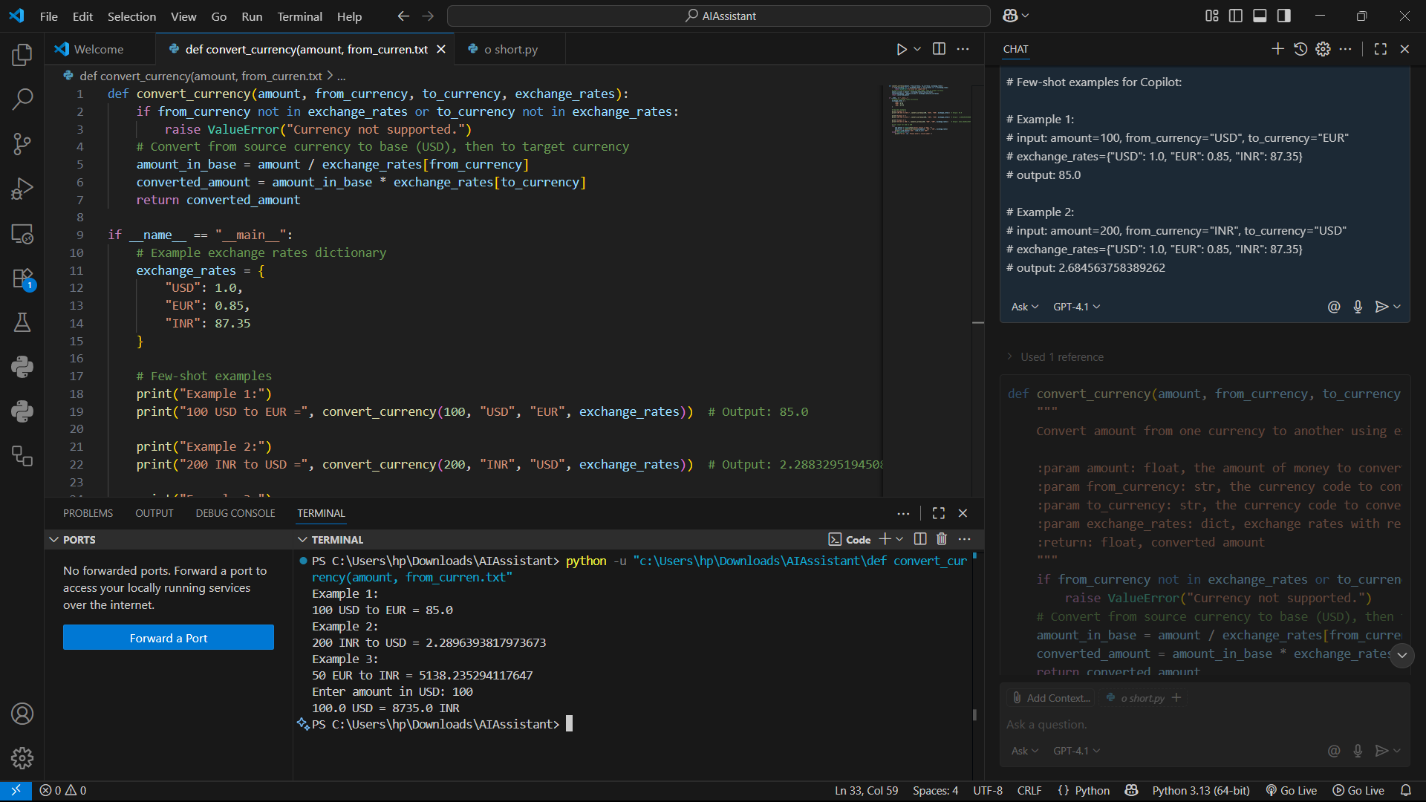
16. Write a Python program to extract all email addresses from a block of text using regular expressions. GitHub Copilot along with VS Code. Use zero shot prompting.

Prompt:- Write a Python program to extract all email addresses from a block of text using regular  
expressions  
  
©Dr. Venkataramana Veeramsetty, Professor Pag. 1 de 1