**Foramen Narrowing and Widening for C3/C4 vertebrae.**

Nodes were selected in an attempt to create orthogonal data points on the undeformed model (figure 1). The C3/C4 nodes were selected to be as similar to the C4/C5 data points used as possible. The following nodes were selected for:

C3/C4 Left:

14886, 16439, 17116, 1297

C3/C4 Right:

21922, 20101, 9037, 4457

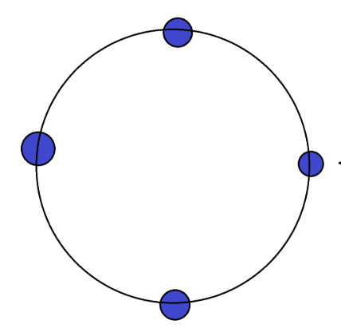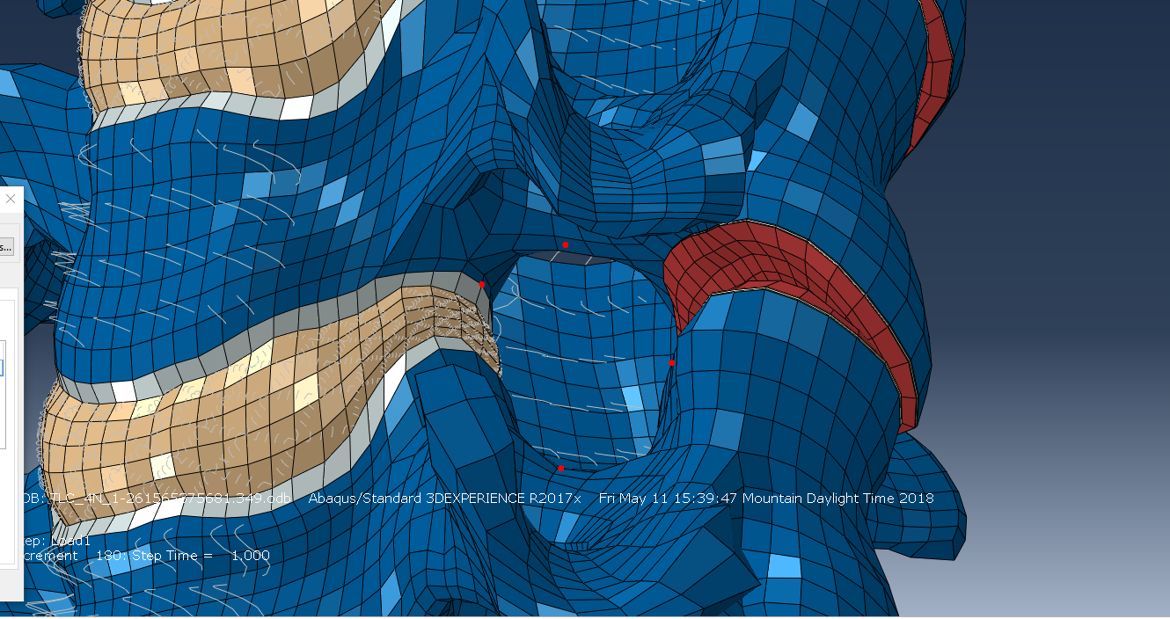

Figure 1. Circle with orthogonal points to aid in understanding node selection, and image from Abaqus showing node selection for C4/C5 Left.

Spatial displacements at each node for each increment were allocated by saving individual txt files for each node and loading scenario and using matlab to convert the txt file to be used in the C3/C4 scripts.