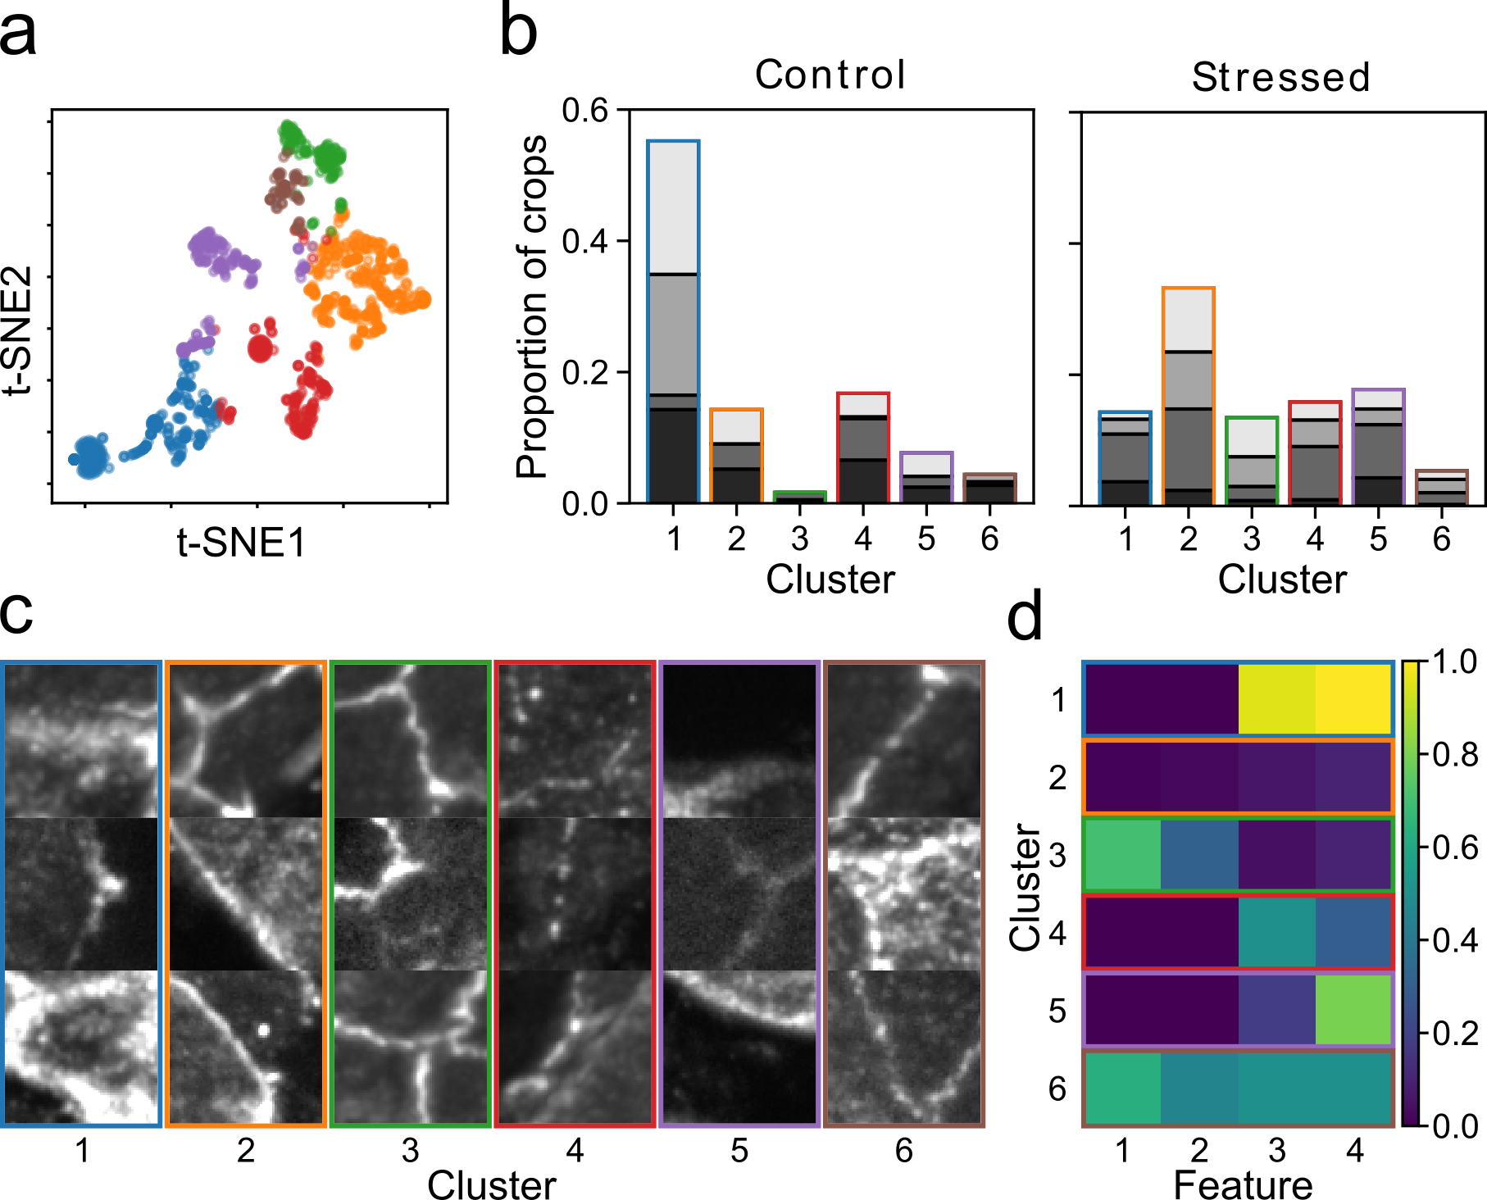

**Figure X.** Clustering analysis of gut tight junction images from control and stressed animals. **a)** t-TSNE visualisation of the clustering. Each color corresponds to a different found cluster. Tight junction crops with similar values are clustered together and are closer together in the t-SNE projection. **b)** Proportion of crops in each cluster for control and stressed animals. Different shades of gray correspond to different images (4 images per condition). In control images, cluster 1 contains over half of the tight junction crops, while very few crops are in cluster 3. In stressed images, there is an increase in crops in clusters 2 and 3. **c)** Example tight junction crops from each cluster. **d)**