dOPM Processing Guide
Bead-based registration, automatic batch processing, fusion and MIPs
A practical guide for users of the dOPM Shared ImageJ Scripts in Fiji/ImageJ.
Recommended approach: learn and validate the manual bead-registration workflow first, then use automatic batch mode for larger experiments once the registration is known to be reliable.
Core principle: Do not batch-process a large biological experiment until the registration reference has been checked visually and the registration log looks credible.
Current guide version: 27 September 2026
Repository:

Example validation dataset:
https://zenodo.org/records/22979717

Contents
1. Method and processing strategy
2. Data and acquisition assumptions
3. Manual bead registration - recommended first-time workflow
4. Apply a validated bead registration to sample data
5. Automatic beads-to-data batch mode
6. Bounding boxes
7. Fusion, export and MIPs
8. Alternative registration strategies and advanced options
9. Troubleshooting and when to stop
10. Further reading and support
Appendix A. Installation and setup
Appendix B. Validate the workflow on a small dataset
Appendix C. File naming and folder structure
Appendix D. Automatic registration defaults in this release
The document uses standard Heading styles so a live Google Docs table of contents can be regenerated after import if desired.

1. Method and processing strategy
Dual-view oblique plane microscopy (dOPM) acquires two overlapping 3D views of the same sample. The raw stacks are skewed relative to the microscope coordinate system. Processing therefore has two conceptually separate jobs: first, apply the known geometric transforms that deskew and orient the two views; second, estimate an experimental registration that aligns corresponding structures between the views.
The default workflow uses a 3D fluorescent-bead acquisition recorded with the same scan geometry as the biological data. Beads are detected as interest points in each view and channel, corresponding points are matched between views, and an affine registration is estimated. The complete transform stack from the bead reference is then copied to sample datasets acquired under the same optical conditions.
raw view 1 + raw view 2
↓
calibration + known dOPM geometry
↓
bead interest-point detection
↓
match corresponding beads between views
↓
affine registration
↓
visual QC of the registered bead volume
↓
copy the validated transform stack to sample datasets
↓
optional common bounding box → fusion → MIPs
Why manual bead registration comes first: The automatic workflow is useful only when the bead-registration assumptions are already understood. A user should first be comfortable creating a bead MVR dataset, reading the registration log, and checking the aligned bead volume in BigDataViewer.

What the scripts automate - and what they do not
- The scripts provide dOPM-specific dialogs and batch logic around Multiview Reconstruction / BigStitcher operations.
- The underlying registration, fusion, HDF5 and BigDataViewer functionality comes from the Fiji Multiview Reconstruction / BigStitcher ecosystem.
- The scripts do not make a poor bead acquisition become a good registration reference. Registration quality still depends on the microscopy data.
- The current automatic script does not automate multiview deconvolution. Deconvolution is available in the underlying MVR/BigStitcher ecosystem and can be used separately.

2. Data and acquisition assumptions

2.1 Bead reference acquisition
Acquire a bead volume with the same scan geometry, pixel size and prism/mirror angle used for the sample experiment. Ideally the bead acquisition is close in time to the biological acquisition so that the optical alignment has not changed.
- Use a bead concentration that provides many isolated beads throughout the 3D volume rather than only a few landmarks or a strongly saturated bead cloud.
- For a dense, useful bead reference, hundreds to thousands of detected interest points per view/channel is a practical expectation. This is not a hard threshold: the important result is that many reliable correspondences survive matching and RANSAC and that the registered volume is visually correct throughout the field.
- If one channel has few or no visible beads, registration in that channel may be weak. Consider whether another channel provides a better common feature or whether registration should be performed differently in MVR.

2.2 Sample acquisition
The standard batch workflow assumes sample data were acquired with the same dOPM geometry as the bead reference. The registration transfer is global: a bead registration is matched by channel and angle and copied across sample tiles, timepoints and well datasets.
Current batch assumption: For a given well, the dataset layout should be regular. In particular, the current well-based batch workflow assumes the tiles belonging to that well have the same number of timepoints.

2.3 Raw ND2 + XML and HDF5 + XML are both valid dataset forms
An MVR XML stores the dataset description and transform stack. The image data referenced by that XML may still be the original ND2 files, or the dataset can be resaved to HDF5. HDF5 is strongly recommended for interactive inspection in BigDataViewer because it supports efficient multi-resolution viewing.
The current bounding-box workflow can work from an HDF5/XML-only bead reference as well as from raw ND2 + XML. For an existing XML, the code first tries to obtain the raw Z depth from the XML ViewSetup size, then falls back to ND2 metadata, and finally prompts the user if neither is available.

For large datasets the value of not using HDF5 is not duplicating space so idea is test setup with beads or subset of data then goes from beads -> sample xml only -> fused data and skip hdf5

3. Manual bead registration - recommended first-time workflow
Use this route when learning the workflow, when setting up a new microscope configuration, or whenever you are not yet confident that automatic registration is reliable for the current bead acquisition.

3.1 Open the dOPM MVR setup tool
1. Start the pinned Fiji installation created for this project.
2. Open the dOPM menu and choose make mvr dataset.
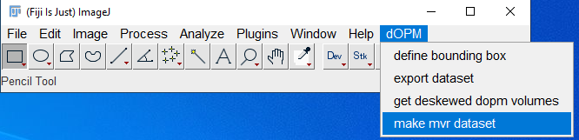
Figure 1. Fiji dOPM menu. Choose “make mvr dataset” to create or transform an MVR dataset.
3. Choose Transform & register beads.
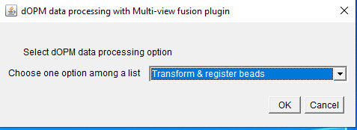
Figure 2. Select the bead-processing mode.

3.2 Select the bead folder and acquisition values
1. Select the folder containing the bead acquisition.
2. Choose the image extension. Nikon ND2 is the main tested route in this release.
3. Leave the canonical file pattern as spim_Time{tttt}_Tile{xxxx}_angle{a}.
4. Enter the physical pixel size in micrometres and the prism/mirror angle used by the microscope.
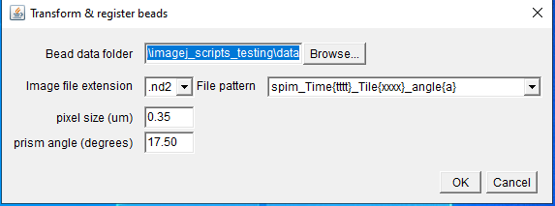
Figure 3. Bead setup dialog. Pixel size and prism/mirror angle must match the acquisition.

3.3 What happens after OK
The bead workflow follows the production order used by the Jython code: create the XML dataset, apply calibration, apply the known dOPM transforms, detect bead interest points, register the dataset, resave to HDF5, then calculate/store a bounding box when requested.
The Fiji Log is useful evidence that the geometric transform stage is running. You should see selected angles/channels and transformation matrices being applied.
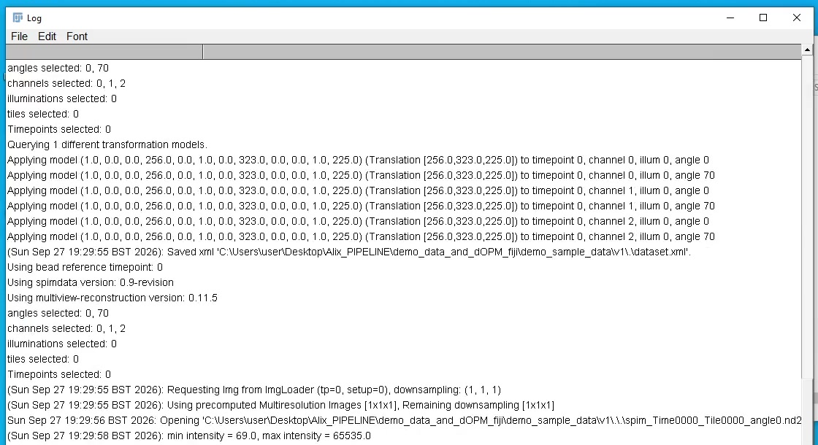
Figure 4. Example Fiji Log during dOPM geometric transformation. The important point is that non-identity transformations are being applied before bead registration.

3.4 QC checkpoint 1 - are enough bead interest points detected?
The automatic bead route uses Difference-of-Gaussian interest-point detection. Watch the Log for “Found … peaks” messages for each view/channel. A good dense bead volume should normally produce many detections across the views rather than only a handful.
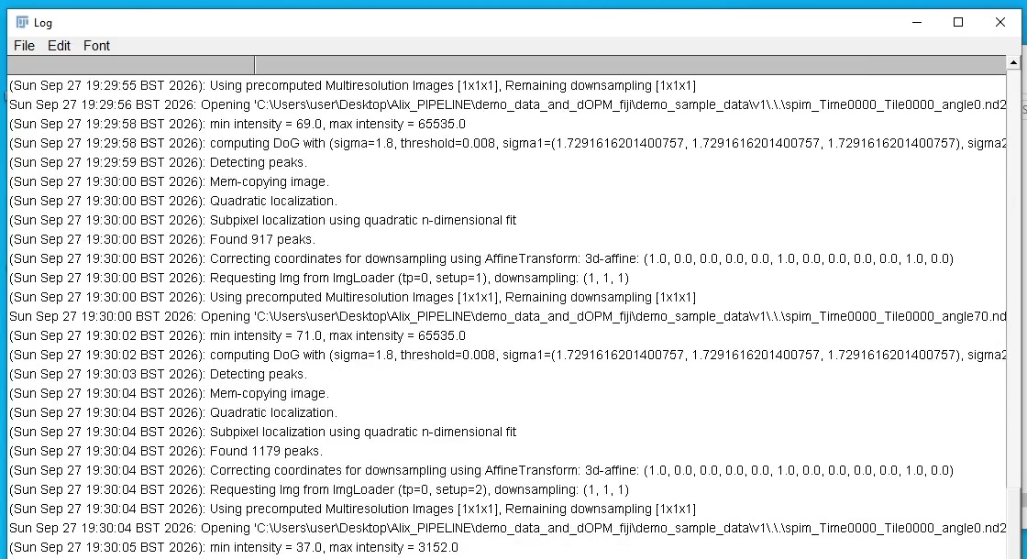
Figure 5. Interest-point detection in the test bead dataset. The example shows 917 and 1179 detected peaks in two view/channel combinations, with additional combinations detected afterwards.
Practical interpretation: Hundreds to thousands of detected points per view/channel is a useful expectation for a dense bead reference, but it is not a pass/fail threshold. The stronger test is whether many of those points match consistently between the two views and whether the final alignment is visually correct.

3.5 QC checkpoint 2 - do corresponding points survive RANSAC?
Registration matches bead descriptors between views and then rejects inconsistent matches using RANSAC. Look for lines reporting “Remaining inliers after RANSAC”. High inlier fractions and sensible sub-pixel/low-pixel errors are reassuring. Very few correspondences, repeated “not enough correspondences”, or a registration graph containing only one view are warning signs.
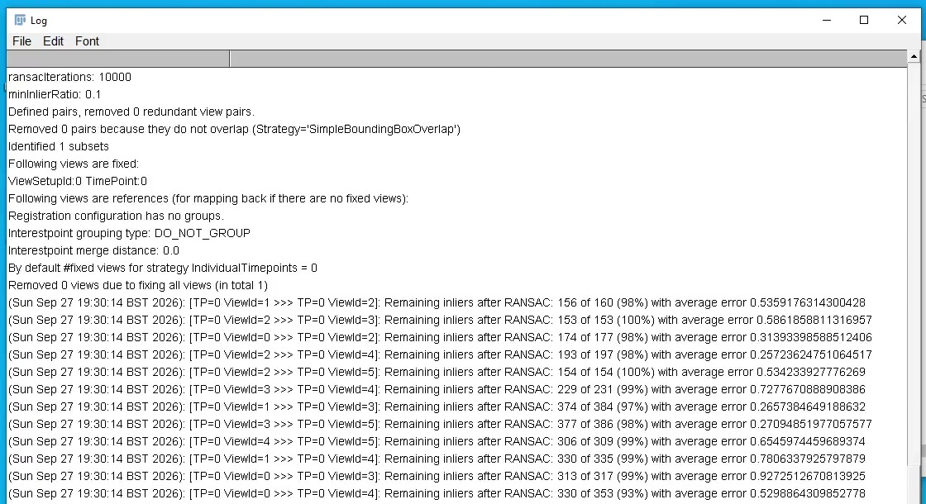
Figure 6. Example pairwise registration log. Many matched pairs retain high inlier fractions after RANSAC in this successful test run.

3.6 QC checkpoint 3 - global registration should be non-trivial and consistent
After pairwise matching, MVR performs global optimisation. The log reports average/minimum/maximum errors and the resulting transformation models. Do not interpret one specific error value as a universal threshold; instead compare with the visual result and with previous good acquisitions on the same microscope.
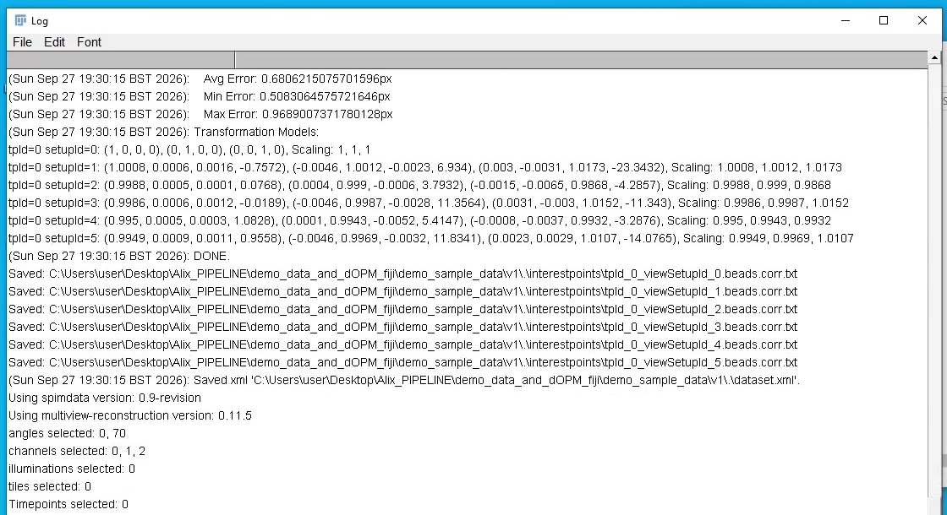
Figure 7. Example successful global optimisation. This test run reports an average error of about 0.68 pixels and non-identity models for the registered views.

3.7 Inspect the bead registration in HDF5/BigDataViewer
The most important manual QC step is visual. Open the HDF5-resaved bead XML using Plugins > Multiview Reconstruction > Multiview Reconstruction Application. The HDF5 dataset is ideal for responsive BigDataViewer inspection.
- Display the two dOPM views in contrasting LUTs, for example green and magenta.
- Inspect several regions of the volume, including the centre and edges.
- Correct registration should make corresponding beads overlap closely throughout the volume. A few bright points near the centre are not enough evidence.
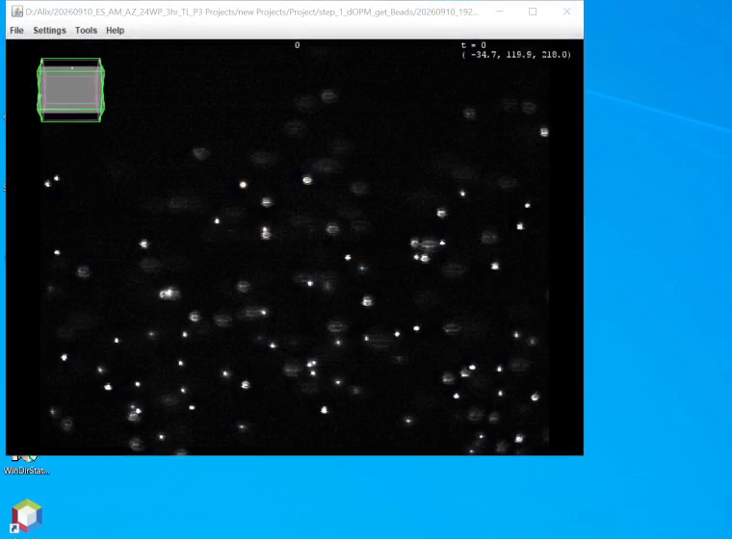
Figure 8. Registered bead data viewed in BigDataViewer. Corresponding bead signals from the two views should overlap throughout the field.
BigStitcher/MVR provides direct access to registration, interest-point and transformation tools from the ViewSetup Explorer. Use these tools when automatic detection or registration needs adjustment.
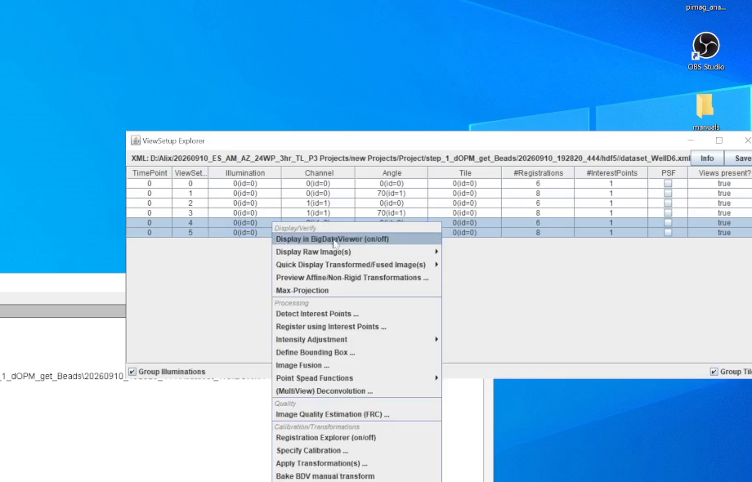
Figure 9. ViewSetup Explorer context menu. The MVR/BigStitcher tools can detect interest points, register using interest points, inspect transformations and fuse the aligned dataset.

3.8 If bead registration is poor
Stop here: Do not apply a questionable bead registration to a large sample dataset.
- Check that the bead and sample acquisitions use the intended two angles and that the pixel size/prism angle are correct.
- Check bead density and focus in every channel used for registration.
- Use the MVR/BigStitcher interest-point management tools to inspect detections directly.
- Repeat interest-point detection with more appropriate settings if needed, then re-run registration.
- If matching repeatedly fails despite a good bead acquisition, consult the Multiview Reconstruction / BigStitcher documentation or seek help from the dOPM script author or MVR/BigStitcher developers. The Jython scripts are wrappers around those plugin capabilities.

4. Apply a validated bead registration to sample data
Only proceed once the bead reference has passed manual QC. The sample workflow creates MVR XML datasets for the biological data, applies the same dOPM geometry and copies the bead registration transform stack into each matching sample channel/angle.

4.1 Sample filename and well grouping
The canonical pattern is spim_Time{tttt}_Tile{xxxx}_angle{a}. Optional well suffixes are recognised. Files with the same Well… suffix are grouped into one MVR XML dataset.
spim_Time0000_Tile0000_angle0__WellF5.nd2
spim_Time0000_Tile0000_angle70__WellF5.nd2
spim_Time0000_Tile0001_angle0__WellF5.nd2
spim_Time0000_Tile0001_angle70__WellF5.nd2
→ dataset_WellF5.xml
Multiple wells are processed independently, for example dataset_WellF5.xml and dataset_WellF6.xml. Timepoints and tiles are preserved within each well dataset.

4.2 Use Transform & register data
1. Run make mvr dataset again and choose Transform & register data.
2. Select the optimised bead/reference XML. The freshly registered HDF5 bead XML is a convenient reference because it is also the dataset you have just inspected visually.
3. Select the sample data folder.
4. Use the same image extension, pixel size and prism/mirror angle as the bead workflow.
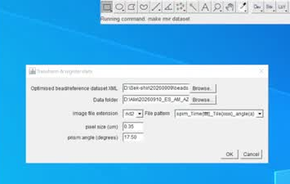
Figure 10. Manual transfer of a validated bead/reference registration to sample data.
The production code discovers the well groups and creates one XML per well. It then copies the bead registration by channel and angle across the sample timepoints and tiles.

4.3 Optional: resave a sample XML to HDF5 for visual QC
Large sample datasets do not need to be converted to HDF5 merely to run the dOPM scripts. However, converting a representative sample or a small subset to HDF5 is very useful for fast interactive inspection in BigDataViewer.
- For a large experiment, validate one or a few representative wells/tiles/timepoints rather than resaving the entire dataset immediately.
- In the MVR application, use the Resave dataset / HDF5 functions and keep the desired angles, channels, tiles and timepoints.

4.4 Visually inspect the registered sample
Open the sample dataset in the MVR application and inspect the two views together. This is the second important visual QC checkpoint. A good bead registration can still be inappropriate for a sample if the microscope alignment changed between bead and sample acquisition.
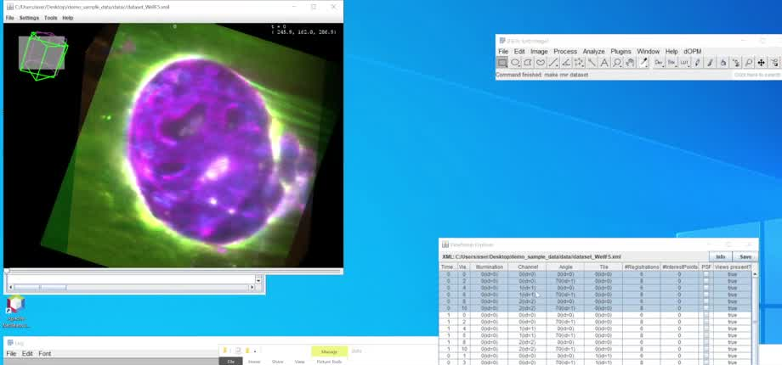
Figure 11. Example sample dataset after the bead registration has been transferred. Inspect several structures and several positions, not only one central object.
If beads look good but samples do not: Check that the sample and bead acquisitions truly used identical geometry and that the optical alignment did not change. If necessary, register using sample features instead of transferring the bead reference.

5. Automatic beads-to-data batch mode
Automatic mode combines the workflow steps that have been validated manually: bead reference handling, per-well sample XML creation, registration transfer, optional common bounding box, batch fusion and optional MIP generation.
Recommended use: First validate automatic mode on a small paired bead + sample subset. Once its output matches your manual workflow, use the same settings on the full experiment.

5.1 Build a small validation subset first
For a new experiment or microscope configuration, make a small test folder containing one bead acquisition and only a few sample volumes - for example one or two wells, a few tiles and a few timepoints. This lets you validate registration and output structure quickly without committing hours of compute to the full experiment.
validation_subset/
beads/ # representative bead acquisition or registered bead XML/HDF5
data/ # one or two wells, a few tiles/timepoints

5.2 Run automatic_batch_workflow.py
The automatic dialog asks for the bead folder, data folder, optional output folder, pixel size, prism/mirror angle, fusion binning and downstream processing options.
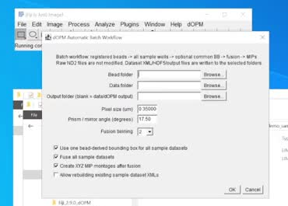
Figure 12. Automatic batch workflow dialog. Common bounding box, fusion and XYZ MIPs can be enabled in one run.

5.3 How automatic mode handles the bead folder
- If a bead dataset XML already exists, the workflow uses an existing registered reference. HDF5 XML is preferred when present.
- If no bead XML exists, the script does not silently proceed. It offers the conservative option to abort and use the manual bead workflow, or an explicit option to try automatic bead processing.
- When automatic bead processing is chosen, it follows the validated order: create XML → calibration → dOPM geometry → interest-point detection/registration → HDF5 resave → optional bead-derived bounding box.
- If several bead XML files are found, the user is asked which registered/optimised XML to use.

5.4 Multi-well batch behaviour
The data folder is scanned for well patterns. Each well receives its own MVR XML, and the bead registration is transferred across the tiles and timepoints in that well. If a common bead-derived bounding box is enabled, the same named bounding box is copied to all sample XMLs.
Existing XML safeguard: Automatic mode stops if sample dataset XMLs already exist unless “Allow rebuilding existing sample dataset XMLs” is explicitly enabled. This reduces accidental overwriting.

5.5 What to inspect after an automatic validation run
- Open the HDF5 bead XML and visually confirm the bead overlap in BigDataViewer.
- Read the bead registration log for detected peaks, RANSAC inliers and a sensible global optimisation.
- Open at least one representative sample dataset and verify that the two views overlap as expected.
- Check that the number of fused TIFFs and MIPs matches the expected tile × timepoint × channel combinations.
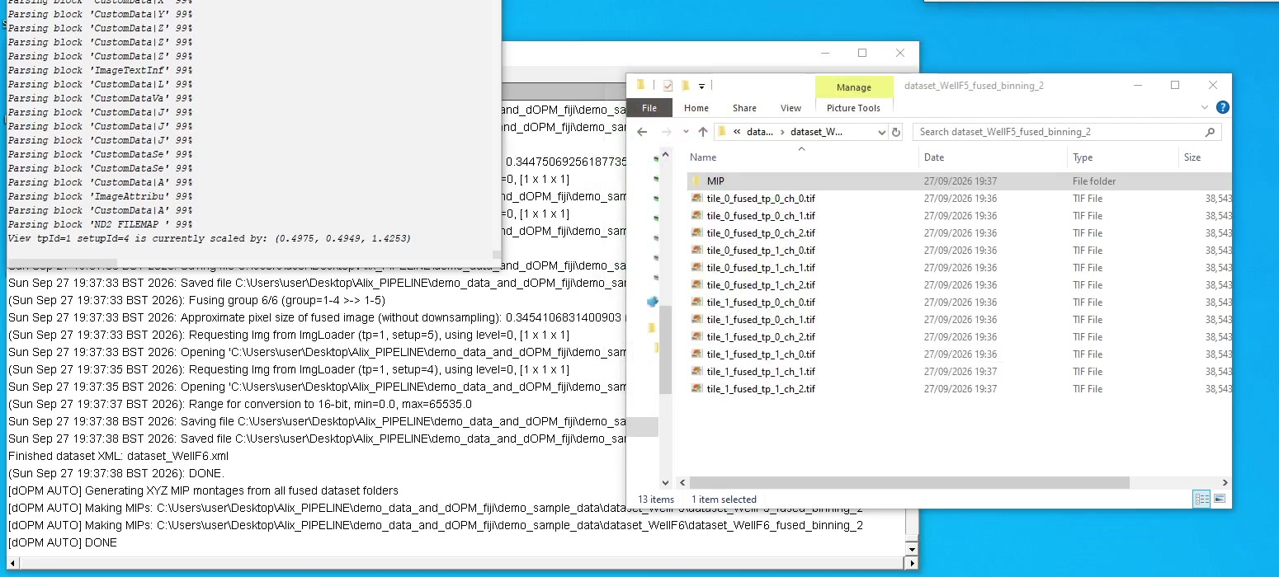
Figure 13. Example automatic run after fusion. The Log reports dataset completion and MIP creation while the output folder contains fused TIFF stacks and a MIP subfolder.

6. Bounding boxes
The overlapping geometry in dOPM remote scanned volume with a typical ROI of 512x512 and 151 planes 1 um spaced makes it desirable to crop a smaller bounding box based on geometry alone saving space. However, its fine to skip this option to get the maximum extent and data size is about 20-30% larger overall.
A bounding box defines the output region in the common registered coordinate system. It can be used to crop away empty transformed space and, importantly for batch experiments, to give multiple sample datasets a consistent output extent.
The recommended batch approach is to derive or define a box from the registered bead reference and apply that same box to all sample XMLs. This is useful when comparing wells, tiles and timepoints because the output volumes share the same spatial extent.
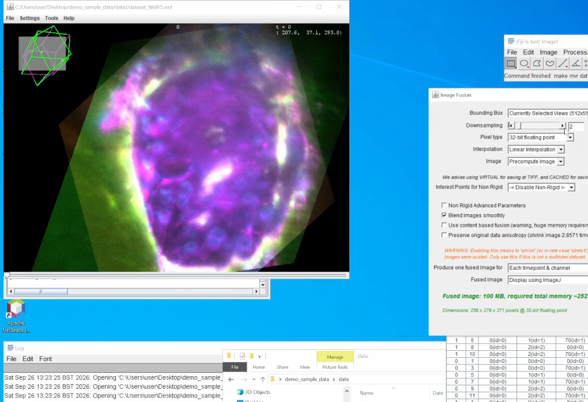
Figure 14. Bounding-box adjustment in the registered dataset. The wireframe shows the crop region in the common transformed coordinate system.
- The bead reference may be raw ND2 + XML or HDF5 + XML.
- For HDF5-only bead datasets, the current code can determine the raw Z depth from the XML ViewSetup size when possible; ND2 metadata is only a fallback.
- If no reliable size can be determined, the user is prompted for the original raw Z-plane count.

7. Fusion, export and MIPs

7.1 Fusion
Once the registration is trusted, the aligned views can be fused into a conventional 3D image stack. Fusion can be run from the dOPM export script or directly from the Multiview Reconstruction / BigStitcher application. The plugin route is useful for understanding and testing the dataset; the dOPM batch route is useful for repeated processing across many wells.
- Binning controls the output sampling/resolution. Binning 1 gives the highest sampling; larger values reduce output dimensions and processing cost.
- Use the common named bounding box when consistent output extents across datasets are important.
- Single-view export is also supported and is useful for diagnostics or downstream comparisons.
- Because in the xmls we aggregate tiles which are not strictly from the same view the fusion macro automatically does fusions per tile not per everything in an xml for instance.

7.2 XYZ maximum-intensity projections
The automatic workflow can generate an XYZ MIP montage for each fused TIFF stack. The current implementation uses CLIJ2 to create maximum projections along Z, X and Y and combines them into a compact QC image.
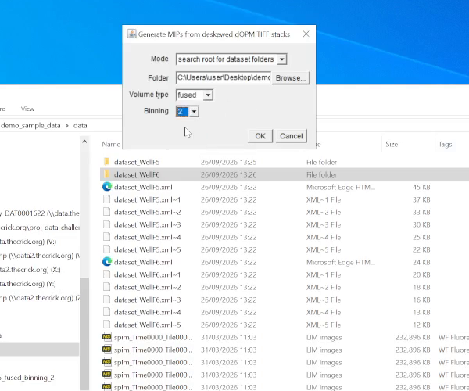
Figure 15. MIP workflow dialog used to search a root folder for fused dataset outputs.
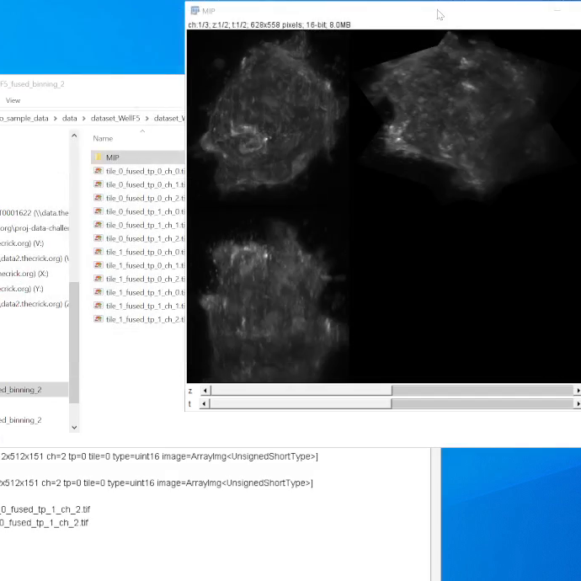
Figure 16. Example grayscale XYZ MIP output from a fused volume.

7.3 Summary montages for high-content experiments
MIPs can be assembled into higher-dimensional summary montages in ImageJ. One useful strategy is to map montage dimensions to combinations of XY/projection orientation, channel, tile and time so that a well can be reviewed rapidly. Image5D-style browsing or montage generation can be useful for checking many fields and timepoints before detailed analysis.
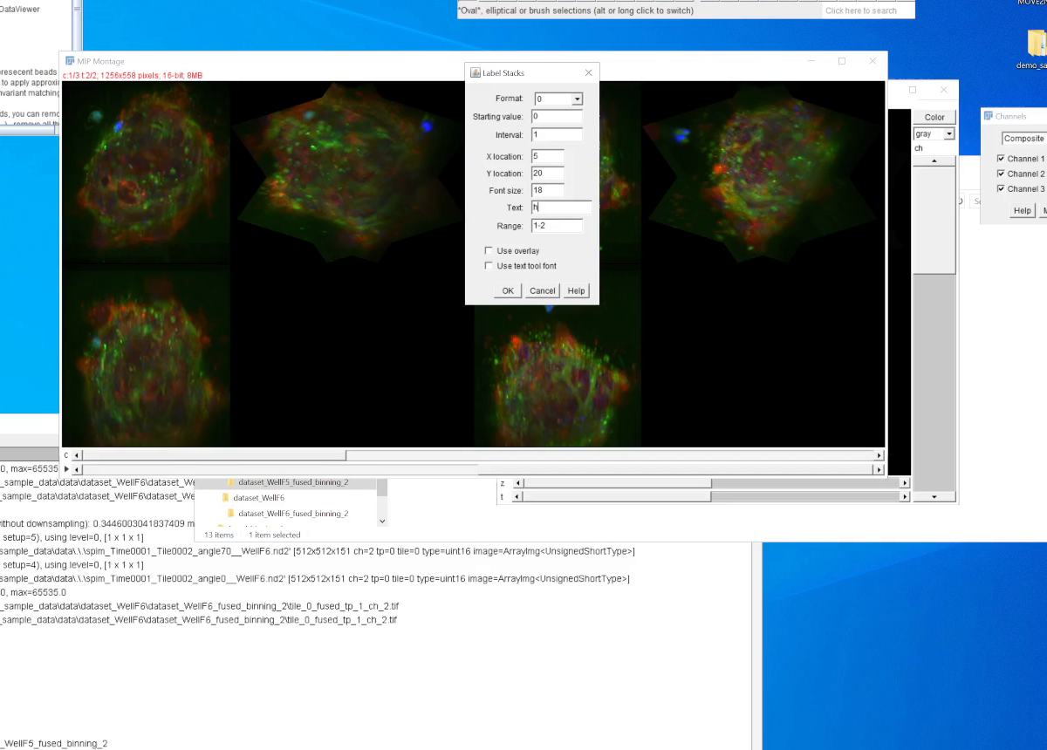
Figure 17. Example multi-panel summary view assembled from processed dOPM outputs. The exact montage organisation can be adapted to the and acquisition layout.
For interactive 3D rendering, other ImageJ/Fiji plugins or scripts can be used. An Images3D-style rendering tool is useful in some workflows but is not included in the pinned Fiji environment installed by this release.

8. Alternative registration strategies and advanced options

8.1 Register using features in the biological sample
Beads are not the only possible registration reference. If the sample contains features visible in both dOPM views - for example nuclei or membrane structures - those features can be detected as interest points and used directly in MVR/BigStitcher.
The current make_mvr_dataset.py includes “Transform two-view data without registering”. This provides the calibrated/deskewed geometry without copying a bead registration. The dataset can then be opened in MVR and registered manually using sample interest points.
When this can be better: Sample-based registration avoids the assumption that the bead reference and the biological acquisition have exactly the same registration. It can be preferable when the microscope alignment has shifted or when there are strong common biological landmarks.

8.2 Use one sample as a reference
A well-registered representative sample can conceptually be used as a reference for related samples in the same way that a bead dataset is used as a reference, provided the acquisition geometry is stable and the transform transfer is appropriate. This is an advanced workflow and should be validated carefully.

8.3 Per-sample registration and drift correction
Multiview Reconstruction / BigStitcher supports more advanced registration over tiles and time, including workflows that can correct sample-specific shifts or temporal drift. These capabilities are provided by the plugins; the current automatic dOPM script does not attempt to choose or optimise these advanced registration strategies for the user.

8.4 Deconvolution
The MVR/BigStitcher ecosystem supports multiview deconvolution after registration and can use point-spread functions derived from beads or supplied separately. Deconvolution is not automated by this release of the dOPM batch script, so users should follow the plugin documentation when this is required.

8.5 Related/future processing modes
Related versions of this processing approach have been adapted for headless/server execution and for stage-scanning OPM data. Those variants are outside the scope of this guide and are not part of the current pinned Fiji release described here.

9. Troubleshooting and when to stop

Very few bead interest points
- Check bead concentration, focus and signal in each relevant channel.
- Check that the correct views/files are present and that the ND2 dimensions are sensible.
- Inspect interest points directly in BigStitcher/MVR and adjust detection parameters if needed.

Many detected beads but few correspondences
- Confirm the dOPM geometry/pixel size/prism angle are correct before registration.
- Check whether the two views genuinely image overlapping sample content.
- Use MVR interest-point visualisation and registration tools to diagnose pairwise matching rather than repeatedly trusting the wrapper script.

Beads register well but sample views do not
- Confirm bead and sample acquisitions used the same optical setup and scan settings.
- Check whether the optical alignment changed between bead and sample acquisitions.
- Consider sample-feature registration instead of global bead transfer.

BigDataViewer/Data Explorer will not open
The pinned Fiji environment includes a specific BigDataViewer compatibility stack. If Fiji has been updated, incompatible JAR versions can break the viewer even while some processing scripts still run. Rebuild the environment with the supplied setup/installer scripts rather than updating the validated Fiji instance in place.

Automatic mode finds existing sample XMLs
By default the automatic workflow stops to avoid rebuilding existing sample datasets. Either move/rename the previous XMLs, use a clean copy of the raw data, or explicitly enable the rebuild option when overwriting is intentional.

Inconsistent timepoints or missing tile/view combinations
The current per-well batch logic expects a regular layout. Missing files or different timepoint counts between tiles can produce incomplete datasets or unexpected outputs. Resolve acquisition/file-organisation inconsistencies before relying on batch output counts.

10. Further reading and support
The dOPM scripts intentionally leverage established Fiji multiview tools. Users who need to diagnose registration, change detection settings or use advanced fusion/deconvolution should become familiar with the plugin documentation.
- Multiview Reconstruction: https://imagej.net/plugins/multiview-reconstruction
- BigStitcher: https://imagej.net/plugins/bigstitcher/
- BigStitcher registration using interest points: https://imagej.net/plugins/bigstitcher/registration
- BigStitcher MultiView mode: https://imagej.net/plugins/bigstitcher/multiview-mode
- SPIM Registration method (historical background): https://imagej.net/plugins/spim-registration/method
- image.sc forum: https://forum.image.sc/
- dOPM Shared ImageJ Scripts repository:
For problems that appear to be specific to the dOPM wrapper logic, contact the code authors or open an issue in the repository. For problems in interest-point detection, registration, BigDataViewer, fusion or deconvolution, the MVR/BigStitcher documentation and developer community are the primary technical reference.

Appendix A. Installation and setup
The main workflow does not require a separate CPython installation. The supplied setup scripts build the validated Fiji environment and deploy the Jython scripts into Fiji automatically.

Windows
1. Download or clone the dOPM_Shared_ImageJ_Scripts repository from GitHub.
2. Extract the repository to a normal writable folder.
3. Double-click installers\setup_dOPM_windows.bat.
4. The setup script builds Fiji_2.9.0_dOPM at the repository root if it is missing, then creates Fiji.app\plugins\Scripts\dOPM and copies the repository-root Python/Jython scripts there.
5. Launch the Fiji executable inside Fiji_2.9.0_dOPM\Fiji.app. Do not run Help > Update before validating the environment.
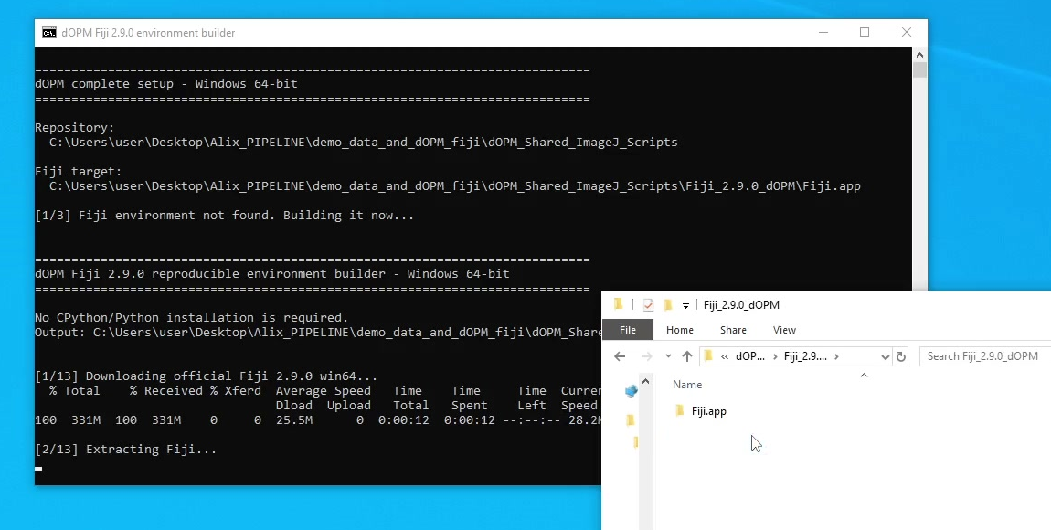
Figure A1. Windows one-step setup building the pinned Fiji environment. The generated Fiji_2.9.0_dOPM folder is placed at the repository root.

Linux x86_64
chmod +x installers/setup_dOPM_linux.sh
./installers/setup_dOPM_linux.sh
The Linux setup builds the same pinned Fiji/Java plugin stack. CLIJ2 MIP generation additionally requires a working OpenCL runtime/driver on the Linux workstation.

Why the Fiji version is pinned
This workflow depends on historical Multiview Reconstruction, BigStitcher/BigDataViewer and CLIJ compatibility. The installer records the versions in FIJI_ENVIRONMENT.md. Rebuilding from the supplied setup script is safer than updating individual JARs in place.

Appendix B. Validate the workflow on a small dataset
A small paired validation dataset is available through Zenodo. It contains two supported bead filename-pattern examples (v1 and v2) and a multi-well sample folder. Use it to confirm that Fiji, registration, registration transfer, bounding boxes, fusion and MIPs work before processing valuable experimental data.
Validation data: https://zenodo.org/records/22979717
demo_sample_data/
v1/ # bead data without a well suffix
v2/ # bead data with a well suffix
data/ # sample data with multiple Well... groups
1. Start the pinned Fiji environment.
2. Run validation/Test_dOPM_EndToEnd_v3_faithful.py.
3. Choose the extracted demo_sample_data folder.
4. For the development validation, the settings 0.35 µm pixel size, 17.5° prism angle and fusion binning 2 were used.
5. The validator copies the input ND2 files into an isolated test area before processing; the source demo data are not modified.
6. A PASS is only useful if it agrees with visual QC. Open the resulting registered HDF5 bead XML and inspect the views in BigDataViewer.
Best practice for your own experiment: Repeat the same idea with a small subset of your own beads and sample data before launching automatic mode on a full multi-well/time-lapse experiment.

Appendix C. File naming and folder structure

Canonical two-view pattern
spim_Time{tttt}_Tile{xxxx}_angle{a}.nd2
Example:
spim_Time0000_Tile0000_angle0.nd2
spim_Time0000_Tile0000_angle70.nd2

Optional well suffix
spim_Time0000_Tile0000_angle0__WellF5.nd2
spim_Time0000_Tile0000_angle70__WellF5.nd2
Well-suffixed files are grouped into datasets such as dataset_WellF5.xml. Files without a well suffix use dataset.xml.

Typical automatic outputs
data/
dataset_WellF5.xml
dataset_WellF6.xml
dOPM_automatic_batch_report.txt
dOPM_output/
dataset_WellF5/
dataset_WellF5_fused_binning_2/
*.tif
MIP/
*.tif

Appendix D. Automatic registration defaults in this release
These settings are defined by dopmmvr.py for the automated bead-registration path. They are useful when comparing the scripted result with manual MVR registration or when troubleshooting.
- Interest-point detection: Difference of Gaussian.
- Signal preset: Weak & small (beads).
- Sub-pixel localisation: 3D quadratic fit.
- Downsampling: 1× in XY and 1× in Z.
- Compute: CPU (Java).
- Registration algorithm: Fast descriptor-based (rotation invariant).
- Compare only overlapping views according to current transformations.
- Fix the first view; do not map back.
- Transformation model: Affine, regularised toward Rigid with lambda 0.10.
- RANSAC allowed error: 5; iteration preset: Normal.
These are reasonable defaults for the validated dOPM bead datasets, not universal biological truth. If the bead volume differs substantially in density, SNR or geometry, use the MVR/BigStitcher interface to inspect and optimise the registration rather than forcing the automatic settings.

End of guide
The safest workflow is simple: establish a trustworthy registration reference, inspect it, validate transfer on a small sample subset, and only then scale to automatic batch processing.

