Wb01 Black spruce - Creeping-snowberry - Peat-moss

Picea mariana - Gaultheria hispidula - Sphagnum

**General Description**

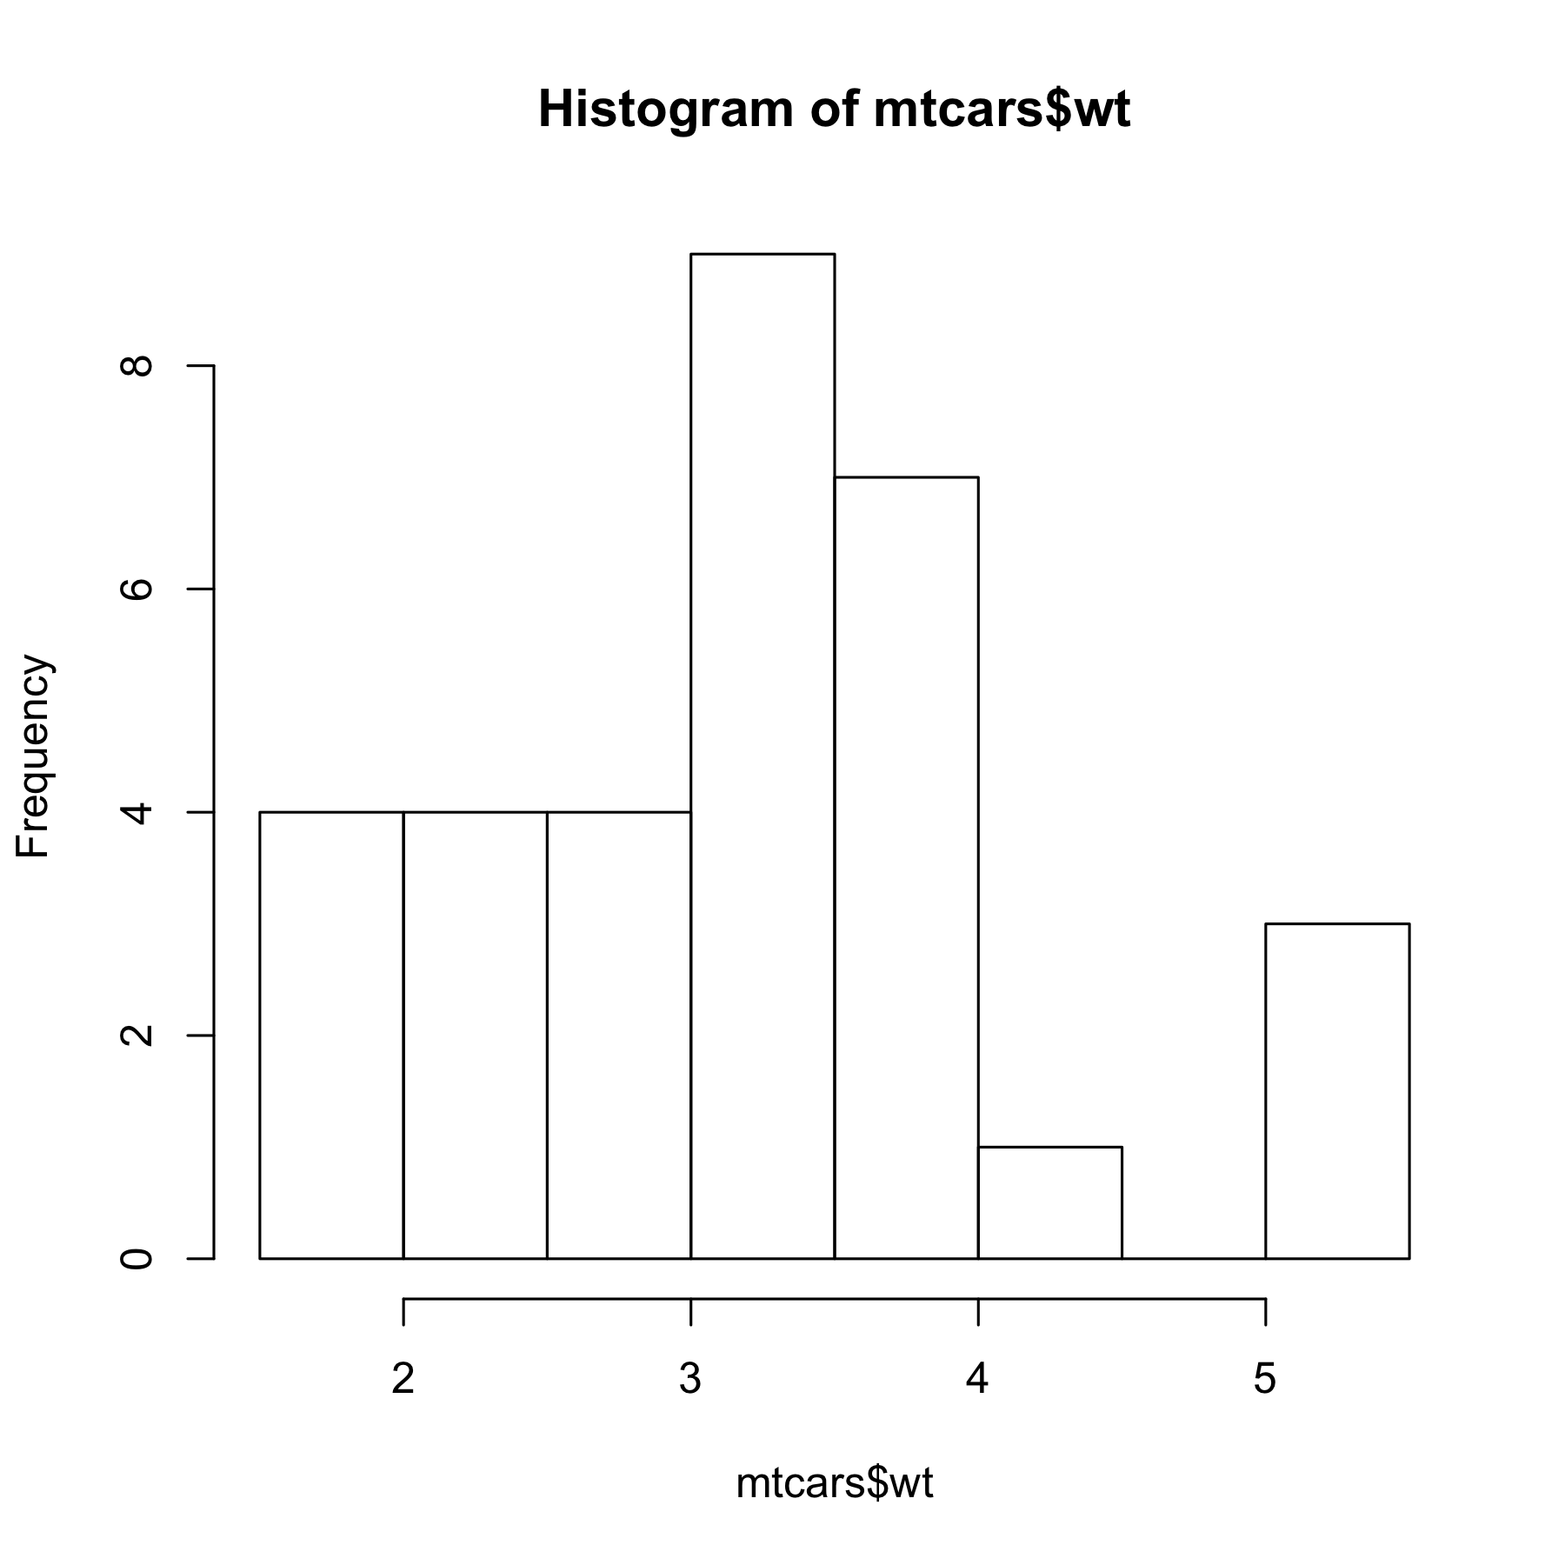I’ve updated the text for the general description. See if you can you pull these text changes back into officer.

Also one of the important factors for this exercise is to be able to have a consistent layout of information and text. So the species list is to be left justified with the grid graphic to the right. See if you can do this. 

| info |
| --- |
| Tree layer |
| Picea mariana (9.45) |
| Shrub layer |
| Picea mariana (12.93) |
| Rhododendron groenlandicum (31.05) |
| Herb layer |
| Gaultheria hispidula (4.59) |
| Vaccinium oxycoccos (4.19) |
| Moss layer |
| Aulacomnium palustre (1.78) |
| Pleurozium schreberi (13.46) |
| Sphagnum capillifolium (32.64) |