Wb01 Black spruce - Creeping-snowberry - Peat-moss

Picea mariana - Gaultheria hispidula - Sphagnum

**General Description**

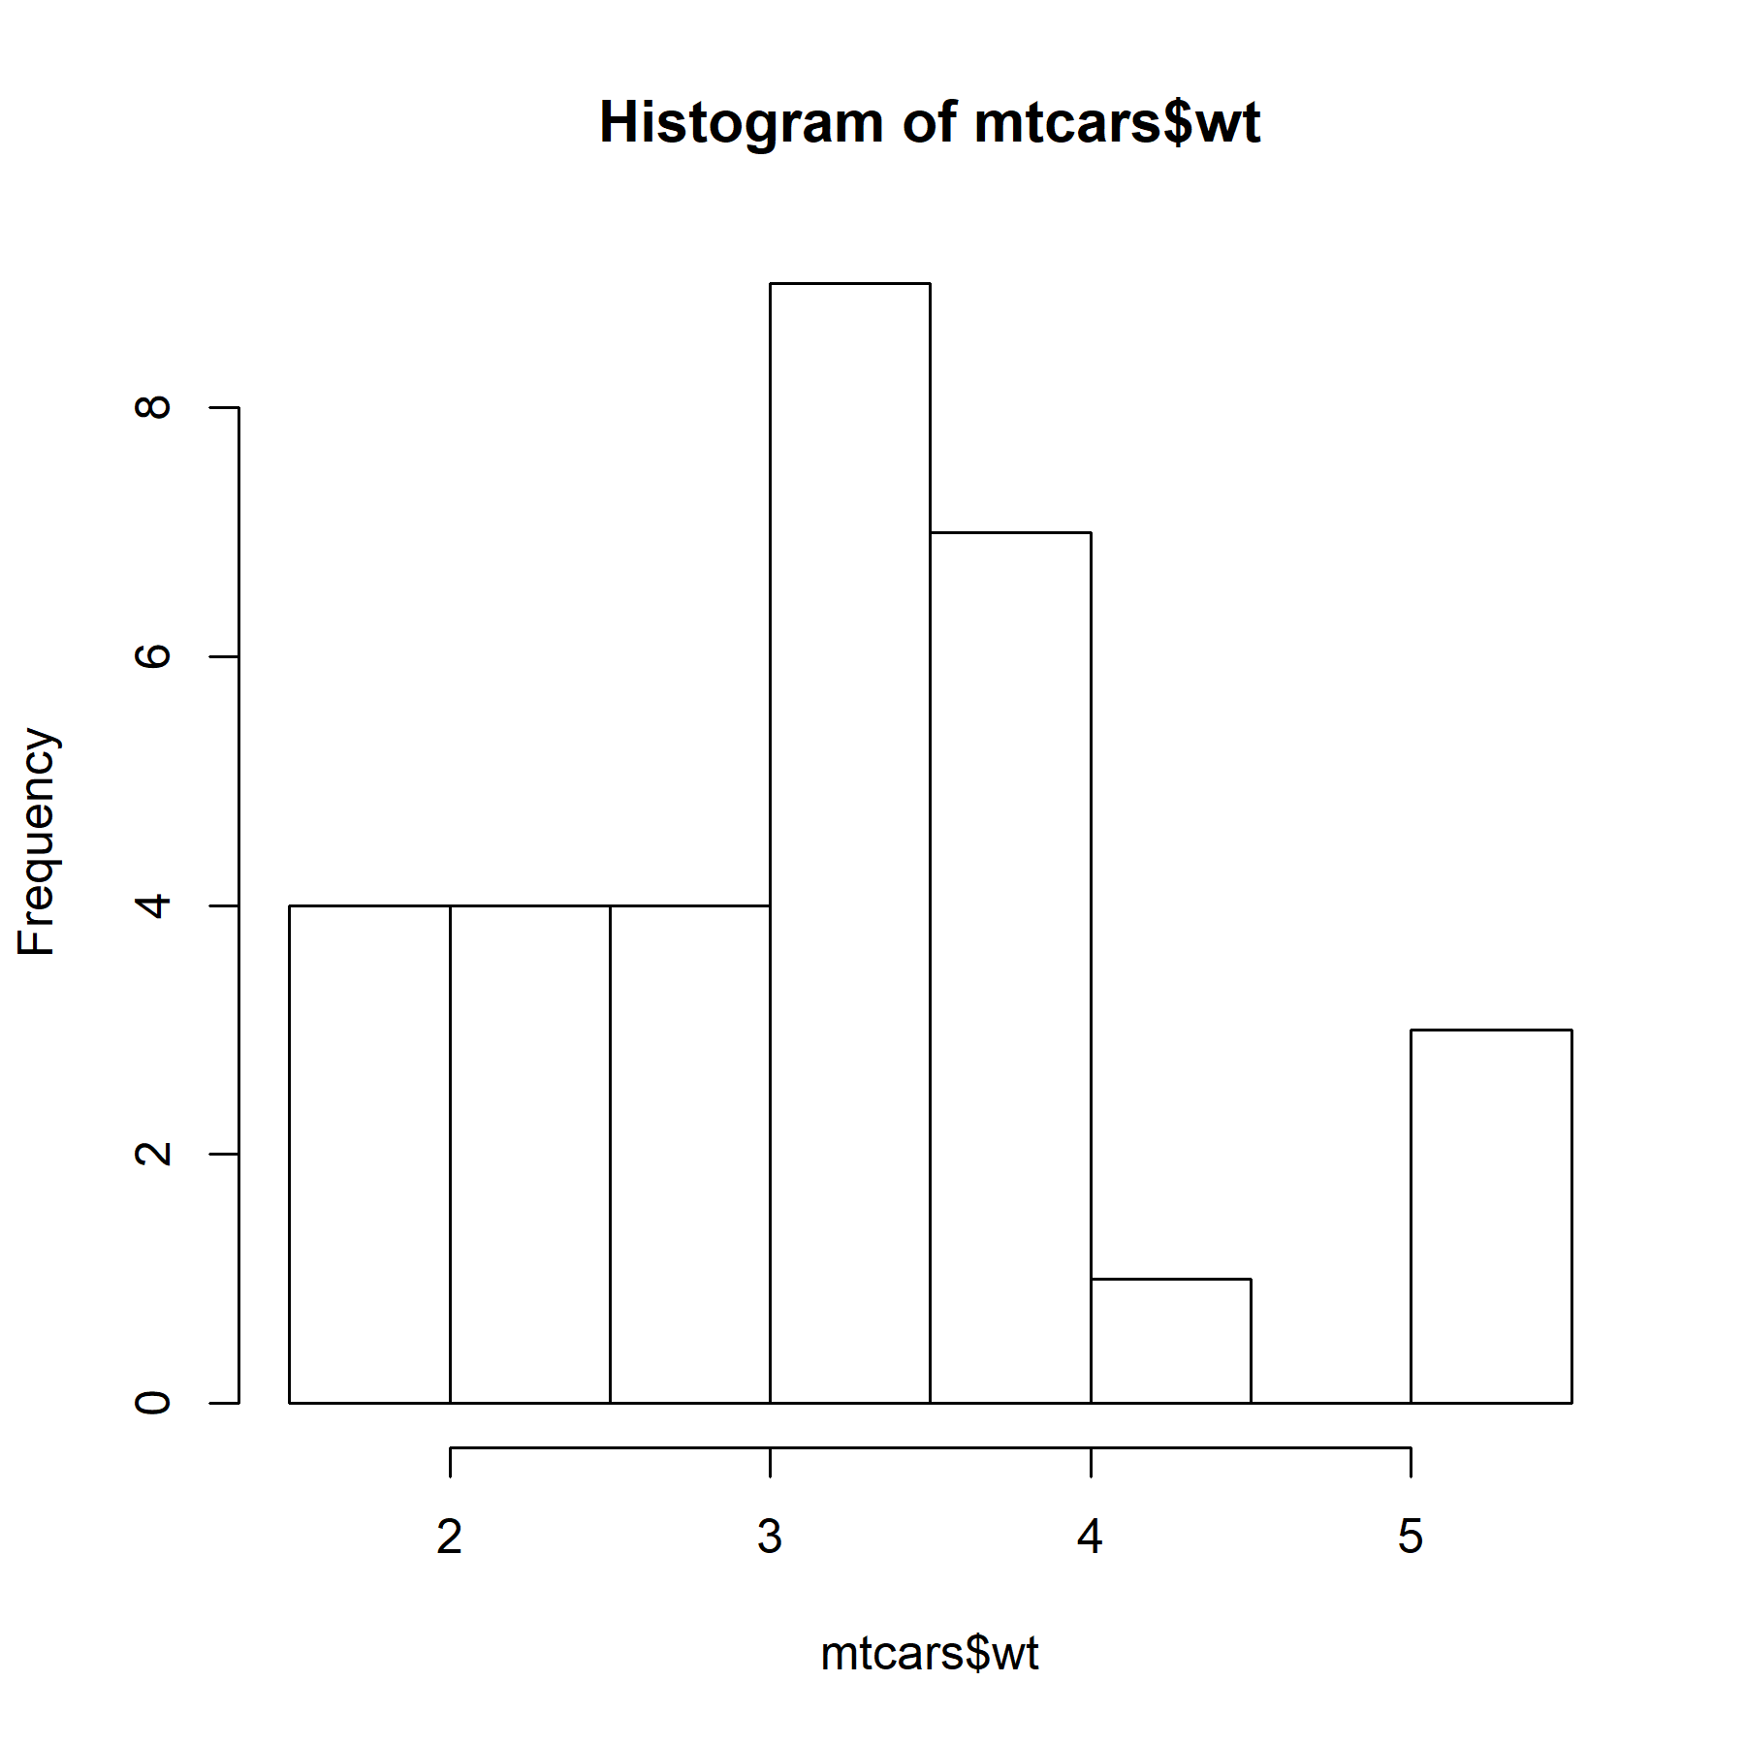I’ve updated the text for the general description. See if you can you pull these text changes back into officer.

| Characteristic Vegetation |
| --- |
| Tree Layer |
| Picea mariana (9.45) |
| Shrub Layer |
| Picea mariana (12.93) |
| Rhododendron groenlandicum (31.05) |
| Herb Layer |
| Gaultheria hispidula (4.59) |
| Vaccinium oxycoccos (4.19) |
| Moss Layer |
| Aulacomnium palustre (1.78) |
| Pleurozium schreberi (13.46) |
| Sphagnum capillifolium (32.64) |

**Wetland Edatopic Grid**



**Comments**

Aenean venenatis varius elit et fermentum vivamus vehicula. Aenean venenatis varius elit et fermentum vivamus vehicula. Aenean venenatis varius elit et fermentum vivamus vehicula. Aenean venenatis varius elit et fermentum vivamus vehicula. Aenean venenatis varius elit et fermentum vivamus vehicula.