**IDFmd1 ; Ensemble model.**

For stage 2 method 2, run the ensemble model using four models : random forest, neural net, xgboost and glmnet as the superlearner. To determine where the model disagreement was high I calculated the proportion of models that agreed/disagreement. (0 – 1). Excluding areas where all models or most models a greed (>0.75). Large areas concentrated in the southern portion

Ensemble disagreement : (blue = 0.5 – half models agree), yellow (0.25 models agree)

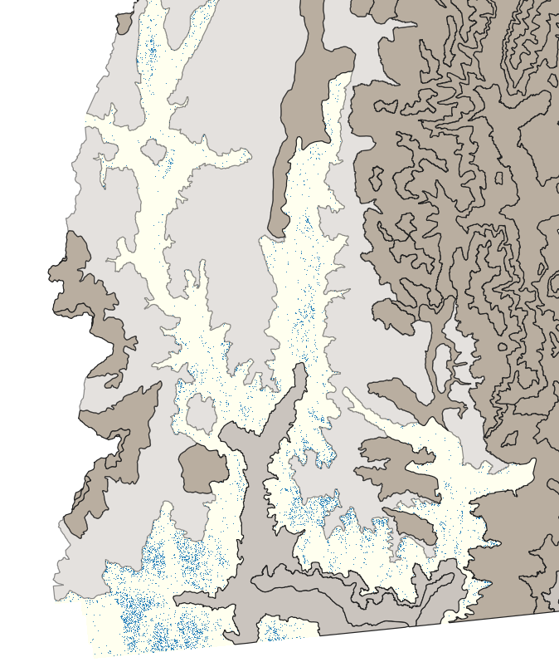

Entropy model – blue areas show areas on uncertainty within ranger model

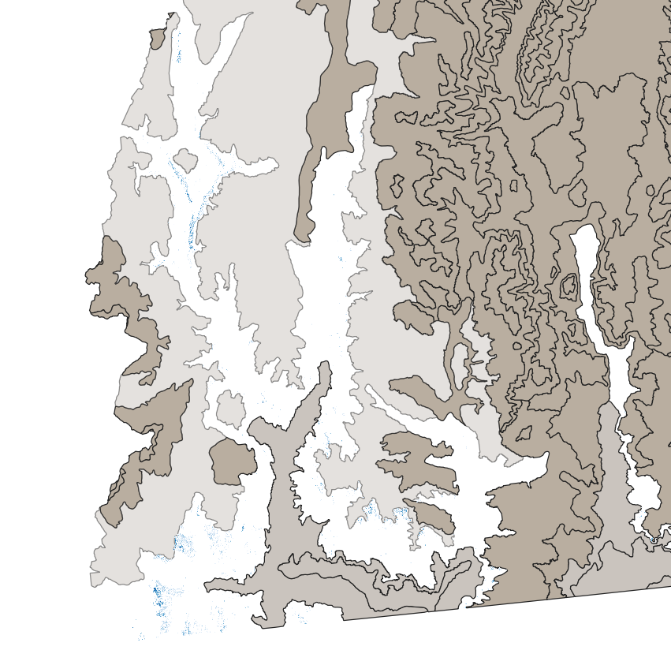

Note some areas overlap but not similar pattern evident.

Also some areas where high confusion where sampling has occurred

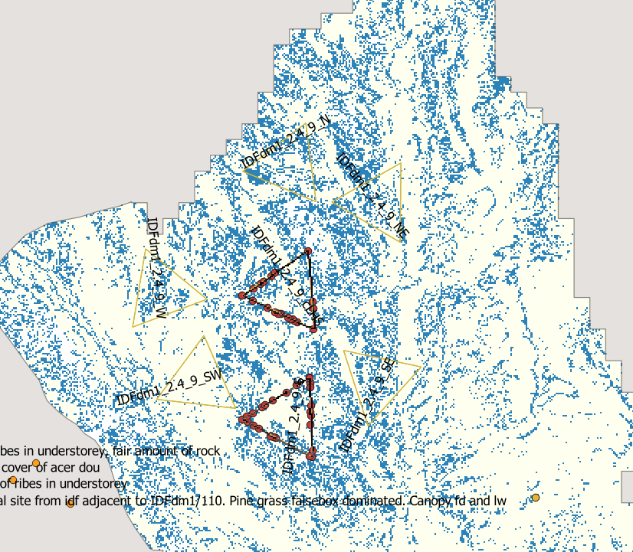

MSdm1

Ensemble spread was fairly speckled (see below – left).

This pattern was not very similar to the entropy pattern (right)

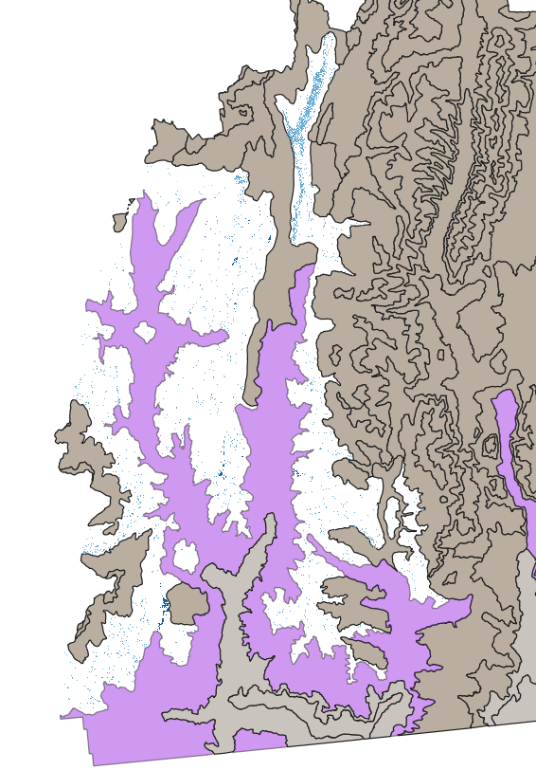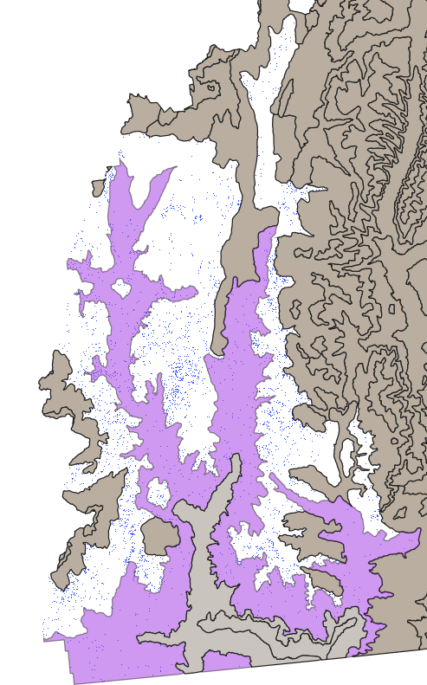

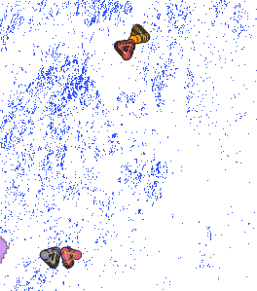

No obvious sign that the disagreement is centered around the sampling sites as seen in IDFdm1