Preliminary analysis of 2020 data

Hardy Griesbauer

10/02/2021

## Introduction

data2020 %>%   
 filter(!Type %in% c("Frost","Demo")) %>% # remove frost and demo sites  
 group_by(Type,Species,Distance,Condition_2020fa) %>%   
 summarise(n=n()) %>%   
 mutate(freq = n / sum(n)) %>% # remember one grouping level peeled off with each summarise  
   
 ggplot()+  
 aes(x=Condition_2020fa,y=freq,fill=Distance)+  
 geom_bar(stat="identity",position="dodge")+  
 facet_grid(Species~Type)+  
 xlab("Condition fall 2020")+  
 ylab("Proportion")+  
 labs(fill="Seed dist.")+  
 theme(axis.text.x = element_text(angle = 90, vjust = 0.2, hjust=1))

## `summarise()` has grouped output by 'Type', 'Species', 'Distance'. You can override using the `.groups` argument.

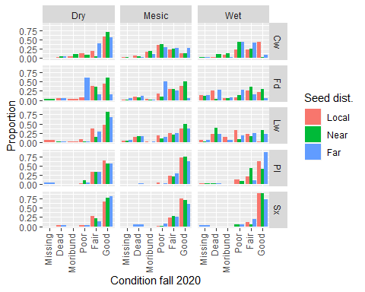

We can show seedling condition a little differently. The figure below allows to compare seedling condition between seedlot, by site type.

data2020 %>%   
 filter(!Type %in% c("Frost","Demo")) %>% # remove frost and demo sites  
 group_by(Type,Species,Distance,Condition_2020fa) %>%   
 summarise(n=n()) %>%   
 mutate(freq = n / sum(n)) %>% # remember one grouping level peeled off with each summarise  
   
 ggplot()+  
 aes(x=Distance,y=freq,fill=Condition_2020fa)+  
 geom_bar(stat="identity",position="stack")+  
 facet_grid(Species~Type)+  
 xlab("Seedlot distance")+  
 ylab("Proportion")+  
 labs(fill="Seedling condition")+  
 theme(axis.text.x = element_text(angle = 90, vjust = 0.2, hjust=1))

## `summarise()` has grouped output by 'Type', 'Species', 'Distance'. You can override using the `.groups` argument.

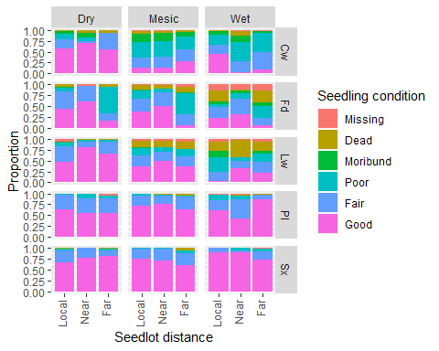

Another way of looking at the same data. Here, seedling condition is arranged to allow comparison of site type, within seedlot:

data2020 %>%   
 filter(!Type %in% c("Frost","Demo")) %>% # remove frost and demo sites  
 group_by(Type,Species,Distance,Condition_2020fa) %>%   
 summarise(n=n()) %>%   
 mutate(freq = n / sum(n)) %>% # remember one grouping level peeled off with each summarise  
   
 ggplot()+  
 aes(x=Type,y=freq,fill=Condition_2020fa)+  
 geom_bar(stat="identity",position="stack")+  
 facet_grid(Species~Distance)+  
 xlab("Site type")+  
 ylab("Proportion")+  
 labs(fill="Seedling condition")+  
 theme(axis.text.x = element_text(angle = 90, vjust = 0.2, hjust=1))

## `summarise()` has grouped output by 'Type', 'Species', 'Distance'. You can override using the `.groups` argument.

