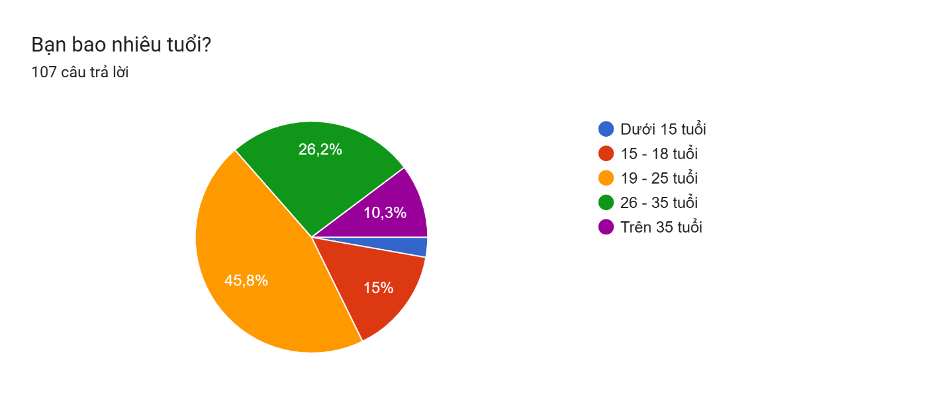Based on the provided pie chart regarding the age distribution of 107 respondents, here is an evaluation and conclusion in English tailored for your startup project – a café combined with a 3D modeling concept:

**Evaluation:**

The pie chart illustrates the age distribution of the surveyed potential customers. Clearly, the largest customer segment falls within the **19–25 age group**, representing **45.8%** of respondents. This indicates that young adults, who are generally more open to new experiences and trendy concepts, show considerable interest. The second-largest segment consists of those aged **26–35 years**, accounting for **26.2%**, which suggests an appreciable level of interest among young professionals. Respondents aged **15–18 years** represent **15%**, reflecting moderate interest among late teenagers. Meanwhile, customers **over 35 years** (10.3%) and those **under 15 years** (smallest percentage) show significantly lower levels of interest.

**Conclusion:**

The survey clearly highlights that the primary target audience for your innovative café integrated with a 3D modeling experience is predominantly young adults between 19 to 35 years old. This demographic is likely attracted by novelty, creativity, and technological integration, making them ideal for targeted marketing strategies and tailored experiences in your café. Efforts should focus predominantly on creating a vibrant atmosphere that resonates with young adults, incorporating contemporary designs, engaging 3D interactive experiences, and leveraging digital marketing channels effectively to reach this key demographic.

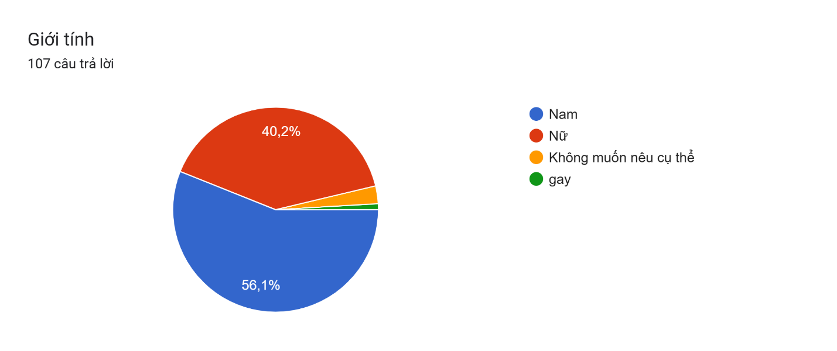

### Evaluation:

The pie chart depicts the gender distribution among the 107 respondents of your survey. It clearly illustrates a higher male participation (**56.1%**) compared to females (**40.2%**). A small portion (**3.7%**) of respondents either preferred not to specify their gender explicitly or identified themselves as gay.

### Conclusion:

Based on the results, your innovative café with integrated 3D modeling primarily appeals slightly more to males than females. However, the difference is not drastic, indicating substantial interest across both genders. It would therefore be beneficial to maintain an inclusive and balanced marketing strategy. The minor percentage representing other gender identifications highlights the importance of creating an inclusive, welcoming atmosphere that respects and accommodates diversity. Ensuring an appealing and comfortable environment for all customers will further enhance your café’s reputation and broad market appeal.

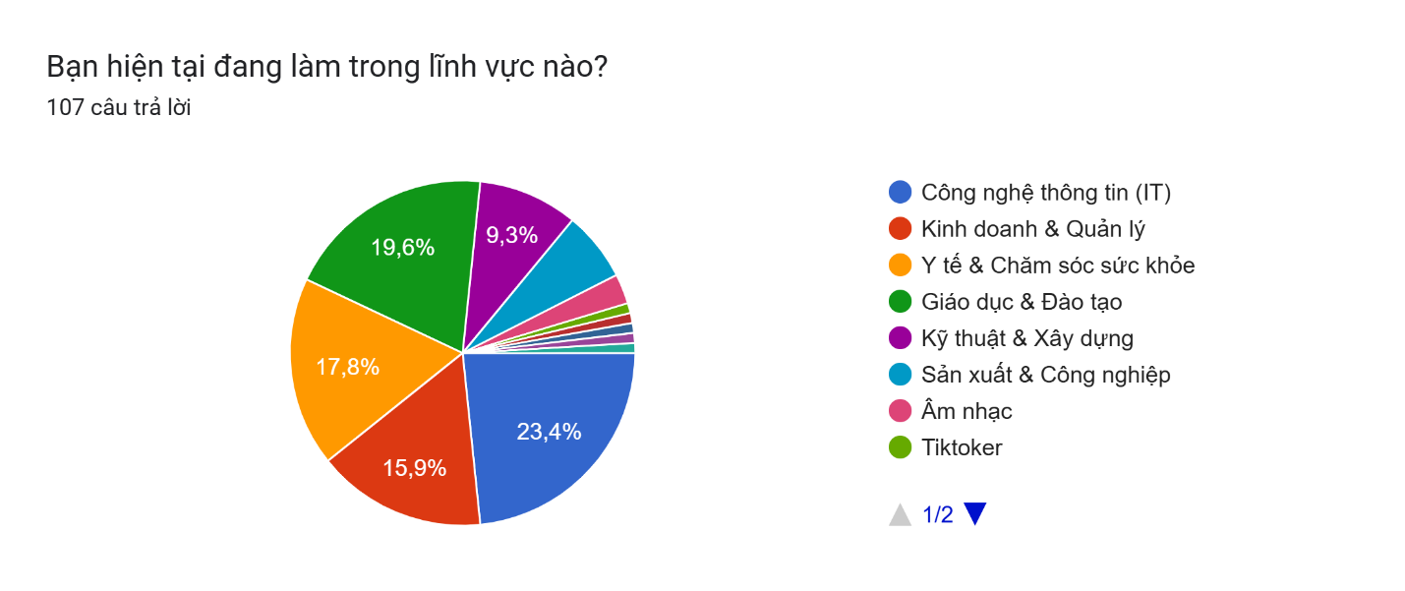

### Evaluation:

The pie chart represents the professional fields of the 107 surveyed respondents. The highest proportion of respondents work in **Information Technology (IT)**, accounting for **23.4%**. This is followed by those in **Education & Training** (**19.6%**) and **Healthcare & Medicine** (**17.8%**). Other notable fields include **Business & Management** at **15.9%** and **Engineering & Construction** at **9.3%**. Smaller proportions represent the fields of manufacturing & industry, music, and TikTok creators.

### Conclusion:

The survey results demonstrate that the primary customer base for your 3D-modeling integrated café comprises professionals and students in technical and knowledge-intensive fields, notably IT, education, and healthcare. This suggests a strong appeal of technology-integrated experiences among respondents who typically value innovation and continuous learning. To effectively cater to these customers, the café might consider hosting industry-specific events, technology demonstrations, workshops, or networking opportunities. Aligning your café's activities and branding towards educational enrichment, technology exploration, and community engagement will resonate deeply with your targeted audience, further distinguishing your venture within the market.

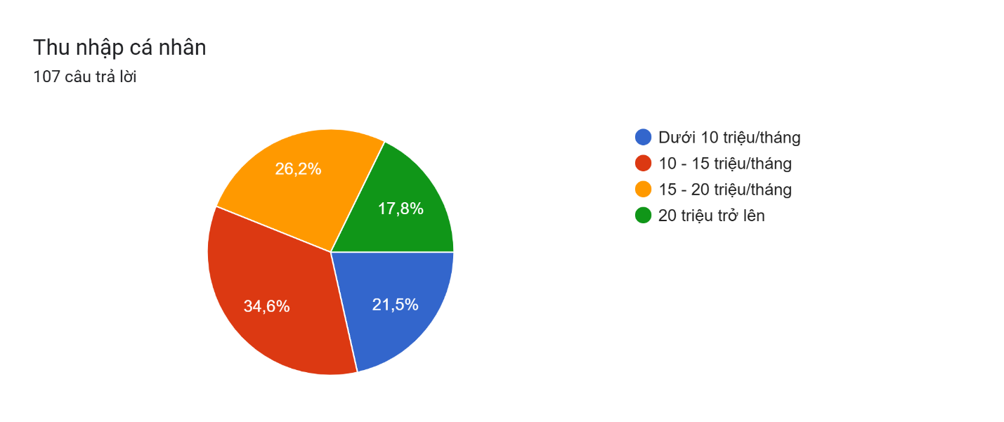

### Evaluation:

The pie chart illustrates the monthly personal income distribution of the 107 survey respondents. The largest segment, **34.6%**, has an income ranging from **10 to 15 million VND/month**, closely followed by **26.2%** with an income of **15 to 20 million VND/month**. Respondents earning **less than 10 million VND/month** make up **21.5%** of the sample, whereas those earning **above 20 million VND/month** account for **17.8%**.

### Conclusion:

The survey indicates that your potential customers primarily consist of individuals within a moderate to relatively high income range, with the majority earning between **10–20 million VND/month**. This income segment suggests customers have adequate disposable income to spend on leisure activities and innovative experiences like your 3D modeling café concept. To effectively attract and retain this customer base, your pricing strategy should be balanced – affordable yet reflective of the unique value and experience your café provides. Additionally, offering special promotions, membership discounts, and tailored premium experiences could further appeal to those in the higher-income segments.

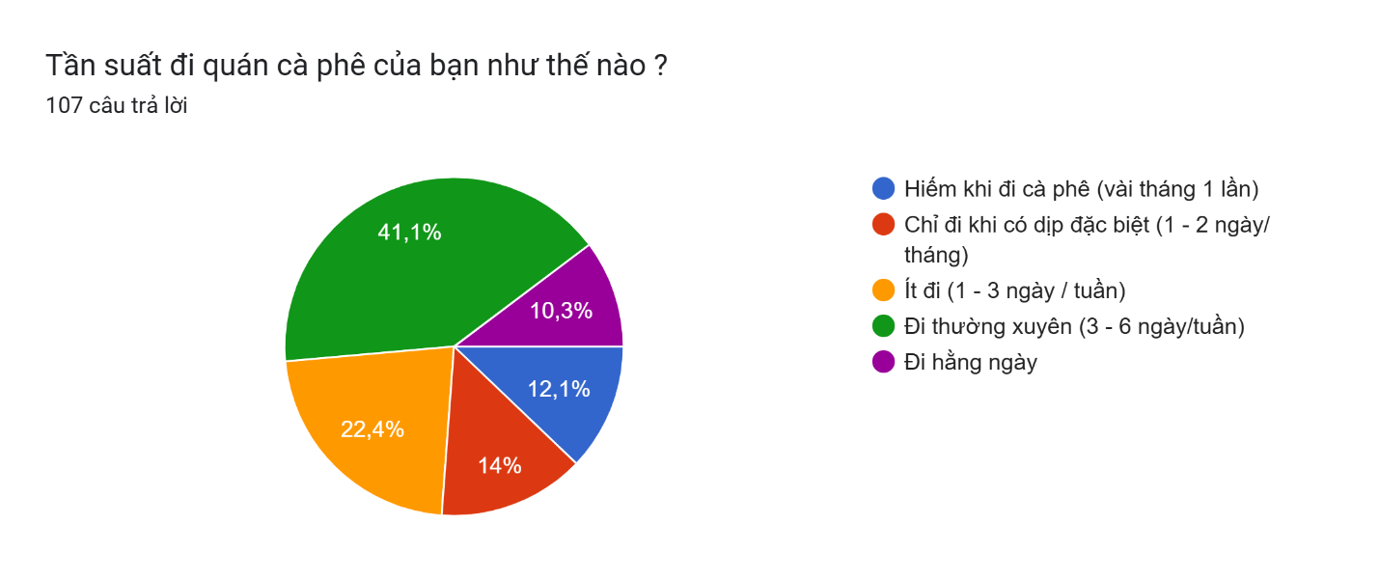

### Evaluation:

The provided pie chart reflects the frequency with which respondents visit cafés. The largest proportion, **41.1%**, reports visiting cafés **regularly (3–6 days/week)**, indicating a substantial group with high café-going habits. Meanwhile, **22.4%** visit cafés occasionally (**1–3 days/week**). A smaller segment, **14%**, goes to cafés only on special occasions (**1–2 days/month**), followed by those who **rarely visit cafés** (every few months), accounting for **12.1%**. The smallest segment (**10.3%**) visits cafés **daily**.

### Conclusion:

This chart clearly highlights that the majority of potential customers frequently visit cafés, suggesting a strong demand for such services and experiences. The significant percentage of respondents visiting cafés 3–6 days a week represents a valuable opportunity to secure regular patrons, ensuring consistent revenue for your 3D-modeling-integrated café.

To effectively capitalize on this data, strategies should focus on customer retention, loyalty programs, subscription-based models, or regular event hosting that encourages repeat visits. By providing consistently high-quality beverages combined with engaging and regularly updated 3D interactive experiences, your café can solidify customer loyalty and cater to the habitual café-goers segment effectively.

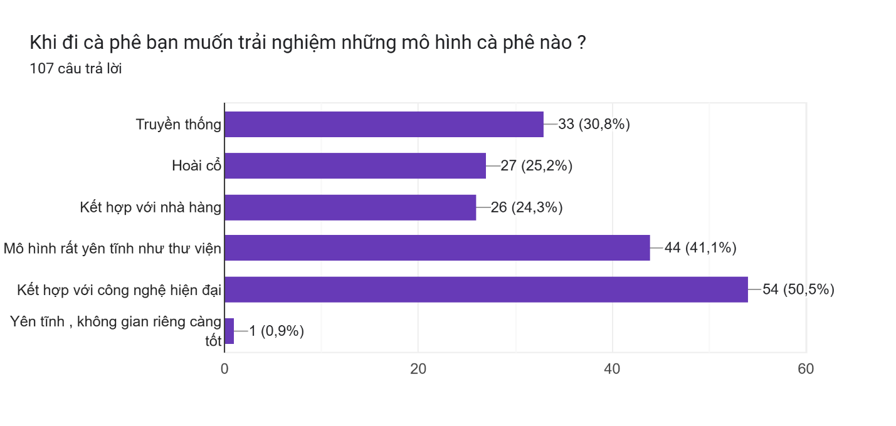

### Evaluation:

This horizontal bar chart presents respondents' preferred café models and experiences. The option **"Combined with modern technology"** received the highest interest (**50.5%**), indicating a strong desire for innovative and technology-driven café concepts. The second most popular choice (**41.1%**) is a **"quiet model like a library"**, showing that many customers appreciate peaceful and relaxed environments. The traditional café model (**30.8%**) and nostalgic concept (**25.2%**) also hold significant appeal. A café combined with a restaurant concept (**24.3%**) attracts moderate interest. Lastly, the preference for a completely quiet, private environment is minimal (**0.9%**).

### Conclusion:

The findings strongly support your business model of combining a café with modern 3D technology experiences, as the majority of respondents explicitly prefer technology-integrated environments. Additionally, incorporating a quiet and comfortable atmosphere similar to libraries may further enhance customer satisfaction, suggesting a combined model of technological novelty and relaxed ambiance. This combination would uniquely position your café, catering directly to the preferences and expectations of the largest segments of your targeted customer base.

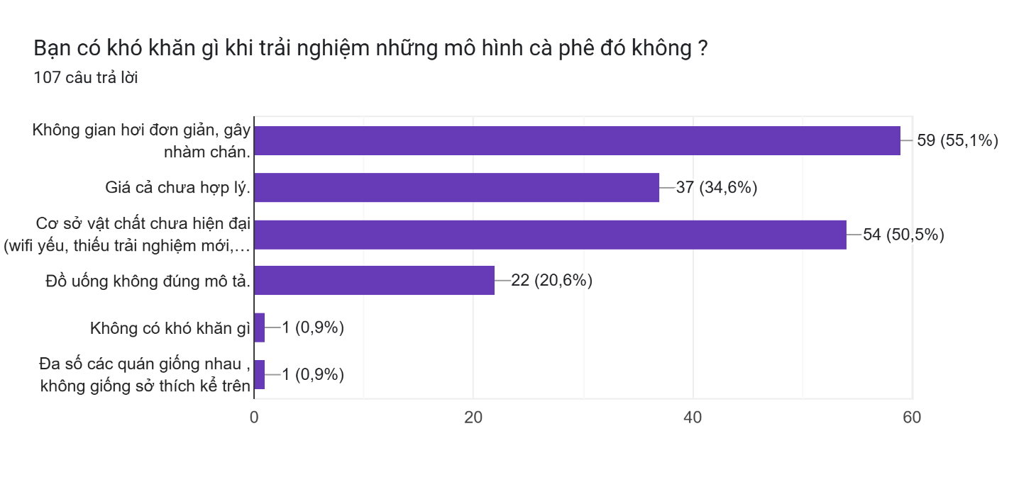

### Evaluation:

This horizontal bar chart addresses the difficulties respondents experienced in various café models. The most significant challenge, indicated by **55.1%** of respondents, is a **"simple and monotonous space causing boredom."** Following closely behind, **50.5%** express concern over **"outdated facilities or weak infrastructure, such as poor Wi-Fi and lack of new experiences."** Pricing is also an important factor, with **34.6%** feeling café prices are unreasonable. A smaller segment (**20.6%**) reported dissatisfaction with beverages not meeting their descriptions. Notably, very few respondents (**0.9% each**) indicated they experienced no difficulties or expressed concerns about lack of distinctiveness among cafés.

### Conclusion:

These insights clearly highlight critical areas for your startup café to focus on. The greatest opportunities for differentiation include designing an engaging, visually appealing, and innovative space to avoid customer boredom, and ensuring modern, reliable facilities—especially robust Wi-Fi connectivity and novel technology integrations—to deliver consistent and satisfying experiences. Additionally, competitive and fair pricing strategies combined with accurate, high-quality beverage descriptions will enhance overall customer satisfaction and loyalty, positioning your 3D-modeling café as a preferred destination in the market.

### Evaluation:

The horizontal bar chart identifies respondents' preferred solutions to enhance their café experience. The highest preference (**68.2%**) is for **"applying new technologies such as 3D and virtual reality,"** clearly supporting your innovative concept. A significant proportion (**46.7%**) suggests **"combining the café with a cinema,"** followed by **"providing a private and quiet space"** (**32.7%**). Smaller percentages indicate preferences for **"combining with restaurants"** (**26.2%**) and **"integrating nature elements"** (**20.6%**).

### Conclusion:

The results strongly validate your concept of integrating new technologies, especially 3D and virtual reality experiences, as this is the most desired feature among your surveyed customers. It reinforces the potential success of your café concept centered around modern, interactive technological experiences. Additionally, exploring partnerships or occasional events that combine your café offerings with cinema experiences could further increase its appeal. Maintaining spaces that allow for quiet and privacy will also attract an important customer segment. Overall, a strategic approach emphasizing technological innovation, entertainment integration, and comfortable, versatile spaces will significantly enhance customer satisfaction and differentiate your café in the marketplace.

### Evaluation:

The pie chart demonstrates respondents' willingness to spend on new technology services within a café. Nearly half of the respondents (**48.6%**) expressed they would spend **under 500,000 VND**. Meanwhile, **27.1%** are willing to spend between **500,000 - 1,000,000 VND**, and notably, **24.3%** indicated willingness to invest **over 1,000,000 VND** on these innovative experiences.

### Conclusion:

These findings indicate a broad willingness among customers to spend money on technology-driven experiences at cafés, with most respondents comfortable with moderate expenses (below 500,000 VND). However, a considerable percentage is open to higher-priced premium offerings, suggesting there’s a potential market segment for specialized or exclusive technology experiences at higher price points. To optimize revenues and customer satisfaction, consider offering tiered pricing structures: affordable basic packages to attract the majority, coupled with exclusive premium experiences catering to higher-spending customers who seek enhanced, unique 3D modeling and virtual reality services. This approach allows you to maximize market reach while ensuring accessibility and inclusivity for various customer segments.

Certainly! Here is your detailed evaluation and conclusion rewritten in paragraph form suitable for inclusion in your presentation:

**Detailed Customer Survey Conclusion**

Based on our comprehensive survey involving 107 respondents, several critical insights emerged that are invaluable for our café startup integrating advanced 3D modeling technology. Firstly, regarding age demographics, our potential customers primarily belong to the young adult and early professional segments. Specifically, 45.8% of respondents fall within the 19–25 age range, and 26.2% are between 26–35 years old. This indicates a strong affinity among younger customers for innovative, technology-driven experiences. Hence, designing our café to cater to the interests and lifestyle of this demographic will be crucial.

Analyzing gender distribution, the survey revealed a higher proportion of male respondents (56.1%) compared to females (40.2%), along with a small percentage preferring not to specify or identifying differently. This balanced yet slightly male-leaning gender distribution suggests our marketing strategy should remain inclusive and appealing to all genders, ensuring a welcoming and comfortable environment for every guest.

Professional backgrounds of respondents showed significant representation from Information Technology (23.4%), Education & Training (19.6%), and Healthcare sectors (17.8%). The dominance of these knowledge-intensive fields suggests an audience comfortable with and attracted to technology-based innovations. Thus, our café concept aligns well with the professional interests and lifestyles of these customer groups, presenting opportunities for specialized workshops, educational events, and professional meetups tailored to their interests.

Regarding financial capability, most customers fall into moderate to relatively high-income brackets, with a combined 60.8% earning between 10–20 million VND per month. This indicates that our potential customers have sufficient disposable income to invest in new experiences, thus validating our café’s positioning in the moderate to premium pricing segment. However, a balanced pricing approach is advisable, including diversified packages and promotions to accommodate different income levels effectively.

Considering visitation frequency to cafés, 41.1% of respondents frequently visit cafés (3–6 times per week), while 22.4% visit occasionally (1–3 times per week). Such high visitation frequency illustrates strong market demand and the opportunity to build lasting customer relationships through loyalty programs, engaging events, and consistent quality.

When asked about preferred café models, over half (50.5%) expressed keen interest in cafés combining modern technology, particularly 3D experiences, validating the central concept of our startup. A significant number (41.1%) also preferred quiet, library-like spaces. These preferences strongly support the implementation of a hybrid model that incorporates advanced technological interactions while maintaining spaces that encourage relaxation and tranquility.

Regarding common challenges faced at current cafés, respondents cited monotonous spaces (55.1%) and outdated, unreliable facilities (50.5%) as key issues. These responses underline the necessity of focusing our investments on innovative, visually appealing interior design and reliable modern amenities, including stable Wi-Fi and interactive technological features, to avoid similar shortcomings.

Respondents also clearly indicated solutions they believe could enhance their café experiences, with a significant majority (68.2%) supporting the integration of new technologies such as 3D and virtual reality. Furthermore, nearly half (46.7%) were interested in cafés combined with cinematic experiences, and a substantial group (32.7%) emphasized the need for private and quiet spaces. This insight strongly advocates for a diversified service approach that includes technological innovation, potential partnerships with entertainment sectors, and the provision of private, peaceful areas.

Finally, when assessing the willingness to spend on technology-centric experiences at cafés, 48.6% preferred spending less than 500,000 VND, while 51.4% were open to spending more, with 24.3% willing to pay over 1,000,000 VND. These findings indicate clear market potential for introducing differentiated pricing models, with accessible entry-level experiences for the broader customer base and premium, exclusive packages aimed at customers willing to invest more substantially in unique technological experiences.

In summary, the customer insights drawn from our survey strongly validate the feasibility and attractiveness of our 3D-modeling integrated café. Moving forward, our strategic focus should center on technology integration, inclusive customer engagement, innovative design, reliable infrastructure, and flexible pricing structures. This comprehensive approach will effectively address customer expectations and position our café distinctively within the competitive market landscape.