`GUVF VF N IO CEBTENZ → THIS IS A VB PROGRAM
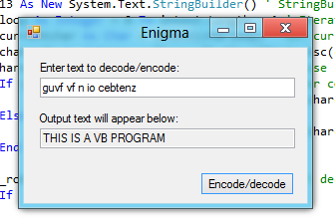

V YVXR PBZCHGVAT → I LIKE COMPUTING
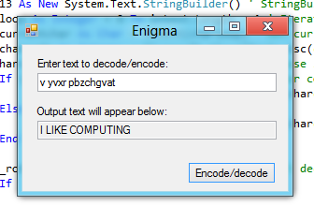

ZREEL PUEVFGZNF → MERRY CHRISTMAS
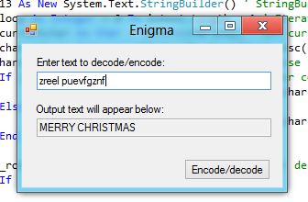

ZGREBVQ CEVZR → METROID PRIME
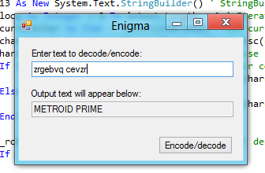

PEBFFJNLF VF TERNG → CROSSWAYS IS GREAT
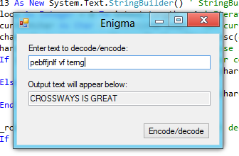

3 SERAPU URAF → 3 FRENCH HENS
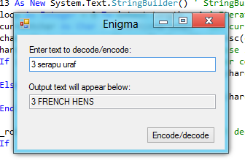

Additional features:
Encode/decode on enter key pressed.

