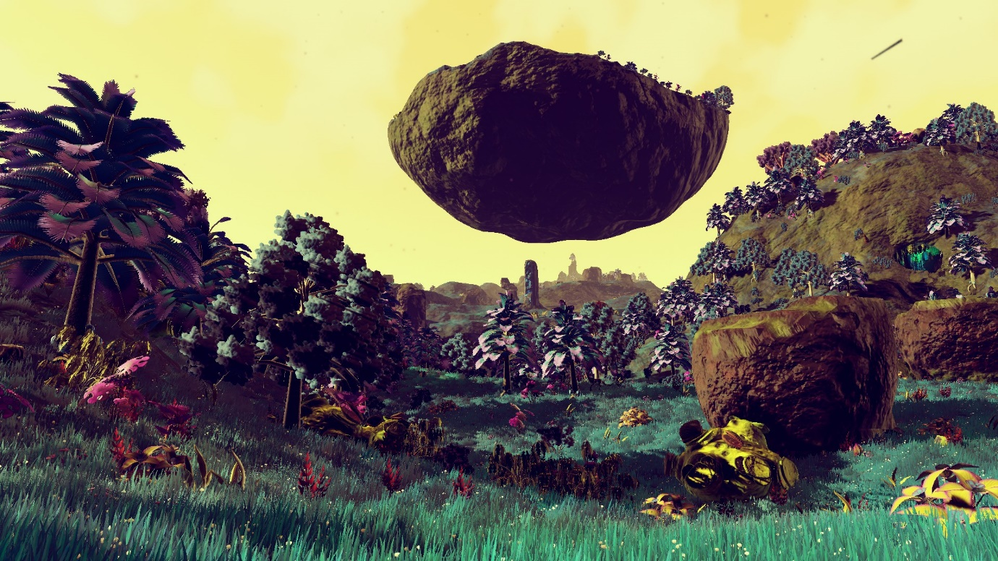**Project Outline  
ENVIRONMENT**- Sci-Fi  
- Inspired by No Man's Sky

**SCOPE**- Bigger than a back yard, smaller than a forest.   
- Timespan: calculations based on a day passing, can be accelerated or decelerated  
- Test case will likely be executed in 2500-10000m²  
- It is assumed that the environment can sustain the chosen vegetation in terms of nutrition and temperature. The only element influencing vegetation growth is placement of surfaces (e.g.: some can only grow on the sides of objects)  
- Environments do not have to be realistic (refer to image’s floating slab of ground)  
- Seasons remain the same as on Earth

**VEGETATION**All vegetation has predefined visuals to indicate various states of progression.  
Most vegetation has a seasonal cycle that changes its properties. (e.g.: grass will stop spreading during cold season, generally seeds are only produced during hot season) **Specific properties:**  
Spreading:  
- Can either reproduce or spread through roots in or on the ground (like our grasses)  
- Can only spread through reproduction (fruits, seed pods)  
Survival:  
- Relies on soil for energy  
- Relies on light for energy  
- Draws from roots of nearby vegetation for energy  
- Draws from tree it is located on for energy  
- Relies on wind for energy  
Growth locations:  
- Can only grow on trees (or other plants)  
- Can grow anywhere as long as it is pointed upwards (i.e.: not on sides or bottoms)  
- Take root above ground and are suspended there  
- Can grow anywhere as long as it is not pointed upwards  
- Can grow anywhere with room to grow upwards (like ivy)  
Progression patterns:  
- Seed => seedling => singular plant or tree => grow => reproduce (back to grow) => die  
- Seed => seedling => singular plant or tree => spread through roots => grow => possibly reproduce (back to spread) => die (when conditions are unfavorable or after lifetime end)  
Seasonal patterns:  
- Spring reproduction => summer growth => fall stagnation => winter pause  
- Spring growth => summer stagnation => fall pause => winter reproduction

**“VISUALIZATION”**- In editor, before running: Create volume, defining which vegetation is allowed to grow in this area and the amount of those plants' seeds being present in the ground before simulating. Note: if there are no plants that can grow just by having a seed in the ground (i.e.: no conditions like needing another plant nearby), nothing will grow. It is also possible to have seeds or roots enter the volume at set intervals. They come from an unknown outside area and were taken here via wind, animals...

- At start: The volume will check all objects inside of it, and spawn the amount of predetermined seeds spread out over the area.

- During running (early stage): The seeds will get a chance to grow. It is likely that most seeds will be eliminated unless the specific vegetation has seed with high chance of surviving. Some vegetation will appear.

- During running (mid stage): Progression pattern is followed; more vegetation will appear and grow bigger.

- During running (final stage): Vegetation will start dying, freeing up space for others to grow. The ones that take their place will grow and eventually die, too. This cycle is repeated indefinitely.