# Specification of TASCAR file format

TASCAR is a toolbox for acoustic scene creation and rendering. Acoustic scenes are stored in a scene definition file in XML format together with a list of sound files. Scenes can be defined either manually or with the help of scene creation tools (e.g., GPS track manipulation and conversion tools). The focus of TASCAR are renderer in Ambisonics format. However, simple renderer in other formats (e.g., binaural) are planned.

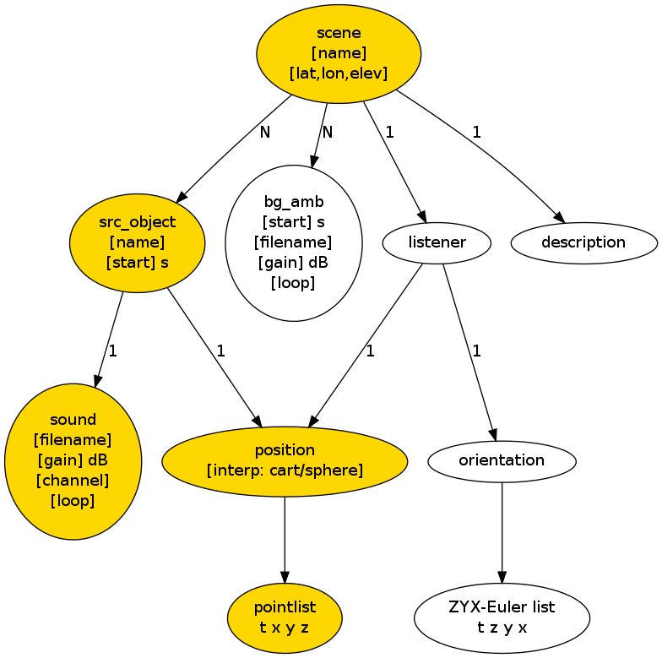

yellow nodes: core definition (available in all clients)

white nodes: renderer-specific or optional

## List of elements:

Given attribute values are default values.

### scene

<scene name=”” lat=”53.155473” lon=”8.167249” elev=”10”>...</scene>

Defines a scene.

Attributes:

* name: provide a scene name
* lat: latitude of scene center
* lon: longitude of scene center
* elev: elevation above sea level in meter

The optional geographical information can be used in a scene creator for importing GPS data.

Allowed sub-nodes:

* src_object
* bg_amb
* listener

### src_object

<src_object name=”” start=”0”>...</src_object>

Define a point source. Multiple point sources are allowed.

Attributes:

* name: name of point source
* start: start time in seconds of audio/position data

Allowed sub-nodes:

* sound
* position

### sound

<sound filename=”” gain=”0” channel=”0” loop=”1”/>

Use a sound file as input for a parent point source.

Attributes:

* filename: name of sound file.
* gain: amplification in dB
* channel: file channel number (zero-based)
* loop: loop count, zero = infinitely (beginning at start time)

If loop != 1 then the whole sound file is looped. The first sample of the sound file is played at the start time of the parent src_object. No sound is played before the start time, even for infinitely looped sounds.

### position

<position interp=”cart”>...</position>

Defines the position of a parent point source. Start time of point source is added to position sample time. Between two samples linear interpolation (either cartesian or spherical; spherical interpolation is relative to scene center) is applied. No extrapolation is applied.

Attributes:

* interp: interpolation type; “cart” means cartesian interpolation of the position between two samples, “sphere” means spherical interpolation. Interpolation is linear.

Content of the position tag is a space separated list of coordinates, one sample per line (pointlist).

### bg_amb

<bg_amb start=”0” filename=”” gain=”0” loop=”1”/>

Background sound in first order Ambisonics format

Attributes:

* start: start time of sound file
* filename: name of sound file
* gain: amplification in dB
* loop: loop count, zero = infinitely (beginning at start time)

Possible extensions may be other background formats (renderer-specific, e.g., binaural).

### listener

<listener>...</listener>

Listener position. Default position is the scene origin. The orientation is tangential to the listener track, or parallel to the x-axis if only a single position sample is provided (i.e., src_objects with x > 0, y=0, z=0 are exactly in front of the listener).

Sub-nodes is a position (see above) and orientation.

### orientation

<orientation>...</orientation>

Orientation of parent object. Orientation is given in ZYX-Euler coordinates. The orientation content is a space separated list, with one line per orientation sample. Each line must contain four numeric values (time, orientation around Z, Y, X axis). Orientation is given in degrees, time in seconds. The Z coordinate corresponds to the heading, the Y coordinate to the elevation. Default orientation is parallel to the x-axis.