1. **MANAGER ID SEQUENCE**

CREATE SEQUENCE COMP_MGR_ID

INCREMENT BY 1

START WITH 1

MAXVALUE 100

NOCACHE

NOCYCLE;

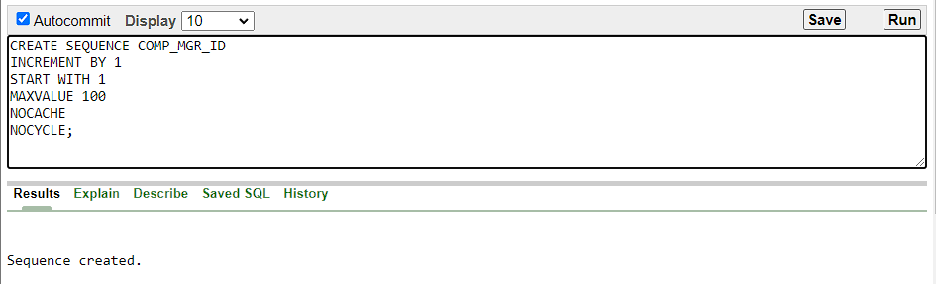

2.**PHONE ID SEQUENCE**

CREATE SEQUENCE PHONE_PHN_ID

INCREMENT BY 1

START WITH 1

MAXVALUE 100

NOCACHE

NOCYCLE;

3.**SELLER ID SEQUENCE**

CREATE SEQUENCE SELLER_SLR_ID

INCREMENT BY 1

START WITH 1

MAXVALUE 100

NOCACHE

NOCYCLE;

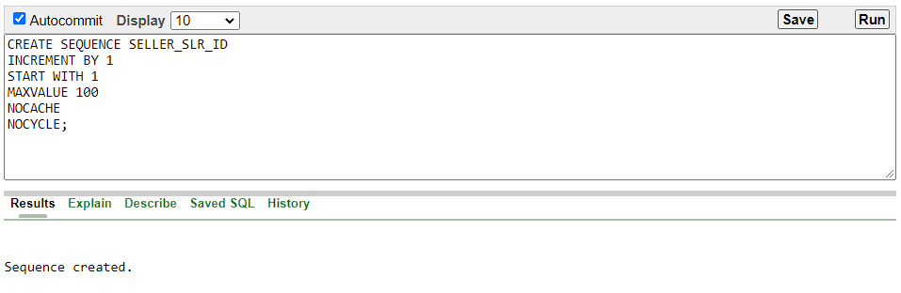

4.**CUSTOMER ID SEQUENCE**

CREATE SEQUENCE CUSTOMER_CUS_ID

INCREMENT BY 1

START WITH 1

MAXVALUE 100

NOCACHE

NOCYCLE;

