PROGREE
DEVOPS INTERNSHIP REPORT
Remote Internship Program
5th July 2026 – 4th August 2026

Intern Name | Fouenang Miguel Bruce
Student ID | B2/724
Position | Remote Devops Intern
Organisation | Progree
Report Date | 4 August 2026
Project Repository | NetOps-hub

TABLE OF CONTENTS
- Executive Summary
- Task 1: Professional LinkedIn Announcement
- Task2 : Application Contenerization & Asset Optimization
- Task3 : Muti-stage Automated CI/CD Deployment Pipeline
- Task 4: Automated Infrastructure as Code & Orchestration
- Skills and Technologies applied
- Challenges Faced and solutions
- Conclusion and Learning Outcomes
- Application Screenshots

1.Executive Summary
This report documents the completion of a four-task DevOps internship program at Progree. Over the course of one month (5th July 2026 to 4th August 2026), I designed, built, and deployed NetOps-Hub — a comprehensive Network Operations and Automation Platform. This full-stack application demonstrates practical application of containerization, continuous integration/continuous deployment (CI/CD), Infrastructure as Code (IaC), and Kubernetes orchestration, while leveraging my background in Linux administration, and full-stack development.

Project | Backend | Frontend | Devops | Networking
NetOps_hub Network Operation Center and Automation Platform | FastAPI,python3.12,SqlAlchemy2.0 | HTML5,CSS3,Bootstrap 5.3,Vanilla Javascript | Docker,Docker-Compose,Github Actions,K | Netmiko,ICMP ping,SSH automation,TCP/IP

2. Professional Linkedin Announcement
2.1 Objective
Share the official internship acceptance on LinkedIn to build professional visibility and network within the DevOps community.
2.2 Execution
- Posted a high-resolution copy of the official Internship Offer Letter on LinkedIn.
- Crafted a compelling caption detailing learning goals in DevOps, Docker, CI/CD, and cloud infrastructure.
- Tagged Progree's official LinkedIn page
- Used required hashtags: #devops #docker #cicd #progree
2.3 Outcome
- Increased professional network visibility
- Established personal brand in the DevOps space
- Connected with peers and mentors in the industry
For this tasks this my Post like and Screenshot of the link of up to today
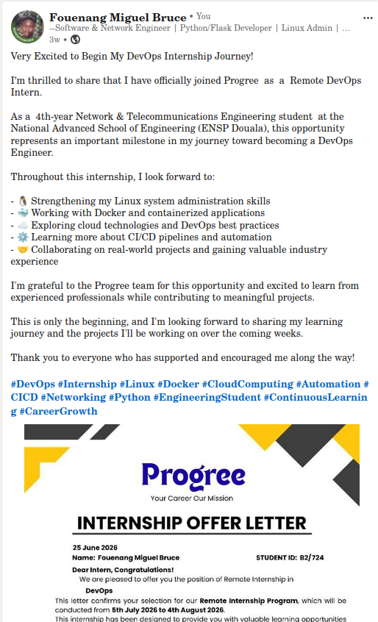

Task1 Internship Link

Project-repo

3. APPLICATION CONTAINERIZATION & ASSET OPTIMIZATION
3.1 Objective
Build a modular, reliable application container environment package with minimal image footprint, secure environment variable handling, and functional port routing.
3.2 Project: NetOps-Hub
NetOps-Hub is a full-stack Network Operations and Automation Platform built with FastAPI, PostgreSQL, and modern web technologies. It provides network engineers and DevOps professionals with a centralized dashboard for device management, network automation, and configuration backup.
3.2.1 Core Application Features

Features | Description
Device management | Complete CRUD operation with search and filter capacity
ICMP ping Testing | Latency and packet loss reporting for network reachability
SSH connectivity | Remote command execution(e.g show version)
Configuration Backup/Restore | Automated backup using Netmiko
Activity Logging | Comprehensive audit trail of all user/system actions
Responsive Dashboard | Real-time statistics with interactive charts

3.2.2 Technology Stack
Layer | Technology
Backend | FastAPI,python3.12,SQLAlchemy 2.0
Database | PortgreSQL with pooling and migrations
Frontend | HTML5,CSS3,Bootstrap 5.3,Vanilla Javascript
Network Automation | Netmiko,ICMP ping,SSH automation,TCP/IP

3.2.3 Multi-Stage Dockerfile Architecture
The Dockerfile implements a two-stage build process to optimize image size and security:

Stage | Purpose | Content
BUILDER | Compile and Validate | Python 3.12 + build deps, all requirements, compiled static assets
PRODUCTION | Runtime Only | Python 3.12 Slim, runtime dependencies only, non-root user

3.2.4 Image Optimization Results

Metrics | Before | After | Improvement
Image Size | 577 MB | 234 MB | 343 MB reduction (59.4%)
Build Tools | Included | Removed | Faster pulls, less storage
Security | Root user | Non-root user | Reduced attack surface

3.2.5 Security Best Practices Applied
- Non-root execution: Application runs as unprivileged user
- Minimal base image: Python slim variant removes unnecessary packages
- Optimized layer caching: Dependency files copied before source code
- No hardcoded secrets: All configuration via environment variables
- Docker Compose: Multi-service orchestration with PostgreSQL service

3.2.6 Docker Compose Configuration
The application includes a docker-compose.yml for local development and testing, orchestrating the web service, PostgreSQL database service, health checks, and restart policies.
3.3 Outcome
- Production-ready containerized application with 59.4% image size reduction
- Multi-service orchestration via Docker Compose
- Full test coverage with Pytest and service mocking
- Demonstrate networking skills through integrated network automation tools

Project Repo

4. MULTI-STAGE AUTOMATED CI/CD DEPLOYMENT PIPELINE
4.1 Objective
Script an automated testing and integration workflow that triggers on remote pushes, executes linting and testing, builds Docker images, and logs deployment metrics.
4.2 CI/CD Pipeline Architecture (GitHub Actions)
The pipeline is implemented using GitHub Actions with three distinct stages:

Stage | Trigger | Action
TEST & VALIDATE | Push to main or PR | Checkout, Setup Python 3.12, Install deps, Start PostgreSQL, Run Pytest, Code quality checks
BUILD & PUSH | Tests pass | Setup Docker Buildx, Login Docker Hub, Build multi-stage image, Tag with SHA + latest, Push to Docker Hub
VERIFY & NOTIFY | Image pushed | Validate pushed image, GitHub UI feedback, Branch protection enforcement

4.3 Pipeline Configuration Highlights

Component | Tool | Purpose
CI Platform | GitHub Actions | Free, integrated, industry-standard
Testing | Pytest with service mocking | Unit and integration testing
Database | PostgreSQL service | Realistic testing environment
Container Build | Docker Buildx | Multi-platform, cached builds
Registry | Docker Hub | Public image distribution
Secrets | GitHub Secrets | Secure credential management
Branch Protection | GitHub Rules | Only main branch triggers production builds

4.4 Automation Coverage
Trigger | Action
Code Push | Automatically triggers CI/CD pipeline
Pull Request | Runs tests before merge approval
Successful Tests | Automatic Docker image build and push
Docker Hub | Image tagged with commit SHA and latest
GitHub UI | Immediate feedback on code quality

4.5 Secrets Management
Secure handling of sensitive credentials using GitHub Secrets:
- DOCKER_USERNAME: Docker Hub ID
- DOCKER_PASSWORD: Docker Hub Access Token
- Database credentials via environment variables
- No secrets committed to version control

4.6 Outcome
- Fully automated pipeline with zero manual intervention
- Every code push triggers complete validation chain
- Docker images versioned with Git SHA for traceability
- Branch protection ensures only tested code reaches production

Project-repo

5. AUTOMATED INFRASTRUCTURE AS CODE & ORCHESTRATION ARCHITECTURE
5.1 Objective
Provision and orchestrate an elastic, highly available microservices cluster environment using declarative IaC tools and Kubernetes.
5.2 Kubernetes Architecture
The Kubernetes manifests define a complete deployment stack within the netops-hub namespace:
Component | Resource | Purpose
Namespace | netops-hub | Logical isolation of all application resources
Deployment | netops-hub-deployment | Application pods with 2 replicas, resource limits, health probes
Service | netops-hub-service | ClusterIP for internal load balancing (Port 80 -> 8000)
PVC | netops-hub-logs-pvc | Persistent storage for configuration backup retention (1Gi)

5.3 Deployment Configuration
The deployment manifest includes production-grade specifications:
Spec | Value | Purpose
Replicas | 2 | High availability with failover capability
Resource Requests | 128Mi memory, 100m CPU | Guaranteed baseline resources
Resource Limits | 256Mi memory, 200m CPU | Prevent resource exhaustion
Security Context | runAsNonRoot: true | Prevent privilege escalation
Liveness Probe | HTTP GET /health, 30s interval | Restart unhealthy pods automatically
Readiness Probe | HTTP GET /health, 10s interval | Only route traffic to ready pods

5.4 Status: Partially Completed
Component | Status | Notes
Namespace | Completed | netops-hub namespace created
Deployment | Completed | Full deployment manifest with security contexts
Service | Completed | ClusterIP service for internal routing
PVC | Completed | Persistent volume for log retention
Ingress | Ready | Manifest prepared, pending cluster deployment
HPA | Ready | Configuration defined, pending metrics server
5.5 Next Steps for Full Completion
- 1. Apply manifests to live Kubernetes cluster (EKS/GKE/Minikube)
- 2. Configure Ingress Controller (NGINX) for external access
- 3. Enable Horizontal Pod Autoscaler based on CPU/memory metrics
- 4. Integrate ConfigMaps/Secrets for environment-specific configuration
- 5. Set up Persistent Volumes for configuration backup retention

6. SKILLS & TECHNOLOGIES APPLIED
6.1 Core DevOps Skills
Skill | Application
Containerization | Multi-stage Docker builds, Docker Compose orchestration
CI/CD | GitHub Actions, automated testing, Docker registry
IaC | Kubernetes manifests for declarative deployment
Orchestration | Kubernetes deployments, services, PVCs
Monitoring | Health checks, activity logging, audit trails
Security | Non-root containers, secrets management, least privilege

6.2 Technologies Used
Category | Technologies
Languages | Python 3.12, JavaScript, Bash, YAML
Framework | FastAPI, SQLAlchemy 2.0
Database | PostgreSQL with connection pooling
Frontend | HTML5, CSS3, Bootstrap 5.3,JS
Containers | Docker, Docker Compose
Orchestration | Kubernetes manifests
CI/CD | GitHub Actions
Networking | Netmiko, ICMP, SSH, TCP/IP

NetOps-Hub

6.3 Leveraged Background Knowledge
- Linux Administration: Terminal mastery, process management, cron jobs, firewall
- Networking (CCNA-level): Subnetting, ICMP, TCP/UDP, DNS, SSH, routing
- Full-Stack Development: Python backend, responsive frontend design

7. CHALLENGES FACED & SOLUTIONS

Challenge | Solution Applied
Container size optimization | Multi-stage Dockerfile reducing image from 577MB to 234MB (59.4% reduction)
Database integration testing | PostgreSQL service in GitHub Actions for realistic test environment
SSH automation security | Netmiko library with credential management via environment variables
Configuration persistence | PVC design for Kubernetes to retain backups across pod restarts
Secret management | GitHub Secrets for Docker Hub and database credentials
Network device compatibility | Modular design supporting multiple device types and vendors

8. CONCLUSION & LEARNING OUTCOMES
8.1 Summary
This internship provided hands-on experience across the complete DevOps lifecycle — from code commit to container deployment. The NetOps-Hub project demonstrates practical competency in:
- Building production-grade full-stack applications with FastAPI and PostgreSQL
- Containerizing applications with significant size optimization
- Automating quality assurance and deployment pipelines with GitHub Actions
- Designing Kubernetes-ready infrastructure with security and scalability in mind
8.2 Task Completion Status
Task | Description | Status
Task 1 | Professional LinkedIn Announcement | Completed
Task 2 | Application Containerization & Asset Optimization | Completed
Task 3 | Multi-Stage Automated CI/CD Deployment Pipeline | Completed
Task 4 | IaC & Orchestration Architecture | Partially Completed
Result: 2 Fully Completed Tasks + 1 Partially Completed Task + 1 Completed Task = Exceeds minimum requirement of 3 tasks for internship eligibility.
8.3 Key Learnings
- Multi-stage Docker builds significantly reduce image size and attack surface
- CI/CD pipelines ensure consistent, repeatable, and reliable deployments
- Kubernetes provides powerful abstractions for container orchestration
- Security must be embedded at every layer (container, pod, application)
- Full-stack development combined with DevOps practices creates powerful solutions
8.4 Future Improvements
- Complete Kubernetes deployment with Ingress and HPA on live cluster
- Implement Helm charts for parameterized deployments
- Add Prometheus/Grafana for comprehensive monitoring dashboards
- Integrate ArgoCD for GitOps-style continuous delivery
- Add TLS termination at the Ingress layer with cert-manager
- Expand network automation with SNMP discovery and LLDP

Project-repo

9. APPLICATION SCREENSHOT
The following screenshots demonstrate the NetOps-Hub application in action, showcasing the dashboard, device management, network automation, configuration backups, and activity logging features.
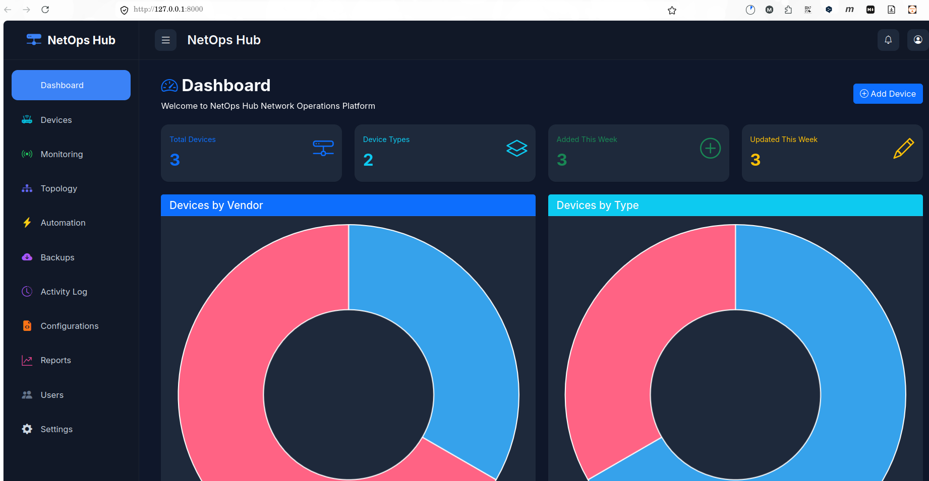
Figure 1: NetOps-Hub Dashboard — Real-time statistics showing device counts (3 total, 2 types), devices added/updated this week, and interactive donut charts for vendor and type distribution.
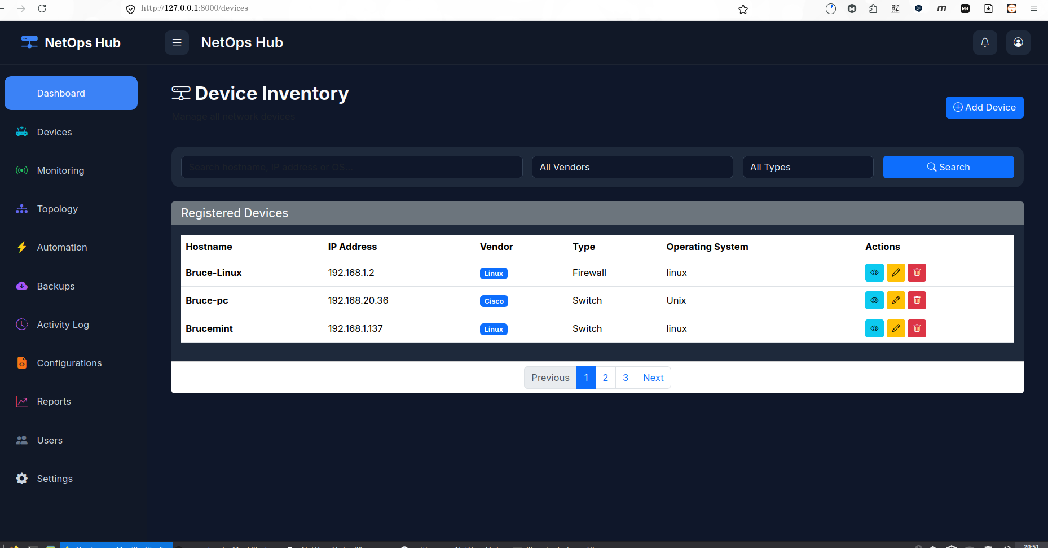
Figure 2: Device Inventory — Complete CRUD operations with search, filter by vendor/type, pagination, and action buttons (view, edit, delete) for each registered device.
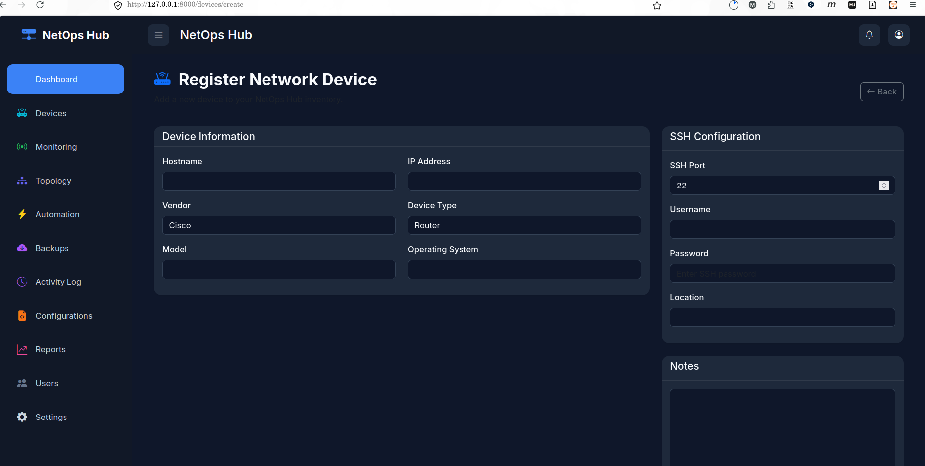
Figure 3: Register Network Device — Form for adding new devices with hostname, IP address, vendor, device type, model, OS, SSH configuration (port, username, password), location, and notes.
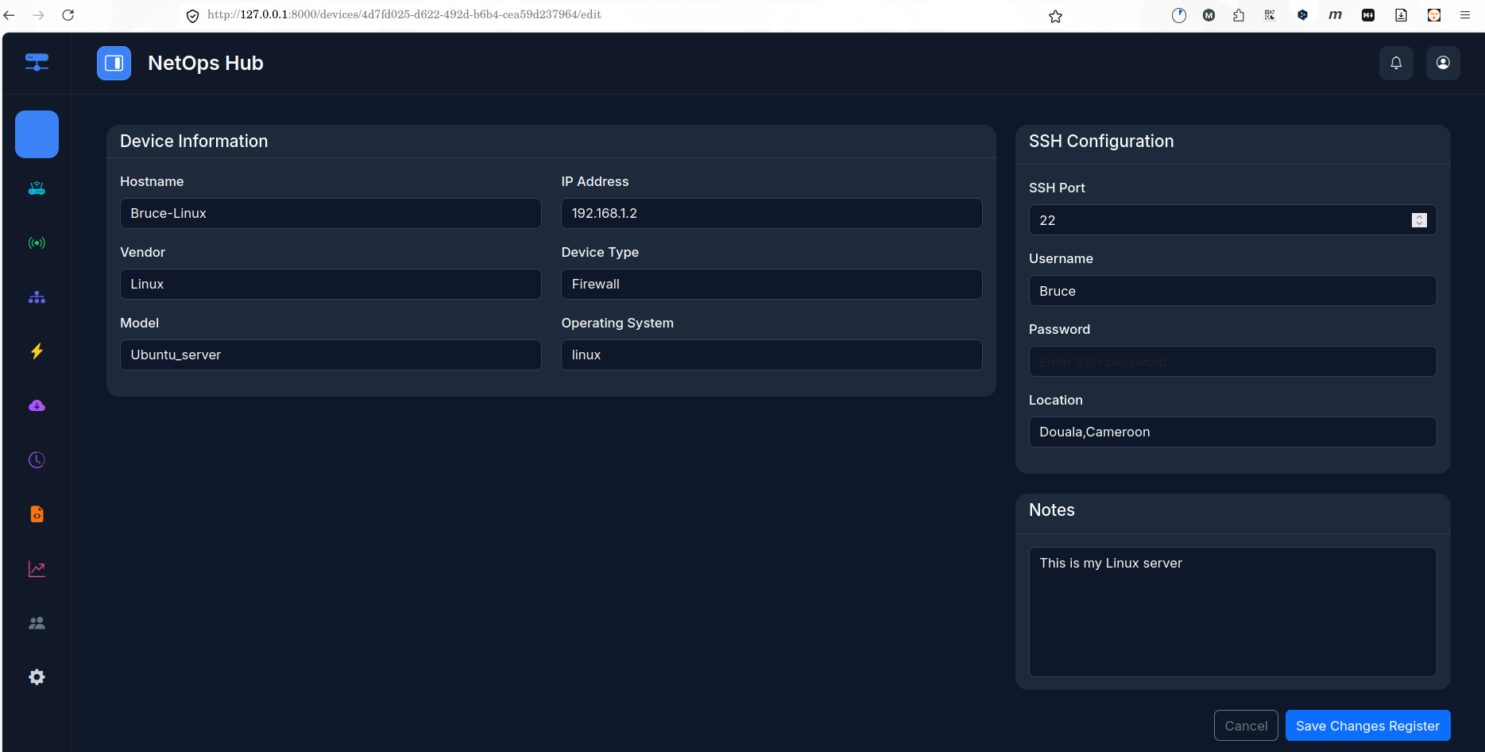
Figure 4: Edit Device — Pre-populated form for updating existing device information including Bruce-Linux (192.168.1.2) with Linux vendor, Firewall type, Ubuntu_server model, and Douala,Cameroon location.

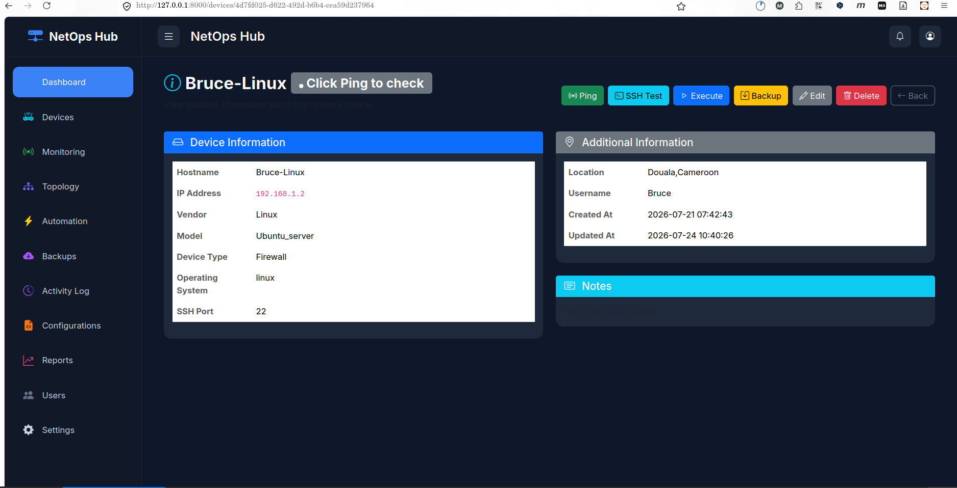
Figure 5: Device Details — Comprehensive device information panel with hostname, IP, vendor, type, model, OS, SSH port, location, username, creation/update timestamps, and action buttons (Ping, SSH Test, Execute, Backup, Edit, Delete).
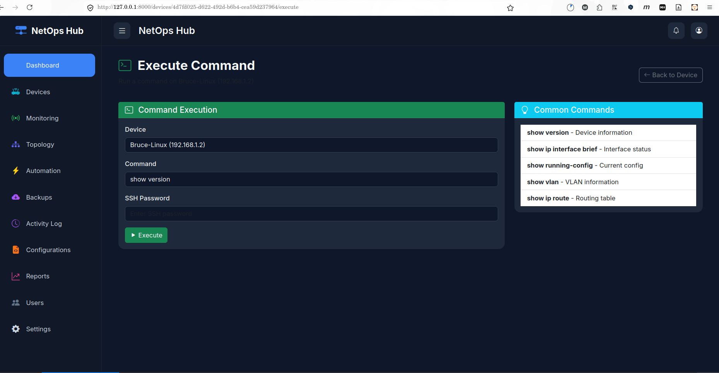
Figure 6: Execute Command — SSH command execution interface with device selection, command input, password prompt, and common commands sidebar (show version, show ip interface brief, show running-config, show vlan, show ip route).

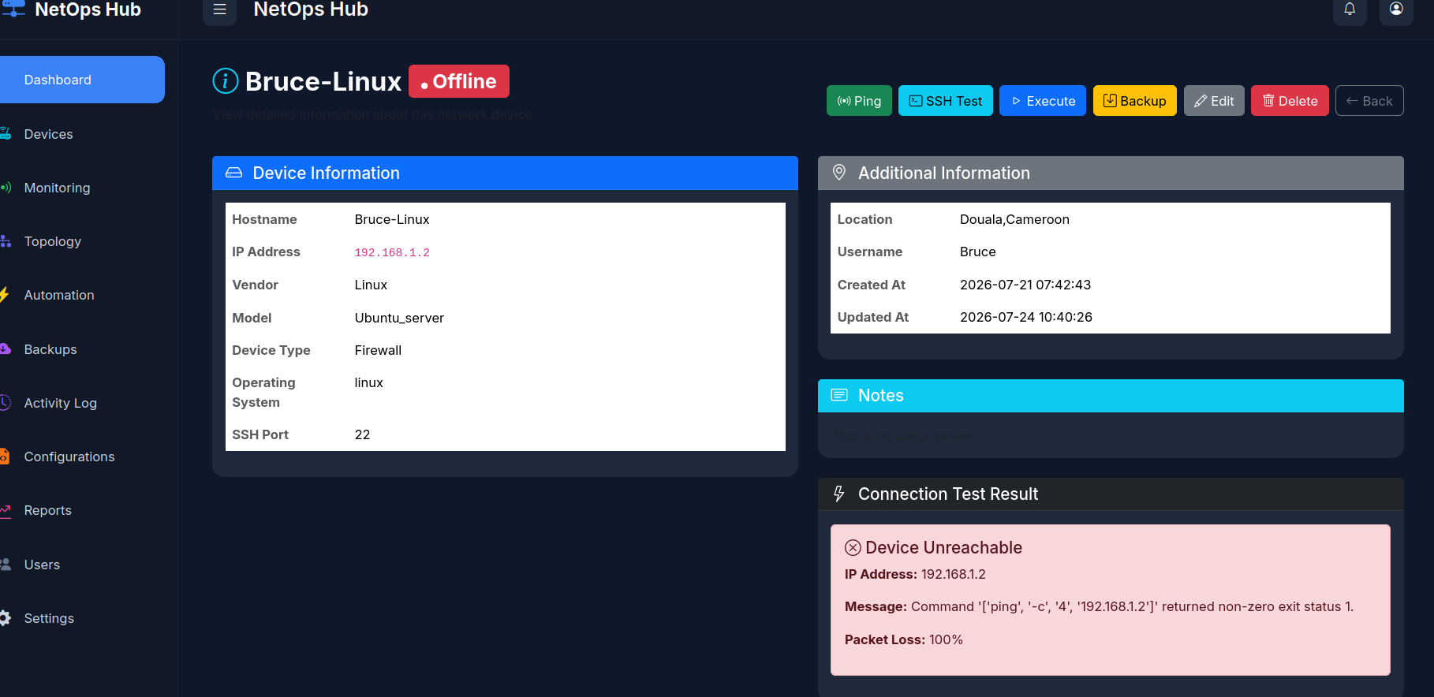
Figure 7: Ping Test Result — ICMP connectivity test showing device unreachable status for Bruce-Linux (192.168.1.2) with 100% packet loss and detailed error message from the ping command execution.
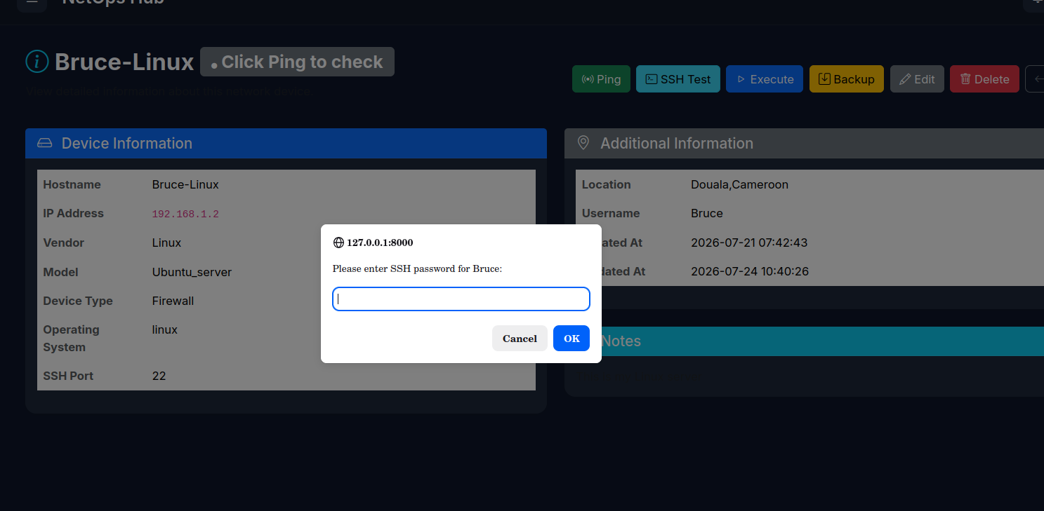
Figure 8: SSH Authentication — Secure password prompt dialog for SSH connectivity testing, requiring user credentials before establishing connection to the target device.

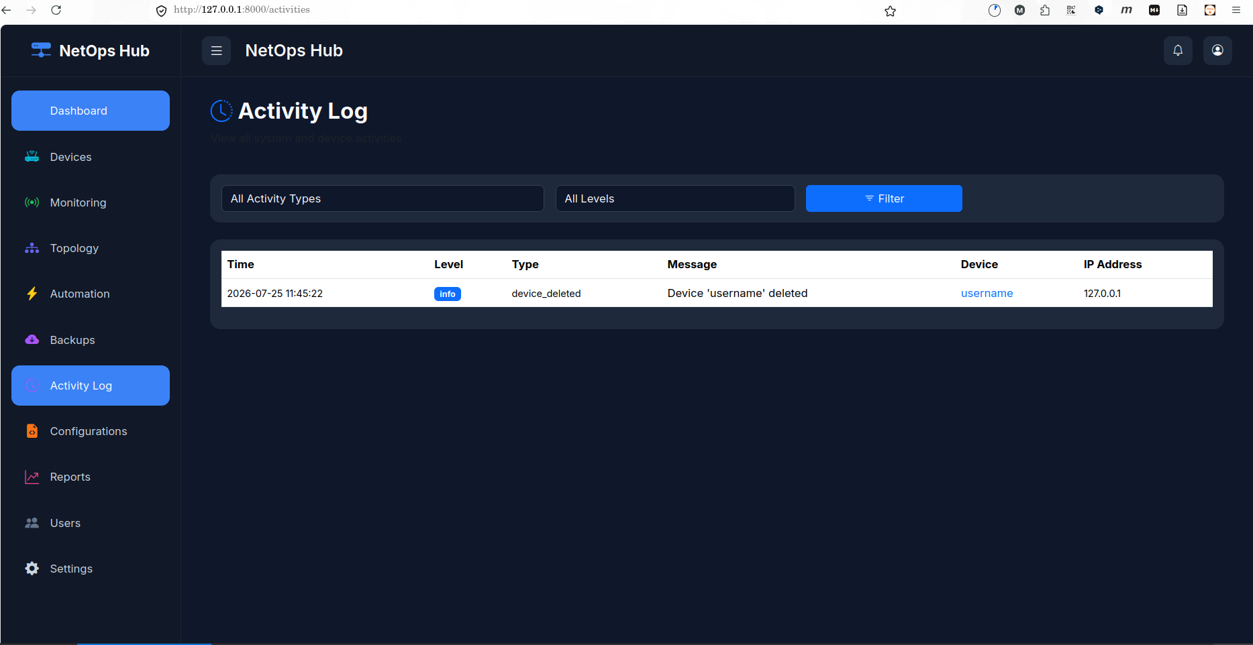
Figure 9: Activity Log — Comprehensive audit trail with timestamp, level (info), type (device_deleted), message, device name, and IP address, with filtering capabilities by activity type and level.
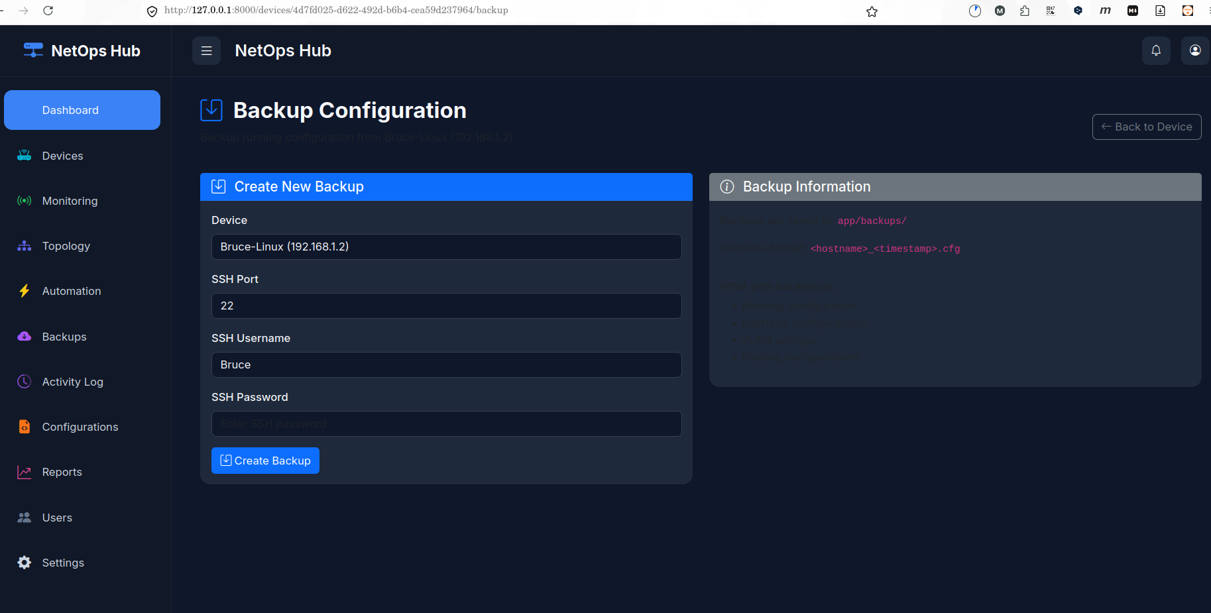
Figure 10: Backup Configuration — SSH-based backup creation form with device selection, SSH port, username, password input, and backup information panel showing storage path and filename format
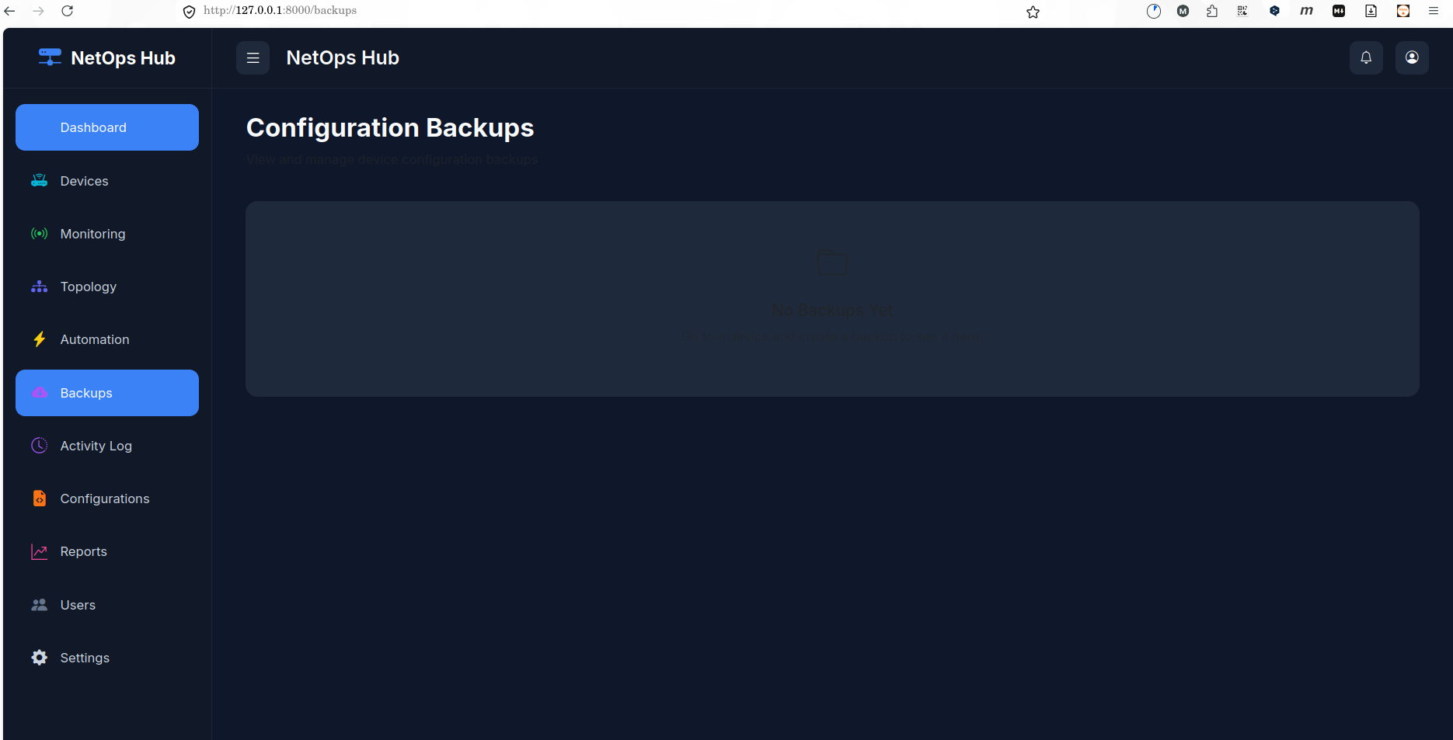.
Figure 11: Configuration Backups — Main backups page for viewing and managing all device configuration backups with file management and restore capabilities.
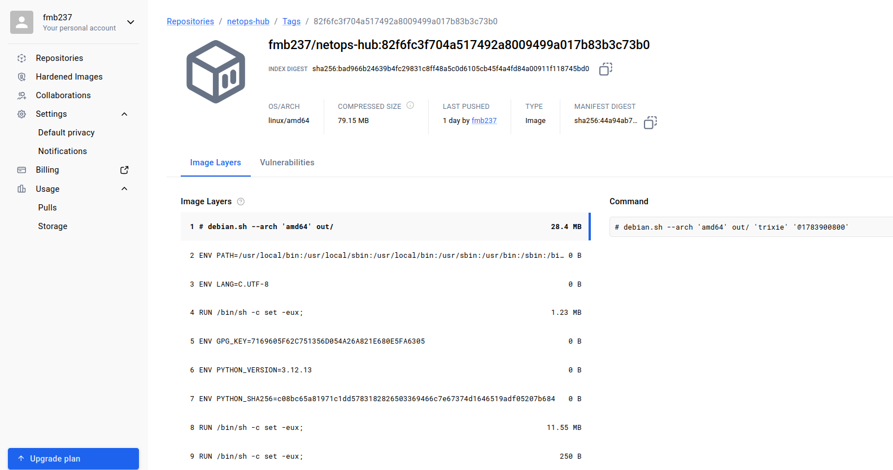

Figure 12: netops_image on dockerhub.Personal build container

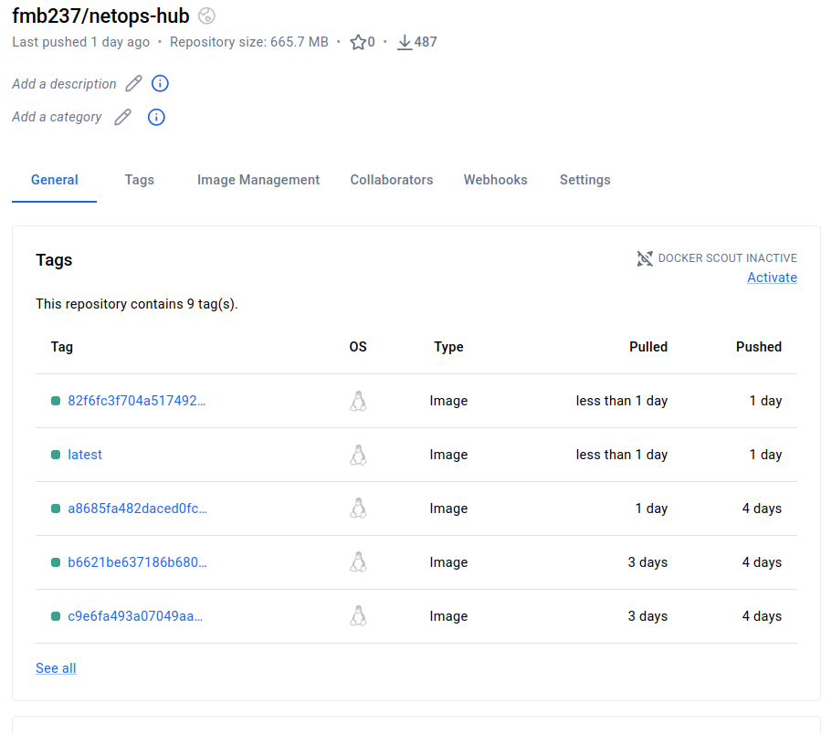
Figure 13: Continuous Deployment of Containers passing the CI/CD pipeline on Github with the use of Github Action.
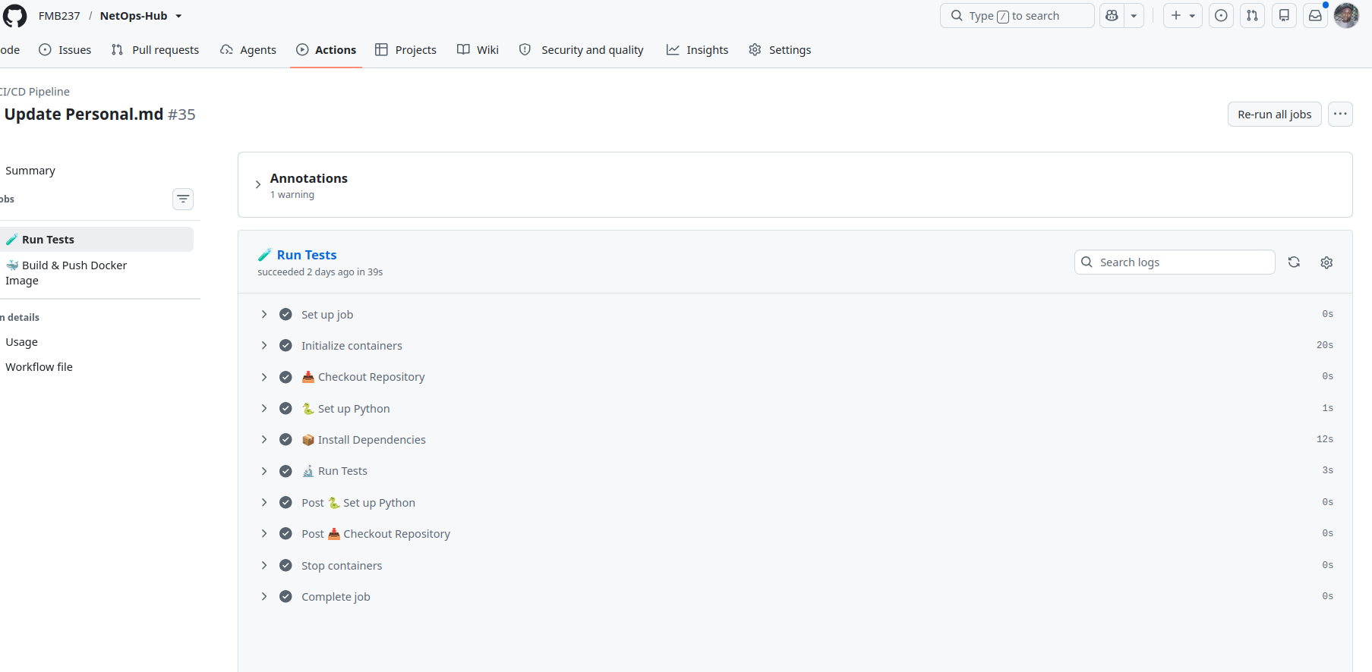
Figure 14 : Netops-hub test Action
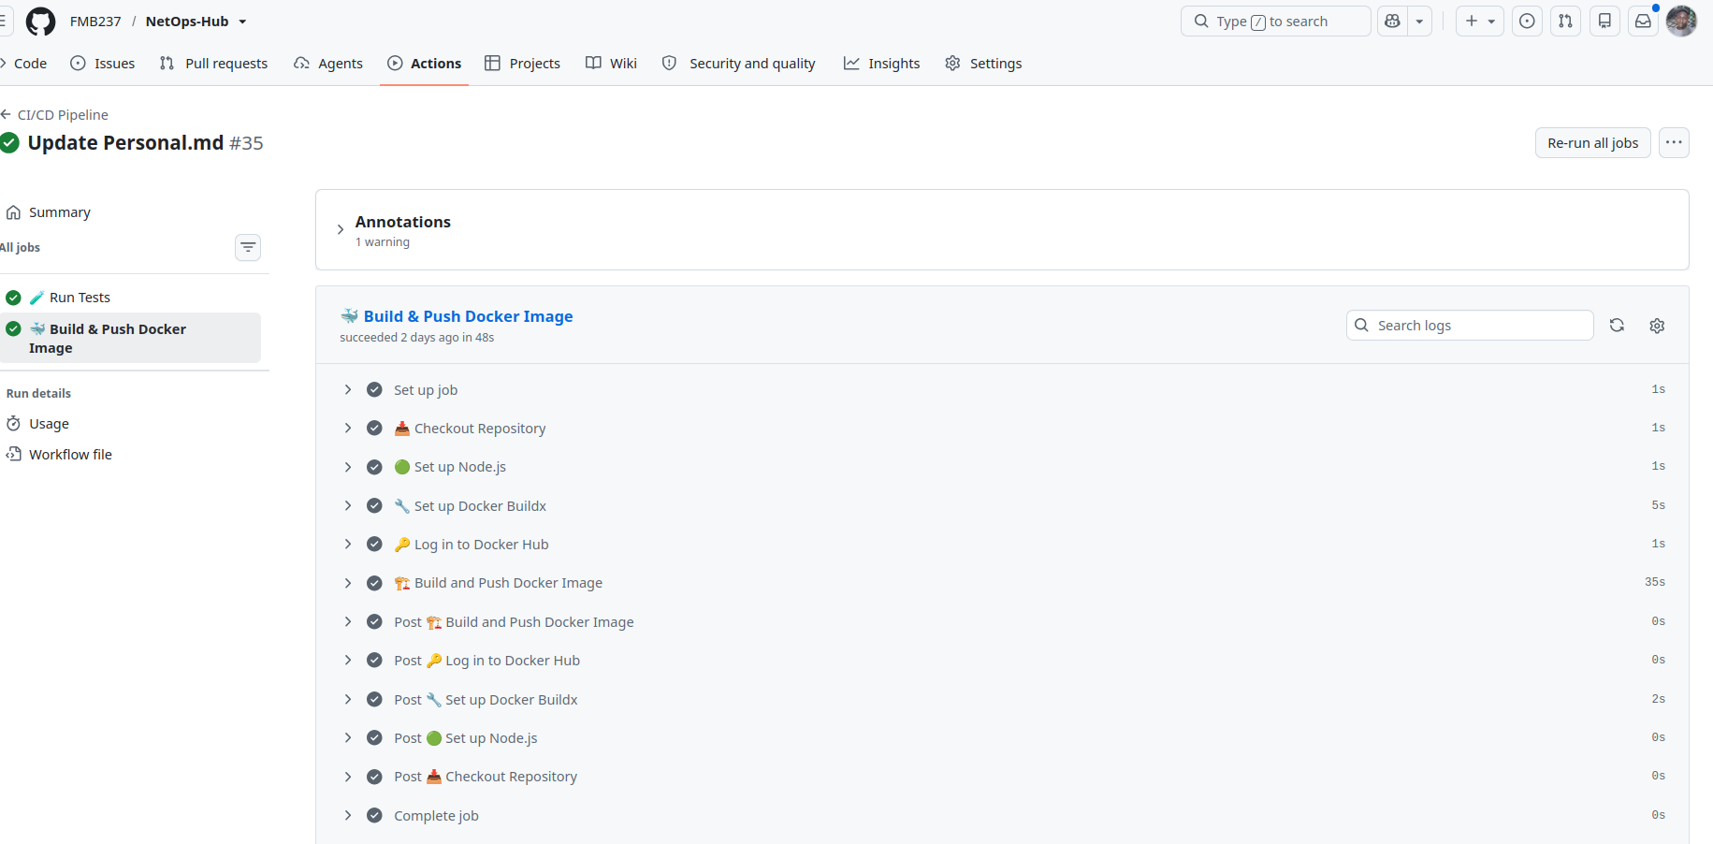
Figure 15 : Netops-hub Build & Push Docker Images
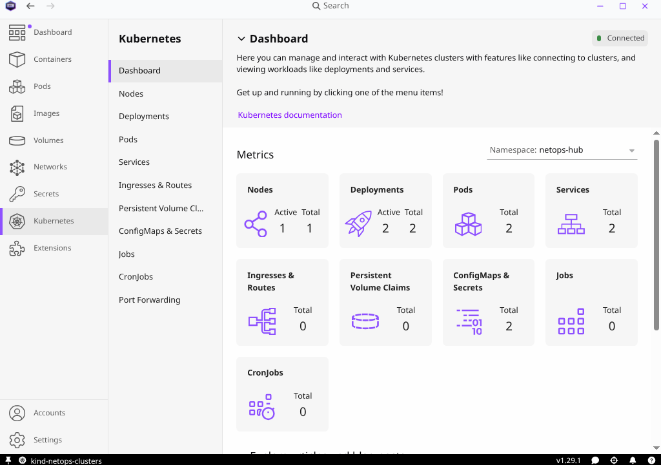

Figure 16 : Netops-hub Cluster with podman Desktop
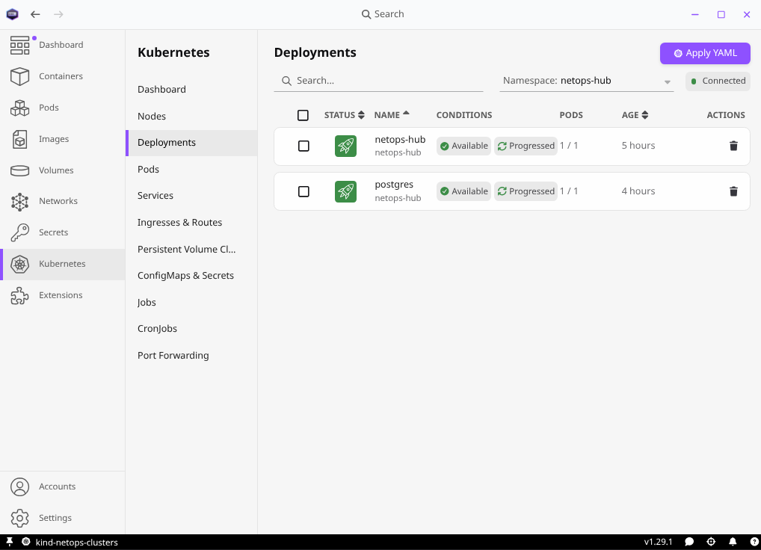
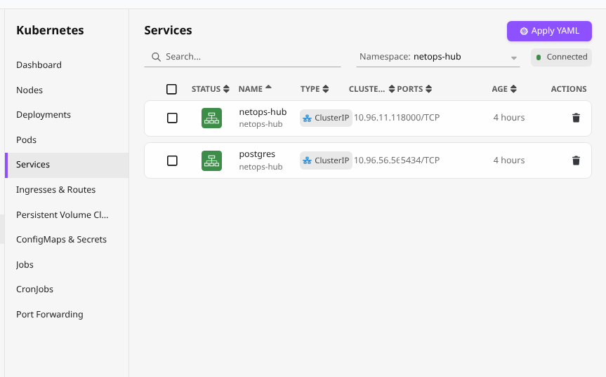

I tried to integrate the kubernetes as much i could using using Podman Desktop as UI
DECLARATION
I hereby declare that this report is a true and accurate account of the work completed during my Remote DevOps Internship at Progree. All information presented herein is based on actual project development, testing, and deployment activities conducted during the internship period.

______________ ______________
Fouenang Miguel Bruce Umar Mushtaq
Intern (Student ID: B2/724) Founder & CEO, Progree
Date: 4th August 2026 Date: _______________

