

**MSG 500**

**Individual project report**

***Investigating alcohol consumption and driving behaviour and their relationship to risk taking and impulsivity***

**Fionn Delahunty**

*Applied Data Science Program*

[Gusdelfi@student.gu.se](mailto:Gusdelfi@student.gu.se)

11th January 2018

**Contents**

|  |  |
| --- | --- |
| **Introduction** |  |
| **Methods** |  |
| **Results** |  |
| **Discussion** |  |
| **Appendix**  **References**  **Dataset Variable index** |  |

Note: Although this project is written in the general tense (we), I am the only contributor to this project.

**Introduction**: Main goal of the analysis, describe the data and problem

**Methods**: Traditionally, this is where you would give the theoretical descriptions of models - you don't need that here. Highlight the methods you used and why.

**Results**: Use subsections here! Examples below (but you can use others).

a) Preliminary data exploration (where you look into variable transformations, missing values, etc). Note - not pages and page of this stuff. If you had to do a lot to your data, put a summary here and the rest in an Appendix

b) Model building. Overview of the full model fit etc.

c) Model selection or model comparison (variable selection, comparing CART/Regression etc).

d) Your special topic: e.g. stability analysis, sensitivity analysis, comparing two different data, etc etc etc

**Discussion**: Summarize your main findings. Interpretation. Predictive performance. Limitations and Concerns. What would future work entail?

Appendix: Your data source URL, Your codes + other stuff (see above).

**Introduction**

The Dublin science gallery is a free public museum based in the capital of Ireland and hosted by trinity college Dublin. The purpose of the museum is to enhance the publics scientific knowledge through interactive and fun exhibitions. Research teams can submit different exhibitions based on the current theme of the gallery. During 2015 the gallery hosted a risk-taking theme, as part of this exhibition participants where offered the ability to fill out two psychometric risk-taking questionnaires and discover their own risk-taking attitudes. A total of 1326 individuals participated in the questionnaire over the two months it was left on display.

In total participants where asked to complete 93 questions. The first 10 of these questions related to demographic characteristics. The next thirteen questions related to participants driving behaviour while the following eight questions related to their alcohol consumption behaviour. Participants then completed the 30 item Barratt Impulsiveness Scale (BIS) in its standardised format and the revised 30-Item Domain-Specific Risk-Taking (DOSPERT) Scale in its respective standard format.

Since the data was collected no analysis has been completed on the dataset. This report is the first primary analysis of the raw dataset. We will discuss the implications of working on such a raw dataset later in the report. For the purpose of this assignment we investigated four different hypothesises related to this dataset. These hypotheses are roughly based on existing psychological research on DOSPERT and BIS scales, but are not an extension of any specific published study. Rather they are designed for the purpose of self-teaching for the MSG500 module.

The four hypotheses are follow.

1. Predicting the number of cigarettes smoked per week from a measure of risk taking in a social context (Domain-Specific Risk-Taking (DOSPERT) Scale)
2. Predicting the number of car crashes from a measure of self-control (Barratt Impulsiveness Scale (BIS))
3. Building a prediction model to predict if a participant in the dataset has smoked during their lifetime.
4. Building a prediction model to predict the age that a participant started drinking alcohol.

Following the establishment of the four hypotheses, our first step was to convert the raw dataset into a useable set of variables. Primarily this involved scoring the two psychometric questionnaires into a set of final variables. A number of questions required reversed scoring as an intermediate process. The 30 item BIS questionnaire was converted into eight final factors, while the DOSPERT questionnaire was reduced into six final factors. A brief description of these factors is provided in the appendix.

Overall this process was considerably more time consuming then initially expected. The majority of issues arose with the collection method. In a minor issue this included variables having to be reordered and re-indexed for scoring. In a more major sense the data collection had little or no response validation, which meant that a single question could contain numbers (1), strings (one) and missing or random values. This was definitely the most time-consuming issue of this project, and in hindsight was because of a lack of experience on our part. Given the time limitation of this project, choosing a clean and neat dataset would have been a much better idea.

A final and unexpected issue that arose was that the data collection system had failed for one specific question on the BIS scale ("I buy things on impulse?") meaning two of our final variables on the BIS (BIS Sum & BIS Motor) where invalid since no data was collected for an aspect of these factors. Since our hypotheses didn’t involve this factor specifically we where easily able to move on with creating the dataset without these two factors.

Following data cleaning, a final dataset was created with all necessary factors.

**Methods**

Throughout this project R programming language was used for all statistical analysis. R code was written and executed in a Jupyter notebook environment. Datasets and code are stored on a private GitHub repository for backup. All code (in notebook format) are attached in the appendix.

All four different hypothesis required the use of different statistical methods in their respective analysis. We will investigate each of the four different methods employed individually.

1. *Predicting the number of cigarettes smoked per week from a measure of risk taking in a social context (Domain-Specific Risk-Taking (DOSPERT) Scale)*

This hypothesis involved one dependent variable (cigarettes smoked per week) and one independent variable (domain-specific risk-taking). Domain specific risk taking is a two-factor measure, composed of social risking taking and recreational risk taking. For the purpose of investigation, we employed the social risking taking measure as the IV. We found this variable to be normally distributed with no extreme outliers.

Cigarettes smoked per week was a continuous variable (0 to 425), the data was skewed to the left-hand side due to the presence of a few extreme outlying values. The majority of the data itself was clustered into groups rather then having an even spread throughout the range. We felt the best way to represent this data was by dividing it into seven levels (spilt into groups of 25). The highest level (150 to 175 cigarettes smoked per week) also included the values 345,390 and 425 cigarettes smoked per week. These where extreme outlying values, and the for the purpose of our work we considered the best solution was to include them in the highest level. These seven levels only included values above 0, the majority of the sample (1064) did not smoke, we talk about this later in method and result section.

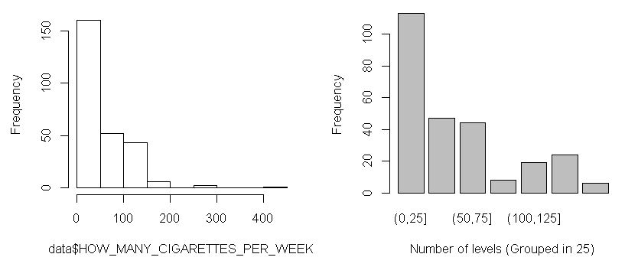

Figure – Raw data on the left-hand side, data divided into 7 levels on the left hand side.

We began investigating the data by first employing an ANOVA to compare the means of cigarettes smoked per week across domain specific risk taking. We also performed a Kruskal-Wallis rank sum test. We have uneven sample size in each of the 7 levels, generally ANOVAs are quite robust to violations of this assumption, but we still preformed the non-parametric test regardless.

To further test the relationship between risk taking and the seven levels we created a binary variable and performed a linear regression model which held the first level as a baseline. We preform a second linear regression with recreational risk taking as well, both social and recreational risk taking should be highly correlated factors.

1. *Predicting the number of car crashes from a measure of self-control (Barratt Impulsiveness Scale (BIS))*

This hypothesis involved one dependent variable (number of car crashes in the last two years) and one independent variable (self-control (BIS Scale)). Self-control variable has a normal distribution with no extreme outliers. The number of car crashes in the last two years variable however is not normally distributed, rather we see it contains a majority (91%) of 0 values, with some 1,2,3 and 4 values. Following some more investigation we grouped the variable in a dichotomise fashion with 0 as no crashes and 1 as having crashed at least once. Our sample sizes where still extremely uneven 1187 in the 0 group and 141 in the 1 group. We performed both an ANOVA and Kruskal-Wallis rank sum test on the dataset to investigate mean differences between the two levels across self-control. We also preformed a logistical regression with the same variables to investigate the relationship further.

1. *Building a prediction model to predict if a participant in the dataset has smoked during their lifetime.*

This hypothesis involved one dependent variable (Have you smoked?) and 11 independent variables. These IVs included age as a demographic variable, all four BIS factors and all six DOSPERT factors. The model employed logistical regression as a means of identifying which factors contributed to the prediction of dichotomise smoked variable. In order to test the effeteness of the model the data was divided into test and training datasets.

1. *Building a prediction model to predict the age that a participant started drinking alcohol.*

This hypothesis involved one dependent variable (The age a participant first consumed alcohol) and 11 independent variables. These IVs included age as a demographic variable, all four BIS factors and all six DOSPERT factors. This hypothesis was not actually tested. On investigation of the age started drinking variable it became clear that the variable was not normally distributed. The majority of participated had first consumed alcohol at the legal age in Ireland (18 years old). Some participants had first consumed it earlier, and some later in life. In order to make the variable investigable we divided it into four levels, those who had never consumed alcohol (*n= 202*), those who had first consumed alcohol under the legal drinking age (*n=510*), those who had consumed alcohol at the legal drinking age *(n=473*) and those who had first consumed alcohol later then the legal drinking age (*n=178*). As a result of dependent variable became a multinomial viable, the best method of investigation would have been multinomial logistic regression. However, given this was not in the scope of our course, along with general time constrictions we did not proceed any further with this investigation.

**Results**

*Predicting the number of cigarettes smoked per week from a measure of risk taking in a social context (Domain-Specific Risk-Taking (DOSPERT) Scale)*

1. **Model building**

Our first step in building this model was to employ both a ANOVA and Kruskal-Wallis rank sum test. Neither of these tests returned statically significant results. By investigating the boxplot in figure 2 we can see an overall difference in the means level of social risk taking, but no clear upwards or downwards tread across the levels. There is no visible suggestion that those who smoke a high number of cigarettes per week have a higher risk taking score.

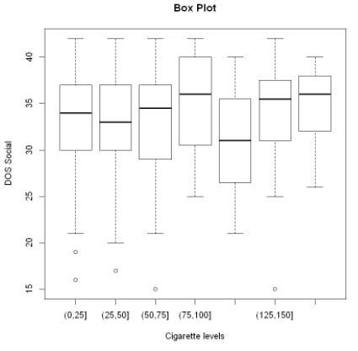

Figure Boxplot of all seven levels of the number of cigarettes smoked per week

1. **Model selection**

In order to further investigate which cigarettes levels contributed to social risk taking we developed a linear regression model after having converted the cigarette levels into a set of dummy variables. In order for regression to occur, we took the first level as a baseline measure. We began model selection with a standard multiple regression, which suggested none of the five levels where significant predictors. The overall model itself was also nonsignificant. We employed a backward model sectional approach will also resulted in an overall insignificant result. No combinations of the variables it employed produced anything significant.

As mentioned previously domain specific risk taking is composed of two different factors, social and recreational risk taking. We decided to add recreational risk taking to the model to see if it would improve prediction. The two factors are not strongly correlated (*R2= 0.347*) since they measure different constructs of the same domain. We began by plotting the two scales against each other and overlaying that with the smoking grouping we had earlier established. Via a visual inspection we see no clear pattern of smoking groups across the spread of risk taking. We employed an additive model in addition to our backward selection with the addition of recreational risk taking as a factor.

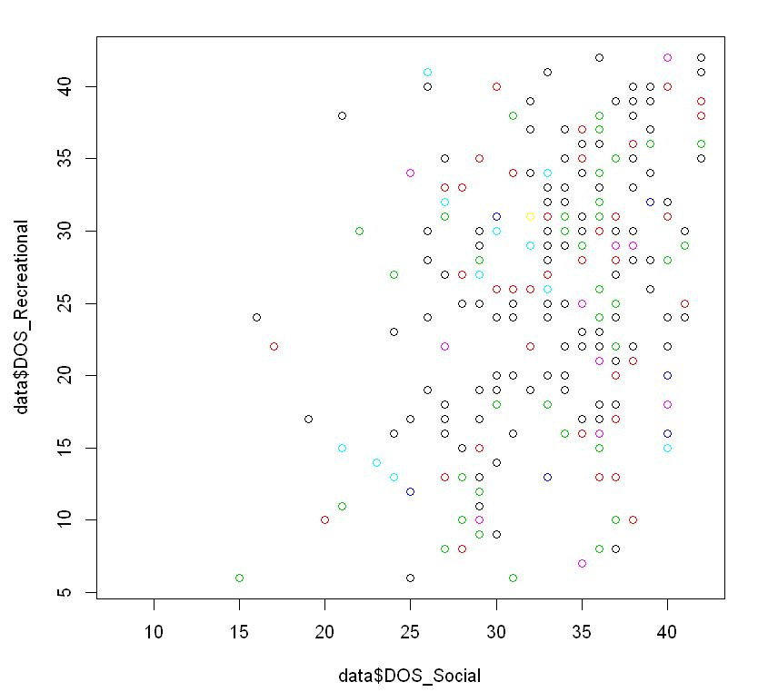

Figure Social risk taking verse recreational risk taking. Colours = smoking levels

1. **Model comparison**

In summary our additive model performed a better fit then our backward selection. Our backward selection found no significant combination of the variables. However our additive model found recreational risk taking strongly contributed to the model, along with the 3rd and 4th grouping having a mild positive significant effect. The pre

**Discussion**

**Appendix**

##

Add in brief description of each variable