31. Juli 2026
Florian M. Katzmann, Matr.-Nr.: 12293439
Semester 4, Master, Economics
Master Thesis
Supervisor: Justyna Kleidysz, Ifo-Institute
Table of Contents
Introduction 4
Literature Review 4
Methodology 4
3.1 Data 4
3.1.1 GermaParl2 4
3.1.2 Party Manifestos: MARPOR 5
3.1.3 Linking and the Analysis Sample 6
3.2 Research Design and Hypotheses 6
3.2.1 Unit of Analysis and Comparison Logic 6
3.2.2 Hypotheses 7
3.2.3 Pre-Commitment Architecture 8
3.3 Speech-Side Preprocessing 8
3.3.1 Sentence Segmentation (SoMaJo) 8
3.3.2 Procedural-Sentence Filter 10
3.4 Automated Classification (ManifestoBERTa) 11
3.5 Validation 14
3.5.1 Gold-Standard Validation 14
3.5.2 Silver-Standard Validation 17
3.5.3 Diagnosis 18
3.6 Corrections 20
3.6.1 Non-Codable Sentences Filter (gbert-000) 20
3.6.2 Exclusion of Code 305 21
3.7 Aggregation and Measurement 23
3.7.1 Topic Buckets 23
3.7.2 Speech-Side Aggregation and the Primary Specification 23
3.7.3 The Measure: Jensen-Shannon Divergence 25
3.7.4 Uncertainty: Sentence Bootstrap 25
3.8 Empirical Strategy 26
3.8.1 Hypothesis H1 27
3.8.2 Hypothesis H2 28
3.8.3 Hypothesis H3 29
3.8.4 Status Table 29
3.9 Robustness Design 30
Results 32
4.1 Analysis Base and Reading Conventions 32
4.2 Agenda Congruence (H1) 32
4.2.1 H1a (confirmatory) 32
4.2.2 H1b (Exploratory) 36
4.3 What Drives and Moderates Divergence (H2) 38
4.3.1 H2a (confirmatory/descriptive) 38
4.3.2 H2b (exploratory) 41
4.3.3 H2c (exploratory) 44
4.4 Polarisation over Time (H3, descriptive and exploratory) 46
4.5 Robustness 51
Conclusion 54
Bibliography 56
Appendix 59
Appendix [X] — Speech-side sentence segmentation: implementation details (cf. Section 3.3.1). 59
Appendix X: Realized Distribution of the Gold Sample across Strata 61
Appendix X — Procedural-Sentence Filter: Hand-Coded Typology 62
Appendix X – Silver-Standard Prompt 76
Appendix X — Code-to-Bucket Crosswalk 93
Appendix G: Software, Runbook and Integrity Checks 97
G.1 Computational Environment 97
G.2 Pipeline Runbook 98
G.3 Integrity Checks 99
G.4 Non-Codable Filter: Training Details 99
Appendix F: Redundancy Test of the Two Corrections 100
F.1 Comparison objects 100
F.2 Derived quantities and pre-stated criteria 101
F.3 Bootstrap Confidence Intervals 101
F.4 Benchmarks of the Congruence Analysis 104
Appendix F.10 The LP-13 elevation: a manifesto-side, window-boundary diagnostic 106
Appendix F Supplementary results and robustness tables 107
F.2 Per-cell salience divergence (H1a) with bootstrap intervals 108
F.3 The code-305 correction: six specification bands 109
F.4 Nearest-manifesto benchmark (identification of the own programme) 112
F.5 Pairwise between-party reference scale 113
F.6 Decoding-temperature sweep 114
F.7 Soft-assignment versus hard-threshold classification 115
F.8 Migration re-split (H1b, buckets 601/607 vs 602/608) 117
F.9 Supplementary directional figures 118
F.10 The LP-13 elevation: a manifesto-side, window-boundary diagnostic 120

Introduction

Literature Review

Methodology
The essential conception of the thesis is to measure the congruence between the proposed agenda of a given party represented by the manifesto of the election from which a legislative period (LP) emerges and the practised agenda in the form of plenary speeches in that LP. This congruence between the manifesto and speech as distance between topic distributions measured as the Jensen-Shannon divergence (Section 3.7.3). To this end we work with a small set of politically distinct topic buckets. We also include a sub-aggregation to some of these categories allowing a directional analysis (Section 3.7.1). The analysis is conducted at the party-period cell level. The chain runs from speech to sentence to MARPOR category to topic bucket to distribution to divergence.
The Primary specification and acceptance criteria were fixed before the analysis, Section 3.2.3. We will first discuss the two data sources (3.1), then the research design and hypotheses (3.2), then speech-side preprocessing (3.3), followed by classification (3.4), validation (3.5), corrections (3.6), aggregation and measurement (3.7), then empirical strategy (3.8) and at last we discuss the robustness design (3.9).

3.1 Data

3.1.1 GermaParl2
The speech side draws on GermaParl2, a linguistically and structurally annotated corpus of Bundestag plenary protocols covering debates since 1949, designed for the quantitative study of parliamentary speech (Blätte and Blessing, 2018); we use release v2.3.0-rc1 (Blaette and Leonhardt, 2025). The corpus is distributed in Corpus Workbench (CWB) format and accessed through polmineR, whose structural attributes (legislative period, date, speaker role, party) drive the extraction described below. Our window covers LPs 13 to 20, from 1994 to the present, as a design choice on comparability grounds: three decades give the time dimension enough variation, while reaching further back would import a party system and political discourse increasingly remote from the periods under study. Among available alternatives, notably ParlSpeech V2 (Rauh and Schwalbach, 2020), GermaParl2 offers the annotation depth and CWB structure this pipeline requires.
We extract only plenary contributions tagged as speech and made by an MP or member of the federal government, which excludes chair and presidium interventions. Interjections or Annotations like applause enter the corpus as parenetical annotations, we strip them from the speech text. We then count the words and drop all speeches below a word count of 100 after clearing. The overall timeframe is chosen from LP 13 onwards (1994), while three decades give a large enough variation to allow for differentiated analysis, going back further would import a party system and political zeitgeist increasingly remote from the periods under study, adding heterogeneity rather than information. We restrict attention to plenary speech, the party-controlled, fully documented, and cross-party comparable arena of parliamentary communication (Proksch and Slapin, 2015).

3.1.2 Party Manifestos: MARPOR
The Manifesto Project (MARPOR; Lehmann et al., 2025-1) provides human-coded content analyses of party manifestos since 1945. Trained coders split each manifesto into quasi-sentences, i.e. sentence sub-parts carrying one distinct political statement, and assign each quasi-sentence to one of the 56 policy categories of the project's coding scheme (Handbook 4; Werner et al., 2011). The scheme is constructed on salience-theoretic grounds, which makes it a natural measurement language for an agenda comparison (Budge et al., 2001; Klingemann et al., 2006). For every party-LP pair this yields an observed distribution over the 56 categories directly: on the manifesto side, no classification step is required.
The speech side carries no such annotation; Sections 3.3 to 3.6 spell out how we close this asymmetry. We use the project's main dataset of aggregated category shares rather than its annotated corpus, whose quasi-sentence texts cover only a subset of our party-LP cells; the permutation procedure originally specified on pooled sentences was dropped with this choice. Category shares are renormalised to sum to one per manifesto. Two properties of the manifesto side matter later: MARPOR codes the CDU and CSU jointly as one programmatic actor, which matches their treatment as one parliamentary party on the speech side, and only Handbook 4 three-digit categories are available, without directional sub-codes, a constraint Section 3.7.1 returns to. Human coding is itself imperfect at the fine-code level (Mikhaylov, Laver and Benoit, 2012); this is the accepted field standard, and the bucket aggregation of Section 3.7.1 smooths fine-code noise.

3.1.3 Linking and the Analysis Sample
Each legislative period is paired with the manifesto of the election from which it emerged: the programme states the announcement, the speeches that follow are read against it; pairing with the following election's manifesto would invert this logic. Which of the party-LP combinations enter the analysis, and why, is declared once in Section 3.8; the resulting sample comprises 38 valid cells.

3.2 Research Design and Hypotheses

3.2.1 Unit of Analysis and Comparison Logic
For each party-LP cell there are two probability distributions over K buckets, one for each manifesto (m) and one for the speech side (s). Consistency is then analysed as the closeness of s to m measured by the Jensen-Shannon divergence, a symmetric, finite, and bounded distance defined in Section 3.7.3.
Here the explicit distinction to the pledge fulfilment literature which codes explicit promises and their enactment (Royed, 1996; Thomson et al., 2017), whereas we ask if parties talk about the same topics they emphasise in their programs. The closest precursor also compares manifestos with parliamentary speeches, but differentiates not by topic buckets, but compares spatial congruence of ideological positions (Louwerse, 2012). The contribution of this thesis is a sentence-based, distribution-wide comparison on the identical coding scheme, which avoids any crosswalk between measurement languages. For Germany, the closest substantive neighbour compares manifesto priorities with the legislative agenda rather than with speech (Guinaudeau and Guinaudeau, 2023); we add the parliamentary speech channel with a scheme-identical design. The directional sub-aggregation approaches positional content but is reported as exploratory throughout (Sections 3.2.2, 3.5).
Speaking time in parliament is budgeted: attention devoted to one issue is unavailable to another, so the scarce resource a party allocates is relative attention. The full distribution of that attention across topic buckets, rather than any single statement or position, is therefore the appropriate level at which announced and practised agendas can be compared (Chapter 2).

3.2.2 Hypotheses
Every analysis that follows carries one of three status labels, assigned here and never changed thereafter. Analyses declared confirmatory were specified before the results were known. The entire directional layer is exploratory, for reasons the validation in Section 3.5 establishes. Descriptive analyses characterise trends without testing them. Chapter 4 applies these labels verbatim, and the exact objects, specifications, and benchmarks of each analysis are declared once in Section 3.8.
H1a (confirmatory). Parties speak closer to their own programme than to those of their competitors: per party-period cell, the Jensen-Shannon divergence between the speech and manifesto topic distributions is small relative to the programmatic differentiation between parties, and a party's own manifesto is the nearest to its speech agenda at a rate above the chance baseline. Parties benefit from the issues they own and compete by selectively emphasising them (Petrocik, 1996; Budge and Farlie, 1983), which leads us to expect plenary emphasis to track the party's own programme (Chapter 2).
H1b (exploratory). Directional consistency extends within domains: in the four directional domains, the composition of parliamentary speech across directional sub-buckets resembles the composition of the same party's manifesto. H1b extends the logic of H1a to the directional layer and is reported as exploratory throughout, as diagnosed in Section 3.5.
H2a (confirmatory/descriptive). Plenary speech is institutionally filtered: floor access and the procedural business of the chamber are controlled at the level of the parliamentary party (Proksch and Slapin, 2015; Chapter 2). Manifesto-speech divergence is not uniform across topics: it concentrates in identifiable buckets, with the largest contributions expected in the institutionally driven Democracy & Political System domain rather than an even spread across the agenda.
H2b (exploratory). Parties moderate their directional positions in parliamentary speech relative to their manifestos: speech positions track manifesto positions with a slope below one, so strongly polarised manifesto positions correspond to more balanced speech compositions.
H2c (exploratory). In parliament, parties must respond to a common agenda regardless of their own priorities, the party-system agenda model (Green-Pedersen and Mortensen, 2010; Chapter 2); this mechanism also underlies the moderation expected in H2b. Because parties in parliament respond to a shared agenda, directional positions disperse less across parties in plenary speech than in their manifestos (cross-channel convergence); at the level of system dispersion, the AfD's entry additionally contributes a compositional component.
H3 (descriptive, exploratory). System-level polarisation of directional positions increases over the observation period, in particular in the Europe and Migration domains and around the AfD's parliamentary entry in 2017; the analysis describes these trends per domain and channel rather than testing them. The AfD's radicalisation across its 2017 parliamentary entry is well documented (Arzheimer and Berning, 2019), which motivates reading 2017 as the expected break (Chapter 2). How all of these declarations were fixed before the analysis is the subject of Section 3.2.3.

3.2.3 Pre-Commitment Architecture
If analytic choices are made after seeing the data, nominal inference loses its meaning even without intentional p-hacking, since every data-dependent choice implicitly adds comparisons; Gelman and Loken (2014) call this the garden of forking paths. In automated text analysis the accepted answer is to fix design decisions before results are inspected (Barberá et al., 2021; Grimmer, Roberts and Stewart, 2022). Following this approach, all decision rules below were fixed in code and project documents before we inspected the primary results. The primary specification and the aggregation scheme were declared before any hypothesis was evaluated (Section 3.7.2). The procedural-sentence typology was decided on formal grounds before we inspected its effects (Section 3.3.2). The acceptance criteria of the robustness battery (Section 3.9), the thresholds of the redundancy verdict on the two corrections (Section 3.6.2), and the frozen gold-standard sample (Section 3.5.1) were also all fixed in advance.
We did not use a formal external registry. Pre-committed in this thesis means that the decision rules were fixed in code and documents before we saw the primary results. One expectation changed against the early project sketch: H2c first expected more dispersion in speech than in manifestos and now states the opposite, derived from the party-system agenda model and kept exploratory. The remaining sections follow the measurement chain from raw transcripts to the per-cell distributions.

3.3 Speech-Side Preprocessing

3.3.1 Sentence Segmentation (SoMaJo)
The speech side is classified sentence by sentence. The classifier used (ManifestoBERTa) is designed to assign one category per sentence. Thus, the sentence is the atomic classification unit on the speech side. Manifestos are classified by quasi-sentences, i.e. partial sentences that carry independent coding-relevant statements, as determined by the human coders. Because quasi-sentence boundaries reflect subjective human-coder decisions, this segmentation cannot be reproduced on the speech side, and we are restricted to the sentence as unit of measurement. As discussed in 3.2.1, the unit of analysis is the party – LP cell, and in that the probabilities are aggregated over all speeches in the given LP by a given party. Therefore, the comparison is never made at the unit (sentence to quasi-sentence) level but done as a distributional average over the whole cell mass. Although the quasi-sentence coding likely allows for a more granular analysis, we argue that a granularity difference which is not systematically correlated with topic averages out at the distribution level and shifts neither distribution’s shape. Further strengthening the tolerability of the segmentation difference between the corpora is that the validation of the speech corpus is conducted also on sentence level, here including gold- and silver-standard validation steps. Thus, the general validity claims are unaffected by this discrepancy. Däubler et al. (2012) question quasi-sentence unitization on the grounds that human identification of quasi-sentence boundaries is itself unreliable, and argue for natural sentences as an exogenous, reproducible coding unit. Nevertheless, the essential discrepancy is acknowledged, which is why inference is restricted to cell-level distributions. Because the sentence is the measurement unit, segmentation quality is itself measurement-relevant and non-trivial for German texts. The period is an overloaded character: phrases like “1. Oktober” and “Art. 5 Abs. 1” make a naive splitting of sentences on punctuation insufficiently accurate. We account for this by utilising SoMaJo (Proisl & Uhrig, 2016) for corpus segmentation, which is a rule-based, deterministic tokenizer and sentence splitter for German using the “de_CMC” model. It relies on hand-crafted rules and curated abbreviation lists rather than a statistical language model, making its output deterministic and, at a pinned version, fully reproducible, with no learned parameters or random seed. SoMaJo tokenizes the text and sets sentence boundaries; each sentence surface is then reconstructed from the token stream via the space_after annotation, which reattaches the punctuation that the CWB representation stores as detached tokens. Sentences that after splitting hold only non-alphabetic contents are removed from the corpus, e.g. numbers, punctuation etc. The criterion is alphabetic content rather than length, so short but genuine sentences (‘Ja.’, ‘Nein.’) are retained; genre-specific but linguistic material such as salutations remain in place and are handled by the procedural filter (Section 3.3.2). Overall, the segmentation of sentences utilising SoMaJo yields a total number of sentences of 6,139,035, discarding 3.2% as non-linguistic residue. Proisl & Uhrig report an F1 of 99.57 for SoMaJo, but on tokenization of web text rather than sentence splitting of parliamentary speech; we therefore validate segmentation quality internally. The silver annotation scheme included a dedicated mis-segmentation category, so each sentence was explicitly checked for mis-segmentation; the mis-segmentation rate under SoMaJo is [0.895%] on this sample — small enough not to shift the cell-level distributions on which inference is built. We acknowledge that the silver sample is based on an AI model (Sonnet 4.6) and represents only a fractional sample of the full corpus; it is nonetheless large enough to support these claims.

3.3.2 Procedural-Sentence Filter
In contrast to manifestos, parliamentary speeches have additional genre specific language e.g. procedural language, greeting and closing remarks etc (Proksch & Slapin, 2015). This difference creates a significant problem in the context of cross domain topic classification as the classifier trained on manifestos only simply has no category for this type of language but is designed to assign a category to every sentence. Hence, it systematically misclassifies sentences of this type. We compiled a corpus-wide frequency list of normalized sentence forms and hand-coded the 500 most frequent as procedural or non-procedural. A sentence is flagged as procedural when its normalized form exactly matches a procedural entry; the primary specification then keeps only the non-flagged sentences, while the full corpus is retained for robustness checks. Because the entire corpus is already classified, flagging rather than deleting lets both the filtered specification and the unfiltered robustness arm derive from the same basis, requiring no re-classification. This procedural sentence filter in total excludes 354,364 sentences, 5.77% of the full corpus after sentence segmentation. The procedural filter and the 000-filter discussed in 3.6.1 are complementary rather than redundant, as the 000-filter also catches procedural sentences outside of the most common sentences forms but still without political information and would be misclassified, while the surface filter catches procedural sentences to which the classifier assigns a spurious substantive label, which would thus survive the 000-filter. We have nevertheless to acknowledge that by coding only the 500 most common normalized sentence forms of the corpus the long tail of such sentences is not caught and remains in the corpus; the residual mass is small, partly absorbed by the 000-filter and the unfiltered robustness arm confirms the results are stable with or without the filter.

3.4 Automated Classification (ManifestoBERTa)
Classifying 6,139,035 sentences by topic is only feasible through automated classification. Transfer learning with models of the BERT family has been established as a standard approach for such tasks in political science (Laurer et al., 2024). We decided on using a transformer encoder model based on the XLM-RoBERTa-large architecture, a multilingual model pretrained by Facebook AI (Conneau et al., 2020).
We use an adaptation of this model called ManifestoBERTa (Burst et al., 2024), which has been fine-tuned in a supervised fashion on 1,691,707 hand-coded quasi-sentences of the Manifesto Corpus, version 2024a (Merz et al., 2016), covering manifestos in 38 languages. Each quasi-sentence is coded into exactly one of the 56 three-digit Handbook-4 codes of the MARPOR scheme, as discussed in detail in 3.1.2.
There are two model types of ManifestoBERTa, a context and a sentence-only one; the version used is 56topics.context.2024.1.1. In the context variant, the input is a sentence pair: the sentence to be classified, and a context block in which the sentence is embedded in its surrounding text. During training, this context was greedily filled up to 200 tokens. In the authors’ held-out evaluation, the context variant achieves an accuracy of 0.64, compared to 0.57 for the sentence-only variant. Our implementation, however, differs from the training convention: we construct the context as the immediately preceding and following sentence only, rather than filling the 200-token budget, a mild train–inference discrepancy; the model card explicitly anticipates variable context lengths, and we return to the point in the limitations. Context is constructed strictly within speech boundaries. The model is used as released on Hugging Face with frozen weights which are not changed at any point in the process. All corrections applied in this thesis operate downstream of the frozen model.
The output we save from the classification run is the full 56-dimensional softmax vector, from which the top-1 category and its probability are derived. The full vector of probabilities is retained because reducing each sentence to its argmax would discard information about certainty of the assignment. Two sentences with distributions of (.35, .33, .32, …) and (.95, .03, .02, …) are indistinguishable using an argmax decision, whilst differing substantially in certainty of prediction. This allows the inference to be built on soft aggregation (3.7.2), robustness checks such as temperature scaling and hard assignment under confidence thresholds (3.9), and the diagnosis of confidence (3.5.3).
To make a meaningful comparison between manifestos and Bundestag speeches, we need to measure both channels in the same categorical space. Because the ManifestoBERTa model is trained to predict into the very scheme on which manifestos are coded, both distributions live in the same 56-category space. Without using the same scheme for both channels a crosswalk has to be made between two schemes. Any such mapping introduces an additional, unvalidated measurement assumption: because the two schemes are not congruent, part of the divergence one measures could originate in the mapping rather than in the texts themselves. This makes the shared coding inside the MARPOR scheme not a convenience but a design requirement. Osnabrügge et al. (2023) establish a precedent for this approach, applying a manifesto-trained classifier to parliamentary speech and validating it against expert coding. Their finding that accuracy varies considerably by topic anticipates the category-specific diagnostics we undertake in Section 3.5.
While the approach of zero-shot domain transfer has practical merit and avoids the mapping problem set out above, it introduces two structural risks that follow directly from the difference between the two domains. Risk one has its origin in the general difference in genres that are being compared. On the one hand there are manifestos, written documents aimed strictly at conveying a political program; on the other hand, Bundestag speeches, also vehicles of political messages but in a very different format, shaped by the spoken word and the debate culture of the institution. Examples would be the voicing of subjective feelings on a given topic and direct attacks on political opponents. This means that the classifier, which has been trained on manifestos alone, has to classify speech texts and their unfamiliar style into categories learned from manifesto-style texts. The risk that follows is that the classifier has learned to look for specific signals in syntax and rhetoric in manifestos for a given topic which then leads to misclassifications in speeches as some signals simply do not exist or are typical of a different topic in this domain. All accuracy figures mentioned above are from in-domain tests, as the model card reports no numbers on cross-domain validity of any sort. Our setting is what Ramponi and Plank (2020) describe as unsupervised domain adaptation: application to a target domain for which no labelled data exists. Their survey documents domain shift as an established methodological problem in NLP. Evidence from related PLM-based (Pretrained language model) classifiers shows this concern to be more than theoretical: Roussinov and Sharoff (2023) report F1 drops of 20–30 percentage points for BERT- and RoBERTa-large under distributional shift between training and application. Their configuration is the inverse of ours. Genre is the target and topic varies, whereas here topic is the target and genre varies, but the underlying entanglement of topic and style is the same. Crucially, this degradation in accuracy is unlikely to be uniform across categories: both Osnabrügge et al. (2023) and Roussinov and Sharoff (2023) find that the size of the performance drop varies substantially across topics. An aggregate accuracy figure would thus conceal rather than reveal the problem, which is why the validation in Section 3.5 evaluates the classifier at the category level.
The second potential risk discussed above is the absence of a residual category. Although manifestos in hand coding do have a 000 category for non-codable content (Werner et al., 2011), the classifier’s label space comprises only the 56 political categories (Burst et al., 2024). The model card states that training used all quasi-sentences of the corpus yet does not document how 000-coded quasi-sentences were handled. In the speech domain there is a considerable part of text that has no inherent political meaning. These genre-specific elements range from procedural content, to voicing of disdain or disagreement, to greetings and thanks. The procedural filter introduced in Section 3.3.2 removes part of this material, but only on the procedural side. By construction, however, it cannot exhaust it: a rule-based surface filter only detects what it matches. Non-codable content that follows no fixed formula leaves no surface signature to match on, passes the filter, and reaches the classifier, which, lacking a residual category, must assign it one of the 56 codes. This is a phenomenon discussed in the literature as the closed-world assumption (Scheirer et al., 2013): the softmax mass over the 56 categories must sum to one, even if the classified sentence does not fit any of them. This forced assignment does not announce itself as uncertainty. Neural classifiers of this type have been shown to be systematically overconfident: their softmax probabilities overstate the empirical accuracy of their predictions (Guo et al., 2017). A code assigned in the absence of any fitting category will therefore appear in the output as a confident prediction. Because the misdirected probability mass is concentrated rather than dispersed, it does not average out across a cell: it shifts the topic distribution in a systematic direction. Consequently, the classifier’s own confidence cannot serve as a signal for detecting non-codable sentences: identifying them requires a signal independent of ManifestoBERTa’s posterior.
The two risks discussed above are logically distinct. The first concerns codable sentences assigned to the wrong category, which is a failure of the mapping from surface to category. The second risk concerns sentences being forced into a wrong category by the classifier, which is a failure of the output range. Neither is remedied by resolving the other: a perfectly genre-adapted classifier would still have no code for a procedural announcement, and a classifier equipped with a residual category would still misread the rhetoric of a hostile intervention. Whether these risks materialise, and how strongly, is an empirical question that Section 3.5 will address.

3.5 Validation
Because automated text-classification methods carry no context-free guarantee of accuracy, they require validation against the specific task to which they are applied (Grimmer & Stewart 2013). To validate the results from the classification two complementary validation instruments are implemented. First a gold-standard sample, which has been hand coded by a human coder, allowing us to measure per-class reliability and targeted precision estimation (esp. code 305); deliberately not corpus-proportional. Second, a silver-standard validation sample, that has been blind coded by Anthropic Claude Sonnet 4.6, to allow us to measure corpus-weighted consistency based of two independent automatic coders. These two instruments together allow the assessing of the two risks discussed in the previous paragraph. The concept of this paragraph is diagnosis; the solutions will be discussed in 3.6.

3.5.1 Gold-Standard Validation
The purpose of the gold-standard validation is per-class validation and precision estimation; the sample is therefore by design not proportional to the corpus. The gold sample comprises 259 sentences, stratified on the model's predicted bucket at the finest level the analysis distinguishes: the B-bucket where the predicted code carries one, the A-bucket otherwise. This yields 16 strata, consisting of the nine B-buckets, the five non-directional A-buckets, and two residual strata for Economy and Welfare codes that carry no B-assignment. For each category the sample is drawn randomly but must contain at least 10 observations. Furthermore, as early checks indicated, that the DPS-bucket(Democracy and Political System) and, in particular the code 305 is over-assigned by the classifier, likely for procedural content. The DPS bucket is therefore deliberately oversampled (n=56. Readers seeking corpus-representative rates must turn to 3.5.2.
The human coding was done by one human coder relying on the MARPOR codebook 4, identically to the coding scheme ManifestoBERTa is trained with. The labeling was done blind to classifier labels, and metadata. It is done by first assigning A bucket labels, and then the B bucket where the assigned A bucket is one of the four directional domains. Agreement is thus estimated at the levels the analysis uses, not at the 56-code level the pipeline never reports. This decision is supported by the literature, in concrete by the finding of Mikhaylov, Laver & Benoit (2012), which report that MARPOR trained coders show only medium reliability on the 56-category scheme. Validating at the 56-code level would therefore measure the granularity of the scheme rather than the performance of the classifier, which inherits that ceiling from its training labels. As the coding has been done by a single human coder, what is measured here is human-versus-model agreement with the human as reference, not inter-coder reliability.
Ten of the 259 coded sentences could not be matched to the final corpus version and are excluded, leaving 249, with two strata thereby falling to nine. The coder-vs-model agreement is measured between the A-bucket carrying the classifier's argmax code and the A-bucket label the coder assigned. The comparison is made using Cohen’s $κ$. Cohen’s $κ$ reports agreement corrected for the agreement expected by chance alone, so a value of zero indicates performance at chance and a value of one perfect correspondence. The $κ(A)$ measured on the 249 sentences is 0.562 with raw agreement of 0.614. Since the classifier has no category in which it could ever express the human coder’s judgement of 000, i.e. a non-codable sentence not fitting any of the 56-categories, the comparison is undefined on those sentences, and agreement is therefore reported a second time with them removed. Restricted to the 226 sentences the human coder identified as codable, the $κ(A)$codable is 0.630 at a raw agreement of 0.677. Krippendorff's $α$ returns 0.561 and 0.630 respectively, so neither figure is an artefact of the κ statistic. Against the conventional interpretive bands (Landis & Koch, 1977), the results fall at the upper end of the moderate range and the lower end of the substantial range respectively, but those bounds are general convention rather than grounded in test theory. The gap between the two figures is structural rather than noise. The 23 sentences (9.2 per cent) the human marked as not assignable cannot be matched by the classifier, because code 000 is not included among the 56 categories and every sentence must therefore receive one of them. $κ(A)$ thus contains a category that only one of the two coders can ever use. Section 3.5.3 returns to what follows from this. The codable-only figure is not a licence to disregard those sentences, as in the corpus they are not identifiable in advance, and the classifier assigns them a code regardless. Section 3.6.1 addresses this. $κ(A)$ scores the argmax label alone, whereas the analysis aggregates over the full posterior (Section 3.7.2). The figure reported here is therefore a conservative floor rather than a summary of the classifier's fitness for the use it is put to.
The gold sample was further designed to estimate precision for code 305, which is why the DPS bucket was oversampled; because it is stratified on the classifier's predicted bucket rather than on the coder's judgement, precision is the quantity it delivers. The classifier assigns code 305 to 28 of the 249 sentences, of which 23 survive the procedural filter. Precision is reported on those 23, so that the estimate rests on the same basis as the primary specification (Section 3.3.2). This works against the exclusion argued in Section 3.6.2 rather than for it: not one of the five procedurally flagged sentences is confirmed by the coder, and their inclusion would lower precision from 43.5 to 35.7 per cent. Of the 23, the coder placed 10 (43.5 per cent) in the DPS bucket and 10 (43.5 per cent) in the non-codable category, the remaining three elsewhere. That as many of these sentences carry no codable content as carry content on democracy and the political system is the forced assignment of Section 3.4 surfacing in the gold data. Nor is the behaviour of this particular category idiosyncratic to our pipeline: Osnabrügge et al. (2023) report the same mislabelling of generic political rhetoric as code 305 in their own cross-domain application.
Two qualifications bound the figure. Confirmation here is bucket-level: the coder assigned the sentence to the DPS bucket, which contains nine codes, so a sentence genuinely belonging to code 301 counts as confirmed although the classifier's 305 is wrong. The 43.5 per cent is therefore an upper bound on precision for code 305 itself. And with n = 23 the estimate is correspondingly imprecise. Section 3.6.2 takes up what follows for the treatment of code 305.
Directional agreement is measured on the B-buckets, comparing the direction the coder assigned to the B-bucket carrying the classifier's argmax code. Since direction is defined only within the four directional domains, the comparison is restricted to the 98 sentences to which the coder assigned one; $κ(B)$ is 0.4560 at a raw agreement of 0.500. Direction is thus recovered less reliably than domain, which is the reason for our decision, to treat the B level as exploratory.

3.5.2 Silver-Standard Validation
The gold-standard sample validation provides insights into precision but, being stratified on the classifier's predictions, it cannot support corpus-representative claims about distributions. That is why we designed a silver-standard validation, for which we used Anthropic’s Claude Sonnet 4.6 to categorize a simple random sample of 10,000 sentences drawn from the full classified speech corpus, a design choice supported by evidence that LLM annotation of political text matches or exceeds crowd-coder quality (Gilardi et al., 2023). The coding is based on a prompt that has been modelled on the MARPOR Handbook 4 (Werner et al., 2011), the same scheme on which the classifier is trained. With one essential distinction: we explicitly instructed the model to assign all non-codable sentences to a non-codable class. This allows us to make an estimate of the corpus-wide share of non-codable sentences. The model received only the sentence in question together with the previous and following sentence, so here too the classification is done blind, as in Section 3.5.1, without metadata or classifier labels.
What the silver sample measures has to be stated precisely: it captures the corpus-weighted consistency of two independent automated coders, not validity in the strict sense. Claude Sonnet is no ground truth, and agreement between two models could in principle reflect shared error rather than shared accuracy. What lends it credibility as a reference in this comparison is its own anchoring in the gold sample: against the human coder, Sonnet reaches a κ(A) of 0.710 on the full gold sample and 0.693 restricted to the sentences the human coder identified as codable, and thereby exceeds the classifier's 0.562 and 0.630 on the same sentences (Section 3.5.1). The silver sample therefore does not replace the human validation but extends it. The gold anchor establishes which of the two automated coders is the more reliable one; the silver sample then projects that comparison onto the corpus-representative basis that 249 gold sentences structurally cannot provide. Two limitations bound this construction. First, the annotation quality of LLMs varies strongly across tasks, and performance on one annotation task does not predict performance on another (Ziems et al., 2024; Pangakis et al., 2023). Benchmark results from other applications therefore carry no guarantee for MARPOR coding of parliamentary speech, which is why the instrument is validated against human labels for this specific application, as discussed above. Second, a proprietary model can be modified or withdrawn by its provider, so that the same request may not return the same output at a later point (Ollion et al., 2024). Full reproducibility can therefore not be guaranteed; what can be fixed is fixed: the exact model identifier and the coding instructions, documented verbatim in Appendix X.
The results of the silver-standard validation are reported in the same way as the gold-standard results. On the domain level, κ(A) is 0.429 across all 10,000 sentences and rises to 0.583 once the comparison is restricted to the 7,711 sentences Sonnet identifies as codable. Krippendorff's α is 0.408 on all and 0.579 on codable sentences, ruling out the possibility that these figures are artefacts of the κ statistic. The gap between the two figures is not noise but the first corpus-scale symptom of the missing null class anticipated in Section 3.4; Section 3.5.3 traces where those sentences go. On the directional level, the two automated coders reach a κ(B) of 0.698 on the 2,576 sentences Sonnet assigns to a directional domain. Conditional on the domain placement, agreement on the direction is therefore higher than agreement on the domain itself. This consistency does not revise the exploratory status assigned to the B level in Section 3.5.1, since agreement between two automated coders cannot substitute for the thin human anchor on which that decision rests. On the fine-code level, the consistency of the two automated coders drops to a κ(F) of 0.363 across all 56 categories, one reason the analysis proceeds on aggregated buckets rather than on raw categories (Section 3.7.1).
Beyond validation, the silver sample serves a second purpose: it provides the training labels for the text-based null-class classifier introduced in Section 3.6.1. For this purpose, we coded a second, disjointly drawn random sample of 10,000 sentences under the same specifications; all reliability figures reported in this section rest on the first sample alone.

3.5.3 Diagnosis
The validation results of the two preceding sections point to two distinct failure modes of the cross-domain transfer. The first is the null-class gap anticipated in Section 3.4. Sonnet, whose label space includes the 000 category, assigns it to 22.9% of the corpus-representative sample, 2,289 of the 10,000 sentences. ManifestoBERTa assigns it to none of them. This is not a difference in judgement but a structural property: the category does not exist in the classifier's label space, so every sentence receives one of the 56 substantive codes regardless of whether it carries codable content. The silver sample shows where these forced codes go. On the code level, 54.2% of the sentences Sonnet deems non-codable (1,240 of 2,289) receive code 305, and on the bucket level 68.6% end up in the Democracy and Political System bucket. These misassignments do not announce themselves as uncertain. The classifier's median confidence on the very sentences that Sonnet codes as 000 and that the classifier codes as 305 is 0.746, a confident error rather than a hesitant one. A confidence threshold can therefore not close the gap: 9.4% of the non-codable sentences receive codes other than 305 at confidences above 0.7, so any cutoff strict enough to catch the forced codes would discard correct predictions wholesale. The gap is a property of the label space, not of calibration, which is why Section 3.6.1 introduces a text-based null-class classifier rather than a confidence filter.
The second failure mode concerns code 305 itself. Across the silver sample, the classifier assigns 305 to 24.9% of the sentences, while Sonnet assigns it to 4.1% of the same sentences. Because both coders read the same speeches under the same scheme, the discrepancy cannot be a property of the genre or of the coding scheme and must lie with one of the two coders. Given the gold anchoring established in Section 3.5.2, it lies with the classifier. The finding has a published precedent: Osnabrügge et al. (2023) report strongly topic-dependent accuracy for the manifesto-to-speech transfer, and their own illustration assigns a generic campaign slogan to the political authority category. Diagnosing the inflation requires the silver sample. Although the gold design deliberately oversamples the DPS bucket (Section 3.5.1), code 305 enters the gold sample at only 11.2% against its 24.9% corpus rate, so the inflation rate is structurally invisible there. What the gold sample contributes is precision: only 43.5% of the classifier's 305 assignments are confirmed by the human coder (n = 23, Section 3.5.1). The two failure modes are connected but not identical. The forced codes of the first mode feed the second, since 54.2% of them land on 305, yet 305 remains over-assigned even among the sentences both coders consider codable. Neither correction can therefore substitute for the other.
Both failure modes are instances of the domain-shift problem discussed in Section 3.4 (Ramponi & Plank, 2020). As named and quantified failure modes, however, forced assignment through a missing null class and sink-category inflation have, to our knowledge, not been documented in political science applications of manifesto-trained classifiers. Osnabrügge et al. (2023) display the phenomenon in their illustration but neither name nor measure it. The diagnosis is therefore a contribution in its own right, and the corrections in Section 3.6 rest directly on it.
Values of κ around 0.6 on the domain level carry aggregated distributional claims, which is what the research design requires. Every Jensen-Shannon divergence in the analysis compares thematic distributions in which each party–LP cell on the speech side aggregates between 41,562 and 279,947 sentences, so random classification noise averages out at this scale. Systematic error does not average out, and the two failure modes described above are systematic, which is why they receive corrections in Section 3.6 rather than caveats. What the figures do not carry are sentence-level claims, fine-grained statements about individual cells, and the directional B level, which Section 3.5.1 designates as exploratory. The per-axis decomposition of the silver sample shows why this designation stands even though the pooled κ(B) of 0.698 appears solid: agreement ranges from an F1 of 0.800 for the Pro-EU direction to 0.148 for the limitation of the welfare state, so the pooled figure conceals axes that differ by more than half the scale. Landis and Koch (1977) locate the domain-level values in the moderate to substantial range. We cite the convention as orientation rather than as a licence, because what matters is not the label but what the estimand requires. These two failure modes are structural, not random. Sections 3.6.1 and 3.6.2 introduce one correction for each.

3.6 Corrections
The validation diagnosed two failure modes of the classification (Section 3.5.3). In the following, we propose and implement one correction for each.

3.6.1 Non-Codable Sentences Filter (gbert-000)
The goal of this instrument is to alleviate the first failure mode diagnosed in Section 3.5.3: the classifier has no null class, so sentences that carry no codable policy content are nonetheless forced into a substantive category. To address this, we trained a deepset/gbert-large model (Chan et al., 2020) to give a binary indication of whether a sentence is codable or non-codable, using as labels the 20,000 randomly drawn sentences of the two silver samples coded by Claude Sonnet based on the coding instructions shown in Appendix C. This allows a preselection of the corpus, so that results are computed on sentences the model labels codable. The use of LLM labels for training a student classifier follows established precedent (Pangakis and Wolken, 2024) and rests on the gold validation of the labelling model itself (Section 3.5.2).
The filter was evaluated out-of-fold by stratified five-fold cross-validation on the 19,821 usable sentences of the two silver samples, 4,414 of which Sonnet coded as 000; the production model applied to the corpus was subsequently retrained on the full labelled sample. Across all thresholds, the filter reaches a PR-AUC of 0.845 and a ROC-AUC of 0.931. The ROC-AUC is the probability that a randomly drawn non-codable sentence receives a higher filter score than a randomly drawn codable one. The PR-AUC summarises precision and recall across all thresholds and is the stricter measure under class imbalance, since its chance baseline equals the positive share of 0.223. At the operating point of 0.5, precision is 0.801 and recall 0.716 (F1 = 0.756): four of five flagged sentences are indeed non-codable, and roughly seven of ten non-codable sentences are caught. The threshold justifies itself on the quantity that matters. Under the filter, the DPS share in the classifier's coding of the evaluation sample falls from 40.0% to 32.2% and thereby almost exactly reaches the oracle mark of 31.7% that a direct adoption of the Sonnet labels would yield. Applied to all 6,139,035 classified sentences, the filter flags 19.34% (1,187,584 sentences) as non-codable, close to the corpus-representative silver rate of 22.9% reported in Section 3.5.3. Nothing is removed at this stage: the flag takes effect as the third step of the filter axis at aggregation time (Section 3.7.2), which keeps the unfiltered robustness arm available without reclassification.
It has to be acknowledged that the filter is not trained on human labels but on labels assigned by a model, so non-codability is defined operationally here: the filter learns Sonnet's notion of what carries non-codable content, and its anchoring in human judgement runs indirectly through the gold validation of Sonnet itself (Section 3.5.2). We therefore checked the filter against the gold sample directly, and report the result as it came out. Of the 23 sentences the human coder marked as non-codable, the filter flags 15, a recall of 0.652 against 0.716 in cross-validation, while flagging 6.6% of the codable sentences. The stratification of the gold sample lowers the share of non-codable sentences and with it the precision of the flags, which is why that figure carries no comparison; recall and the false-positive rate do not depend on the class shares, and both are consistent with the cross-validated values. What the filter cannot reach are the codable sentences themselves: even with every non-codable sentence perfectly removed, the classifier's DPS share would stand at 31.7% where Sonnet assigns 19.3% to the same sentences. This remaining gap is the second failure mode at work among codable sentences, and it is the reason the correction of Section 3.6.2 cannot be substituted by the filter.

3.6.2 Exclusion of Code 305
To alleviate the second failure type, we exclude code 305 from the per-cell distributions in the main specification. The second failure, as discussed in Section 3.5.3, concerns codable sentences assigned to the wrong category, which is a failure of the mapping from surface to category. There are three arguments underpinning our decision to exclude code 305 from the main specification. First, the discrepancy between the two automated coders: ManifestoBERTa assigns code 305 to 24.9% of the silver sentences where Sonnet assigns it to 4.1% of the same sentences, and the gold anchoring of Section 3.5.3 locates this discrepancy with the classifier rather than with the reference. Second, even after applying the non-codable sentences filter discussed above, the speech-side 305 share exceeds the manifesto share of 305-coded sentences in the 38 cells on average by 0.132, and the excess is positive in all cells. Third, of the 23 gold sentences ManifestoBERTa classified as 305, the human coder placed only 10 (43.5%) in the DPS bucket; because confirmation is bucket-level, no claim is possible about how many of those are code 305 rather than another DPS code, so the figure is an upper bound. The bound gains force from the remaining sentences: the human coder identified 10 of the 23 as non-codable, which is the artefact sink of Section 3.5.3 surfacing in the gold data. This measure is implemented by excluding code 305 from the per-cell distributions on both the speech and the manifesto side and renormalising. Part of the excess may well be genuine, as parliamentary speech plausibly carries more claims to political authority than manifestos do. The exclusion does not deny this: it removes a category whose confirmed share is a minority and whose artefactual channel is identified, and the inclusive specification runs alongside as robustness (Section 3.9).
An obvious objection is that the two corrections might be redundant, since 54.2% of the forced codes land on 305 and the null-class filter removes many of them already. This question was anticipated, and the criteria were declared before the results were known (Section 3.2.3). The exclusion would have been redundant if it removed less than 15% of DPS-driven divergence beyond what the filter removes alone. It removes 115.2% of what the filter alone removes (Appendix F). It does not miss the redundancy threshold narrowly but by an order of magnitude, which is why the two corrections are complements rather than substitutes. This is the quantitative counterpart of the gap left by the filter in Section 3.6.1. The scope of the exclusion has to be stated precisely. It defines the primary specification on the A level, where the salience distributions of H1a and H2a are compared. The B level runs inclusive, because code 305 maps to no directional domain and there is nothing to exclude, which is consistent with the exploratory status of that level (Section 3.5.1). A final alternative deserves an answer. Reclassifying the affected sentences instead of excluding the category would require a target label for every sentence, and no such label exists. The diagnosis establishes that the codes are wrong in the majority of cases, not what would be correct in their place, which is why exclusion with renormalisation is the conservative and transparent operation. With both corrections defined, the full specification of the per-cell distributions can be stated compactly.

3.7 Aggregation and Measurement

3.7.1 Topic Buckets
The analysis is undertaken on an aggregated level above the 56-MARPOR categories, aggregating the 56 codes into 9 substantively defined buckets, which we call Aggregation A: Foreign Policy & Defence, European Integration, Democracy & Political System, Economy, Environment, Welfare & Social Policy, Law & Order and National Identity, Migration, Social Groups (see Appendix X). This is motivated by the low reliability of the fine-grained codes: in the silver standard validation, $κ\left(F\right)$ is found to be only 0.363 (Section 3.5.2), insufficient for substantive claims. This is supported by the literature, as Mikhaylov, Laver & Benoit (2012) show that fine-code misclassification is substantial even among trained human coders. Furthermore, many of the codes encode directional positions, for example 108 (Pro-EU) and 110 (Contra-EU), making aggregation the natural choice for salience analysis. The exploratory directional analysis is based on a sub-aggregation of A, where four buckets are split into directional sub-buckets, while the rest is bundled into a residual category. This aggregation is called Aggregation B. The four directional categories are as follows: Economy, which is split into market liberalism (401, 402, 407, 414) vs. state intervention (403, 404, 405, 409, 412, 413), plus a residual general-economy bucket (408, 410, 411), since economic but non-ideological content remains of interest for the directional analysis; Welfare: expansion (503, 504, 506) vs. retrenchment (505, 507); Migration: restrictive (601, 608) vs. liberal (602, 607); Europe: pro-EU (108) vs. contra-EU (110) (see Appendix A). One limitation of this directional scheme must be stated openly: Handbook 4 provides no subcodes, so categories 601 and 602 bundle general appeals to the national way of life with genuine migration positions, which asymmetrically inflates the restrictive bucket with content that is not about migration at all. We therefore pre-committed a sensitivity arm that re-splits the migration axis to the clean multiculturalism pair alone (restrictive = 608, liberal = 607); its design is fixed here, while its results are reported in Chapter 4.

3.7.2 Speech-Side Aggregation and the Primary Specification
With the buckets fixed, the aggregation from sentence-level classifier output to per-cell distributions can now be stated compactly. The unit of analysis is the cell, a party × legislative-period combination. Let $p_{s}$denote the 56-dimensional posterior distribution ManifestoBERTa assigns to sentence s (Section 3.4) and let $S_{c}$ be the set of sentences of cell c that pass the active filter, under the primary specification neither procedural (Section 3.3.2) nor non-codable (Section 3.6.1). The speech-side agenda of cell c is then the normalised sum of these posteriors, mapped into bucket space by the code-to-bucket assignment of Section 3.7.1:
$$π_{c}∝\sum{\left\{sϵS_{c}\right\}}M'p_{s}$$
normalised to sum to one, where M is the 56 × 9 indicator matrix that places every code in exactly one bucket. Because every posterior itself sums to one, $π_{c}$ reduces to the simple mean of the sentence-level bucket vectors under the inclusive specification; the normalisation becomes material only under the 305 exclusion, which subtracts each sentence's probability mass on code 305 from its Democracy & Political System component before summation (Section 3.6.2), so that $π_{c}$ is defined on the correspondingly reduced simplex. The temperature arms rescale each posterior before the mapping by applying a softmax with temperature τ to its log probabilities: the native τ = 1 leaves the posteriors unchanged and defines the primary specification, while the sharpened (τ = 0.5) and flattened (τ = 2.0) variants run as robustness arms (Section 3.9). Aggregating full posteriors rather than argmax labels is the defining choice of this step: a sentence carrying probability mass 0.55 on Economy and 0.45 on Welfare contributes both, in exactly these proportions, rather than a full unit to Economy alone, which is why the classifier's uncertainty is carried into the measurement instead of being discarded sentence by sentence.
There are three corpus-wide specification decisions which together span the primary and robustness specifications of the speech side. The first is the filter, with three levels: unfiltered, the procedural filter (procedural sentences removed, Section 3.3.2), and the full filter (additionally non-codable sentences removed, Section 3.6.1), a ladder that isolates the marginal effect of each filter. The second is the treatment of code 305, included or excluded (Section 3.6.2). The third is the temperature of 0.5, 1, or 2. All combinations are computed in a single pass over the corpus, yielding eighteen specifications per cell and scheme. The primary specification, declared ex ante (Section 3.2.3), is the full filter with code 305 excluded at the native temperature for scheme A, and the full filter with code 305 included at the native temperature for scheme B, as code 305 maps to no directional bucket and drops out under within-domain renormalisation. The manifesto side requires none of these decisions except the 305 exclusion. Since manifestos carry human-assigned MARPOR codes rather than classifier posteriors, there is no temperature to apply, and since they contain no procedural or non-codable material by construction, there is no filter axis either. The per-cell manifesto distribution is therefore simply the observed share of quasi-sentences per code, mapped into bucket space by the same indicator matrix as the speech side. The 305 treatment, however, applies to both sides identically: under the exclusive specification, code 305 is removed from the manifesto distribution as well and both sides are renormalised, so that speech and manifesto distributions are compared on the same reduced simplex (Section 3.6.2). This leaves two manifesto variants against the eighteen speech-side specifications.

3.7.3 The Measure: Jensen-Shannon Divergence
With the per-cell distributions defined, the comparison of speech and manifesto agendas requires a measure of distance between two distributions over the same buckets. We use the Jensen-Shannon divergence:
$$JSD\left(p,q\right)=\frac{1}{2}KL\left(p∥m\right)+\frac{1}{2}KL\left(q∥m\right) with m=\frac{1}{2}(p+q)$$
where KL denotes the Kullback-Leibler divergence and both inputs are renormalised to sum to one before the computation, which matters under the exclusive specification (Section 3.7.2). Computed with the base-2 logarithm, the measure is bounded between 0 and 1 (Lin, 1991). Three properties motivate this choice. First, the JSD is symmetric: neither side is privileged as the true distribution, which fits a comparison in which speech and manifesto are equally measured quantities. Second, it remains finite when one side assigns zero mass to a bucket, a case in which the KL divergence itself diverges; with nine buckets across 38 cells this is a real occurrence rather than a theoretical one. Third, the bound makes values comparable across cells, parties, and legislative periods. The measure additionally decomposes into per-bucket contributions whose sum equals the total, which is the instrument for H2a: the decomposition makes visible which topics drive the divergence of a cell. It has to be acknowledged that no canonical measure of agenda congruence between programmatic and parliamentary text has established itself in the field, which is why the choice is justified by these properties rather than by precedent; the closest established relative is the issue convergence index of Sigelman and Buell (2004), a distance on issue shares that serves the same comparative purpose, to which the JSD adds boundedness and the decomposition above. A single JSD value carries no absolute interpretation. The scale is therefore provided empirically, by the distribution of divergences between different parties, which Section 3.8 introduces as the reference frame for H1a.

3.7.4 Uncertainty: Sentence Bootstrap
Each JSD value is a point estimate based on a finite set of sentences. We quantify the sampling uncertainty of the speech side by a nonparametric bootstrap within cells: for each of 1,000 draws, the sentences of a cell are resampled with replacement, the bucket distribution is re-aggregated as specified in Section 3.7.2, and the JSD against the fixed manifesto distribution is recomputed. The 95% confidence interval is the percentile interval of these draws, and a fixed seed makes the procedure deterministic. We report the interval of the primary specification; the intervals of the remaining filter and 305 combinations are reported in Appendix F, where they show that neither correction inflates the uncertainty. The scope of these intervals must be stated precisely. They capture the sentence sampling uncertainty of the speech side, conditional on the classification and on the manifesto. The manifesto side is treated as fixed, so the uncertainty of the human coding is not propagated (Benoit, Laver and Mikhaylov, 2009), and the classification uncertainty enters only through the soft posteriors of Section 3.7.2, not through resampling of the classifier itself. The intervals are therefore lower bounds on the total uncertainty, and we read them as such.
With this, the measurement pipeline is complete. The final specification confronts the validation findings rather than evading them: both failure modes diagnosed in Section 3.5.3 are structurally addressed, and the reliability evidence carries the aggregate level on which the analysis proceeds. Independent computation paths agree to within a numerical tolerance of 10⁻⁶, and row-sum checks run over every cell and specification; the details are documented in Appendix G. Section 3.8 states, for each hypothesis, the exact quantities and benchmarks that are computed.

3.8 Empirical Strategy
This section states, for each hypothesis, the objects computed, the benchmarks against which they are read, and the status under which Chapter 4 reports them. The base of every analysis is the set of party-period cells: six parties over eight legislative periods (LPs 13 to 20) span 48 mechanical combinations, of which 42 carry speech data, as the AfD, founded in 2013, missed the five per cent threshold that year with 4.7% of the vote and entered the Bundestag only in 2017, which leaves its first six cells structurally empty. Two exclusions reduce this set further. The FDP was not represented in the 18th Bundestag, so its LP 18 cell is excluded and the few sentences attributed to it are treated as misattributions. The Linke cells of LPs 13 to 15 are excluded as a party-continuity decision rather than a data constraint: coded PDS manifestos exist for 1994 to 2002, but we do not treat the PDS and Die Linke, which emerged from the merger of the PDS and the WASG (Decker, 2026), as the same programmatic actor, a break that the MARPOR party list itself draws with separate party ids and that the merger literature documents substantively (Olsen, 2007). This leaves n = 38 valid cells (CDU/CSU 8, SPD 8, Grüne 8, FDP 7, Linke 5, AfD 2). Under the full filter, the speech side of a valid cell comprises between 41,562 and 279,947 sentences (median 106,641), and cells enter the analysis only above a pre-specified floor of 1,000 filtered sentences, which the smallest cell clears by a factor of more than forty. At these counts, the sentence-level noise diagnosed in Section 3.5.3 averages out, and the analysis therefore proceeds on the aggregate level.

3.8.1 Hypothesis H1
H1a states that parties speak closer to their own manifesto than to the manifestos of other parties (Section 3.2.2). Its first object is the per-cell JSD between the speech and manifesto distributions under the primary specification (Section 3.7.2), reported with the 95% percentile bootstrap interval of Section 3.7.4 (1,000 draws, seed 20260507); the full table of all 38 cells is given in Appendix F.2, and the intervals are read as lower bounds on the total uncertainty. We read these values against two benchmarks fixed in advance. The first is a nearest-manifesto test: for each cell, the speech distribution is compared against the manifestos of all parties competing at that election, and we record whether the own manifesto is the nearest and which rank it takes among the four to six candidates. Both baselines of this test are derived rather than simulated. Under random assignment, the own manifesto is identified with probability 21.1%, and its expected rank is 2.95. The second benchmark is a double reference computed on the same specification and cell base as H1a itself: all unordered pairwise between-party JSDs, once on the speech side and once on the manifesto side (n = 74 pairs each). The speech-side reference states the floor that a shared parliamentary agenda imposes on any distance between agendas; the manifesto-side reference states the ceiling that programmatic differentiation makes available. The reference is a scale for what counts as a large agenda distance, not a second measurement of the same quantity. It compares speech with speech and manifesto with manifesto, while H1a compares speech with manifesto.
H1b extends the consistency claim of H1a to the directional layer: within the four directional domains, the composition of parliamentary speech across directional sub-buckets is expected to resemble the composition of the same party's manifesto (Section 3.2.2). As diagnosed in Section 3.5, all analyses on scheme B are exploratory and are reported as such throughout. The objects of H1b are the within-domain JSD on scheme B and the directional composition of each domain; code 305 requires no treatment on this layer, as its mass drops out under the within-domain renormalisation (Section 3.7.2). Migration values are defined only for cells that carry migration mass on both sides, which yields n = 37 for the baseline and n = 36 under the 607/608 re-split. The re-split was fixed as a sensitivity arm in Section 3.7.1 and appears as arm (5) in Section 3.9

3.8.2 Hypothesis H2
H2a states that manifesto-speech divergence is not uniform across topics but concentrates in identifiable buckets, with the largest contributions expected in the institutionally driven Democracy & Political System domain (Section 3.2.2). Its first object is the per-bucket decomposition introduced in Section 3.7.3, computed per cell and aggregated across cells; the nine contributions sum exactly to the cell's JSD hence, concentration can be read off directly. Part of the remaining contribution of the Democracy & Political System bucket is plausibly genuine after the corrections, as argued in Section 3.6.2. The second object records the direction of the divergence: the signed per-bucket differences between speech and manifesto shares, in percentage points, state whether plenary speech over- or under-weights a bucket relative to the manifesto. The intervention matrix of Section 3.6 remains diagnostic material for the corrections and is not an object of H2a.
H2b states that parties moderate their directional positions in parliamentary speech relative to their manifestos (Section 3.2.2); like every analysis on scheme B, it is exploratory. H2b, H2c, and H3 all rely on the same polarisation score, defined here once. Per domain and side, the score is the share of the right-coded pole minus the share of the left-coded pole, divided by the sum of the two poles, so that it is signed and bounded in [−1, 1], with positive values denoting the market-liberal, retrenchment, restrictive, and EU-sceptic poles. The general-economy bucket does not enter the denominator of the Economy score, and a cell without mass on either pole of a domain carries no score rather than a zero. H2b then fits an OLS of speech position on manifesto position per domain (n = 38; migration n = 37, Section 3.8.1), and a slope below one against the 45-degree reference is read as a descriptive signature of moderation, not as a test.
H2c states that directional positions disperse less across parties in plenary speech than in their manifestos, the cross-channel convergence claim (Section 3.2.2), and is likewise exploratory. Its object is the Dalton-weighted standard deviation of position scores per legislative period, domain, and channel, defined in Section 3.8.3, compared across channels at the level, together with a compositional decomposition of system dispersion with and without the AfD; speech-based measurement of political polarisation has established precedent in economics (Gentzkow, Shapiro and Taddy, 2019). H2c compares dispersion levels and their composition across channels in levels, H3 addresses their change over time. Thus, the two analyses divide the labour rather than duplicate it.

3.8.3 Hypothesis H3
H3 describes how the polarisation of the party system evolves over time, with an increase expected in particular in the Europe and Migration domains and around the AfD's parliamentary entry in 2017 (Section 3.2.2); as an analysis of directional positions, it runs on scheme B and is reported as descriptive and exploratory throughout. System-level polarisation is the Dalton-weighted standard deviation of the party position scores defined in Section 3.8.2: per legislative period, domain, and channel, the weights are renormalised to sum to one and polarisation is the square root of the weighted variance around the weighted mean position (Dalton, 2008); it is undefined where fewer than two parties carry a score. The manifesto channel is weighted by party-list vote shares at the respective election and the speech channel by seat shares at the start of the legislative period, before any defections, so that each channel weights a position by the weight the party actually carried there (Bundeswahlleiterin, 2025; Deutscher Bundestag, n.d.). The two channels do not cover the same party set in every period, which matters for every pre and post comparison. The AfD enters the manifesto channel in LP 18, with a 2013 manifesto and a vote share of 4.7%, but the speech channel only in LP 19, so LP 18 counts six parties in the manifesto channel and four in the speech channel.
The evolution over time is then described by two complementary objects. First, we fit an OLS trend of polarisation on legislative period per domain and channel and report slope, standard error, and p as descriptive quantities, with eight data points each, no significance language attaches to them. Second, a pre and post 2017 contrast compares mean polarisation across LPs 13 to 18 with LPs 19 to 20, an openly unbalanced split of six against two periods. Finally, the trends are refit without the AfD, with the weights of the remaining parties renormalised, as the pre-committed sensitivity arm (6) of Section 3.9. Published work locates change at the parliamentary entry of a radical right competitor (Abou-Chadi and Krause, 2020). Therefore, the refit isolates how much of any trend is carried by the entry itself. A causal design around that threshold is beyond the scope of this thesis.

3.8.4 Status Table
Table [X] summarises the declarations of this section: for each analysis its layer, objects, benchmark, specification, and status. These labels bind the remainder of the thesis: Chapter 4 applies them verbatim and reports every analysis under its declared status, and no analysis is upgraded after the fact. The per-cell values and intervals behind H1a are tabulated in Appendix F.2, the six bootstrap bands of the specification cross in Appendix F.3, and the benchmark tables in Appendices F.4 and F.5.
Table [X]: Analysis status overview: layer, objects, benchmarks, specification, and status per analysis.
Analysis | Layer | Object | Benchmark / reference | Specification | Status
H1a | A | per-cell JSD with 95% bootstrap CI | double reference (speech side and manifesto side); nearest-manifesto test (derived baseline 21.1%, expected rank 2.95) | full filter × 305 excl × native τ, M1 | confirmatory
H1b | B | within-domain JSD + directional composition | 607/608 re-split as pre-committed sensitivity (arm 5) | full filter × 305 incl × native τ, residual excluded, renormalised | exploratory
H2a | A | per-bucket decomposition + signed per-bucket differences | none | as H1a | confirmatory/descriptive
H2b | B | polarisation score per cell; OLS speech ~ manifesto | 45-degree reference (slope = 1) | as H1b | exploratory
H2c | B | Dalton-weighted dispersion per channel (level, incl. all vs excl-AfD composition) | cross-channel comparison | as H1b; weights: votes / seats | exploratory
H3 | B | Dalton-weighted polarisation over time; descriptive OLS trends; pre/post-2017 contrast | all vs excl-AfD slope (arm 6) | as H1b; weights: votes / seats | descriptive, exploratory
Note: Specifications refer to Section 3.7.2; M1 assigns each legislative period the manifesto of the preceding election. Status labels are introduced in Section 3.2 and diagnosed in Section 3.5.

3.9 Robustness Design
The robustness battery translates the pre-commitment architecture of Section 3.2.3 into six numbered arms: for each arm, this section states what varies, what the variation tests, and the criterion fixed before the analysis, which is the operational answer to the problem of undisclosed analytic flexibility (Gelman and Loken, 2014). Chapter 4 reports the outcomes of every arm as they came out, with full tables in Appendix F, and the numbering below is binding: the results table in Section 4.5 and Appendix F reference the arms by it. Not every arm carries a binary criterion, and we state this rather than invent thresholds after the fact: arms (1) and (2) carry pre-committed rank-correlation criteria, arm (3) carries the pre-stated redundancy thresholds of Section 3.6.2, and arms (4) to (6) are sensitivity designs that report the shift a design variant induces. Table X summarises the battery.
Table X: The pre-committed robustness battery. Acceptance criteria were fixed before the analysis; the results table in Section 4.5 and Appendix F reference the arms by their numbers.
Arm | Varies | Tests | Acceptance criterion | Results reported in
(1) | temperature τ ∈ {0.5, 1, 2} applied to the sentence posteriors (Section 3.7.2) | dependence on the calibration sharpness inherited from the classifier | Spearman ρ ≥ 0.90 between the cell rankings of each τ pair, for H1a and H1b separately | Section 4.5
(2) | argmax assignment with thresholds 0.4 and 0.5, sub-threshold mass to a residual bucket | soft versus hard aggregation, the defining choice of Section 3.7.2 | Spearman ρ ≥ 0.85, same basis | Section 4.5
(3) | filter ladder crossed with the 305 treatment (3 × 2) | marginal effect and redundancy of the two corrections of Section 3.6 | redundancy thresholds fixed in advance: the exclusion counts as redundant if it removes less than 15% additional mass and the convergence share stays below 15% | Section 3.6.2 and Appendix F.3; Section 4.5 cross-references
(4) | tightened prefilter of at least eight words per sentence on top of the full filter | sensitivity of H2a to sentence length | sensitivity: rank agreement with the primary specification reported, no binary criterion | Section 4.5
(5) | migration axis re-split to the multiculturalism pair alone (restrictive 608, liberal 607) | contamination of the restrictive pole by codes 601 and 602 (Section 3.7.1) | sensitivity: directional composition and the cell-level spread of the JSD differences reported (cell bases as in Section 3.8.1) | Section 4.2; Section 4.5 cross-references
(6) | polarisation trends refit without the AfD, weights renormalised | AfD entry effect in the trends of H3 | sensitivity: slope shift reported | Section 4.4; Section 4.5 cross-references
Two clarifications prevent misreadings of the table. First, arm (2) runs on code 305 included for construction reasons, so its JSD levels sit on the inclusive basis, with a soft-aggregation mean of 0.0510 rather than the 0.0297 of the primary specification; the arm therefore compares rank orders across the 38 cells, never levels, and Section 4.5 reports it accordingly. Second, arm (4) varies sentence length only: its originally envisaged speaker-role and short-speech components are already enforced upstream during corpus extraction and would be no-ops, which is why the arm reports the rank agreement of the tightened corpus with the primary specification without a binary criterion.
The battery closes with what it takes to reproduce it. The evaluation stage is deterministic: the fixed bootstrap seed of Section 3.7.4 reproduces every interval, and identical runs reproduce every number in this thesis exactly. The analysis tier, from the classified sentences to every table and figure, runs in R without GPUs or external services; only the classification stage of Sections 3.4 and 3.6.1 requires GPU inference and API access. Appendix G documents the software versions, the pipeline overview, and the runbook, together with the integrity checks referenced in Section 3.7.5.

Results

4.1 Analysis Base and Reading Conventions
In this section we will discuss the results of our manifesto-speech comparison across 38 party-period cells: eight each for CDU/CSU, SPD and Grüne, seven for FDP, five for Linke and two for AfD. The exclusions are discussed in Section 3.8. Each cell aggregates between 41,562 and 279,947 sentences (median 106,641). The results reported here follow the primary specification spelled out in Section 3.7.2, namely the full filter, code 305 excluded and native temperature. All deviations from this specification are marked as robustness arms. The status labels introduced in Section 3.8 indicate how far we press the evidence on a given hypothesis, and those labels are retained throughout the analysis.
A Jensen–Shannon divergence, our principal measure of manifesto-speech congruence as discussed in Section 3.7.3, carries no absolute reading, which is why every congruence claim in this chapter is measured against the between-party reference scale introduced in Section 3.8. That scale frames the size of a divergence between a lower and an upper bound: at the lower end, how far apart two parties' plenary agendas typically stand from one another, and at the upper end, how far apart their manifestos stand. The numerical bounds will be introduced in detail in Section 4.2.1 Directional findings on Aggregation B are read differently, as shifts in composition rather than against this salience scale

4.2 Agenda Congruence (H1)

4.2.1 H1a (confirmatory)
The main unit of analysis in H1a is the Jensen–Shannon divergence. Over the 38 cells, the JSDs are distributed with a mean of 0.0297 and a median of 0.0238. The smallest value is found for the FDP in LP 14 at 0.0114 and the largest for the CDU/CSU in LP 13 at 0.1125. Because a JSD carries no absolute reading, two bounds are introduced to give it a scale: a lower bound of 0.0074, the mean distance between plenary agendas, and an upper bound of 0.0520, the mean distance between manifestos, about seven times higher. Against these, the mean within-party divergence is four times as large as the distance between agendas but only 0.57 of the distance between manifestos.
Figure 4.1 makes this comparison visible period by period. For each legislative period it draws the spread of the pairwise distances between parties' plenary agendas as a grey box, whose edges mark the quartiles of that between-party reference, and overlays each party's own manifesto-speech divergence as a coloured point. Were a party's speeches as close to its own manifesto as parties' agendas are to one another, its point would fall inside the grey box. Every one of the 38 points sits above the upper quartile of its own period, all 38 lie above the third quartile of the between-party agenda distances pooled across periods (0.0093), and 13 (34.2%) rise above even the largest distance observed between any two agendas (0.0303). The boxes sit low and stable from LP 14 to LP 18 and lift in LP 19 and 20.
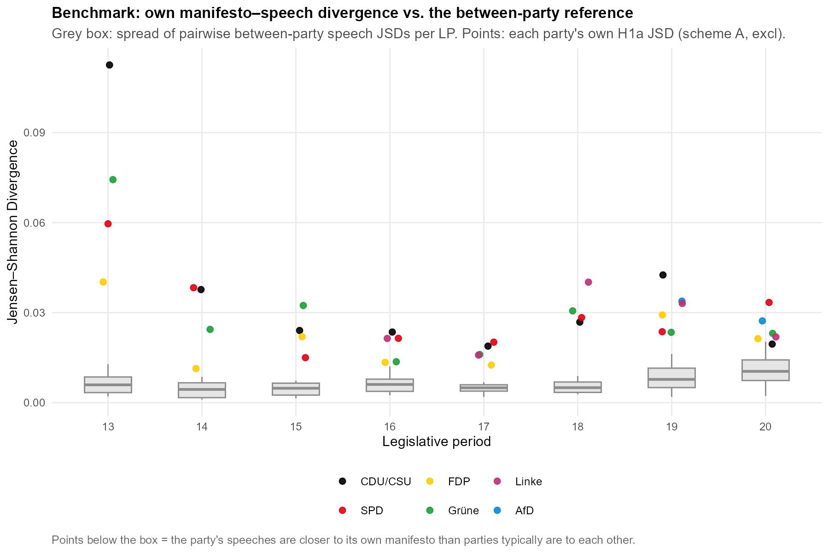Each cell value is reported with a 95% sentence bootstrap interval, and across the 38 cells these intervals are narrow, with a mean width of 0.0013 against point estimates ranging from 0.0114 to 0.1125. As Section 3.7.4 sets out, they are read as lower bounds on the total uncertainty, which is why we locate each cell on the reference scale rather than comparing the overlap of intervals between cells. On this scale the within-party divergence is intermediate rather than small, as its mean sits at almost exactly halfway along the interval between the two bounds. Plenary speech neither reproduces the manifesto nor drifts as far from it as parties' programmes stand from one another, settling in between. On the reference benchmark, then, the divergence stays below the programmatic differentiation between parties, as H1a expects, but not by a wide margin. Overall, it can be said that the divergence between channels is roughly in the middle of the scale between mean inner channel differences.
Across parties the JSD values are relatively similar, with means of CDU/CSU 0.0382, SPD 0.0300, Grüne 0.0297, Linke 0.0265, FDP 0.0214, and AfD 0.0305 (n = 2). Their movement over time is not flat, however, as Figure 4.2 shows, in six diagrams, one for each party: within each, the party's divergence for every legislative period. In each of the four parties observed since 1994 the points fall into the same rough U-shape, with divergence highest in LP 13, dropping to a trough in the middle of the window, and re-rising moderately from LP 18. Averaged across parties, the legislative period means fall from 0.0717 in LP 13 to 0.0167 in LP 17 and return to around 0.03 (0.0315 in LP 18, 0.0310 in LP 19, 0.0244 in LP 20). Two features of the diagrams are worth noting. First, for each observation the bootstrap interval is depicted, but its bars are so short that they are barely visible against the points, which means the shape of each party's series is not an artefact of sampling. Second, the re-rise is broad but mild, its one exception the CDU/CSU in LP 19 at 0.0426, the tallest point outside LP 13 anywhere in the figure.
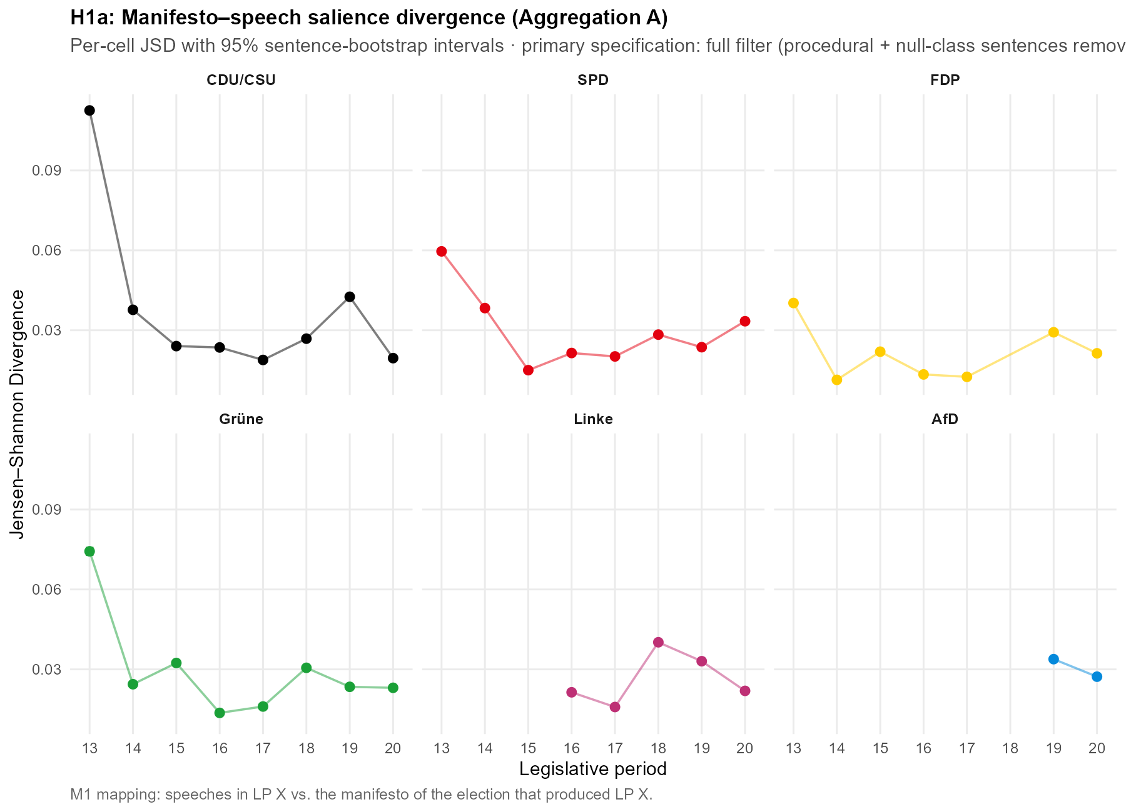The LP-13 column is what stands out. In four of the diagrams the 1994 cell is the highest the party reaches, at 4.4 times the CDU/CSU's own median, 3.1 times for the Grüne, 2.3 for the SPD, and 1.9 for the FDP. These same four cells are the points that sit highest above their boxes in Figure 4.1. Because the peak recurs in every party present in 1994 rather than in one, we read it as a property of the period, not four coincident outliers. That property sits on the manifesto side and at the edge of the observation window. The 1994 programmes are the earliest we observe, and they stand farther from each party's later, more settled manifestos of 1998 to 2021, which the genre-stable plenary speech most resembles, than any other election in the window. The step from the 1990 to the 1994 manifesto is itself unremarkable by each party's long-run standard. The elevation is therefore a boundary effect of the window, not an anomalous 1994 document and not a coding or pipeline artefact, as Appendix F.10 shows. Excluding the window-boundary LP-13 cells lowers the mean JSD from 0.0297 to 0.0247, barely moves the median (0.0238 to 0.0235), and leaves both reference-scale comparisons in place, so no congruence claim rests on that period.
The other benchmark discussed in Section 3.8 is the nearest-manifesto test, which asks whether a party's own manifesto is the nearest to that party's speech agenda in a given LP. The own manifesto is the nearest in 42.1% of cells against a 21.1% chance baseline, and its mean rank is 1.87 against a chance expectation of 2.95; identification thus succeeds far above chance yet fails in a majority of cells, and the own manifesto never ranks worse than fourth. What is interesting here is the strong party heterogeneity in how often a party's own manifesto is the closest to its agenda: FDP 7/7, AfD 2/2, Grüne 4/8, CDU/CSU 2/8, SPD 1/8, Linke 0/5. Where the non-matching agendas gravitate instead follows a roughly consistent pattern. Across the cells in which a party's speeches are not closest to its own programme, the FDP manifesto is by a clear margin the most frequent nearest neighbour, and it is the nearest manifesto in 18 of the 38 cells overall. This is not an artefact of the FDP appearing often as a candidate: taking the mean divergence from all 38 speech cells to each party's manifesto in the same period, the FDP programme is the closest to the pool of parliamentary speech at 0.0253, ahead of the SPD (0.0379), the Grüne (0.0396), the Linke (0.0457), the CDU/CSU (0.0463) and the AfD (0.0638), and it stays first when each party's distance to its own speech is excluded. Figure 4.3 sets this out in two panels. Panel A ranks the party programmes by that mean distance to the whole body of parliamentary speech, and the FDP sits clearly closest, with the Linke and the AfD farthest. Panel B shows why: the bars give the chamber's average agenda across the nine salience buckets, comparatively heavy on governance and economy and light on welfare and migration, and the overlaid points give the manifesto agendas of the FDP and of the two most distant programmes, so that the FDP is seen to track the parliamentary profile while the welfare-centred Linke and the migration-centred AfD depart from it most. It should be stressed that this is a statement about salience, that is, about which topics are emphasised, and not about position: the agenda of debate resembles the FDP's agenda, it does not show speech adopting FDP positions. How much of this resemblance reflects the institutional genre of a governing chamber rather than a substantive lean is taken up in the conclusion (Chapter 5).
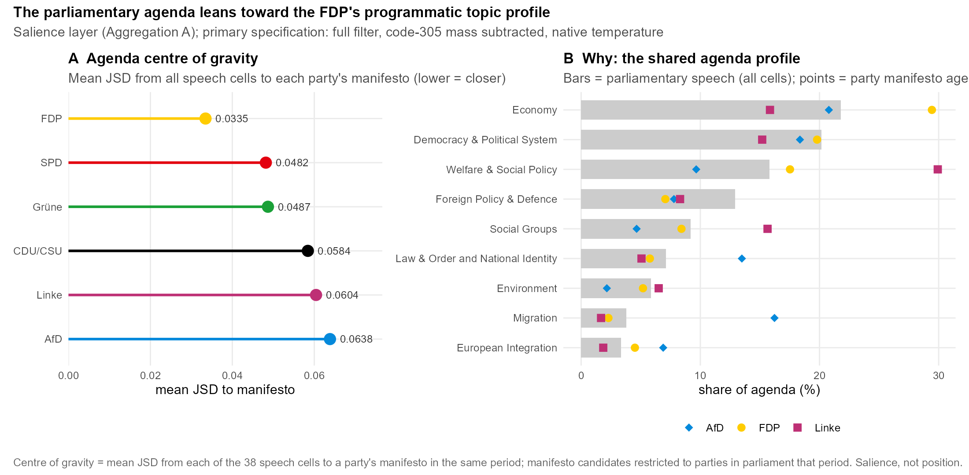

4.2.2 H1b (Exploratory)
The directional layer on Aggregation B is reported as exploratory throughout, as declared in Section 3.8. Overall, the mean JSD across the B buckets is 0.0506 (median 0.0520), with party-specific means of Grüne 0.0744, Linke 0.0676, AfD 0.0596, FDP 0.0440, CDU/CSU 0.0361 and SPD 0.0342. To analyse the directional differences between the two channels we compare the domain-pooled within-domain shares of manifestos and speeches. On migration, the restrictive share rises from 41.8% in manifestos to 68.4% in speeches. On the EU stance, the contra-EU share rises from 17.6% to 36.0%. Economy divides into three categories: speech is more market-liberal (23.2% to 29.2%) and correspondingly less interventionist (state intervention 32.9% to 29.3%, general economy 43.9% to 41.5%), so the market-liberal gain comes at the expense of interventionist rather than general economic language. Welfare is essentially unchanged between the channels (retrenchment 5.8% versus 7.4%).
The largest and clearest shift is on migration, where speeches carry a far higher restrictive share than the corresponding manifestos. Two reservations bound how this is read. First, a non-negligible part of the gap reflects national-way-of-life rather than immigration-control language: re-splitting the migration bucket so that only the multiculturalism codes (codes 607,608) define the restrictive and liberal poles (robustness arm 5) lowers the restrictive speech share from 68.4% to 48.6% and the manifesto share from 42.9% to 28.0%, even though the mean migration divergence barely moves (a matched mean change of −0.0062 across 36 cells). The composition shift is therefore material even where the divergence level is unchanged. Second, the direction itself is imperfectly identified: against the silver reference the classifier assigns "restrictive" too readily (precision 0.466, recall 0.753), so part of the speech-side overhang may be an assignment artefact. The same reservation attaches to the EU stance, where the classifier over-assigns contra-EU relative to the silver reference (precision 0.525), while the pro-EU pole is the most reliably identified axis in the scheme. The welfare direction is too weakly identified (F1 0.148) to bear any interpretation beyond the near-identity just noted.
Figure 4.4 shows that this restrictive and EU-sceptic lean is not a uniform drift but a compression. The parties with the most liberal migration programmes move furthest toward the restrictive pole (the Grüne from 9.6% to 61.1%, the Linke from 0.3% to 54.4%, the FDP from 35.9% to 72.1%), while the two parties whose programmes are already restrictive move slightly the other way (CDU/CSU from 82.2% to 77.6%, AfD from 99.0% to 85.4%); contra-EU follows the same pattern. The manifesto range of 0.3% to 99.0% on the restrictive share collapses to 54.4% to 85.4% in speech, a convergence of the parties onto a shared, restrictive-leaning speech profile rather than a shift of every party in the same direction. This cell-spanning compression is the same phenomenon that Section 4.3 measures on the position scale as cross-channel convergence.
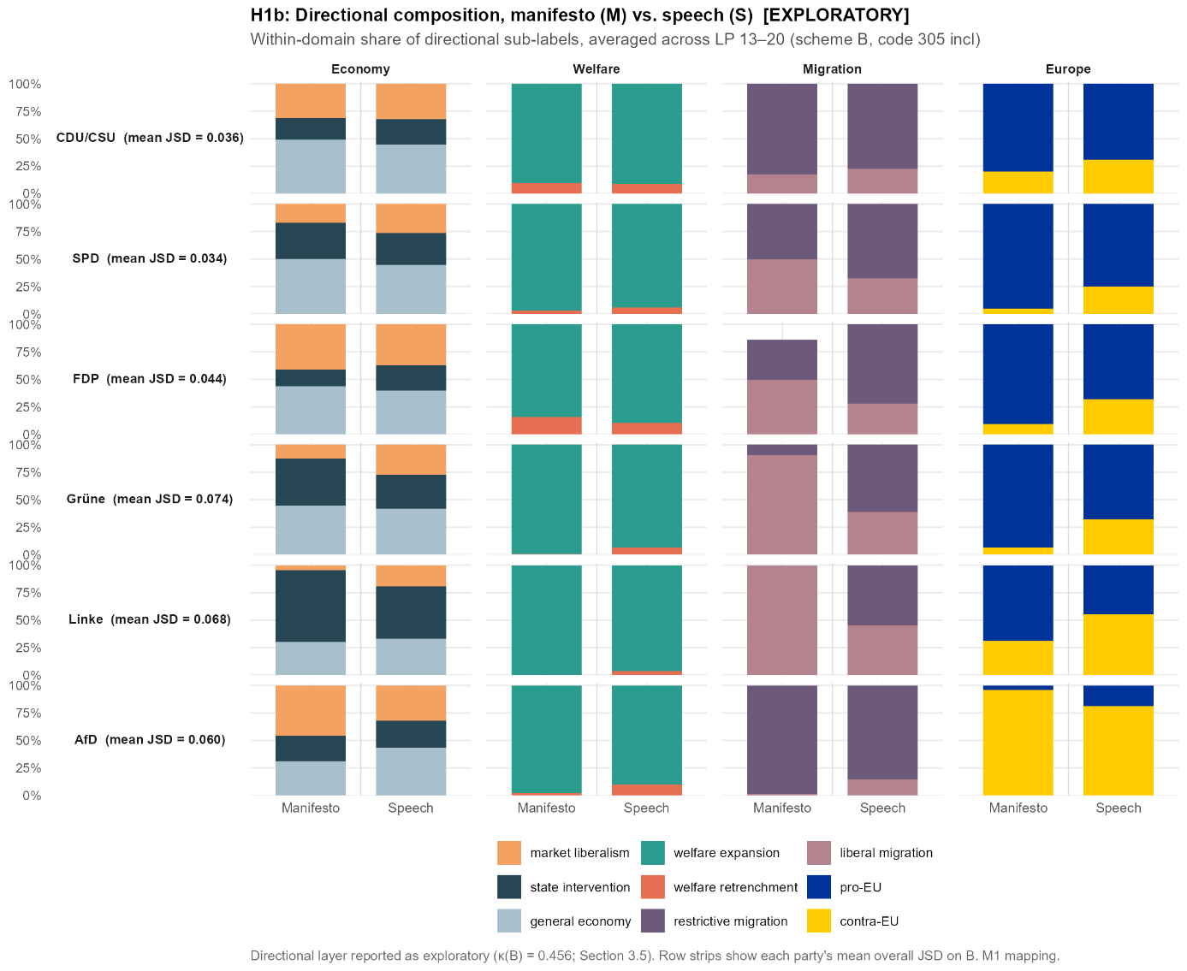
Read as consistent with, rather than as demonstrating, a systematic pattern, plenary speech leans more restrictive on migration and more EU-sceptic than the same parties' manifestos, is modestly more market-liberal, and is almost indistinguishable on welfare, with part of the migration and EU lean attributable to coding behaviour we can name.

4.3 What Drives and Moderates Divergence (H2)
The second hypothesis family is concerned with what drives divergence, with emphasis on topic differences and how these in turn differ by parties.

4.3.1 H2a (confirmatory/descriptive)
Tabelle 4.2
Bucket | mean contribution | sd | share
Democracy & Political System | 0.0062 | 0.0088 | 20.9%
Welfare & Social Policy | 0.0048 | 0.0041 | 16.1%
Foreign Policy & Defence | 0.0047 | 0.0037 | 15.8%
Law & Order and National Identity | 0.0032 | 0.0065 | 10.6%
Environment | 0.0030 | 0.0046 | 10.0%
Migration | 0.0029 | 0.0040 | 9.6%
Economy | 0.0019 | 0.0026 | 6.5%
Social Groups | 0.0016 | 0.0024 | 5.3%
European Integration | 0.0015 | 0.0018 | 5.2%
The breakdown of the mean divergence across the 9 topic buckets, as reported in Table 4.2, shows the mean per-bucket contributions, summing exactly to the mean JSD. The DPS (Democracy & Political System) bucket holds the largest part of the divergences between speeches and manifestos at 0.0062 (20.9%) of the mean JSD. As discussed in Section 3.6, this bucket is already cut substantially by the two measures we implemented to alleviate the cross-domain topic classification artifact. Still, this is to be treated as only partly substantive, although still likely holding some of the forced misclassification. Second and third largest are Welfare at 0.0048 (16.1%) and Foreign Policy & Defence at 0.0047 (15.8%). The smallest part of the JSD distribution is carried by European Integration at 0.0015 (5.2%). Figure 4.5 shows the individual party-period cells behind these averages. Their contributions are right-skewed, and while the most extreme cells are the LP-13 cells discussed in Section 4.2, the typical cell sits close to its bucket average, so the ranking does not rest on those few outliers. 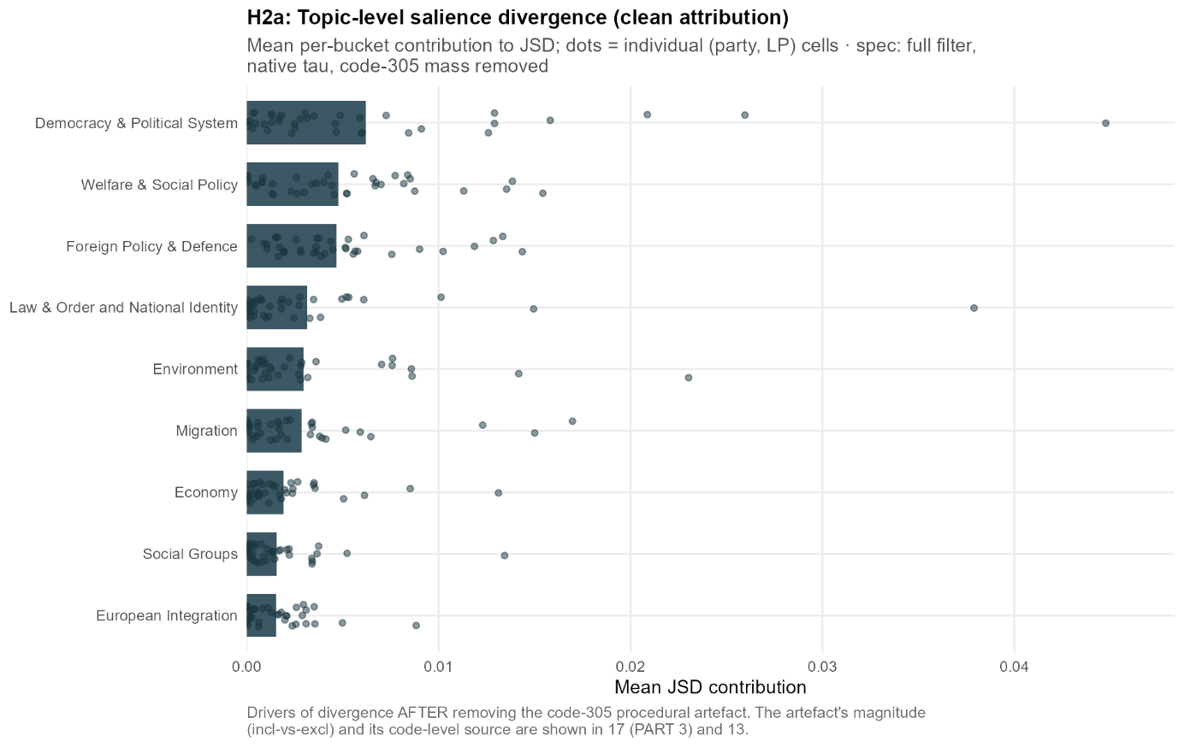
Figure 4.5. Per-bucket contribution to the manifesto-speech divergence (H2a). Bars give each salience bucket's mean contribution to the cell JSD, dots the individual party-period cells (n = 38). Aggregation A, primary specification: full filter, code-305 mass subtracted, native temperature. The artefact correction is set out in Section 3.6, and the exact values are in Table 4.2.

Beyond how much each topic contributes, the divergence also has a direction, and that direction is heterogeneous across topics. On some it is strikingly uniform across parties, while on others it is very party-dependent. Two topics take up a larger share of every party's plenary speech than of its manifesto: Democracy & Political System, the language of government and Foreign Policy & Defence. The first rises from about 15% of the manifesto agenda to about 20% of the speech agenda, the second from about 7% to about 12%, and both rise for all six parties without exception. These are the only two topics on which every party moves the same way, so the shift is not the work of one or two parties but a property of the chamber. Figure 4.6 shows this directly, as in the Democracy & Political System and Foreign Policy panels every party's speech share sits above its manifesto share, whereas in the other panels the parties move in both directions.
The reverse movement, where a topic takes up less of the speech than of the manifesto, is real but far less uniform, and here the levels are what matter. Welfare is the clearest case. It fills a large part of the left's programmes, 31.9% of the Linke's manifesto agenda, 24.0% of the SPD's and 22.6% of the Grüne's, against only 12.4% of the CDU/CSU's and 9.7% of the AfD's. In speech these shares move toward one another. The Linke still gives welfare the most room of any party at 20.9%, but the wide spread across the manifestos narrows to a band between roughly 13% and 21%, as the parties that emphasise welfare most in their programmes pull back while the CDU/CSU and the AfD give it a little more room than before. What on first glance looks like the left playing welfare down is therefore better read as the chamber converging on a common level. The remaining topics differ only in party-specific ways, such as the CDU/CSU giving law-and-order and national-identity language less room in speech than in its programme. We therefore read the divergence as a genre signature of parliamentary debate. Speaking from government and about the state and foreign affairs pulls every party's plenary agenda in the same direction, whereas on the other topics it varies from party to party, on some issues along ideological lines. What this signature implies for reading legislative speech against manifestos is taken up in broader scope in Chapter 5.
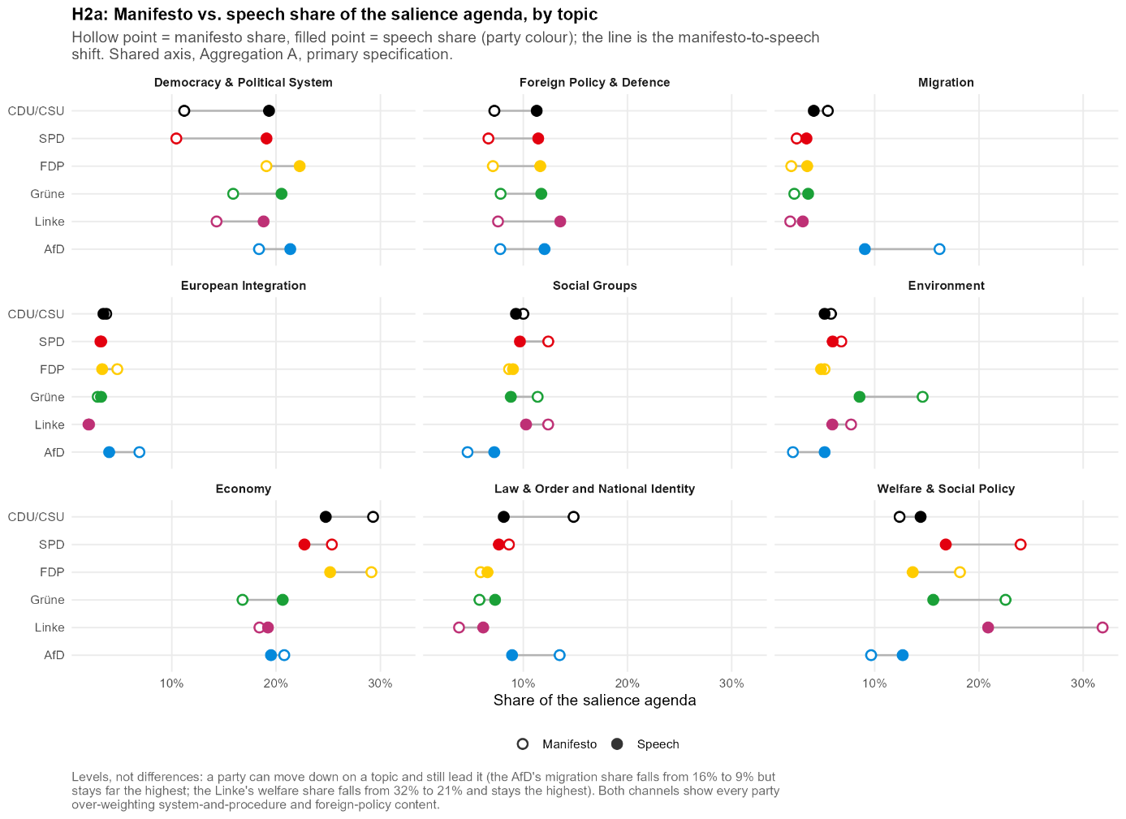

4.3.2 H2b (exploratory)
The goal of this exploratory analysis is to see how positioning in manifestos carries over into the positions parties take in plenary speech, broken down by domain. The main measure we introduce to analyse this is a position score in [-1, 1] that captures a party's directional position within a given domain. The spread of these positions across parties, which we take up in H2c, is what constitutes system polarisation. We code the right-leaning pole as positive and the left-leaning pole as negative. Concretely we calculate for each domain: Domain score = (right wing direction – left wing direction) / (sum both directions). Note that in the economy domain we include only the two directional sub-categories and exclude the neutral one, since it is the only domain with a sizeable non-directional category. These scores are calculated for speeches from the classifier's directional sub-label shares and for manifestos from the MARPOR category shares. Because it is a ratio of the two directional shares within the domain, the score is independent of how salient that domain is, so it measures direction only and not the salience analysed under H1.
To compare the two channels, we implement a simple OLS model regressing the speech scores on the manifesto scores:
$$speech_{pol}= β_{0}+ β_{1}*manifesto_{pol}+ ε$$
The unit of observation is the cell (party-period), pooled over all parties and all LPs (n = 38, all valid party-period cells, except for migration here n = 37). The slope β1 measures how strongly the between-party differences in manifesto position carry over into differences in speech position. The intercept β0 can be read as the estimated speech position of a party with a directionally perfectly balanced manifesto, which would mean a manifesto score of zero. The r² reports how closely the cells fall along the fitted line, that is, the share of the variance in speech position that manifesto position accounts for. It is separate from the slope, since a line can be flat and still fit tightly.
Two effects have to be kept apart, since they show up in different coefficients. A slope below one is moderation, meaning the spread between parties shrinks from manifesto to speech, so they speak from positions closer to one another. That is not a move towards the centre, only towards each other. Where the compressed positions sit is set by the intercept. The link between the two is exact, since the fitted line runs through the two-channel means, so the mean speech position equals β0 + β1 · mean manifesto position. The level shift is then the gap between the two means and depends on slope, intercept and starting level together, which is why we read compression from the slope and the level from the intercept.
In every domain the slope falls well below one, so moderation holds throughout. Economy sits at 0.389, Europe at 0.481, Welfare at 0.267 and Migration at 0.239, and manifesto position still predicts speech position well, with r² between 0.53 and 0.78, so the parties are drawn closer together without changing their order. Migration is the tightest fit despite the flattest slope, so its parties keep their order even as their spread is squeezed hardest.

But compression is not a move towards the centre, and the four domains differ in where the compressed positions sit. Welfare compresses in place, its party mean barely moving from −0.88 in manifestos to −0.85 in speech while the standard deviation of the positions falls from 0.18 to 0.07, so the parties converge onto a level that stays firmly on the expansion side. Migration does the opposite and relocates as a block towards the restrictive pole, from a manifesto mean of −0.14 to a speech mean of +0.36, its intercept of +0.40 lifting even a balanced manifesto across the line. Economy compresses around a near-neutral level, from −0.14 to +0.01, and Europe compresses towards the centre while its mean stays on the pro-EU side, from −0.65 to −0.28.
Figure F.9.1 plots the four domains against the 45-degree line, where each cloud runs flatter than the diagonal, and the migration cloud alone sits above it, so the moderation shows as a rotation and the migration level shift as a vertical offset.
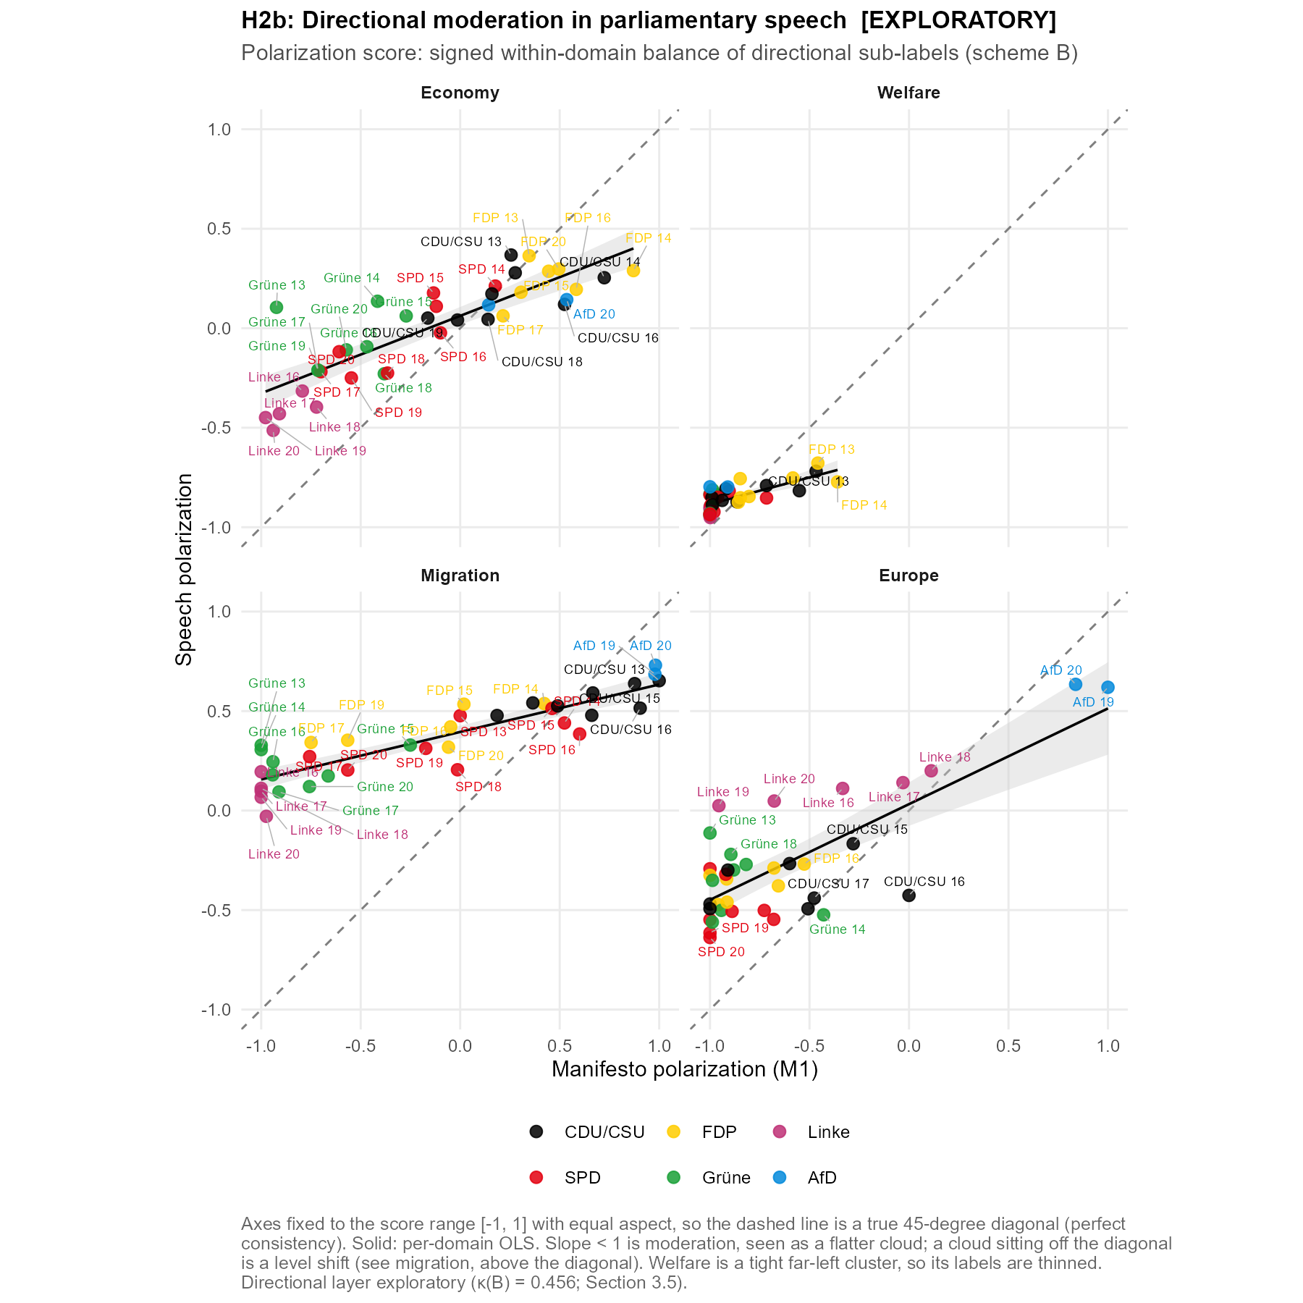Because H2b reads directions on the speech side, the classifier's reliability on those directions matters, and it matters most for the headline result. The migration shift towards the restrictive pole sits on exactly the label the classifier assigns least reliably, with a restrictive-migration precision against the silver standard of 0.466 and contra-EU only a little higher at 0.525. Part of that shift may therefore be over-assignment of the restrictive label rather than a real relocation. The manifesto side is coded from MARPOR and is untouched, and the concern is the direction of the shift rather than its compression, so it is the migration level shift in particular that should be read with this caveat in mind.

4.3.3 H2c (exploratory)
This exploratory hypothesis analyses whether the directional positions disperse less across parties in plenary speech than in their manifestos. This is the cross-channel convergence that the compression of directional shares in Section 4.2.2 already pointed to, now measured on the position scale rather than in shares. We further ask whether the AfD's entry adds a compositional component to system dispersion, which we report as a decomposition rather than as a causal effect. To do this, we take the party-period position scores of Section 4.3.2 and compute their Dalton-weighted standard deviation across parties, for each legislative period, domain and channel, then compare the two channels directly. See Section 3.8 for the methodological discussion of the measures we employ here. While H2b analyses how much is carried over from manifestos to speech as a slope below one, suggesting that the spread between parties narrows, the approach taken in H2c measures that decline directly as the dispersion of those same positions across parties in each channel, weighted by the vote or seat share the party carries there. We read these dispersions as levels and compare them between channels here, while their change over time is discussed in Section 4.4.
The analysis suggests that there is a decline in the weighted SDs of the position scores for each domain going from manifesto to speeches, although the size of the effects is largely heterogeneous. Figure 4.7 plots the two channels side by side for each domain, the filled speech marker sitting to the left of the hollow manifesto marker throughout. Concretely for the economy domain the dispersion is 0.396 on the manifesto side vs. 0.144 on the speech side in mean value over all periods, on migration we see 0.574 on the manifesto side vs. 0.140 on the speech side, welfare 0.107 on the manifesto side vs. 0.036 on the speech side and Europe 0.366 on the manifesto side vs. 0.232 on the speech side. Migration compresses most, from the widest manifesto spread down to about a quarter of it, meaning that although there is high polarisation in manifestos on the issue the speech side is more tempered. Economy and welfare fall to roughly a third. Europe narrows least, holding at about two-thirds of its manifesto level and leaving the highest speech-side dispersion of the four domains, so the parties stay comparatively far apart on Europe even in the chamber. That residual spread on Europe has a compositional source, which we turn to next, while its development over time is discussed in Section 4.4.
The convergence holds not only on average but period by period, with speech dispersing less than manifestos in 31 of the 32 domain-period pairs. The one exception is Europe in LP 13, where the 1994 manifestos are barely dispersed on Europe at all, an emergence Section 4.4 traces. Europe's high spread at the other end of the window has a clear compositional source. In LP 19 and LP 20 the manifesto dispersion is at its highest, 0.677 and 0.567, and most of it comes from the AfD. Recomputed without that party it falls to 0.014 and 0.078, and the speech dispersion roughly halves, from 0.396 and 0.392 to 0.188 and 0.187. It is the presence of one party at the EU-sceptic end of the scale, not a widening among the established parties, that accounts for the Europe spread in these periods.
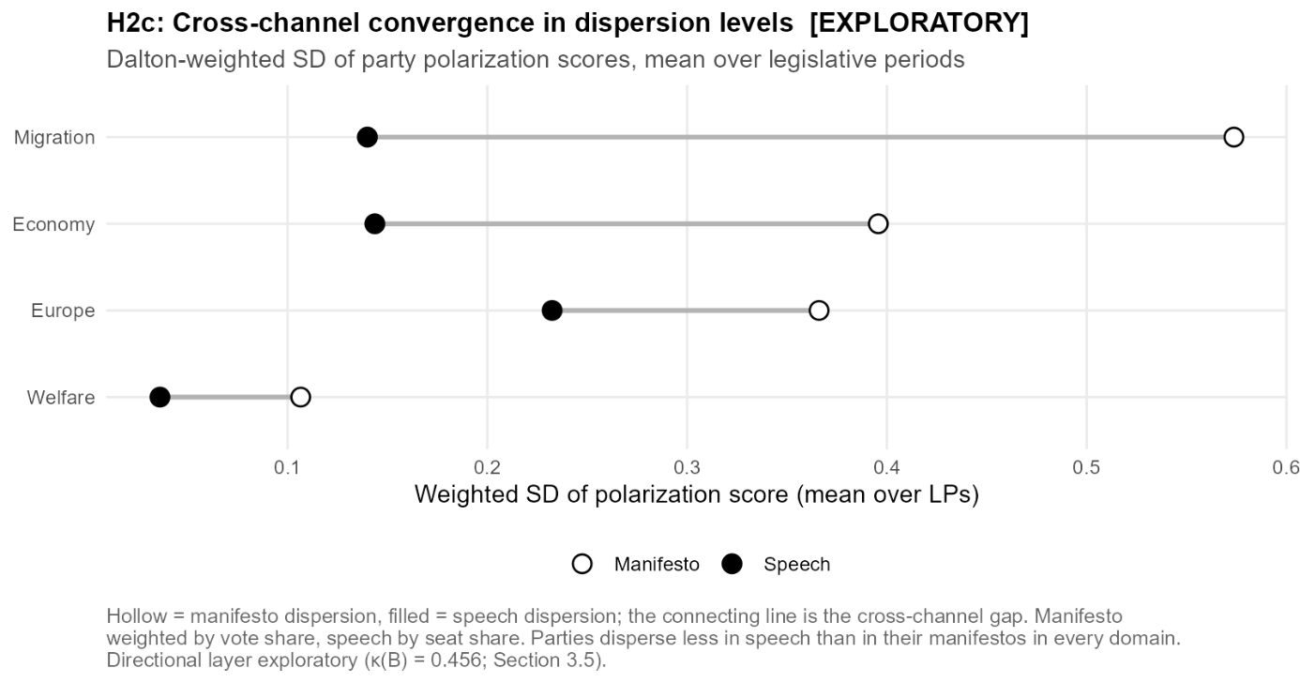

4.4 Polarisation over Time (H3, descriptive and exploratory)
The exploratory H3 hypothesis asks whether system-level polarisation, measured by the Dalton-weighted standard deviation of position scores, the same measure as used in Section 4.3.3, increases over the observation period, in particular in the Europe and Migration domains and around the AfD's parliamentary entry in 2017. We analyse the changes in this measure to describe domain-specific trends over time but refrain from claiming causality since we read these as descriptive trends on the exploratory directional layer, not as tests. A full discussion of the measure utilised here is found in Section 3.8.3.
To analyse the time trends in domain polarisation we employ a simple OLS model regressing polarisation on the legislative period, fitted separately for each domain and channel, with the period entering as a numeric variable running from 13 to 20.
$$polarisation=β_{0}+ β_{1}*LP+ ε$$
The unit of observation here is the period (n=8). $β_{1}$ can be interpreted as the mean change in weighted dispersion per legislative period, while $β_{0}$, the intercept, has no meaningful reading, since it is the extrapolated value at a legislative period of zero, far outside the window. r² reports how closely the eight points follow a straight line. Standard errors are reported but not read as significance tests, in line with the convention set out in Section 4.1. To localise what the AfD's entry contributes to each trend, every fit is run a second time without the party, as pre-committed in arm 6 of the robustness design (Section 3.9). For these refits the dispersion of each period is recomputed over the remaining parties, with their weights renormalised to sum to one, so the series describes the party system as it would stand without the AfD. Only the periods in which the party carries weight are affected, the manifesto series from LP 18 and the speech series from LP 19 (Section 3.8.3), while all earlier points are identical by construction. The difference between the two slopes then isolates the share of a trend that hangs on the AfD's entry. Where the two estimates coincide, the trend does not depend on the party's presence, and where they diverge, it is carried by the changed composition of the system rather than by movement among the remaining parties.
Europe is the one domain where the fits register a clear rise in both channels. Over the eight periods the manifesto dispersion climbs at a slope of 0.0667 per legislative period (SE 0.0191, p = 0.013, r² 0.67) and the speech dispersion at 0.0344 (SE 0.0094, p = 0.011, r² 0.69). The series behind these fits, plotted in Figure 4.8, shows that the climb is not a steady one. The manifesto dispersion moves between 0.29 and 0.39 from LP 14 to LP 18 and then jumps to 0.677 and 0.567 in the last two periods, while the speech dispersion rises from a band of 0.15 to 0.22 to 0.396 and 0.392. The jump falls in the two periods that follow the euro crisis and the AfD's foundation as an anti-euro party in 2013, the first of them starting with its entry into the Bundestag in 2017. The window also opens at a peculiar point. In LP 13 the 1994 manifestos are barely dispersed on Europe at all, at 0.011 against 0.175 in speech, the one pair in which speech disperses more than manifestos, as Section 4.3.3 recorded. The European conflict axis is not present at the start of the window but emerges within it, which is what leaves room for a rise in the first place.
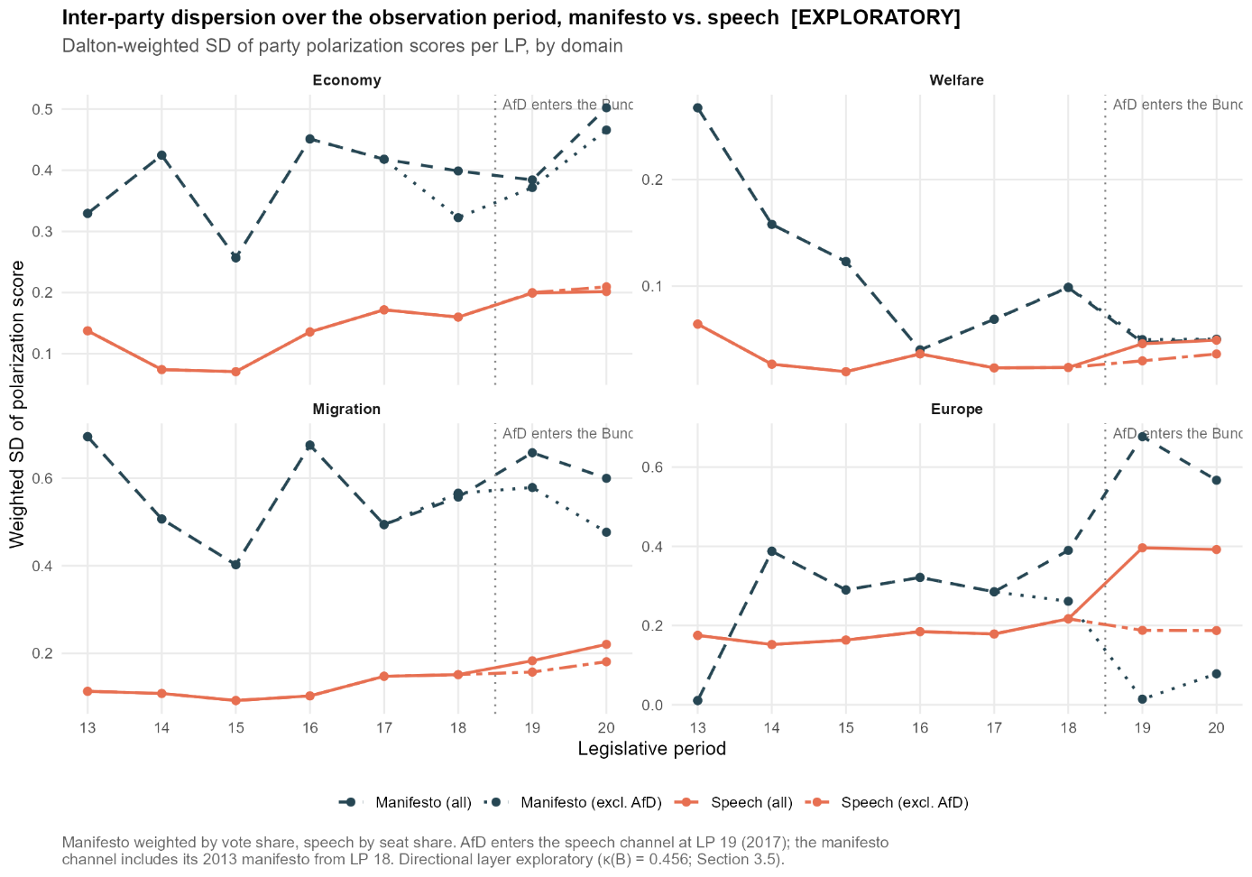 The refit without the AfD turns both trends flat. The manifesto slope flips sign, from 0.0667 to −0.0181 (p = 0.47), and the speech slope falls from 0.0344 to 0.0050 (p = 0.09), slope differences of 0.0848 and 0.0295 that are by far the largest in the battery. Figure 4.9 plots both slope estimates for each domain and channel, the full fit next to the refit without the AfD: the Europe manifesto pair is the only one whose two estimates lie far apart, the exclusion dragging the slope across zero. Read together with the level decomposition reported in Section 4.3.3, the rise in European polarisation is a compositional effect of one party entering at the EU-sceptic end of the scale, not a widening among the established parties, whose refitted trends are essentially flat in both channels.

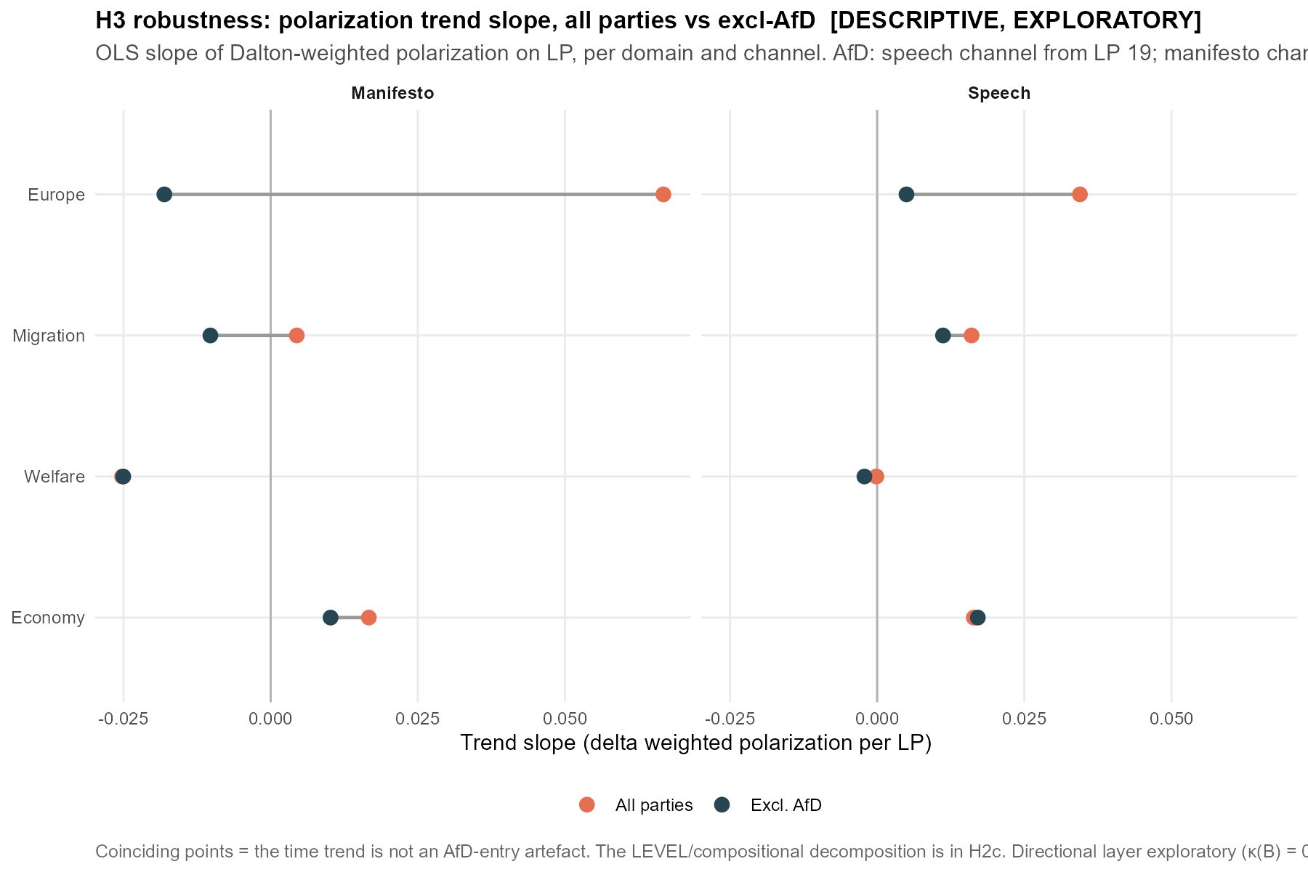 We do not want to overstate this finding. That a weighted dispersion measure jumps as one party enters at the opposite pole of a position all other parties share is arithmetically expected. Furthermore, the domain least salient of the four directional domains is Europe, so its scores rest on comparatively little text. The decomposition shows nearly the entire rise is due to one party, while the established parties barely move in either channel. Additionally, the speech series runs through the classifier and may be partly inflated by the over-assignment of contra-EU, a concern we take up below. The manifesto series is coded from MARPOR and is not affected by this. For the reading of system-level polarisation series this means that a rising curve does not by itself show parties drifting apart. In our case it mainly reflects the entry of one party at the opposite pole rather than a change in positions among the established parties.
The other domains do not follow the Europe pattern, which is why we report all four in Table 4.3. In the economy domain the speech slope is +0.0164 (p = 0.018) and stays practically unchanged without the AfD (+0.0171), so speech-side polarisation in economic policy rises with or without the party. In welfare the movement sits on the manifesto side, where the slope is −0.0252 (p = 0.016) and equally robust to the exclusion (−0.0250), while the speech series stays flat (−0.0001, p = 0.96). This programmatic de-polarisation also explains the near-meeting of the two channels at the close of the window, at 0.047 against 0.046 in LP 19 and 0.050 against 0.049 in LP 20, visible in the welfare panel of Figure 4.8: it is the manifesto dispersion falling to the already low level of speech, not speech rising to it. In migration the speech slope of +0.0160 (p = 0.004) drops to +0.0112 (p = 0.005) without the AfD, so part of the rise hangs on the party, but a part remains that does not. The migration manifesto slope is close to zero on either side of the exclusion and we read it as flat rather than as a second sign flip. The overall positive trend on the speech side for migration is, on closer inspection, largely attributable to the periods from LP 17 (2009 to 2013) onwards, beginning before the 2015 migration crisis and steepening over the periods that contain and follow it. Beyond the trends, economy and migration show the cross-channel gap without complication, the speech series staying clearly below the manifesto series in every period, with migration keeping the widest separation of the four domains, its parties far apart in their programmes while speaking from a narrow band. In Figure 4.9 all these pairs lie almost on top of each other, which is the visual counterpart of the same point: these trends are not an artefact of the AfD's entry. While the Europe trend is likely compositional, the movements in the other domains are weaker but more substantive, since they reflect actual repositioning within the established party set. The two clearest movements among the established parties run in opposite directions, rising polarisation in economic policy speech and declining polarisation in welfare programmes.
Domain | Channel | Slope (SE) | p | Slope excl. AfD | p | Δ slope
Economy | Manifesto | +0.0167 (0.0105) | 0.164 | +0.0102 | 0.406 | +0.0065
Economy | Speech | +0.0164 (0.0051) | 0.018 | +0.0171 | 0.015 | −0.0007
Welfare | Manifesto | −0.0252 (0.0076) | 0.016 | −0.0250 | 0.017 | −0.0002
Welfare | Speech | −0.0001 (0.0026) | 0.963 | −0.0022 | 0.363 | +0.0020
Migration | Manifesto | +0.0044 (0.0170) | 0.803 | −0.0102 | 0.549 | +0.0147
Migration | Speech | +0.0160 (0.0035) | 0.004 | +0.0112 | 0.005 | +0.0049
Europe | Manifesto | +0.0667 (0.0191) | 0.013 | −0.0181 | 0.473 | +0.0848
Europe | Speech | +0.0344 (0.0094) | 0.011 | +0.0050 | 0.090 | +0.0295
Table 4.3: Descriptive OLS trend slopes of the Dalton-weighted polarisation on the legislative period, per domain and channel (LP 13 to 20, n = 8 points per fit), for all parties and refit without the AfD (arm 6, Section 3.9). Δ slope is the difference between the two estimates and localises the AfD's contribution to a trend. The manifesto channel is weighted by vote shares and the speech channel by seat shares, with the AfD carrying weight in the manifesto channel from LP 18 and in the speech channel from LP 19 (Section 3.8.3). Standard errors in parentheses. The p values are reported for transparency and are not read as significance tests (Section 4.1). Directional layer exploratory (Section 3.5).
The trend slopes compress each path into a single line, but as Figure 4.8 shows the actual path in Europe is closer to a jump, which is also why the fits are not perfectly linear. As a second and model-free view we therefore compare the mean dispersion before and after the AfD's entry, over LP 13 to 18 against LP 19 to 20. For Europe the manifesto mean rises from 0.2807 to 0.6219, a difference of +0.3412, and the speech mean from 0.1785 to 0.3942, a difference of +0.2157. The remaining domains move far less, with +0.0826 for migration and +0.0755 for economy on the speech side and −0.0774 for welfare on the manifesto side. With six pre and only two post periods this is a description, not a test. Note also that the pre period already contains an AfD contribution in the manifesto channel, since the party carries weight there from LP 18 (Section 3.8.3), so the manifesto contrast is understated if anything.
The speech side of the Europe series carries a caveat we flagged above. Against the silver reference the classifier over-assigns the contra-EU label, with a precision of 0.525 at an F1 of 0.634, and assigns it nearly twice as often as the Sonnet reference does, while the gold standard contains too few contra-EU sentences to quantify the label at all (n = 3). This is exactly the mechanism that can inflate a speech-side polarisation signal, since hostile rhetoric, in particular from the AfD, may be read as EU rejection. The asymmetry matters for how far the two sides of the axis can be trusted: pro-EU is the most robust label of the directional scheme (F1 = 0.800), so the pro-EU side of the series is more reliable than the contra-EU side. The manifesto series does not run through the classifier at all, and since the sign flip sits on the manifesto side, the core reading of this section does not depend on the label in question.

4.5 Robustness
In this section we discuss the robustness tests we have undertaken, all of them with acceptance criteria fixed before the analysis (Section 3.9), and report the outcomes as they came out. We specifically test both aggregations by applying arms 1 and 2 to H1a on Aggregation A and to H1b on Aggregation B. Because H2 and H3 rest on these same two aggregations, testing both here covers the measurement construction they share, so the sweeps are not repeated on them.
Arm | Comparison | H1a (A) | H1b (B)
Temperature (1) | sharp vs native | 0.970 ✓ | 0.956 ✓
 | sharp vs flat | 0.579 ✗ | 0.706 ✗
 | native vs flat | 0.729 ✗ | 0.843 ✗
Threshold (2) | soft vs hard 0.4 | 0.943 ✓ | 0.861 ✓
 | soft vs hard 0.5 | 0.929 ✓ | 0.772 ✗
 | hard 0.4 vs hard 0.5 | 0.996 ✓ | 0.964 ✓
Table 4.4: The two robustness arms that carry a pre-committed rank-correlation criterion (arms 1 and 2 of Section 3.9). Each entry is the Spearman rank correlation between the rankings of the 38 party-period cells under two specifications, reported for the salience layer (H1a, Aggregation A) and the directional layer (H1b, Aggregation B) separately. The temperature arm rescales the sentence posteriors before aggregation, with sharp τ = 0.5, native τ = 1 and flat τ = 2. The threshold arm replaces the soft aggregation of the primary specification with argmax assignment at cut-offs of 0.4 and 0.5. The criteria were fixed before the analysis, ρ ≥ 0.90 for the temperature arm and ρ ≥ 0.85 for the threshold arm. A tick marks a pass and a cross a miss. The threshold arm is computed on code 305 included for construction reasons, so it compares rank orders across the cells and not divergence levels (Section 3.9). Full per-cell results are in Appendix F.6 for the temperature arm and F.7 for the threshold arm.
The per-cell detail behind these correlations is given in the appendix. Appendix F.6 plots the temperature sweep cell by cell, where the flat variant visibly reshuffles the ordering that the sharp and native variants preserve. Appendix F.7 plots each hard-threshold variant against the soft baseline, where the points track the identity line up to a level shift, which is what the rank correlations summarise. The remaining arms are reported where their design concern arises. Arm 3, which crosses the filter ladder with the code-305 treatment, is reported with the corrections themselves in Section 3.6.2 and Appendix F.3, where the two corrections are shown to be complementary rather than redundant.
Arm 4, a tightened prefilter of at least eight words per sentence, was computed as a sensitivity check on H2a and returns near-perfect rank agreement with the primary specification, so it is subsumed by the full filter and not tabulated separately. Arm 5, the re-split of the migration axis to the multiculturalism codes alone, is reported with the directional composition in Section 4.2.2, where it lowers the restrictive shares without moving the migration divergence. Arm 6, the refit of the polarisation trends without the AfD, is reported with the trends themselves in Section 4.4, where it localises the European rise to the party's entry.
The corrections also do not buy their lower headline numbers at the price of wider uncertainty. Across the six bands that cross the filter ladder with the code-305 treatment at native temperature, the sentence bootstrap intervals do not widen as the corrections are applied. The mean interval width is 0.0013 for all three code-305-excluded bands against 0.0016 to 0.0017 for the included bands, while the mean divergence falls from 0.0715 and 0.0333 without a filter to 0.0641 and 0.0322 under the procedural filter and to 0.0510 and 0.0297 under the full filter, for the included and excluded bands respectively. The excluded bands are, if anything, the tighter ones. The full table of the six bands is given in Appendix F.3.
Two things are stable across both layers. The temperature effect between the sharp and native variants holds at 0.970 and 0.956, so neither ranking depends on the calibration sharpness inherited from the classifier within that range. What fails on both layers is the flat variant. Raising the temperature to 2 pushes every posterior towards the uniform distribution and inflates the divergence itself, from 0.0297 to 0.0368 on H1a and from 0.0506 to 0.0852 on H1b, so the reshuffling is what extreme flattening does rather than an accident, but the criterion is missed all the same. The two layers part company on the threshold arm. On the salience layer the choice between soft and hard aggregation is close to inconsequential, from 0.929 to 0.996, while on the directional layer it is not, with the soft-to-hard comparison at the higher cut-off falling to 0.772. This is the same fragility that led us to label every scheme-B hypothesis exploratory. We read it as reflecting the finer-grained directional distinctions the B scheme draws, which rest on the less reliable code-level signal noted in Section 3.5. In sum, the results are robust to moderate temperature variation on both layers and to the argmax alternative on the salience layer, but they are not robust to extreme flattening, and the directional layer inherits part of that fragility, consistent with its exploratory status.

Conclusion
Chapter 5 material — conceptual facts and structure (no prose)
The finding
- Beyond "own manifesto is nearest in 42.1%," the complementary question: which single programme is the whole chamber's speech agenda closest to.
- Answer: the FDP programme, decisively, as an agenda attractor and as a centre of gravity.
Evidence (all primary spec, salience/Aggregation A)
- Attractor count: FDP nearest in 18/38 cells; Grüne 7, SPD 6, CDU/CSU 5, AfD 2, Linke 0.
- Per-party pull when own is not nearest: CDU/CSU → FDP 4 of 6 non-own; SPD → FDP 4 of 7 non-own; Grüne → FDP 2; Linke → centre-left (Grüne 2, SPD 2) + FDP 1; only FDP and AfD always match their own.
- Centre of gravity (mean JSD from all 38 speeches to each manifesto, within period): FDP 0.0253, SPD 0.0379, Grüne 0.0396, Linke 0.0457, CDU/CSU 0.0463, AfD 0.0638.
- Robust to the obvious confound: FDP still first (0.0263 vs SPD 0.0400) when own-party speech–manifesto pairs are excluded, so it is not FDP self-similarity or FDP being a frequent candidate.
Mechanism (why FDP)
- Grand speech agenda: governance ~20%, economy ~22%, welfare ~16%, migration ~4%.
- FDP is the only programme with that shape: alone in putting ~19% on governance (others 10–16%), welfare only moderate (18% vs SPD 24 / Grüne 22 / Linke 32), low migration and low law-and-order/national-identity.
- Farthest programmes are structurally explained: Linke by welfare weight (32%), AfD by migration weight (16% vs 4% in speech).
Interpretation layer 1 — salience, not position
- The nearest-manifesto instrument compares topic emphasis, not directional stance.
- "Discourse leans FDP" = the agenda of debate resembles the FDP's agenda; it is not evidence that speech adopts FDP positions.
Interpretation layer 2 — genre, not (only) ideology
- The driving bucket is governance/procedure (Democracy & Political System), which H2a already shows speech structurally over-weights (+5.4 pp over manifestos), alongside foreign policy (+4.6 pp), and under-weights welfare (−4.1 pp).
- That is the institutional voice of a governing chamber (state, competence, procedure); the FDP writes manifestos shaped like that voice, rather than the FDP having pulled debate toward liberalism.
- Note this is the same bucket flagged as genre-inflected and already corrected for code 305, so the residual resemblance is substantially genre.
Interpretation layer 3 — the B-layer only half-agrees with a "market-liberal" reading
- Supports it on economy: speech's market-liberalism share rises 23.2% → 29.2% (H1b), a genuine economic-liberal tilt.
- Contradicts it elsewhere: speech leans more restrictive on migration and more EU-sceptic than the same parties' programmes, the opposite of the FDP's liberal, pro-EU positions.
- Net: convergence on an FDP-shaped agenda with a weak economic-liberal tilt, not on FDP positions across the board.
What it adds to the thesis narrative (links)
- Complements H2c cross-channel convergence: not only do parties speak more alike than they write (convergence), the common ground sits at a definable location in agenda space (FDP-shaped, governance/economy-heavy).
- Complements H2a signed structure: the direction of the manifesto–speech gap (over-weight governance/foreign, under-weight welfare) is exactly what makes the FDP the centre of gravity.
- Reframes the headline manifesto–speech gap: speech is not a neutral rendering of each party's programme but is pulled toward a shared, governance-and-economy agenda.
Caveats / limits to state
- Exploratory and descriptive; the nearest-manifesto test was designed as a benchmark, not a directional instrument.
- Salience ≠ position must be stated explicitly wherever "FDP" or "market-liberal" appears.
- No causal claim: the resemblance does not show the FDP shaping debate; the more parsimonious reading is shared parliamentary genre.
- Manifesto agendas are time-varying; the measure is computed within period, so it is not a pooling artefact.
Optional substantive readings to offer (clearly hedged)
- The chamber debates on a governing-competence-and-economy agenda regardless of who governs, an institutional homogeniser of the issue agenda.
- If any party's programme "speaks parliament's language," it is the FDP's, which is at least suggestive about which programmatic style travels into floor debate, to be raised as a question rather than a conclusion.

Bibliography

Abou-Chadi, T., & Krause, W. (2020). The causal effect of radical right success on mainstream parties’ policy positions: A regression discontinuity approach. British Journal of Political Science, 50(3), 829-847.
Arzheimer, K., & Berning, C. C. (2019). How the Alternative for Germany (AfD) and their voters veered to the radical right, 2013–2017. Electoral Studies, 60, 102040.
Blätte, A., & Blessing, A. (2018, May). The GermaParl corpus of parliamentary protocols. In proceedings of the eleventh international conference on language resources and evaluation (LREC 2018).
Blaette, A., & Leonhardt, C. (2025). GermaParl corpus of plenary protocols (v2.3.0-rc1) [Data set]. Zenodo. https://doi.org/10.5281/zenodo.15495748
Budge, I. (2001). Mapping policy preferences: estimates for parties, electors, and governments, 1945-1998 (Vol. 1). OUP Oxford.
Budge, I., & Farlie, D. J. (2025). Explaining and predicting elections: Issue effects and party strategies in twenty-three democracies. Taylor & Francis.
Bundeswahlleiterin. (2025). Ergebnisse früherer Bundestagswahlen. Retrieved July 20, 2026, from https://www.bundeswahlleiterin.de/dam/jcr/397735e3-0585-46f6-a0b5-2c60c5b83de6/btw_ab49_gesamt.pdf
Burst, Tobias / Lehmann, Pola / Franzmann, Simon / Al-Gaddooa, Denise / Ivanusch, Christoph / Regel, Sven / Riethmüller, Felicia / Weßels, Bernhard / Zehnter, Lisa (2024): manifestoberta. Version 56topics.context.2024.1.1. Berlin: Wissenschaftszentrum Berlin für Sozialforschung (WZB) / Göttingen: Institut für Demokratieforschung (IfDem). https://doi.org/10.25522/manifesto.manifestoberta.56topics.context.2024.1.1
Chan, B., Schweter, S., & Möller, T. (2020, December). German’s next language model. In Proceedings of the 28th international conference on computational linguistics (pp. 6788-6796).
Conneau, A., Khandelwal, K., Goyal, N., Chaudhary, V., Wenzek, G., Guzmán, F., ... & Stoyanov, V. (2020, July). Unsupervised cross-lingual representation learning at scale. In Proceedings of the 58th annual meeting of the association for computational linguistics (pp. 8440-8451).
Dalton, R. J. (2008). The quantity and the quality of party systems: Party system polarization, its measurement, and its consequences. Comparative political studies, 41(7), 899-920.
Däubler, T., Benoit, K., Mikhaylov, S., & Laver, M. (2012). Natural sentences as valid units for coded political texts. British Journal of Political Science, 42(4), 937-951.
Decker, F. (2026, May 28). Etappen der Parteigeschichte der Linken. Bundeszentrale für politische Bildung. https://www.bpb.de/themen/parteien/parteien-in-deutschland/die-linke/42130/etappen-der-parteigeschichte-der-linken/
Deutscher Bundestag. (n.d.). Datenhandbuch zur Geschichte des Deutschen Bundestages: Kapitel 1, Wahlen zum Deutschen Bundestag. Retrieved July 20, 2026, from https://www.bundestag.de/dokumente/parlamentsarchiv/datenhandbuch/01
Green‐Pedersen, C., & Mortensen, P. B. (2010). Who sets the agenda and who responds to it in the Danish parliament? A new model of issue competition and agenda‐setting. European Journal of Political Research, 49(2), 257-281.
Gilardi, F., Alizadeh, M., & Kubli, M. (2023). ChatGPT outperforms crowd workers for text-annotation tasks. Proceedings of the National Academy of Sciences, 120(30), e2305016120.
Grimmer, J., & Stewart, B. M. (2013). Text as data: The promise and pitfalls of automatic content analysis methods for political texts. Political analysis, 21(3), 267-297.
Guinaudeau, B., & Guinaudeau, I. (2023). (When) do electoral mandates set the agenda? Government capacity and mandate responsiveness in Germany. European Journal of Political Research, 62(4), 1212-1234.
Klingemann, H. D. (2006). Mapping policy preferences II: estimates for parties, electors, and governments in Eastern Europe, European Union, and OECD 1990-2003 (Vol. 2). Oxford University Press.
Landis, J. R., & Koch, G. G. (1977). A one-way components of variance model for categorical data. Biometrics, 671-679.
Laurer, M., Van Atteveldt, W., Casas, A., & Welbers, K. (2024). Less annotating, more classifying: Addressing the data scarcity issue of supervised machine learning with deep transfer learning and bert-nli. Political Analysis, 32(1), 84-100.
Lehmann, P., Franzmann, S., Al-Gaddooa, D., Burst, T., Ivanusch, C., Lewandowski, J., ... & Zehnter, L. (2025). Manifesto Main Dataset. Version: 2025-1.
Louwerse, T. (2020). Mechanisms of issue congruence: The democratic party mandate. In Assessing Political Representation in Europe (pp. 33-55). Routledge.
Mikhaylov, S., Laver, M., & Benoit, K. R. (2012). Coder reliability and misclassification in the human coding of party manifestos. Political analysis, 20(1), 78-91.
Guo, C., Pleiss, G., Sun, Y., & Weinberger, K. Q. (2017, July). On calibration of modern neural networks. In International conference on machine learning (pp. 1321-1330). PMLR.
Olsen, J. (2007). The merger of the PDS and WASG: From Eastern German regional party to national radical left party?. German Politics, 16(2), 205-221.
Petrocik, J. R. (1996). Issue ownership in presidential elections, with a 1980 case study. American journal of political science, 825-850.
Proksch, S. O., & Slapin, J. B. (2015). The politics of parliamentary debate: Parties, rebels and representation. Cambridge University Press.
Ramponi, A., & Plank, B. (2020, December). Neural unsupervised domain adaptation in NLP—A survey. In Proceedings of the 28th international conference on computational linguistics (pp. 6838-6855).
Rauh, C., & Schwalbach, J. (2020). The ParlSpeech V2 data set: Full-text corpora of 6.3 million parliamentary speeches in the key legislative chambers of nine representative democracies. Harvard Dataverse, 1(1).
Roussinov, D., & Sharoff, S. (2023, December). BERT goes off-topic: Investigating the domain transfer challenge using genre classification. In Findings of the Association for Computational Linguistics: EMNLP 2023 (pp. 468-483)
Royed, T. J. (1996). Testing the mandate model in Britain and the United States: Evidence from the Reagan and Thatcher eras. British Journal of Political Science, 26(1), 45-80.
Scheirer, W. J., de Rezende Rocha, A., Sapkota, A., & Boult, T. E. (2012). Toward open set recognition. IEEE transactions on pattern analysis and machine intelligence, 35(7), 1757-1772.
Thomson, R., Royed, T., Naurin, E., Artés, J., Costello, R., Ennser‐Jedenastik, L., ... & Praprotnik, K. (2017). The fulfillment of parties’ election pledges: A comparative study on the impact of power sharing. American Journal of Political Science, 61(3), 527-542.
Werner, A., Lacewell, O., & Volkens, A. (2011). Manifesto coding instructions (4th fully revised edition). Wissenschaftszentrum Berlin für Sozialforschung (WZB).

Appendix

Appendix [X] — Speech-side sentence segmentation: implementation details (cf. Section 3.3.1).
This appendix documents the segmentation procedure applied to the speech corpus, implemented in 02_resegment_somajo.py using SoMaJo [version X — Quelle: Pipeline-Log] with the de_CMC model. Three implementation choices bear on reproduction.
(a) Surface reconstruction. SoMaJo returns each sentence as a list of tokens, each carrying a space_after flag. We reconstructed the sentence surface by concatenating tokens and inserting a single space only where space_after is set [and applying a trailing strip() — verify against 02]. This step is required because ManifestoBERTa operates on natural-language strings rather than token lists, and a naive whitespace join would yield corrupted surfaces (e.g. “z . B .”) that the model never encountered in training. Because the GermaParl2/CWB representation stores punctuation as detached tokens with explicit spacing information, the space_after annotation is precisely what is needed to reattach punctuation to its host token and restore the original typography deterministically — the same detached-punctuation problem that defeats naive regular-expression splitting (Section 3.3.1) is resolved here.
(b) Camel-case splitting disabled. SoMaJo’s default behaviour, oriented toward computer-mediated communication, may split tokens on internal capitalisation (hashtag-style segmentation). We set split_camel_case=False, because parliamentary prose contains legitimate intra-capital tokens — party and programme abbreviations such as GroKo and BAföG, and comparable proper nouns — that must not be fragmented, as fragmentation would corrupt token counts and degrade downstream classification. We note that de_CMC is SoMaJo’s only German model; adaptation to running parliamentary prose is therefore achieved through option settings such as this one, not through model selection.
(c) Non-alphabetic fragment removal. After boundaries are set and surfaces reconstructed, every candidate sentence passes an alphabetic-content filter prior to classification. A candidate is retained if and only if it contains at least [N — Quelle: 02] token(s) with at least one character in the class [A-Za-zÄÖÜäöüß]; candidates failing this test are discarded. The filter targets non-linguistic residue produced by the protocol layout — lines consisting solely of punctuation, isolated page or agenda-item numbers, tabular and formatting artefacts, and symbol-only lines — none of which carries codeable content, yet each of which would otherwise receive a forced label from ManifestoBERTa and add spurious mass to the speech-side distribution. Because the criterion is defined over alphabetic presence rather than sentence length, short but genuinely content-bearing sentences (e.g. Ja., Nein.) are retained by construction. The step is deliberately confined to non-linguistic residue: genre-specific but alphabetic material — salutations, applause annotations such as (Beifall), and comparable floor language — passes unchanged and is handled separately by the procedural-sentence filter (Section 3.3.2). Taken together, surface reconstruction and residue removal reduced the sentence count from [5,977,336] under naive splitting to [5,751,659], a net decline of approximately [3.8%]; of this, [X — Quelle: Diagnostik-Output 02] is attributable to residue removal and the remainder to the rejoining of false boundaries at abbreviations and ordinals.

Appendix X: Realized Distribution of the Gold Sample across Strata
The gold sample was drawn stratified on the classifier's predicted bucket at the finest level the analysis distinguishes: the B-bucket where the predicted code carries one, the A-bucket otherwise. Each stratum was drawn with a floor of ten sentences, and the DPS bucket was deliberately oversampled. Because the draw is path-dependent, it cannot be reproduced; the table below documents the realized allocation. “Coded” reports the sentences assigned to each stratum and coded by hand, “carried” those matched to the final corpus version, which is the basis of every figure reported in Section 3.5.1.
Table X: Gold sample allocation by stratum, as drawn and as carried onto the final corpus version.
Stratum | Level | Coded | Carried
Marktliberalismus | B (Economy) | 13 | 11
Staatsintervention | B (Economy) | 10 | 10
Wirtschaft Allgemein | B (Economy) | 12 | 11
Sozialstaat Ausbau | B (Welfare) | 10 | 9
Sozialstaat Begrenzung | B (Welfare) | 10 | 10
Migration restriktiv | B (Migration) | 16 | 15
Migration liberal | B (Migration) | 12 | 12
Pro-EU | B (Europe) | 13 | 12
Contra-EU | B (Europe) | 10 | 9
Economy (residual) | residual | 11 | 11
Welfare & Social Policy (residual) | residual | 13 | 13
Democracy & Political System | A | 56 | 53
Foreign Policy & Defence | A | 18 | 18
Environment | A | 18 | 18
Law & Order and National Identity | A | 18 | 18
Social Groups | A | 19 | 19
Total |  | 259 | 249

Ten sentences could not be matched to the final corpus version. Three of them fall in the DPS stratum, the remainder are spread thinly across six further strata. Two strata, Sozialstaat Ausbau and Contra-EU, drop from ten to nine sentences and therefore no longer meet the design floor. At the level of the nine A-buckets of the human coding, the smallest cell retains twelve sentences.

Appendix X — Procedural-Sentence Filter: Hand-Coded Typology
The table lists the 500 most frequent normalized sentence forms in the speech corpus, each assigned a typology by hand on the basis of surface form alone, before any inspection of classification or divergence effects (pre-commitment). A form is flagged as procedural when its typology is not KEPT; forms coded KEPT (kept, shown in grey) are retained as substantive language. Of the 500 forms, 221 are flagged as procedural and 279 are kept. Normalization masks named appellations to a placeholder (e.g. “Herr Präsident!” → “herr <name>”); the identical routine builds this list and matches the corpus.
Typology labels: salutation (salutation), thanks/ closing (thanks / closing), procedural (procedural staging), interjection (interjection), structuring (structuring / enumeration), KEPT (kept, i.e. non-procedural).
Rank | Count | Normalized form | Example (original) | Typology
1 | 37,151 | liebe kolleginnen und kollegen | Liebe Kolleginnen und Kollegen! | salutation
2 | 34,144 | herr <name> | Herr Präsident! | salutation
3 | 33,384 | frau <name> | Frau Präsidentin! | salutation
4 | 28,819 | vielen dank | Vielen Dank. | thanks/ closing
5 | 21,752 | meine damen und herren | Meine Damen und Herren! | salutation
6 | 13,026 | sehr geehrte frau <name> | Sehr geehrte Frau Präsidentin! | salutation
7 | 12,950 | herzlichen dank | Herzlichen Dank. | thanks/ closing
8 | 11,470 | sehr geehrter herr <name> | Sehr geehrter Herr Rexrodt! | salutation
9 | 10,248 | meine sehr verehrten damen und herren | Meine sehr verehrten Damen und Herren! | salutation
10 | 9,124 | zweitens | Zweitens. | structuring
11 | 7,984 | danke schön | Danke schön. | thanks/ closing
12 | 6,951 | meine sehr geehrten damen und herren | Meine sehr geehrten Damen und Herren! | salutation
13 | 5,307 | drittens | Drittens. | structuring
14 | 5,166 | sehr geehrte damen und herren | Sehr geehrte Damen und Herren! | salutation
15 | 4,423 | erstens | Erstens. | structuring
16 | 4,051 | danke | Danke. | thanks/ closing
17 | 3,508 | ich danke ihnen | Ich danke Ihnen. | thanks/ closing
18 | 2,994 | ja | Ja. | interjection
19 | 2,960 | verehrte kolleginnen und kollegen | Verehrte Kolleginnen und Kollegen! | salutation
20 | 2,705 | liebe kollegen | Liebe Kollegen! | salutation
21 | 2,417 | sehr geehrte kolleginnen und kollegen | Sehr geehrte Kolleginnen und Kollegen! | salutation
22 | 2,297 | liebe kolleginnen | Liebe Kolleginnen! | salutation
23 | 2,152 | vielen dank für ihre aufmerksamkeit | Vielen Dank für Ihre Aufmerksamkeit. | thanks/ closing
24 | 2,127 | meine lieben kolleginnen und kollegen | Meine lieben Kolleginnen und Kollegen! | salutation
25 | 2,064 | viertens | Viertens. | structuring
26 | 1,992 | werte kolleginnen und kollegen | Werte Kolleginnen und Kollegen! | salutation
27 | 1,875 | vielen dank, frau <name> | Vielen Dank, Frau Präsidentin. | thanks/ closing
28 | 1,870 | nein | Nein. | interjection
29 | 1,822 | vielen dank, herr <name> | Vielen Dank, Herr Präsident! | thanks/ closing
30 | 1,562 | ich komme zum schluss | Ich komme zum Schluss. | thanks/ closing
31 | 1,487 | warum | Warum? | KEPT
32 | 1,451 | schönen dank | Schönen Dank. | thanks/ closing
33 | 1,301 | kolleginnen und kollegen | Kolleginnen und Kollegen! | salutation
34 | 1,157 | vielen dank für die aufmerksamkeit | Vielen Dank für die Aufmerksamkeit. | thanks/ closing
35 | 1,116 | meine sehr verehrten kolleginnen und kollegen | Meine sehr verehrten Kolleginnen und Kollegen! | salutation
36 | 1,074 | herzlichen dank für ihre aufmerksamkeit | Herzlichen Dank für Ihre Aufmerksamkeit. | thanks/ closing
37 | 921 | fünftens | Fünftens. | structuring
38 | 918 | herzlichen dank für die aufmerksamkeit | Herzlichen Dank für die Aufmerksamkeit. | thanks/ closing
39 | 894 | das ist die wahrheit | Das ist die Wahrheit. | KEPT
40 | 847 | vielen herzlichen dank | Vielen herzlichen Dank. | thanks/ closing
41 | 845 | gerne | Gerne. | KEPT
42 | 799 | ich bedanke mich | Ich bedanke mich.. | thanks/ closing
43 | 739 | das ist richtig | Das ist richtig. | KEPT
44 | 694 | ich danke ihnen für ihre aufmerksamkeit | Ich danke Ihnen für Ihre Aufmerksamkeit. | thanks/ closing
45 | 684 | ich danke für ihre aufmerksamkeit | Ich danke für Ihre Aufmerksamkeit. | thanks/ closing
46 | 638 | verehrte frau <name> | Verehrte Frau Präsidentin Vollmer! | salutation
47 | 636 | ja, bitte | Ja, bitte. | procedural
48 | 632 | bitte | Bitte. | procedural
49 | 606 | bitte schön | — Bitte schön. | procedural
50 | 606 | meine herren | Meine Herren! | salutation
51 | 585 | ja, gerne | Ja, gerne. | procedural
52 | 585 | sehr verehrte frau <name> | Sehr verehrte Frau Präsidentin! | salutation
53 | 545 | danke sehr | Danke sehr. | thanks/ closing
54 | 517 | liebe gäste | Liebe Gäste! | salutation
55 | 510 | ich bedanke mich für ihre aufmerksamkeit | Ich bedanke mich für Ihre Aufmerksamkeit. | thanks/ closing
56 | 473 | das wollen wir nicht | Das wollen wir nicht. | KEPT
57 | 470 | darum geht es | Darum geht es. | KEPT
58 | 451 | meine sehr geehrten kolleginnen und kollegen | Meine sehr geehrten Kolleginnen und Kollegen! | salutation
59 | 451 | liebe frau <name> | Liebe Frau Beer! | salutation
60 | 435 | ich danke ihnen für die aufmerksamkeit | Ich danke Ihnen für die Aufmerksamkeit. | thanks/ closing
61 | 434 | zweiter punkt | Zweiter Punkt. | structuring
62 | 433 | das ist die realität | Das ist die Realität! | KEPT
63 | 425 | das geht nicht | Das geht nicht. | KEPT
64 | 413 | sechstens | Sechstens. | structuring
65 | 413 | selbstverständlich | Selbstverständlich! | interjection
66 | 408 | das ist gut so | Das ist gut so. | KEPT
67 | 408 | ich danke für die aufmerksamkeit | Ich danke für die Aufmerksamkeit. | thanks/ closing
68 | 408 | sehr verehrte damen und herren | Sehr verehrte Damen und Herren! | salutation
69 | 405 | werte kollegen | Werte Kollegen! | salutation
70 | 401 | das gegenteil ist der fall | Das Gegenteil ist der Fall. | KEPT
71 | 381 | sehr geehrte präsidentin | Sehr geehrte Präsidentin! | salutation
72 | 375 | das ist das problem | Das ist das Problem. | KEPT
73 | 369 | sehr geehrte kollegen | Sehr geehrte Kollegen! | salutation
74 | 361 | nichts | Nichts! | interjection
75 | 361 | meine kolleginnen und kollegen | Meine Kolleginnen und Kollegen! | salutation
76 | 358 | ich bedanke mich für die aufmerksamkeit | Ich bedanke mich für die Aufmerksamkeit. | thanks/ closing
77 | 358 | danke, herr <name> | Danke, Herr Präsident Hirsch. | thanks/ closing
78 | 356 | das ist falsch | Das ist falsch. | KEPT
79 | 348 | fehlanzeige | Fehlanzeige! | KEPT
80 | 336 | liebe kollegen und kolleginnen | Liebe Kollegen und Kolleginnen! | salutation
81 | 331 | meine verehrten kolleginnen und kollegen | Meine verehrten Kolleginnen und Kollegen! | salutation
82 | 327 | so weit, so gut | So weit, so gut. | KEPT
83 | 321 | meine damen | Meine Damen! | salutation
84 | 316 | worum geht es | Worum geht es? | KEPT
85 | 313 | sehr verehrte kolleginnen und kollegen | Sehr verehrte Kolleginnen und Kollegen! | salutation
86 | 307 | ganz herzlichen dank | Ganz herzlichen Dank. | thanks/ closing
87 | 305 | das ist der richtige weg | Das ist der richtige Weg. | KEPT
88 | 302 | geschätzte kolleginnen und kollegen | Geschätzte Kolleginnen und Kollegen! | salutation
89 | 296 | bitte sehr | Bitte sehr. | procedural
90 | 296 | danke, frau <name> | Danke, Frau Präsidentin. | thanks/ closing
91 | 290 | verehrter herr <name> | Verehrter Herr Präsident! | thanks/ closing
92 | 290 | das ist gut | Das ist gut. | KEPT
93 | 285 | danke für die aufmerksamkeit | Danke für die Aufmerksamkeit. | thanks/ closing
94 | 280 | gut | Gut. | interjection
95 | 278 | das ist der entscheidende punkt | Das ist der entscheidende Punkt. | KEPT
96 | 277 | sehr gerne | Sehr gerne. | procedural
97 | 276 | meine damen und herren kollegen | Meine Damen und Herren Kollegen! | salutation
98 | 273 | sehr verehrter herr <name> | Sehr verehrter Herr Präsident! | salutation
99 | 269 | genau | -- Genau. | interjection
100 | 268 | besten dank | Besten Dank. | thanks/ closing
101 | 268 | verehrte damen und herren | Verehrte Damen und Herren! | salutation
102 | 264 | das ist der punkt | Das ist der Punkt. | KEPT
103 | 257 | das stimmt | Das stimmt. | KEPT
104 | 254 | herzlichen dank dafür | Herzlichen Dank dafür! | thanks/ closing
105 | 253 | das ist der unterschied | Das ist der Unterschied. | KEPT
106 | 248 | das darf nicht sein | Das darf nicht sein. | KEPT
107 | 243 | das ist wichtig | Das ist wichtig. | KEPT
108 | 241 | das ist so | — Das ist so. | KEPT
109 | 240 | vielen dank, meine damen und herren | Vielen Dank, meine Damen und Herren. | thanks/ closing
110 | 239 | was heißt das | Was heißt das? | KEPT
111 | 239 | glück auf | Glück auf! | thanks/ closing
112 | 237 | meine sehr verehrten damen | Meine sehr verehrten Damen! | salutation
113 | 235 | ich danke | Ich danke. | thanks/ closing
114 | 233 | dritter punkt | Dritter Punkt. | structuring
115 | 227 | das ist auch gut so | Das ist auch gut so. | KEPT
116 | 213 | das ist nicht der fall | Das ist nicht der Fall. | KEPT
117 | 212 | natürlich | — Natürlich. | interjection
118 | 212 | das ist nicht in ordnung | Das ist nicht in Ordnung. | KEPT
119 | 210 | der zweite punkt | Der zweite Punkt. | structuring
120 | 210 | warum ist das so | Warum ist das so? | KEPT
121 | 209 | das kann nicht sein | Das kann nicht sein. | KEPT
122 | 202 | erster punkt | Erster Punkt. | structuring
123 | 200 | danke für ihre aufmerksamkeit | Danke für Ihre Aufmerksamkeit. | thanks/ closing
124 | 197 | ich komme zum ende | Ich komme zum Ende. | thanks/ closing
125 | 197 | ein weiterer punkt | Ein weiterer Punkt. | structuring
126 | 197 | das ist der falsche weg | Das ist der falsche Weg. | KEPT
127 | 196 | richtig | Richtig! | interjection
128 | 196 | gern | Gern. | procedural
129 | 195 | ja, natürlich | Ja, natürlich. | interjection
130 | 195 | vielen dank dafür | Vielen Dank dafür! | thanks/ closing
131 | 194 | das ist ein skandal | Das ist ein Skandal. | KEPT
132 | 193 | zum zweiten | Zum zweiten. | structuring
133 | 192 | letzter punkt | Letzter Punkt. | structuring
134 | 190 | liebe zuhörerinnen und zuhörer | Liebe Zuhörerinnen und Zuhörer! | salutation
135 | 187 | siebtens | Siebtens. | structuring
136 | 187 | zum schluss | Zum Schluss. | thanks/ closing
137 | 186 | das muss sich ändern | Das muss sich ändern. | KEPT
138 | 185 | ja, selbstverständlich | Ja, selbstverständlich. | KEPT
139 | 184 | lieber herr <name> | Lieber Herr Kollege Pinger! | salutation
140 | 183 | das ist unser ziel | Das ist unser Ziel. | KEPT
141 | 180 | so einfach ist das | So einfach ist das. | KEPT
142 | 178 | okay | — Okay. | interjection
143 | 174 | doch | — Doch. | interjection
144 | 172 | ich komme zum schluß | Ich komme zum Schluß. | thanks/ closing
145 | 171 | aber gerne | Aber gerne. | procedural
146 | 171 | liebe bürgerinnen und bürger | Liebe Bürgerinnen und Bürger! | salutation
147 | 170 | das ist das entscheidende | Das ist das Entscheidende. | KEPT
148 | 169 | herzlichen dank, herr <name> | Herzlichen Dank, Herr Präsident. | thanks/ closing
149 | 163 | das lehnen wir ab | Das lehnen wir ab. | KEPT
150 | 160 | so geht es nicht | So geht es nicht. | KEPT
151 | 159 | vielen dank. - herr <name> | Vielen Dank. - Herr Präsident! | thanks/ closing
152 | 157 | herzlichen glückwunsch | Herzlichen Glückwunsch. | thanks/ closing
153 | 156 | das ist die situation | Das ist die Situation. | KEPT
154 | 156 | danke schön, herr <name> | Danke schön, Herr Präsident. | thanks/ closing
155 | 155 | das ist unverantwortlich | Das ist unverantwortlich. | KEPT
156 | 154 | das ist unsere aufgabe | Das ist unsere Aufgabe. | KEPT
157 | 154 | was bedeutet das | Was bedeutet das? | KEPT
158 | 153 | das stimmt nicht | Das stimmt nicht. | KEPT
159 | 152 | liebe zuschauerinnen und zuschauer | Liebe Zuschauerinnen und Zuschauer! | salutation
160 | 152 | liebe zuschauer | Liebe Zuschauer! | salutation
161 | 151 | das machen wir nicht mit | Das machen wir nicht mit. | KEPT
162 | 151 | was machen sie | Was machen Sie? | KEPT
163 | 150 | das müssen wir ändern | Das müssen wir ändern. | KEPT
164 | 149 | das ist das eine | — Das ist das eine. | KEPT
165 | 149 | recht hat er | Recht hat er. | KEPT
166 | 147 | herzlichen dank, frau <name> | Herzlichen Dank, Frau Kollegin. | thanks/ closing
167 | 146 | das ist der erste punkt | — Das ist der erste Punkt. | KEPT
168 | 145 | nein, danke | Nein, danke. | thanks/ closing
169 | 145 | das passt nicht zusammen | Das passt nicht zusammen. | KEPT
170 | 145 | liebe kolleginnen und kolle gen | Liebe Kolleginnen und Kolle gen! | salutation
171 | 144 | das geht so nicht | Das geht so nicht. | KEPT
172 | 144 | verehrte kollegen | Verehrte Kollegen! | salutation
173 | 142 | das ist wahr | Das ist wahr. | KEPT
174 | 141 | sehr geehrte damen und herren abgeordnete | Sehr geehrte Damen und Herren Abgeordnete! | salutation
175 | 140 | das ist gar keine frage | Das ist gar keine Frage. | KEPT
176 | 140 | aber selbstverständlich | Aber selbstverständlich. | interjection
177 | 140 | ein letzter punkt | Ein letzter Punkt. | structuring
178 | 140 | werte frau <name> | Werte Frau Präsidentin! | salutation
179 | 139 | meine sehr geehrten herren und damen | Meine sehr geehrten Herren und Damen! | salutation
180 | 138 | so ist es | So ist es. | interjection
181 | 136 | das ist überhaupt keine frage | Das ist überhaupt keine Frage. | KEPT
182 | 136 | guten morgen, herr <name> | Guten Morgen, Herr Präsident! | salutation
183 | 135 | das ist völlig klar | Das ist völlig klar. | KEPT
184 | 134 | entschuldigung | Entschuldigung! | procedural
185 | 134 | was ist passiert | Was ist passiert? | KEPT
186 | 133 | das ist ganz wichtig | Das ist ganz wichtig. | KEPT
187 | 130 | das wissen sie | Das wissen Sie. | KEPT
188 | 130 | recht herzlichen dank | Recht herzlichen Dank. | thanks/ closing
189 | 130 | punkt | Punkt! | interjection
190 | 130 | sehr geehrte gäste | Sehr geehrte Gäste! | salutation
191 | 128 | vielen dank. - frau <name> | Vielen Dank. - Frau Präsidentin! | thanks/ closing
192 | 127 | das wissen wir | Das wissen wir. | KEPT
193 | 127 | sehr geehrter präsident | Sehr geehrter Präsident! | salutation
194 | 127 | das ist ihre politik | Das ist Ihre Politik. | KEPT
195 | 127 | woran liegt das | Woran liegt das? | KEPT
196 | 125 | das ist doch absurd | Das ist doch absurd. | KEPT
197 | 125 | sehr verehrte kolleginnen | Sehr verehrte Kolleginnen! | salutation
198 | 123 | ich komme zum schluss, herr <name> | Ich komme zum Schluss, Herr Präsident. | thanks/ closing
199 | 122 | dem ist nichts hinzuzufügen | Dem ist nichts hinzuzufügen. | KEPT
200 | 121 | und warum | Und warum? | KEPT
201 | 121 | das ist klar | Das ist klar. | KEPT
202 | 121 | das ist doch die wahrheit | Das ist doch die Wahrheit! | KEPT
203 | 120 | liebe kolleginnen, liebe kollegen | Liebe Kolleginnen, liebe Kollegen! | salutation
204 | 120 | das sind die fakten | Das sind die Fakten. | KEPT
205 | 118 | meine sehr verehrten damen und herren kollegen | Meine sehr verehrten Damen und Herren Kollegen! | salutation
206 | 117 | schade | — Schade! | KEPT
207 | 117 | warum sage ich das | Warum sage ich das? | KEPT
208 | 117 | das ist nicht hinnehmbar | Das ist nicht hinnehmbar. | KEPT
209 | 116 | jawohl | Jawohl. | KEPT
210 | 116 | meine damen und herren, ich komme zum schluss | Meine Damen und Herren, ich komme zum Schluss. | thanks/ closing
211 | 116 | liebe gäste auf den tribünen | Liebe Gäste auf den Tribünen! | salutation
212 | 115 | das dürfen wir nicht zulassen | Das dürfen wir nicht zulassen! | KEPT
213 | 115 | letzter satz | Letzter Satz. | structuring
214 | 114 | ja, bitte schön | Ja, bitte schön. | procedural
215 | 114 | darauf können wir stolz sein | Darauf können wir stolz sein. | KEPT
216 | 114 | danke schön, frau <name> | Danke schön, Frau Präsidentin! | thanks/ closing
217 | 114 | ich komme zum schluss, frau <name> | Ich komme zum Schluss, Frau Präsidentin. | thanks/ closing
218 | 113 | das ist nicht akzeptabel | Das ist nicht akzeptabel. | KEPT
219 | 113 | das ist zu wenig | Das ist zu wenig. | KEPT
220 | 113 | dafür herzlichen dank | Dafür herzlichen Dank! | thanks/ closing
221 | 112 | im gegenteil | Im Gegenteil. | KEPT
222 | 112 | das ist mit uns nicht zu machen | Das ist mit uns nicht zu machen. | KEPT
223 | 111 | warum nicht | Warum nicht? | KEPT
224 | 111 | daran arbeiten wir | Daran arbeiten wir. | KEPT
225 | 111 | das wollen wir ändern | Das wollen wir ändern. | KEPT
226 | 110 | liebe kolleginnen und liebe kollegen | Liebe Kolleginnen und liebe Kollegen! | salutation
227 | 109 | darauf können sie sich verlassen | Darauf können Sie sich verlassen. | KEPT
228 | 109 | das ist fakt | Das ist Fakt. | KEPT
229 | 109 | genau darum geht es | Genau darum geht es. | KEPT
230 | 109 | das funktioniert nicht | Das funktioniert nicht! | KEPT
231 | 108 | ja, gern | Ja, gern. | procedural
232 | 108 | das ist in ordnung | Das ist in Ordnung. | KEPT
233 | 108 | damit muss schluss sein | Damit muss Schluss sein! | KEPT
234 | 108 | geschätzte frau <name> | Geschätzte Frau Präsidentin! | salutation
235 | 107 | achtens | Achtens. | structuring
236 | 106 | das tun wir | Das tun wir. | KEPT
237 | 105 | werter herr <name> | Werter Herr Präsident! | salutation
238 | 105 | das ist ein wichtiger punkt | Das ist ein wichtiger Punkt. | KEPT
239 | 105 | geehrte kolleginnen und kollegen | Geehrte Kolleginnen und Kollegen! | salutation
240 | 104 | das wissen sie ganz genau | Das wissen Sie ganz genau. | KEPT
241 | 103 | ich bitte sie | Ich bitte Sie. | KEPT
242 | 103 | liebe landsleute | Liebe Landsleute! | salutation
243 | 102 | punkt zwei | Punkt zwei. | structuring
244 | 102 | das ist absurd | Das ist absurd! | KEPT
245 | 101 | herzlichen dank fürs zuhören | Herzlichen Dank fürs Zuhören. | thanks/ closing
246 | 100 | zweites beispiel | Zweites Beispiel. | structuring
247 | 100 | das ist notwendig | Das ist notwendig. | KEPT
248 | 100 | sehr geehrte abgeordnete | Sehr geehrte Abgeordnete! | salutation
249 | 100 | zitat ende | Zitat Ende. | KEPT
250 | 99 | bitte schön, herr <name> | Bitte schön, Herr Kirschner. | KEPT
251 | 99 | darauf kommt es an | Darauf kommt es an. | KEPT
252 | 99 | darauf sind wir stolz | Darauf sind wir stolz. | KEPT
253 | 97 | das ist völlig richtig | Das ist völlig richtig. | KEPT
254 | 97 | herr <name>, vielen dank | Herr Präsident, vielen Dank. | thanks/ closing
255 | 97 | das ist auch richtig so | -- Das ist auch richtig so. | KEPT
256 | 96 | das ist keine frage | Das ist keine Frage. | KEPT
257 | 96 | das ist ein ganz wichtiger punkt | Das ist ein ganz wichtiger Punkt. | KEPT
258 | 96 | letzte bemerkung | Letzte Bemerkung. | KEPT
259 | 96 | wunderbar | -- Wunderbar. | KEPT
260 | 96 | das lassen wir ihnen nicht durchgehen | Das lassen wir Ihnen nicht durchgehen. | KEPT
261 | 95 | ich freue mich darauf | Ich freue mich darauf. | KEPT
262 | 92 | so geht das nicht | So geht das nicht. | KEPT
263 | 92 | frau <name>, ich komme zum schluss | Frau Präsidentin, ich komme zum Schluss. | thanks/ closing
264 | 92 | liebe bürger | Liebe Bürger! | salutation
265 | 91 | vielen dank fürs zuhören | Vielen Dank fürs Zuhören. | thanks/ closing
266 | 90 | was ist zu tun | Was ist zu tun? | KEPT
267 | 89 | das wissen sie auch | Das wissen Sie auch. | KEPT
268 | 88 | das ist ganz klar | Das ist ganz klar. | KEPT
269 | 87 | das wird nicht funktionieren | Das wird nicht funktionieren. | KEPT
270 | 87 | das zweite | Das zweite. | KEPT
271 | 87 | werte gäste | Werte Gäste! | salutation
272 | 86 | das haben wir getan | Das haben wir getan. | KEPT
273 | 86 | das ist nicht richtig | Das ist nicht richtig. | KEPT
274 | 86 | das kann es nicht sein | Das kann es nicht sein! | KEPT
275 | 86 | auch das gehört zur wahrheit | Auch das gehört zur Wahrheit. | KEPT
276 | 85 | nein, herr <name> | — Nein, Herr Präsident. | procedural
277 | 84 | das gegenteil ist richtig | Das Gegenteil ist richtig. | KEPT
278 | 84 | das wissen wir alle | Das wissen wir alle. | KEPT
279 | 84 | stimmen sie unserem antrag zu | Stimmen Sie unserem Antrag zu! | KEPT
280 | 84 | dafür setzen wir uns ein | Dafür setzen wir uns ein. | KEPT
281 | 84 | nächster punkt | Nächster Punkt. | structuring
282 | 84 | das ist aber nicht der fall | Das ist aber nicht der Fall. | KEPT
283 | 84 | darin sind wir uns einig | Darin sind wir uns einig. | KEPT
284 | 84 | das ist ihr problem | Das ist Ihr Problem. | KEPT
285 | 84 | aber was machen sie | Aber was machen Sie? | KEPT
286 | 83 | alles gute | Alles Gute. | KEPT
287 | 82 | bitte, herr <name> | Bitte, Herr Dreßen. | KEPT
288 | 82 | das finde ich gut | Das finde ich gut. | KEPT
289 | 82 | das ist eine tatsache | Das ist eine Tatsache. | KEPT
290 | 82 | sehr geehrte herren und damen | Sehr geehrte Herren und Damen! | salutation
291 | 82 | geschätzter herr <name> | Geschätzter Herr Präsident! | salutation
292 | 81 | wir sind dazu bereit | Wir sind dazu bereit. | KEPT
293 | 81 | ich weiß es nicht | Ich weiß es nicht. | KEPT
294 | 81 | wir sind auf einem guten weg | Wir sind auf einem guten Weg. | KEPT
295 | 81 | herr <name>, ich komme zum schluss | Herr Präsident, ich komme zum Schluss. | thanks/ closing
296 | 80 | ich bin sofort fertig | Ich bin sofort fertig. | thanks/ closing
297 | 80 | das werden wir tun | Das werden wir tun. | KEPT
298 | 80 | beides gehört zusammen | Beides gehört zusammen. | KEPT
299 | 80 | und das ist gut so | Und das ist gut so. | KEPT
300 | 80 | das haben sie nicht getan | Das haben Sie nicht getan. | KEPT
301 | 80 | wissen sie was | Wissen Sie was? | KEPT
302 | 79 | so ist das | — So ist das. | interjection
303 | 79 | packen wir es an | Packen wir es an! | KEPT
304 | 79 | gut so | Gut so! | KEPT
305 | 79 | verehrtes präsidium | Verehrtes Präsidium! | salutation
306 | 78 | das tun wir auch | Das tun wir auch. | KEPT
307 | 78 | hört | Hört! | KEPT
308 | 78 | vielen dank für die frage | Vielen Dank für die Frage! | thanks/ closing
309 | 77 | und was machen sie | Und was machen Sie? | KEPT
310 | 77 | das kann doch nicht wahr sein | Das kann doch nicht wahr sein. | KEPT
311 | 77 | sehr gern | Sehr gern. | procedural
312 | 77 | das muss man sich einmal vorstellen | Das muss man sich einmal vorstellen. | KEPT
313 | 76 | das ist das ergebnis ihrer politik | Das ist das Ergebnis Ihrer Politik! | KEPT
314 | 76 | ganz im gegenteil | Ganz im Gegenteil. | KEPT
315 | 76 | das begrüßen wir | Das begrüßen wir. | KEPT
316 | 76 | das ist gut und richtig | Das ist gut und richtig. | KEPT
317 | 76 | ja, sehr gerne | Ja, sehr gerne. | procedural
318 | 76 | das wäre der richtige weg | Das wäre der richtige Weg. | KEPT
319 | 75 | es tut mir leid | — Es tut mir leid. | interjection
320 | 75 | warum eigentlich | Warum eigentlich? | KEPT
321 | 75 | was haben sie gemacht | Was haben Sie gemacht? | KEPT
322 | 75 | meine verehrten damen und herren | Meine verehrten Damen und Herren! | salutation
323 | 75 | das ist schade | Das ist schade. | KEPT
324 | 75 | lassen sie mich zum schluss kommen | Lassen Sie mich zum Schluss kommen. | thanks/ closing
325 | 74 | das ist ein problem | Das ist ein Problem. | KEPT
326 | 74 | wir wollen das nicht | Wir wollen das nicht. | KEPT
327 | 74 | das ist ein erfolg | Das ist ein Erfolg. | KEPT
328 | 74 | das ist ein großer erfolg | Das ist ein großer Erfolg! | KEPT
329 | 74 | das ist ungerecht | Das ist ungerecht. | KEPT
330 | 73 | wir sind auf dem richtigen weg | Wir sind auf dem richtigen Weg. | KEPT
331 | 73 | da machen wir nicht mit | Da machen wir nicht mit. | KEPT
332 | 73 | daran müssen wir arbeiten | Daran müssen wir arbeiten. | KEPT
333 | 73 | das kann doch wohl nicht wahr sein | Das kann doch wohl nicht wahr sein! | KEPT
334 | 73 | ich danke ihnen fürs zuhören | Ich danke Ihnen fürs Zuhören. | thanks/ closing
335 | 73 | frau <name>, vielen dank | Frau Präsidentin, vielen Dank! | thanks/ closing
336 | 73 | damit muss endlich schluss sein | Damit muss endlich Schluss sein. | KEPT
337 | 72 | dazu stehen wir | Dazu stehen wir. | KEPT
338 | 72 | das ist doch der punkt | Das ist doch der Punkt. | KEPT
339 | 72 | ein letztes | Ein Letztes. | structuring
340 | 72 | das unterstützen wir | Das unterstützen wir. | KEPT
341 | 72 | ich freue mich auf die beratungen | Ich freue mich auf die Beratungen. | KEPT
342 | 71 | das ist doch das problem | Das ist doch das Problem. | KEPT
343 | 70 | herzlichen dank, meine damen und herren | Herzlichen Dank, meine Damen und Herren. | thanks/ closing
344 | 70 | die zeit drängt | Die Zeit drängt. | KEPT
345 | 69 | das kann nicht funktionieren | Das kann nicht funktionieren. | KEPT
346 | 69 | hören sie zu | — Hören Sie zu! | KEPT
347 | 69 | ein zweiter punkt | Ein zweiter Punkt. | structuring
348 | 68 | das darf nicht passieren | Das darf nicht passieren. | KEPT
349 | 68 | ich fasse zusammen | Ich fasse zusammen. | KEPT
350 | 68 | das kann doch nicht sein | Das kann doch nicht sein. | KEPT
351 | 68 | das ist dringend notwendig | Das ist dringend notwendig. | KEPT
352 | 68 | meine damen und her ren | Meine Damen und Her ren! | salutation
353 | 67 | ja, ja | — Ja, ja. | procedural
354 | 67 | dafür stehen wir | Dafür stehen wir. | KEPT
355 | 67 | da haben sie recht | Da haben Sie recht. | KEPT
356 | 67 | genau das wollen wir nicht | Genau das wollen wir nicht. | KEPT
357 | 67 | das kann doch nicht ihr ernst sein | Das kann doch nicht Ihr Ernst sein. | KEPT
358 | 67 | ja, genau | -- Ja, genau. | interjection
359 | 67 | ja, klar | Ja, klar. | KEPT
360 | 67 | liebe gäste auf der tribüne | Liebe Gäste auf der Tribüne! | salutation
361 | 66 | aber gern | Aber gern. | procedural
362 | 66 | zum ersten | Zum ersten. | structuring
363 | 66 | das werden wir nicht mitmachen | Das werden wir nicht mitmachen. | KEPT
364 | 66 | das ist das eigentliche problem | Das ist das eigentliche Problem. | KEPT
365 | 66 | gar nichts | Gar nichts! | KEPT
366 | 66 | das muss geändert werden | Das muss geändert werden. | KEPT
367 | 65 | liebe zuhörer | Liebe Zuhörer! | salutation
368 | 64 | sehr geehrte kollegen und kolleginnen | Sehr geehrte Kollegen und Kolleginnen! | salutation
369 | 64 | dem ist nicht so | Dem ist nicht so. | KEPT
370 | 64 | herzlichen dank und glück auf | Herzlichen Dank und Glück auf! | thanks/ closing
371 | 63 | das ist die wirklichkeit | Das ist die Wirklichkeit. | KEPT
372 | 63 | das ist das ziel | Das ist das Ziel. | KEPT
373 | 63 | ich glaube das nicht | Ich glaube das nicht. | KEPT
374 | 63 | vielen dank, herr <name>, dass sie die zwischenfrage zulassen | Vielen Dank, Herr Kollege, dass Sie die Zwischenfrage zulassen. | thanks/ closing
375 | 62 | zweite bemerkung | Zweite Bemerkung. | KEPT
376 | 62 | aha | — Aha. | interjection
377 | 62 | und drittens | Und drittens. | structuring
378 | 62 | verehrte präsidentin | Verehrte Präsidentin! | salutation
379 | 62 | das ist richtig so | Das ist richtig so. | KEPT
380 | 61 | aber natürlich | — Aber natürlich. | KEPT
381 | 61 | das ist die eine seite | Das ist die eine Seite. | KEPT
382 | 61 | vierter punkt | Vierter Punkt. | structuring
383 | 61 | das ist der entscheidende unterschied | Das ist der entscheidende Unterschied. | KEPT
384 | 61 | das reicht nicht | Das reicht nicht! | KEPT
385 | 61 | genau das tun wir | -- Genau das tun wir. | KEPT
386 | 60 | verehrte damen | Verehrte Damen! | salutation
387 | 60 | einverstanden | Einverstanden. | KEPT
388 | 60 | dabei bleibt es | Dabei bleibt es. | KEPT
389 | 60 | das werden wir nicht zulassen | Das werden wir nicht zulassen. | KEPT
390 | 60 | das ist eine schande | Das ist eine Schande. | KEPT
391 | 60 | punkt eins | -- Punkt eins. | structuring
392 | 60 | eine letzte bemerkung | Eine letzte Bemerkung. | KEPT
393 | 60 | das kann so nicht weitergehen | Das kann so nicht weitergehen. | KEPT
394 | 60 | danke fürs zuhören | Danke fürs Zuhören. | thanks/ closing
395 | 60 | verehrte gäste | Verehrte Gäste! | salutation
396 | 59 | darum geht es doch | Darum geht es doch. | KEPT
397 | 59 | ich will ihnen auch sagen, warum | Ich will Ihnen auch sagen, warum. | KEPT
398 | 59 | ich bin gleich fertig | Ich bin gleich fertig. | KEPT
399 | 59 | das ist das erste | Das ist das erste. | KEPT
400 | 59 | davon bin ich überzeugt | Davon bin ich überzeugt. | KEPT
401 | 59 | das verstehe ich nicht | Das verstehe ich nicht. | KEPT
402 | 59 | der dritte punkt | Der dritte Punkt. | structuring
403 | 59 | das ist inakzeptabel | Das ist inakzeptabel. | KEPT
404 | 59 | das ist eine gute nachricht | Das ist eine gute Nachricht. | KEPT
405 | 59 | das machen wir | Das machen wir. | KEPT
406 | 59 | das tun sie aber nicht | Das tun Sie aber nicht. | KEPT
407 | 59 | das muss aufhören | Das muss aufhören. | KEPT
408 | 59 | liebe besucherinnen und besucher | Liebe Besucherinnen und Besucher! | salutation
409 | 58 | ja, herr <name> | — Ja, Herr Geis. | interjection
410 | 58 | das ist nun einmal so | Das ist nun einmal so. | KEPT
411 | 58 | das kann nicht richtig sein | Das kann nicht richtig sein. | KEPT
412 | 58 | das wollen wir | Das wollen wir. | KEPT
413 | 58 | deshalb lehnen wir ihren antrag ab | Deshalb lehnen wir Ihren Antrag ab. | KEPT
414 | 58 | das ist unglaublich | Das ist unglaublich. | KEPT
415 | 58 | meine sehr geehrten damen und herren abgeordnete | Meine sehr geehrten Damen und Herren Abgeordnete! | salutation
416 | 57 | nein, nein | — Nein, nein. | interjection
417 | 57 | da sind wir uns einig | Da sind wir uns einig. | KEPT
418 | 57 | das ist unerträglich | Das ist unerträglich. | KEPT
419 | 57 | das ist unbestritten | Das ist unbestritten. | KEPT
420 | 56 | sehr gut | Sehr gut! | interjection
421 | 56 | ich bitte um ihre zustimmung | Ich bitte um Ihre Zustimmung. | procedural
422 | 56 | das haben wir gemacht | Das haben wir gemacht. | KEPT
423 | 56 | das werden wir auch tun | Das werden wir auch tun. | KEPT
424 | 56 | liebe damen und herren | Liebe Damen und Herren! | salutation
425 | 55 | ich glaube, das ist der richtige weg | Ich glaube, das ist der richtige Weg. | KEPT
426 | 55 | ein letzter satz | Ein letzter Satz. | structuring
427 | 55 | das tun sie nicht | Das tun Sie nicht. | KEPT
428 | 55 | nichts ist passiert | Nichts ist passiert. | KEPT
429 | 55 | ja, das ist richtig | Ja, das ist richtig. | KEPT
430 | 55 | das ist entscheidend | Das ist entscheidend. | KEPT
431 | 55 | verehrte kolleginnen | Verehrte Kolleginnen! | salutation
432 | 55 | vielen dank, liebe kolleginnen und kollegen | Vielen Dank, liebe Kolleginnen und Kollegen. | thanks/ closing
433 | 54 | neuntens | Neuntens. | structuring
434 | 54 | das ist auch richtig | Das ist auch richtig. | KEPT
435 | 54 | das halten wir für falsch | Das halten wir für falsch. | KEPT
436 | 54 | was heißt das konkret | Was heißt das konkret? | KEPT
437 | 54 | natürlich nicht | Natürlich nicht. | KEPT
438 | 54 | das ist bedauerlich | Das ist bedauerlich. | KEPT
439 | 54 | daran führt kein weg vorbei | Daran führt kein Weg vorbei. | KEPT
440 | 54 | das ist der eine punkt | Das ist der eine Punkt. | KEPT
441 | 54 | so sieht es aus | So sieht es aus. | KEPT
442 | 54 | was tun sie | Was tun Sie? | KEPT
443 | 54 | das ist sehr wichtig | Das ist sehr wichtig. | KEPT
444 | 54 | liebe kolleginnen und kol legen | Liebe Kolleginnen und Kol legen! | salutation
445 | 54 | genau so ist es | Genau so ist es. | KEPT
446 | 54 | das muss unser ziel sein | Das muss unser Ziel sein. | KEPT
447 | 54 | liebe zuhörerinnen und zuhörer auf den tribünen | Liebe Zuhörerinnen und Zuhörer auf den Tribünen! | salutation
448 | 54 | ja, vielen dank | Ja, vielen Dank. | thanks/ closing
449 | 53 | aber bitte | Aber bitte. | procedural
450 | 53 | so | So! | KEPT
451 | 53 | was können wir tun | Was können wir tun? | KEPT
452 | 53 | was ist daraus geworden | Was ist daraus geworden? | KEPT
453 | 53 | das ist ihr gutes recht | Das ist ihr gutes Recht. | KEPT
454 | 53 | das ist verantwortungslos | Das ist verantwortungslos. | KEPT
455 | 53 | schämen sie sich | Schämen Sie sich! | KEPT
456 | 52 | ich halte das für richtig | Ich halte das für richtig. | KEPT
457 | 52 | ich verstehe das nicht | Ich verstehe das nicht. | KEPT
458 | 52 | und heute | Und heute? | KEPT
459 | 52 | schönen dank für die aufmerksamkeit | Schönen Dank für die Aufmerksamkeit. | thanks/ closing
460 | 52 | das ist die entscheidende frage | Das ist die entscheidende Frage. | KEPT
461 | 52 | auch das ist richtig | Auch das ist richtig. | KEPT
462 | 52 | das kann so nicht bleiben | Das kann so nicht bleiben. | KEPT
463 | 52 | ich glaube, nicht | Ich glaube, nicht. | KEPT
464 | 52 | ja, ich komme zum schluss | Ja, ich komme zum Schluss. | thanks/ closing
465 | 52 | das muss ein ende haben | Das muss ein Ende haben. | KEPT
466 | 52 | liebe kolleginnen und kollegen der demokratischen fraktionen | Liebe Kolleginnen und Kollegen der demokratischen Fraktionen! | salutation
467 | 51 | das ist alles richtig | Das ist alles richtig. | KEPT
468 | 51 | zum dritten | Zum dritten. | structuring
469 | 51 | mitnichten | Mitnichten. | KEPT
470 | 51 | darum geht es nicht | Darum geht es nicht. | KEPT
471 | 51 | das wissen auch sie | Das wissen auch Sie. | KEPT
472 | 51 | das ist selbstverständlich | Das ist selbstverständlich. | KEPT
473 | 51 | das ist eine gute sache | Das ist eine gute Sache. | KEPT
474 | 51 | erstes beispiel | Erstes Beispiel. | structuring
475 | 51 | das haben sie nicht gemacht | Das haben Sie nicht gemacht. | KEPT
476 | 51 | ich sage ihnen auch, warum | Ich sage Ihnen auch, warum. | KEPT
477 | 51 | handeln sie endlich | Handeln Sie endlich! | KEPT
478 | 51 | wohl kaum | -- Wohl kaum. | KEPT
479 | 51 | ja, das stimmt | -- Ja, das stimmt. | KEPT
480 | 51 | hier müssen wir ansetzen | Hier müssen wir ansetzen. | KEPT
481 | 51 | liebe kolleginnen und kollegen, ich komme zum schluss | Liebe Kolleginnen und Kollegen, ich komme zum Schluss. | thanks/ closing
482 | 50 | das ist wohl wahr | Das ist wohl wahr. | KEPT
483 | 50 | das freut mich | Das freut mich.. | KEPT
484 | 50 | das ist nicht so | Das ist nicht so. | KEPT
485 | 50 | darüber müssen wir reden | Darüber müssen wir reden. | KEPT
486 | 50 | weit gefehlt | Weit gefehlt! | KEPT
487 | 50 | das ist zu begrüßen | Das ist zu begrüßen. | KEPT
488 | 50 | gerne, herr <name> | Gerne, Herr Präsident. | salutation
489 | 50 | das ist schön | Das ist schön. | KEPT
490 | 50 | das stimmt einfach nicht | Das stimmt einfach nicht. | KEPT
491 | 50 | vielen dank, herr <name>. - liebe kolleginnen und kollegen | Vielen Dank, Herr Präsident. - Liebe Kolleginnen und Kollegen! | thanks/ closing
492 | 50 | genau das gegenteil ist der fall | Genau das Gegenteil ist der Fall. | KEPT
493 | 50 | das können wir nicht hinnehmen | Das können wir nicht hinnehmen. | KEPT
494 | 50 | zum ersten punkt | Zum ersten Punkt. | KEPT
495 | 50 | das ist die wahrheit, meine damen und herren | Das ist die Wahrheit, meine Damen und Herren. | KEPT
496 | 50 | so viel dazu | So viel dazu. | KEPT
497 | 49 | ich weiß, wovon ich rede | — Ich weiß, wovon ich rede. | KEPT
498 | 49 | das ist die aufgabe | Das ist die Aufgabe. | KEPT
499 | 49 | ich meine, nein | Ich meine, nein. | KEPT
500 | 49 | das ist sehr bedauerlich | Das ist sehr bedauerlich. | KEPT

Appendix X – Silver-Standard Prompt
The following contains the exact prompt used for both silver-standard sample A and B
# Codieranweisung: MARPOR-Kodierung einzelner Bundestags-Sätze

*(Silber-Standard, v2 — mit Fehltrennungs-Flag; ergänzt v1 um die symmetrische Behandlung von Segmentierungsbrüchen analog zum menschlichen Gold-Standard.)*

## Rolle und Aufgabe

Du bist ein erfahrener, regeltreuer Inhaltskodierer nach dem Schema des Comparative Manifesto Project (CMP/MARPOR, 4. Auflage des Kodierhandbuchs). Deine Aufgabe: Du ordnest jeden vorgelegten, bereits segmentierten Satz aus einer Bundestagsrede **genau einem** der 56 MARPOR-Codes (101–706) **oder dem Code 000** zu — und markierst zusätzlich, ob die vorgelegte Einheit überhaupt eine gültige Kodiereinheit ist (siehe „Fehltrennung").

Du kodierst die **im Satz vertretene Aussage** — die Botschaft, die der Sprecher übermitteln will — nicht die mutmaßliche Partei des Sprechers und niemals nach deiner eigenen politischen Wertung. Du wendest die Regeln konsistent an; im Zweifel hat die Regel Vorrang vor der Intuition.

## Die Kodiereinheit

Die Sätze sind bereits in Kodiereinheiten (Quasi-Sätze) zerlegt. Du **schneidest nicht** und fasst nicht zusammen. Du kodierst die **eine dominante Aussage** des vorgelegten Satzes. Verstehe die Botschaft, aber lies nicht zu viel hinein — Texte sind keine zu entschlüsselnden Codes, sondern werden so kodiert, wie sie geschrieben sind.

## Grundfrage und Vorgehen

Stelle bei jedem Satz die Frage: **Welche Botschaft vertritt dieser Satz? Welche Position übermittelt er?** Lies den Satz sorgfältig und vergib den **spezifischsten passenden** Code. Die Kategoriendefinitionen sind nicht abschließend — sie geben die Grundidee; ordne jede Aussage zu, die zur allgemeinen Idee der Kategorie gehört.

---

## Das Kategoriensystem (56 Codes + 000)

### Domäne 1 — Außenbeziehungen
- **101 Spezielle Außenbeziehungen: Positiv** — wohlwollende Erwähnung bestimmter Länder, zu denen eine besondere Beziehung besteht; Kooperation mit oder Hilfe für sie.
- **102 Spezielle Außenbeziehungen: Negativ** — negative Erwähnung solcher Länder.
- **103 Anti-Imperialismus** — gegen imperiales/dominierendes Verhalten eines Staates über andere; für Selbstbestimmung/Entkolonialisierung.
- **104 Militär: Positiv** — Bedeutung von äußerer Sicherheit/Verteidigung; Erhalt/Erhöhung der Militärausgaben, Modernisierung, Bündnisverpflichtungen, Wehrpflicht.
- **105 Militär: Negativ** — gegen Militär/Kriegseinsatz; Abrüstung, Senkung der Ausgaben, reduzierte Wehrpflicht, „Übel des Krieges".
- **106 Frieden** — Bekenntnis zu Frieden und friedlicher Konfliktlösung **ohne** Militärbezug; Verhandlungen, Beendigung von Kriegen.
- **107 Internationalismus: Positiv** — internationale Kooperation, Entwicklungshilfe, Weltordnung, internationale Gerichte, Unterstützung für UN/internationale Organisationen.
- **108 Europäische Union: Positiv** — wohlwollende Erwähnung der EU; Beitritt/Verbleib, Ausweitung der EU-Kompetenzen, Stärkung des Europäischen Parlaments.
- **109 Internationalismus: Negativ** — gegen internationale Kooperation; nationale Souveränität/Unabhängigkeit, Isolation, Unilateralismus.
- **110 Europäische Union: Negativ** — gegen die EU; Opposition zu EU-Politiken oder zum Nettobeitrag.

### Domäne 2 — Freiheit und Demokratie
- **201 Freiheit und Menschenrechte** — persönliche Freiheit, Bürgerrechte, Meinungs-/Presse-/Versammlungsfreiheit, Freiheit von staatlichem/bürokratischem Zwang, Individualismus.
- **202 Demokratie** — Unterstützung der Demokratie als alleinige Ordnung; Bürgerbeteiligung, direkte/repräsentative Demokratie, Rechtsstaat, Gewaltenteilung, Unabhängigkeit der Gerichte.
- **203 Verfassung: Positiv** — Erhalt des Status quo der Verfassung; Unterstützung bestimmter Verfassungsaspekte; Verfassung als Argument.
- **204 Verfassung: Negativ** — Opposition zur Verfassung; Rufe nach Verfassungsänderungen/-reformen.

### Domäne 3 — Politisches System
- **301 Föderalismus/Dezentralisierung** — Unterstützung für Föderalismus/Dezentralisierung, Subsidiarität, Autonomie subnationaler Ebenen, lokale Bräuche/Expertise.
- **302 Zentralisierung** — gegen Entscheidungen auf unteren Ebenen; Einheitsstaat, mehr zentrale Verwaltung.
- **303 Verwaltungseffizienz** *(Auffangkategorie)* — Effizienz/Sparsamkeit in Regierung und Verwaltung, Behördenreform, Bürokratieabbau. **Spezifische Politik hat Vorrang.**
- **304 Politische Korruption** — Notwendigkeit, Korruption und Amtsmissbrauch zu beseitigen.
- **305 Staatsautorität** *(Auffangkategorie)* — Regierungsfähigkeit der eigenen Partei / fehlende Kompetenz anderer; Wunsch nach starker/stabiler Regierung. **Spezifische Politik hat Vorrang.**

### Domäne 4 — Wirtschaft
- **401 Freier Markt** — freier Markt/Kapitalismus, Laissez-faire, Überlegenheit privaten Unternehmertums, Privateigentum, individuelle Initiative.
- **402 Anreize** — angebotsorientiert, Hilfe für Unternehmen, Subventionen/Steuererleichterungen zur Förderung von Unternehmertum.
- **403 Marktregulierung** — fairer/offener Markt, Verbraucherschutz, gegen Monopole, Verteidigung kleiner gegen große Unternehmen, soziale Marktwirtschaft.
- **404 Wirtschaftsplanung** — staatliche Wirtschaftsplanung (konsultativ/indikativ).
- **405 Korporatismus/Mischwirtschaft** — Zusammenarbeit von Regierung, Arbeitgebern und Gewerkschaften in der Wirtschaftsplanung.
- **406 Protektionismus: Positiv** — Schutz interner Märkte: Zölle, Quoten, Exportsubventionen.
- **407 Protektionismus: Negativ** — Freihandel, offene Märkte, Abbau von Marktschutz.
- **408 Wirtschaftsziele** *(Auffangkategorie)* — breite/allgemeine wirtschaftliche Ziele ohne spezifischen Bezug. **Spezifische Politik hat Vorrang.**
- **409 Keynesianismus** — nachfrageorientiert, Hilfe für Konsumenten, öffentliche Nachfrage/Sozialausgaben, Konjunkturprogramme.
- **410 Wirtschaftswachstum** — Wachstumsparadigma, Förderung der Produktion.
- **411 Technologie und Infrastruktur** — Modernisierung von Industrie, Verkehr/Kommunikation, Forschung in der Wirtschaft, öffentliche Infrastrukturausgaben (Straßen, Breitband). *(Technische Ausbildung hier, nicht 506.)*
- **412 Gelenkte Wirtschaft** — direkte staatliche Kontrolle (Preise, Mindestlöhne).
- **413 Verstaatlichung** — staatliches Eigentum an Industrie/Boden.
- **414 Wirtschaftsorthodoxie** — Haushaltsdisziplin, Defizitabbau, Sparsamkeit, starke Währung, traditionelle Wirtschaftsinstitutionen.
- **415 Marxismus** — positive Bezüge auf marxistisch-leninistische Ideologie/Terminologie.
- **416 Anti-Wachstum/Nachhaltigkeit** — Ablehnung von „jedes Wachstum ist gut", nachhaltige Entwicklung, Wachstum mit Umwelt-/Gesellschaftsschäden.

### Domäne 5 — Wohlfahrt und Lebensqualität
- **501 Umweltschutz** — Schutz von Umwelt/Klima, „grüne" Politik, Erhalt von Natur/Wäldern/Nationalparks, Tierschutz.
- **502 Kultur** — staatliche Förderung von Kultur/Freizeit/Kunst/Sport (Museen, Bibliotheken, Vereine).
- **503 Gleichheit** — soziale Gerechtigkeit, faire Behandlung aller, Schutz Benachteiligter, Abbau von Klassenschranken, Ende von Diskriminierung.
- **504 Sozialstaat-Ausbau** — Einführung/Erhalt/Ausweitung sozialer Dienste/Sicherung: Gesundheit, Kinderbetreuung, Pflege, Renten, sozialer Wohnungsbau. *(Bildung ausgenommen.)*
- **505 Sozialstaat-Begrenzung** — Begrenzung von Sozialausgaben; private vor staatlicher Fürsorge (Subsidiarität).
- **506 Bildungs-Ausbau** — Ausbau/Verbesserung von Bildung auf allen Stufen. *(Technische Ausbildung → 411.)*
- **507 Bildungs-Begrenzung** — Begrenzung von Bildungsausgaben, Studiengebühren, mehr Privatschulen.

### Domäne 6 — Gesellschaftliches Gefüge
- **601 Nationale Lebensweise: Positiv** — Nation/Geschichte, Patriotismus, Nationalismus, Nationalstolz, etablierte nationale Ideen; Aussetzung von Freiheiten zum Schutz des Staates.
- **602 Nationale Lebensweise: Negativ** — gegen Patriotismus/Nationalismus/Nationalstaat/Nationalstolz.
- **603 Traditionelle Moral: Positiv** — traditionelle/religiöse Werte, Stabilität der traditionellen Familie, Rolle der Religion.
- **604 Traditionelle Moral: Negativ** — gegen traditionelle Moral; Scheidung/Abtreibung, moderne Familienformen, Trennung von Kirche und Staat.
- **605 Recht und Ordnung: Positiv** — strikte Strafverfolgung, härteres Vorgehen gegen Kriminalität, Unterstützung der Polizei, innere Sicherheit.
- **606 Bürgersinn: Positiv** — nationale Solidarität, gesellschaftlicher Zusammenhalt, Gemeinsinn, öffentliches Interesse.
- **607 Multikulturalismus: Positiv** — kulturelle Vielfalt/Pluralität, Erhalt religiöser/sprachlicher Eigenständigkeit.
- **608 Multikulturalismus: Negativ** — kulturelle Integration/Homogenität, Anpassung.

### Domäne 7 — Soziale Gruppen *(Auffangdomäne, außer 703)*
- **701 Arbeitnehmer: Positiv** — Arbeiterschaft/Arbeitslose, Gewerkschaften, gute Behandlung von Beschäftigten (Jobs, Bedingungen, Löhne, Renten) — als Gruppe, ohne spezifische Politik.
- **702 Arbeitnehmer: Negativ** — gegen Arbeitnehmergruppen/Gewerkschaften, „Machtmissbrauch" der Gewerkschaften.
- **703 Landwirtschaft und Bauern: Positiv** — spezifische Politik für Landwirtschaft/Bauern (nur wenn Landwirtschaft das zentrale Anliegen ist). *(Sonderregel: 703 schlägt andere Kategorien.)*
- **704 Mittelschicht und Berufsgruppen** — Mittelschicht, Professionen (Ärzte, Anwälte), Angestellte, Dienstleistungssektor. **Soziale**, keine ökonomische Kategorie.
- **705 Benachteiligte Minderheiten** — Behinderte, Homosexuelle, Immigranten u. ä. — nur, wenn nicht anderweitig kodierbar (503, 504, 604 …).
- **706 Nicht-ökonomische demografische Gruppen** — Frauen, Studierende, Altersgruppen — nur, wenn nicht unter anderen Kategorien erfasst (503, 504 …).

**000 Keine sinnvolle Kategorie** — Aussagen, die von keiner Kategorie erfasst werden oder völlig bedeutungslos sind (siehe Abschnitt „Wann 000"). **Nicht** für Segmentierungsbrüche — dafür das Fehltrennungs-Flag (siehe unten).

---

## Entscheidungsregeln

Wende diese Regeln in der angegebenen Priorität an.

### 1. Spezifisch schlägt Auffangkategorie
**303, 305, 408 und 701–706 (außer 703) sind Auffangkategorien.** Verwende sie **nur, wenn keine spezifischere Politikkategorie passt.** Sie sind zu vermeiden, sobald ein konkreter Politikcode greift — gelten aber sehr wohl, wenn nichts Spezifisches passt.
- „Wir heben die Renten an" → **504** (konkrete Sozialpolitik), nicht 706.
- „Menschen mit Behinderungen erhalten besseren Eingliederungshilfe-Anspruch" → **504**/503 (konkrete Leistung), nicht 705.
- „Wir würdigen die Arbeit der Gewerkschaften" ohne konkrete Politik → **701** (kein spezifischer Code → Auffangkategorie gilt).
- „Wir brauchen eine effizientere Verwaltung" ohne konkrete Maßnahme → **303**; mit konkreter Maßnahme (z. B. Stellenabbau zum Sparen) → der spezifische Wirtschaftscode.

**Besonders für 305:** „klingt nach Staat/Autorität" ist **kein** hinreichender Grund. 305 nur, wenn der Satz wirklich von Regierungs-/Oppositionskompetenz oder dem Wunsch nach starker/stabiler Regierung handelt **und** keine konkrete Politik trägt. Sobald eine Sachpolitik im Satz steht (auch ein anderer Demokratie-Code wie 303 oder 202), kodiere diese. Prozedurales/Verfahren → 000 (nicht 305). Verlasse dich nicht auf Autoritäts-Vokabular allein.

### 2. Ziel schlägt Mittel
Bei „Wir wollen A erreichen, indem wir B tun" kodierst du **A** (das Ziel); B ist nur Werkzeug.
- „Wir ändern das Grundgesetz, **um** den Klimaschutz zu verankern" → **501** (Ziel = Umwelt), nicht 204. Die Verfassungsänderung ist nur Mittel.
- **Ausnahme:** Wird das Mittel als **einzige/zwingende** Option betont, wird es zur eigenständigen Botschaft. („Um Frieden zu erreichen, müssen wir die NATO verlassen und das Militär abrüsten" → Frieden 106 **und** Militär-negativ 105.)

### 3. Kritik am Ist-Zustand = Unterstützung des Ideals
Eine kritische Bemerkung über den **aktuellen Zustand** von X ist meist **Unterstützung** für das Ideal X, kein Statement gegen X.
- „Unsere Demokratie funktioniert nicht mehr gut genug!" → **202** (Sorge um die Demokratie, positiv), nicht gegen Demokratie.
- „Unser Sozialstaat lässt immer mehr Menschen im Stich" → **504** (pro Sozialstaat), nicht 505. Nur explizites „weniger/kürzen" → 505.

### 4. Einleitungs- und Verbindungssätze erben den Kontext — nicht 000
Überleitende, einführende oder verbindende Sätze sind keine eigenständigen Aussagen, sondern Teil eines fortlaufenden Arguments. Sie bekommen den **Code des umgebenden Arguments** (bzw. des Absatzes), **nicht** 000 — **vorausgesetzt, die Einheit ist grammatisch vollständig.** (Ist die Einheit dagegen zerrissen, → Fehltrennung, nicht erben.)
- Kontext „Wir investieren massiv in den sozialen Wohnungsbau." → Satz „Ich möchte das an zwei Beispielen verdeutlichen." → **504** (erbt das Wohnungsbau-Argument), nicht 000.
- Nutze dafür den vorhergehenden und folgenden Satz (siehe Regel 8).

### 5. Agrar-Sonderregel
Steht die Wahl zwischen **703** und einer anderen (oft wirtschaftlichen) Kategorie, wähle **703** — aber nur, wenn der Satz **tatsächlich** um Landwirtschaft/Bauern geht. Das bloße Wort „Bauer" macht noch keine 703.

### 6. Einseitige Kategorien → 000
Einige Codes existieren nur positiv (Umwelt 501/416, Landwirtschaft 703). Eine klar **gegenläufige** Aussage hat keinen passenden Code → **000**, sofern kein anderer Code greift.
- Eine reine „Agrarpolitik schadet"-Aussage ohne anderen Bezug → **000**.
- Eine Anti-Umwelt-Aussage, die ökonomisch gerahmt ist, bekommt den Wirtschaftscode; ist sie es nicht → 000.

### 7. Wie geschrieben kodieren — keine eigene Wertung
Kodiere die **behauptete** Position, auch wenn sie dir falsch oder unrealistisch erscheint.
- „Wir erhöhen die Militärausgaben, **um Frieden zu sichern**" → **106** (Frieden, das genannte Ziel).
- Hintergrundwissen nur zur Auflösung mehrdeutiger Sätze; persönliche Meinung **nie**.

### 8. Kontext-Hierarchie bei Mehrdeutigkeit
Ist der Satz allein unklar, nutze Kontext in dieser Reihenfolge — die nächstliegende Ebene zuerst: 1) der Rest des Satzes, 2) der **vorhergehende und folgende Satz**. (Weitere Ebenen wie Absatz, Kapitel oder Gesamttext stehen bei isolierten Redesätzen nicht zur Verfügung.) Nutze Kontext nur, um den Satz zu **verstehen**, nicht, um einen an sich klaren Satz umzuetikettieren.

---

## Wann 000 — eng auslegen

Grundsatz: Verwende, wann immer möglich, einen sinnvollen Code (101–706). **000 nur**, wenn:
1. die Aussage **völlig bedeutungslos** ist und auch **im Kontext nicht** kodierbar (prüfe zuerst Regel 4!), **oder**
2. eine Politikposition vorliegt, die das Schema nicht kennt (inklusive der falschen Richtung einer einseitigen Kategorie, Regel 6).

**Nicht** 000 für Einleitungs-/Verbindungssätze innerhalb einer Sachpassage — die erben (Regel 4). **Nicht** 000 für Segmentierungsbrüche — die bekommen das Fehltrennungs-Flag (siehe unten).

000 ist eine **vollständige, wohlgeformte** Äußerung ohne Policy-Gehalt: Anrede, Dank, Aphorismus, Sprichwort, sarkastische oder meta-kommentierende Bemerkung („Nach dem Ende ist vor dem Anfang.", „Sehr geehrte Frau Präsidentin!", „Ich glaube, uns ist gar nicht klar, was wir hier beschließen."). Entscheidend: die Einheit ist intakt, sie trägt nur keine Politik.

---

## Besonderheit Bundestagsreden

Reden enthalten mehr Verfahrens-, Zwischenruf- und vor allem **Segmentierungs**-Material als Parteiprogramme. Entscheide in **drei** Schritten:

1. **Ist die vorgelegte Einheit grammatisch zerrissen** (Bruch durch fehlerhafte Segmentierung)? → **Fehltrennung-Flag** (siehe nächster Abschnitt). Dies zuerst prüfen.
2. **Sonst — ist der Satz in ein laufendes Sachargument eingebettet** (vollständig, aber ohne eigene Botschaft)? → **Kontext erben** (Regel 4).
3. **Sonst — freistehendes, wohlgeformtes Verfahrensrauschen ohne Policy** (echte Zwischenrufe/Heckling, Anreden, Geschäftsordnungs-/Verfahrensfloskeln, inhaltsleere Ausrufe)? → **000**.

Leitfrage in einem Satz: **zerrissen → Fehltrennung; eingebettet → erben; freistehend & inhaltsleer → 000.**

---

## Fehltrennung — Segmentierungsbruch (eigenes Flag, nicht 000)

Manche vorgelegten „Sätze" sind **keine gültige Kodiereinheit**, weil die automatische Satztrennung sie falsch geschnitten hat. Das ist ein **Datenqualitäts**-Problem, kein Inhaltsproblem — und wird mit einem **eigenen Flag** markiert, damit solche Einheiten später symmetrisch zum menschlichen Gold-Standard ausgeschlossen werden können (dort war „Fehltrennung" eine eigene Kategorie, getrennt von 000).

**Typische Auslöser** (Abkürzungen/Zahlen über die Satzgrenze zerrissen, mitten in der Konstruktion abgeschnitten, verwaiste Teilsätze, fehlattribuierte Dialog-Fragmente):
- Eine **Ordnungszahl oder ein Datum** ist zerrissen: `context_before` endet auf „… zum 1." und der Satz beginnt mit „Januar 2025 in Kraft …".
- Eine **Abkürzung oder ein Aktenzeichen** ist zerrissen: `context_before` endet auf „… Verordnung Nr." und der Satz beginnt mit „2019/1234 …"; oder der Satz endet auf „… bzw." / „… F.D.P." / „… z. B." und läuft im `context_after` weiter.
- Ein **verwaister Teilsatz** ohne eigenständige Aussage, dessen Hauptsatz im Kontext liegt und dessen Botschaft durch den Bruch nicht mehr eindeutig rekonstruierbar ist.
- Ein **Dialog-/Zwischenruf-Fragment** mit führendem „–" oder „--", bei dem die Einheitengrenze erkennbar falsch liegt und kein eigenständiger Satz vorliegt.

**Abgrenzungen:**
- **Fehltrennung vs. 000:** 000 = vollständige, wohlgeformte Äußerung ohne Policy. Fehltrennung = gebrochene/zerrissene Einheit. Faustregel: *grammatisch vollständig, nur inhaltlich leer* → 000; *Einheit selbst zerrissen* → Fehltrennung. (Ein führendes „–" allein macht noch keine Fehltrennung — ist der Satz danach vollständig und nur inhaltsleer, bleibt es 000.)
- **Fehltrennung vs. Regel 4 (erben):** Regel 4 erbt nur **grammatisch vollständige** Überleitungssätze. **Zerrissene** Einheiten werden **nicht** geerbt, sondern als Fehltrennung markiert.
- **Botschaft überlebt den Bruch:** Ist trotz unsauberer Trennung **eine** klare Policy-Botschaft erkennbar (z. B. fehlt nur das Subjekt, der Sinn ist eindeutig), kodiere den **Inhalt** und setze `fehltrennung = false`. Fehltrennung nur, wenn der Bruch eine eindeutige Kodierung **verhindert**.

**Ausgabe bei Fehltrennung:** `marpor = "000"` und `fehltrennung = true`. (Der Ausschluss erfolgt downstream über das Flag, nicht über den Code; `flag_unsure` bleibt hier `false`, da keine inhaltliche Code-Konkurrenz vorliegt.)

**Hinweis:** Auf einem sauber re-segmentierten Korpus (z. B. nach SoMaJo mit deutscher Abkürzungsliste) sind die meisten dieser Fälle — vor allem zerrissene Abkürzungen, Aktenzeichen und Ordnungszahlen — bereits behoben. `fehltrennung = true` sollte dann **selten** feuern. Nutze es **nicht** als Mülleimer für schwer kodierbare, aber **gültige** Sätze — die bekommen einen Code (ggf. mit `flag_unsure = true`).

---

## Konfidenz und Unsicherheit

Gib zu jedem Satz eine Konfidenz an:
- **high** — eindeutige Einzelbotschaft; ein spezifischer Code passt klar. (Auch ein klarer Fehltrennungs- oder 000-Fall kann „high" sein.)
- **medium** — kodierbar, aber Urteilssache (Abwägung Spezifisch-vs-Auffang, Kontext nötig, Ziel-vs-Mittel). **Geerbte Überleitungssätze (Regel 4) und Grenzfälle „000 vs. erben vs. Fehltrennung" sind typischerweise höchstens medium.**
- **low** — echt mehrdeutig: mehrere plausible Codes oder schwaches Signal. Vergib „low" **nicht** reflexhaft nur, weil ein Satz kein Lehrbuchbeispiel ist.

Setze `flag_unsure = true` bei genuiner Code-Konkurrenz **zwischen gültigen Codes** (z. B. 602 vs. 607, 701 vs. 405). Bei Fehltrennung bleibt `flag_unsure = false`. `note`: höchstens ein kurzer Satz, nur bei Grenzfällen.

---

## Ausgabeformat

Gib **ausschließlich** ein JSON-Array zurück — ein Objekt pro Eingabesatz, in derselben Reihenfolge. **Kein** Fließtext, **keine** Markdown-Codezäune, **keine** Kommentare außerhalb des JSON.

Schema pro Objekt:
```
{"gs_id": "<id>", "marpor": "<NNN>", "fehltrennung": <true|false>,
"flag_unsure": <true|false>, "confidence": "high"|"medium"|"low", "note": "<kurz oder leer>"}
```
- `marpor` ist ein dreistelliger Code als String: einer von 101–706 oder `"000"`. Bei `fehltrennung = true` immer `"000"`.
- `fehltrennung` markiert einen Segmentierungsbruch (ungültige Einheit), **getrennt** von inhaltlichem 000.
- `flag_unsure` markiert inhaltliche Code-Konkurrenz zwischen gültigen Codes (bei Fehltrennung `false`).
- `note` ist leer (`""`), außer bei einem Grenzfall (≤ 1 Satz Begründung).

Die Eingabe ist ein JSON-Array von Objekten mit den Feldern `gs_id`, `context_before`, `sentence`, `context_after`. Kodiere stets nur `sentence`; `context_before`/`context_after` dienen ausschließlich dem Verständnis (Regel 4 und 8) und der Erkennung von Segmentierungsbrüchen.

---

## Beispiele

**Eingabe:**
```
[
{"gs_id":"B01","context_before":"","sentence":"Wir entlasten Unternehmen von Bürokratie und stärken den Wettbewerb.","context_after":""},
{"gs_id":"B02","context_before":"","sentence":"Wasser und Energie gehören in öffentliche Hand.","context_after":""},
{"gs_id":"B03","context_before":"","sentence":"Wir stärken die Tarifautonomie und das Streikrecht der Gewerkschaften.","context_after":""},
{"gs_id":"B04","context_before":"","sentence":"Wir heben die Renten für langjährig Versicherte deutlich an.","context_after":""},
{"gs_id":"B05","context_before":"","sentence":"Menschen mit Behinderungen erhalten einen verbesserten Anspruch auf Eingliederungshilfe.","context_after":""},
{"gs_id":"B06","context_before":"","sentence":"Unsere Bäuerinnen und Bauern brauchen faire Preise und verlässliche Förderung.","context_after":""},
{"gs_id":"B07","context_before":"","sentence":"Wir wollen das Grundgesetz ändern, um den Klimaschutz als Staatsziel zu verankern.","context_after":""},
{"gs_id":"B08","context_before":"In der Aussprache ging es um die Reform der Schuldenbremse.","sentence":"Diese Grundgesetzänderung muss in diesem Hohen Haus eine Mehrheit finden.","context_after":"Wir appellieren an alle Fraktionen."},
{"gs_id":"B09","context_before":"","sentence":"Unser Land braucht endlich wieder eine handlungsfähige, stabile Regierung.","context_after":""},
{"gs_id":"B10","context_before":"Wir investieren massiv in den sozialen Wohnungsbau.","sentence":"Ich möchte Ihnen das an zwei Beispielen verdeutlichen.","context_after":"Erstens bauen wir 100.000 neue Sozialwohnungen pro Jahr."},
{"gs_id":"B11","context_before":"Sie verteilen hier Zahlen ohne Grundlage.","sentence":"Meine sehr verehrten Damen und Herren!","context_after":"Lassen Sie uns zur Sache kommen."},
{"gs_id":"B12","context_before":"","sentence":"Unser Sozialstaat lässt immer mehr Menschen im Stich.","context_after":""},
{"gs_id":"B13","context_before":"","sentence":"Die Sozialausgaben sind nicht mehr finanzierbar und müssen gesenkt werden.","context_after":""},
{"gs_id":"B14","context_before":"","sentence":"Wer bei uns Schutz sucht, verdient ein faires Asylverfahren und eine echte Chance auf Integration.","context_after":""},
{"gs_id":"B15","context_before":"","sentence":"Wir brauchen mehr Polizei und härtere Strafen gegen Kriminalität.","context_after":""},
{"gs_id":"B16","context_before":"","sentence":"Nur ein geeintes und handlungsfähiges Europa kann sich behaupten.","context_after":""},
{"gs_id":"B17","context_before":"","sentence":"Die Bundeswehr muss ihren Bündnisverpflichtungen nachkommen können.","context_after":""},
{"gs_id":"B18","context_before":"","sentence":"Der Ausbau erneuerbarer Energien ist der Schlüssel zum Klimaschutz.","context_after":""},
{"gs_id":"B19","context_before":"Die neue Förderregelung soll zum 1.","sentence":"Januar 2025 in Kraft treten.","context_after":"Damit schaffen wir Planungssicherheit für Investoren."},
{"gs_id":"B20","context_before":"Wir verweisen ausdrücklich auf die EU-Verordnung Nr.","sentence":"2019/1234 zur Lebensmittelsicherheit.","context_after":"Diese gilt unmittelbar in allen Mitgliedstaaten."}
]
```

**Ausgabe:**
```
[
{"gs_id":"B01","marpor":"401","fehltrennung":false,"flag_unsure":false,"confidence":"medium","note":"Wettbewerb/Markt; 402 (Buerokratieabbau f. Unternehmen) denkbar"},
{"gs_id":"B02","marpor":"413","fehltrennung":false,"flag_unsure":false,"confidence":"high","note":""},
{"gs_id":"B03","marpor":"701","fehltrennung":false,"flag_unsure":true,"confidence":"medium","note":"Gewerkschaftsunterstuetzung; 405 Korporatismus denkbar"},
{"gs_id":"B04","marpor":"504","fehltrennung":false,"flag_unsure":false,"confidence":"high","note":"spezifische Sozialpolitik schlaegt 706"},
{"gs_id":"B05","marpor":"504","fehltrennung":false,"flag_unsure":false,"confidence":"medium","note":"spezifische Leistung schlaegt 705"},
{"gs_id":"B06","marpor":"703","fehltrennung":false,"flag_unsure":false,"confidence":"high","note":"Agrar-Sonderregel"},
{"gs_id":"B07","marpor":"501","fehltrennung":false,"flag_unsure":false,"confidence":"high","note":"Ziel schlaegt Mittel: Umwelt, nicht Verfassung"},
{"gs_id":"B08","marpor":"204","fehltrennung":false,"flag_unsure":false,"confidence":"medium","note":"Verfassungsaenderung selbst, kein uebergeordnetes Sachziel"},
{"gs_id":"B09","marpor":"305","fehltrennung":false,"flag_unsure":false,"confidence":"medium","note":"Staatsautoritaet, kein spezifischer Code"},
{"gs_id":"B10","marpor":"504","fehltrennung":false,"flag_unsure":false,"confidence":"medium","note":"Verbindungssatz erbt Wohnungsbau-Kontext, nicht 000"},
{"gs_id":"B11","marpor":"000","fehltrennung":false,"flag_unsure":false,"confidence":"high","note":"wohlgeformte Anrede ohne Policy -> 000, NICHT Fehltrennung (Einheit intakt)"},
{"gs_id":"B12","marpor":"504","fehltrennung":false,"flag_unsure":false,"confidence":"medium","note":"Kritik am Ist-Zustand = pro Sozialstaat"},
{"gs_id":"B13","marpor":"505","fehltrennung":false,"flag_unsure":false,"confidence":"high","note":"explizit weniger -> Begrenzung"},
{"gs_id":"B14","marpor":"607","fehltrennung":false,"flag_unsure":true,"confidence":"medium","note":"Integration/Vielfalt; 503 denkbar"},
{"gs_id":"B15","marpor":"605","fehltrennung":false,"flag_unsure":false,"confidence":"high","note":""},
{"gs_id":"B16","marpor":"108","fehltrennung":false,"flag_unsure":false,"confidence":"high","note":""},
{"gs_id":"B17","marpor":"104","fehltrennung":false,"flag_unsure":false,"confidence":"high","note":""},
{"gs_id":"B18","marpor":"501","fehltrennung":false,"flag_unsure":false,"confidence":"high","note":""},
{"gs_id":"B19","marpor":"000","fehltrennung":true,"flag_unsure":false,"confidence":"high","note":"Datum '1. Januar' ueber Satzgrenze zerrissen -> Segmentierungsbruch"},
{"gs_id":"B20","marpor":"000","fehltrennung":true,"flag_unsure":false,"confidence":"high","note":"Aktenzeichen 'Nr. 2019/1234' zerrissen, verwaister Fragmentsatz"}
]
```

> Hinweis zum Kontrast B11 vs. B19/B20: alle drei ergeben `marpor = "000"`, aber B11 ist eine **intakte** Anrede (`fehltrennung = false`, echtes 000), während B19/B20 **zerrissene** Einheiten sind (`fehltrennung = true`). Downstream wird über das Flag entschieden, ob die Zeile als „kein Policy-Gehalt" behalten oder als Datenfehler ausgeschlossen wird.

Appendix X — Code-to-Bucket Crosswalk
This appendix documents the complete assignment of the 56 MARPOR categories to the two aggregation schemes defined in Section 3.7.1. Table A.1 reports scheme A, which partitions all 56 codes into nine substantively defined buckets; every code is placed in exactly one bucket, so no probability mass is lost or duplicated in the aggregation of Section 3.7.2, and the row sums of the resulting indicator matrix equal one by construction. Table A.2 reports scheme B, which splits four domains into directional sub-buckets for the exploratory directional analysis. The 32 codes outside these four domains fall into a residual category that drops out when the directional domains are renormalised; code 305 in particular maps to no directional bucket, which is why the 305 exclusion of Section 3.6.2 is immaterial on the B level. Category labels follow Handbook 4 (Volkens et al.); the assignment is defined once in the analysis configuration (00_config.R) and read by every downstream script.
Table A.1: Scheme A — partition of the 56 MARPOR categories into nine buckets.
Code | MARPOR category (Handbook 4) | Bucket (scheme A)
101 | Foreign Special Relationships: Positive | Foreign Policy & Defence
102 | Foreign Special Relationships: Negative | Foreign Policy & Defence
103 | Anti-Imperialism | Foreign Policy & Defence
104 | Military: Positive | Foreign Policy & Defence
105 | Military: Negative | Foreign Policy & Defence
106 | Peace | Foreign Policy & Defence
107 | Internationalism: Positive | Foreign Policy & Defence
109 | Internationalism: Negative | Foreign Policy & Defence
108 | European Community/Union: Positive | European Integration
110 | European Community/Union: Negative | European Integration
201 | Freedom and Human Rights | Democracy & Political System
202 | Democracy | Democracy & Political System
203 | Constitutionalism: Positive | Democracy & Political System
204 | Constitutionalism: Negative | Democracy & Political System
301 | Decentralization | Democracy & Political System
302 | Centralization | Democracy & Political System
303 | Governmental and Administrative Efficiency | Democracy & Political System
304 | Political Corruption | Democracy & Political System
305 | Political Authority | Democracy & Political System
401 | Free Market Economy | Economy
402 | Incentives | Economy
403 | Market Regulation | Economy
404 | Economic Planning | Economy
405 | Corporatism/Mixed Economy | Economy
406 | Protectionism: Positive | Economy
407 | Protectionism: Negative | Economy
408 | Economic Goals | Economy
409 | Keynesian Demand Management | Economy
410 | Economic Growth | Economy
411 | Technology and Infrastructure | Economy
412 | Controlled Economy | Economy
413 | Nationalisation | Economy
414 | Economic Orthodoxy | Economy
415 | Marxist Analysis | Economy
416 | Anti-Growth Economy: Positive | Environment
501 | Environmental Protection | Environment
502 | Culture: Positive | Welfare & Social Policy
503 | Equality: Positive | Welfare & Social Policy
504 | Welfare State Expansion | Welfare & Social Policy
505 | Welfare State Limitation | Welfare & Social Policy
506 | Education Expansion | Welfare & Social Policy
507 | Education Limitation | Welfare & Social Policy
603 | Traditional Morality: Positive | Law & Order and National Identity
604 | Traditional Morality: Negative | Law & Order and National Identity
605 | Law and Order: Positive | Law & Order and National Identity
606 | Civic Mindedness: Positive | Law & Order and National Identity
601 | National Way of Life: Positive | Migration
602 | National Way of Life: Negative | Migration
607 | Multiculturalism: Positive | Migration
608 | Multiculturalism: Negative | Migration
701 | Labour Groups: Positive | Social Groups
702 | Labour Groups: Negative | Social Groups
703 | Agriculture and Farmers | Social Groups
704 | Middle Class and Professional Groups | Social Groups
705 | Underprivileged Minority Groups | Social Groups
706 | Non-economic Demographic Groups | Social Groups
Note: Exact partition: each of the 56 codes appears exactly once. Codes are listed in MARPOR numerical order within buckets.
Table A.2: Scheme B — directional sub-buckets within four domains.
Domain | Directional bucket (scheme B) | MARPOR codes
Economy | Market liberalism | 401 (Free Market Economy); 402 (Incentives); 407 (Protectionism: Negative); 414 (Economic Orthodoxy)
Economy | State intervention | 403 (Market Regulation); 404 (Economic Planning); 405 (Corporatism/Mixed Economy); 409 (Keynesian Demand Management); 412 (Controlled Economy); 413 (Nationalisation)
Economy | General economy (residual) | 408 (Economic Goals); 410 (Economic Growth); 411 (Technology and Infrastructure)
Welfare | Welfare expansion | 503 (Equality: Positive); 504 (Welfare State Expansion); 506 (Education Expansion)
Welfare | Welfare retrenchment | 505 (Welfare State Limitation); 507 (Education Limitation)
Migration | Migration restrictive | 601 (National Way of Life: Positive); 608 (Multiculturalism: Negative)
Migration | Migration liberal | 602 (National Way of Life: Negative); 607 (Multiculturalism: Positive)
Europe | Pro-EU | 108 (European Community/Union: Positive)
Europe | Contra-EU | 110 (European Community/Union: Negative)
Note: Scheme B covers 24 of the 56 codes. All remaining codes form a residual category (Andere) that is dropped under within-domain renormalisation. The bucket labels in the analysis code carry German names (Marktliberalismus, Staatsintervention, Wirtschaft Allgemein, Sozialstaat Ausbau, Sozialstaat Begrenzung, Migration restriktiv, Migration liberal, Pro-EU, Contra-EU); the manuscript uses the English forms shown here throughout.

Appendix G: Software, Runbook and Integrity Checks
This appendix documents the computational environment, the order in which the analysis scripts run, the integrity checks referenced in Section 3.7.4, and the training details of the non-codable filter of Section 3.6.1. All specification constants, including the primary specification, the temperature values, the bootstrap draws and the seeds, are declared once in the configuration script and read by every downstream script, which rules out divergent hard-coded settings by construction.

G.1 Computational Environment
Table G.1: Software, models and data versions.
Component | Version and details
Operating system | Windows 11 [FILL: exact build]
Hardware | NVIDIA RTX 5070 Laptop GPU (classification, filter training and inference)
R | [FILL: version]; key packages: data.table [FILL], arrow [FILL], manifestoR [FILL], polmineR [FILL], here [FILL]
Python | [FILL: version]; torch [FILL] (CUDA 12.8 build), transformers [FILL, >= 4.40], pandas [FILL], pyarrow [FILL], numpy [FILL]
Classifier | manifesto-project/manifestoberta-xlm-roberta-56policy-topics-context-2024-1-1 (Section 3.4)
Filter model | deepset/gbert-large, fine-tuned as described in G.4
Labelling model | Claude Sonnet [FILL: exact model string and access dates] (Section 3.5.2)
Corpora and data | GermaParl2 [FILL: version and DOI]; MARPOR Main Dataset [FILL: version and access date]
Note: [FILL] entries are to be taken from the session logs and the package lockfiles before print.

G.2 Pipeline Runbook
Table G.2: Analysis scripts in execution order.
Script | Purpose
00_config.R | Single source of truth: paths, the 56-code list, both aggregation schemes, specification axes, primary-specification constants, seeds, JSD and bootstrap functions. Every downstream script sources this file and never hard-codes a specification.
01 [FILL: exact name] | Speech extraction from the CWB corpus: speaker roles, minimum length, sentence segmentation (Section 3.3.1).
04_classify_manifestoberta.py | GPU classification of all sentences into the 56 categories with context windows (Section 3.4); writes the chunked per-sentence posterior files.
05_pull_marpor.R | Manifesto data via manifestoR; per-manifesto code distributions.
06_gold_realign_validate.R | Gold-standard alignment and validation metrics (Section 3.5.1), including the carried triple comparison.
09 [FILL: exact name] | Silver-standard agreement analysis between ManifestoBERTa and the Sonnet labels (Sections 3.5.2 and 3.5.3).
10_train_000.py | Trains the non-codable filter (G.4); writes model_000_gbert/ and the cross-validated metrics.
11_apply_000.py | Applies the filter to all chunks; adds p_000 and is_000 to every sentence, non-destructively and resumably (Section 3.6.1).
12_aggregate.R | Single streaming pass over the corpus: all 18 specifications per scheme, manifesto distributions, bootstrap intervals, cell diagnostics (Section 3.7).
13_dps_speclock.R | DPS deep dive: 305 asymmetry, redundancy test, migration re-split arm, independent recomputation of the primary JSD (Sections 3.6.2 and 3.9).
17_robustness.R | Pre-committed robustness arms and acceptance criteria (Section 3.9).
gold_000_check.py | Post-hoc check of the filter against the gold labels (Section 3.6.1).
Note: Script names follow the repository; [FILL] entries denote scripts whose exact file name is to be confirmed against the repository before print. Intermediate outputs are written to Data/ and cache/ under the project root.

G.3 Integrity Checks
Three layers of checks guard the aggregation. First, the code-to-bucket indicator matrices are verified at load time: every one of the 56 codes is placed in exactly one bucket of scheme A, so the row sums of the indicator matrix equal one by construction and no probability mass can be lost or duplicated. Second, every per-cell distribution of every specification is renormalised and checked to sum to one within a numerical tolerance of 10^-6, on the speech side and the manifesto side alike. Third, the primary JSD values of the aggregation script are recomputed independently in the specification-lock script from the stored per-sentence bucket masses; the two computation paths agree to within [FILL: maximum absolute deviation from the 13 console log, expected below 10^-6]. In addition, the filter application of Section 3.6.1 writes atomically and resumably, so an interrupted run cannot leave partially written chunks, and the null-class probability is stored per sentence, so every threshold decision remains reversible without re-inference.

G.4 Non-Codable Filter: Training Details
Table G.3: Training and evaluation of the gBERT-000 filter.
Item | Value
Base model | deepset/gbert-large (Chan et al., 2020)
Task | Binary classification, codable versus non-codable (000)
Labels | Claude Sonnet silver labels, samples A and B combined; 19,821 usable sentences, 4,414 labelled 000 (22.3%)
Input | Sentence with surrounding context (use_context = true)
Evaluation | Stratified five-fold cross-validation, out-of-fold predictions; the production model is a final refit on all labelled data
Epochs per fold | 3
Out-of-fold metrics | PR-AUC 0.845, ROC-AUC 0.931; at threshold 0.5: precision 0.801, recall 0.716, F1 0.756
Operating point | is_000 := p_000 >= 0.5; p_000 is stored per sentence, so the threshold can be varied downstream without re-inference
Threshold justification | DPS share in the evaluation sample: 40.0% unfiltered, 32.2% at threshold 0.5, oracle 31.7% (Section 3.6.1)
Note: Metrics from model_000_text_metrics.json; see Section 3.6.1 for the gold-sample check of the filter.

Appendix F: Redundancy Test of the Two Corrections
This appendix documents the comparison objects and derived quantities of the redundancy test reported in Section 3.6.2. The measured quantity is the mean per-cell contribution of the Democracy and Political System bucket to the manifesto–speech Jensen-Shannon divergence, computed under Aggregation A with native temperature across the 38 valid party–LP cells. The four objects vary the two intervention axes: the filter stage (unfiltered, procedural filter, procedural and null-class filter) and the treatment of code 305 (included, excluded). Source: intervention_000_vs_305_redundancy.csv, produced by the robustness script (Part 3).

F.1 Comparison objects
Object | Specification (filter × code 305) | Role | Description | Mean DPS JSD contribution
D_raw | unfiltered × incl | Inflated baseline | No procedural filter, no null-class filter, code 305 included. | 0.0387
B_old | filtered × excl | Old primary | Procedural filter with code 305 excluded, before the null-class filter was introduced. | 0.0086
A_new | filtered_000 × incl | Filter only | Procedural and null-class filter applied, code 305 kept. Isolates what the null-class filter achieves on its own. | 0.0236
C_dbl | filtered_000 × excl | Declared primary | Both corrections applied: null-class filter and symmetric exclusion of code 305. | 0.0062

F.2 Derived quantities and pre-stated criteria
The exclusion would have been judged redundant if both pre-stated criteria had been met: an additional removal share below 15% on top of the null-class filter, and agreement of the new primary with the old corrected primary to within 15% of the correction magnitude. The criteria were declared before the results were known (Section 3.2.3).
Quantity | Definition | Value
Removed by the null-class filter alone | D_raw − A_new | 0.0151
Removed by the 305-exclusion on top of the filter | A_new − C_dbl | 0.0174
Additional share removed by the exclusion | (A_new − C_dbl) / (D_raw − A_new) | 115.2% (redundancy threshold: below 15%)
Convergence of new and old primary | |A_new − B_old| / |D_raw − B_old| | 49.8% (threshold: below 15%)
Verdict | Both criteria | Not redundant. The exclusion remains the primary correction.

Note. Contributions are taken from intervention_000_vs_305_redundancy.csv (rounded to four decimals there); the two shares are computed from these rounded values and are to be cross-checked against the full-precision figures in the robustness script log during the final verification pass. C_dbl below A_new by construction does not indicate over-correction as long as the reduction reflects the removal of 305 mass on both sides; the per-bucket decomposition underlying this table is reported in intervention_per_bucket_long.csv.

F.3 Bootstrap Confidence Intervals
This section reports the bootstrap uncertainty of the per-cell JSD values, following the procedure of Section 3.7.4: for each of 1,000 draws, the sentences of a cell are resampled with replacement, the bucket distribution is re-aggregated as specified in Section 3.7.2, and the JSD against the fixed manifesto distribution is recomputed. The interval is the 2.5th to 97.5th percentile of the draws, computed with a fixed seed. Intervals are built for the six combinations of the filter axis and the 305 treatment at the native temperature on scheme A. Table F.2 reports the per-cell intervals of the primary specification, the full filter with code 305 excluded. Table F.3 summarises all six bands; the comparison of interval widths across bands underlies the statement in Section 3.7.4 that neither correction of Section 3.6 inflates the uncertainty of the measure.
Table F.2: Per-cell JSD with 95% bootstrap confidence intervals, primary specification (scheme A, full filter, code 305 excluded, native temperature).
Party | LP | n_sent | JSD | 95% CI lower | 95% CI upper
CDU/CSU | 13 | 186,508 | 0.1125 | 0.1116 | 0.1134
CDU/CSU | 14 | 160,735 | 0.0377 | 0.0371 | 0.0383
CDU/CSU | 15 | 144,595 | 0.0241 | 0.0235 | 0.0246
CDU/CSU | 16 | 183,016 | 0.0235 | 0.0231 | 0.0240
CDU/CSU | 17 | 279,947 | 0.0189 | 0.0185 | 0.0192
CDU/CSU | 18 | 255,663 | 0.0268 | 0.0264 | 0.0273
CDU/CSU | 19 | 229,032 | 0.0426 | 0.0421 | 0.0431
CDU/CSU | 20 | 158,802 | 0.0195 | 0.0191 | 0.0200
SPD | 13 | 141,711 | 0.0596 | 0.0588 | 0.0605
SPD | 14 | 210,661 | 0.0383 | 0.0378 | 0.0390
SPD | 15 | 154,903 | 0.0150 | 0.0146 | 0.0154
SPD | 16 | 189,120 | 0.0215 | 0.0210 | 0.0219
SPD | 17 | 176,714 | 0.0202 | 0.0197 | 0.0206
SPD | 18 | 173,434 | 0.0284 | 0.0278 | 0.0289
SPD | 19 | 153,494 | 0.0236 | 0.0231 | 0.0242
SPD | 20 | 174,767 | 0.0334 | 0.0328 | 0.0340
FDP | 13 | 79,052 | 0.0402 | 0.0394 | 0.0412
FDP | 14 | 63,566 | 0.0114 | 0.0108 | 0.0120
FDP | 15 | 45,480 | 0.0220 | 0.0210 | 0.0229
FDP | 16 | 90,192 | 0.0134 | 0.0129 | 0.0140
FDP | 17 | 135,368 | 0.0125 | 0.0121 | 0.0129
FDP | 19 | 80,049 | 0.0292 | 0.0284 | 0.0301
FDP | 20 | 86,007 | 0.0213 | 0.0207 | 0.0220
Grüne | 13 | 62,126 | 0.0743 | 0.0729 | 0.0757
Grüne | 14 | 92,079 | 0.0244 | 0.0237 | 0.0252
Grüne | 15 | 63,320 | 0.0324 | 0.0315 | 0.0334
Grüne | 16 | 83,434 | 0.0137 | 0.0131 | 0.0142
Grüne | 17 | 105,587 | 0.0161 | 0.0156 | 0.0166
Grüne | 18 | 101,791 | 0.0306 | 0.0299 | 0.0314
Grüne | 19 | 80,115 | 0.0234 | 0.0227 | 0.0242
Grüne | 20 | 107,695 | 0.0231 | 0.0225 | 0.0237
Linke | 16 | 83,410 | 0.0214 | 0.0207 | 0.0221
Linke | 17 | 110,325 | 0.0159 | 0.0153 | 0.0164
Linke | 18 | 95,911 | 0.0402 | 0.0393 | 0.0411
Linke | 19 | 75,403 | 0.0331 | 0.0322 | 0.0340
Linke | 20 | 41,562 | 0.0219 | 0.0210 | 0.0230
AfD | 19 | 91,207 | 0.0338 | 0.0331 | 0.0347
AfD | 20 | 76,761 | 0.0273 | 0.0265 | 0.0281
Note: 38 valid cells (Section 3.1.3). Values from cache/bootstrap_ci.rds, filter = filtered_000, code305 = excl. 1,000 draws, percentile intervals, fixed seed.
Table F.3: Summary of the six bootstrap bands (scheme A, native temperature): filter axis crossed with the 305 treatment.
Filter | Code 305 | Mean JSD | Mean CI width | Median CI width
No filter | included | 0.0715 | 0.0017 | 0.0016
No filter | excluded | 0.0333 | 0.0013 | 0.0012
Procedural filter | included | 0.0641 | 0.0017 | 0.0016
Procedural filter | excluded | 0.0322 | 0.0013 | 0.0012
Full filter | included | 0.0510 | 0.0016 | 0.0015
Full filter | excluded (primary) | 0.0297 | 0.0013 | 0.0012
Note: CI width is the difference between the upper and lower 95% bound of a cell; mean and median are taken over the 38 cells within each band. The interval widths of the corrected bands are no wider than those of the uncorrected bands; the widths under the 305 exclusion are in fact narrower, which supports the statement in Section 3.7.4. Manuscript terms map to the analysis code as follows: no filter = unfiltered, procedural filter = filtered, full filter = filtered_000.

F.4 Benchmarks of the Congruence Analysis
This section tabulates the two benchmarks declared in Section 3.8 for hypothesis H1a. Table F.4 reports the nearest-manifesto test per cell: for each valid cell, the speech distribution is compared against the manifestos of all parties competing at the respective election under the primary specification, and the table lists the number of candidate manifestos, the party whose manifesto is nearest, and the rank of the own manifesto among the candidates. The distance to the own manifesto equals the JSD reported in Table F.2 and is not repeated. Table F.5 summarises the double reference: all unordered pairwise between-party JSDs on the same specification and cell base, computed once on the speech side and once on the manifesto side. Source: benchmark_nearest_manifesto.csv and benchmark_pairwise_jsd.csv.
Table F.4: Nearest-manifesto test per cell, primary specification (scheme A, full filter, code 305 excluded, native temperature).
Party | LP | Candidate manifestos | Nearest manifesto | Rank of own manifesto
CDU/CSU | 13 | 4 | FDP | 4
CDU/CSU | 14 | 4 | FDP | 3
CDU/CSU | 15 | 4 | SPD | 3
CDU/CSU | 16 | 5 | FDP | 3
CDU/CSU | 17 | 5 | FDP | 2
CDU/CSU | 18 | 4 | CDU/CSU | 1
CDU/CSU | 19 | 6 | SPD | 3
CDU/CSU | 20 | 6 | CDU/CSU | 1
SPD | 13 | 4 | FDP | 2
SPD | 14 | 4 | FDP | 3
SPD | 15 | 4 | FDP | 2
SPD | 16 | 5 | Grüne | 3
SPD | 17 | 5 | FDP | 2
SPD | 18 | 4 | CDU/CSU | 2
SPD | 19 | 6 | SPD | 1
SPD | 20 | 6 | CDU/CSU | 4
FDP | 13 | 4 | FDP | 1
FDP | 14 | 4 | FDP | 1
FDP | 15 | 4 | FDP | 1
FDP | 16 | 5 | FDP | 1
FDP | 17 | 5 | FDP | 1
FDP | 19 | 6 | FDP | 1
FDP | 20 | 6 | FDP | 1
Grüne | 13 | 4 | FDP | 3
Grüne | 14 | 4 | FDP | 2
Grüne | 15 | 4 | SPD | 2
Grüne | 16 | 5 | Grüne | 1
Grüne | 17 | 5 | Grüne | 1
Grüne | 18 | 4 | Grüne | 1
Grüne | 19 | 6 | Grüne | 1
Grüne | 20 | 6 | CDU/CSU | 2
Linke | 16 | 5 | Grüne | 2
Linke | 17 | 5 | Grüne | 2
Linke | 18 | 4 | SPD | 2
Linke | 19 | 6 | SPD | 2
Linke | 20 | 6 | FDP | 2
AfD | 19 | 6 | AfD | 1
AfD | 20 | 6 | AfD | 1
Note: 38 valid cells (Section 3.8). Rank 1 denotes the nearest manifesto; ties take the minimum rank. The own manifesto ranks first in 16 of 38 cells (42.1%), the mean rank of the own manifesto is 1.87, and the rank distribution is 16/13/7/2 for ranks 1 to 4; the rank is never worse than 4. The derived chance baselines follow from the candidate counts: sixteen cells offer four candidates, ten cells five, and twelve cells six, which yields a random hit probability of mean(1/n) = 8/38 = 21.1% and an expected own-manifesto rank of mean((n+1)/2) = 2.95 (Section 3.8.1).
Table F.5: Between-party reference distributions (double reference), primary specification and cell base as in Table F.2.
Reference side | n pairs | Mean | Median | q25 | q75 | Max
Speech side (speech vs speech) | 74 | 0.0074 | 0.0063 | 0.0034 | 0.0093 | 0.0303
Manifesto side (manifesto vs manifesto) | 74 | 0.0520 | 0.0420 | 0.0281 | 0.0662 | 0.1760
Note: All unordered between-party pairs per legislative period across the 38 valid cells, pooled over LPs 13 to 20. The speech-side reference states the floor a shared parliamentary agenda imposes; the manifesto-side reference states the ceiling programmatic differentiation makes available (Section 3.8.1). Source: benchmark_pairwise_jsd.csv.

Appendix F.10 The LP-13 elevation: a manifesto-side, window-boundary diagnostic
Section 4.2 reports that the manifesto–speech divergence peaks at LP 13, where all four cells (CDU/CSU, SPD, FDP, Grüne) are the maximum of their party and the CDU/CSU cell of 0.1125 is the largest value in the chapter. This appendix establishes that the elevation is a property of the manifesto input and of where the observation window opens, not an anomalous 1994 election and not a segmentation, classification, or mapping artefact. Three checks converge.
First, the divergence is localised to the manifesto side by a cross-swap. Holding the LP-13 speech distribution fixed and replacing the 1994 manifesto with the party’s typical in-window manifesto, the mean of its other 1994–2021 programmes, removes most of the divergence, whereas holding the manifesto fixed and replacing the speech leaves it unchanged (Table F.10.1). For the CDU/CSU the manifesto swap reduces the divergence from 0.1125 to 0.0150, while the speech swap leaves it at 0.1214. The speeches at LP 13 are therefore ordinary; the 1994 manifestos carry the divergence.
Cell (LP 13) | Actual JSD | Manifesto → typical | Speech → typical
CDU/CSU | 0.1125 | 0.0150 | 0.1214
SPD | 0.0596 | 0.0207 | 0.0706
FDP | 0.0402 | 0.0175 | 0.0390
Grüne | 0.0743 | 0.0171 | 0.0791
Table F.10.1. Cross-swap localisation of the LP-13 divergence. Each LP-13 cell’s JSD (Actual), recomputed with the 1994 manifesto replaced by the party’s typical in-window manifesto (Manifesto → typical) and with the LP-13 speech replaced by the party’s typical speech (Speech → typical). Aggregation A, primary specification.
Second, the 1994 manifesto is not itself an aberrant document. Across each party’s full manifesto record in the Manifesto Project main dataset, the change from the 1990 to the 1994 programme is unremarkable, and far larger shifts occurred in earlier decades (Table F.10.2, Figure F.10.1). For the CDU/CSU the 1994 change equals its long-run average and ranks sixth of twenty transitions; for the FDP it is one of the smallest on record, eighteenth of twenty. The Green record before 1994 is not captured by the party identifier used here, so the comparison is reported for the three parties with a long history; the 1994 Green change of 0.0369 is modest in absolute terms.
Party | 1994 change | Pre-1994 mean | Pre-1994 max (year) | Rank of 1994
CDU/CSU | 0.0619 | 0.0616 | 0.1579 (1957) | 6 of 20
SPD | 0.0427 | 0.0548 | 0.1015 (1976) | 8 of 20
FDP | 0.0112 | 0.0547 | 0.1079 (1972) | 18 of 20
Grüne | 0.0369 | — | — | 1 of 9

Appendix F Supplementary results and robustness tables
This appendix collects the full-resolution results and the robustness evidence summarised in Chapter 4. Section F.1 (above) documents the primary specification. Sections F.2 to F.10 report, in order: every H1a cell with its bootstrap interval (F.2); the six-band decomposition of the code-305 correction (F.3); the two between-party benchmark tables that calibrate the reference scale (F.4, F.5); the temperature and threshold sweeps (F.6, F.7); the migration re-split (F.8); the supplementary directional figures (F.9); and the LP-13 diagnostic (F.10). Unless stated otherwise every quantity uses the primary specification — full filter, code 305 mass subtracted (Aggregation A) or retained (Aggregation B), native decoding temperature — and every interval is a 1000-draw non-parametric bootstrap (seed 20260507). The intervals are reported as lower bounds on total uncertainty and are not read as significance tests.

F.2 Per-cell salience divergence (H1a) with bootstrap intervals
Table F.2.1 lists the salience-level (Aggregation A) manifesto–speech Jensen–Shannon divergence for each of the 38 party × legislative-period cells that enter H1a, together with its 95 % bootstrap interval and the number of speech sentences on which the cell rests. The cells are ordered by party and legislative period. The FDP is absent from LP 18 and the smaller parties enter only once they hold parliamentary seats, which is why the panel is unbalanced. The single largest value, the CDU/CSU cell at LP 13 (0.1125), and the pattern by which LP 13 is every party's maximum are examined in F.10.
Party | LP | JSD | 95 % low | 95 % high | Sentences (n)
CDU/CSU | 13 | 0.1125 | 0.1116 | 0.1134 | 186,508
CDU/CSU | 14 | 0.0377 | 0.0371 | 0.0383 | 160,735
CDU/CSU | 15 | 0.0241 | 0.0235 | 0.0246 | 144,595
CDU/CSU | 16 | 0.0235 | 0.0231 | 0.0240 | 183,016
CDU/CSU | 17 | 0.0189 | 0.0185 | 0.0192 | 279,947
CDU/CSU | 18 | 0.0268 | 0.0264 | 0.0273 | 255,663
CDU/CSU | 19 | 0.0426 | 0.0421 | 0.0431 | 229,032
CDU/CSU | 20 | 0.0195 | 0.0191 | 0.0200 | 158,802
SPD | 13 | 0.0596 | 0.0588 | 0.0605 | 141,711
SPD | 14 | 0.0383 | 0.0378 | 0.0390 | 210,661
SPD | 15 | 0.0150 | 0.0146 | 0.0154 | 154,903
SPD | 16 | 0.0215 | 0.0210 | 0.0219 | 189,120
SPD | 17 | 0.0202 | 0.0197 | 0.0206 | 176,714
SPD | 18 | 0.0284 | 0.0278 | 0.0289 | 173,434
SPD | 19 | 0.0236 | 0.0231 | 0.0242 | 153,494
SPD | 20 | 0.0334 | 0.0328 | 0.0340 | 174,767
FDP | 13 | 0.0402 | 0.0394 | 0.0412 | 79,052
FDP | 14 | 0.0114 | 0.0108 | 0.0120 | 63,566
FDP | 15 | 0.0220 | 0.0210 | 0.0229 | 45,480
FDP | 16 | 0.0134 | 0.0129 | 0.0140 | 90,192
FDP | 17 | 0.0125 | 0.0121 | 0.0129 | 135,368
FDP | 19 | 0.0292 | 0.0284 | 0.0301 | 80,049
FDP | 20 | 0.0213 | 0.0207 | 0.0220 | 86,007
Grüne | 13 | 0.0743 | 0.0729 | 0.0757 | 62,126
Grüne | 14 | 0.0244 | 0.0237 | 0.0252 | 92,079
Grüne | 15 | 0.0324 | 0.0315 | 0.0334 | 63,320
Grüne | 16 | 0.0137 | 0.0131 | 0.0142 | 83,434
Grüne | 17 | 0.0161 | 0.0156 | 0.0166 | 105,587
Grüne | 18 | 0.0306 | 0.0299 | 0.0314 | 101,791
Grüne | 19 | 0.0234 | 0.0227 | 0.0242 | 80,115
Grüne | 20 | 0.0231 | 0.0225 | 0.0237 | 107,695
Linke | 16 | 0.0214 | 0.0207 | 0.0221 | 83,410
Linke | 17 | 0.0159 | 0.0153 | 0.0164 | 110,325
Linke | 18 | 0.0402 | 0.0393 | 0.0411 | 95,911
Linke | 19 | 0.0331 | 0.0322 | 0.0340 | 75,403
Linke | 20 | 0.0219 | 0.0210 | 0.0230 | 41,562
AfD | 19 | 0.0338 | 0.0331 | 0.0347 | 91,207
AfD | 20 | 0.0273 | 0.0265 | 0.0281 | 76,761
Table F.2.1. Per-cell salience divergence (H1a), primary specification. JSD between each party’s legislative-period speech distribution and its nearest manifesto over the nine salience buckets, with 95 % bootstrap interval (1000 draws) and speech sentence count. Aggregation A, full filter, code 305 subtracted, native temperature.

F.3 The code-305 correction: six specification bands
The mass carried by code 305 (political authority / competence claims) is a genre feature of parliamentary speech rather than a policy position, so the primary specification subtracts it on the salience side. Table F.3.1 crosses the three speech-filter stages (no filter, procedural filter, full filter) with the two code-305 treatments (retained, subtracted) and reports, for each of the six bands, the mean per-cell JSD, the mean 95 % interval width, and the share of the divergence attributable to code 305 (the divergence-per-share of that code). The correction lowers the mean divergence monotonically and removes between one fifth and one half of it, the effect growing as the speech filter tightens; the primary band (full filter, subtracted) retains 20.9 % of the divergence as substantive.
Speech filter | Code 305 | Mean JSD | Mean CI width | 305 share
no filter | incl | 0.0715 | 0.0017 | 54.0%
no filter | excl | 0.0333 | 0.0013 | 28.6%
procedural filter | incl | 0.0641 | 0.0017 | 52.1%
procedural filter | excl | 0.0322 | 0.0013 | 26.7%
full filter | incl | 0.0510 | 0.0016 | 46.3%
full filter | excl | 0.0297 | 0.0013 | 20.9%
Table F.3.1. Mean per-cell divergence across the six filter × code-305 bands. Mean JSD and mean 95 % bootstrap-interval width over the 38 H1a cells; “305 share” is the mean divergence-per-share attributable to code 305. Aggregation A. The primary specification is the final row (full filter, excl.).
Figures F.3.1 to F.3.4 unpack the correction. Figure F.3.1 shows the per-code contribution to the raw divergence, isolating code 305 as the dominant single contributor; Figure F.3.2 shows the asymmetry of code 305 between the manifesto and speech sides that motivates subtracting rather than down-weighting it. Figures F.3.3 and F.3.4 place the code-305 subtraction on the intervention ladder, first as its effect on the divergence-per-share and then across all nine buckets, confirming that no other bucket is disturbed by the correction.
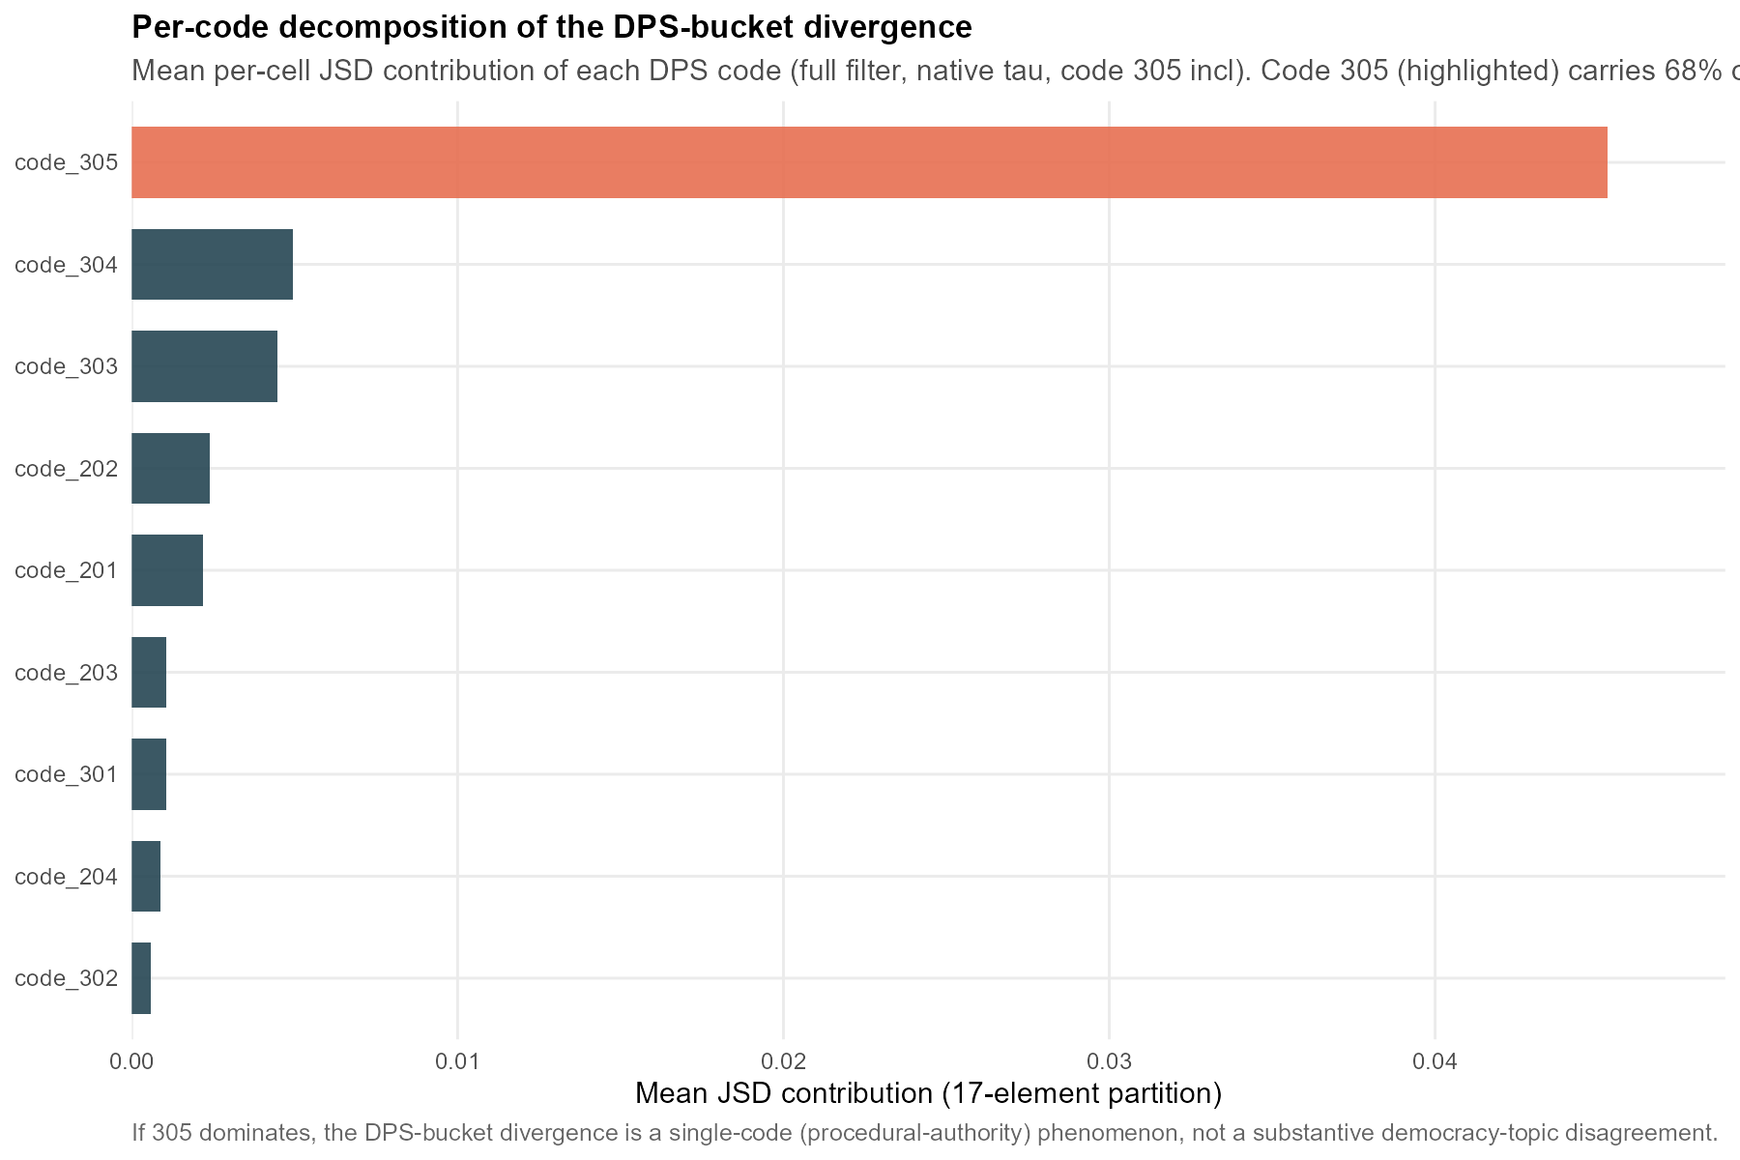
Figure F.3.1. Divergence-per-share by MARPOR code. Contribution of each code to the raw manifesto–speech divergence, ranked; code 305 is the single largest contributor on the speech side.
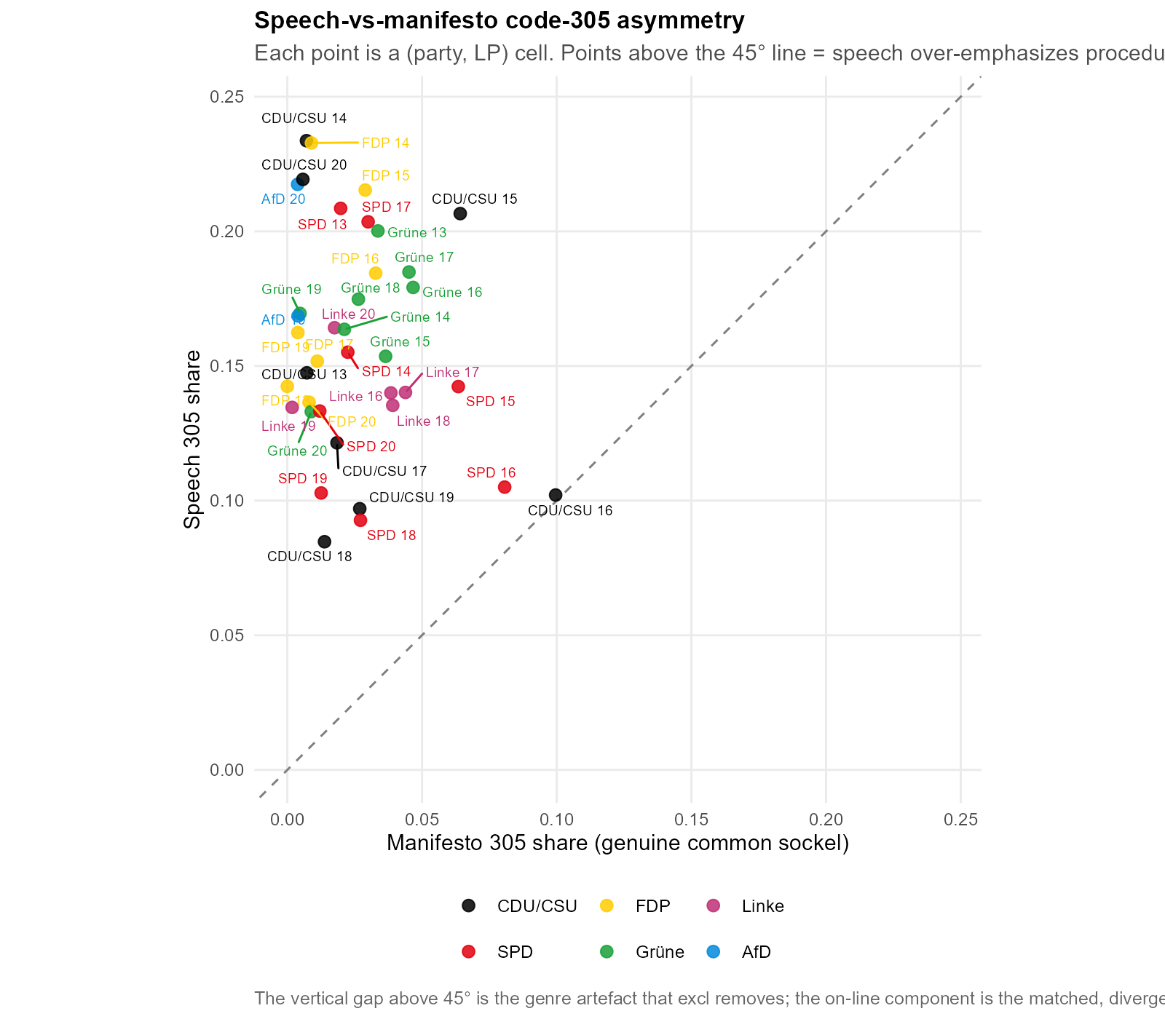
Figure F.3.2. Code-305 asymmetry between sides. Manifesto versus speech share of code 305 per cell; the systematic speech-side excess is the genre signal removed by the primary specification.
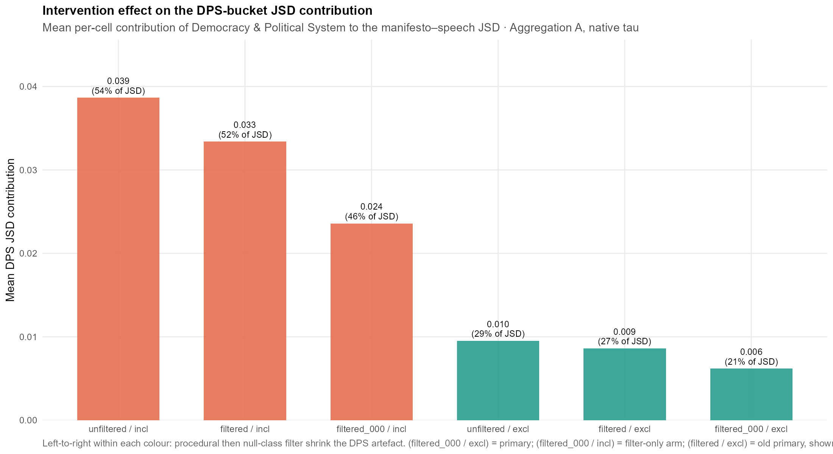
Figure F.3.3. Divergence-per-share along the intervention ladder. Effect of each successive correction (filtering, then code-305 subtraction) on the mean divergence-per-share.
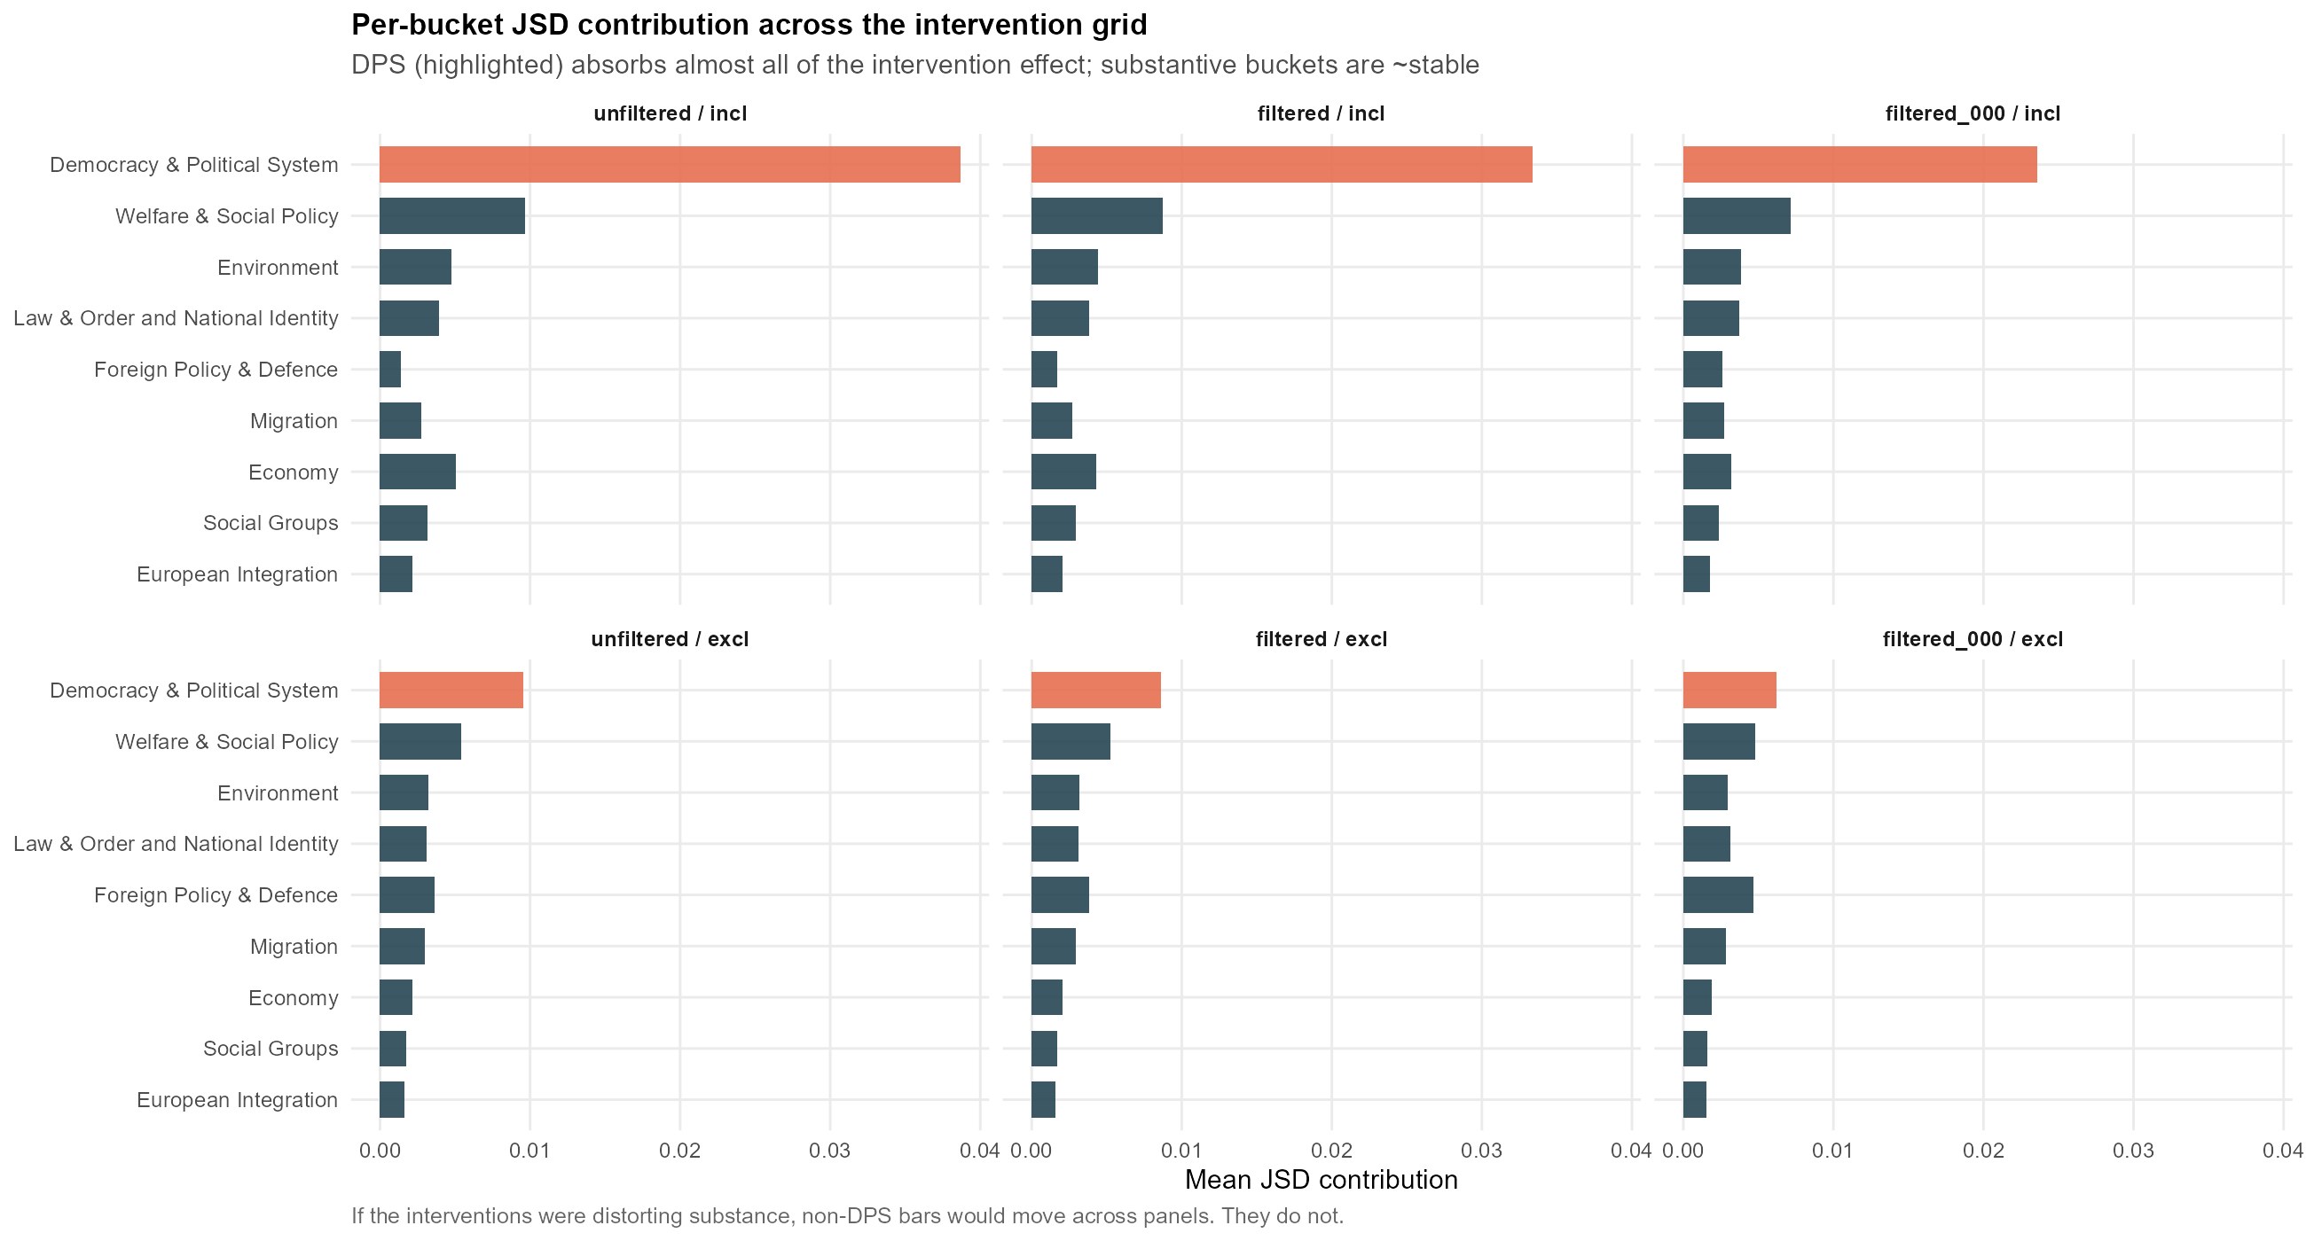
Figure F.3.4. Bucket-wise effect of the code-305 subtraction. Change in each of the nine salience buckets’ mean share under the correction; only the code-305-bearing bucket moves materially.

F.4 Nearest-manifesto benchmark (identification of the own programme)
The nearest-manifesto benchmark asks, for each speech cell, whether the party’s own manifesto is the closest of all parties’ manifestos in the same period. Table F.4.1 reports, per party, how often the own manifesto is nearest, that hit rate, and the mean rank of the own manifesto (1 = nearest). Across all 38 cells the own manifesto is nearest in 16 (42.1 %, against a 21.1 % chance baseline of one in the average field of 4.7 parties) and its mean rank is 1.87. The FDP and AfD identify their own programme in every period; the Linke never does, reflecting its position near the field centroid.
Party | Own nearest | Hit rate | Mean rank
CDU/CSU | 2 / 8 | 25.0% | 2.50
SPD | 1 / 8 | 12.5% | 2.38
FDP | 7 / 7 | 100.0% | 1.00
Grüne | 4 / 8 | 50.0% | 1.62
Linke | 0 / 5 | 0.0% | 2.00
AfD | 2 / 2 | 100.0% | 1.00
Total | 16 / 38 | 42.1% | 1.87
Table F.4.1. Nearest-manifesto identification by party. Cells in which the party’s own manifesto is the closest of all parties’ manifestos, the corresponding hit rate, and the mean rank of the own manifesto (1 = nearest). Aggregation A, primary specification. Chance baseline 21.1 %.
The complementary question, taken up as Figure 4.3 in the main text, is which single programme the chamber’s speech agenda sits closest to across all parties. Table F.4.2 gives the supporting quantity: the mean divergence from every one of the 38 speech cells to each party’s manifesto in the same period, both over all pairs and with each party’s distance to its own speech removed, alongside the number of cells in which that manifesto is the nearest of all. The FDP programme is the closest to the pool of parliamentary speech by a clear margin, and stays first when own-party pairs are excluded, so the result is neither self-similarity nor an effect of the FDP appearing often as a candidate. The mechanism is one of salience, not position: the chamber’s agenda is comparatively heavy on governance and economy and light on welfare and migration, which is the shape of the FDP’s programmatic agenda, while the welfare-centred Linke and the migration-centred AfD sit farthest. This is discussed in the conclusion; it is a statement about which topics are emphasised, not about the positions taken on them.
Manifesto | Mean JSD (all) | Mean JSD (excl. own) | Times nearest
FDP | 0.0253 | 0.0263 | 18
SPD | 0.0379 | 0.0400 | 6
Grüne | 0.0396 | 0.0422 | 7
Linke | 0.0457 | 0.0503 | 0
CDU/CSU | 0.0463 | 0.0484 | 5
AfD | 0.0638 | 0.0705 | 2
Table F.4.2. Agenda centre of gravity. For each party’s manifesto: the mean Jensen–Shannon divergence from all 38 speech cells to that manifesto in the same period (lower = the programme the chamber’s agenda most resembles), the same excluding each party’s distance to its own speech, and the number of cells in which that manifesto is the nearest of all. Manifesto candidates are restricted to parties in parliament that period. Aggregation A, primary specification. Salience, not position.

F.5 Pairwise between-party reference scale
The reference scale that calibrates H1a is built from between-party divergences on each side. Table F.5.1 reports the distribution of pairwise JSDs among speeches (the within-genre floor) and among manifestos (the cross-programme ceiling). The speech floor (mean 0.0074) and manifesto ceiling (mean 0.0520) bracket the observed H1a mean of 0.0297, which sits at 4.01 times the floor and 0.57 times the ceiling, that is, 49.9 % of the way along the floor-to-ceiling interval. The manifesto–speech divergence is therefore intermediate between the two reference regimes rather than small.
Side | Mean | Median | Q25 | Q75 | Min | Max | n
Speech (floor) | 0.0074 | 0.0063 | 0.0034 | 0.0093 | 0.0011 | 0.0303 | 74
Manifesto (ceiling) | 0.0520 | 0.0420 | 0.0281 | 0.0662 | 0.0082 | 0.1760 | 74
Table F.5.1. Between-party pairwise divergence, by side. Distribution of pairwise JSDs among all party speeches (floor) and among all party manifestos (ceiling), pooled across periods. Aggregation A, primary specification. n = number of party pairs × periods.

F.6 Decoding-temperature sweep
The primary specification decodes the classifier at its native temperature. Table F.6.1 re-runs H1a and H1b at a sharp (τ = 0.5), native (τ = 1.0) and flat (τ = 2.0) temperature and reports the Spearman rank correlations between the three resulting cell orderings, alongside the mean divergence level at each temperature. The cross-temperature rank correlations remain high for H1a (0.579 to 0.970) and for H1b (0.706 to 0.956); the sharp-to-native correlation, the pair that brackets the native specification, is 0.970 for H1a and 0.956 for H1b. Temperature shifts the level of the divergence but preserves the ordering of cells that carries the substantive claims.
Hypothesis | sharp–native | sharp–flat | native–flat
H1a (A) | 0.970 | 0.579 | 0.729
H1b (B) | 0.956 | 0.706 | 0.843
Table F.6.1a. Rank stability across decoding temperature. Spearman ρ between cell orderings at sharp (τ = 0.5), native (τ = 1.0) and flat (τ = 2.0) temperatures, for H1a (Aggregation A) and H1b (Aggregation B).
Hypothesis | sharp (0.5) | native (1.0) | flat (2.0)
H1a (A) | 0.0283 | 0.0297 | 0.0368
H1b (B) | 0.0444 | 0.0506 | 0.0852
Table F.6.1b. Mean divergence level across decoding temperature. Mean per-cell JSD at each temperature; the native column reproduces the primary specification.
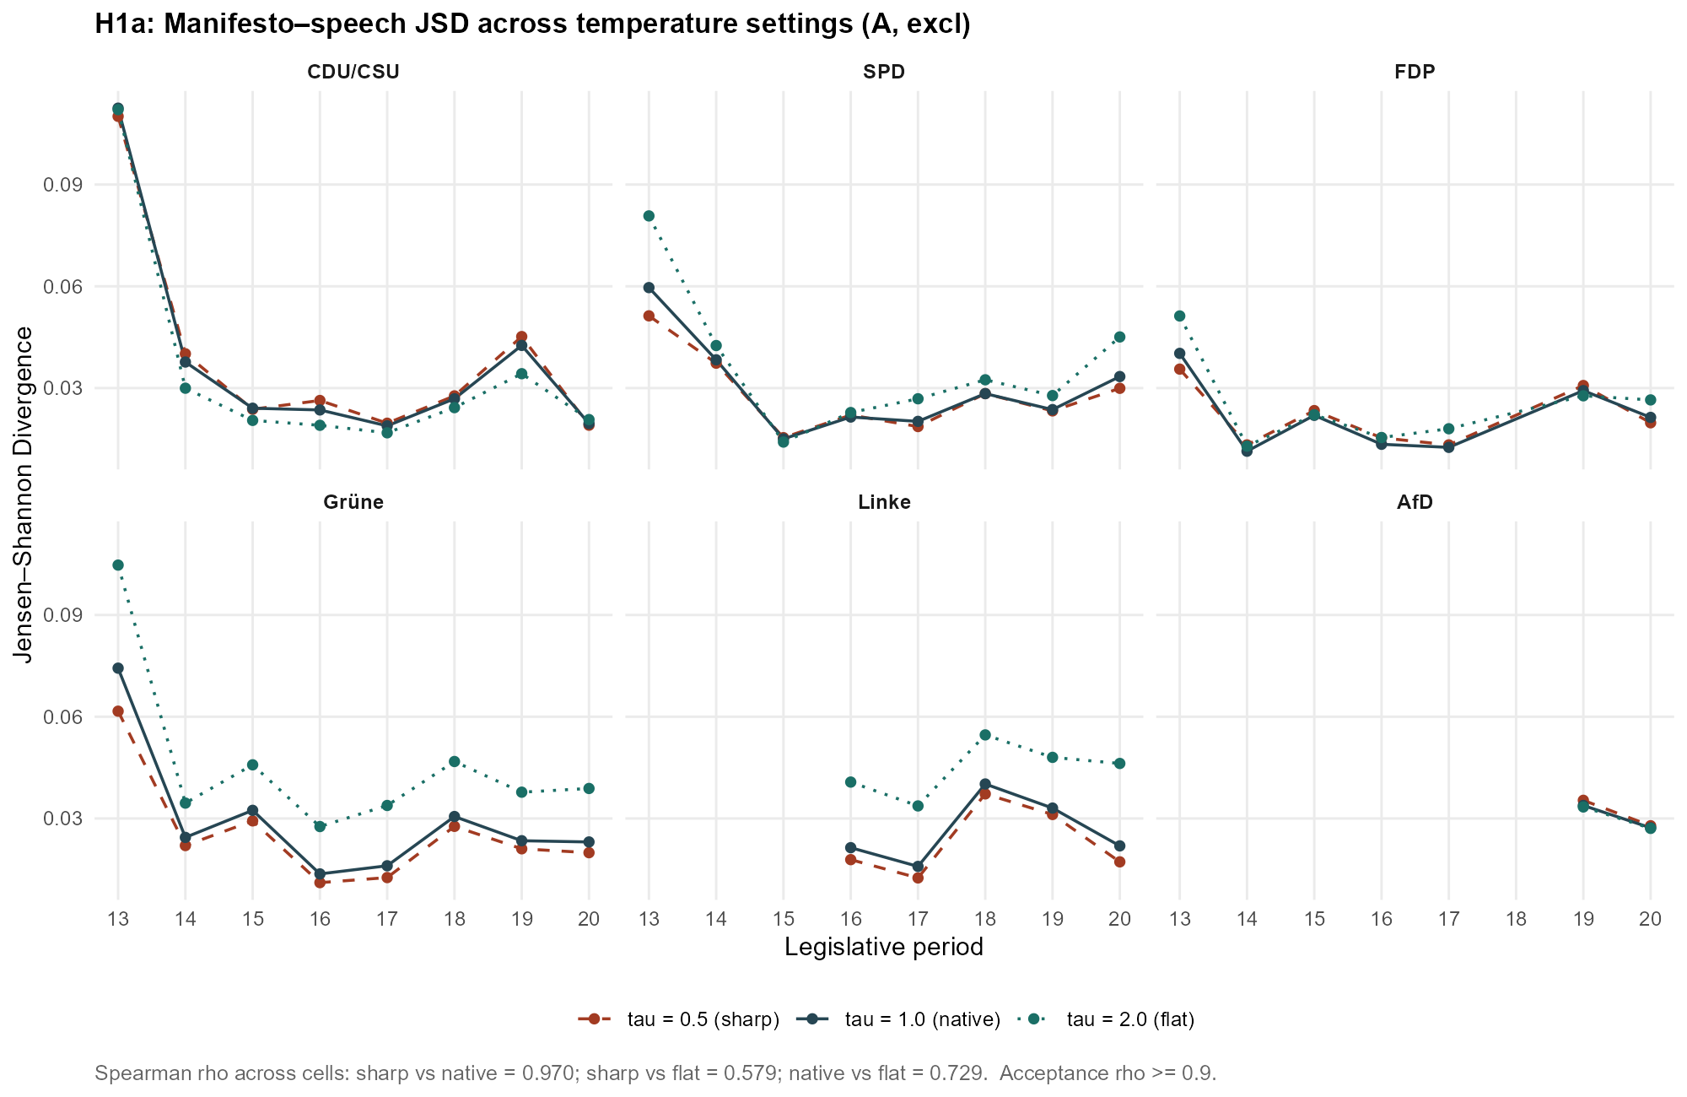
Figure F.6.1. H1a divergence across decoding temperature. Per-cell JSD at each temperature; cell orderings are preserved as the level shifts.
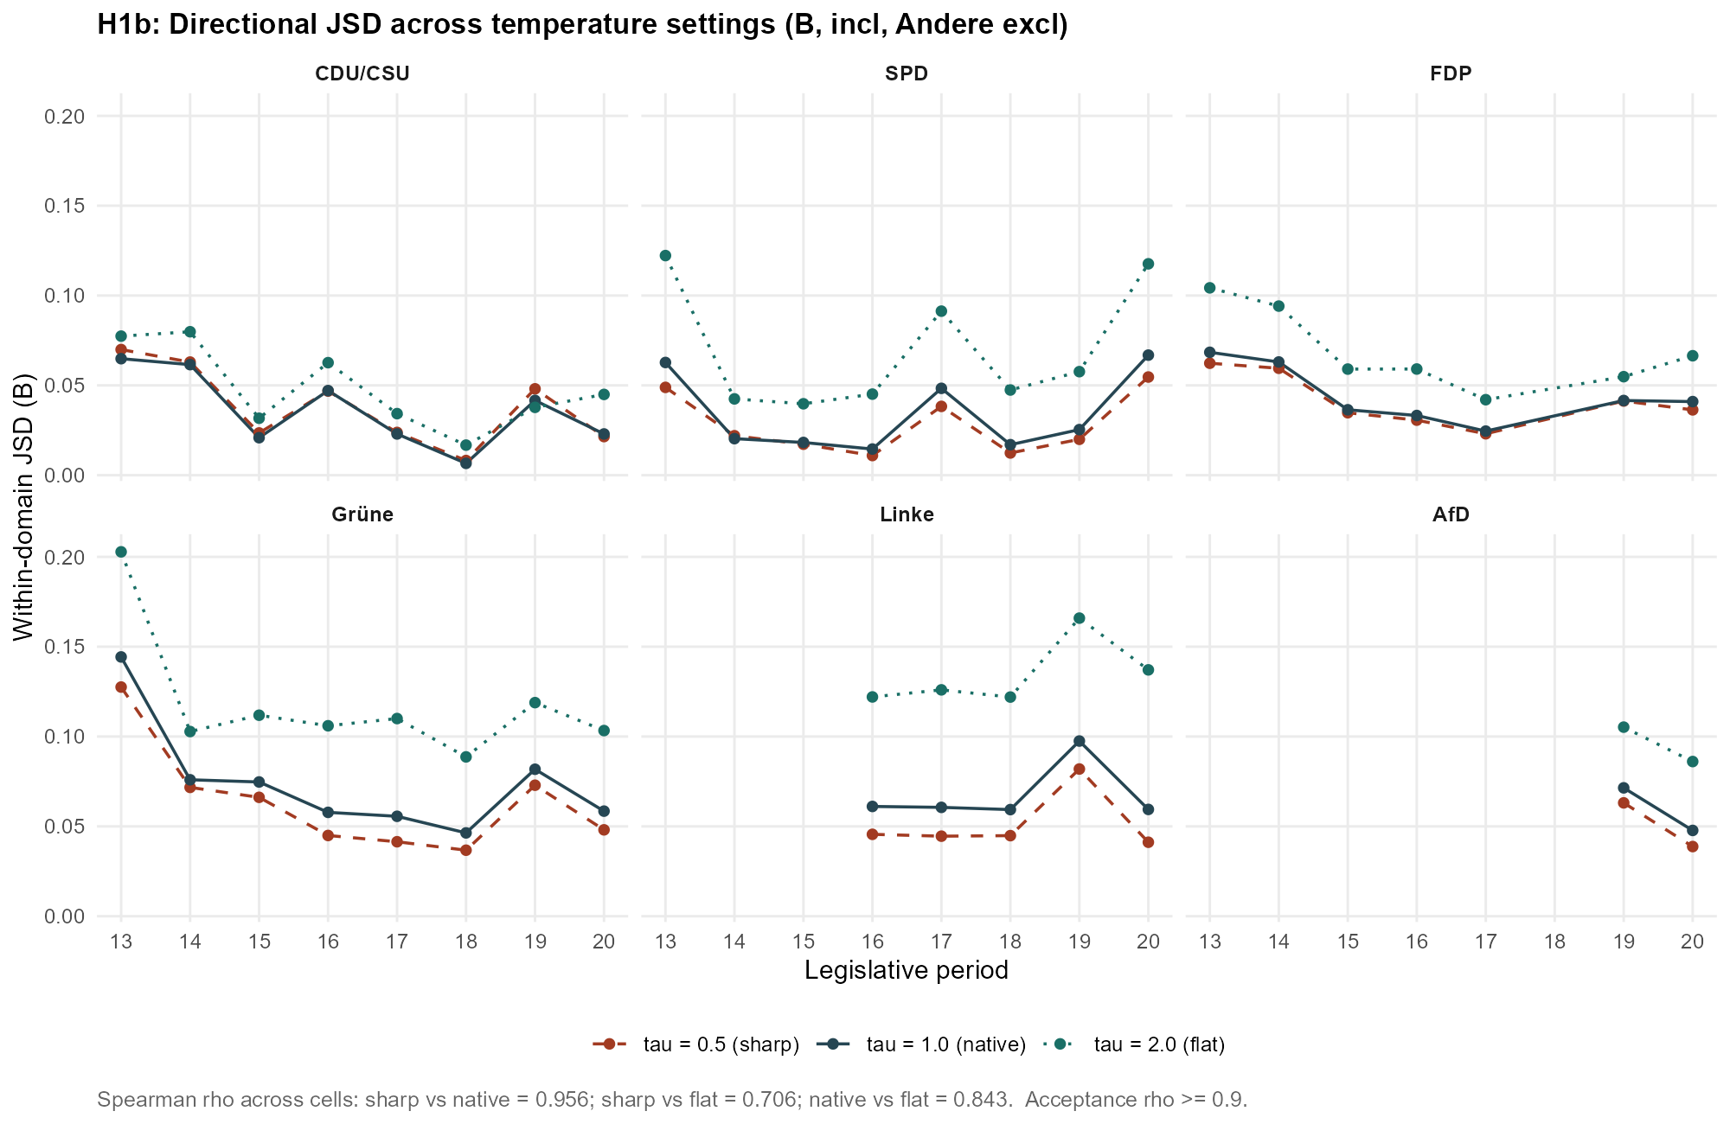
Figure F.6.2. H1b divergence across decoding temperature. As Figure F.6.1, for the directional specification (Aggregation B).

F.7 Soft-assignment versus hard-threshold classification
The primary specification uses the classifier’s soft label distribution. Table F.7.1 compares it against two hard-threshold variants that assign each sentence to a single bucket when the top label exceeds 0.4 or 0.5. The rank correlations between the soft ordering and each hard ordering stay high (H1a 0.929 to 0.943; H1b 0.772 to 0.861), and the two hard variants agree almost perfectly with each other (0.996 for H1a, 0.964 for H1b). The mean level rises modestly under hard assignment, as expected when soft mass is collapsed onto single buckets, without reordering the cells.
Hypothesis | soft–hard0.4 | soft–hard0.5 | hard0.4–hard0.5
H1a (A) | 0.943 | 0.929 | 0.996
H1b (B) | 0.861 | 0.772 | 0.964
Table F.7.1a. Rank stability under hard-threshold assignment. Spearman ρ between the soft-assignment ordering and each hard-threshold ordering (top label > 0.4, > 0.5), and between the two hard variants. H1a and H1b.
Hypothesis | soft (τ = 1.0) | hard > 0.4 | hard > 0.5
H1a (A) | 0.0510 | 0.0577 | 0.0602
H1b (B) | 0.0506 | 0.0411 | 0.0409
Table F.7.1b. Mean divergence level under hard-threshold assignment. Mean per-cell JSD for the soft specification and each hard-threshold variant.
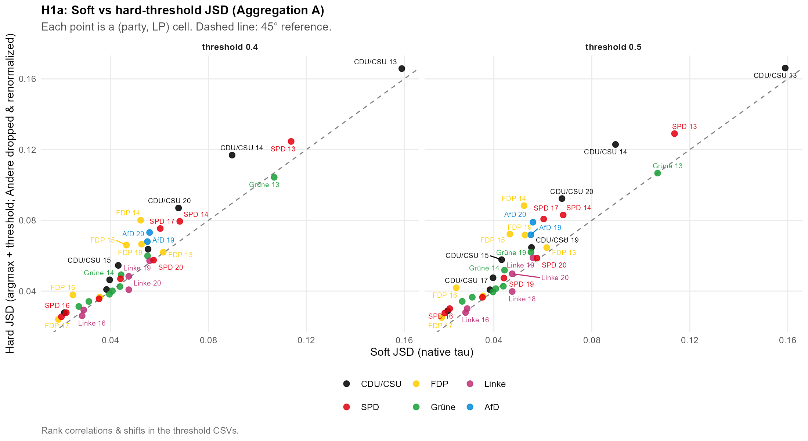
Figure F.7.1. H1a: soft versus hard-threshold divergence. Per-cell JSD under soft assignment against the hard-threshold variants; points track the identity line up to a level shift.
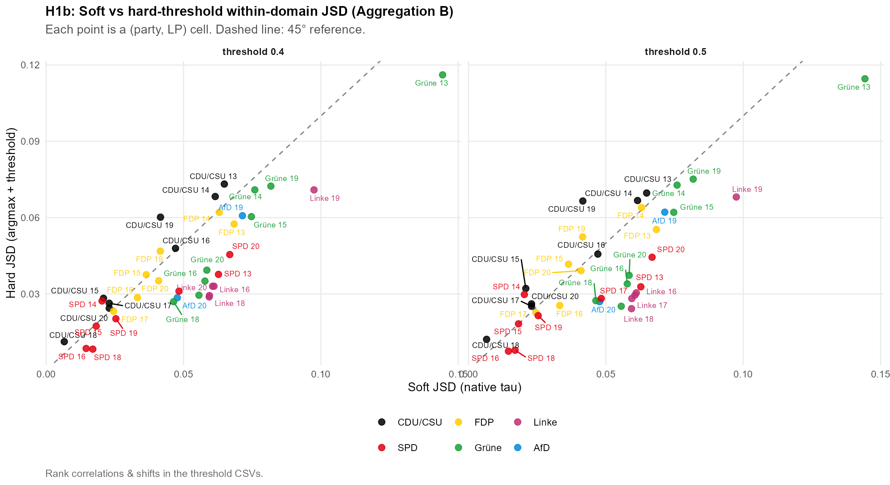
Figure F.7.2. H1b: soft versus hard-threshold divergence. As Figure F.7.1, for the directional specification.

F.8 Migration re-split (H1b, buckets 601/607 vs 602/608)
The directional migration bucket pools the MARPOR national-way-of-life and multiculturalism codes. Because the split between border/immigration control and cultural integration is contested, Table F.8.1 re-runs the H1b migration cell two ways: the baseline restrictive/liberal split (601+608 restrictive, 602+607 liberal) and a narrower split that treats only multiculturalism as the axis (608 restrictive, 607 liberal). The mean divergence is essentially unchanged (0.1392 to 0.1344, a difference of −0.0062), and the restrictive share on the speech side falls from 68.4 % to 48.6 %, which localises the composition finding to the multiculturalism codes without overturning it.
Split | Cells (n) | Mean JSD | Restr. share (speech)
Baseline (601+608 / 602+607) | 37 | 0.1392 | 68.4%
Multiculturalism only (608 / 607) | 36 | 0.1344 | 48.6%
Table F.8.1. Migration re-split sensitivity (H1b). Mean migration-cell JSD and restrictive speech share under the baseline split (601+608 / 602+607) and the multiculturalism-only split (608 / 607). Δ mean JSD = -0.0062. Aggregation B, primary specification.
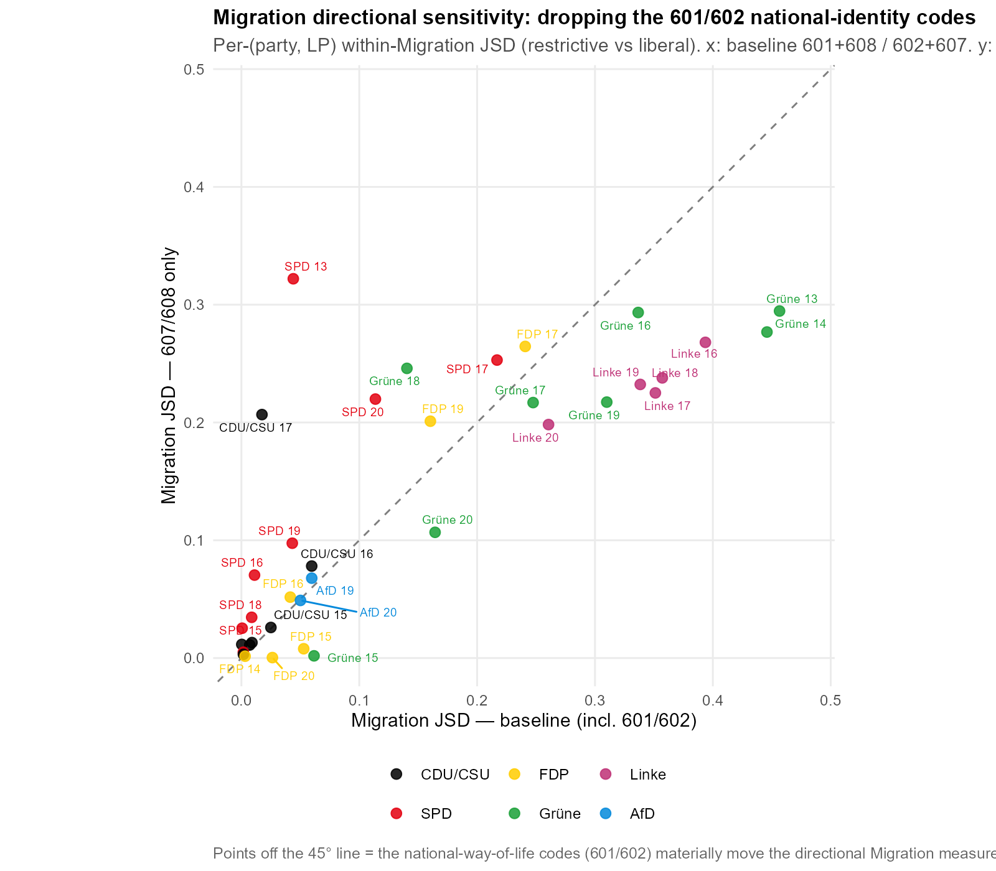
Figure F.8.1. Migration re-split sensitivity, per cell. Migration-cell JSD under the baseline and multiculturalism-only splits; the cell ordering is preserved and the level barely moves.

F.9 Supplementary directional figures
Three further figures support the directional analysis in Chapter 4. Figure F.9.1 is the H2b moderation scatter, plotting each cell’s speech-side against its manifesto-side polarization score so that the slope comparison of H2b can be read cell by cell: clouds flatter than the 45-degree line indicate moderation, and a cloud displaced from the line indicates a level shift of the channel. Figure F.9.2 shows the H3 mean directional positions, the manifesto and speech means on each directional sub-scale over time, against which the H3 congruence coefficient κ(B) = 0.456 is computed. Figure F.9.3 reproduces the system-level polarization series of Figure 4.5 without the excl-AfD overlay; the underlying values are identical, and the figure is provided so the all-party series can be read uncluttered.
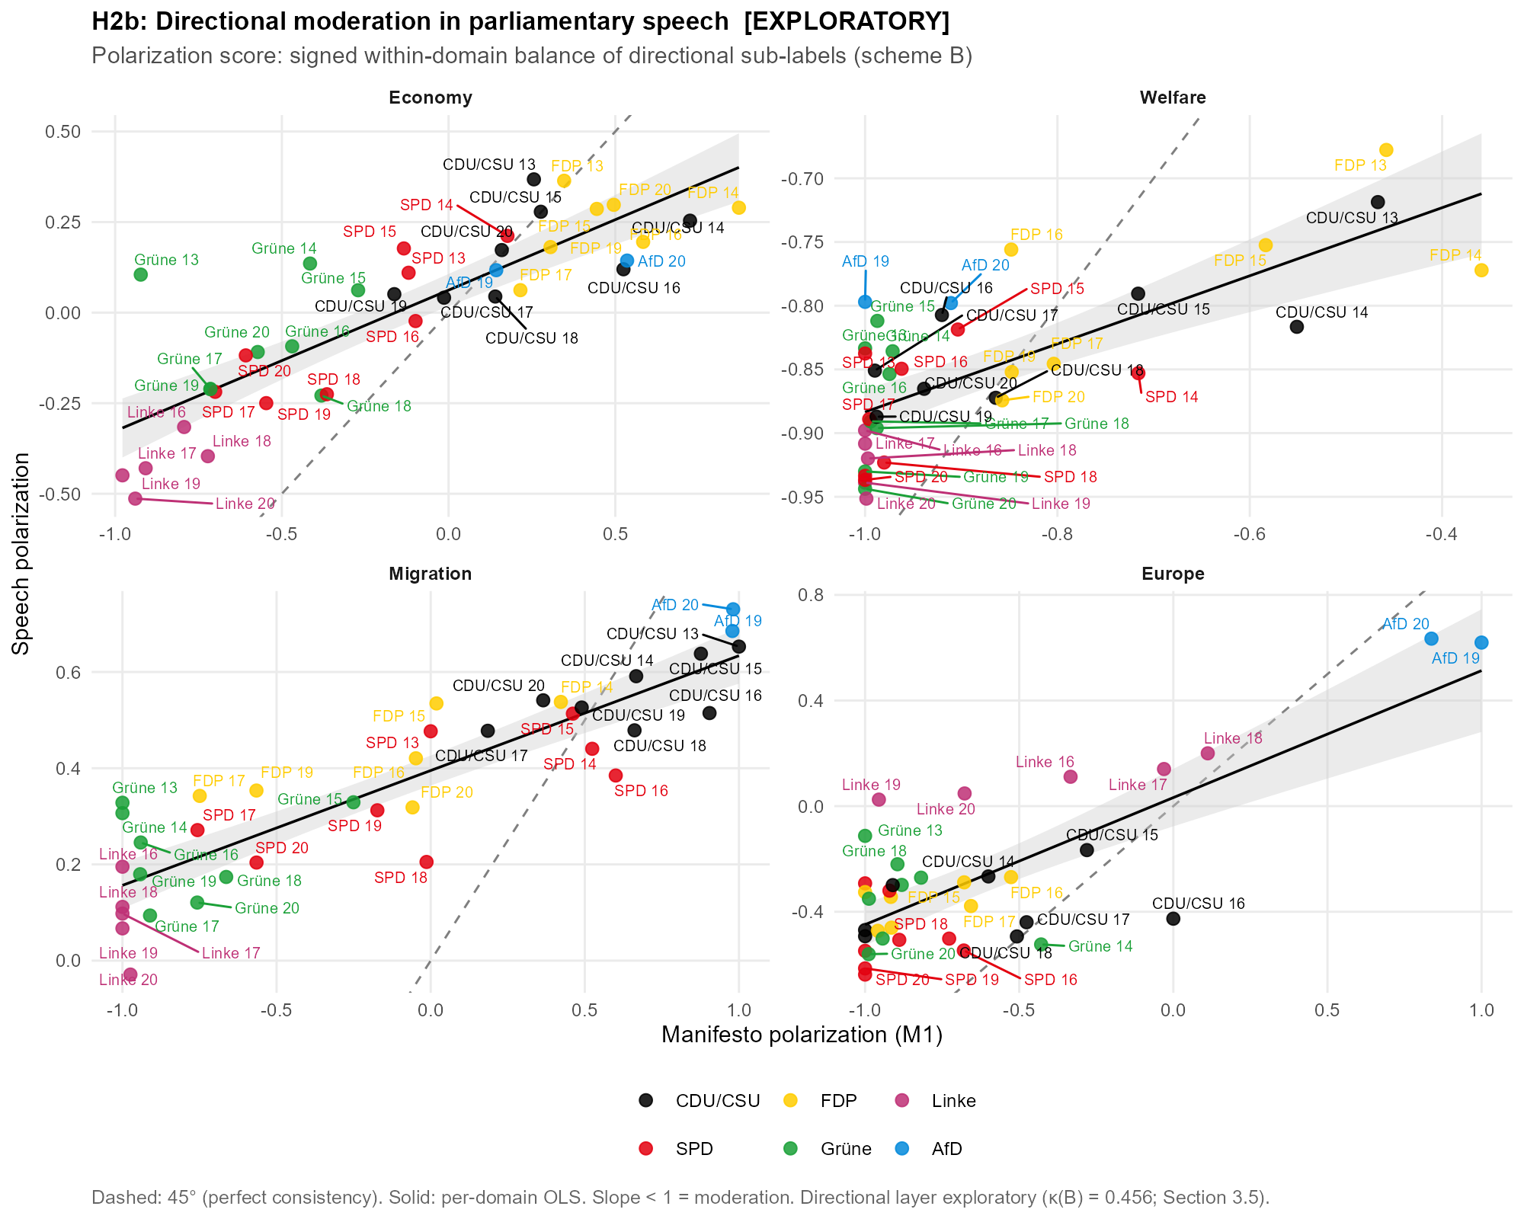
Figure F.9.1. H2b: speech versus manifesto polarization scores. Each point is a party × period cell; axes are the signed within-domain directional balance in each channel, dashed line = 45° (perfect consistency), solid line = per-domain OLS. Aggregation B, primary specification.
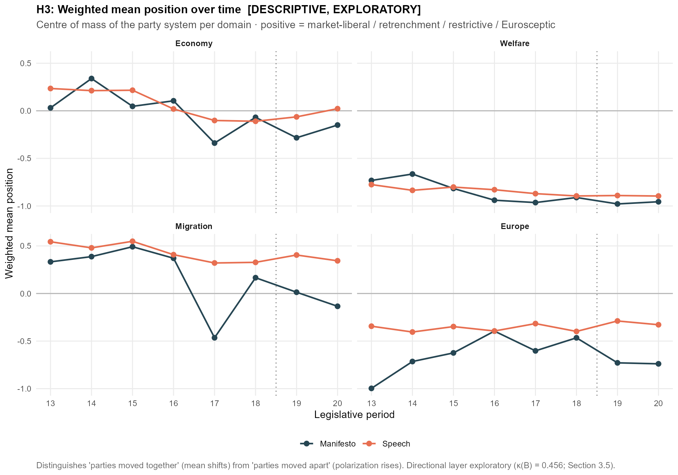
Figure F.9.2. H3: mean directional positions over time. Manifesto and speech means on each directional sub-scale by period; the congruence coefficient is κ(B) = 0.456. Aggregation B, primary specification.
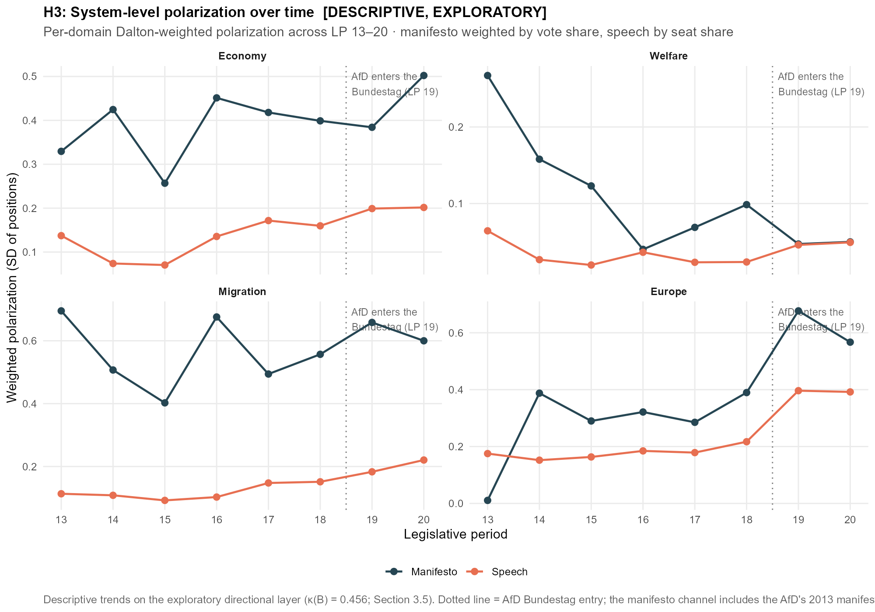
Figure F.9.3. System-level polarization over time, all parties. Dalton-weighted SD of party positions per period, domain and channel (manifesto weighted by vote share, speech by seat share); identical series to the in-text figure, shown without the excl-AfD overlay. Aggregation B, primary specification.

F.10 The LP-13 elevation: a manifesto-side, window-boundary diagnostic
Section 4.2 reports that the manifesto–speech divergence peaks at LP 13, where all four cells (CDU/CSU, SPD, FDP, Grüne) are the maximum of their party and the CDU/CSU cell of 0.1125 is the largest value in the chapter. This subsection establishes that the elevation is a property of the manifesto input and of where the observation window opens, not an anomalous 1994 election and not a segmentation, classification, or mapping artefact. Three checks converge.
First, the divergence is localised to the manifesto side by a cross-swap. Holding the LP-13 speech distribution fixed and replacing the 1994 manifesto with the party’s typical in-window manifesto, the mean of its other 1994–2021 programmes, removes most of the divergence, whereas holding the manifesto fixed and replacing the speech leaves it unchanged (Table F.10.1). For the CDU/CSU the manifesto swap reduces the divergence from 0.1125 to 0.0150, while the speech swap leaves it at 0.1214. The speeches at LP 13 are therefore ordinary; the 1994 manifestos carry the divergence.
Cell (LP 13) | Actual JSD | Manifesto → typical | Speech → typical
CDU/CSU | 0.1125 | 0.0150 | 0.1214
SPD | 0.0596 | 0.0207 | 0.0706
FDP | 0.0402 | 0.0175 | 0.0390
Grüne | 0.0743 | 0.0171 | 0.0791
Table F.10.1. Cross-swap localisation of the LP-13 divergence. Each LP-13 cell’s JSD (Actual), recomputed with the 1994 manifesto replaced by the party’s typical in-window manifesto (Manifesto → typical) and with the LP-13 speech replaced by the party’s typical speech (Speech → typical). Aggregation A, primary specification.
Second, the 1994 manifesto is not itself an aberrant document. Across each party’s full manifesto record in the Manifesto Project main dataset, the change from the 1990 to the 1994 programme is unremarkable, and far larger shifts occurred in earlier decades (Table F.10.2, Figure F.10.1). For the CDU/CSU the 1994 change equals its long-run average and ranks sixth of twenty transitions; for the FDP it is one of the smallest on record, eighteenth of twenty. The Green record before 1994 is not captured by the party identifier used here, so the comparison is reported for the three parties with a long history; the 1994 Green change of 0.0369 is modest in absolute terms.
Party | 1994 change | Pre-1994 mean | Pre-1994 max (year) | Rank of 1994
CDU/CSU | 0.0619 | 0.0616 | 0.1579 (1957) | 6 of 20
SPD | 0.0427 | 0.0548 | 0.1015 (1976) | 8 of 20
FDP | 0.0112 | 0.0547 | 0.1079 (1972) | 18 of 20
Grüne | 0.0369 | — | — | 1 of 9
Table F.10.2. The 1994 manifesto change in historical perspective. JSD between each party’s 1994 manifesto and its immediately preceding programme (1994 change), against the mean and maximum of that party’s pre-1994 election-to-election changes and the rank of the 1994 change among all its transitions (1 = largest). Aggregation A.
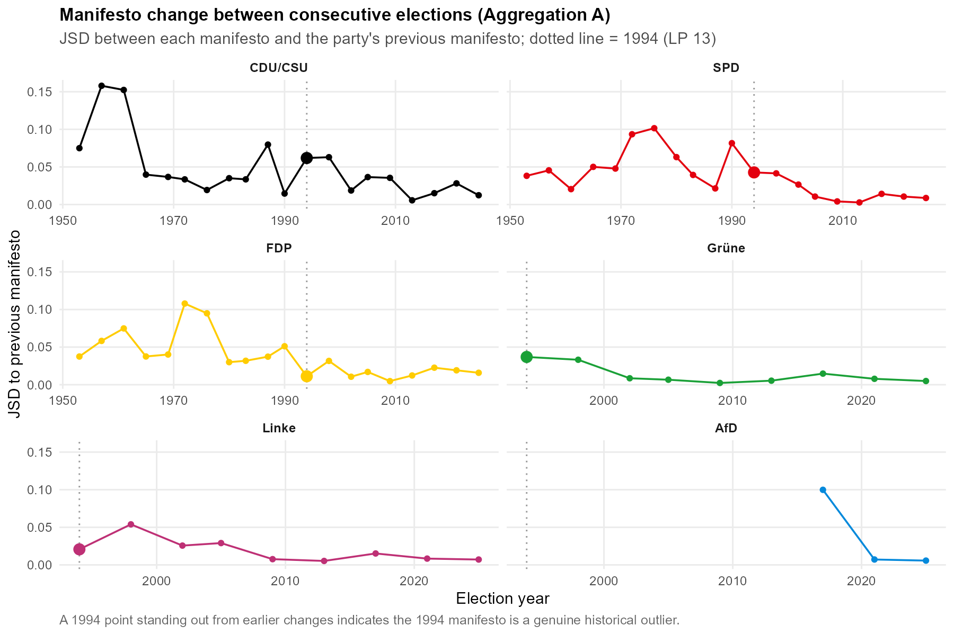
Figure F.10.1. Manifesto change between consecutive elections, by party. JSD between each manifesto and the party’s previous programme; the dotted line marks 1994. The 1994 change does not stand out from the party’s earlier transitions.
Third, the composition series explains why the 1994 programmes stand apart within the analysis window without being anomalous. Manifesto compositions drift steadily from one election to the next (Figure F.10.2), and for the three long-observed parties the election-to-election change is visibly smaller after the mid-1990s than before: the parties settle into the more similar profiles of 1998 to 2021. The 1994 manifesto is simply the earliest in the window, and therefore the most distant from that later cluster, which the genre-stable plenary speech resembles more closely than it resembles the older programme.
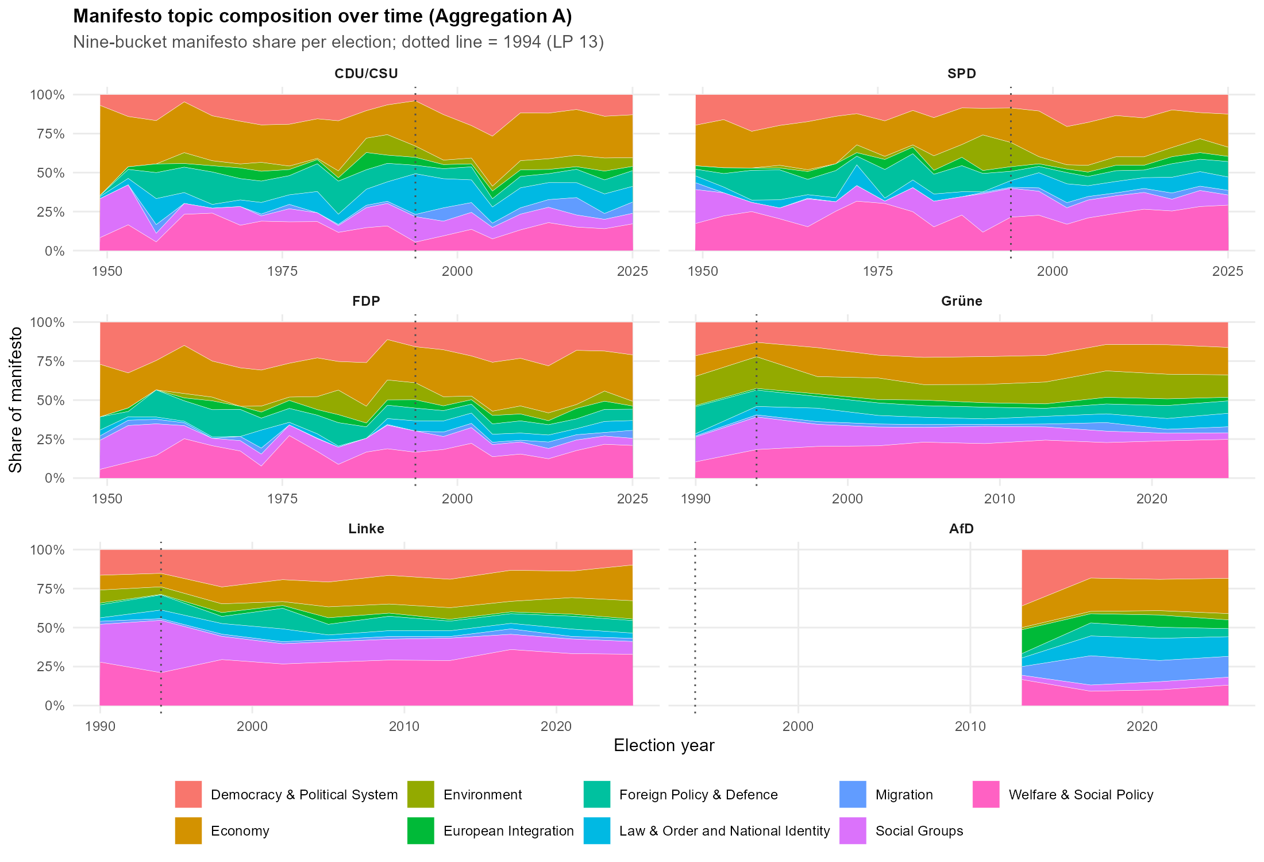
Figure F.10.2. Manifesto topic composition over time, by party. Nine-bucket manifesto share per election; the dotted line marks 1994. Compositions drift steadily, and the post-1994 profiles form a tighter cluster.
Taken together, the LP-13 elevation is a boundary effect of where the observation window opens, carried entirely by the manifesto side, and it requires no substantive account of the 1994 election. Chapter 4 reports it as such and does not read it as evidence about any single party or period.

Contrary to the default behaviour, split_camel_case is set to false, since abbreviations such as GroKo must not be split.
The version of SoMaJo used here is 2.4.3
Normalization masks named appellations to a placeholder ('Herr Kubicki' → 'herr <name>'), then lowercases, collapses whitespace, and strips leading/trailing punctuation; the identical routine builds the candidate list and matches the corpus, so a single entry (‘herzlichen dank, herr <name>') captures all name variants.
Pretrained by Facebook AI on 2.5 TB of filtered CommonCrawl data in 100 languages, with about 560M parameters (Conneau et al., 2020).
The standard classification head was modified by removing the tanh activation and the intermediate linear layer, reducing it to a direct linear projection from the sentence representation onto the 56 logits (Burst et al., 2024).
Accuracy figures as reported on the Hugging Face model card (accessed 10 July 2026).
The model is run in evaluation mode, which deactivates dropout; inference is thus deterministic in design (no stochastic components), although exact bitwise reproducibility across hardware configurations is, as usual for GPU inference, not guaranteed.
Against the prediction stored at sampling time, κ(A) over all 259 coded sentences is 0.570, against 0.562 over the 249 carried. The loss does not shift the estimate.
model identifier claude-sonnet-4-6, accessed via the batch API
See Appendix X
The gold sample supports the same ordering at the directional level: against the human coder, Sonnet reaches a κ(B) of 0.622 to the classifier's 0.490 (n = 111, strict direction handling, full gold basis, which is why κ(B) here differs to the κ(B) reported in section 3.5.1).
FDP LP13 has no migration content and is taken as 0, over the 37 cells that carry migration content the manifesto figure is 42.9%
This is due to the fact that the FDP's 1994 manifesto contains no migration-coded material, so its manifesto score is undefined and the cell drops from the migration regression.

