Master Thesis
Supervisor: Justyna Klejdysz, Ifo-Institute

31. Juli 2026
Florian M. Katzmann, Matr.-Nr.: 12293439
Semester 4, Master, Economics
Table of Contents
Introduction 4
Literature Review 8
2.1 Issue Competition, Salience and Ownership 8
2.2 The Manifesto and the Plenary Arena 10
2.3 From Programmes to Parliamentary Speech 12
2.4 Party System Change and the Politicisation of Europe 14
2.5 Expectations and Hypotheses 17
Data 18
3.1 GermaParl2 18
3.2 Party Manifestos: MARPOR 19
3.3 Linking and the Analysis Sample 20
Methods 20
4.1 Unit of Analysis and Comparison Logic 20
4.2 Pre-Commitment Architecture 21
4.3 Speech-Side Preprocessing 21
4.3.1 Sentence Segmentation (SoMaJo) 21
4.3.2 Procedural-Sentence Filter 23
4.4 Automated Classification (ManifestoBERTa) 24
4.5 Validation 27
4.5.1 Gold-Standard Validation 28
4.5.2 Silver-Standard Validation 30
4.5.3 Diagnosis 32
4.6 Corrections 33
4.6.1 Non-Codable Sentences Filter (gbert-000) 33
4.6.2 Exclusion of Code 305 35
4.7 Aggregation and Measurement 36
4.7.1 Topic Buckets 36
4.7.2 Speech-Side Aggregation and the Primary Specification 37
4.7.3 The Jensen–Shannon Divergence 38
4.7.4 The Sentence Bootstrap 39
4.8 Empirical Strategy 39
4.8.1 Hypothesis H1 40
4.8.2 Hypothesis H2 41
4.8.3 Hypothesis H3 42
4.8.4 Analysis Overview 43
4.9 Robustness Design 43
Results 45
5.1 Analysis Base and Reading Conventions 45
5.2 Agenda Congruence (H1) 45
5.2.1 H1a 45
5.2.2 H1b 50
5.3 What Drives and Moderates Divergence (H2) 52
5.3.1 H2a 52
5.3.2 H2b 55
5.3.3 H2c 58
5.4 Polarisation over Time (H3) 60
5.5 Robustness 65
Conclusion 67
Erklärung an Eidesstatt 73
Übersicht verwendeter Hilfsmittel 73
Ehrenwörtliche Erklärung 75
Bibliography 76
Appendix 83
Appendix A: Speech-Side Sentence Segmentation — Implementation Details (cf. Section 4.3.1) 83
Appendix B: Procedural-Sentence Filter — Hand-Coded Typology 84
Appendix C: Realised Distribution of the Gold Sample across Strata 98
Appendix D: Silver-Standard Prompt 100
Appendix E: Code-to-Bucket Crosswalk 117
Appendix F: Supplementary Results and Robustness Tables 121
F.1 Redundancy Test of the Two Corrections 121
F.2 Per-cell salience divergence (H1a) with bootstrap intervals 123
F.3 The code-305 correction: six specification bands (robustness arm 3) 125
F.4 Nearest-manifesto benchmark (identification of the own programme) 128
F.5 Pairwise between-party reference scale 131
F.6 Decoding-temperature sweep (robustness arm 1) 132
F.7 Soft-assignment versus hard-threshold classification (robustness arm 2) 133
F.8 Migration re-split (H1b, buckets 601/608 vs 602/607; robustness arm 5) 135
F.9 Supplementary directional figures 136
F.10 The LP-13 elevation: a manifesto-side, window-boundary diagnostic 139
Appendix G: Software, Runbook and Integrity Checks 141

Introduction
Elections are built on promises, promises parties make in a time of intense competition and fierce rivalry. The clearest form these take is the party manifesto, the document in which a party sets out what it promises, what it prioritises and what it stands for. Against it stands a suspicion as old as party democracy, that what is announced before an election bears little relation to what follows it, and that such announcements serve to soothe an expectant public rather than to bind the party that makes them. Where the suspicion can be checked against the record, the evidence runs the other way: parties that reach office keep considerably more of their pledges, at least in part, than their reputation allows, although how many depends on whether they govern alone or share power with others (Thomson et al., 2017). That record is read off legislation and policy outputs. But what about the arena in between, the plenary chamber? This thesis asks whether parties practise in parliament what they announce in their programmes. At issue is not the fate of single pledges, but whether the emphasis a party sets out on paper returns in what it chooses to talk about on the floor. To our knowledge, that comparison has not been made systematically for Germany.
In the literature the consensus is that the attention profiles in the political arena are a reputational asset. By prioritising issues the individual party forms a recognisable profile, which motivates it to keep emphasising its preferred topics (Petrocik, 1996). This would mean that manifestos should be recognisable in a party's shared parliamentary agenda. But another angle, also well documented in the literature, is that there is a party-system agenda in parliament to which all parties are subject. While each party takes an active part in its formation, the democratic nature of the formation of this party-system agenda, especially in the German system, binds all parties to a jointly negotiated order of business (Green-Pedersen and Mortensen, 2010; Sieberer, 2006). This means that party speech agendas as represented by their MPs speeches taken together must be subject to this party-system agenda and cannot be fully individually adjusted. We therefore take programmatic differentiation as the ceiling of the divergence between the two channels, since the distance between programmes is the largest one parties deliberately create, and the differentiation between speech agendas as its floor, since a shared order of business keeps any party from bringing its speeches fully into line with its programme. How far apart, then, do the announced and the practised agenda of the same party lie? In an attempt to quantify this divergence, we will analyse how far apart the two channels are and where those divergences lie across the political domains.
This thesis measures the agendas of both channels in the same category space, by using the manifesto categories of the MARPOR coding scheme (Lehmann et al., 2025) to classify speeches thematically. This is implemented by using a classifier model, ManifestoBERTa (Burst et al., 2024), fine-tuned on hand-coded quasi-sentences from the Manifesto Corpus, to classify plenary speeches from GermaParl2 (Blaette and Leonhardt, 2025) sentence by sentence, while the manifesto side enters directly from the project's main dataset. In total the plenary speech corpus classified in this way holds more than six million sentences, aggregated to 38 party-period cells over eight legislative periods from 1994 onwards. The measure we use to quantify the divergence is the Jensen–Shannon divergence between the two distributions over the nine political domain buckets into which we aggregate the 56-code MARPOR scheme, so what is measured is a distance in emphasis and not in position. As a JSD value carries no absolute reading of its own, the values are read against a double reference: as a floor the mean divergence between parties' speech agendas and as a ceiling the divergence between their manifestos, and against a second benchmark, whether the nearest programme to a party's speech agenda is its own. To further differentiate directional signals, we implement a second directional aggregation scheme separating economy, welfare, migration and European integration into sub-buckets. The analysis using this aggregation is read with more caution throughout, for reasons the validation establishes. We find two structural failure modes when employing a manifesto-trained classifier for speech classification, which are diagnosed and corrected before any result is read, as discussed in Chapter 4. The observation window also holds an opportunity, since a Eurosceptic challenger, the AfD, enters the Bundestag within it in 2017, and because the system quantities are recomputed without that party, a change in them can be traced either to its arrival or to movement among the parties already present. Chapter 2 derives three expectations from this literature, that the two agendas are systematically linked, that the divergence which remains is shaped by the institution rather than spread evenly, and that polarisation moves with the arrival of the challenger, and Section 2.5 states them as hypotheses.
We find that the answer has two sides. Parties do adhere to the priorities they put forth in their manifestos, but this adherence is bounded by the agenda they share in the chamber. To put this in perspective, parties' speeches diverge on average roughly four times as much from their manifestos as their speech agendas do from one another, and only 0.57 times as much as the manifestos of different parties diverge from each other. The congruence is therefore real and at the same time capped by the institution. Concretely, the manifesto of the respective party is the nearest to the speech agenda in 42.1% of cells, against a chance baseline of 21.1%. This differs strongly between parties. The AfD and the FDP are always nearest to their own manifesto, the Linke never is, the CDU/CSU and the SPD are in only a few cells and the Grüne in half of theirs, a spread that does not sort along ideological lines.
The part of a party's agenda that does not carry into the chamber has a shape of its own: it is not noise but structure. In the speech channel, content on governance and on foreign policy and defence is systematically over-weighted. On average, speech agendas raise their share of Democracy & Political System content from about 15% to about 20% relative to manifestos, and Foreign Policy content from about 7% to about 12%. This increase holds in every one of the six parties, and these are the only two domains on which all of them move the same way. Other domains are under-weighted, and in many cases it is the domain a party emphasises most in its manifesto that is given less room in its speech agenda, so that wide programmatic spreads narrow into a common band, a good example of the institutional filter levelling attention rather than positions. Furthermore, under the directional aggregation, speech positions follow manifesto positions with slopes well below one, meaning that the order of party positions stays the same while the parties move closer to one another. This decrease in dispersion holds in all four directional domains. What is interesting is that migration alone adds a level shift to this compression, moving from a liberal manifesto mean to a speech mean on the restrictive side. But part of this may be a known artefact of the classifier. Taken together, these shifts leave the chamber with an agenda profile of its own, one in which governance and the economy carry more weight than welfare and migration do. No single programme resembles that profile as closely as the FDP's, which comes nearest in 18 of the 38 cells, a claim about the topics that get emphasis and not about the positions taken on them.
Taking a closer look at system-level polarisation, by looking at the party-strength-weighted spread of the position scores, we also find that there are strongly heterogeneous trends across domains, described here rather than tested. While the economy shows a rising trend in polarisation on the speech side over the observation period, welfare becomes less polarised in the manifestos over time, and both movements survive a refit of the trends that leaves the AfD out. For Europe an interesting mechanism can be seen. In 1994 the programmes hardly differ on Europe at all, so the axis of conflict forms inside the observation window, and over its course polarisation rises in both channels, with most of the movement falling in the final two periods. Refitting without the AfD, however, reverses the manifesto trend from +0.0769 to −0.0079 and flattens the speech trend to near zero. This rise almost fully stems from the arrival of a pole, as the established parties do not move apart on this domain. On migration a slowly increasing polarisation can be seen on the speech side, and it is not the AfD story one might have expected, since it sets in before the party exists and only part of it drops out under that refit, the rest being a fanning out among the parties already present. A rising polarisation curve alone cannot tell a new pole from parties drifting apart, which is why the recomputation without the entrant belongs to the design and not to the robustness battery.
The mandate literature this thesis joins has concentrated its efforts at the far end of the chain, following programmes into laws, executive programmes and parliamentary questions, and for Germany the closest study traces manifesto priorities into the legislative agenda across three decades (Guinaudeau and Guinaudeau, 2023). The designs that come nearest to the comparison made here each supply part of what it needs. Louwerse (2011, 2012) treats mandate fulfilment as manifesto-to-speech congruence, but positionally and for one election per decade. Osnabrügge et al. (2023) supply the transfer template, a manifesto-trained classifier carried over to plenary speech and validated against human coding, and name the comparison of priorities across a party's channels as the programme their method opens. Ivanusch (2025) makes such a comparison for press releases, social media and parliamentary speech, in a cross-section built to compare channels rather than to follow parties over a longer horizon. What the question asked here needs is all three at once: one category space on both sides, the party and the legislative period as the unit of observation, and a window wide enough to take in the arrival of a challenger. Supplying that combination is the first contribution of this thesis, and to our knowledge no one has yet set what a German party announces against what it practises in the chamber in this way.
The second contribution is a pair of instruments that outlast the case. The double reference answers a question every text-distance measure runs into, namely when a distance counts as large, and it answers it with quantities the parties themselves provide rather than with a threshold set from outside. The decomposition of system polarisation into the arrival of a pole and movement among those already present does the same service for polarisation series. The third contribution is diagnostic. A classifier trained on manifestos and turned loose on parliamentary language fails in two systematic ways. It is forced to assign a code where its label space holds no null class, and the category that absorbs those forced codes swells accordingly. Both are named, quantified and corrected before any agenda is compared, and we are not aware of either being documented elsewhere in this literature. Both follow from the training design rather than from the particular model, which is reason to expect them wherever a manifesto-trained classifier meets parliamentary language.
Chapter 2 develops the two strands of literature whose opposing pulls keep the question open and condenses them into the hypotheses, two that carry the argument and four that deepen it. Chapter 3 introduces the two corpora and the analysis sample. Chapter 4 builds the measurement chain from the raw protocols to the cell distributions, validates the transfer of the classifier to parliamentary language, diagnoses and corrects its two failure modes, and fixes every specification before any result is read. Chapter 5 reports the findings along the hypotheses and puts them through a battery of robustness checks. Chapter 6 draws the results together, reads them against the literature they came from, states the limits of what the design can carry and sketches where the question goes next.

Literature Review
This chapter locates the thesis in the literature for which the congruence between a party's announced and practised agenda is a theoretically meaningful quantity. Section 2.1 introduces the theory of issue competition, Section 2.2 develops the institutional asymmetry of the two arenas we compare, and Section 2.3 reviews the direct evidence linking programmes to parliaments. Section 2.4 turns to the dynamics of challenger entry and the politicisation of Europe. Section 2.5 condenses the argument into three substantive expectations and hands over to the research design.

2.1 Issue Competition, Salience and Ownership
One of the early models that established the basis for the modern study of party competition is the spatial model of parties and the electorate. Formulating a purely theoretical "economic theory of democracy", Downs (1957) develops a model in which parties as rational actors compete for votes by taking positions on a shared policy dimension and voters maximise their utility by choosing the platform closest to their own preferences, which in two-party competition drives both parties towards the median voter. Stokes (1963) objected that this model quietly rests on several assumptions that do not hold empirically. One of these is the assumption of a conflict space that is stable and shared across actors and over time, against which he argued that the dimensions salient to voters change over time. As a second objection, he introduced the concept of valence issues, topics on which there is effectively only one position a party can take: voters broadly agree on the desirable outcome, and the conflict between parties is over who takes this position more convincingly. What is needed, Stokes concluded, is "language that would express the fact that different weights should be given different dimensions at different times" (Stokes, 1963, p. 372). Saliency theory turned this objection into a model of inter-party competition in its own right. Parties are less prone to confronting each other than to selectively emphasising the topics they are positively associated with, keeping quiet on other topics (Robertson, 1976; Budge and Farlie, 1983; for a conceptual overview, Budge, 2015). The real competition then lies not in the confrontation with other parties but in control over which topics are on the agenda in the first place. This theoretical approach supplied the intellectual foundation of the Comparative Manifesto Project and its successor MARPOR, whose category scheme we use as the common measurement language of both channels. If competition takes place on the agenda-setting dimension, then the composition of that agenda, and the congruence between the agenda a party announces and the agenda it practises, become measurements with theoretical importance.
Issue ownership explains why these attention profiles are stable enough to be measured. Petrocik (1996) defines ownership as a reputation for handling an issue, produced by a party's history of attention and initiative on it. Later work separates this competence dimension from an associative one, the spontaneous association of a party with an issue irrespective of perceived competence, and shows that the two are conceptually and empirically distinct (Walgrave, Tresch and Lefevere, 2015). Ownership so understood is a long-term asset: comparative evidence finds it stable over time and similar across countries rather than fluid and context-bound (Seeberg, 2017). It also disciplines behaviour. Parties prioritise their owned issues in campaigns and in office (Egan, 2013), and how strongly a party leans on its best issues, as opposed to riding the wave of current concerns, varies systematically with its organisation and resources (Wagner and Meyer, 2014). But the saliency prediction is not a law. In a direct test with independent measures of salience and positions, parties do disproportionately emphasise the issues they own, yet they engage one another on the same issues far more often than saliency theory allows (Dolezal et al., 2014). Ownership also reaches beyond the campaign: issue reputations shape executive and legislative agendas once parties govern (Green and Jennings, 2019). A party's profile of attention is thus to a considerable degree a reputational asset it carries across contexts, not a choice it makes anew in each arena.
Stable profiles do not, however, add up to segregated agendas. In United States presidential campaigns between 1960 and 2000, a high degree of similarity in the issue emphases of the two sides was the norm rather than the exception (Sigelman and Buell, 2004). This holds even though the experimental evidence gives candidates no reward for synchronising their messages with the news agenda, and rewards them instead for advertising on the issues they own (Ansolabehere and Iyengar, 1994).
European party research reaches the same conclusion from a different direction. Issue competition, the contest over what the party-political agenda should be about, has become a defining feature of West European party competition (Green-Pedersen, 2007), and parties engage with the issues of their competitors far more than a pure avoidance logic predicts, in patterns structured by party family and party size (Green-Pedersen and Mortensen, 2015). The reason is that no party competes in a vacuum. Drawing on the agenda-setting tradition (Baumgartner and Jones, 1993), Green-Pedersen and Mortensen (2010) model a party-system agenda, a common stock of salient issues that no party can ignore. In twenty-five years of Danish data they find that opposition parties remain freer to stay on the issues that favour them, while governing parties are the ones repeatedly forced to respond. Party issue profiles are thus sticky enough to be recognisable, yet observed agendas overlap far more than a pure ownership logic predicts. The congruence between a party's announced and its practised agenda is therefore an empirical quantity, not settled in advance.

2.2 The Manifesto and the Plenary Arena
The two channels we compare differ in who controls their agenda. The manifesto side is the clearest case: the manifesto is the one major channel whose agenda a party authors alone. Manifestos are programmatic documents that a party authorises as a collective actor, even though the drafting process itself varies with party organisation and government status (Dolezal et al., 2012). Their functions reach beyond advertising: candidates treat the manifesto as the compendium of valid party positions, as a device that streamlines the campaign, and as campaign material (Eder, Jenny and Müller, 2017). The production and purposes of manifestos have become objects of comparative study in their own right (Harmel, 2018). In the mandate tradition, the manifesto counts as the most authoritative expression of what a party asks to be elected for (Klingemann, Hofferbert and Budge, 1994). We return to this role in Section 2.3. For present purposes one property matters most: on the manifesto side the agenda is essentially unconstrained. External events and rival parties shape what a party considers worth addressing, but the weight it ultimately gives each issue is its own choice.
Plenary speech follows a different logic. In the comparative theory of legislative debate, floor time is a scarce party resource: where electoral success runs through the party label, as in Germany, party leaderships control access to the floor and allocate it in the service of the party's message (Proksch and Slapin, 2012). Debates are staged as position-taking before an audience (Proksch and Slapin, 2015), in ways that vary systematically across parliaments (Bäck and Debus, 2016). What is spoken about is constrained before any speaker rises: the agenda of the Bundestag is set consensually, negotiated in the Council of Elders with unanimity as the working rule, and government control over it is weak by design (Sieberer, 2006). Governing adds pressures of its own, since coalition parties balance programmatic differentiation against the demonstration of unity across the electoral cycle (Sagarzazu and Klüver, 2017). Governments must also attend to problems as they arise rather than only to their announced priorities, a point we develop in Section 2.3.
Direct channel comparisons make the resulting asymmetry visible. Across parliamentary speeches, press releases and social media in Germany, Austria and Switzerland, channel characteristics moderate how much of its ideal agenda, the agenda of its manifesto, a party can communicate. That share is smallest in channels that operate under a pre-given agenda, of which plenary speech is the model case (Ivanusch, 2025). Within a single chamber, parties still put considerable emphasis on their issue preferences in speeches, but how much depends on their agenda-setting power, as evidence from the Austrian Nationalrat shows (Ivanusch, 2024). Positions, by contrast, travel across arenas and measurement sources more robustly than salience profiles do (Helbling and Tresch, 2011; Gessler and Hutter, 2026), which marks the agenda as the channel-sensitive layer of party communication. In the Bundestag, floor time is a party resource allocated under a pre-set agenda. Plenary speech therefore measures a party agenda after the institution has filtered it.
Together, the two arguments spelled out above bound what congruence between the channels can look like. Section 2.1 established that programmatic differentiation is real and strategically intended, with parties cultivating distinctive profiles of attention and association. Based on this, the distance between programmes can be taken as the outer bound of the divergence we measure. Furthermore, Section 2.2 showed the restrictions on differentiation in the plenary arena, where each party's speech agenda is strongly bound by the shared parliamentary agenda. While each party can exert some influence on that shared agenda, precisely its shared character limits each party's ability to align its speech agenda fully with its own programme. Programmatic differentiation sets the ceiling of the divergence a channel switch could produce, and the shared parliamentary agenda sets the floor of the congruence a party can reach, which is why we later read manifesto-to-speech distances against both references rather than against an absolute standard (Section 4.8).

2.3 From Programmes to Parliamentary Speech
That programmes matter beyond the campaign is one of the older findings of comparative party research: across ten democracies, the emphases of election programmes systematically prefigure the policy priorities of the governments that follow (Klingemann, Hofferbert and Budge, 1994). The dominant strand of the mandate literature has since become the pledge approach, which codes specific, testable commitments and traces their enactment. The approach goes back to Royed (1996), who traced individual pledges under Reagan and Thatcher and found fulfilment markedly higher in Britain — an institutional difference rather than a partisan one. In the largest comparative study, spanning thousands of pledges in twelve countries, governing parties fulfil far more of their promises than their public reputation suggests, conditional on how power is shared (Thomson et al., 2017; Naurin, Royed and Thomson, 2019). We ask a related but distinct question: not whether individual promises are kept, but whether the allocation of attention announced in the programme recurs in a party's communication.
This attention-based reading of the mandate has a literature of its own. In Britain, the legislative programme of governments follows the priorities of the governing party's platform, but competes with an anticipatory agenda that responds to public concern and to unforeseen problems (Froio, Bevan and Jennings, 2017). The sovereign debt crisis raised the weight of current voter priorities in Southern European parliaments without displacing the party mandate (Borghetto and Russo, 2018), and comparatively, electoral priorities shape policy agendas across Western Europe without amounting to partisan mandates in the conventional sense (Grossman and Guinaudeau, 2022). For Germany, the closest study finds the legislative agenda from 1983 to 2016 markedly responsive to manifesto priorities, though again conditional on government capacity. A one per cent rise in a topic's manifesto salience goes with some 2.8 per cent more legislation on the topic in a given month (Guinaudeau and Guinaudeau, 2023). Nearly all of this evidence ends at policy outputs: laws, questions, executive programmes. Between the programme and the statute sits plenary speech, the arena in which parties actually spend their words. On this arena, the mandate literature is thinnest.
Four designs come closest to the one adopted here. Louwerse (2011, 2012) reads collective mandate fulfilment as congruence between manifestos and parliamentary speeches, for one election per decade between 1950 and 2010 in the Netherlands and the United Kingdom. He finds no difference in mandate fulfilment between the consensus and the majoritarian democracy. His congruence, however, is positional: within issue areas, texts are scaled into party positions, so what is compared are spatial configurations rather than distributions of attention in one shared coding scheme. Osnabrügge, Ash and Morelli (2023) supply the transfer template. They train a classifier on coded manifestos, apply it to the plenary speeches of the New Zealand Parliament from 1987 to 2002, and validate the transfer against human coding. They also explicitly name the systematic comparison of priorities across manifestos, speeches and other party documents as a research programme their method opens. Ivanusch (2025) carries out a first such comparison at scale, classifying speeches, press releases and tweets from Germany, Austria and Switzerland with a manifesto-trained model, and shows that channel characteristics moderate how much of its ideal agenda a party communicates. His design is a cross-section of the years 2019 to 2021, built to compare channels, not to measure congruence per party and legislative period over a long horizon. For the Bundestag itself, Rauh (2015) demonstrates for European Union affairs that issue salience in the plenary is measurable and can be explained institutionally. We return to this study in Section 2.4. Each of these studies supplies one element our design needs: a shared category space, a manifesto-to-speech comparison, or a long horizon. None supplies all three at once. Table 2.1 gives an overview of the comparison with neighbouring studies.
What is missing is a design that measures manifestos and plenary speech in one categorical space, at the level of the party and the legislative period, across a horizon long enough to contain the entry of a challenger party. We provide that design for Germany, over eight legislative periods from 1994 onwards. To our knowledge, it is the first systematic measurement of agenda congruence between programmes and plenary speech for the German party system. We extend the comparison by a directional reading of the same texts and by the polarisation dynamics motivated in Section 2.4. Transferring a manifesto-trained classifier to parliamentary language does require corrections of its own, which Chapter 4 sets out.
Table 2.1: Direct predecessors: manifesto-to-parliament agenda linkage
Study | Country and period | Channels linked | Category space | Congruence concept | What remains open
Louwerse (2011, 2012) | NL and UK, one election per decade, 1950 to 2010 | Manifestos and plenary speeches | Issue areas with positions scaled by Wordfish | Positional congruence of electoral and parliamentary competition | Salience distributions; one shared coding scheme on both sides
Froio, Bevan and Jennings (2017) | UK, 1983 to 2008 | Manifestos and the government's legislative programme | CAP topics | Attention responsiveness (promissory versus anticipatory agenda) | The speech channel; congruence at the party level
Brouard et al. (2018) | France, 1981 to 2012 | Manifestos and legislation | CAP topics | Conditional programme-to-policy attention linkage | The speech channel
Borghetto and Russo (2018) | Italy, Portugal, Spain, 2003 to 2014 | Manifestos and parliamentary oral questions | CAP topics | Issue attention balancing mandate and current voter priorities | Plenary speech; distribution-level congruence
Guinaudeau and Guinaudeau (2023) | Germany, 1983 to 2016 | Manifestos and legislation | CAP topics | Mandate responsiveness, conditional on government capacity | The speech channel; congruence per party and legislative period
Osnabrügge, Ash and Morelli (2023) | New Zealand, speeches 1987 to 2002 | Manifesto-trained classifier applied to plenary speeches | Manifesto-derived topics (44 and 8 categories) | Method precedent; cross-channel priority comparison named as future research | Germany; a long panel; congruence as the quantity of interest; a directional layer
Ivanusch (2025) | Germany, Austria, Switzerland, 2019 to 2021 | Manifesto-trained model applied to speeches, press releases, tweets | Manifesto-derived issue categories (20) | Channel moderation of the ideal agenda | A long horizon; congruence per party and legislative period; challenger entry
Note: The final column records design differences relative to the present study, not a quality assessment of the works listed.

2.4 Party System Change and the Politicisation of Europe
How party systems change when a new competitor arrives is a question the literature has answered mostly for the electoral arena. Niche and challenger parties compete by politicising issues the mainstream neglects or consciously suppresses, and their fate depends on how the established parties respond. Mainstream strategies of ignoring, accommodating or attacking the newcomer's issue shift that issue's salience and ownership, and with them the challenger's electoral fortunes (Meguid, 2005, 2008). Challengers act, in this reading, as issue entrepreneurs who challenge the established order by mobilising around an underrepresented topic. Parties that lose on the dominant dimension of competition have the strongest incentive to mobilise new issues, most prominently European integration (Hobolt and de Vries, 2015; De Vries and Hobolt, 2020).
The responses of the established side are real but heterogeneous. Radical right success causes mainstream parties on the left and the right to shift their positions on the cultural dimension, as a regression discontinuity design around electoral thresholds shows (Abou-Chadi and Krause, 2020). The effect differs by challenger type: radical right success raises anti-immigrant emphasis, while green success leads established parties to de-emphasise the environment (Abou-Chadi, 2016). Anti-immigration parties also exert a contagion effect on immigration positions across entire party systems, with opposition parties more vulnerable than governing ones (van Spanje, 2010). Two features of this literature matter for our design: it is predominantly about positions, and it is predominantly about electoral competition. How the entry of a challenger reshapes agendas and speech inside parliament has been studied far less. Challenger parties thus change party systems in two ways: through what they say themselves, and through what they make everyone else say.
Of the four domains we read directionally, Europe is the one whose place needs an argument. Economy, welfare and migration are standing axes of German party competition, whereas the conflict structure of the European domain forms within the observation window itself, which is what makes it theoretically interesting here. Integration was long explained by the functional pressures of interdependence and settled among elites, while publics looked on with indifference. The postfunctionalist account, which breaks with that functional logic, holds that this permissive consensus is gone: integration is now contested in elections and referendums, and the contestation runs on national identity rather than on economic efficiency. Governments must therefore anticipate opposition at home before conceding further competences, a condition Hooghe and Marks (2009) call a constraining dissensus. The reaction against European and transnational integration has since been read as a new transnational cleavage, which transforms party systems through rising parties rather than through the conversion of programmatically inflexible established ones (Hooghe and Marks, 2018).
The empirical politicisation research qualifies this picture. Politicisation of Europe is episodic and crisis-driven rather than secular, varies strongly across countries, and is carried above all by populist challengers of the mainstream. Mainstream parties themselves, bound by coalition considerations and internal divisions, often have incentives to keep the issue off the agenda (Hutter, Grande and Kriesi, 2016; Dolezal and Hellström, 2016; Hutter and Kriesi, 2019). Across Europe the issue has nonetheless remained a giant fast asleep, rarely politicised because mainstream parties had little incentive to raise it (Green-Pedersen, 2012). Germany fits that pattern. In the Bundestag between 1991 and 2013, attention to European Union affairs grew with the transfers of authority to the European level and was pushed by the mainstream and particularly the governing parties, not by challengers (Rauh, 2015). Until the euro crisis, Europe in German politics was a mainstream project with little partisan contestation, which is why the arrival of a Eurosceptic challenger is the sharpest available test of how entry reshapes a domain.
That challenger arrived in two steps. The Alternative for Germany (AfD) was founded in 2013 as an anti-euro party. On the evidence of its early programmatic material, it was positioned at the far right of the German party system but neither populist nor radical right, and is best classified as soft Eurosceptic (Arzheimer, 2015). By its parliamentary entry in 2017, the party had transformed into a radical right party, with general right-wing views and negative attitudes towards immigration as the main motivation of its electorate (Arzheimer and Berning, 2019). What populist challengers do once inside parliament is documented mostly beyond Germany: in the Netherlands, populist opposition parties favour scrutiny of the government over participation in policy-making (Louwerse and Otjes, 2019). For the Bundestag itself, the closest study scales plenary debates around the entries of the Greens, the PDS, the Left Party and the AfD with Wordfish, a positional method. It finds that new parties often use populist language, but that the arrival of new contesters does not necessarily increase polarisation on their core issues: the established parties distance themselves from the newcomer's framing rather than converge on it (Lewandowsky et al., 2022). That finding is positional and rests on a different measurement logic than an agenda-based design, but it sharpens the question we put to the data. Whether the entry of a challenger polarises a parliament is not settled by its arrival alone. It depends on whether the established parties move.
Before polarisation can be traced, it needs a concept. At the level of the party system, polarisation is understood as the dispersion of party positions around the system's centre of gravity, weighted by party strength (Dalton, 2008). Dispersion of this kind can also be measured in parliamentary speech and interpreted over time. For the United Kingdom, the separability of the two main parties' speech tracks polarisation across 78 years of House of Commons debates and places today's Westminster at roughly the level of the mid-1960s (Peterson and Spirling, 2018). In the econometric literature on language divergence between groups, the partisanship of United States congressional speech is far higher today than through most of the preceding century and has risen sharply from the early 1990s (Gentzkow, Shapiro and Taddy, 2019). One identification problem is central for what follows. When a new party enters and system polarisation rises, the rise can have two observationally equivalent sources at the trend level. The first is contagion, in which the established parties move apart, the mechanism of the accommodation literature above. The second is composition, in which a new pole is added while the established parties stand still. Separating the two requires recomputing the system quantity without the entering party, and that recomputation is therefore built into our design rather than added as an afterthought. A polarisation trend that disappears once the entering party is excluded identifies composition, one that persists identifies contagion, that is, movement among the established parties. The exclusion separates the arrival of a pole from movement among the parties already present, but not the direction of that movement, for which the weighted mean position has to be read alongside the dispersion.

2.5 Expectations and Hypotheses
From the literature we discussed above, we derive three distinct substantive expectations, stated below as six hypotheses. Two of them carry the main argument, H1a on the topics parties raise and H2a on where the two agendas come apart, and four deepen it on the directional layer, on which the validation of Section 4.5 sets a weaker floor.
First, we expect manifesto and speech agendas of the same party to be systematically linked: close relative to how strongly programmes differ across parties, and recognisable among the other parties' manifestos at a rate above chance, if not uniformly so, yet never so congruent that the institution in between would leave no mark. This follows from the mandate evidence of Section 2.3 read through the ownership logic of Section 2.1: if a party's attention profile is a reputational asset built for association and the manifesto its authoritative announcement, then speeches should resemble the announced agenda closely enough to be recognised, but, as discussed in Section 2.2, only within the limits the institution sets. To the extent that direction can be recovered from text, the same logic extends to the directional composition of what parties say within a policy domain.
H1a: Parties speak in parliament about the topics their election programmes emphasise. A party's speech agenda stands closer to its own programme than party programmes stand to one another, and is identifiable among the other parties' programmes at a rate well above chance.
H1b: The same holds for the side a party takes. Within a policy domain, the balance a party strikes between opposing positions in parliament resembles the balance struck in its own programme.
Second, if the institution drives the remaining divergence, then that divergence should look much the same for every party. It should hold content attributable to the parliamentary setting itself, such as the workings of the political system, the conduct of government and reactions to external events, rather than spreading evenly across the respective party agendas, and it should point in the same direction for every party. Where directional content can be recovered, speeches should show attenuated positions, moderated by the shared agenda towards a negotiable middle position. And across parties, speech positions should lie closer together than programme positions do, showing convergence across the channel within a period, not convergence over time.
H2a: Where speech and programme diverge, the divergence is concentrated on a few topics rather than spread evenly across the agenda, and it is largest on the Democracy & Political System domain. It also points the same way for every party.
H2b: Parties argue less one-sidedly in parliament than in their programmes. A party that argues strongly for one side of an issue in its programme strikes a more even balance in plenary speech.
H2c: Party positions lie closer together in parliamentary speech than in party programmes, within the same period rather than as a development over time.
H2b and H2c follow from the same mechanism but are not the same claim, since a flatter mapping of manifesto onto speech positions compresses the individual party while the spread across parties can stay where it is, and a shift that moves every party alike changes the mapping without changing that spread at all.
Third, we expect polarisation in the European domain to rise in both channels once the AfD becomes part of them, which happens with its 2013 programme on the manifesto side and with its entry into the Bundestag in 2017 on the speech side, and the same logic extends to the migration domain, on which the AfD's radicalisation centred. Whether such a rise reflects only the entrant or also movement among the established parties is the fork discussed in Section 2.4: the arrival of a polarising challenger does not by itself settle how the established parties react. The design therefore separates the two sources by recomputing the system quantity without the AfD. On the speech side, this expectation inherits the conditionality of the directional layer, holding to the extent that direction can be recovered from text.
H3: Over the observation window the positions of the parties move further apart, in particular on Europe and migration, and around the AfD's entry into parliament in 2017.
The measurement decisions behind every term used here follow in Chapter 4, and Section 4.8 restates each hypothesis in the form in which it is taken to the data.

Data

3.1 GermaParl2
The speech side draws on GermaParl2, a linguistically and structurally annotated corpus of Bundestag plenary protocols covering debates since 1949, designed for the quantitative study of parliamentary speech (Blätte and Blessing, 2018); we use release v2.3.0-rc1 (Blaette and Leonhardt, 2025). The corpus is distributed in Corpus Workbench (CWB) format and accessed through polmineR, whose structural attributes (legislative period, date, speaker role, party) drive the extraction described below. Our window covers LPs 13 to 20, from 1994 to the present, as a design choice on comparability grounds: three decades give the time dimension enough variation, while reaching further back would import a party system and political discourse increasingly remote from the periods under study. Among available alternatives, notably ParlSpeech V2 (Rauh and Schwalbach, 2020), GermaParl2 offers the annotation depth and CWB structure this pipeline requires.
We extract only plenary contributions tagged as speech and made by an MP or member of the federal government, which excludes chair and presidium interventions. Interjections or Annotations like applause enter the corpus as parenetical annotations, we strip them from the speech text. We then count the words and drop all speeches below a word count of 100 after clearing. We restrict attention to plenary speech, the party-controlled, fully documented, and cross-party comparable arena of parliamentary communication (Proksch and Slapin, 2015).

3.2 Party Manifestos: MARPOR
The Manifesto Project (MARPOR; Lehmann et al., 2025) provides human-coded content analyses of party manifestos since 1945. Trained coders split each manifesto into quasi-sentences, i.e. sentence sub-parts carrying one distinct political statement, and assign each quasi-sentence to one of the 56 policy categories of the project's coding scheme (Handbook 4; Werner et al., 2011). The scheme is constructed on salience-theoretic grounds, which makes it a natural measurement language for an agenda comparison (Budge et al., 2001; Klingemann et al., 2006). For every party-LP pair this yields an observed distribution over the 56 categories directly: on the manifesto side, no classification step is required.
The speech side carries no such annotation and Sections 4.3 to 4.6 spell out how we close this asymmetry. We use the project's main dataset of aggregated category shares rather than its annotated corpus, whose quasi-sentence texts cover only a subset of our party-LP cells. The permutation procedure originally specified on pooled sentences was dropped with this choice. Category shares are renormalised to sum to one per manifesto. Two properties of the manifesto side matter later: MARPOR codes the CDU and CSU jointly as one programmatic actor, which matches their treatment as one parliamentary party on the speech side, and only Handbook 4 three-digit categories are available, without directional sub-codes, as have been introduced in Handbook 5, a constraint Section 4.7.1 returns to. Human coding is itself imperfect at the fine-code level (Mikhaylov et al., 2012). This is the accepted field standard, and the bucket aggregation of Section 4.7.1 smooths fine-code noise.

3.3 Linking and the Analysis Sample
Each legislative period is paired with the manifesto of the election from which it emerged: the programme states the announcement, the speeches that follow are read against it. Pairing with the following election's manifesto would invert this logic. Which of the party-LP combinations enter the analysis, and why, is declared once in Section 4.8; the resulting sample comprises 38 valid cells.

Methods
The essential conception of the thesis is to measure the congruence between the proposed agenda of a given party represented by the manifesto of the election from which a legislative period (LP) emerges and the practised agenda in the form of plenary speeches in that LP. This congruence between the manifesto and speech as distance between topic distributions measured as the Jensen–Shannon divergence (Section 4.7.3). To this end we work with a small set of politically distinct topic buckets. We also include a sub-aggregation to some of these categories allowing a directional analysis (Section 4.7.1). The analysis is conducted at the party-period cell level. The chain runs from speech to sentence to MARPOR category to topic bucket to distribution to divergence.
The Primary specification and acceptance criteria were fixed before the analysis, Section 4.2. We will first discuss the two data sources (Chapter 3), then the research design (4.1 and 4.2), then speech-side preprocessing (4.3), followed by classification (4.4), validation (4.5), corrections (4.6), aggregation and measurement (4.7), then empirical strategy (4.8) and at last we discuss the robustness design (4.9).

4.1 Unit of Analysis and Comparison Logic
The unit of analysis is the party-period cell, one party observed over one legislative period. For each cell we derive two probability distributions over the same topic buckets (Section 4.7.1), one from the party's manifesto (m) and one from its parliamentary speeches (s). Congruence is then read as the closeness of s to m, measured by the Jensen–Shannon divergence (Section 4.7.3). The divergence summarises in a single number how differently the two distributions spread their attention, and runs from zero, where they are identical, to one, where they place their mass on entirely separate buckets.
Speaking time in parliament is budgeted: attention devoted to one issue is unavailable to another, so the scarce resource a party allocates is relative attention. The full distribution of that attention across topic buckets, rather than any single statement or position, is therefore the level at which an announced and a practised agenda can be compared (Chapter 2). What the comparison measures is accordingly salience and not position. The divergence responds to how much attention each bucket receives and not to what is said inside it, so a manifesto and a speech that give migration the same share of attention agree on that bucket even when one argues for restriction and the other against it. The directional sub-aggregation of Section 4.7.1 recovers part of that positional content, but it rests on the weaker validation floor of Section 4.5 and is read with corresponding caution throughout.

4.2 Pre-Commitment Architecture
If analytic choices are made after seeing the data, nominal inference loses its meaning even without intentional p-hacking (Gelman and Loken, 2014). The accepted answer in automated text analysis is to fix design decisions before results are inspected (Barberá et al., 2021; Grimmer, Roberts and Stewart, 2022). We follow this approach without a formal external registry: the decision rules were fixed in code and project documents before we inspected the primary results. Five choices carry the design: the primary specification and the aggregation scheme (Section 4.7.2), the procedural-sentence typology, decided on formal grounds before its effects were inspected (Section 4.3.2), the acceptance criteria of the robustness battery (Section 4.9), the thresholds of the redundancy verdict on the two corrections (Section 4.6.2), and the frozen gold-standard sample (Section 4.5.1). The sections of this chapter document each of these choices in the order of the measurement chain.

4.3 Speech-Side Preprocessing

4.3.1 Sentence Segmentation (SoMaJo)
The speech side is classified sentence by sentence. The classifier used (ManifestoBERTa) takes a single sentence as its input unit. Thus, the sentence is the atomic classification unit on the speech side. Manifestos are classified by quasi-sentences, i.e. partial sentences that carry independent coding-relevant statements, as determined by the human coders. Because quasi-sentence boundaries reflect subjective human-coder decisions, this segmentation cannot be reproduced on the speech side, and we are restricted to the sentence as unit of measurement. As discussed in 4.1, the unit of analysis is the party – LP cell, and in that the probabilities are aggregated over all speeches in the given LP by a given party. Therefore, the comparison is never made at the unit (sentence to quasi-sentence) level but done as a distributional average over the whole cell mass. Although the quasi-sentence coding allows a more granular analysis, the granularity difference cannot be assumed to be uncorrelated with topic. The soft aggregation of Section 4.7.2 spreads each sentence's posterior across categories, so a sentence touching several topics does register on more than one of them, but its total weight stays at one under the inclusive specification, and this is more a representation of classifier uncertainty than the classifier assigning more than one topic. A manifesto sentence that a coder splits into three quasi-sentences contributes three coded units instead. Content that typically enters as a subordinate statement may therefore carry less relative mass on the speech side than the same content carries in a manifesto. The classifier is also trained on quasi-sentences each carrying a single code, so the spread of its posterior expresses uncertainty about which one code applies rather than a mixture of topics. We treat this as a limitation of the transfer design rather than as a difference that averages out, and three considerations bound its weight. The validation of the speech corpus is conducted on the same sentence basis, in both the gold- and the silver-standard step, so the reliability figures are measured under the same unit constraint the analysis operates under. Däubler et al. (2012) question quasi-sentence unitisation on the grounds that human identification of quasi-sentence boundaries is itself unreliable, and argue for natural sentences as an exogenous, reproducible coding unit. And the threshold arm of Section 4.9 replaces the soft aggregation with argmax assignment, and on the salience layer the cell rankings survive that replacement up to a level shift, so the salience results do not turn on how the posterior is read. The essential discrepancy is nevertheless acknowledged, which is why inference is restricted to cell-level distributions. Because the sentence is the measurement unit, segmentation quality is itself measurement-relevant and non-trivial for German texts. The period is an overloaded character: phrases like “1. Oktober” and “Art. 5 Abs. 1” make a naive splitting of sentences on punctuation insufficiently accurate. We account for this by utilising SoMaJo (Proisl and Uhrig, 2016) for corpus segmentation, which is a rule-based, deterministic tokeniser and sentence splitter for German using the “de_CMC” model. It relies on hand-crafted rules and curated abbreviation lists rather than a statistical language model, making its output deterministic and, at a pinned version, fully reproducible, with no learned parameters or random seed. SoMaJo tokenises the text and sets sentence boundaries; each sentence surface is then reconstructed from the token stream via the space_after annotation, which reattaches the punctuation that the CWB representation stores as detached tokens. Sentences that after splitting hold only non-alphabetic contents are removed from the corpus, e.g. numbers, punctuation etc. The criterion is alphabetic content rather than length, so short but genuine sentences (‘Ja.’, ‘Nein.’) are retained; genre-specific but linguistic material such as salutations remain in place and are handled by the procedural filter (Section 4.3.2). Overall, the segmentation of sentences utilising SoMaJo yields a total number of sentences of 6,139,035, discarding 3.2% as non-linguistic residue. Proisl and Uhrig report an F1 of 99.57 for SoMaJo, but on tokenisation of web text rather than sentence splitting of parliamentary speech. We therefore validate segmentation quality internally. The silver annotation scheme included a dedicated mis-segmentation category, so each sentence was explicitly checked for mis-segmentation. The mis-segmentation rate under SoMaJo is 0.895% on this sample, which is small enough not to shift the cell-level distributions on which inference is built. We acknowledge that the silver sample is based on an AI model (Sonnet 4.6) and represents only a fractional sample of the full corpus; it is nonetheless large enough (at n = 10,000) to support these claims. Implementation details of the segmentation are documented in Appendix A.

4.3.2 Procedural-Sentence Filter
In contrast to manifestos, parliamentary speeches have additional genre specific language e.g. procedural language, greeting and closing remarks etc (Proksch and Slapin, 2015). This difference creates a significant problem in the context of cross domain topic classification as the classifier trained on manifestos only simply has no category for this type of language but is designed to assign a category to every sentence. Hence, it systematically misclassifies sentences of this type. To remove some of these sentences we built a dictionary of procedural sentence forms. We compiled a corpus-wide frequency list of normalised sentence forms and hand-coded the 500 most frequent, flagging 221 of them across five types: salutations, thanks and closing formulas, structuring markers, interjections and the short exchanges that accompany an intervention. Because normalisation masks names, one entry covers all of its surface variants, so 'herr <name>' matches 'Herr Präsident!' as well as any address to a named member, while 'vielen dank' covers the closing formula in its most frequent form. A sentence is flagged as procedural when its normalised form exactly matches a dictionary entry. The primary specification then keeps only the non-flagged sentences, while the full corpus is retained for robustness checks. Because the entire corpus is already classified, flagging rather than deleting lets both the filtered specification and the unfiltered robustness arm derive from the same basis, requiring no re-classification. This procedural sentence filter in total excludes 354,364 sentences, 5.77% of the full corpus after sentence segmentation. The procedural filter and the 000-filter discussed in 4.6.1 are complementary rather than redundant, as the 000-filter also catches procedural sentences outside of the most common sentences forms but still without political information and would be misclassified, while the surface filter catches procedural sentences to which the classifier assigns a spurious substantive label, which would thus survive the 000-filter. We have nevertheless to acknowledge that by coding only the 500 most common normalised sentence forms of the corpus the long tail of such sentences is not caught and remains in the corpus; the residual mass is small, partly absorbed by the 000-filter and the unfiltered robustness arm confirms the results are stable with or without the filter. The full hand-coded typology is reproduced in Appendix B.

4.4 Automated Classification (ManifestoBERTa)
Classifying 6,139,035 sentences by topic is only feasible through automated classification. Transfer learning with models of the BERT family has been established as a standard approach for such tasks in political science (Laurer et al., 2024). We decided on using a transformer encoder model based on the XLM-RoBERTa-large architecture, a multilingual model pretrained by Facebook AI (Conneau et al., 2020).
We use an adaptation of this model called ManifestoBERTa (Burst et al., 2024), which has been fine-tuned in a supervised fashion on 1,691,707 hand-coded quasi-sentences of the Manifesto Corpus, version 2024a (Merz et al., 2016), covering manifestos in 38 languages. Each quasi-sentence is coded into exactly one of the 56 three-digit Handbook-4 codes of the MARPOR scheme, as discussed in detail in 3.2.
There are two model types of ManifestoBERTa, a context and a sentence-only one. The version used is 56topics.context.2024.1.1. In the context variant, the input is a sentence pair: the sentence to be classified, and a context block in which the sentence is embedded in its surrounding text. During training, this context was greedily filled up to 200 tokens. In the authors’ held-out evaluation, the context variant achieves an accuracy of 0.64, compared to 0.57 for the sentence-only variant. Our implementation, however, differs from the training convention: we construct the context as the immediately preceding and following sentence only, rather than filling the 200-token budget, a mild train–inference discrepancy; the model card explicitly anticipates variable context lengths, and we return to the point in the limitations. Context is constructed strictly within speech boundaries. The model is used as released on Hugging Face with frozen weights which are not changed at any point in the process. All corrections applied in this thesis operate downstream of the frozen model.
The output we save from the classification run is the full 56-dimensional softmax vector, from which the top-1 category and its probability are derived. The full vector of probabilities is retained because reducing each sentence to its argmax would discard information about certainty of the assignment. Two sentences with distributions of (.35, .33, .32, …) and (.95, .03, .02, …) are indistinguishable using an argmax decision, whilst differing substantially in certainty of prediction. This allows the inference to be built on soft aggregation (4.7.2), robustness checks such as temperature scaling and hard assignment under confidence thresholds (4.9), and the diagnosis of confidence (4.5.3).
To make a meaningful comparison between manifestos and Bundestag speeches, we need to measure both channels in the same categorical space. Because the ManifestoBERTa model is trained to predict into the very scheme on which manifestos are coded, both distributions live in the same 56-category space. Without using the same scheme for both channels a crosswalk has to be made between two schemes. Any such mapping introduces an additional, unvalidated measurement assumption: because the two schemes are not matching, part of the divergence one measures could originate in the mapping rather than in the texts themselves. This makes the shared coding inside the MARPOR scheme not a convenience but a design requirement. Osnabrügge et al. (2023) establish a precedent for this approach, applying a manifesto-trained classifier to parliamentary speech and validating it against expert coding. Their finding that accuracy varies considerably by topic anticipates the category-specific diagnostics we undertake in Section 4.5.
While the approach of zero-shot domain transfer has practical merit and avoids the mapping problem set out above, it introduces two structural risks that follow directly from the difference between the two domains.
Risk one has its origin in the general difference in genres that are being compared. On the one hand there are manifestos, written documents aimed strictly at conveying a political program; on the other hand, Bundestag speeches, also vehicles of political messages but in a very different format, shaped by the spoken word and the debate culture of the institution. Examples would be the voicing of subjective feelings on a given topic and direct attacks on political opponents. This means that the classifier, which has been trained on manifestos alone, has to classify speech texts and their unfamiliar style into categories learned from manifesto-style texts. The risk that follows is that the classifier has learned to look for specific signals in syntax and rhetoric in manifestos for a given topic which then leads to misclassifications in speeches as some signals simply do not exist or are typical of a different topic in this domain. All accuracy figures mentioned above are from in-domain tests, as the model card reports no numbers on cross-domain validity of any sort. Our setting is what Ramponi and Plank (2020) describe as unsupervised domain adaptation: application to a target domain for which no labelled data exists. Their survey documents domain shift as an established methodological problem in NLP. Evidence from related PLM-based (Pretrained language model) classifiers shows this concern to be more than theoretical: Roussinov and Sharoff (2023) report F1 drops of 20–30 percentage points for BERT- and RoBERTa-large under distributional shift between training and application. Their configuration is the inverse of ours. Genre is the target and topic varies, whereas here topic is the target and genre varies, but the underlying entanglement of topic and style is the same. Crucially, this degradation in accuracy is unlikely to be uniform across categories: both Osnabrügge et al. (2023) and Roussinov and Sharoff (2023) find that the size of the performance drop varies substantially across topics. An aggregate accuracy figure would thus conceal rather than reveal the problem, which is why the validation in Section 4.5 evaluates the classifier at the category level.
The second potential risk discussed above is the absence of a residual category. Although manifestos in hand coding do have a 000 category for non-codable content (Werner et al., 2011), the classifier’s label space comprises only the 56 political categories (Burst et al., 2024). The model card states that training used all quasi-sentences of the corpus yet does not document how 000-coded quasi-sentences were handled. In the speech domain there is a considerable part of text that has no inherent political meaning. These genre-specific elements range from procedural content, to voicing of disdain or disagreement, to greetings and thanks. The procedural filter introduced in Section 4.3.2 removes part of this material, but only on the procedural side. By construction, however, it cannot exhaust it: a rule-based surface filter only detects what it matches. Non-codable content that follows no fixed formula leaves no surface signature to match on, passes the filter, and reaches the classifier, which, lacking a residual category, must assign it one of the 56 codes. This is a phenomenon discussed in the literature as the closed-world assumption (Scheirer et al., 2013): the softmax mass over the 56 categories must sum to one, even if the classified sentence does not fit any of them. This forced assignment does not announce itself as uncertainty. Neural classifiers of this type have been shown to be systematically overconfident, as it has been shown that their softmax probabilities overstate the empirical accuracy of their predictions (Guo et al., 2017). A code assigned in the absence of any fitting category will therefore appear in the output as a confident prediction. Because the misdirected probability mass is concentrated rather than dispersed, it does not average out across a cell: it shifts the topic distribution in a systematic direction. Consequently, the classifier’s own confidence cannot serve as a signal for detecting non-codable sentences: identifying them requires a signal independent of ManifestoBERTa’s posterior.
The two risks discussed above are logically distinct. The first concerns codable sentences assigned to the wrong category, which is a failure of the mapping from surface to category. The second risk concerns sentences being forced into a wrong category by the classifier, which is a failure of the output range. Neither is remedied by resolving the other: a perfectly genre-adapted classifier would still have no code for a procedural announcement, and a classifier equipped with a residual category would still misread the rhetoric of a hostile intervention. Whether these risks materialise, and how strongly, is an empirical question that Section 4.5 will address.

4.5 Validation
Because automated text-classification methods carry no context-free guarantee of accuracy, they require validation against the specific task to which they are applied (Grimmer and Stewart, 2013). To validate the results from the classification two complementary validation instruments are implemented. First a gold-standard sample, which has been hand coded by a human coder, allowing us to measure per-class reliability and targeted precision estimation (esp. code 305), which is deliberately not corpus-proportional. Second, a silver-standard validation sample, that has been blind coded by Anthropic Claude Sonnet 4.6, to allow us to measure corpus-weighted consistency based of two independent automatic coders. These two instruments together allow the assessing of the two risks discussed in Section 4.4. The purpose of this section is diagnosis, the solutions will be discussed in 4.6.

4.5.1 Gold-Standard Validation
The purpose of the gold-standard validation is per-class validation and precision estimation; the sample is therefore by design not proportional to the corpus. The gold sample comprises 259 sentences, stratified on the model's predicted bucket at the finest level the analysis distinguishes: the B-bucket where the predicted code carries one, the A-bucket otherwise. This yields 16 strata, consisting of the nine B-buckets, the five non-directional A-buckets, and two residual strata for Economy and Welfare codes that carry no B-assignment. For each category the sample is drawn randomly but must contain at least 10 observations. Furthermore, as early checks indicated, that the DPS-bucket (Democracy & Political System) and, in particular the code 305 is over-assigned by the classifier, likely for procedural content. The DPS bucket is therefore deliberately oversampled (n=56. Readers seeking corpus-representative rates must turn to 4.5.2. The realised allocation of the gold sample across the strata is documented in Appendix C.
The human coding was done by one human coder relying on the MARPOR codebook 4, identically to the coding scheme ManifestoBERTa is trained with. The labeling was done blind to classifier labels, and metadata. It is done by first assigning A bucket labels, and then the B bucket where the assigned A bucket is one of the four directional domains. Agreement is thus estimated at the levels the analysis uses, not at the 56-code level the pipeline never reports. This decision is supported by the literature, in concrete by the finding of Mikhaylov, Laver and Benoit (2012), which report that MARPOR trained coders show only medium reliability on the 56-category scheme. Validating at the 56-code level would therefore measure the granularity of the scheme rather than the performance of the classifier, which inherits that ceiling from its training labels. As the coding has been done by a single human coder, what is measured here is human-versus-model agreement with the human as reference, not inter-coder reliability.
Ten of the 259 coded sentences could not be matched to the final corpus version and are excluded, leaving 249, with two strata thereby falling to nine. The coder-vs-model agreement is measured between the A-bucket carrying the classifier's argmax code and the A-bucket label the coder assigned. The comparison is made using Cohen's κ. Cohen's κ reports agreement corrected for the agreement expected by chance alone, so a value of zero indicates performance at chance and a value of one perfect correspondence. The κ(A) measured on the 249 sentences is 0.562 with raw agreement of 0.614. Since the classifier has no category in which it could ever express the human coder's judgement of 000, i.e. a non-codable sentence not fitting any of the 56 categories, every such sentence enters the comparison as a disagreement by construction, and agreement is therefore reported a second time with them removed. Restricted to the 226 sentences the human coder identified as codable, κ(A) rises to 0.630 at a raw agreement of 0.677. Krippendorff's α returns 0.561 and 0.630 (codable sentences) respectively, so neither figure is an artefact of the κ statistic. Against the conventional interpretive bands (Landis and Koch, 1977), the results fall at the upper end of the moderate range and the lower end of the substantial range respectively, but those bounds are general convention rather than grounded in test theory.
The gap between the two figures is structural rather than noise. The 23 sentences (9.2 per cent) the human marked as not assignable cannot be matched by the classifier, because code 000 is not included among the 56 categories and every sentence must therefore receive one of them. κ(A) thus contains a category that only one of the two coders can ever use. Section 4.5.3 returns to what follows from this. The codable-only figure is not a licence to disregard those sentences, as in the corpus they are not identifiable in advance, and the classifier assigns them a code regardless. Section 4.6.1 addresses this. κ(A) scores the argmax label alone, whereas the analysis aggregates over the full posterior (Section 4.7.2). The figure reported here is therefore a conservative floor rather than a summary of the classifier's fitness for the use it is put to.
The gold sample was further designed to estimate precision for code 305, which is why the DPS bucket was oversampled. Because it is stratified on the classifier's predicted bucket rather than on the coder's judgement, precision is the quantity it delivers. The classifier assigns code 305 to 28 of the 249 sentences, of which 23 survive the procedural filter. Precision is reported on those 23, so that the estimate rests on the procedurally filtered corpus rather than on the raw classifier output (Section 4.3.2). This works against the exclusion argued in Section 4.6.2 rather than for it: not one of the five procedurally flagged sentences is confirmed by the coder, and their inclusion would lower precision from 43.5 to 35.7 per cent. The null-class filter of Section 4.6.1 is not applied here, since this validation is what motivates it. Because that filter removes precisely the kind of sentence the coder marks as non-codable, applying it would raise the reported precision further, so the figure also sits below what the primary specification would yield. Of the 23, the coder placed 10 (43.5 per cent) in the DPS bucket and 10 (43.5 per cent) in the non-codable category, the remaining three elsewhere. That as many of these sentences carry no codable content as carry content on democracy and the political system is the forced assignment of Section 4.4 surfacing in the gold data.
Two qualifications bound the figure. Confirmation here is bucket-level: the coder assigned the sentence to the DPS bucket, which contains nine codes, so a sentence genuinely belonging to code 301 counts as confirmed although the classifier's 305 is wrong. The 43.5 per cent is therefore an upper bound on precision for code 305 itself. And with n = 23 the estimate is correspondingly imprecise. Section 4.6.2 takes up what follows for the treatment of code 305. Directional agreement is measured on the B-buckets, comparing the direction the coder assigned to the B-bucket carrying the classifier's argmax code. Since direction is defined only within the four directional domains, the comparison is restricted to the 98 sentences to which the coder assigned one; κ(B) is 0.4560 at a raw agreement of 0.500. Direction is thus recovered less reliably than domain, which is the reason for our decision to read findings on the B level with more caution.

4.5.2 Silver-Standard Validation
The gold-standard sample validation provides insights into precision but, being stratified on the classifier's predictions, it cannot support corpus-representative claims about distributions. That is why we designed a silver-standard validation, for which we used Anthropic’s Claude Sonnet 4.6 to categorise a simple random sample of 10,000 sentences drawn from the full classified speech corpus, a design choice supported by evidence that LLM annotation of political text matches or exceeds crowd-coder quality (Gilardi et al., 2023). The coding is based on a prompt that has been modelled on the MARPOR Handbook 4 (Werner et al., 2011), the same scheme on which the classifier is trained. With one essential distinction: we explicitly instructed the model to assign all non-codable sentences to a non-codable class. This allows us to make an estimate of the corpus-wide share of non-codable sentences. The model received only the sentence in question together with the previous and following sentence, so here too the classification is done blind, as in Section 4.5.1, without metadata or classifier labels.
What the silver sample measures has to be stated precisely: it captures the corpus-weighted consistency of two independent automated coders, not validity in the strict sense. Claude Sonnet is no ground truth, and agreement between two models could in principle reflect shared error rather than shared accuracy. What lends it credibility as a reference in this comparison is its own anchoring in the gold sample: against the human coder, Sonnet reaches a κ(A) of 0.710 on the full gold sample and 0.693 restricted to the sentences the human coder identified as codable, and thereby exceeds the classifier's 0.562 and 0.630 on the same sentences (Section 4.5.1). The silver sample therefore does not replace the human validation but extends it. The gold anchor establishes which of the two automated coders is the more reliable one; the silver sample then projects that comparison onto the corpus-representative basis that 249 gold sentences structurally cannot provide. Two limitations bound this construction. First, the annotation quality of LLMs varies strongly across tasks, and performance on one annotation task does not predict performance on another (Ziems et al., 2024; Pangakis et al., 2023). Benchmark results from other applications therefore carry no guarantee for MARPOR coding of parliamentary speech, which is why the instrument is validated against human labels for this specific application, as discussed above. Second, a proprietary model can be modified or withdrawn by its provider, so that the same request may not return the same output at a later point (Ollion et al., 2024). Full reproducibility can therefore not be guaranteed; what can be fixed is fixed: the exact model identifier and the coding instructions, documented verbatim in Appendix D.
The results of the silver-standard validation are reported in the same way as the gold-standard results. On the domain level, κ(A) is 0.429 across all 10,000 sentences and rises to 0.583 once the comparison is restricted to the 7,711 sentences Sonnet identifies as codable. Krippendorff's α is 0.408 on all and 0.579 on codable sentences, ruling out the possibility that these figures are artefacts of the κ statistic. The gap between the two figures is not noise but the first corpus-scale symptom of the missing null class anticipated in Section 4.4; Section 4.5.3 traces where those sentences go. On the directional level, the two automated coders reach a κ(B) of 0.698 on the 2,576 sentences Sonnet assigns to a directional domain. Conditional on the domain placement, agreement on the direction is therefore higher than agreement on the domain itself. This consistency does not revise the assessment of the B level in Section 4.5.1, since agreement between two automated coders cannot substitute for the thin human anchor on which that decision rests. On the fine-code level, the consistency of the two automated coders drops to a κ(F) of 0.363 across all 56 categories, one reason the analysis proceeds on aggregated buckets rather than on raw categories (Section 4.7.1).
Beyond validation, the silver sample serves a second purpose: it provides the training labels for the text-based null-class classifier introduced in Section 4.6.1. For this purpose, we coded a second, disjointly drawn random sample of 10,000 sentences under the same specifications; all reliability figures reported in this section rest on the first sample alone. That second sample also provides an unplanned check on the reproducibility caveat above. Coded independently under the same instructions, it returns a null-class share of 23.0% against 22.9% in the first sample, a domain-level κ(A) of 0.429 against 0.429, and 0.583 against 0.583 once the comparison is restricted to codable sentences. The one difference that reaches conventional significance is Sonnet's own use of code 305, at 3.4% against 4.1%, which widens rather than narrows the discrepancy reported in Section 4.5.3. The figures of this section are therefore not an artefact of a single coding run.

4.5.3 Diagnosis
The validation results of the two preceding sections point to two distinct failure modes of the cross-domain transfer. One is the null-class gap, anticipated as the second risk in Section 4.4. Sonnet, whose label space includes the 000 category, assigns it to 22.9% of the corpus-representative sample, 2,289 of the 10,000 sentences. ManifestoBERTa assigns it to none of them. This is not a difference in judgement but a structural property: the category does not exist in the classifier's label space, so every sentence receives one of the 56 substantive codes regardless of whether it carries codable content. The silver sample shows where these forced codes go. On the code level, 54.2% of the sentences Sonnet deems non-codable (1,240 of 2,289) receive code 305, and on the bucket level 68.6% end up in the Democracy & Political System bucket. These misassignments do not announce themselves as uncertain. The classifier's median confidence on the very sentences that Sonnet codes as 000 and that the classifier codes as 305 is 0.746, a confident error rather than a hesitant one. A confidence threshold can therefore not close the gap: 9.4% of the non-codable sentences receive codes other than 305 at confidences above 0.7, so any cutoff strict enough to catch the forced codes would discard correct predictions wholesale. The gap is a property of the label space, not of calibration, which is why Section 4.6.1 introduces a text-based null-class classifier rather than a confidence filter.
The other, sink-category inflation, concerns code 305 itself. Across the silver sample, the classifier assigns 305 to 24.9% of the sentences, while Sonnet assigns it to 4.1% of the same sentences. Because both coders read the same speeches under the same scheme, the discrepancy cannot be a property of the genre or of the coding scheme and must lie with one of the two coders. Given the gold anchoring established in Section 4.5.2, it lies with the classifier. That accuracy varies strongly by topic in this kind of transfer is documented (Osnabrügge et al., 2023), but the direction does not carry over: in their English-language application political authority is one of the better-performing categories, which is why the inflation observed here has to be established on this corpus rather than assumed from theirs. Diagnosing the inflation requires the silver sample. Although the gold design deliberately oversamples the DPS bucket (Section 4.5.1), code 305 enters the gold sample at only 11.2% against its 24.9% corpus rate, so the inflation rate is structurally invisible there. What the gold sample contributes is precision: only 43.5% of the classifier's 305 assignments are confirmed by the human coder (n = 23, Section 4.5.1), a figure computed over all of them, including those the coder marks as non-codable. The two failure modes are connected but not identical. The forced codes of the null-class gap feed the inflation, since 54.2% of them land on 305, yet 305 remains over-assigned even among the sentences both coders consider codable, which is the residual the null-class filter cannot reach and which Section 4.6.1 quantifies. Neither correction can therefore substitute for the other.
The two modes do not stand in one-to-one correspondence with the two risks of Section 4.4. The null-class risk materialises in both of them, whereas the genre risk has no mode of its own, surfacing here only as the part of the 305 inflation that survives among codable sentences, and otherwise in the category-level agreement figures rather than in any single displaced category. That is why it receives no correction but bounds how the results are read. A diffuse loss of accuracy cannot be subtracted, only measured, which is what the category-level design of Section 4.5 is for and why the directional layer is held to the weaker floor throughout.
Both failure modes are instances of the domain-shift problem discussed in Section 4.4 (Ramponi and Plank, 2020). As named and quantified failure modes, however, forced assignment through a missing null class and sink-category inflation have, to our knowledge, not been documented in political science applications of manifesto-trained classifiers. Osnabrügge et al. (2023) document topic-dependent accuracy and propose diagnostics for it, but neither mode is named or measured there. The diagnosis is therefore a contribution in its own right, and the corrections in Section 4.6 rest directly on it.
Values of κ around 0.6 on the domain level carry aggregated distributional claims, which is what the research design requires. Every Jensen–Shannon divergence in the analysis compares thematic distributions in which each party–LP cell on the speech side aggregates between 41,562 and 279,947 sentences, so random classification noise averages out at this scale. Systematic error does not average out, and the two failure modes described above are systematic, which is why they receive corrections in Section 4.6 rather than caveats. What the figures do not carry are sentence-level claims, fine-grained statements about individual cells, and the directional B level, for which Section 4.5.1 sets the weaker floor. The per-axis decomposition of the silver sample shows why this designation stands even though the pooled κ(B) of 0.698 appears solid: agreement ranges from an F1 of 0.848 for welfare expansion and 0.800 for the Pro-EU direction down to 0.148 for the limitation of the welfare state, so the pooled figure conceals axes that differ by more than half the scale. The weakest of them is also the thinnest. It rests on 33 reference sentences, and the second silver sample returns 0.310 on 38, so the point estimate itself carries little precision. Both readings place the axis far below every other one, which is what the designation rests on. Landis and Koch (1977) locate the domain-level values in the moderate to substantial range. We cite the convention as orientation rather than as a licence, because what matters is not the label but what the estimand requires.

4.6 Corrections
The validation diagnosed two failure modes of the classification (Section 4.5.3). In the following, we propose and implement one correction for each.

4.6.1 Non-Codable Sentences Filter (gbert-000)
The goal of this instrument is to alleviate the null-class gap diagnosed in Section 4.5.3. The classifier has no null class, so sentences that carry no codable policy content are nonetheless forced into a substantive category. To address this, we trained a deepset/gbert-large model (Chan et al., 2020) to predict whether a sentence is codable or non-codable. Its training data are the 20,000 randomly drawn sentences of the two silver samples, and its label is the code Claude Sonnet assigned to each of them under the coding instructions shown in Appendix D. This allows a preselection of the corpus, so that results are computed on the sentences the filter labels codable. The use of LLM labels for training a student classifier follows established precedent (Pangakis and Wolken, 2024) and rests on the gold validation of the labelling model itself (Section 4.5.2).
The filter was evaluated out-of-fold by stratified five-fold cross-validation on the 19,821 usable sentences of the two silver samples, 4,414 of which Sonnet coded as 000. The production model applied to the corpus was subsequently retrained on the full labelled sample. Across all thresholds, the filter reaches a PR-AUC of 0.845 and a ROC-AUC of 0.931. At the operating point of 0.5, precision is 0.801 and recall 0.716 (F1 = 0.756), which means that four in five flagged sentences carry the non-codable label and that roughly seven in ten of the sentences carrying it are caught. The operating point is justified on the quantity that matters. Under the filter, the DPS share in the classifier's coding of the evaluation sample falls from 40.0% to 32.2%, almost exactly the oracle value of 31.7% that a direct adoption of the Sonnet labels would yield. What this establishes is that the filter reproduces its training target closely at this threshold, not that the target is itself correct. That second claim rests on the gold anchoring of Section 4.5.2. Applied to all 6,139,035 classified sentences, the filter flags 19.34% (1,187,584 sentences) as non-codable. This is not a recovery of the corpus-representative silver rate of 22.9% reported in Section 4.5.3, nor should it be. At the cross-validated recall of 0.716 and precision of 0.801, that rate implies a flag rate of about 20.5%, which is what the corpus figure approaches. Nothing is removed at this stage. The flag takes effect as the third step of the filter axis at aggregation time (Section 4.7.2), which keeps the unfiltered robustness arm available without reclassification. The effect of the filter on the individual buckets is reported in Appendix F.3 alongside the same diagnostic for the code-305 correction. Measured on the analysis sample, it removes a quarter of the Democracy & Political System bucket against an overall rate of 14.5%, and no other bucket lies above that overall rate.
The filter is not trained on human labels but on labels assigned by a model, so non-codability is defined operationally here. What the filter learns is Sonnet's notion of what counts as non-codable, and its anchoring in human judgement runs indirectly, through the gold validation of Sonnet itself (Section 4.5.2). We checked the filter against the gold sample directly, and report the result as it stands. Of the 23 sentences the human coder marked as non-codable across the whole gold sample, the filter catches 15, a recall of 0.652 against 0.716 in cross-validation, at a false-positive rate of 6.6%. The stratification of the gold sample lowers the share of non-codable sentences and with it the precision of the flags, which is why no precision figure is reported for the gold check. Recall and the false-positive rate are invariant to class shares, but the gold sample is stratified on the classifier's predicted bucket rather than on the class itself, and 68.6% of non-codable sentences are routed to the Democracy & Political System bucket (Section 4.5.3), so the 23 gold non-codables over-represent that route. With n = 23 the recall estimate spans roughly 0.45 to 0.81 at 95% confidence. We therefore read the check as a plausibility test that finds no contradiction, not as an independent estimate of corpus recall. What the filter cannot reach are the codable sentences themselves. Even with every non-codable sentence perfectly removed, the classifier's DPS share would stand at 31.7% against the 19.3% Sonnet assigns to the same sentences. This remaining gap is sink-category inflation at work among codable sentences, and it is the reason the filter cannot substitute for the correction of Section 4.6.2.

4.6.2 Exclusion of Code 305
Code 305, political authority, covers claims about a party's or a leader's competence to govern, including the lack of it in others, together with favourable mentions of strong and stable government. In scheme A it maps to the Democracy & Political System bucket (Appendix E). To alleviate sink-category inflation, we exclude code 305 from the per-cell distributions in the primary specification. As Section 4.5.3 established, this mode draws on two sources: the forced codes of the null-class gap, of which 54.2% land on 305, and the over-assignment of 305 that persists among the sentences both coders consider codable. The null-class filter reaches only the first of these. Three arguments underpin the exclusion, and they answer three different questions: what the filter leaves behind, whose behaviour that residue reflects, and how much of it is confirmed. First, the residue is substantial and general. Even after the non-codable sentences filter, the speech-side share of code 305 exceeds the manifesto share of 305-coded sentences in the 38 cells by 0.132 on average, and the excess is positive in every cell. The oracle comparison of Section 4.6.1 makes the same point from the other side, since even a perfect removal of non-codable sentences would leave the classifier's share of the Democracy & Political System bucket well above the share Sonnet assigns to the same sentences. Second, the residue is the classifier's. ManifestoBERTa assigns code 305 to 24.9% of the silver sentences where Sonnet assigns it to 4.1% of the same sentences, and the gold anchoring of Section 4.5.2 locates the discrepancy with the classifier rather than with the reference. Measured before the filter, this figure bounds the phenomenon as a whole rather than the residue alone. Third, little of the residue is confirmed. Of the 23 gold sentences ManifestoBERTa classified as 305, the human coder placed only 10 (43.5%) in the Democracy & Political System bucket, and because confirmation is bucket-level, no claim is possible about how many of those carry code 305 rather than another code of that bucket, so the figure is an upper bound. The bound gains force from the remaining sentences: the coder identified 10 of the 23 as non-codable, which is the artefact sink of Section 4.5.3 surfacing in the gold data. The measure is therefore applied on both the speech and the manifesto side, with the distributions renormalised afterwards. Part of the excess may well be genuine, as parliamentary speech plausibly carries more claims to political authority than manifestos do. The exclusion does not deny this: it removes a category whose confirmed share is a minority and whose artefactual channel is identified, and the inclusive specification runs alongside as robustness (Section 4.9).
An obvious objection is that the two corrections might be redundant, since 54.2% of the forced codes land on 305 and the null-class filter removes many of them already. This question was anticipated, and two criteria were declared before the results were known (Section 4.2). The exclusion would have counted as redundant only if both had been met: an additional removal of less than 15% of DPS-driven divergence on top of what the null-class filter removes, and agreement of the new primary with the previously corrected primary to within 15% of the correction magnitude. Neither is met. On top of what the filter removes, the exclusion removes a further 115.2% of that amount, and the two primaries differ by 49.8% (Appendix F.1). The two corrections are therefore complements rather than substitutes. This is the quantitative counterpart of the gap left by the filter in Section 4.6.1. The scope of the exclusion has to be stated precisely. It defines the primary specification on the A level, where the salience distributions of H1a and H2a are compared. The B level runs inclusive, because code 305 maps to no directional sub-bucket. Its mass sits in the residual category and drops out when the directional buckets are renormalised, so the exclusion has nothing to act on, which is consistent with the weaker validation of that level (Section 4.5.1). A final alternative deserves an answer. Reclassifying the affected sentences instead of excluding the category would require a target label for every sentence, and no such label exists. The diagnosis establishes that the codes are wrong in the majority of cases, not what would be correct in their place, which is why exclusion with renormalisation is the conservative and transparent operation.

4.7 Aggregation and Measurement

4.7.1 Topic Buckets
The analysis proceeds on a level above the 56 MARPOR categories, which are aggregated into nine substantively defined buckets. We call this scheme Aggregation A. The nine buckets are Foreign Policy & Defence, European Integration, Democracy & Political System, Economy, Welfare & Social Policy, Environment, Law & Order and National Identity, Migration and Social Groups (see Appendix E).
Two considerations motivate the aggregation. The first is the low reliability of the fine-grained codes. In the silver-standard validation, κ(F) reaches only 0.363 (Section 4.5.2), which is insufficient for substantive claims, and Mikhaylov, Laver and Benoit (2012) show that fine-code misclassification is substantial even among trained human coders. The second is that many of the codes encode directional positions, for example 108 (Pro-EU) against 110 (Contra-EU). A salience measure has to be blind to direction, so codes that differ only in the sign of the position they express belong in the same bucket.
The directional analysis rests on a second scheme, called Aggregation B, which redefines four domains as directional sub-buckets and assigns everything else to a residual category. Economy is divided into market liberalism (401, 402, 407, 414) and state intervention (403, 404, 405, 409, 412, 413), together with a third, non-directional bucket for general economic content (408, 410, 411), which remains of interest for the directional analysis even though it carries no ideological direction. Welfare is divided into expansion (503, 504, 506) and retrenchment (505, 507), migration into restrictive (601, 608) and liberal (602, 607), and Europe into pro-EU (108) and contra-EU (110). Aggregation B is not a refinement of Aggregation A. Three codes that Aggregation A places inside these domains carry no direction on the relevant axis and fall into the residual as well, namely 406, 415 and 502, so Aggregation B covers 24 of the 56 codes across nine directional sub-buckets and leaves the remaining 32 in the residual (see Appendix E).
One limitation of this directional scheme has to be stated openly. Handbook 4 provides no subcodes, so categories 601 and 602 bundle general appeals to the national way of life with genuine migration positions. The bundling is symmetric in design but not in effect, because 601 is considerably more frequent than 602, so the restrictive bucket absorbs the larger share of content that is not about migration at all. We therefore pre-committed a sensitivity arm that re-splits the migration axis to the clean multiculturalism pair alone, with 608 as the restrictive and 607 as the liberal pole. Its design is fixed here, and its results are reported as arm (5) of the robustness battery (Section 4.9) and in Appendix F.8.

4.7.2 Speech-Side Aggregation and the Primary Specification
With the buckets fixed, the aggregation from sentence-level classifier output to per-cell distributions can now be stated. The unit of analysis is the cell, a party × legislative-period combination. Let p_{s} denote, as a column vector, the 56-dimensional posterior distribution ManifestoBERTa assigns to sentence s (Section 4.4), and let S_{c} be the set of sentences of cell c that pass the active filter, which under the primary specification are the sentences that are neither procedural (Section 4.3.2) nor non-codable (Section 4.6.1). Let M be the 56 × 9 indicator matrix of Aggregation A, each of whose rows carries a single one, in the column of the bucket to which that code belongs. The speech-side agenda of cell c is then the bucket-mapped sentence mass of the cell, normalised to sum to one:
$$π_{c}=\frac{\sum_{s∈S_{c}}{M^{T}p_{s}}}{1^{T}\sum_{s∈S_{c}}{M^{T}p_{s}}}$$
where 1 is the vector of ones, so that the denominator is the total mass of the numerator. Because M assigns every code to exactly one bucket, each mapped posterior is itself a distribution over the nine buckets. The denominator therefore equals the number of sentences in the cell, and π_{c} is the simple mean of the sentence-level bucket vectors. This holds in every arm in which no mass is removed in bucket space, both temperature arms and all three filter levels included. Under Aggregation B the same construction applies with a 56 × 10 matrix whose tenth column is the residual category of Section 4.7.1.
The normalisation acquires content only under the 305 exclusion, which subtracts each sentence’s probability mass on code 305 from its Democracy & Political System entry, and under Aggregation B from the residual, before the cell-level normalisation (Section 4.6.2). Each sentence then enters with mass 1 − p_{s}(305) rather than one, so that π_{c} becomes the mean of the sentence-level bucket vectors weighted by their non-305 mass. A sentence that is almost entirely political-authority language contributes almost nothing, rather than contributing its remaining mass at full sentence weight. This is the intended reading of the exclusion, and it is the operation applied to the manifesto side as well. The buckets themselves are unchanged. π_{c} remains a point in the nine-bucket simplex, and only the Democracy & Political System bucket is now spanned by eight codes rather than nine.
The temperature arms rescale each posterior before the mapping by applying a softmax with temperature τ to its log probabilities. Because log probabilities and logits differ only by a row constant, this is exactly a tempering of the classifier’s logits. The native τ = 1 leaves the posteriors unchanged and defines the primary specification, while the sharpened (τ = 0.5) and the flattened (τ = 2.0) variants run as robustness arms (Section 4.9). Two properties of this arm have to be stated. Tempering acts on the 56 codes and does not commute with the bucket mapping, so it redistributes mass according to how widely a posterior is spread within a bucket. In the limit of full flattening every sentence approaches the distribution of codes across buckets, 26.8 per cent for the fifteen-code Economy bucket against 3.6 per cent for the two-code Environment bucket, rather than the uniform distribution over the buckets themselves. And because the manifesto side carries no posteriors, the arm perturbs only one side of the divergence. It is therefore a bounded sensitivity check on the confidence profile of the speech measurement. Its limit as τ approaches zero is the argmax assignment, which places the sharpened arm on the same axis as the hard-assignment check of Section 4.9 rather than beside it as an independent one.
Aggregating full posteriors rather than argmax labels is the defining choice of this step. Its justification is aggregate rather than sentence-level. As Section 4.3.1 notes, the spread of a posterior expresses uncertainty about which single code applies and not a mixture of topics. The sum of posterior mass in a bucket is nevertheless the expected number of the cell’s sentences belonging to it, so the soft sum estimates the cell’s bucket composition directly. Argmax discards precisely the information that separates a sentence the classifier is certain about from one it is not, and across 56 classes it biases the resulting counts towards the categories the classifier favours a priori. What the soft sum carries into the measurement is therefore the expected category frequency and not the uncertainty itself, which is quantified separately in Section 4.7.4.
There are three corpus-wide specification decisions that together span the primary and the robustness specifications of the speech side. The first is the filter, which has three levels. The unfiltered corpus retains every sentence, the procedural filter removes procedural sentences (Section 4.3.2), and the full filter additionally removes non-codable ones (Section 4.6.1). The ladder isolates the marginal effect of each filter. The second is the treatment of code 305, which is either included or excluded (Section 4.6.2). We refer to the two levels as the inclusive and the exclusive specification. The third is the decoding temperature, at 0.5, 1 or 2. All combinations are computed in a single pass over the corpus, which yields eighteen specifications per cell and scheme. The primary specification, declared ex ante (Section 4.2), is the full filter with code 305 excluded at the native temperature for scheme A, and the full filter with code 305 included at the native temperature for scheme B, because code 305 maps to no directional sub-bucket and drops out when the directional buckets are renormalised.
The manifesto side requires none of these decisions except the treatment of code 305. Manifestos carry human-assigned MARPOR codes rather than classifier posteriors, so there is no temperature to apply. The non-codable share of a manifesto is already removed by the coding procedure itself, since MARPOR leaves uncoded quasi-sentences out of the per-category percentages and the remainder is renormalised to sum to one, so there is no filter axis either. The null-class filter of Section 4.6.1 is the speech-side counterpart of that step. The per-cell manifesto distribution is therefore the observed share of quasi-sentences per code, renormalised across the 56 codes and mapped into bucket space by the same indicator matrix as the speech side. Which manifesto belongs to which cell is fixed by the pairing rule of Section 3.3. The treatment of code 305, however, applies to both sides identically. Under the exclusive specification, code 305 is removed from the manifesto distribution as well and both sides are renormalised, so that speech and manifesto distributions are formed on the same reduced code base (Section 4.6.2). This leaves two manifesto variants against the eighteen speech-side specifications.

4.7.3 The Jensen–Shannon Divergence
With the per-cell distributions defined, the comparison of speech and manifesto agendas requires a measure of distance between two distributions over the same buckets. Writing p for the speech-side distribution π_{c} of a cell and q for the manifesto distribution of the same cell, we use the Jensen–Shannon divergence:
$$JSD\left(p,q\right)=\frac{1}{2}KL\left(p∥m\right)+\frac{1}{2}KL\left(q∥m\right), with m=\frac{1}{2}\left(p+q\right)$$
Here KL denotes the Kullback–Leibler divergence, and both inputs are renormalised to sum to one before the computation, which matters under the exclusive specification (Section 4.7.2). Computed with the base-2 logarithm, the measure is bounded between 0 and 1 (Lin, 1991).
Three properties motivate this choice. First, the divergence is symmetric, so neither side is privileged as the true distribution, which fits a comparison in which speech and manifesto are equally measured quantities. Second, it remains finite when one side assigns zero mass to a bucket, a case in which the Kullback–Leibler divergence itself diverges. Under soft aggregation the speech side never assigns exactly zero, so the case arises on the manifesto side, and it is the rule rather than the exception on the directional layer, where the contra-EU bucket rests on a single code. Third, the bound makes values comparable across cells, parties and legislative periods measured on the same bucket set. The measure additionally decomposes into per-bucket contributions that are individually non-negative and sum exactly to the total, which is the instrument for H2a, because it makes visible which topics drive the divergence of a cell.
It has to be acknowledged that no canonical measure of agenda congruence between programmatic and parliamentary text has established itself in the field, which is why the choice is justified by these properties rather than by precedent. The closest established relative is the issue convergence index of Sigelman and Buell (2004), which subtracts the summed absolute differences in issue shares from a fixed maximum and is, like the Jensen–Shannon divergence, bounded and additive across issues. The two differ in how they weight a given gap. Their index counts an absolute difference equally wherever it occurs, whereas the divergence used here scales it to the mass of the bucket in which it occurs, so that a gap of two percentage points between shares of five and three per cent contributes roughly eight times what the same gap contributes between thirty-two and thirty per cent. Since the buckets differ by an order of magnitude in the mass they carry, this is the property the comparison needs.
A single divergence value carries no absolute interpretation. The scale is therefore provided empirically, by the distribution of divergences between different parties, which Section 4.8 introduces as the reference frame for H1a.

4.7.4 The Sentence Bootstrap
Each divergence value is a point estimate based on a finite set of sentences. We quantify the sampling uncertainty of the speech side by a nonparametric bootstrap within cells. For each of 1,000 draws, the sentences of a cell are resampled with replacement, the bucket distribution is re-aggregated as specified in Section 4.7.2, and the divergence against the fixed manifesto distribution is recomputed. The 95% confidence interval is the percentile interval of these draws, and a fixed seed makes the procedure deterministic. We report the interval of the primary specification. The intervals of the remaining filter and 305 combinations are reported in Appendix F.3, which shows that neither correction inflates them.
The scope of these intervals has to be stated precisely. They capture the sentence sampling uncertainty of the speech side, conditional on the classification and on the manifesto. The manifesto side is treated as fixed, so the uncertainty of the human coding is not propagated (Benoit, Laver and Mikhaylov, 2009). The classification enters only through the posteriors of Section 4.7.2, which the bootstrap holds fixed, so classifier uncertainty is not resampled either. And the procedure treats sentences as independent draws, whereas sentences cluster within speeches and within speakers, so a block bootstrap at the speech level would widen the intervals further. All three omissions point in the same direction. The intervals are therefore lower bounds on the total uncertainty, and we read them as such.
With this, the measurement pipeline is complete. The final specification confronts the validation findings rather than evading them. Both failure modes diagnosed in Section 4.5.3 are structurally addressed, and the reliability evidence carries the aggregate level on which the analysis proceeds. Independent computation paths agree to within a numerical tolerance of 10⁻⁶, and row-sum checks run over every cell and specification. The details are documented in Appendix G. Section 4.8 states, for each hypothesis, the exact quantities and benchmarks that are computed.

4.8 Empirical Strategy
This section states, for each hypothesis, the objects computed, the benchmarks against which they are read, and the group to which each belongs. The base of every analysis is the set of party-period cells. Six parties over eight legislative periods (LPs 13 to 20) span 48 mechanical combinations, of which 42 carry speech data, as the AfD, founded in 2013, missed the five per cent threshold that year with 4.7% of the vote and entered the Bundestag only in 2017, which leaves its first six cells structurally empty. Two exclusions reduce this set further. The FDP was not represented in the 18th Bundestag, so its LP 18 cell is excluded and the few sentences attributed to it are treated as misattributions. The Linke cells of LPs 13 to 15 are excluded as a party-continuity decision rather than a data constraint. Coded PDS manifestos exist for 1994 to 2002, but we do not treat the PDS and Die Linke, which emerged from the merger of the PDS and the WASG (Decker, 2026), as the same programmatic actor, a break that the MARPOR party list itself draws with separate party ids and that the merger literature documents substantively (Olsen, 2007). This leaves n = 38 valid cells (CDU/CSU 8, SPD 8, Grüne 8, FDP 7, Linke 5, AfD 2). Under the full filter, the speech side of a valid cell comprises between 41,562 and 279,947 sentences (median 106,641), and cells enter the analysis only above a pre-specified floor of 1,000 sentences after the procedural filter, which the smallest cell clears by a factor of more than forty. At these counts the random component of the sentence-level error averages out, while the two systematic failure modes diagnosed in Section 4.5.3 do not, which is why they are corrected at source in Section 4.6 rather than absorbed by the aggregation. The analysis therefore proceeds on the aggregate level.

4.8.1 Hypothesis H1
H1a states that a party's speech agenda stands close to its own manifesto relative to how far party programmes stand apart, and that it is identifiable among the other parties' manifestos above chance (Section 2.5). Its first object is the per-cell JSD between the speech and manifesto distributions under the primary specification (Section 4.7.2), reported with the 95% percentile bootstrap interval of Section 4.7.4 (1,000 draws; the per-cell seeds are derived deterministically from the base seed 20260507). The full table of all 38 cells is given in Appendix F.2, and the intervals are read as lower bounds on the total uncertainty. We read these values against two benchmarks fixed in advance. The first is a nearest-manifesto test. For each cell, the speech distribution is compared against the manifestos of all parties that hold a valid cell in the same legislative period, and we record whether the own manifesto is the nearest and which rank it takes among the four to six candidates. Both baselines of this test are derived rather than simulated. Under random assignment, the own manifesto is identified with probability 21.1%, and its expected rank is 2.95. The second benchmark is a double reference computed on the same specification and cell base as H1a itself. It comprises all unordered pairwise between-party JSDs, once on the speech side and once on the manifesto side (n = 74 pairs each). The speech-side reference states the floor that a shared parliamentary agenda imposes on any distance between agendas. The manifesto-side reference states the ceiling that programmatic differentiation makes available. The reference is a scale for what counts as a large agenda distance, not a second measurement of the same quantity. It compares speech with speech and manifesto with manifesto, while H1a compares speech with manifesto.
H1b extends the consistency claim of H1a to the directional layer. Within the four directional domains, the composition of parliamentary speech across directional sub-buckets is expected to resemble the composition of the same party's manifesto (Section 2.5). As diagnosed in Section 4.5.3, all analyses on scheme B rest on the weaker validation floor and are read with more caution throughout. The objects of H1b are the per-cell divergence across the nine directional sub-buckets, computed after the residual category is dropped and the remainder renormalised, and the within-domain composition of each of the four domains. The migration domain additionally carries a within-domain divergence, which is the quantity the re-split of arm (5) varies. H1b is read as a composition claim; no nearest-manifesto counterpart is computed on this layer. Code 305 requires no treatment on this layer, as its mass drops out under the within-domain renormalisation (Section 4.7.2). Migration values are defined only for cells that carry migration mass on both sides, which yields n = 37 for the baseline and n = 36 under the 608/607 re-split. The re-split was fixed as a sensitivity arm in Section 4.7.1 and appears as arm (5) in Section 4.9.

4.8.2 Hypothesis H2
H2a states that manifesto–speech divergence is not uniform across topics but concentrates in identifiable buckets, with the largest contributions expected in the institutionally driven Democracy & Political System domain, and that it points in the same direction for every party (Section 2.5). Its first object is the per-bucket decomposition introduced in Section 4.7.3, computed per cell and aggregated across cells. Because the nine contributions sum exactly to the cell JSD, concentration can be read off directly. Part of the remaining contribution of the Democracy & Political System bucket is plausibly genuine after the corrections, as argued in Section 4.6.2. The second object records the direction of the divergence. The signed per-bucket differences between speech and manifesto shares, in percentage points, state whether plenary speech over- or under-weights a bucket relative to the manifesto. The intervention ladder of Section 4.6, which crosses the filter with the code-305 treatment, remains diagnostic material for the corrections and is not an object of H2a; its results are reported in Appendices F.1 and F.3.
H2b states that parties moderate their directional positions in parliamentary speech relative to their manifestos (Section 2.5), and like every analysis on scheme B it carries the caution Section 4.5.1 sets out. H2b, H2c, and H3 all rely on the same polarisation score, defined here once. Per domain and side, the score is the share of the positive pole minus the share of the negative pole, divided by the sum of the two, so that it is signed and bounded in [−1, 1], with positive values denoting the market-liberal, retrenchment, restrictive, and EU-sceptic poles. The general-economy bucket does not enter the denominator of the Economy score, and a cell without mass on either pole of a domain carries no score rather than a zero. H2b then fits an OLS of speech position on manifesto position per domain (n = 38; migration n = 37, Section 4.8.1) and reports slope and intercept. A slope below one against the 45-degree reference is the descriptive signature of compression, read as the between-party differences carrying over only in part, and the intercept states where the compressed positions sit. The two are read together, since compression towards a shifted level is not the same as compression towards a balanced position, and neither is read as a test.
H2c states that directional positions disperse less across parties in plenary speech than in their manifestos, the cross-channel convergence claim (Section 2.5), and it carries the same caution; measuring polarisation from what politicians say has established precedent (Gentzkow, Shapiro and Taddy, 2019). Its object is the Dalton-weighted standard deviation of position scores per legislative period, domain, and channel, defined in Section 4.8.3, compared between the two channels as levels, together with a compositional decomposition of system dispersion with and without the AfD. The two channels do not cover the same party set in every period, which matters here as it does for the trends of Section 4.8.3: in LP 18 the manifesto channel carries six parties against four in the speech channel, and the two additional programmes are those of the AfD and the FDP, so part of any cross-channel gap in that period is compositional rather than substantive. H2c owns the comparison of levels, H3 the change of those levels over time, and H2b the mapping of one channel onto the other within a party. A slope below one and a narrower spread are not the same finding, since a flatter mapping compresses the individual party while residual variation can leave the spread across parties where it was (Section 2.5).

4.8.3 Hypothesis H3
H3 describes how the polarisation of the party system evolves over time, with an increase expected in particular in the Europe and Migration domains and around the AfD's parliamentary entry in 2017 (Section 2.5). As an analysis of directional positions, it runs on scheme B and is read as a description of trends rather than as a test. System-level polarisation is the Dalton-weighted standard deviation of the party position scores defined in Section 4.8.2. Per legislative period, domain, and channel, the weights are renormalised to sum to one and polarisation is the square root of the weighted variance around the weighted mean position (Dalton, 2008). The quantity is undefined where fewer than two parties carry a score. Because the same formula returns the weighted mean position as the centre of that dispersion, we read the two together, the dispersion stating how far apart the parties stand and the mean stating where the system as a whole sits. The manifesto channel is weighted by party-list vote shares at the respective election and the speech channel by seat shares at the start of the legislative period, before any defections, so that each channel weights a position by the weight the party actually carried there (Bundeswahlleiterin, 2025; Deutscher Bundestag, n.d.). The two channels do not cover the same party set in every period, which matters for every pre/post comparison. The AfD enters the manifesto channel in LP 18, with a 2013 manifesto and a vote share of 4.7%, but the speech channel only in LP 19, so LP 18 counts six parties in the manifesto channel and four in the speech channel.
The evolution over time is then described by two complementary objects. First, we fit an OLS trend of polarisation on legislative period per domain and channel and report slope, standard error, and p as descriptive quantities, with eight data points each. No significance language attaches to them. Second, a pre/post-2017 contrast compares mean polarisation across LPs 13 to 18 with LPs 19 to 20, an openly unbalanced split of six against two periods. Finally, the trends are refit without the AfD, with the weights of the remaining parties renormalised, as the pre-committed sensitivity arm (6) of Section 4.9. Published work finds that the success of a radical right competitor also moves the established parties (Abou-Chadi and Krause, 2020), so the refit cannot separate the two sources. What it isolates is the compositional part, the contribution the AfD's own position and weight make to a trend, while whatever its entry set in motion among the other parties remains in the refit and is not attributed to it. A causal design around that threshold is beyond the scope of this thesis.

4.8.4 Analysis Overview
Table 4.1 summarises the declarations of this section, giving for each analysis its layer, objects, benchmark, specification, and group. The grouping binds the remainder of the thesis. Chapter 5 reports every analysis under the group declared here, and no analysis is moved between groups after the fact. The per-cell values and intervals behind H1a are tabulated in Appendix F.2, the six bootstrap bands of the specification cross in Appendix F.3, and the benchmark tables in Appendices F.4 and F.5.
Table 4.1: Analysis overview: layer, objects, benchmarks, specification, and group per analysis.
Analysis | Layer | Object | Benchmark / reference | Specification | Group
H1a | A | per-cell JSD with 95% bootstrap CI | double reference (speech side and manifesto side); nearest-manifesto test (derived baseline 21.1%, expected rank 2.95) | full filter × 305 excl × native decoding temperature | main
H1b | B | per-cell divergence across the nine directional sub-buckets + within-domain composition | 608/607 re-split as pre-committed sensitivity (arm 5) | full filter × 305 incl × native τ, residual excluded, renormalised | additional
H2a | A | per-bucket decomposition + signed per-bucket differences | even-spread reference (1/9 = 11.1% per bucket); sign consistency of the per-bucket differences across parties | as H1a | main
H2b | B | polarisation score per cell; OLS speech ~ manifesto (slope and intercept) | 45-degree reference (slope = 1) | as H1b | additional
H2c | B | Dalton-weighted dispersion per channel (level, incl. all vs excl-AfD composition) | cross-channel comparison | as H1b; weights: votes / seats | additional
H3 | B | Dalton-weighted polarisation over time; descriptive OLS trends; pre/post-2017 contrast | all vs excl-AfD slope (arm 6) | as H1b; weights: votes / seats | additional
Note: Specifications refer to Section 4.7.2. The manifesto of each legislative period is that of the election from which the period emerged (Section 3.3).

4.9 Robustness Design
The robustness battery translates the pre-commitment architecture of Section 4.2 into six numbered arms: for each arm, this section states what varies, what the variation tests, and the criterion fixed before the analysis, which is the operational answer to the problem of undisclosed analytic flexibility (Gelman and Loken, 2014). Chapter 5 reports the outcomes of every arm as they came out, with full tables in Appendix F, and the numbering below is binding: the results table in Section 5.5 and Appendix F reference the arms by it. Not every arm carries a binary criterion, and we state this rather than invent thresholds after the fact: arms (1) and (2) carry pre-committed rank-correlation criteria, arm (3) carries the pre-stated redundancy thresholds of Section 4.6.2, and arms (4) to (6) are sensitivity designs that report the shift a design variant induces. Table 4.2 summarises the battery.
Table 4.2: The pre-committed robustness battery. Acceptance criteria were fixed before the analysis; the results table in Section 5.5 and Appendix F reference the arms by their numbers.
Arm | Varies | Tests | Acceptance criterion | Results reported in
(1) | temperature τ ∈ {0.5, 1, 2} applied to the sentence posteriors (Section 4.7.2) | dependence on the calibration sharpness inherited from the classifier | Spearman ρ ≥ 0.90 between the cell rankings of each τ pair, for H1a and H1b separately | Section 5.5
(2) | argmax assignment with thresholds 0.4 and 0.5, sub-threshold mass to a residual bucket | soft versus hard aggregation, the defining choice of Section 4.7.2 | Spearman ρ ≥ 0.85, same basis | Section 5.5
(3) | filter ladder crossed with the 305 treatment (3 × 2) | marginal effect and redundancy of the two corrections of Section 4.6 | redundancy thresholds fixed in advance: the exclusion counts as redundant if it removes less than 15% additional mass and the convergence share stays below 15% | Section 4.6.2 and Appendix F.3; Section 5.5 cross-references
(4) | tightened prefilter of at least eight words per sentence on top of the full filter | sensitivity of H2a to sentence length | sensitivity: rank agreement with the primary specification reported, no binary criterion | Section 5.5
(5) | migration axis re-split to the multiculturalism pair alone (restrictive 608, liberal 607) | contamination of the restrictive pole by codes 601 and 602 (Section 4.7.1) | sensitivity: directional composition and the cell-level spread of the JSD differences reported (cell bases as in Section 4.8.1) | Section 5.2; Section 5.5 cross-references
(6) | polarisation trends refit without the AfD, weights renormalised | AfD entry effect in the trends of H3 | sensitivity: slope shift reported | Section 5.4; Section 5.5 cross-references
Two clarifications prevent misreadings of the table. First, arm (2) runs on code 305 included for construction reasons, so its JSD levels sit on the inclusive basis, with a soft-aggregation mean of 0.0510 rather than the 0.0297 of the primary specification; the arm therefore compares rank orders across the 38 cells, never levels, and Section 5.5 reports it accordingly. Second, arm (4) varies sentence length only: its originally envisaged speaker-role and short-speech components are already enforced upstream during corpus extraction and would be no-ops, which is why the arm reports the rank agreement of the tightened corpus with the primary specification without a binary criterion.
The battery closes with what it takes to reproduce it. The evaluation stage is deterministic: the fixed bootstrap seed of Section 4.7.4 reproduces every interval, and identical runs reproduce every number in this thesis exactly. The analysis tier, from the classified sentences to every table and figure, runs in R without GPUs or external services; only the classification stage of Sections 4.4 and 4.6.1 requires GPU inference and API access. Appendix G documents the software versions, the pipeline overview, and the runbook, together with the integrity checks referenced in Section 4.7.4.

Results

5.1 Analysis Base and Reading Conventions
The hypotheses are read as stated in Section 2.5. H1a and H2a carry the main argument, and H1b, H2b, H2c and H3 deepen it. Findings on the directional layer rest on the weaker validation floor of Section 4.5 and are therefore read with more caution, and the trend analyses of Section 5.4 describe developments without attaching formal tests to them. This chapter reports the results of the manifesto–speech comparison across 38 party-period cells: eight each for CDU/CSU, SPD and Grüne, seven for FDP, five for Linke and two for AfD. The exclusions are discussed in Section 4.8. Each cell aggregates between 41,562 and 279,947 sentences (median 106,641). The results reported here follow the primary specification of Section 4.7.2: the full filter at native decoding temperature throughout, with code 305 excluded on the salience layer (Aggregation A) and retained on the directional layer (Aggregation B), where it maps to no directional bucket and drops out under within-domain renormalisation. All deviations from this specification are marked as robustness arms.
The Jensen–Shannon divergence, our principal measure of manifesto–speech congruence (Section 4.7.3), carries no absolute reading, which is why every congruence claim in this chapter is measured against the between-party reference scale introduced in Section 4.8.1. That scale frames the size of a divergence between a lower and an upper reference point: at the lower end, how far apart two parties' speech agendas typically stand from one another, and at the upper end, how far apart their manifestos stand. The numerical reference points are introduced in Section 5.2.1. Directional findings on Aggregation B are read differently, as shifts in composition rather than against this salience scale.

5.2 Agenda Congruence (H1)

5.2.1 H1a
The main unit of analysis in H1a is the Jensen–Shannon divergence. Over the 38 cells, the JSDs are distributed with a mean of 0.0297 and a median of 0.0238. The smallest value is found for the FDP in LP 14 at 0.0114 and the largest for the CDU/CSU in LP 13 at 0.1125. Because a JSD carries no absolute reading, two reference points give it a scale: a lower reference of 0.0074, the mean distance between speech agendas, and an upper reference of 0.0520, the mean distance between manifestos, about seven times higher. Neither is a bound in the strict sense, since three cells, all in LP 13, exceed the upper reference. Against these, the mean within-party divergence is four times as large as the distance between agendas but only 57% of the distance between manifestos.
Figure 5.1 makes this comparison visible period by period. For each legislative period it draws the spread of the pairwise distances between parties' speech agendas as a grey box, whose edges mark the quartiles of that between-party reference, and overlays each party's own manifesto–speech divergence as a coloured point. Were a party's speeches as close to its own manifesto as parties' agendas are to one another, its point would fall inside the grey box. Every one of the 38 points sits above the third quartile of its own period, and all 38 above the pooled third quartile of the between-party agenda distances (0.0093), and 13 (34.2%) rise above even the largest distance observed between any two agendas (0.0303). The boxes sit low and remain stable from LP 14 to LP 18, and rise in LPs 19 and 20.
Figure 5.1. Own manifesto–speech divergence against the between-party reference, by legislative period. Grey boxes give the quartiles of the pairwise between-party speech JSDs within each period; coloured points give each party's own manifesto–speech JSD. A point inside the box would mean a party's speeches are as close to its own manifesto as parties' agendas are to one another. Aggregation A, primary specification, n = 38 cells.
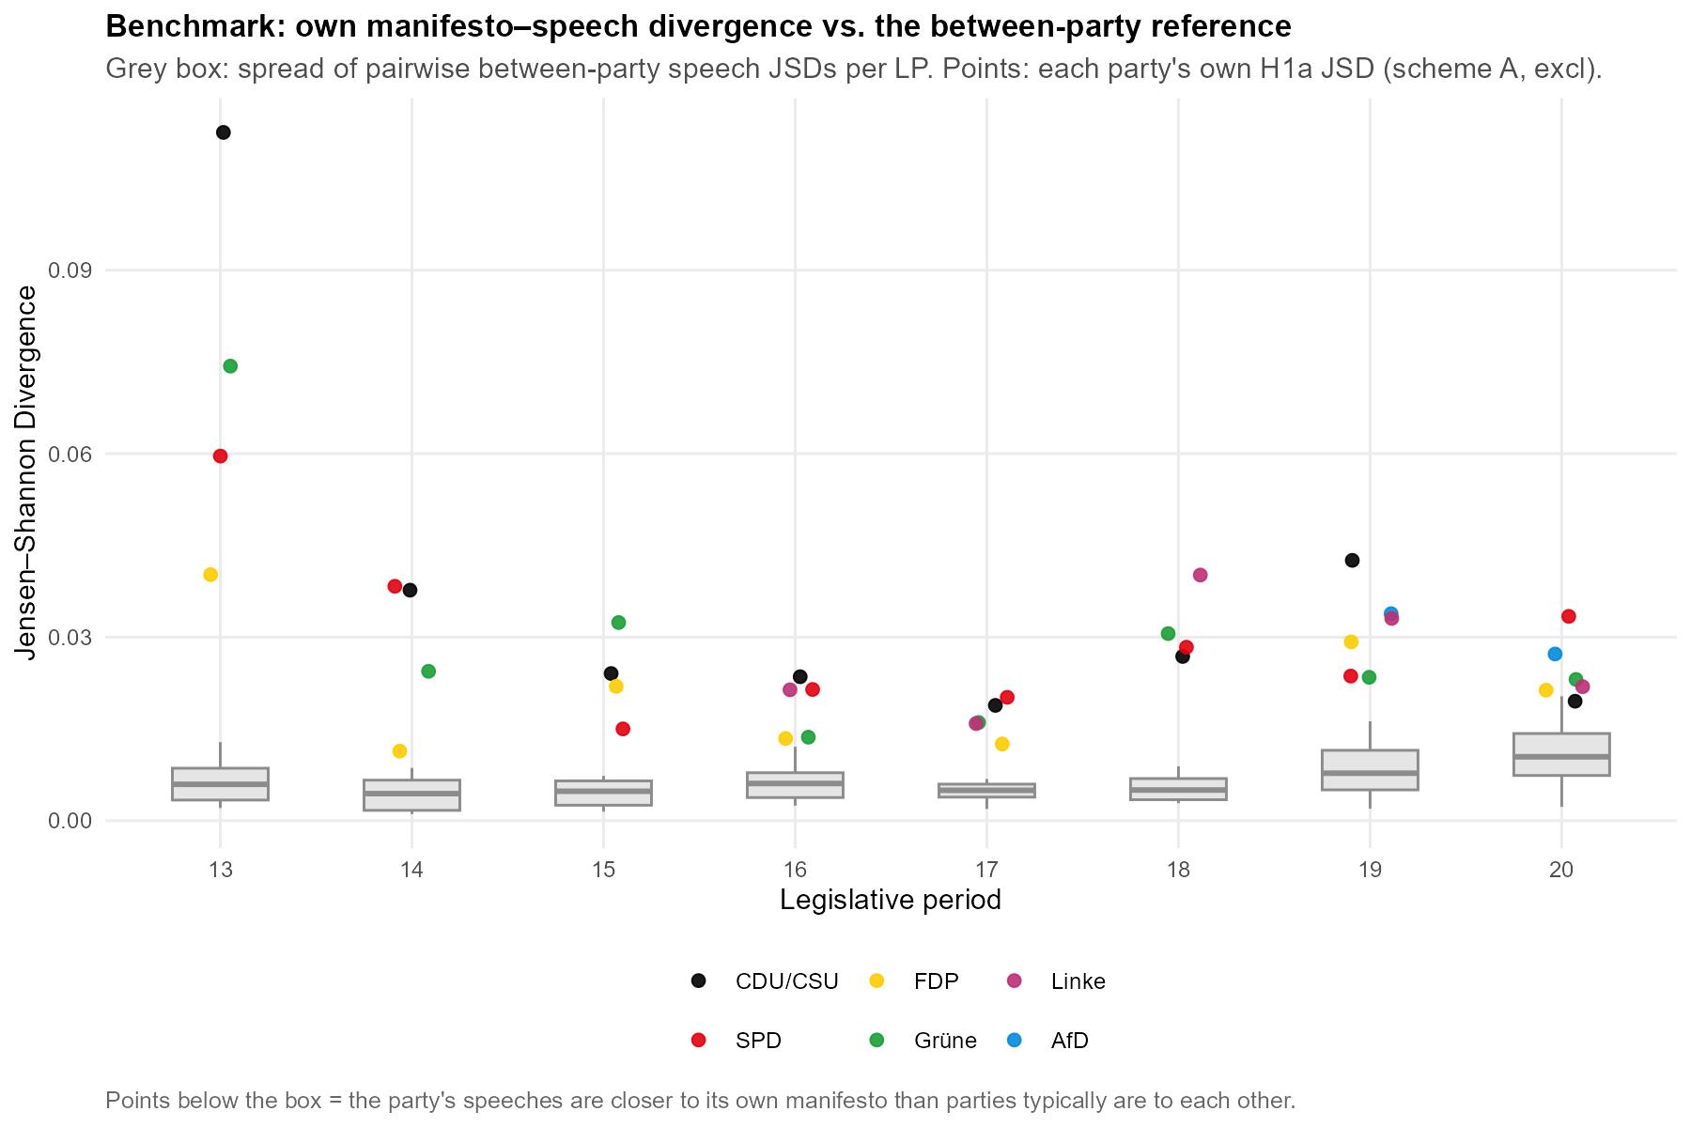Each cell value is reported with a 95% sentence bootstrap interval, and across the 38 cells these intervals are narrow, with a mean width of 0.0013 against point estimates ranging from 0.0114 to 0.1125. As Section 4.7.4 sets out, they are read as lower bounds on the total uncertainty, which is why we locate each cell on the reference scale rather than comparing the overlap of intervals between cells. On this scale the within-party divergence is intermediate rather than small, as its mean sits almost exactly halfway between the two reference points. On average, plenary speech neither reproduces the manifesto nor drifts as far from it as parties' programmes stand from one another. On the reference benchmark, the divergence stays below the programmatic differentiation between parties, but not by a wide margin. H1a as stated has two parts, and the two benchmarks separate them: the reference scale supports the first, since a party's speeches stay closer to its own manifesto than parties' programmes stand to one another, while the nearest-manifesto test of the next paragraph qualifies the second, since the own programme is recognisable far above chance but is not reliably the nearest.
Across parties the JSD values are relatively similar, with means of CDU/CSU 0.0382, SPD 0.0300, Grüne 0.0297, Linke 0.0265, FDP 0.0214, and AfD 0.0305 (n = 2). Their movement over time is not flat, however. Figure 5.2 shows this in six panels, one per party, each plotting that party's divergence for every legislative period. In each of the four parties observed since 1994 the points fall into a broadly similar shape: highest in LP 13, dropping to a trough somewhere between LP 14 and LP 17 depending on the party, and rising moderately again towards the end of the window. Averaged across parties, the legislative period means fall from 0.0717 in LP 13 to 0.0167 in LP 17 and return to around 0.03 (0.0315 in LP 18, 0.0310 in LP 19, 0.0244 in LP 20). Two features of the diagrams are worth noting. First, for each observation the bootstrap interval is depicted, but its bars are so short that they are barely visible against the points, so the shape of each party's series is not an artefact of sentence-level sampling, which is the only source of uncertainty these intervals capture. Second, the re-rise is broad but mild, its one exception being the CDU/CSU in LP 19, at 0.0426, the tallest point outside LP 13 anywhere in the figure.
Figure 5.2. Manifesto-speech salience divergence per party and legislative period, with 95% sentence-bootstrap intervals. One panel per party; each legislative period is paired with the manifesto of the election from which it emerged (Section 3.3). Aggregation A, primary specification.
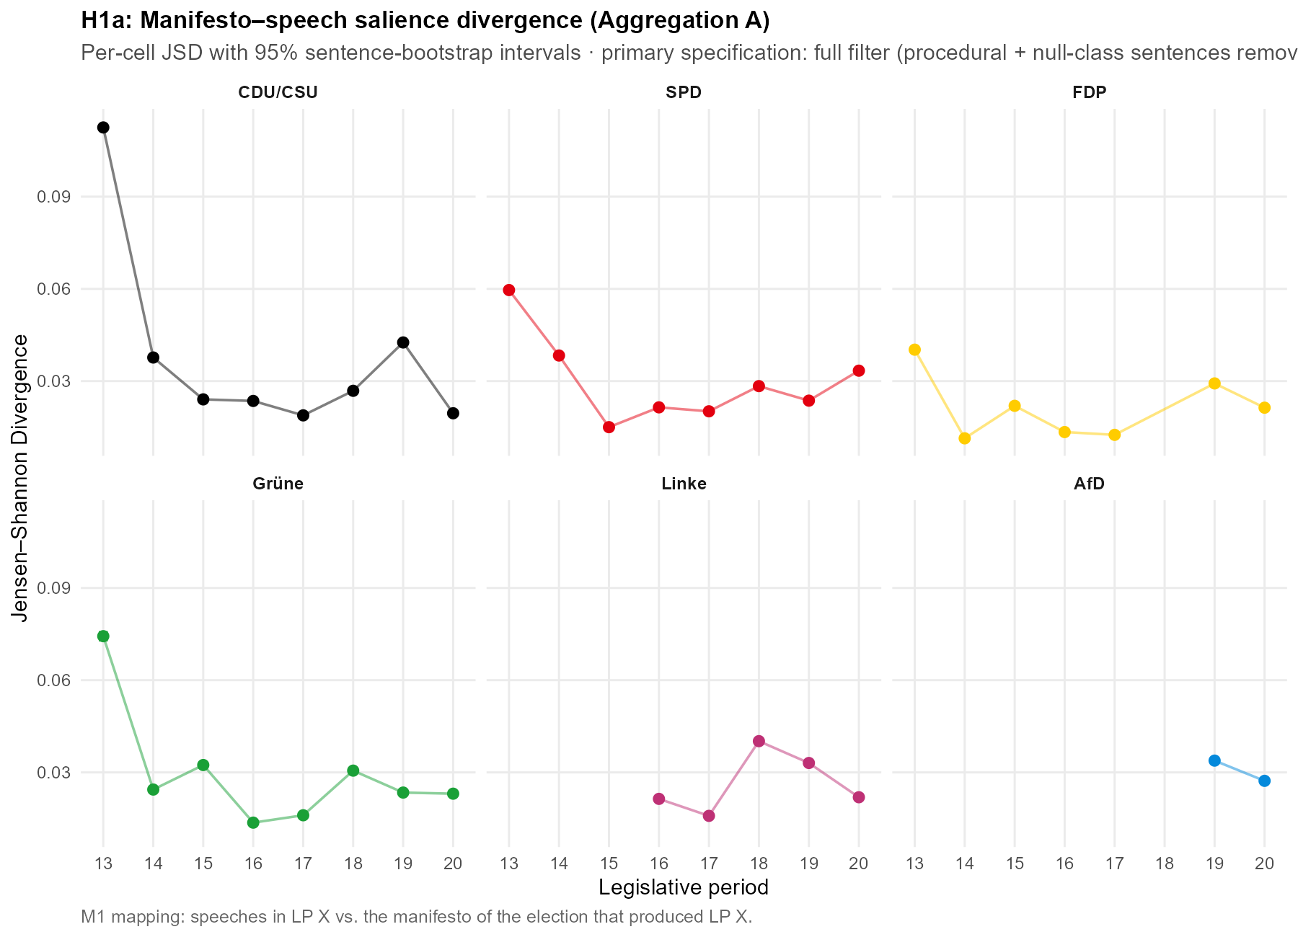The LP-13 column is what stands out. In four of the diagrams the 1994 cell is the highest the party reaches, at 4.4 times the CDU/CSU's own median, 3.1 times for the Grüne, 2.3 for the SPD, and 1.9 for the FDP. The three highest points in Figure 5.1 are the LP-13 cells of the CDU/CSU, the Grüne and the SPD; the FDP's LP-13 cell sits high but not exceptionally so. Because the peak recurs in every party present in 1994 rather than in one, we read it as a property of the period, not as four coincident outliers. That property sits on the manifesto side and at the edge of the observation window. The 1994 programmes are the earliest we observe, and they stand farther from each party's later, more settled manifestos of 1998 to 2021, which the genre-stable plenary speech most resembles, than any other election in the window. The step to the 1994 manifesto is unremarkable by the long-run standard of the three parties with a long coded record; for the Grüne, whose pre-1994 record is not captured by the party identifier used here, it is the largest of the observed transitions but small in absolute terms. The elevation is therefore a boundary effect of the window, not an anomalous 1994 document and not a coding or pipeline artefact, as Appendix F.10 shows. Excluding the window-boundary LP-13 cells lowers the mean JSD from 0.0297 to 0.0247, barely moves the median (0.0238 to 0.0235), and leaves both reference-scale comparisons in place, so no congruence claim rests on that period.
The other benchmark discussed in Section 4.8.1 is the nearest-manifesto test, which asks whether a party's own manifesto is the nearest to that party's speech agenda in a given LP. A party's own manifesto is the nearest in 42.1% of cells against a 21.1% chance baseline, and its mean rank is 1.87 against a chance expectation of 2.95; identification thus succeeds far above chance yet fails in a majority of cells, and a party's own manifesto never ranks worse than fourth. What is interesting here is the strong party heterogeneity in how often a party's own manifesto is the closest to its agenda: FDP 7/7, AfD 2/2, Grüne 4/8, CDU/CSU 2/8, SPD 1/8, Linke 0/5. Which manifestos the non-matching agendas gravitate towards instead follows a roughly consistent pattern. Across the cells in which a party's speeches are not closest to its own programme, the FDP manifesto is by a clear margin the most frequent nearest neighbour, and it is the nearest manifesto in 18 of the 38 cells overall. This is not an artefact of the FDP appearing often as a candidate: if we take the mean divergence from each of the 38 speech cells to every party's manifesto in the same period, the FDP programme sits closest to the pool of parliamentary speech at 0.0257, ahead of the SPD (0.0379), the Grüne (0.0396), the CDU/CSU (0.0463), the Linke (0.0524) and the AfD (0.0638), and it stays first when each party's distance to its own speech is excluded. Figure 5.3 sets this out in two panels. Panel A ranks the party programmes by that mean distance to the whole body of parliamentary speech, and the FDP sits clearly closest, with the Linke and the AfD farthest. Panel B shows why: the bars give the chamber's average agenda across the nine salience buckets, comparatively heavy on governance and economy and light on welfare and migration, and the overlaid points give the manifesto agendas of the FDP and of the two most distant programmes, so that the FDP is seen to track the parliamentary profile while the welfare-centred Linke and the migration-centred AfD depart from it most. It should be stressed that this is a statement about salience, that is, about which topics are emphasised, and not about position: the agenda of debate resembles the FDP's agenda, it does not show speech adopting FDP positions. How much of this resemblance reflects the institutional genre of a legislative chamber rather than a substantive lean is taken up in the conclusion (Chapter 6).
Figure 5.3. Where the parliamentary agenda sits among the party programmes. Panel A ranks each party's manifesto by its mean divergence to the body of parliamentary speech in the same period (lower = the programme the chamber's agenda most resembles). Panel B gives the chamber's mean agenda across the nine salience buckets (bars) against the manifesto agendas of the FDP and of the two most distant programmes (points). Salience, not position. Aggregation A, primary specification, 38 speech cells.
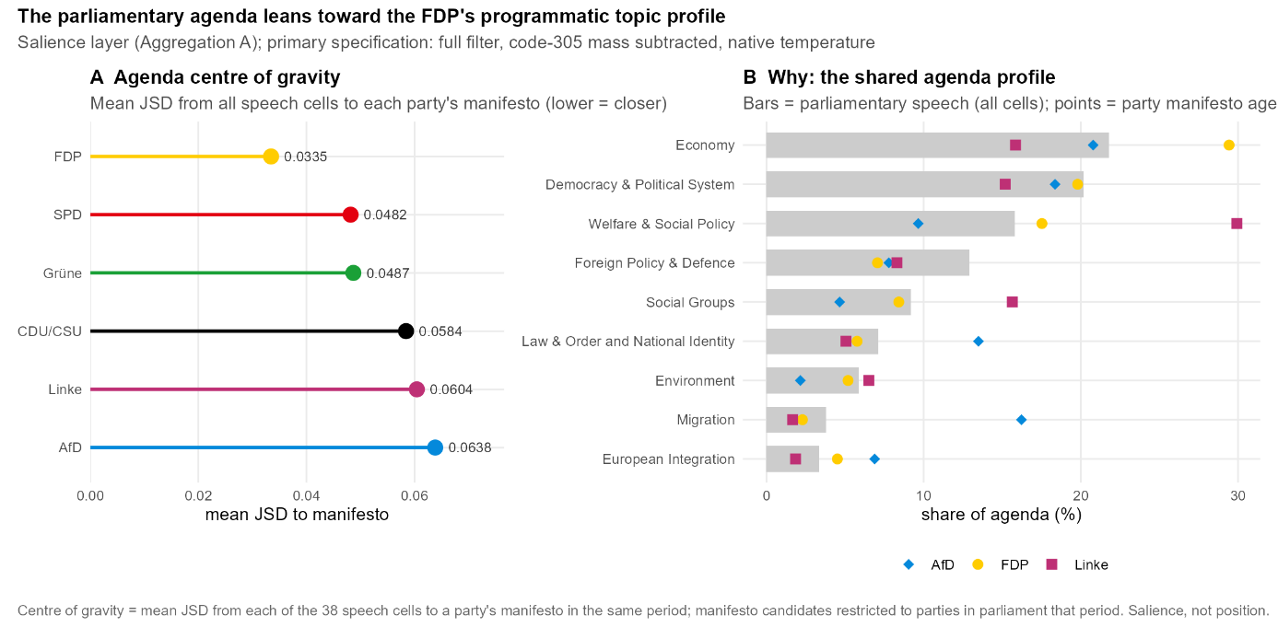

5.2.2 H1b
Overall, the mean JSD across the B buckets is 0.0506 (median 0.0520), with party-specific means of Grüne 0.0744, Linke 0.0676, AfD 0.0596, FDP 0.0440, CDU/CSU 0.0361 and SPD 0.0342. To analyse the directional differences between the two channels we compare the domain-pooled within-domain shares of manifestos and speeches. On migration, the restrictive share rises from 42.9% in manifestos to 68.4% in speeches. On the EU stance, the contra-EU share rises from 17.6% to 36.0%. Economy divides into three categories: speech is more market-liberal (23.2% to 29.2%) and correspondingly less interventionist (state intervention 32.9% to 29.3%, general economy 43.9% to 41.5%), so the market-liberal gain comes at the expense of interventionist rather than general economic language. Welfare is essentially unchanged between the channels (retrenchment 5.8% versus 7.4%).
The largest and clearest shift is on migration, where speeches carry a far higher restrictive share than the corresponding manifestos. Two reservations bound how this is read. First, a non-negligible part of the gap reflects general national-identity rather than multiculturalism language: re-splitting the migration bucket so that only the multiculturalism codes (607 and 608) define the restrictive and liberal poles (robustness arm 5) lowers the restrictive speech share from 68.4% to 48.6% and the manifesto share from 42.9% to 28.0%, even though the mean migration divergence barely moves (a matched mean change of −0.0062 across 36 cells). The composition shift is therefore material even where the divergence level is unchanged. Second, the direction itself is imperfectly identified: against the silver reference the classifier assigns "restrictive" too readily (precision 0.466, recall 0.753), so part of the speech-side overhang may be an assignment artefact. The same reservation attaches to the EU stance, where the classifier over-assigns contra-EU relative to the silver reference (precision 0.525), while the pro-EU pole is among the most reliably identified labels in the scheme. The welfare direction is too weakly identified (F1 = 0.148) to bear any interpretation beyond the near-identity just noted.
Figure 5.4 shows that this restrictive and EU-sceptic lean is not a uniform drift but a compression. The parties with the most liberal migration programmes move furthest towards the restrictive pole (the Grüne from 9.6% to 61.1%, the Linke from 0.3% to 54.4%, the FDP from 35.9% to 72.1%), while the two parties whose programmes are already restrictive move in the other direction, the CDU/CSU marginally (82.2% to 77.6%) and the AfD more clearly (99.0% to 85.4%); contra-EU follows the same pattern. The manifesto range of 0.3% to 99.0% on the restrictive share collapses to 54.4% to 85.4% in speech, a convergence of the parties onto a shared, restrictive-leaning speech profile rather than a shift of every party in the same direction. This cell-spanning compression is the same phenomenon that Section 5.3 measures on the position scale as cross-channel convergence.
Figure 5.4. Directional composition of manifestos and speeches within the four directional domains, averaged across LP 13 to LP 20. Bars give the within-domain share of each directional sub-label; row strips give each party's mean overall divergence on Aggregation B. The FDP's migration bar on the manifesto side does not fill the panel because the party's 1994 manifesto carries no migration-coded material. Aggregation B, code 305 retained; directional layer validated at κ(B) = 0.456.
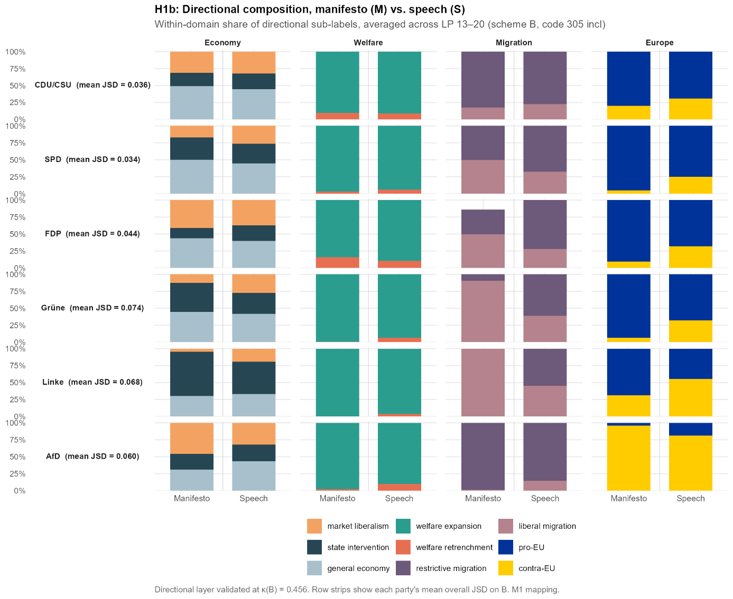
H1b is read here as a composition claim rather than as an identification claim, since no nearest-manifesto counterpart is computed on the directional layer, which the weaker validation floor of Section 4.5 would not carry. These findings are read as consistent with, rather than as demonstrating, a systematic pattern: plenary speech leans more restrictive on migration and more EU-sceptic than the same parties' manifestos, is modestly more market-liberal, and is almost indistinguishable on welfare, with part of the migration and EU lean attributable to coding behaviour we can name.

5.3 What Drives and Moderates Divergence (H2)
The second hypothesis family is concerned with what drives divergence, with emphasis on topic differences and how these in turn differ by parties.

5.3.1 H2a
Table 5.1: Per-bucket decomposition of the manifesto–speech divergence. Mean contribution of each of the nine salience buckets to the cell JSD, with standard deviation across cells and share of the mean JSD. Contributions sum exactly to the mean JSD. Aggregation A, primary specification, n = 38 cells.
Bucket | mean contribution | sd | share
Democracy & Political System | 0.0062 | 0.0088 | 20.9%
Welfare & Social Policy | 0.0048 | 0.0041 | 16.1%
Foreign Policy & Defence | 0.0047 | 0.0037 | 15.8%
Law & Order and National Identity | 0.0032 | 0.0065 | 10.6%
Environment | 0.0030 | 0.0046 | 10.0%
Migration | 0.0029 | 0.0040 | 9.6%
Economy | 0.0019 | 0.0026 | 6.5%
Social Groups | 0.0016 | 0.0024 | 5.3%
European Integration | 0.0015 | 0.0018 | 5.2%
The breakdown of the mean divergence across the nine topic buckets, as reported in Table 5.1, shows the mean per-bucket contributions, summing exactly to the mean JSD. The Democracy & Political System bucket holds the largest part of the divergences between speeches and manifestos at 0.0062 (20.9%) of the mean JSD. As discussed in Section 4.6, this bucket is already cut substantially by the two measures we implemented to alleviate the cross-domain topic-classification artefact. Both corrections therefore pull against the expectation under test: they remove mass from precisely the bucket H2a predicts will lead, and it leads all the same. This contribution should nevertheless be treated as only partly substantive, since the bucket probably still absorbs some forced misclassification. Second and third largest are Welfare at 0.0048 (16.1%) and Foreign Policy & Defence at 0.0047 (15.8%). The smallest contribution comes from European Integration at 0.0015 (5.2%). Figure 5.5 shows the individual party-period cells behind these averages. Their contributions are right-skewed, and while the most extreme cells are the LP-13 cells discussed in Section 5.2, the typical cell sits close to its bucket average, so the ranking does not rest on those few outliers.
Figure 5.5. Contribution of each salience bucket to the manifesto–speech divergence. Bars give the mean per-bucket contribution across the 38 cells; points give the individual party-period cells. Contributions sum to the cell JSD. Aggregation A, primary specification.
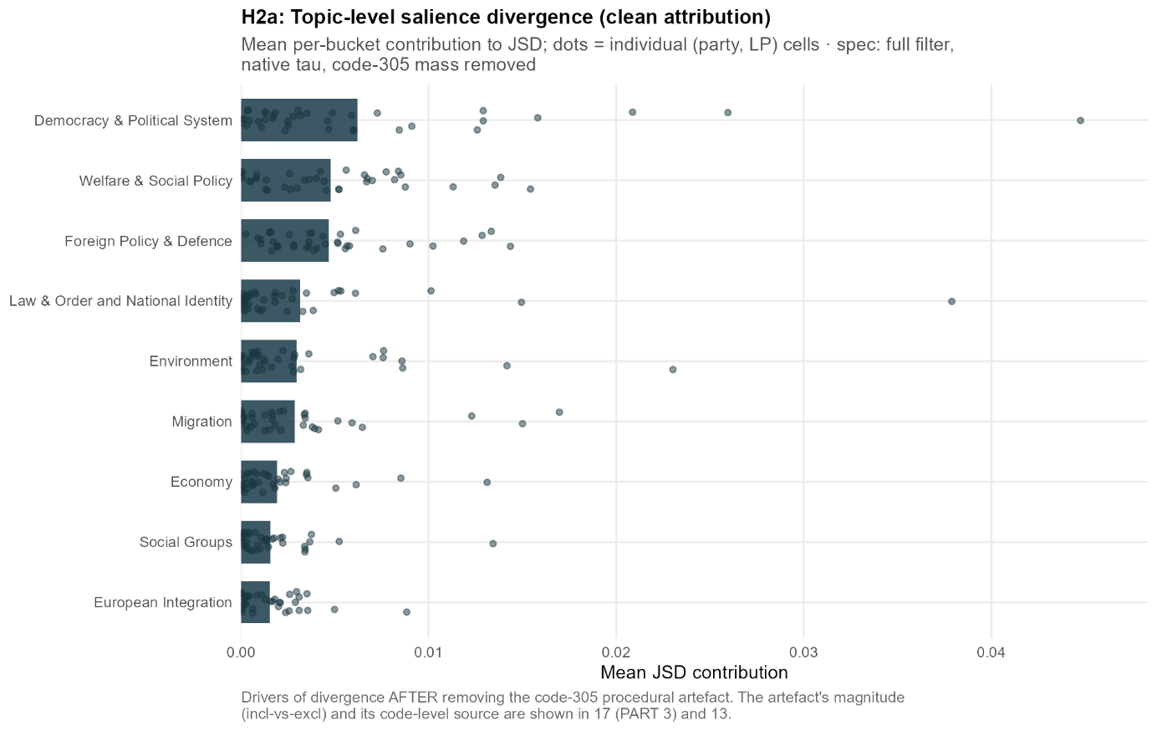
Figure 5.5. Per-bucket contribution to the manifesto–speech divergence (H2a). Bars give each salience bucket's mean contribution to the cell JSD, dots the individual party-period cells (n = 38). Aggregation A, primary specification: full filter, code-305 mass subtracted, native temperature. The artefact correction is set out in Section 4.6, and the exact values are in Table 5.1.

Beyond how much each topic contributes, the divergence also has a direction, and that direction is heterogeneous across topics. On some it is strikingly uniform across parties, while on others it is very party-dependent. Two topics take up a larger share of every party's plenary speech than of its manifesto: Democracy & Political System — the language of government — and Foreign Policy & Defence. The first rises from about 15% of the manifesto agenda to about 20% of the speech agenda, the second from about 7% to about 12%, and both rise for all six parties without exception. These are the only two topics on which every party moves the same way, so the shift is not the work of one or two parties but a property of the chamber. Figure 5.6 shows this directly: in the Democracy & Political System and Foreign Policy & Defence panels, every party's speech share sits above its manifesto share, whereas in the other panels the parties move in both directions.
The reverse movement, where a topic takes up less of the speech than of the manifesto, is real but far less uniform, and here the levels are what matter. Welfare is the clearest case. It fills a large part of the left's programmes, 31.9% of the Linke's manifesto agenda, 24.0% of the SPD's and 22.6% of the Grüne's, against only 12.4% of the CDU/CSU's and 9.7% of the AfD's. In speech these shares move towards one another. The Linke still gives welfare the most room of any party at 20.9%, but the wide spread across the manifestos narrows to a band between roughly 13% and 21%, as the parties that emphasise welfare most in their programmes pull back while the CDU/CSU and the AfD give it a little more room than before. What at first glance looks like the left downplaying welfare is therefore better read as the chamber converging on a common level. The remaining topics differ only in party-specific ways, such as the CDU/CSU giving law-and-order and national-identity language less room in speech than in its programme. We therefore read the divergence as a genre signature of parliamentary debate. Speaking from government and about the state and foreign affairs pulls every party's speech agenda in the same direction, whereas on the other topics it varies from party to party, on some issues along ideological lines. What this signature implies for reading legislative speech against manifestos is taken up more broadly in Chapter 6.
Figure 5.6. Manifesto and speech share of the salience agenda, by topic and party. Hollow points give the manifesto share, filled points the speech share; the connecting line is the manifesto-to-speech shift. The axis is shared across panels, so levels are comparable between topics. Aggregation A, primary specification, party means over legislative periods.
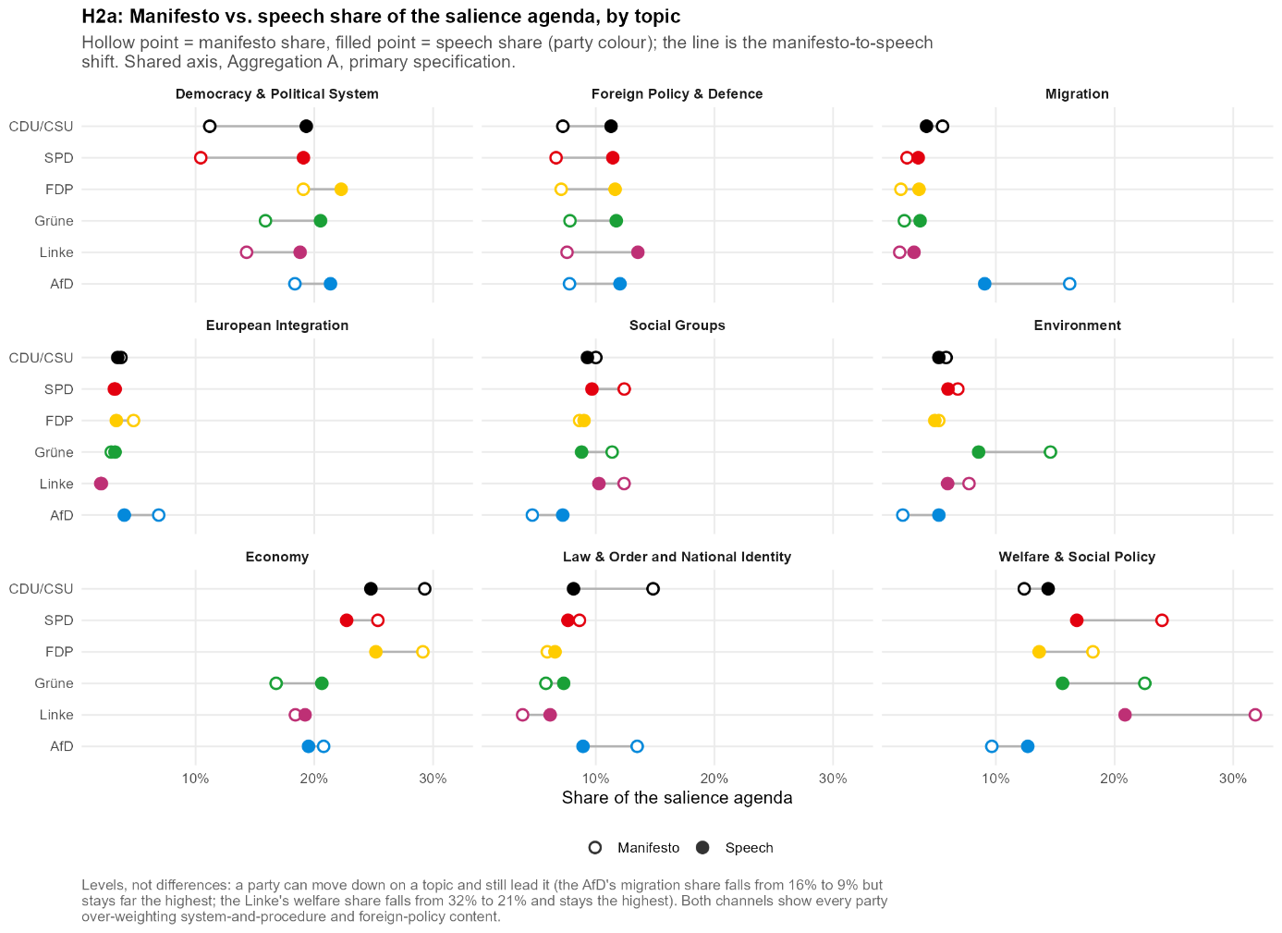

5.3.2 H2b
The goal of this analysis is to see how positioning in manifestos carries over into the positions parties take in plenary speech, broken down by domain. The main measure we introduce to analyse this is a position score in [−1, 1] that captures a party's directional position within a given domain. The spread of these positions across parties, which we take up in H2c, is what constitutes system polarisation. We code one pole of each domain as positive, namely the market-liberal, retrenchment, restrictive and EU-sceptic side, and the opposing pole as negative. Concretely we calculate for each domain: domain score = (positive pole − negative pole) / (sum of both poles). Note that in the economy domain we include only the two directional sub-categories and exclude the neutral one, since Economy is the only domain in scheme B that carries a non-directional category at all (Section 4.7.1). These scores are calculated for speeches from the classifier's directional sub-label shares and for manifestos from the MARPOR category shares. Because it is a ratio of the two directional shares within the domain, the score is independent of how salient that domain is, so it measures direction only and not the salience analysed under H1.
To compare the two channels, we implement a simple OLS model regressing the speech scores on the manifesto scores:
$$speech_{pol}= β_{0}+ β_{1}*manifesto_{pol}+ ε$$
The unit of observation is the cell (party-period), pooled over all parties and all LPs (n = 38, all valid party-period cells; for migration, n = 37). The slope $β_{1}$ measures how strongly the between-party differences in manifesto position carry over into differences in speech position. The intercept $β_{0}$ can be read as the estimated speech position of a party with a directionally perfectly balanced manifesto, which would mean a manifesto score of zero. R² reports how closely the cells fall along the fitted line, that is, the share of the variance in speech position that manifesto position accounts for. It is separate from the slope, since a line can be flat and still fit tightly.
Two effects have to be kept apart, since they show up in different coefficients. A slope below one is moderation, meaning the spread between parties shrinks from manifesto to speech, so they speak from positions closer to one another. That is not a move towards the centre, only towards each other. Where the compressed positions sit is read off the intercept together with the slope. The link between the two is exact, since the fitted line runs through the two-channel means, so the mean speech position equals β₀ + β₁ · mean manifesto position. The level shift is then the gap between the two means and depends on slope, intercept and starting level together, which is why we read compression from the slope and the level from the intercept.
In every domain the slope falls well below one, so moderation holds throughout. Economy sits at 0.389, Europe at 0.481, Welfare at 0.267 and Migration at 0.239, and manifesto position still predicts speech position well, with R² between 0.53 and 0.78, so the parties are drawn closer together without changing their order. The 38 cells are six parties observed over eight periods rather than independent draws, so these fits are read as descriptions of the pooled cloud, not as estimates with a sampling interpretation (Section 4.8.2). Migration is the tightest fit despite the flattest slope, so its parties keep their order even as their spread is squeezed hardest.
But the four domains differ in where the compressed positions sit. Welfare compresses in place, its party mean barely moving from −0.88 in manifestos to −0.85 in speech while the standard deviation of the positions falls from 0.18 to 0.07, so the parties converge onto a level that stays firmly on the expansion side. Migration does the opposite and relocates as a block towards the restrictive pole, from a manifesto mean of −0.14 to a speech mean of +0.36, its intercept of +0.40 lifting even a balanced manifesto across the line. This is a comparison pooled across cells; its development over time is taken up in Section 5.4. Economy compresses around a near-neutral level, from −0.14 to +0.01, and Europe compresses towards the centre while its mean stays on the pro-EU side, from −0.65 to −0.28.
Figure 5.7 plots speech position against manifesto position for the four domains, with the 45-degree line as reference. In every domain the fitted line runs flatter than the diagonal, which is the moderation, and it is migration whose cloud is lifted farthest above the line, clear across zero onto the restrictive side, which is the level shift.
Figure 5.7. Speech position against manifesto position, by domain. Each point is a party-period cell; the axes give the signed within-domain directional balance in each channel on the fixed range [−1, 1]. The dashed line is the 45-degree reference (perfect consistency), the solid line the per-domain OLS fit. A flatter cloud is compression, a cloud off the diagonal is a level shift. Aggregation B; directional layer validated at κ(B) = 0.456.
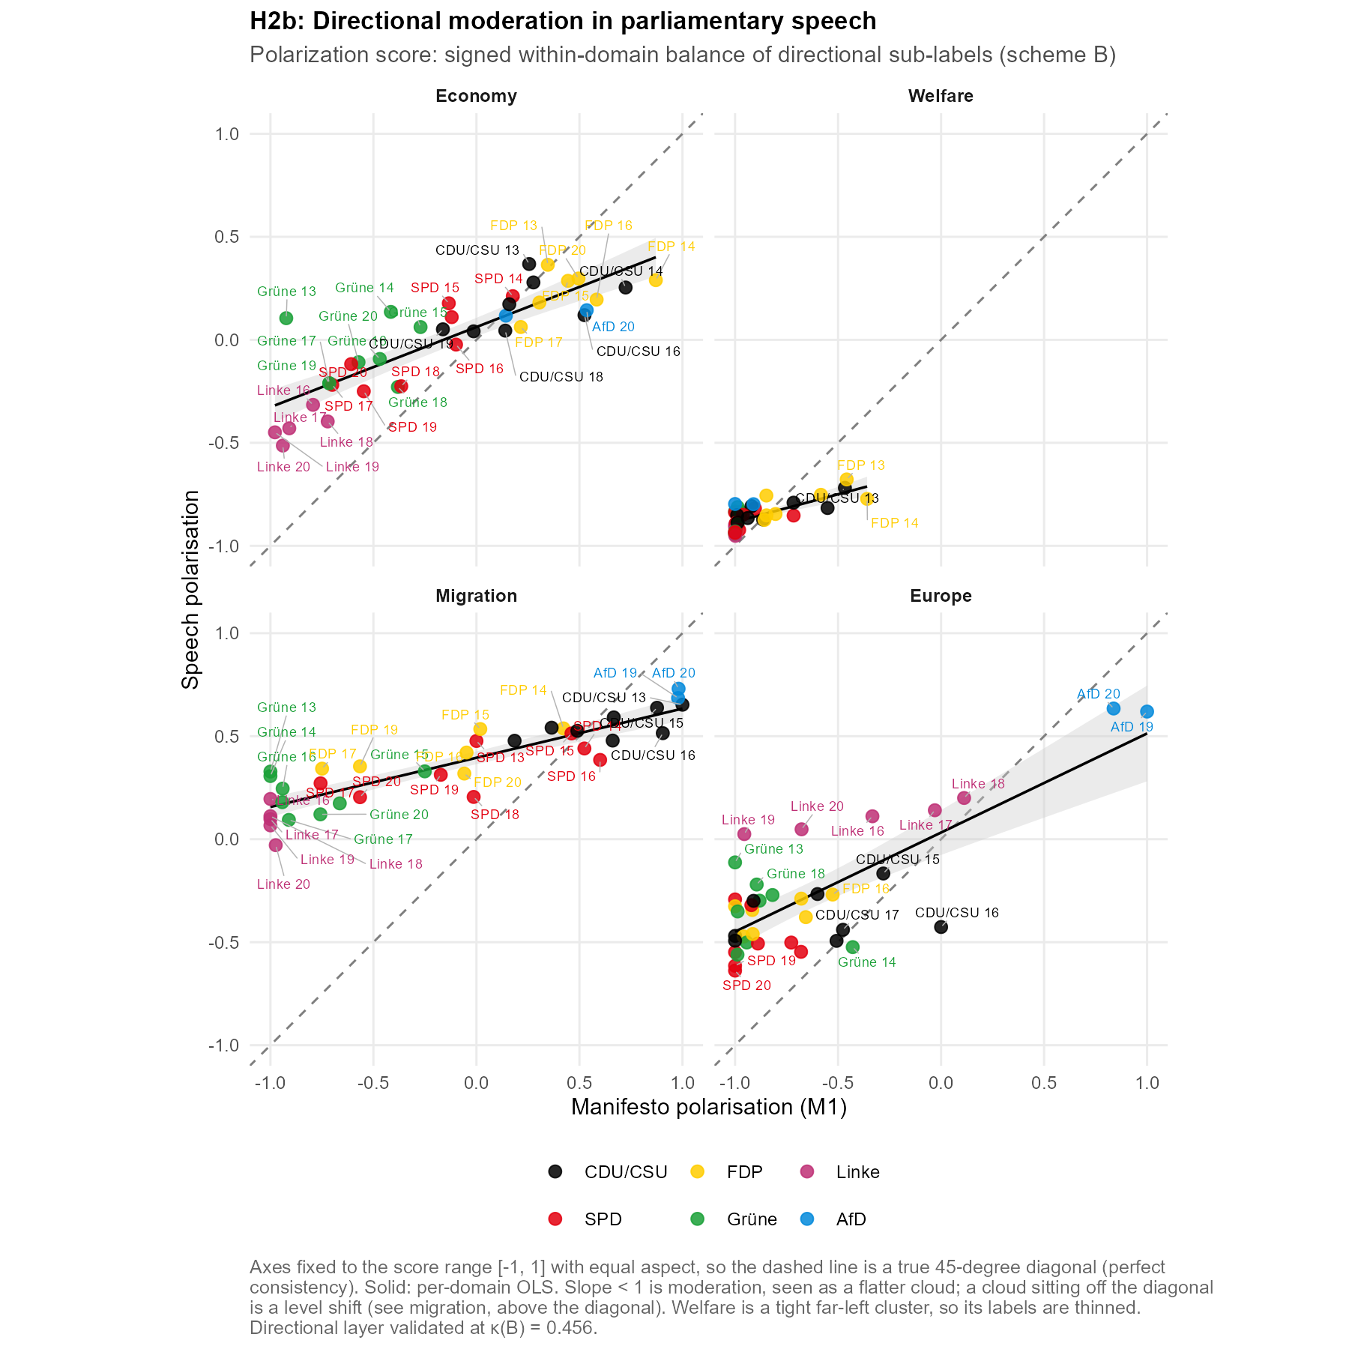
This result is read with caution, because the finding at issue, that migration shifts towards the restrictive pole, rests on one of the least reliably assigned labels in the scheme: restrictive-migration precision against the silver reference is 0.466, and contra-EU is only a little higher at 0.525. Only the welfare-retrenchment label is weaker still, and no reading in this chapter rests on it. Part of the migration shift may therefore be over-assignment of the restrictive label rather than a real relocation. The manifesto side is coded from MARPOR and is untouched, and the concern is the direction of the shift rather than its compression.

5.3.3 H2c
This hypothesis asks whether the directional positions disperse less across parties in plenary speech than in their manifestos. This is the cross-channel convergence that the compression of directional shares in Section 5.2.2 already pointed to, now measured on the position scale rather than in shares. To do this, we take the party-period position scores of Section 5.3.2 and compute their Dalton-weighted standard deviation across parties, for each legislative period, domain and channel, then compare the two channels directly. See Section 4.8.3 for the methodological discussion of the measures we employ here. While H2b analyses how much is carried over from manifestos to speech as a slope below one, suggesting that the spread between parties narrows, the approach taken in H2c measures that decline directly as the dispersion of those same positions across parties in each channel, weighted by the vote or seat share the party carries there. We read these dispersions as levels and compare them between channels here, while their change over time is discussed in Section 5.4.
The analysis suggests that there is a decline in the weighted SDs of the position scores for each domain going from manifesto to speeches, although the size of the gap varies considerably across domains. Figure 5.8 plots the two channels side by side for each domain, the filled speech marker sitting to the left of the hollow manifesto marker throughout. Averaged over all periods, dispersion falls from 0.386 on the manifesto side to 0.138 on the speech side in the Economy domain, from 0.551 to 0.136 on Migration, from 0.104 to 0.035 on Welfare, and from 0.345 to 0.222 on Europe. Read as a mechanism, the pattern is the same in every domain. Parties show clearly separated positions in their programmes and then speak from a much narrower band, so the programmatic distances between them contract once the debate moves into the chamber. Migration shows this most sharply because its parties start furthest apart, from the widest manifesto spread of the four down to about a quarter of it. This convergence onto a shared band is what H2 anticipated as a response to the common parliamentary agenda; why the chamber compresses positions in this way is taken up in Chapter 6.
The convergence holds not only on average but period by period, with speech dispersing less than manifestos in 31 of the 32 domain-period pairs. The one exception is Europe in LP 13, where the 1994 manifestos are barely dispersed on Europe at all, an emergence that Section 5.4 traces. Europe's high spread at the other end of the window has a clear compositional source. In LP 19 and LP 20 the manifesto dispersion is at its highest, 0.677 and 0.567, and most of it comes from the AfD. Recomputed without that party it falls to 0.014 and 0.078, and the speech dispersion roughly halves, from 0.396 and 0.392 to 0.188 and 0.187. It is the presence of one party at the EU-sceptic end of the scale, not a widening among the established parties, that accounts for the Europe spread in these periods.
Figure 5.8. Inter-party dispersion of directional positions, manifesto against speech. Dalton-weighted standard deviation of party position scores, averaged over legislative periods; hollow = manifesto (weighted by vote share), filled = speech (weighted by seat share). Aggregation B; directional layer validated at κ(B) = 0.456.
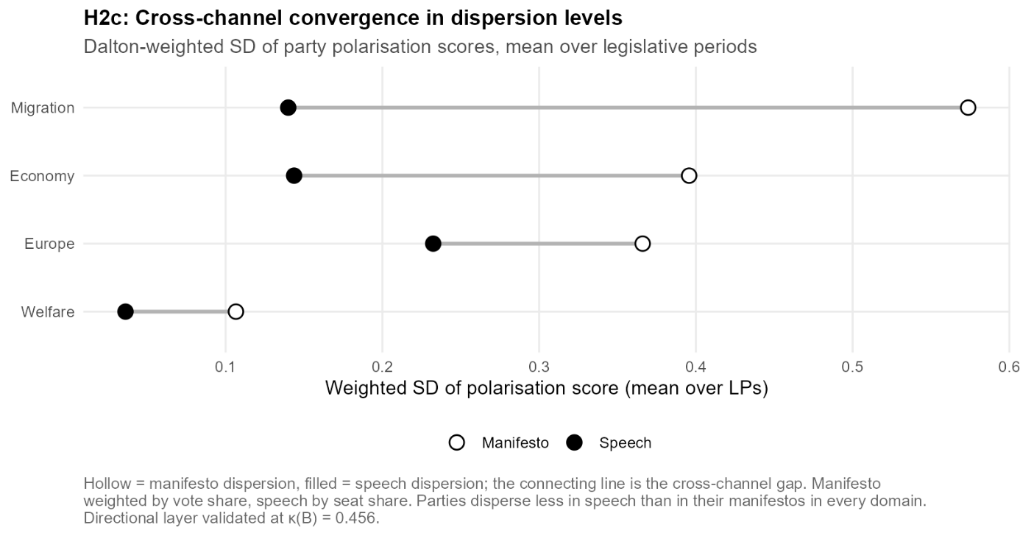

5.4 Polarisation over Time (H3)
H3 asks whether system-level polarisation — measured by the Dalton-weighted standard deviation of position scores, the same measure used in Section 5.3.3 — increases over the observation period, in particular in the Europe and Migration domains and around the AfD's parliamentary entry in 2017. We analyse the changes in this measure to describe domain-specific trends over time but refrain from claiming causality since we read these as trends rather than as tests. A full discussion of the measure utilised here is found in Section 4.8.3.
To analyse the time trends we fit a simple OLS regression of polarisation on the legislative period, separately for each domain and channel, with the period entering as a numeric variable from 13 to 20.
$$polarisation=β_{0}+ β_{1}*LP+ ε$$
The unit of observation is the period (n = 8). The slope $β_{1}$ is the mean change in weighted dispersion per period, while the intercept $β_{0}$ has no meaningful reading, being the extrapolated value at period zero. R² reports how closely the eight points follow a straight line, and standard errors are reported but not read as significance tests, in line with Section 5.1. To localise the AfD's contribution, each fit is run a second time without the party, its weight redistributed over the others (arm 6, Section 4.9), so that only the periods in which it carries weight change. The difference between the two slopes then isolates the share of a trend that hangs on the party's entry: where the estimates coincide, the trend is independent of it, and where they diverge, it is carried by the changed composition of the system.
Europe is the one domain where the fits register a clear rise in both channels, at a manifesto slope of 0.0769 per legislative period (SE 0.0139, p = 0.001) and a speech slope of 0.0407 (SE 0.0080, p = 0.002). Figure 5.9 shows that the rise is concentrated in the last two periods rather than steady, and that the window opens with Europe almost undispersed in the 1994 manifestos, so the conflict axis emerges within the window rather than being present at its start. The two periods that carry the jump follow the euro crisis and the AfD's foundation as an anti-euro party in 2013, with its entry into the Bundestag in 2017. Refitting without the AfD turns both trends flat, the manifesto slope flipping from 0.0769 to −0.0079 and the speech slope falling to 0.0113, the largest exclusion effects in the battery (Figure 5.10). The sign-flip locates the rise in the AfD's own position rather than in any movement of the established parties, confirming on the trend what Section 5.3.3 showed on the level.
This is less surprising than it looks. That a weighted dispersion measure jumps when one party enters at the pole opposite all the others is arithmetically expected, and Europe is the least salient of the four domains, so its scores rest on little text. What the decomposition adds is the quantification: almost the entire rise is compositional. The established parties do not move apart on this domain — in the manifesto channel they in fact converge sharply, their dispersion excluding the AfD falling from 0.261 in LP 18 to 0.014 in LP 19, which is what turns the refitted slope negative. That is the caution a system-level polarisation series calls for: a rising curve need not mean parties are drifting apart, and here it coincides with the established parties moving closer together. The speech side may in addition be inflated by the over-assignment of contra-EU, taken up below, while the manifesto series is MARPOR-coded and unaffected.
Figure 5.9. Inter-party dispersion over the observation period, by domain and channel. Dalton-weighted standard deviation of party position scores per legislative period, with and without the AfD. The AfD enters the speech channel at LP 19 and the manifesto channel at LP 18. Note the free y-axis per panel. Aggregation B; directional layer validated at κ(B) = 0.456.
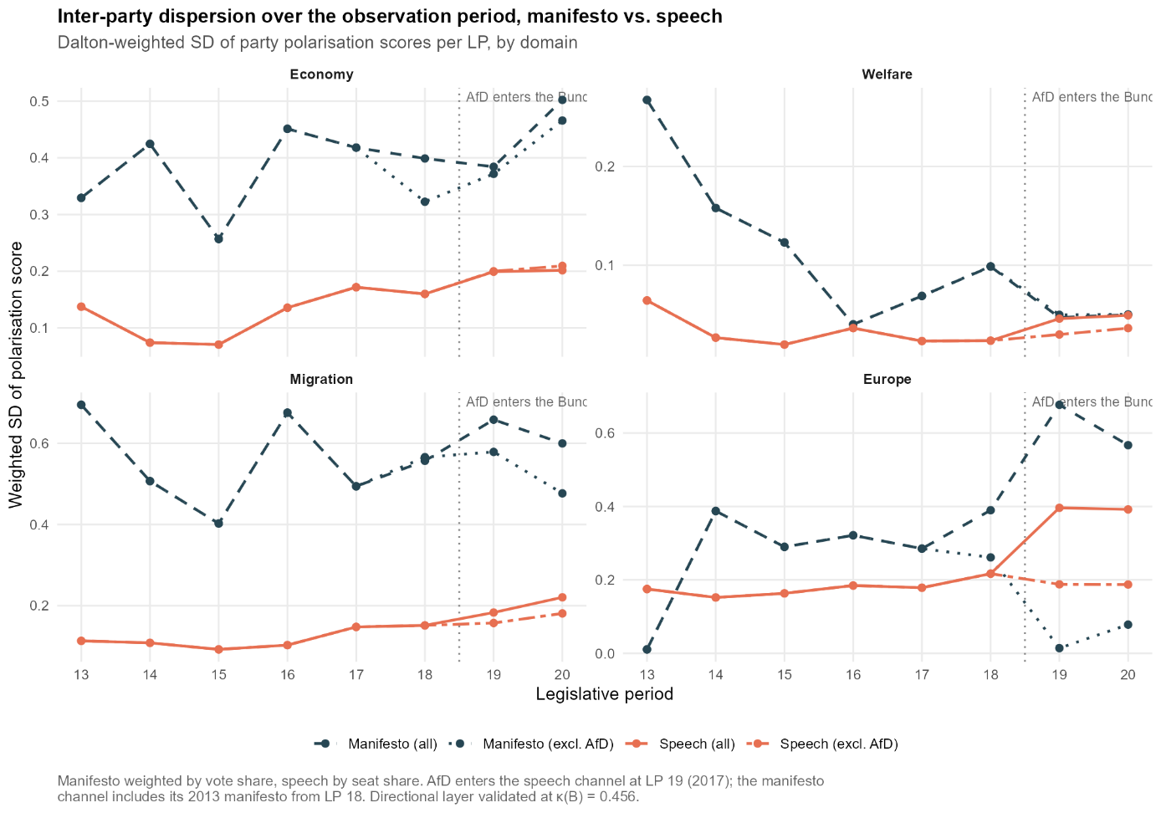
Figure 5.10. Polarisation trend slopes, all parties against excl-AfD. OLS slope of Dalton-weighted polarisation on legislative period, per domain and channel; coinciding points indicate a trend that does not depend on the AfD. Standard errors and p values are given in Table 5.2 and are read descriptively. Aggregation B.
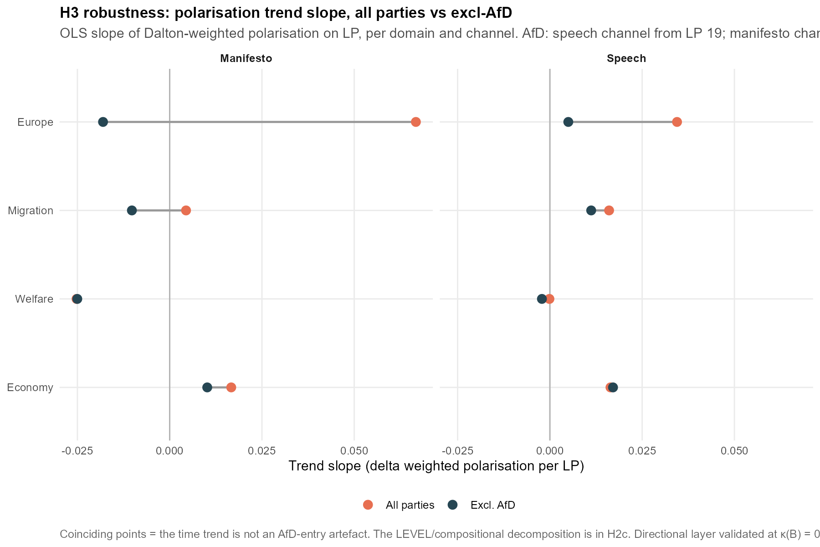

The other domains do not follow the Europe pattern, which is why we report all four in Table 5.2. In the economy domain the speech slope is +0.0195 (p = 0.016) and stays practically unchanged without the AfD (+0.0201), so speech-side polarisation in economic policy rises with or without the party. In welfare the movement sits on the manifesto side, where the slope is −0.0240 (p = 0.022) and equally robust to the exclusion (−0.0238), while the speech series stays flat (+0.0002 against a standard error of 0.0026, indistinguishable from zero at this resolution). This programmatic de-polarisation also explains the near-meeting of the two channels at the close of the window, at 0.047 against 0.046 in LP 19 and 0.050 against 0.049 in LP 20, visible in the welfare panel of Figure 5.9: it is the manifesto dispersion falling to the already low level of speech, not speech rising to it. In migration the speech slope of +0.0181 (p = 0.001) drops to +0.0132 (p = 0.001) without the AfD, so part of the rise hangs on the party, but a part remains that does not. The migration manifesto slope is close to zero on either side of the exclusion, at +0.0154 with all parties and +0.0007 without the AfD, so we read it as flat. The overall positive trend on the speech side for migration is, on closer inspection, largely attributable to the periods from LP 17 (2009 to 2013) onwards, beginning before the 2015 migration crisis and steepening over the periods that contain and follow it. In Figure 5.10 all these pairs lie almost on top of each other, which is the visual counterpart of the same point: these trends are not an artefact of the AfD's entry. While the Europe trend is likely compositional, the movements in the other domains are weaker but harder to attribute to composition, since they persist within the established party set. The two clearest movements among the established parties run in opposite directions, rising polarisation in economic policy speech and declining polarisation in welfare programmes.
The residual rise the preceding paragraph leaves on migration invites one further question, because the dispersion measure is invariant to the level. If every party shifted by the same amount the weighted standard deviation would not move at all, so a modest rise is compatible with the chamber drifting as a block as much as with the parties moving apart. On migration the difference is not academic, since the two readings imply opposite things about where the chamber sits. The weighted mean position, which the same formula returns alongside the dispersion, separates them. Speech dispersion more than doubles across the window, from 0.104 in LP 13 to 0.221 in LP 20, while the weighted mean moves in the opposite direction, from +0.554 to +0.344, that is, towards the liberal pole rather than the restrictive one. Disaggregated by party, the pattern is a fan rather than a drift. Between LP 13 and LP 20 every established party moves towards the liberal pole — the Grüne from +0.33 to +0.12, the SPD from +0.48 to +0.20, the FDP from +0.59 to +0.32 — and the CDU/CSU moves least, from +0.65 to +0.54. The Linke, which enters the analysis sample in LP 16, moves from +0.20 to −0.03 and is the only party whose balance ends on the liberal side of zero. The AfD enters at +0.69, above the entire previous range, and moves to +0.73. Removing the AfD leaves the dispersion rising to 0.181 rather than 0.221, so about two thirds of the increase is carried by the parties already present. This is what the residual consists of, and it is the counterpart to Europe, where the same decomposition removed the rise almost entirely.
The same reading applies beyond migration. Across the window the weighted mean moves by −0.22 on economy and by −0.12 on welfare in speech while the corresponding dispersions move by +0.07 and −0.01, and on the manifesto side the migration mean moves by −0.54 while its dispersion falls slightly. In each case the level moves further than the spread, and a series reporting only the spread would have missed it. Figure F.9.2 reports these means for all four domains and both channels, and Figure F.9.4 sets the migration trajectories beside the system series. Whether the parties moved and whether they moved apart are separate questions, and only the second is what a dispersion series reports.
Table 5.2: Polarisation trend slopes by domain and channel. OLS slope of the Dalton-weighted dispersion of party position scores on legislative period (n = 8 periods per fit), with the standard error in parentheses, alongside the same fit with the AfD excluded and its weight redistributed (arm 6, Section 4.9). Δ slope = slope (all parties) − slope (excl. AfD). p values are reported as descriptive quantities and are not read as significance tests (Section 4.8.3). Aggregation B; directional layer validated at κ(B) = 0.456.
Domain | Channel | Slope (SE) | p | Slope excl. AfD | p | Δ slope
Economy | Manifesto | +0.0208 (0.0102) | 0.086 | +0.0143 | 0.242 | +0.0065
Economy | Speech | +0.0195 (0.0059) | 0.016 | +0.0201 | 0.014 | −0.0007
Welfare | Manifesto | −0.0240 (0.0078) | 0.022 | −0.0238 | 0.023 | −0.0002
Welfare | Speech | +0.0002 (0.0026) | 0.932 | −0.0018 | 0.446 | +0.0020
Migration | Manifesto | +0.0154 (0.0183) | 0.431 | +0.0007 | 0.969 | +0.0147
Migration | Speech | +0.0181 (0.0032) | 0.001 | +0.0132 | 0.001 | +0.0049
Europe | Manifesto | +0.0769 (0.0139) | 0.001 | −0.0079 | 0.725 | +0.0848
Europe | Speech | +0.0407 (0.0080) | 0.002 | +0.0113 | 0.011 | +0.0295
Table 5.2: Descriptive OLS trend slopes of the Dalton-weighted polarisation on the legislative period, per domain and channel (LP 13 to 20, n = 8 points per fit), for all parties and refit without the AfD (arm 6, Section 4.9). Δ slope is the difference between the two estimates and localises the AfD's contribution to a trend. The manifesto channel is weighted by vote shares and the speech channel by seat shares, with the AfD carrying weight in the manifesto channel from LP 18 and in the speech channel from LP 19 (Section 4.8.3). Standard errors in parentheses. The p values are reported for transparency and are not read as significance tests (Section 5.1). Directional layer: weaker validation floor (Section 4.5).
The trend slopes compress each path into a single line, but, as Figure 5.9 shows, the Europe path is closer to a jump, which is also why the fits are not perfectly linear. As a model-free view we compare the mean dispersion before and after the AfD's entry, LP 13 to 18 against LP 19 to 20. For Europe the manifesto mean rises from 0.2527 to 0.6219 (+0.3692) and the speech mean from 0.1650 to 0.3942 (+0.2291). The remaining domains move far less, +0.0878 for migration and +0.0836 for economy on the speech side and −0.0738 for welfare on the manifesto side. With six pre-entry and only two post-entry periods, this is a description, not a test, and the pre period already carries an AfD contribution in the manifesto channel from LP 18 (Section 4.8.3), so the manifesto contrast is understated if anything.
The speech side of the Europe series carries the caveat we flagged above. Against the silver reference the classifier over-assigns contra-EU (precision 0.525, F1 = 0.634), applying the label about one and a half times as often as the Sonnet reference does, while the gold standard contains too few contra-EU sentences to quantify it at all (n = 3). This is the mechanism that can inflate a speech-side polarisation signal, since hostile rhetoric, in particular from the AfD, may be read as EU rejection. The asymmetry matters for how far the two sides can be trusted: the pro-EU pole reaches an F1 of 0.800 against the contra-EU pole's 0.634, so the pro-EU side of the series is the more reliable one. The manifesto series does not run through the classifier, and since the sign flip sits on the manifesto side, the core reading of this section does not depend on this label.

5.5 Robustness
This section reports the robustness battery of Section 4.9. All six arms were specified in advance; arms (1) to (3) carry pre-committed acceptance criteria, while arms (4) to (6) are sensitivity designs that report the shift a variant induces. The outcomes are reported as they came out. Arms 1 and 2 are applied to H1a on Aggregation A and to H1b on Aggregation B, so both aggregations are tested at the layer at which they are constructed. They are not repeated for H2 and H3: those analyses use a different functional of the same distributions, a within-domain ratio rather than a divergence, so the rank stability established here does not transfer to them automatically, and their results carry the corresponding caution on top of the validation floor of Section 4.5.
Table 5.3: Pre-committed robustness arms 1 and 2. Spearman rank correlation between the 38 cell rankings of each pair of variants, computed separately for H1a on Aggregation A and H1b on Aggregation B. ✓ = the pre-committed acceptance criterion of Section 4.9 is met, ✗ = it is missed; the criterion is ρ ≥ 0.90 for the temperature arm and ρ ≥ 0.85 for the threshold arm. Arm 2 runs on the code-305-inclusive basis for construction reasons and compares rank orders, never levels (Section 4.9).
Arm | Comparison | H1a (A) | H1b (B)
Temperature (1) | sharp vs native | 0.970 ✓ | 0.956 ✓
 | sharp vs flat | 0.579 ✗ | 0.706 ✗
 | native vs flat | 0.729 ✗ | 0.843 ✗
Threshold (2) | soft vs hard 0.4 | 0.943 ✓ | 0.861 ✓
 | soft vs hard 0.5 | 0.929 ✓ | 0.772 ✗
 | hard 0.4 vs hard 0.5 | 0.996 ✓ | 0.964 ✓
Table 5.3: The two robustness arms that carry a pre-committed rank-correlation criterion (arms 1 and 2 of Section 4.9). Each entry is the Spearman rank correlation between the rankings of the 38 party-period cells under two specifications, reported for the salience layer (H1a, Aggregation A) and the directional layer (H1b, Aggregation B) separately. The temperature arm rescales the sentence posteriors before aggregation, with sharp τ = 0.5, native τ = 1 and flat τ = 2. The threshold arm replaces the soft aggregation of the primary specification with argmax assignment at cut-offs of 0.4 and 0.5. The criteria were fixed before the analysis, ρ ≥ 0.90 for the temperature arm and ρ ≥ 0.85 for the threshold arm. A tick marks a pass and a cross a miss. The threshold arm is computed on code 305 included for construction reasons, so it compares rank orders across the cells and not divergence levels (Section 4.9). Full per-cell results are in Appendix F.6 for the temperature arm and F.7 for the threshold arm.
Two things are stable across both layers. The temperature effect between the sharp and native variants holds at 0.970 and 0.956, so neither ranking depends on the calibration sharpness inherited from the classifier within that range. Sharp against native is the comparison that carries that claim, since both are calibrations under which the pipeline could plausibly have run. The flat variant is not one of them. It fails on both layers, and it inflates the divergence itself, from 0.0297 to 0.0368 on H1a and from 0.0506 to 0.0852 on H1b. The pre-committed criterion is missed, and we report it as missed. Read after the fact, the failure is uninformative about the primary specification rather than a threat to it: raising the temperature to 2 pushes every posterior towards the uniform distribution, which is not a calibration the pipeline could plausibly have run under. What the arm establishes in retrospect is that the measure responds at all rather than returning the same ordering whatever it is fed. The two layers part company on the threshold arm. On the salience layer the choice between soft and hard aggregation is close to inconsequential, from 0.929 to 0.996, while on the directional layer it is not, with the soft-to-hard comparison at the higher cut-off falling to 0.772. This is the same fragility that led us to read every scheme-B result with more caution. We read it as reflecting the finer-grained directional distinctions the B scheme draws, which rest on the less reliable code-level signal noted in Section 4.5.
The per-cell detail behind these correlations is given in the appendix. Appendix F.6 plots the temperature sweep cell by cell, showing that the flat variant visibly reshuffles the ordering that the sharp and native variants preserve. Appendix F.7 plots each hard-threshold variant against the soft baseline; in it the points track the identity line up to a level shift, which is what the rank correlations summarise. The remaining arms are reported where their design concern arises. Arm 3, which crosses the filter ladder with the code-305 treatment, is reported with the corrections themselves in Section 4.6.2 and Appendices F.1 and F.3, where the two corrections are shown to be complementary rather than redundant.
Arm 4, a tightened prefilter of at least eight words per sentence, was specified as a sensitivity check on H2a. It is subsumed by the full filter, which already removes the sentences it targets, and is therefore not reported separately. Arm 5, the re-split of the migration axis to the multiculturalism codes alone, is reported with the directional composition in Section 5.2.2, where it lowers the restrictive shares without moving the migration divergence. Arm 6, the refit of the polarisation trends without the AfD, is reported with the trends themselves in Section 5.4, where it localises the European rise to the party's own position and weight.
The corrections also do not buy their lower headline numbers at the price of wider uncertainty. Across the six bands that cross the filter ladder with the code-305 treatment at native temperature, the sentence bootstrap intervals do not widen as the corrections are applied. The mean interval width is 0.0013 for all three code-305-excluded bands against 0.0016 to 0.0017 for the included bands. For the code-305-included bands the mean divergence falls from 0.0715 without a filter to 0.0641 under the procedural filter and 0.0510 under the full filter; for the excluded bands the corresponding values are 0.0333, 0.0322 and 0.0297. The excluded bands are, if anything, the tighter ones. The full table of the six bands is given in Appendix F.3.
In sum, the results are robust to moderate temperature variation on both layers and to the argmax alternative on the salience layer, but they are not robust to extreme flattening, and the directional layer inherits part of that fragility, consistent with its weaker validation.

5.6 Summary of Findings
H1a holds in the sense the reference scale defines: a party's speeches stay closer to its own manifesto than party programmes stand to one another, at 0.57 of that distance, though the own programme is the nearest of all programmes in only 42.1% of cells. H1b is read as a composition claim and is consistent with a systematic pattern rather than demonstrating one, since speech leans restrictive on migration and EU-sceptic on Europe, is modestly more market-liberal, and is almost unchanged on welfare. H2a holds: the divergence concentrates rather than spreads, the Democracy & Political System bucket leads at 20.9% of the mean divergence even after both corrections, and two topics move the same way for all six parties. H2b holds: the slope falls well below one in every domain, and migration adds a level shift to that compression. H2c holds: dispersion is lower in speech than in manifestos in all four domains and in 31 of the 32 domain-period pairs. H3 holds only in part and only descriptively, since polarisation rises on Europe in both channels but the rise is compositional and disappears when the AfD is excluded, while the smaller rises on economy and migration in speech survive the exclusion. Every finding on the directional layer carries the weaker validation floor of Section 4.5.

Conclusion
How does the agenda a party announces in its manifesto compare with the agenda it practises in parliament? To answer this question, this thesis has compared the manifestos and the plenary speech of the parties represented in the Bundestag in one shared category scheme, across 38 party-period cells spanning eight legislative periods from 1994 onwards. The distance between the two agendas is measured as the Jensen–Shannon divergence between their topic distributions, a distance in emphasis rather than position, and it is read against a scale derived from the parties themselves: how far their speech agendas typically stand from one another at the lower end, and how far their manifestos do at the upper end. The observation window also contains the parliamentary entry of a challenger party, which lets us follow how a new competitor registers in both channels. The answer is two-sided. Parties practise their announced agendas to a recognisable degree, and the institution they speak in bounds how much of the manifesto carries into the chamber.
On that scale, the divergence sits between the two references, at roughly four times the typical distance between parties' speech agendas yet only 0.57 times the typical distance between their manifestos. A party's own manifesto is identifiable in its speech agenda far above chance, but it is the nearest manifesto in only 42.1% of cells against a chance baseline of 21.1%. The identification varies strongly across parties, with the FDP and the AfD matching their own programme in every period, the Linke in none, and the remaining parties in between. The congruence between the two channels is therefore real but institutionally capped, as the review led us to expect. Plenary speech neither reproduces the manifesto nor escapes it.
The divergence that remains is not noise but structure. Decomposed by topic, one pattern holds across the whole spectrum. Speeches over-weight institutional content, the Democracy & Political System bucket rising from about 15% of the manifesto agenda to about 20% of the speech agenda and Foreign Policy & Defence from about 7% to about 12%, and both rise in every one of the six parties. The movement in the other direction is party-specific, and where it is substantial it takes the same shape. On welfare, the parties that give the domain most room in their programmes pull back while the CDU/CSU and the AfD give it slightly more, so the wide programmatic spread narrows into a much tighter band in speech. Migration repeats the pattern around a different party, the AfD and the CDU/CSU pulling back from the two heaviest programmatic emphases while the remaining parties raise theirs a little, and the AfD remains the most migration-heavy party in both channels. What looks like parties playing down their signature issues is better read as the chamber converging on a common level. The directional layer adds three observations, each read with the caution the validation calls for. Speech positions follow manifesto positions at a slope well below one, so the distance between parties shrinks as the channel changes while their ordering survives, which is compression and not a move to the centre. Dispersion tells the same story, smaller in speech than in manifestos in all four domains and falling to about a quarter of the manifesto spread on migration, the same compression that the directional shares of Section 5.2.2 show on a different scale. Migration alone adds a level shift to that compression, its party mean moving from −0.14 in manifestos to +0.36 in speech and crossing from the liberal to the restrictive side, though the classifier assigns the restrictive label too readily against the silver reference at a precision of 0.466, so part of that shift may be an artefact we can name.
This shape is not accidental: it is exactly the pattern the literature predicts. The two-sided result follows from two forces that work on plenary speech from opposite directions. On one side, the agenda of the chamber is set by procedure and formed by all parties together as a party-system agenda that no party can ignore (Green-Pedersen and Mortensen, 2010; Sieberer, 2006). On the other, parties have a strong interest in speaking on the issues they are most closely associated with, and their leaderships allocate floor time in the service of that message (Proksch and Slapin, 2012). Of the channels available to a party, the plenary is the one in which a pre-given agenda constrains its own agenda most (Ivanusch, 2025). The compression of positions follows from the same shared agenda and from the events the chamber must respond to, which draw parties towards common ground without any of them abandoning its position or disturbing the established order, narrowing the range of differences rather than removing it. A second reading of the same compression is available, since coalition parties have reason to demonstrate unity as much as to differentiate (Sagarzazu and Klüver, 2017), and the cells we pool contain parties in office and parties out of it. What speaks against reading the whole pattern as an effect of office is that the institutional shift holds for every one of the six parties, including the Linke and the AfD, neither of which was part of a federal government in any period of the window. Plenary speech is therefore not a neutral rendering of a party agenda but that agenda after the institution has filtered it. Congruence accordingly has a floor in the distance between parties' speech agendas and a ceiling in the distance between their manifestos, and without such a frame of reference a congruence value cannot be interpreted at all, which is why the double reference travels beyond this study as a scale for comparing programmes with parliamentary speech. The attention-based mandate survives the channel switch as an ordering of emphases while their levels shift markedly. Each force has its literature, the institutional logic accounting for the moderation between parties and the ownership logic for the party profile that persists in spite of it.
Which single programme the filtered agenda of debate most resembles has a clear answer, and it is the FDP's, the nearest manifesto in 18 of the 38 speech cells, on average the closest programme to the pooled parliamentary speech (0.0257), and first even when own-party pairs are set aside (Section 5.2.1, Figure 5.3). What this means must be disentangled carefully. To be clear, this is a by-product of a benchmark built to test identification, and it concerns which topics debate emphasises in the chamber, not the positions taken, since topic weights carry no direction. Interpreted descriptively, it tells us how the domain profile of the plenary debate itself is shaped, weighted towards economy and governance and comparatively light on welfare and migration. Concretely, this does not show that the agenda of debate is shaped by the FDP but that the FDP's programmes happen to resemble it most closely, while the more migration-focused and welfare-focused programmes do not. This is the institutional filter discussed above seen from the other side, showing which programme sits closest to its result. On the directional layer the resemblance holds only for economy, where the market-liberal share rises from 23.2% to 29.2% from manifestos to speeches on average. It does not hold for migration or Europe, where speech is more restrictive and more EU-sceptic than the parties' manifestos. The chamber converges on an FDP-shaped agenda, at most with a modest economic-liberal tilt, not on FDP positions. If any programmatic style speaks parliament's language, it is the FDP's, and whether that style travels more easily into debate is a question this design can raise but not settle.
So far the discussion has taken the party system as stable, but the window contains a change to the system itself: the entry of a challenger. Concretely, we describe how the entry of the AfD in 2017 registers in the directional positions of the other parties and across the four domains. The clearest movement appears on the directional layer, where polarisation in the European domain rises in both channels. The axis itself emerges inside the window, since Europe is almost undispersed in the 1994 manifestos, so the rise starts from close to nothing. That rise is almost entirely attributable to the entrant, since refitting the trend without the AfD flips the manifesto slope from +0.0769 to −0.0079 and drops the speech slope to near zero, while the established parties do not move apart on this domain — in the manifesto channel they converge sharply on one another. The established parties do not move apart on this domain, so the rise is composition in the sense of Section 2.4 rather than a response of any kind. It is also an instance of a transnational cleavage transforming party systems through rising parties rather than through the conversion of the established ones (Hooghe and Marks, 2018). But the entry registers strongly on the European domain alone. Economic polarisation in speech rises over the window as well, but it rises with and without the party. On migration a smaller but steady increase in speech polarisation likewise survives the exclusion, and it sets in two legislative periods before the entry. In welfare the movement runs the other way and sits on the manifesto side, where polarisation declines across the window, again regardless of the exclusion.
The European movement is therefore the larger one but also the one that decomposes into an arrival, while the trends in the other domains are smaller and reflect movement among the parties already present, which makes them the more substantive finding. Migration is the case in which the exclusion removes part of the rise and leaves part of it standing, and what remains is not identifiable from these data. The parties may have been responding to a changed environment, since the chamber must address problems as they arise, or they may have been responding to one another, which is the contagion mechanism reported for the electoral arena (van Spanje, 2010; Abou-Chadi, 2016). The design we implemented cannot separate the two, since it describes trends rather than identifying what produces them. What it can rule out is one direction of the second reading. Contagion in the positional sense would mean the established parties moving towards the position the challenger holds, and on migration none of them does, since every established party moves towards the liberal pole in speech across the window, the CDU/CSU least of all. The rise in dispersion therefore comes from the established parties moving apart from one another rather than converging on the entrant, and the direction of that movement is away from the pole the entrant would later occupy, which is the pattern Lewandowsky et al. (2022) report for this chamber rather than the convergence contagion would produce. Europe is the contrast to this rather than the parallel, since there the established parties do not move apart at all and the rise is carried by the arrival alone. On migration the movement is under way before the AfD takes its seats, so the pattern holds without the entry having to be its cause. The caution this calls for runs in more than one direction. A rising system polarisation score does not differentiate between a new pole and movement among the parties already there, and a flat one does not differentiate a system at rest from a system moving as a block. Recomputing without the entrant settles the first question but not the second, and it leaves open in which direction the parties already present have moved, which is what separates contagion from distancing. This is why we treat the recomputation as a constitutive part of the analysis rather than a robustness measure, and why the weighted mean belongs beside the dispersion. Migration makes the second point on the programmatic side, where the directional balance of the party system moves by almost half a scale unit across the window while its dispersion barely changes.
This thesis contributes to the literature in two ways. First, on a substantive level, to our knowledge this is the first systematic measurement of agenda congruence between election programmes and plenary speech for the German party system, carried out in one shared category scheme, extended by a directional layer, at the level of the party-period cell, and over a window long enough to contain the entry of a challenger to the established order. Second, on a methodological level, we show that the cross-domain application of a manifesto-trained classifier fails in two systematic ways, namely through forced assignment where the label space contains no null class and through the inflation of the sink category that absorbs it. To our knowledge neither mode has been named and quantified in political science applications of such classifiers. Both are structural rather than random and do not average out with corpus size, so they call for correction rather than caveat, and finding them at all required a corpus-representative reference rather than a hand-coded sample alone. Two instruments introduced along the way carry beyond this application, the double reference that makes a text distance readable and the recomputation of a polarisation series without the entering party.
Our results themselves are bounded, and most of the limits were fixed with the design rather than discovered after it. The salience layer captures what parties talk about and not what they advocate, so agenda congruence is not positional congruence. The weaker validation of the directional layer was established before the analysis, and the classifier assigns the restrictive and the contra-EU direction more generously than the silver reference warrants, the latter at a precision of 0.525, and the welfare direction bears no interpretation, so part of the restrictive and EU-sceptic lean in speech may belong to the classifier rather than to the parties. Our main results do not rest on this layer. Even after both corrections the largest single contribution to the divergence remains only partly substantive, since the bucket that carries it is the one in which both failure modes concentrate, and the speech side gives every sentence the same total weight however many topics it carries, which may thin out secondary topics relative to the quasi-sentence coding of the manifestos (Section 4.3.1). A Jensen–Shannon divergence has no meaning of its own, so every congruence claim is anchored to the reference scale rather than to an adjective, and the bootstrap intervals are lower bounds on the total uncertainty. None of the analyses identifies causal effects, and the trend fits describe the whole window with only two periods after the entry and the AfD present in two cells. The cells are also not distinguished by whether a party held office in the period, so the divergence we report pools governing and opposition parties, and any part of it that follows from office rather than from the chamber cannot be separated within this design. Beyond that, the findings hold for one country, one chamber and one observation window, with the elevation of its earliest period diagnosed as a boundary effect, and for a manifesto side that enters as fixed MARPOR aggregates. None of these limits appears here for the first time, each being stated in the chapter that produced it, and no claim is pressed beyond them.
A number of questions lie beyond the scope of this thesis, and for some of them the design we implemented is already equipped. The literature expects governing and opposition parties to differ in the latitude they have to place an agenda of their own, since a government must respond to problems as they arise while an opposition remains freer to stay on the issues that favour it (Green-Pedersen and Mortensen, 2010), and because the role of almost every party changes at least once across our window, that claim can be tested on the cells we already have. A second extension would raise the directional layer onto a firmer validation footing, since targeted training data on the few axes the validation identifies least reliably would let those hypotheses be tested rather than explored. A third concerns migration, where our results leave open whether parties were responding to a changing environment or to one another, and separating the two would require either external event and salience series entering as covariates or an identification strategy such as the regression discontinuity design Abou-Chadi and Krause (2020) apply to the electoral arena. The latter needs variation across many entries and elections, which one country cannot provide, and this points to the extension with the widest reach, running the same comparison across several parliaments. The method transfers without modification, since manifestos are coded in one scheme across countries, and what such a comparison would deliver goes well beyond additional cases. It would show whether the genre signature we describe is a property of this chamber or of parliamentary debate as such, it would answer whether one programmatic style sits closest to the language of parliament everywhere or only here, and it would test the mechanism itself, since the floor that a shared agenda sets should vary with how far a chamber controls its own order of business, and the Bundestag, where agenda setting is consensual and government control weak by design, marks only one point on that scale. Whatever those comparisons find, the answer for this chamber stands. Each party carries its own agenda and its own message into parliament. Both are tempered by a level the institution sets for everyone alike.

Erklärung an Eidesstatt

Übersicht verwendeter Hilfsmittel
Die folgende Übersicht führt alle generativen und nicht-generativen KI-Werkzeuge auf, die bei der Erstellung dieser Arbeit verwendet wurden, mit Angabe von Umfang, Zweck und den betroffenen Abschnitten. Die eingesetzten Klassifikations- und Annotationsmodelle sind zugleich Gegenstand der Arbeit und werden in Kapitel 5 sowie Appendix G im Detail dokumentiert.
Werkzeug und Version | Umfang | Zweck | Abschnitte
ManifestoBERTa (manifesto-project/manifestoberta-xlm-roberta-56policy-topics-context-2024-1-1) | Klassifikation des gesamten Redekorpus von über sechs Millionen Sätzen | Forschungsinstrument: thematische Zuordnung der Plenarreden zu den 56 MARPOR-Kategorien | 5.4, Appendix G
Claude Sonnet (claude-sonnet-4-6, Anthropic, Batch-API) | Blindkodierung von zwei disjunkten Zufallsstichproben zu je 10.000 Sätzen | Forschungsinstrument: Silber-Standard-Validierung und Erzeugung der Trainingslabels für den Null-Klassen-Filter | 5.5.2, 5.6.1, Appendix D, Appendix G
deepset/gbert-large | Fine-Tuning auf den 20.000 silberkodierten Sätzen, Anwendung auf das Gesamtkorpus | Forschungsinstrument: binäre Erkennung nicht kodierbarer Sätze | 5.6.1, Appendix G
SoMaJo (de_CMC, Proisl and Uhrig, 2016) | Segmentierung des Gesamtkorpus | Regelbasierte, deterministische Satzsegmentierung, kein generatives Modell | 5.3.1, Appendix A
Claude Opus 4.8; Claude Opus 5; Claude Fable, Anthropic | Als unterstützendes Hilfsmittel bei Recherche, Kodieren, Grammatik und Gegenlesen, Logiküberprüfung, Überprüfung mathematischer Feinheiten. | Unterstützung bei Literaturrecherche und Strukturierung, Erstellung von Gliederungs- und Schreibplänen, kritische Durchsicht von Methodenkapitel und Argumentation, Unterstützung bei der Erstellung und Prüfung der R- und Python-Skripte. Sämtliche Vorschläge wurden eigenständig geprüft, überarbeitet und in den eigenen Text überführt; kein Textabschnitt wurde unbearbeitet übernommen und die Arbeit basiert auf eigenen Ideen und Konzepten. | Kapitel 1 bis 7, Analyseskripte
R und Python | Gesamte Auswertungspipeline | Datenaufbereitung, Aggregation, Messung, Robustheitsanalysen; Paketliste in Appendix G | Kapitel 5 und 6, Appendix G

Ehrenwörtliche Erklärung
Ich versichere hiermit ehrenwörtlich, dass ich die vorliegende Arbeit selbstständig und ohne Benutzung anderer als der angegebenen Hilfsmittel angefertigt habe. Die aus fremden Quellen direkt oder indirekt übernommenen Gedanken sind als solche kenntlich gemacht. Die Arbeit wurde bisher in gleicher oder ähnlicher Form keiner anderen Prüfungsbehörde vorgelegt und auch nicht veröffentlicht.
Im Falle der Nutzung von generativen Modellen zur Erstellung von Texten, Abbildungen, Berechnungen, Skripten und anderen Leistungen verantworte ich die Auswahl, Übernahme und sämtliche Ergebnisse des von mir verwendeten generierten Outputs vollumfänglich selbst.
Im Verzeichnis „Übersicht verwendeter Hilfsmittel" habe ich alle verwendeten generativen Modelle mit ihrem Produktnamen benannt und angegeben, wie, in welchem Umfang und zu welchem Zweck diese benutzt wurden.

___________________________________________________________________________

Bibliography
Abou-Chadi, T. (2016). Niche party success and mainstream party policy shifts – how green and radical right parties differ in their impact. British Journal of Political Science, 46(2), 417-436.
Abou-Chadi, T., & Krause, W. (2020). The causal effect of radical right success on mainstream parties’ policy positions: A regression discontinuity approach. British Journal of Political Science, 50(3), 829-847.
Ansolabehere, S., & Iyengar, S. (1994). Riding the wave and claiming ownership over issues: The joint effects of advertising and news coverage in campaigns. Public Opinion Quarterly, 58(3), 335-357.
Arzheimer, K. (2015). The AfD: Finally a successful right-wing populist Eurosceptic party for Germany? West European Politics, 38(3), 535-556.
Arzheimer, K., & Berning, C. C. (2019). How the Alternative for Germany (AfD) and their voters veered to the radical right, 2013–2017. Electoral Studies, 60, 102040.
Bäck, H., & Debus, M. (2016). Political parties, parliaments and legislative speechmaking. Palgrave Macmillan.
Barberá, P., Boydstun, A. E., Linn, S., McMahon, R., & Nagler, J. (2021). Automated text classification of news articles: A practical guide. Political Analysis, 29(1), 19-42.
Baumgartner, F. R., & Jones, B. D. (1993). Agendas and instability in American politics. University of Chicago Press.
Benoit, K., Laver, M., & Mikhaylov, S. (2009). Treating words as data with error: Uncertainty in text statements of policy positions. American Journal of Political Science, 53(2), 495-513.
Blaette, A., & Leonhardt, C. (2025). GermaParl corpus of plenary protocols (v2.3.0-rc1) [Data set]. Zenodo. https://doi.org/10.5281/zenodo.15495748
Blätte, A., & Blessing, A. (2018, May). The GermaParl corpus of parliamentary protocols. In proceedings of the eleventh international conference on language resources and evaluation (LREC 2018).
Borghetto, E., & Russo, F. (2018). From agenda setters to agenda takers? The determinants of party issue attention in times of crisis. Party Politics, 24(1), 65-77.
Brouard, S., Grossman, E., Guinaudeau, I., Persico, S., & Froio, C. (2018). Do party manifestos matter in policy-making? Capacities, incentives and outcomes of electoral programmes in France. Political Studies, 66(4), 903-921.
Budge, I., Klingemann, H.-D., Volkens, A., Bara, J., & Tanenbaum, E. (2001). Mapping policy preferences: estimates for parties, electors, and governments, 1945-1998 (Vol. 1). Oxford University Press.
Budge, I. (2015). Issue emphases, saliency theory and issue ownership: A historical and conceptual analysis. West European Politics, 38(4), 761-777.
Budge, I., & Farlie, D. J. (1983). Explaining and predicting elections: Issue effects and party strategies in twenty-three democracies. George Allen & Unwin.
Bundeswahlleiterin. (2025). Ergebnisse früherer Bundestagswahlen. Retrieved July 20, 2026, from https://www.bundeswahlleiterin.de/dam/jcr/397735e3-0585-46f6-a0b5-2c60c5b83de6/btw_ab49_gesamt.pdf
Burst, Tobias / Lehmann, Pola / Franzmann, Simon / Al-Gaddooa, Denise / Ivanusch, Christoph / Regel, Sven / Riethmüller, Felicia / Weßels, Bernhard / Zehnter, Lisa (2024): manifestoberta. Version 56topics.context.2024.1.1. Berlin: Wissenschaftszentrum Berlin für Sozialforschung (WZB) / Göttingen: Institut für Demokratieforschung (IfDem). https://doi.org/10.25522/manifesto.manifestoberta.56topics.context.2024.1.1
Chan, B., Schweter, S., & Möller, T. (2020, December). German’s next language model. In Proceedings of the 28th international conference on computational linguistics (pp. 6788-6796).
Conneau, A., Khandelwal, K., Goyal, N., Chaudhary, V., Wenzek, G., Guzmán, F., ... & Stoyanov, V. (2020, July). Unsupervised cross-lingual representation learning at scale. In Proceedings of the 58th annual meeting of the association for computational linguistics (pp. 8440-8451).
Dalton, R. J. (2008). The quantity and the quality of party systems: Party system polarization, its measurement, and its consequences. Comparative political studies, 41(7), 899-920.
Däubler, T., Benoit, K., Mikhaylov, S., & Laver, M. (2012). Natural sentences as valid units for coded political texts. British Journal of Political Science, 42(4), 937-951.
Decker, F. (2026, May 28). Etappen der Parteigeschichte der Linken. Bundeszentrale für politische Bildung. https://www.bpb.de/themen/parteien/parteien-in-deutschland/die-linke/42130/etappen-der-parteigeschichte-der-linken/
Deutscher Bundestag. (n.d.). Datenhandbuch zur Geschichte des Deutschen Bundestages: Kapitel 1, Wahlen zum Deutschen Bundestag. Retrieved July 20, 2026, from https://www.bundestag.de/dokumente/parlamentsarchiv/datenhandbuch/01
De Vries, C. E., & Hobolt, S. B. (2020). Political entrepreneurs: The rise of challenger parties in Europe. Princeton University Press.
Dolezal, M., Ennser-Jedenastik, L., Müller, W. C., & Winkler, A. K. (2012). The life cycle of party manifestos: The Austrian case. West European Politics, 35(4), 869-895.
Dolezal, M., Ennser-Jedenastik, L., Müller, W. C., & Winkler, A. K. (2014). How parties compete for votes: A test of saliency theory. European Journal of Political Research, 53(1), 57-76.
Dolezal, M., & Hellström, J. (2016). The radical right as driving force in the electoral arena? In S. Hutter, E. Grande, & H. Kriesi (Eds.), Politicising Europe: Integration and mass politics (pp. 156-180). Cambridge University Press.
Downs, A. (1957). An economic theory of democracy. Harper.
Eder, N., Jenny, M., & Müller, W. C. (2017). Manifesto functions: How party candidates view and use their party's central policy document. Electoral Studies, 45, 75-87.
Egan, P. J. (2013). Partisan priorities: How issue ownership drives and distorts American politics. Cambridge University Press.
Froio, C., Bevan, S., & Jennings, W. (2017). Party mandates and the politics of attention: Party platforms, public priorities and the policy agenda in Britain. Party Politics, 23(6), 692-703.
Gelman, A., & Loken, E. (2014). The statistical crisis in science. American Scientist, 102(6), 460-465.
Gentzkow, M., Shapiro, J. M., & Taddy, M. (2019). Measuring group differences in high-dimensional choices: Method and application to congressional speech. Econometrica, 87(4), 1307-1340.
Gessler, T., & Hutter, S. (2026). Measuring party positions and issue salience with mass media and manifesto data: Comparing PolDem with Manifesto Project data. Party Politics. Advance online publication. https://doi.org/10.1177/13540688261415753
Gilardi, F., Alizadeh, M., & Kubli, M. (2023). ChatGPT outperforms crowd workers for text-annotation tasks. Proceedings of the National Academy of Sciences, 120(30), e2305016120.
Green, J., & Jennings, W. (2019). Party reputations and policy priorities: How issue ownership shapes executive and legislative agendas. British Journal of Political Science, 49(2), 443-466.
Green-Pedersen, C. (2007). The growing importance of issue competition: The changing nature of party competition in Western Europe. Political Studies, 55(3), 607-628.
Green-Pedersen, C. (2012). A giant fast asleep? Party incentives and the politicisation of European integration. Political Studies, 60(1), 115-130.
Green-Pedersen, C., & Mortensen, P. B. (2010). Who sets the agenda and who responds to it in the Danish parliament? A new model of issue competition and agenda-setting. European Journal of Political Research, 49(2), 257-281.
Green-Pedersen, C., & Mortensen, P. B. (2015). Avoidance and engagement: Issue competition in multiparty systems. Political Studies, 63(4), 747-764.
Grimmer, J., Roberts, M. E., & Stewart, B. M. (2022). Text as data: A new framework for machine learning and the social sciences. Princeton University Press.
Grimmer, J., & Stewart, B. M. (2013). Text as data: The promise and pitfalls of automatic content analysis methods for political texts. Political analysis, 21(3), 267-297.
Grossman, E., & Guinaudeau, I. (2022). Do elections (still) matter? Mandates, institutions, and policies in Western Europe. Oxford University Press.
Guinaudeau, B., & Guinaudeau, I. (2023). (When) do electoral mandates set the agenda? Government capacity and mandate responsiveness in Germany. European Journal of Political Research, 62(4), 1212-1234.
Guo, C., Pleiss, G., Sun, Y., & Weinberger, K. Q. (2017, July). On calibration of modern neural networks. In International conference on machine learning (pp. 1321-1330). PMLR.
Harmel, R. (2018). The how's and why's of party manifestos: Some guidance for a cross-national research agenda. Party Politics, 24(3), 229-239.
Helbling, M., & Tresch, A. (2011). Measuring party positions and issue salience from media coverage: Discussing and cross-validating new indicators. Electoral Studies, 30(1), 174-183.
Hobolt, S. B., & de Vries, C. E. (2015). Issue entrepreneurship and multiparty competition. Comparative Political Studies, 48(9), 1159-1185.
Hooghe, L., & Marks, G. (2009). A postfunctionalist theory of European integration: From permissive consensus to constraining dissensus. British Journal of Political Science, 39(1), 1-23.
Hooghe, L., & Marks, G. (2018). Cleavage theory meets Europe's crises: Lipset, Rokkan, and the transnational cleavage. Journal of European Public Policy, 25(1), 109-135.
Hutter, S., Grande, E., & Kriesi, H. (Eds.). (2016). Politicising Europe: Integration and mass politics. Cambridge University Press.
Hutter, S., & Kriesi, H. (2019). Politicizing Europe in times of crisis. Journal of European Public Policy, 26(7), 996-1017.
Ivanusch, C. (2024). Issue competition in parliamentary speeches? A computer-based content analysis of legislative debates in the Austrian Nationalrat. Legislative Studies Quarterly, 49(1), 203-221.
Ivanusch, C. (2025). Where do parties talk about what? Party issue salience across communication channels. West European Politics, 48(3), 618-644.
Klingemann, H.-D., Volkens, A., Bara, J., Budge, I., & McDonald, M. D. (2006). Mapping policy preferences II: estimates for parties, electors, and governments in Eastern Europe, European Union, and OECD 1990-2003 (Vol. 2). Oxford University Press.
Klingemann, H.-D., Hofferbert, R. I., & Budge, I. (1994). Parties, policies, and democracy. Westview Press.
Landis, J. R., & Koch, G. G. (1977). A one-way components of variance model for categorical data. Biometrics, 671-679.
Laurer, M., Van Atteveldt, W., Casas, A., & Welbers, K. (2024). Less annotating, more classifying: Addressing the data scarcity issue of supervised machine learning with deep transfer learning and bert-nli. Political Analysis, 32(1), 84-100.
Lehmann, P., Franzmann, S., Al-Gaddooa, D., Burst, T., Ivanusch, C., Lewandowski, J., ... & Zehnter, L. (2025). Manifesto Main Dataset. Version: 2025-1.
Lewandowsky, M., Schwanholz, J., Leonhardt, C., & Blätte, A. (2022). New parties, populism, and parliamentary polarization: Evidence from plenary debates in the German Bundestag. In M. Oswald (Ed.), The Palgrave handbook of populism (pp. 611-627). Palgrave Macmillan.
Lin, J. (1991). Divergence measures based on the Shannon entropy. IEEE Transactions on Information Theory, 37(1), 145-151.
Louwerse, T. (2011). The spatial approach to the party mandate. Parliamentary Affairs, 64(3), 425-447.
Louwerse, T. (2012). Mechanisms of issue congruence: The democratic party mandate. West European Politics, 35(6), 1249-1271.
Louwerse, T., & Otjes, S. (2019). How populists wage opposition: Parliamentary opposition behaviour and populism in Netherlands. Political Studies, 67(2), 479-495.
Meguid, B. M. (2005). Competition between unequals: The role of mainstream party strategy in niche party success. American Political Science Review, 99(3), 347-359.
Meguid, B. M. (2008). Party competition between unequals: Strategies and electoral fortunes in Western Europe. Cambridge University Press.
Merz, N., Regel, S., & Lewandowski, J. (2016). The Manifesto Corpus: A new resource for research on political parties and quantitative text analysis. Research & Politics, 3(2), Article 2053168016643346.
Mikhaylov, S., Laver, M., & Benoit, K. R. (2012). Coder reliability and misclassification in the human coding of party manifestos. Political analysis, 20(1), 78-91.
Naurin, E., Royed, T. J., & Thomson, R. (Eds.). (2019). Party mandates and democracy: Making, breaking, and keeping election pledges in twelve countries. University of Michigan Press.
Ollion, É., Shen, R., Macanovic, A., & Chatelain, A. (2024). The dangers of using proprietary LLMs for research. Nature Machine Intelligence, 6(1), 4-5.
Olsen, J. (2007). The merger of the PDS and WASG: From Eastern German regional party to national radical left party?. German Politics, 16(2), 205-221.
Osnabrügge, M., Ash, E., & Morelli, M. (2023). Cross-domain topic classification for political texts. Political Analysis, 31(1), 59-80.
Pangakis, N., & Wolken, S. (2024). Knowledge distillation in automated annotation: Supervised text classification with LLM-generated training labels. In Proceedings of the Sixth Workshop on Natural Language Processing and Computational Social Science (NLP+CSS 2024) (pp. 113-131). Association for Computational Linguistics.
Pangakis, N., Wolken, S., & Fasching, N. (2023). Automated annotation with generative AI requires validation (arXiv:2306.00176) [Preprint]. arXiv. https://doi.org/10.48550/arXiv.2306.00176
Peterson, A., & Spirling, A. (2018). Classification accuracy as a substantive quantity of interest: Measuring polarization in Westminster systems. Political Analysis, 26(1), 120-128.
Petrocik, J. R. (1996). Issue ownership in presidential elections, with a 1980 case study. American journal of political science, 825-850.
Proisl, T., & Uhrig, P. (2016). SoMaJo: State-of-the-art tokenization for German web and social media texts. In Proceedings of the 10th Web as Corpus Workshop (WAC-X) and the EmpiriST Shared Task (pp. 57-62). Association for Computational Linguistics.
Proksch, S.-O., & Slapin, J. B. (2012). Institutional foundations of legislative speech. American Journal of Political Science, 56(3), 520-537.
Proksch, S.-O., & Slapin, J. B. (2015). The politics of parliamentary debate: Parties, rebels and representation. Cambridge University Press.
Ramponi, A., & Plank, B. (2020, December). Neural unsupervised domain adaptation in NLP—A survey. In Proceedings of the 28th international conference on computational linguistics (pp. 6838-6855).
Rauh, C. (2015). Communicating supranational governance? The salience of EU affairs in the German Bundestag, 1991-2013. European Union Politics, 16(1), 116-138.
Rauh, C., & Schwalbach, J. (2020). The ParlSpeech V2 data set: Full-text corpora of 6.3 million parliamentary speeches in the key legislative chambers of nine representative democracies. Harvard Dataverse, 1(1).
Robertson, D. (1976). A theory of party competition. John Wiley & Sons.
Roussinov, D., & Sharoff, S. (2023, December). BERT goes off-topic: Investigating the domain transfer challenge using genre classification. In Findings of the Association for Computational Linguistics: EMNLP 2023 (pp. 468-483)
Royed, T. J. (1996). Testing the mandate model in Britain and the United States: Evidence from the Reagan and Thatcher eras. British Journal of Political Science, 26(1), 45-80.
Sagarzazu, I., & Klüver, H. (2017). Coalition governments and party competition: Political communication strategies of coalition parties. Political Science Research and Methods, 5(2), 333-349.
Scheirer, W. J., de Rezende Rocha, A., Sapkota, A., & Boult, T. E. (2013). Toward open set recognition. IEEE transactions on pattern analysis and machine intelligence, 35(7), 1757-1772.
Seeberg, H. B. (2017). How stable is political parties' issue ownership? A cross-time, cross-national analysis. Political Studies, 65(2), 475-492.
Sieberer, U. (2006). Agenda setting in the German Bundestag: A weak government in a consensus democracy. German Politics, 15(1), 49-72.
Sigelman, L., & Buell, E. H., Jr. (2004). Avoidance or engagement? Issue convergence in U.S. presidential campaigns, 1960-2000. American Journal of Political Science, 48(4), 650-661.
Stokes, D. E. (1963). Spatial models of party competition. American Political Science Review, 57(2), 368-377.
Thomson, R., Royed, T., Naurin, E., Artés, J., Costello, R., Ennser-Jedenastik, L., ... & Praprotnik, K. (2017). The fulfillment of parties’ election pledges: A comparative study on the impact of power sharing. American Journal of Political Science, 61(3), 527-542.
van Spanje, J. (2010). Contagious parties: Anti-immigration parties and their impact on other parties' immigration stances in contemporary Western Europe. Party Politics, 16(5), 563-586.
Wagner, M., & Meyer, T. M. (2014). Which issues do parties emphasise? Salience strategies and party organisation in multiparty systems. West European Politics, 37(5), 1019-1045.
Walgrave, S., Tresch, A., & Lefevere, J. (2015). The conceptualisation and measurement of issue ownership. West European Politics, 38(4), 778-796.
Werner, A., Lacewell, O., & Volkens, A. (2011). Manifesto coding instructions (4th fully revised edition). Wissenschaftszentrum Berlin für Sozialforschung (WZB).
Ziems, C., Held, W., Shaikh, O., Chen, J., Zhang, Z., & Yang, D. (2024). Can large language models transform computational social science? Computational Linguistics, 50(1), 237-291.

Appendix

Appendix A: Speech-Side Sentence Segmentation — Implementation Details (cf. Section 4.3.1)
This appendix documents the segmentation procedure applied to the speech corpus, implemented in 02_resegment_somajo.py using SoMaJo version 2.4.3 with the de_CMC model. Three implementation choices bear on reproduction.
(a) Surface reconstruction. SoMaJo returns each sentence as a list of tokens, each carrying a space_after flag. We reconstructed the sentence surface by concatenating tokens and inserting a single space only where space_after is set, followed by a trailing strip(). This step is required because ManifestoBERTa operates on natural-language strings rather than token lists, and a naive whitespace join would yield corrupted surfaces (e.g. “z . B .”) that the model never encountered in training. Because the GermaParl2/CWB representation stores punctuation as detached tokens with explicit spacing information, the space_after annotation is precisely what is needed to reattach punctuation to its host token and restore the original typography deterministically — the same detached-punctuation problem that defeats naive regular-expression splitting (Section 4.3.1) is resolved here.
(b) Camel-case splitting disabled. SoMaJo’s default behaviour, oriented towards computer-mediated communication, may split tokens on internal capitalisation (hashtag-style segmentation). We set split_camel_case=False, because parliamentary prose contains legitimate intra-capital tokens — party and programme abbreviations such as GroKo and BAföG, and comparable proper nouns — that must not be fragmented, as fragmentation would corrupt token counts and degrade downstream classification. We note that de_CMC is SoMaJo’s only German model; adaptation to running parliamentary prose is therefore achieved through option settings such as this one, not through model selection.
(c) Non-alphabetic fragment removal. After boundaries are set and surfaces reconstructed, every candidate sentence passes an alphabetic-content filter prior to classification. A candidate is retained if and only if it contains at least one alphabetic character (Python's str.isalpha(), which covers the German umlauts and ß); candidates failing this test are discarded. The filter targets non-linguistic residue produced by the protocol layout — lines consisting solely of punctuation, isolated page or agenda-item numbers, tabular and formatting artefacts, and symbol-only lines — none of which carries codeable content, yet each of which would otherwise receive a forced label from ManifestoBERTa and add spurious mass to the speech-side distribution. Because the criterion is defined over alphabetic presence rather than sentence length, short but genuinely content-bearing sentences (e.g. Ja., Nein.) are retained by construction. The step is deliberately confined to non-linguistic residue: genre-specific but alphabetic material — salutations, applause annotations such as (Beifall), and comparable floor language — passes unchanged and is handled separately by the procedural-sentence filter (Section 4.3.2). Taken together, surface reconstruction and residue removal reduced the sentence count from 5,977,336 under naive splitting to 5,751,659, a net decline of approximately 3.8%. The decline combines residue removal with the rejoining of false boundaries at abbreviations and ordinals; the pipeline does not log the two contributions separately.

Appendix B: Procedural-Sentence Filter — Hand-Coded Typology
The table lists the 500 most frequent normalised sentence forms in the speech corpus, each assigned a typology by hand on the basis of surface form alone, before any inspection of classification or divergence effects (pre-commitment). A form is flagged as procedural when its typology is not KEPT; forms coded KEPT (kept, shown in grey) are retained as substantive language. Of the 500 forms, 221 are flagged as procedural and 279 are kept. Normalization masks named appellations to a placeholder (e.g. “Herr Präsident!” → “herr <name>”); the identical routine builds this list and matches the corpus.
Table B.1: Hand-coded typology of the 500 most frequent normalised sentence forms. Typology labels: salutation (salutation), thanks/ closing (thanks / closing), procedural (procedural staging), interjection (interjection), structuring (structuring / enumeration), KEPT (kept, i.e. non-procedural).
Rank | Count | Normalized form | Example (original) | Typology
1 | 37,151 | liebe kolleginnen und kollegen | Liebe Kolleginnen und Kollegen! | salutation
2 | 34,144 | herr <name> | Herr Präsident! | salutation
3 | 33,384 | frau <name> | Frau Präsidentin! | salutation
4 | 28,819 | vielen dank | Vielen Dank. | thanks/ closing
5 | 21,752 | meine damen und herren | Meine Damen und Herren! | salutation
6 | 13,026 | sehr geehrte frau <name> | Sehr geehrte Frau Präsidentin! | salutation
7 | 12,950 | herzlichen dank | Herzlichen Dank. | thanks/ closing
8 | 11,470 | sehr geehrter herr <name> | Sehr geehrter Herr Rexrodt! | salutation
9 | 10,248 | meine sehr verehrten damen und herren | Meine sehr verehrten Damen und Herren! | salutation
10 | 9,124 | zweitens | Zweitens. | structuring
11 | 7,984 | danke schön | Danke schön. | thanks/ closing
12 | 6,951 | meine sehr geehrten damen und herren | Meine sehr geehrten Damen und Herren! | salutation
13 | 5,307 | drittens | Drittens. | structuring
14 | 5,166 | sehr geehrte damen und herren | Sehr geehrte Damen und Herren! | salutation
15 | 4,423 | erstens | Erstens. | structuring
16 | 4,051 | danke | Danke. | thanks/ closing
17 | 3,508 | ich danke ihnen | Ich danke Ihnen. | thanks/ closing
18 | 2,994 | ja | Ja. | interjection
19 | 2,960 | verehrte kolleginnen und kollegen | Verehrte Kolleginnen und Kollegen! | salutation
20 | 2,705 | liebe kollegen | Liebe Kollegen! | salutation
21 | 2,417 | sehr geehrte kolleginnen und kollegen | Sehr geehrte Kolleginnen und Kollegen! | salutation
22 | 2,297 | liebe kolleginnen | Liebe Kolleginnen! | salutation
23 | 2,152 | vielen dank für ihre aufmerksamkeit | Vielen Dank für Ihre Aufmerksamkeit. | thanks/ closing
24 | 2,127 | meine lieben kolleginnen und kollegen | Meine lieben Kolleginnen und Kollegen! | salutation
25 | 2,064 | viertens | Viertens. | structuring
26 | 1,992 | werte kolleginnen und kollegen | Werte Kolleginnen und Kollegen! | salutation
27 | 1,875 | vielen dank, frau <name> | Vielen Dank, Frau Präsidentin. | thanks/ closing
28 | 1,870 | nein | Nein. | interjection
29 | 1,822 | vielen dank, herr <name> | Vielen Dank, Herr Präsident! | thanks/ closing
30 | 1,562 | ich komme zum schluss | Ich komme zum Schluss. | thanks/ closing
31 | 1,487 | warum | Warum? | KEPT
32 | 1,451 | schönen dank | Schönen Dank. | thanks/ closing
33 | 1,301 | kolleginnen und kollegen | Kolleginnen und Kollegen! | salutation
34 | 1,157 | vielen dank für die aufmerksamkeit | Vielen Dank für die Aufmerksamkeit. | thanks/ closing
35 | 1,116 | meine sehr verehrten kolleginnen und kollegen | Meine sehr verehrten Kolleginnen und Kollegen! | salutation
36 | 1,074 | herzlichen dank für ihre aufmerksamkeit | Herzlichen Dank für Ihre Aufmerksamkeit. | thanks/ closing
37 | 921 | fünftens | Fünftens. | structuring
38 | 918 | herzlichen dank für die aufmerksamkeit | Herzlichen Dank für die Aufmerksamkeit. | thanks/ closing
39 | 894 | das ist die wahrheit | Das ist die Wahrheit. | KEPT
40 | 847 | vielen herzlichen dank | Vielen herzlichen Dank. | thanks/ closing
41 | 845 | gerne | Gerne. | KEPT
42 | 799 | ich bedanke mich | Ich bedanke mich.. | thanks/ closing
43 | 739 | das ist richtig | Das ist richtig. | KEPT
44 | 694 | ich danke ihnen für ihre aufmerksamkeit | Ich danke Ihnen für Ihre Aufmerksamkeit. | thanks/ closing
45 | 684 | ich danke für ihre aufmerksamkeit | Ich danke für Ihre Aufmerksamkeit. | thanks/ closing
46 | 638 | verehrte frau <name> | Verehrte Frau Präsidentin Vollmer! | salutation
47 | 636 | ja, bitte | Ja, bitte. | procedural
48 | 632 | bitte | Bitte. | procedural
49 | 606 | bitte schön | — Bitte schön. | procedural
50 | 606 | meine herren | Meine Herren! | salutation
51 | 585 | ja, gerne | Ja, gerne. | procedural
52 | 585 | sehr verehrte frau <name> | Sehr verehrte Frau Präsidentin! | salutation
53 | 545 | danke sehr | Danke sehr. | thanks/ closing
54 | 517 | liebe gäste | Liebe Gäste! | salutation
55 | 510 | ich bedanke mich für ihre aufmerksamkeit | Ich bedanke mich für Ihre Aufmerksamkeit. | thanks/ closing
56 | 473 | das wollen wir nicht | Das wollen wir nicht. | KEPT
57 | 470 | darum geht es | Darum geht es. | KEPT
58 | 451 | meine sehr geehrten kolleginnen und kollegen | Meine sehr geehrten Kolleginnen und Kollegen! | salutation
59 | 451 | liebe frau <name> | Liebe Frau Beer! | salutation
60 | 435 | ich danke ihnen für die aufmerksamkeit | Ich danke Ihnen für die Aufmerksamkeit. | thanks/ closing
61 | 434 | zweiter punkt | Zweiter Punkt. | structuring
62 | 433 | das ist die realität | Das ist die Realität! | KEPT
63 | 425 | das geht nicht | Das geht nicht. | KEPT
64 | 413 | sechstens | Sechstens. | structuring
65 | 413 | selbstverständlich | Selbstverständlich! | interjection
66 | 408 | das ist gut so | Das ist gut so. | KEPT
67 | 408 | ich danke für die aufmerksamkeit | Ich danke für die Aufmerksamkeit. | thanks/ closing
68 | 408 | sehr verehrte damen und herren | Sehr verehrte Damen und Herren! | salutation
69 | 405 | werte kollegen | Werte Kollegen! | salutation
70 | 401 | das gegenteil ist der fall | Das Gegenteil ist der Fall. | KEPT
71 | 381 | sehr geehrte präsidentin | Sehr geehrte Präsidentin! | salutation
72 | 375 | das ist das problem | Das ist das Problem. | KEPT
73 | 369 | sehr geehrte kollegen | Sehr geehrte Kollegen! | salutation
74 | 361 | nichts | Nichts! | interjection
75 | 361 | meine kolleginnen und kollegen | Meine Kolleginnen und Kollegen! | salutation
76 | 358 | ich bedanke mich für die aufmerksamkeit | Ich bedanke mich für die Aufmerksamkeit. | thanks/ closing
77 | 358 | danke, herr <name> | Danke, Herr Präsident Hirsch. | thanks/ closing
78 | 356 | das ist falsch | Das ist falsch. | KEPT
79 | 348 | fehlanzeige | Fehlanzeige! | KEPT
80 | 336 | liebe kollegen und kolleginnen | Liebe Kollegen und Kolleginnen! | salutation
81 | 331 | meine verehrten kolleginnen und kollegen | Meine verehrten Kolleginnen und Kollegen! | salutation
82 | 327 | so weit, so gut | So weit, so gut. | KEPT
83 | 321 | meine damen | Meine Damen! | salutation
84 | 316 | worum geht es | Worum geht es? | KEPT
85 | 313 | sehr verehrte kolleginnen und kollegen | Sehr verehrte Kolleginnen und Kollegen! | salutation
86 | 307 | ganz herzlichen dank | Ganz herzlichen Dank. | thanks/ closing
87 | 305 | das ist der richtige weg | Das ist der richtige Weg. | KEPT
88 | 302 | geschätzte kolleginnen und kollegen | Geschätzte Kolleginnen und Kollegen! | salutation
89 | 296 | bitte sehr | Bitte sehr. | procedural
90 | 296 | danke, frau <name> | Danke, Frau Präsidentin. | thanks/ closing
91 | 290 | verehrter herr <name> | Verehrter Herr Präsident! | thanks/ closing
92 | 290 | das ist gut | Das ist gut. | KEPT
93 | 285 | danke für die aufmerksamkeit | Danke für die Aufmerksamkeit. | thanks/ closing
94 | 280 | gut | Gut. | interjection
95 | 278 | das ist der entscheidende punkt | Das ist der entscheidende Punkt. | KEPT
96 | 277 | sehr gerne | Sehr gerne. | procedural
97 | 276 | meine damen und herren kollegen | Meine Damen und Herren Kollegen! | salutation
98 | 273 | sehr verehrter herr <name> | Sehr verehrter Herr Präsident! | salutation
99 | 269 | genau | -- Genau. | interjection
100 | 268 | besten dank | Besten Dank. | thanks/ closing
101 | 268 | verehrte damen und herren | Verehrte Damen und Herren! | salutation
102 | 264 | das ist der punkt | Das ist der Punkt. | KEPT
103 | 257 | das stimmt | Das stimmt. | KEPT
104 | 254 | herzlichen dank dafür | Herzlichen Dank dafür! | thanks/ closing
105 | 253 | das ist der unterschied | Das ist der Unterschied. | KEPT
106 | 248 | das darf nicht sein | Das darf nicht sein. | KEPT
107 | 243 | das ist wichtig | Das ist wichtig. | KEPT
108 | 241 | das ist so | — Das ist so. | KEPT
109 | 240 | vielen dank, meine damen und herren | Vielen Dank, meine Damen und Herren. | thanks/ closing
110 | 239 | was heißt das | Was heißt das? | KEPT
111 | 239 | glück auf | Glück auf! | thanks/ closing
112 | 237 | meine sehr verehrten damen | Meine sehr verehrten Damen! | salutation
113 | 235 | ich danke | Ich danke. | thanks/ closing
114 | 233 | dritter punkt | Dritter Punkt. | structuring
115 | 227 | das ist auch gut so | Das ist auch gut so. | KEPT
116 | 213 | das ist nicht der fall | Das ist nicht der Fall. | KEPT
117 | 212 | natürlich | — Natürlich. | interjection
118 | 212 | das ist nicht in ordnung | Das ist nicht in Ordnung. | KEPT
119 | 210 | der zweite punkt | Der zweite Punkt. | structuring
120 | 210 | warum ist das so | Warum ist das so? | KEPT
121 | 209 | das kann nicht sein | Das kann nicht sein. | KEPT
122 | 202 | erster punkt | Erster Punkt. | structuring
123 | 200 | danke für ihre aufmerksamkeit | Danke für Ihre Aufmerksamkeit. | thanks/ closing
124 | 197 | ich komme zum ende | Ich komme zum Ende. | thanks/ closing
125 | 197 | ein weiterer punkt | Ein weiterer Punkt. | structuring
126 | 197 | das ist der falsche weg | Das ist der falsche Weg. | KEPT
127 | 196 | richtig | Richtig! | interjection
128 | 196 | gern | Gern. | procedural
129 | 195 | ja, natürlich | Ja, natürlich. | interjection
130 | 195 | vielen dank dafür | Vielen Dank dafür! | thanks/ closing
131 | 194 | das ist ein skandal | Das ist ein Skandal. | KEPT
132 | 193 | zum zweiten | Zum zweiten. | structuring
133 | 192 | letzter punkt | Letzter Punkt. | structuring
134 | 190 | liebe zuhörerinnen und zuhörer | Liebe Zuhörerinnen und Zuhörer! | salutation
135 | 187 | siebtens | Siebtens. | structuring
136 | 187 | zum schluss | Zum Schluss. | thanks/ closing
137 | 186 | das muss sich ändern | Das muss sich ändern. | KEPT
138 | 185 | ja, selbstverständlich | Ja, selbstverständlich. | KEPT
139 | 184 | lieber herr <name> | Lieber Herr Kollege Pinger! | salutation
140 | 183 | das ist unser ziel | Das ist unser Ziel. | KEPT
141 | 180 | so einfach ist das | So einfach ist das. | KEPT
142 | 178 | okay | — Okay. | interjection
143 | 174 | doch | — Doch. | interjection
144 | 172 | ich komme zum schluß | Ich komme zum Schluß. | thanks/ closing
145 | 171 | aber gerne | Aber gerne. | procedural
146 | 171 | liebe bürgerinnen und bürger | Liebe Bürgerinnen und Bürger! | salutation
147 | 170 | das ist das entscheidende | Das ist das Entscheidende. | KEPT
148 | 169 | herzlichen dank, herr <name> | Herzlichen Dank, Herr Präsident. | thanks/ closing
149 | 163 | das lehnen wir ab | Das lehnen wir ab. | KEPT
150 | 160 | so geht es nicht | So geht es nicht. | KEPT
151 | 159 | vielen dank. - herr <name> | Vielen Dank. - Herr Präsident! | thanks/ closing
152 | 157 | herzlichen glückwunsch | Herzlichen Glückwunsch. | thanks/ closing
153 | 156 | das ist die situation | Das ist die Situation. | KEPT
154 | 156 | danke schön, herr <name> | Danke schön, Herr Präsident. | thanks/ closing
155 | 155 | das ist unverantwortlich | Das ist unverantwortlich. | KEPT
156 | 154 | das ist unsere aufgabe | Das ist unsere Aufgabe. | KEPT
157 | 154 | was bedeutet das | Was bedeutet das? | KEPT
158 | 153 | das stimmt nicht | Das stimmt nicht. | KEPT
159 | 152 | liebe zuschauerinnen und zuschauer | Liebe Zuschauerinnen und Zuschauer! | salutation
160 | 152 | liebe zuschauer | Liebe Zuschauer! | salutation
161 | 151 | das machen wir nicht mit | Das machen wir nicht mit. | KEPT
162 | 151 | was machen sie | Was machen Sie? | KEPT
163 | 150 | das müssen wir ändern | Das müssen wir ändern. | KEPT
164 | 149 | das ist das eine | — Das ist das eine. | KEPT
165 | 149 | recht hat er | Recht hat er. | KEPT
166 | 147 | herzlichen dank, frau <name> | Herzlichen Dank, Frau Kollegin. | thanks/ closing
167 | 146 | das ist der erste punkt | — Das ist der erste Punkt. | KEPT
168 | 145 | nein, danke | Nein, danke. | thanks/ closing
169 | 145 | das passt nicht zusammen | Das passt nicht zusammen. | KEPT
170 | 145 | liebe kolleginnen und kolle gen | Liebe Kolleginnen und Kolle gen! | salutation
171 | 144 | das geht so nicht | Das geht so nicht. | KEPT
172 | 144 | verehrte kollegen | Verehrte Kollegen! | salutation
173 | 142 | das ist wahr | Das ist wahr. | KEPT
174 | 141 | sehr geehrte damen und herren abgeordnete | Sehr geehrte Damen und Herren Abgeordnete! | salutation
175 | 140 | das ist gar keine frage | Das ist gar keine Frage. | KEPT
176 | 140 | aber selbstverständlich | Aber selbstverständlich. | interjection
177 | 140 | ein letzter punkt | Ein letzter Punkt. | structuring
178 | 140 | werte frau <name> | Werte Frau Präsidentin! | salutation
179 | 139 | meine sehr geehrten herren und damen | Meine sehr geehrten Herren und Damen! | salutation
180 | 138 | so ist es | So ist es. | interjection
181 | 136 | das ist überhaupt keine frage | Das ist überhaupt keine Frage. | KEPT
182 | 136 | guten morgen, herr <name> | Guten Morgen, Herr Präsident! | salutation
183 | 135 | das ist völlig klar | Das ist völlig klar. | KEPT
184 | 134 | entschuldigung | Entschuldigung! | procedural
185 | 134 | was ist passiert | Was ist passiert? | KEPT
186 | 133 | das ist ganz wichtig | Das ist ganz wichtig. | KEPT
187 | 130 | das wissen sie | Das wissen Sie. | KEPT
188 | 130 | recht herzlichen dank | Recht herzlichen Dank. | thanks/ closing
189 | 130 | punkt | Punkt! | interjection
190 | 130 | sehr geehrte gäste | Sehr geehrte Gäste! | salutation
191 | 128 | vielen dank. - frau <name> | Vielen Dank. - Frau Präsidentin! | thanks/ closing
192 | 127 | das wissen wir | Das wissen wir. | KEPT
193 | 127 | sehr geehrter präsident | Sehr geehrter Präsident! | salutation
194 | 127 | das ist ihre politik | Das ist Ihre Politik. | KEPT
195 | 127 | woran liegt das | Woran liegt das? | KEPT
196 | 125 | das ist doch absurd | Das ist doch absurd. | KEPT
197 | 125 | sehr verehrte kolleginnen | Sehr verehrte Kolleginnen! | salutation
198 | 123 | ich komme zum schluss, herr <name> | Ich komme zum Schluss, Herr Präsident. | thanks/ closing
199 | 122 | dem ist nichts hinzuzufügen | Dem ist nichts hinzuzufügen. | KEPT
200 | 121 | und warum | Und warum? | KEPT
201 | 121 | das ist klar | Das ist klar. | KEPT
202 | 121 | das ist doch die wahrheit | Das ist doch die Wahrheit! | KEPT
203 | 120 | liebe kolleginnen, liebe kollegen | Liebe Kolleginnen, liebe Kollegen! | salutation
204 | 120 | das sind die fakten | Das sind die Fakten. | KEPT
205 | 118 | meine sehr verehrten damen und herren kollegen | Meine sehr verehrten Damen und Herren Kollegen! | salutation
206 | 117 | schade | — Schade! | KEPT
207 | 117 | warum sage ich das | Warum sage ich das? | KEPT
208 | 117 | das ist nicht hinnehmbar | Das ist nicht hinnehmbar. | KEPT
209 | 116 | jawohl | Jawohl. | KEPT
210 | 116 | meine damen und herren, ich komme zum schluss | Meine Damen und Herren, ich komme zum Schluss. | thanks/ closing
211 | 116 | liebe gäste auf den tribünen | Liebe Gäste auf den Tribünen! | salutation
212 | 115 | das dürfen wir nicht zulassen | Das dürfen wir nicht zulassen! | KEPT
213 | 115 | letzter satz | Letzter Satz. | structuring
214 | 114 | ja, bitte schön | Ja, bitte schön. | procedural
215 | 114 | darauf können wir stolz sein | Darauf können wir stolz sein. | KEPT
216 | 114 | danke schön, frau <name> | Danke schön, Frau Präsidentin! | thanks/ closing
217 | 114 | ich komme zum schluss, frau <name> | Ich komme zum Schluss, Frau Präsidentin. | thanks/ closing
218 | 113 | das ist nicht akzeptabel | Das ist nicht akzeptabel. | KEPT
219 | 113 | das ist zu wenig | Das ist zu wenig. | KEPT
220 | 113 | dafür herzlichen dank | Dafür herzlichen Dank! | thanks/ closing
221 | 112 | im gegenteil | Im Gegenteil. | KEPT
222 | 112 | das ist mit uns nicht zu machen | Das ist mit uns nicht zu machen. | KEPT
223 | 111 | warum nicht | Warum nicht? | KEPT
224 | 111 | daran arbeiten wir | Daran arbeiten wir. | KEPT
225 | 111 | das wollen wir ändern | Das wollen wir ändern. | KEPT
226 | 110 | liebe kolleginnen und liebe kollegen | Liebe Kolleginnen und liebe Kollegen! | salutation
227 | 109 | darauf können sie sich verlassen | Darauf können Sie sich verlassen. | KEPT
228 | 109 | das ist fakt | Das ist Fakt. | KEPT
229 | 109 | genau darum geht es | Genau darum geht es. | KEPT
230 | 109 | das funktioniert nicht | Das funktioniert nicht! | KEPT
231 | 108 | ja, gern | Ja, gern. | procedural
232 | 108 | das ist in ordnung | Das ist in Ordnung. | KEPT
233 | 108 | damit muss schluss sein | Damit muss Schluss sein! | KEPT
234 | 108 | geschätzte frau <name> | Geschätzte Frau Präsidentin! | salutation
235 | 107 | achtens | Achtens. | structuring
236 | 106 | das tun wir | Das tun wir. | KEPT
237 | 105 | werter herr <name> | Werter Herr Präsident! | salutation
238 | 105 | das ist ein wichtiger punkt | Das ist ein wichtiger Punkt. | KEPT
239 | 105 | geehrte kolleginnen und kollegen | Geehrte Kolleginnen und Kollegen! | salutation
240 | 104 | das wissen sie ganz genau | Das wissen Sie ganz genau. | KEPT
241 | 103 | ich bitte sie | Ich bitte Sie. | KEPT
242 | 103 | liebe landsleute | Liebe Landsleute! | salutation
243 | 102 | punkt zwei | Punkt zwei. | structuring
244 | 102 | das ist absurd | Das ist absurd! | KEPT
245 | 101 | herzlichen dank fürs zuhören | Herzlichen Dank fürs Zuhören. | thanks/ closing
246 | 100 | zweites beispiel | Zweites Beispiel. | structuring
247 | 100 | das ist notwendig | Das ist notwendig. | KEPT
248 | 100 | sehr geehrte abgeordnete | Sehr geehrte Abgeordnete! | salutation
249 | 100 | zitat ende | Zitat Ende. | KEPT
250 | 99 | bitte schön, herr <name> | Bitte schön, Herr Kirschner. | KEPT
251 | 99 | darauf kommt es an | Darauf kommt es an. | KEPT
252 | 99 | darauf sind wir stolz | Darauf sind wir stolz. | KEPT
253 | 97 | das ist völlig richtig | Das ist völlig richtig. | KEPT
254 | 97 | herr <name>, vielen dank | Herr Präsident, vielen Dank. | thanks/ closing
255 | 97 | das ist auch richtig so | -- Das ist auch richtig so. | KEPT
256 | 96 | das ist keine frage | Das ist keine Frage. | KEPT
257 | 96 | das ist ein ganz wichtiger punkt | Das ist ein ganz wichtiger Punkt. | KEPT
258 | 96 | letzte bemerkung | Letzte Bemerkung. | KEPT
259 | 96 | wunderbar | -- Wunderbar. | KEPT
260 | 96 | das lassen wir ihnen nicht durchgehen | Das lassen wir Ihnen nicht durchgehen. | KEPT
261 | 95 | ich freue mich darauf | Ich freue mich darauf. | KEPT
262 | 92 | so geht das nicht | So geht das nicht. | KEPT
263 | 92 | frau <name>, ich komme zum schluss | Frau Präsidentin, ich komme zum Schluss. | thanks/ closing
264 | 92 | liebe bürger | Liebe Bürger! | salutation
265 | 91 | vielen dank fürs zuhören | Vielen Dank fürs Zuhören. | thanks/ closing
266 | 90 | was ist zu tun | Was ist zu tun? | KEPT
267 | 89 | das wissen sie auch | Das wissen Sie auch. | KEPT
268 | 88 | das ist ganz klar | Das ist ganz klar. | KEPT
269 | 87 | das wird nicht funktionieren | Das wird nicht funktionieren. | KEPT
270 | 87 | das zweite | Das zweite. | KEPT
271 | 87 | werte gäste | Werte Gäste! | salutation
272 | 86 | das haben wir getan | Das haben wir getan. | KEPT
273 | 86 | das ist nicht richtig | Das ist nicht richtig. | KEPT
274 | 86 | das kann es nicht sein | Das kann es nicht sein! | KEPT
275 | 86 | auch das gehört zur wahrheit | Auch das gehört zur Wahrheit. | KEPT
276 | 85 | nein, herr <name> | — Nein, Herr Präsident. | procedural
277 | 84 | das gegenteil ist richtig | Das Gegenteil ist richtig. | KEPT
278 | 84 | das wissen wir alle | Das wissen wir alle. | KEPT
279 | 84 | stimmen sie unserem antrag zu | Stimmen Sie unserem Antrag zu! | KEPT
280 | 84 | dafür setzen wir uns ein | Dafür setzen wir uns ein. | KEPT
281 | 84 | nächster punkt | Nächster Punkt. | structuring
282 | 84 | das ist aber nicht der fall | Das ist aber nicht der Fall. | KEPT
283 | 84 | darin sind wir uns einig | Darin sind wir uns einig. | KEPT
284 | 84 | das ist ihr problem | Das ist Ihr Problem. | KEPT
285 | 84 | aber was machen sie | Aber was machen Sie? | KEPT
286 | 83 | alles gute | Alles Gute. | KEPT
287 | 82 | bitte, herr <name> | Bitte, Herr Dreßen. | KEPT
288 | 82 | das finde ich gut | Das finde ich gut. | KEPT
289 | 82 | das ist eine tatsache | Das ist eine Tatsache. | KEPT
290 | 82 | sehr geehrte herren und damen | Sehr geehrte Herren und Damen! | salutation
291 | 82 | geschätzter herr <name> | Geschätzter Herr Präsident! | salutation
292 | 81 | wir sind dazu bereit | Wir sind dazu bereit. | KEPT
293 | 81 | ich weiß es nicht | Ich weiß es nicht. | KEPT
294 | 81 | wir sind auf einem guten weg | Wir sind auf einem guten Weg. | KEPT
295 | 81 | herr <name>, ich komme zum schluss | Herr Präsident, ich komme zum Schluss. | thanks/ closing
296 | 80 | ich bin sofort fertig | Ich bin sofort fertig. | thanks/ closing
297 | 80 | das werden wir tun | Das werden wir tun. | KEPT
298 | 80 | beides gehört zusammen | Beides gehört zusammen. | KEPT
299 | 80 | und das ist gut so | Und das ist gut so. | KEPT
300 | 80 | das haben sie nicht getan | Das haben Sie nicht getan. | KEPT
301 | 80 | wissen sie was | Wissen Sie was? | KEPT
302 | 79 | so ist das | — So ist das. | interjection
303 | 79 | packen wir es an | Packen wir es an! | KEPT
304 | 79 | gut so | Gut so! | KEPT
305 | 79 | verehrtes präsidium | Verehrtes Präsidium! | salutation
306 | 78 | das tun wir auch | Das tun wir auch. | KEPT
307 | 78 | hört | Hört! | KEPT
308 | 78 | vielen dank für die frage | Vielen Dank für die Frage! | thanks/ closing
309 | 77 | und was machen sie | Und was machen Sie? | KEPT
310 | 77 | das kann doch nicht wahr sein | Das kann doch nicht wahr sein. | KEPT
311 | 77 | sehr gern | Sehr gern. | procedural
312 | 77 | das muss man sich einmal vorstellen | Das muss man sich einmal vorstellen. | KEPT
313 | 76 | das ist das ergebnis ihrer politik | Das ist das Ergebnis Ihrer Politik! | KEPT
314 | 76 | ganz im gegenteil | Ganz im Gegenteil. | KEPT
315 | 76 | das begrüßen wir | Das begrüßen wir. | KEPT
316 | 76 | das ist gut und richtig | Das ist gut und richtig. | KEPT
317 | 76 | ja, sehr gerne | Ja, sehr gerne. | procedural
318 | 76 | das wäre der richtige weg | Das wäre der richtige Weg. | KEPT
319 | 75 | es tut mir leid | — Es tut mir leid. | interjection
320 | 75 | warum eigentlich | Warum eigentlich? | KEPT
321 | 75 | was haben sie gemacht | Was haben Sie gemacht? | KEPT
322 | 75 | meine verehrten damen und herren | Meine verehrten Damen und Herren! | salutation
323 | 75 | das ist schade | Das ist schade. | KEPT
324 | 75 | lassen sie mich zum schluss kommen | Lassen Sie mich zum Schluss kommen. | thanks/ closing
325 | 74 | das ist ein problem | Das ist ein Problem. | KEPT
326 | 74 | wir wollen das nicht | Wir wollen das nicht. | KEPT
327 | 74 | das ist ein erfolg | Das ist ein Erfolg. | KEPT
328 | 74 | das ist ein großer erfolg | Das ist ein großer Erfolg! | KEPT
329 | 74 | das ist ungerecht | Das ist ungerecht. | KEPT
330 | 73 | wir sind auf dem richtigen weg | Wir sind auf dem richtigen Weg. | KEPT
331 | 73 | da machen wir nicht mit | Da machen wir nicht mit. | KEPT
332 | 73 | daran müssen wir arbeiten | Daran müssen wir arbeiten. | KEPT
333 | 73 | das kann doch wohl nicht wahr sein | Das kann doch wohl nicht wahr sein! | KEPT
334 | 73 | ich danke ihnen fürs zuhören | Ich danke Ihnen fürs Zuhören. | thanks/ closing
335 | 73 | frau <name>, vielen dank | Frau Präsidentin, vielen Dank! | thanks/ closing
336 | 73 | damit muss endlich schluss sein | Damit muss endlich Schluss sein. | KEPT
337 | 72 | dazu stehen wir | Dazu stehen wir. | KEPT
338 | 72 | das ist doch der punkt | Das ist doch der Punkt. | KEPT
339 | 72 | ein letztes | Ein Letztes. | structuring
340 | 72 | das unterstützen wir | Das unterstützen wir. | KEPT
341 | 72 | ich freue mich auf die beratungen | Ich freue mich auf die Beratungen. | KEPT
342 | 71 | das ist doch das problem | Das ist doch das Problem. | KEPT
343 | 70 | herzlichen dank, meine damen und herren | Herzlichen Dank, meine Damen und Herren. | thanks/ closing
344 | 70 | die zeit drängt | Die Zeit drängt. | KEPT
345 | 69 | das kann nicht funktionieren | Das kann nicht funktionieren. | KEPT
346 | 69 | hören sie zu | — Hören Sie zu! | KEPT
347 | 69 | ein zweiter punkt | Ein zweiter Punkt. | structuring
348 | 68 | das darf nicht passieren | Das darf nicht passieren. | KEPT
349 | 68 | ich fasse zusammen | Ich fasse zusammen. | KEPT
350 | 68 | das kann doch nicht sein | Das kann doch nicht sein. | KEPT
351 | 68 | das ist dringend notwendig | Das ist dringend notwendig. | KEPT
352 | 68 | meine damen und her ren | Meine Damen und Her ren! | salutation
353 | 67 | ja, ja | — Ja, ja. | procedural
354 | 67 | dafür stehen wir | Dafür stehen wir. | KEPT
355 | 67 | da haben sie recht | Da haben Sie recht. | KEPT
356 | 67 | genau das wollen wir nicht | Genau das wollen wir nicht. | KEPT
357 | 67 | das kann doch nicht ihr ernst sein | Das kann doch nicht Ihr Ernst sein. | KEPT
358 | 67 | ja, genau | -- Ja, genau. | interjection
359 | 67 | ja, klar | Ja, klar. | KEPT
360 | 67 | liebe gäste auf der tribüne | Liebe Gäste auf der Tribüne! | salutation
361 | 66 | aber gern | Aber gern. | procedural
362 | 66 | zum ersten | Zum ersten. | structuring
363 | 66 | das werden wir nicht mitmachen | Das werden wir nicht mitmachen. | KEPT
364 | 66 | das ist das eigentliche problem | Das ist das eigentliche Problem. | KEPT
365 | 66 | gar nichts | Gar nichts! | KEPT
366 | 66 | das muss geändert werden | Das muss geändert werden. | KEPT
367 | 65 | liebe zuhörer | Liebe Zuhörer! | salutation
368 | 64 | sehr geehrte kollegen und kolleginnen | Sehr geehrte Kollegen und Kolleginnen! | salutation
369 | 64 | dem ist nicht so | Dem ist nicht so. | KEPT
370 | 64 | herzlichen dank und glück auf | Herzlichen Dank und Glück auf! | thanks/ closing
371 | 63 | das ist die wirklichkeit | Das ist die Wirklichkeit. | KEPT
372 | 63 | das ist das ziel | Das ist das Ziel. | KEPT
373 | 63 | ich glaube das nicht | Ich glaube das nicht. | KEPT
374 | 63 | vielen dank, herr <name>, dass sie die zwischenfrage zulassen | Vielen Dank, Herr Kollege, dass Sie die Zwischenfrage zulassen. | thanks/ closing
375 | 62 | zweite bemerkung | Zweite Bemerkung. | KEPT
376 | 62 | aha | — Aha. | interjection
377 | 62 | und drittens | Und drittens. | structuring
378 | 62 | verehrte präsidentin | Verehrte Präsidentin! | salutation
379 | 62 | das ist richtig so | Das ist richtig so. | KEPT
380 | 61 | aber natürlich | — Aber natürlich. | KEPT
381 | 61 | das ist die eine seite | Das ist die eine Seite. | KEPT
382 | 61 | vierter punkt | Vierter Punkt. | structuring
383 | 61 | das ist der entscheidende unterschied | Das ist der entscheidende Unterschied. | KEPT
384 | 61 | das reicht nicht | Das reicht nicht! | KEPT
385 | 61 | genau das tun wir | -- Genau das tun wir. | KEPT
386 | 60 | verehrte damen | Verehrte Damen! | salutation
387 | 60 | einverstanden | Einverstanden. | KEPT
388 | 60 | dabei bleibt es | Dabei bleibt es. | KEPT
389 | 60 | das werden wir nicht zulassen | Das werden wir nicht zulassen. | KEPT
390 | 60 | das ist eine schande | Das ist eine Schande. | KEPT
391 | 60 | punkt eins | -- Punkt eins. | structuring
392 | 60 | eine letzte bemerkung | Eine letzte Bemerkung. | KEPT
393 | 60 | das kann so nicht weitergehen | Das kann so nicht weitergehen. | KEPT
394 | 60 | danke fürs zuhören | Danke fürs Zuhören. | thanks/ closing
395 | 60 | verehrte gäste | Verehrte Gäste! | salutation
396 | 59 | darum geht es doch | Darum geht es doch. | KEPT
397 | 59 | ich will ihnen auch sagen, warum | Ich will Ihnen auch sagen, warum. | KEPT
398 | 59 | ich bin gleich fertig | Ich bin gleich fertig. | KEPT
399 | 59 | das ist das erste | Das ist das erste. | KEPT
400 | 59 | davon bin ich überzeugt | Davon bin ich überzeugt. | KEPT
401 | 59 | das verstehe ich nicht | Das verstehe ich nicht. | KEPT
402 | 59 | der dritte punkt | Der dritte Punkt. | structuring
403 | 59 | das ist inakzeptabel | Das ist inakzeptabel. | KEPT
404 | 59 | das ist eine gute nachricht | Das ist eine gute Nachricht. | KEPT
405 | 59 | das machen wir | Das machen wir. | KEPT
406 | 59 | das tun sie aber nicht | Das tun Sie aber nicht. | KEPT
407 | 59 | das muss aufhören | Das muss aufhören. | KEPT
408 | 59 | liebe besucherinnen und besucher | Liebe Besucherinnen und Besucher! | salutation
409 | 58 | ja, herr <name> | — Ja, Herr Geis. | interjection
410 | 58 | das ist nun einmal so | Das ist nun einmal so. | KEPT
411 | 58 | das kann nicht richtig sein | Das kann nicht richtig sein. | KEPT
412 | 58 | das wollen wir | Das wollen wir. | KEPT
413 | 58 | deshalb lehnen wir ihren antrag ab | Deshalb lehnen wir Ihren Antrag ab. | KEPT
414 | 58 | das ist unglaublich | Das ist unglaublich. | KEPT
415 | 58 | meine sehr geehrten damen und herren abgeordnete | Meine sehr geehrten Damen und Herren Abgeordnete! | salutation
416 | 57 | nein, nein | — Nein, nein. | interjection
417 | 57 | da sind wir uns einig | Da sind wir uns einig. | KEPT
418 | 57 | das ist unerträglich | Das ist unerträglich. | KEPT
419 | 57 | das ist unbestritten | Das ist unbestritten. | KEPT
420 | 56 | sehr gut | Sehr gut! | interjection
421 | 56 | ich bitte um ihre zustimmung | Ich bitte um Ihre Zustimmung. | procedural
422 | 56 | das haben wir gemacht | Das haben wir gemacht. | KEPT
423 | 56 | das werden wir auch tun | Das werden wir auch tun. | KEPT
424 | 56 | liebe damen und herren | Liebe Damen und Herren! | salutation
425 | 55 | ich glaube, das ist der richtige weg | Ich glaube, das ist der richtige Weg. | KEPT
426 | 55 | ein letzter satz | Ein letzter Satz. | structuring
427 | 55 | das tun sie nicht | Das tun Sie nicht. | KEPT
428 | 55 | nichts ist passiert | Nichts ist passiert. | KEPT
429 | 55 | ja, das ist richtig | Ja, das ist richtig. | KEPT
430 | 55 | das ist entscheidend | Das ist entscheidend. | KEPT
431 | 55 | verehrte kolleginnen | Verehrte Kolleginnen! | salutation
432 | 55 | vielen dank, liebe kolleginnen und kollegen | Vielen Dank, liebe Kolleginnen und Kollegen. | thanks/ closing
433 | 54 | neuntens | Neuntens. | structuring
434 | 54 | das ist auch richtig | Das ist auch richtig. | KEPT
435 | 54 | das halten wir für falsch | Das halten wir für falsch. | KEPT
436 | 54 | was heißt das konkret | Was heißt das konkret? | KEPT
437 | 54 | natürlich nicht | Natürlich nicht. | KEPT
438 | 54 | das ist bedauerlich | Das ist bedauerlich. | KEPT
439 | 54 | daran führt kein weg vorbei | Daran führt kein Weg vorbei. | KEPT
440 | 54 | das ist der eine punkt | Das ist der eine Punkt. | KEPT
441 | 54 | so sieht es aus | So sieht es aus. | KEPT
442 | 54 | was tun sie | Was tun Sie? | KEPT
443 | 54 | das ist sehr wichtig | Das ist sehr wichtig. | KEPT
444 | 54 | liebe kolleginnen und kol legen | Liebe Kolleginnen und Kol legen! | salutation
445 | 54 | genau so ist es | Genau so ist es. | KEPT
446 | 54 | das muss unser ziel sein | Das muss unser Ziel sein. | KEPT
447 | 54 | liebe zuhörerinnen und zuhörer auf den tribünen | Liebe Zuhörerinnen und Zuhörer auf den Tribünen! | salutation
448 | 54 | ja, vielen dank | Ja, vielen Dank. | thanks/ closing
449 | 53 | aber bitte | Aber bitte. | procedural
450 | 53 | so | So! | KEPT
451 | 53 | was können wir tun | Was können wir tun? | KEPT
452 | 53 | was ist daraus geworden | Was ist daraus geworden? | KEPT
453 | 53 | das ist ihr gutes recht | Das ist ihr gutes Recht. | KEPT
454 | 53 | das ist verantwortungslos | Das ist verantwortungslos. | KEPT
455 | 53 | schämen sie sich | Schämen Sie sich! | KEPT
456 | 52 | ich halte das für richtig | Ich halte das für richtig. | KEPT
457 | 52 | ich verstehe das nicht | Ich verstehe das nicht. | KEPT
458 | 52 | und heute | Und heute? | KEPT
459 | 52 | schönen dank für die aufmerksamkeit | Schönen Dank für die Aufmerksamkeit. | thanks/ closing
460 | 52 | das ist die entscheidende frage | Das ist die entscheidende Frage. | KEPT
461 | 52 | auch das ist richtig | Auch das ist richtig. | KEPT
462 | 52 | das kann so nicht bleiben | Das kann so nicht bleiben. | KEPT
463 | 52 | ich glaube, nicht | Ich glaube, nicht. | KEPT
464 | 52 | ja, ich komme zum schluss | Ja, ich komme zum Schluss. | thanks/ closing
465 | 52 | das muss ein ende haben | Das muss ein Ende haben. | KEPT
466 | 52 | liebe kolleginnen und kollegen der demokratischen fraktionen | Liebe Kolleginnen und Kollegen der demokratischen Fraktionen! | salutation
467 | 51 | das ist alles richtig | Das ist alles richtig. | KEPT
468 | 51 | zum dritten | Zum dritten. | structuring
469 | 51 | mitnichten | Mitnichten. | KEPT
470 | 51 | darum geht es nicht | Darum geht es nicht. | KEPT
471 | 51 | das wissen auch sie | Das wissen auch Sie. | KEPT
472 | 51 | das ist selbstverständlich | Das ist selbstverständlich. | KEPT
473 | 51 | das ist eine gute sache | Das ist eine gute Sache. | KEPT
474 | 51 | erstes beispiel | Erstes Beispiel. | structuring
475 | 51 | das haben sie nicht gemacht | Das haben Sie nicht gemacht. | KEPT
476 | 51 | ich sage ihnen auch, warum | Ich sage Ihnen auch, warum. | KEPT
477 | 51 | handeln sie endlich | Handeln Sie endlich! | KEPT
478 | 51 | wohl kaum | -- Wohl kaum. | KEPT
479 | 51 | ja, das stimmt | -- Ja, das stimmt. | KEPT
480 | 51 | hier müssen wir ansetzen | Hier müssen wir ansetzen. | KEPT
481 | 51 | liebe kolleginnen und kollegen, ich komme zum schluss | Liebe Kolleginnen und Kollegen, ich komme zum Schluss. | thanks/ closing
482 | 50 | das ist wohl wahr | Das ist wohl wahr. | KEPT
483 | 50 | das freut mich | Das freut mich.. | KEPT
484 | 50 | das ist nicht so | Das ist nicht so. | KEPT
485 | 50 | darüber müssen wir reden | Darüber müssen wir reden. | KEPT
486 | 50 | weit gefehlt | Weit gefehlt! | KEPT
487 | 50 | das ist zu begrüßen | Das ist zu begrüßen. | KEPT
488 | 50 | gerne, herr <name> | Gerne, Herr Präsident. | salutation
489 | 50 | das ist schön | Das ist schön. | KEPT
490 | 50 | das stimmt einfach nicht | Das stimmt einfach nicht. | KEPT
491 | 50 | vielen dank, herr <name>. - liebe kolleginnen und kollegen | Vielen Dank, Herr Präsident. - Liebe Kolleginnen und Kollegen! | thanks/ closing
492 | 50 | genau das gegenteil ist der fall | Genau das Gegenteil ist der Fall. | KEPT
493 | 50 | das können wir nicht hinnehmen | Das können wir nicht hinnehmen. | KEPT
494 | 50 | zum ersten punkt | Zum ersten Punkt. | KEPT
495 | 50 | das ist die wahrheit, meine damen und herren | Das ist die Wahrheit, meine Damen und Herren. | KEPT
496 | 50 | so viel dazu | So viel dazu. | KEPT
497 | 49 | ich weiß, wovon ich rede | — Ich weiß, wovon ich rede. | KEPT
498 | 49 | das ist die aufgabe | Das ist die Aufgabe. | KEPT
499 | 49 | ich meine, nein | Ich meine, nein. | KEPT
500 | 49 | das ist sehr bedauerlich | Das ist sehr bedauerlich. | KEPT

Appendix C: Realised Distribution of the Gold Sample across Strata
The gold sample was drawn stratified on the classifier's predicted bucket at the finest level the analysis distinguishes: the B-bucket where the predicted code carries one, the A-bucket otherwise. Each stratum was drawn with a floor of ten sentences, and the DPS bucket was deliberately oversampled. Because the draw is path-dependent, it cannot be reproduced; the table below documents the realised allocation. “Coded” reports the sentences assigned to each stratum and coded by hand, “carried” those matched to the final corpus version, which is the basis of every figure reported in Section 4.5.1.
Table C.1: Gold sample allocation by stratum, as drawn and as carried onto the final corpus version.
Stratum | Level | Coded | Carried
Marktliberalismus | B (Economy) | 13 | 11
Staatsintervention | B (Economy) | 10 | 10
Wirtschaft Allgemein | B (Economy) | 12 | 11
Sozialstaat Ausbau | B (Welfare) | 10 | 9
Sozialstaat Begrenzung | B (Welfare) | 10 | 10
Migration restriktiv | B (Migration) | 16 | 15
Migration liberal | B (Migration) | 12 | 12
Pro-EU | B (Europe) | 13 | 12
Contra-EU | B (Europe) | 10 | 9
Economy (residual) | residual | 11 | 11
Welfare & Social Policy (residual) | residual | 13 | 13
Democracy & Political System | A | 56 | 53
Foreign Policy & Defence | A | 18 | 18
Environment | A | 18 | 18
Law & Order and National Identity | A | 18 | 18
Social Groups | A | 19 | 19
Total |  | 259 | 249

Ten sentences could not be matched to the final corpus version. Three of them fall in the DPS stratum, the remainder are spread thinly across six further strata. Two strata, Sozialstaat Ausbau and Contra-EU, drop from ten to nine sentences and therefore no longer meet the design floor. At the level of the nine A-buckets of the human coding, the smallest cell retains twelve sentences.

Appendix D: Silver-Standard Prompt
The following contains the exact prompt used for both silver-standard sample A and B
# Codieranweisung: MARPOR-Kodierung einzelner Bundestags-Sätze

*(Silber-Standard, v2 — mit Fehltrennungs-Flag; ergänzt v1 um die symmetrische Behandlung von Segmentierungsbrüchen analog zum menschlichen Gold-Standard.)*

## Rolle und Aufgabe

Du bist ein erfahrener, regeltreuer Inhaltskodierer nach dem Schema des Comparative Manifesto Project (CMP/MARPOR, 4. Auflage des Kodierhandbuchs). Deine Aufgabe: Du ordnest jeden vorgelegten, bereits segmentierten Satz aus einer Bundestagsrede **genau einem** der 56 MARPOR-Codes (101–706) **oder dem Code 000** zu — und markierst zusätzlich, ob die vorgelegte Einheit überhaupt eine gültige Kodiereinheit ist (siehe „Fehltrennung").

Du kodierst die **im Satz vertretene Aussage** — die Botschaft, die der Sprecher übermitteln will — nicht die mutmaßliche Partei des Sprechers und niemals nach deiner eigenen politischen Wertung. Du wendest die Regeln konsistent an; im Zweifel hat die Regel Vorrang vor der Intuition.

## Die Kodiereinheit

Die Sätze sind bereits in Kodiereinheiten (Quasi-Sätze) zerlegt. Du **schneidest nicht** und fasst nicht zusammen. Du kodierst die **eine dominante Aussage** des vorgelegten Satzes. Verstehe die Botschaft, aber lies nicht zu viel hinein — Texte sind keine zu entschlüsselnden Codes, sondern werden so kodiert, wie sie geschrieben sind.

## Grundfrage und Vorgehen

Stelle bei jedem Satz die Frage: **Welche Botschaft vertritt dieser Satz? Welche Position übermittelt er?** Lies den Satz sorgfältig und vergib den **spezifischsten passenden** Code. Die Kategoriendefinitionen sind nicht abschließend — sie geben die Grundidee; ordne jede Aussage zu, die zur allgemeinen Idee der Kategorie gehört.

---

## Das Kategoriensystem (56 Codes + 000)

### Domäne 1 — Außenbeziehungen
- **101 Spezielle Außenbeziehungen: Positiv** — wohlwollende Erwähnung bestimmter Länder, zu denen eine besondere Beziehung besteht; Kooperation mit oder Hilfe für sie.
- **102 Spezielle Außenbeziehungen: Negativ** — negative Erwähnung solcher Länder.
- **103 Anti-Imperialismus** — gegen imperiales/dominierendes Verhalten eines Staates über andere; für Selbstbestimmung/Entkolonialisierung.
- **104 Militär: Positiv** — Bedeutung von äußerer Sicherheit/Verteidigung; Erhalt/Erhöhung der Militärausgaben, Modernisierung, Bündnisverpflichtungen, Wehrpflicht.
- **105 Militär: Negativ** — gegen Militär/Kriegseinsatz; Abrüstung, Senkung der Ausgaben, reduzierte Wehrpflicht, „Übel des Krieges".
- **106 Frieden** — Bekenntnis zu Frieden und friedlicher Konfliktlösung **ohne** Militärbezug; Verhandlungen, Beendigung von Kriegen.
- **107 Internationalismus: Positiv** — internationale Kooperation, Entwicklungshilfe, Weltordnung, internationale Gerichte, Unterstützung für UN/internationale Organisationen.
- **108 Europäische Union: Positiv** — wohlwollende Erwähnung der EU; Beitritt/Verbleib, Ausweitung der EU-Kompetenzen, Stärkung des Europäischen Parlaments.
- **109 Internationalismus: Negativ** — gegen internationale Kooperation; nationale Souveränität/Unabhängigkeit, Isolation, Unilateralismus.
- **110 Europäische Union: Negativ** — gegen die EU; Opposition zu EU-Politiken oder zum Nettobeitrag.

### Domäne 2 — Freiheit und Demokratie
- **201 Freiheit und Menschenrechte** — persönliche Freiheit, Bürgerrechte, Meinungs-/Presse-/Versammlungsfreiheit, Freiheit von staatlichem/bürokratischem Zwang, Individualismus.
- **202 Demokratie** — Unterstützung der Demokratie als alleinige Ordnung; Bürgerbeteiligung, direkte/repräsentative Demokratie, Rechtsstaat, Gewaltenteilung, Unabhängigkeit der Gerichte.
- **203 Verfassung: Positiv** — Erhalt des Status quo der Verfassung; Unterstützung bestimmter Verfassungsaspekte; Verfassung als Argument.
- **204 Verfassung: Negativ** — Opposition zur Verfassung; Rufe nach Verfassungsänderungen/-reformen.

### Domäne 3 — Politisches System
- **301 Föderalismus/Dezentralisierung** — Unterstützung für Föderalismus/Dezentralisierung, Subsidiarität, Autonomie subnationaler Ebenen, lokale Bräuche/Expertise.
- **302 Zentralisierung** — gegen Entscheidungen auf unteren Ebenen; Einheitsstaat, mehr zentrale Verwaltung.
- **303 Verwaltungseffizienz** *(Auffangkategorie)* — Effizienz/Sparsamkeit in Regierung und Verwaltung, Behördenreform, Bürokratieabbau. **Spezifische Politik hat Vorrang.**
- **304 Politische Korruption** — Notwendigkeit, Korruption und Amtsmissbrauch zu beseitigen.
- **305 Staatsautorität** *(Auffangkategorie)* — Regierungsfähigkeit der eigenen Partei / fehlende Kompetenz anderer; Wunsch nach starker/stabiler Regierung. **Spezifische Politik hat Vorrang.**

### Domäne 4 — Wirtschaft
- **401 Freier Markt** — freier Markt/Kapitalismus, Laissez-faire, Überlegenheit privaten Unternehmertums, Privateigentum, individuelle Initiative.
- **402 Anreize** — angebotsorientiert, Hilfe für Unternehmen, Subventionen/Steuererleichterungen zur Förderung von Unternehmertum.
- **403 Marktregulierung** — fairer/offener Markt, Verbraucherschutz, gegen Monopole, Verteidigung kleiner gegen große Unternehmen, soziale Marktwirtschaft.
- **404 Wirtschaftsplanung** — staatliche Wirtschaftsplanung (konsultativ/indikativ).
- **405 Korporatismus/Mischwirtschaft** — Zusammenarbeit von Regierung, Arbeitgebern und Gewerkschaften in der Wirtschaftsplanung.
- **406 Protektionismus: Positiv** — Schutz interner Märkte: Zölle, Quoten, Exportsubventionen.
- **407 Protektionismus: Negativ** — Freihandel, offene Märkte, Abbau von Marktschutz.
- **408 Wirtschaftsziele** *(Auffangkategorie)* — breite/allgemeine wirtschaftliche Ziele ohne spezifischen Bezug. **Spezifische Politik hat Vorrang.**
- **409 Keynesianismus** — nachfrageorientiert, Hilfe für Konsumenten, öffentliche Nachfrage/Sozialausgaben, Konjunkturprogramme.
- **410 Wirtschaftswachstum** — Wachstumsparadigma, Förderung der Produktion.
- **411 Technologie und Infrastruktur** — Modernisierung von Industrie, Verkehr/Kommunikation, Forschung in der Wirtschaft, öffentliche Infrastrukturausgaben (Straßen, Breitband). *(Technische Ausbildung hier, nicht 506.)*
- **412 Gelenkte Wirtschaft** — direkte staatliche Kontrolle (Preise, Mindestlöhne).
- **413 Verstaatlichung** — staatliches Eigentum an Industrie/Boden.
- **414 Wirtschaftsorthodoxie** — Haushaltsdisziplin, Defizitabbau, Sparsamkeit, starke Währung, traditionelle Wirtschaftsinstitutionen.
- **415 Marxismus** — positive Bezüge auf marxistisch-leninistische Ideologie/Terminologie.
- **416 Anti-Wachstum/Nachhaltigkeit** — Ablehnung von „jedes Wachstum ist gut", nachhaltige Entwicklung, Wachstum mit Umwelt-/Gesellschaftsschäden.

### Domäne 5 — Wohlfahrt und Lebensqualität
- **501 Umweltschutz** — Schutz von Umwelt/Klima, „grüne" Politik, Erhalt von Natur/Wäldern/Nationalparks, Tierschutz.
- **502 Kultur** — staatliche Förderung von Kultur/Freizeit/Kunst/Sport (Museen, Bibliotheken, Vereine).
- **503 Gleichheit** — soziale Gerechtigkeit, faire Behandlung aller, Schutz Benachteiligter, Abbau von Klassenschranken, Ende von Diskriminierung.
- **504 Sozialstaat-Ausbau** — Einführung/Erhalt/Ausweitung sozialer Dienste/Sicherung: Gesundheit, Kinderbetreuung, Pflege, Renten, sozialer Wohnungsbau. *(Bildung ausgenommen.)*
- **505 Sozialstaat-Begrenzung** — Begrenzung von Sozialausgaben; private vor staatlicher Fürsorge (Subsidiarität).
- **506 Bildungs-Ausbau** — Ausbau/Verbesserung von Bildung auf allen Stufen. *(Technische Ausbildung → 411.)*
- **507 Bildungs-Begrenzung** — Begrenzung von Bildungsausgaben, Studiengebühren, mehr Privatschulen.

### Domäne 6 — Gesellschaftliches Gefüge
- **601 Nationale Lebensweise: Positiv** — Nation/Geschichte, Patriotismus, Nationalismus, Nationalstolz, etablierte nationale Ideen; Aussetzung von Freiheiten zum Schutz des Staates.
- **602 Nationale Lebensweise: Negativ** — gegen Patriotismus/Nationalismus/Nationalstaat/Nationalstolz.
- **603 Traditionelle Moral: Positiv** — traditionelle/religiöse Werte, Stabilität der traditionellen Familie, Rolle der Religion.
- **604 Traditionelle Moral: Negativ** — gegen traditionelle Moral; Scheidung/Abtreibung, moderne Familienformen, Trennung von Kirche und Staat.
- **605 Recht und Ordnung: Positiv** — strikte Strafverfolgung, härteres Vorgehen gegen Kriminalität, Unterstützung der Polizei, innere Sicherheit.
- **606 Bürgersinn: Positiv** — nationale Solidarität, gesellschaftlicher Zusammenhalt, Gemeinsinn, öffentliches Interesse.
- **607 Multikulturalismus: Positiv** — kulturelle Vielfalt/Pluralität, Erhalt religiöser/sprachlicher Eigenständigkeit.
- **608 Multikulturalismus: Negativ** — kulturelle Integration/Homogenität, Anpassung.

### Domäne 7 — Soziale Gruppen *(Auffangdomäne, außer 703)*
- **701 Arbeitnehmer: Positiv** — Arbeiterschaft/Arbeitslose, Gewerkschaften, gute Behandlung von Beschäftigten (Jobs, Bedingungen, Löhne, Renten) — als Gruppe, ohne spezifische Politik.
- **702 Arbeitnehmer: Negativ** — gegen Arbeitnehmergruppen/Gewerkschaften, „Machtmissbrauch" der Gewerkschaften.
- **703 Landwirtschaft und Bauern: Positiv** — spezifische Politik für Landwirtschaft/Bauern (nur wenn Landwirtschaft das zentrale Anliegen ist). *(Sonderregel: 703 schlägt andere Kategorien.)*
- **704 Mittelschicht und Berufsgruppen** — Mittelschicht, Professionen (Ärzte, Anwälte), Angestellte, Dienstleistungssektor. **Soziale**, keine ökonomische Kategorie.
- **705 Benachteiligte Minderheiten** — Behinderte, Homosexuelle, Immigranten u. ä. — nur, wenn nicht anderweitig kodierbar (503, 504, 604 …).
- **706 Nicht-ökonomische demografische Gruppen** — Frauen, Studierende, Altersgruppen — nur, wenn nicht unter anderen Kategorien erfasst (503, 504 …).

**000 Keine sinnvolle Kategorie** — Aussagen, die von keiner Kategorie erfasst werden oder völlig bedeutungslos sind (siehe Abschnitt „Wann 000"). **Nicht** für Segmentierungsbrüche — dafür das Fehltrennungs-Flag (siehe unten).

---

## Entscheidungsregeln

Wende diese Regeln in der angegebenen Priorität an.

### 1. Spezifisch schlägt Auffangkategorie
**303, 305, 408 und 701–706 (außer 703) sind Auffangkategorien.** Verwende sie **nur, wenn keine spezifischere Politikkategorie passt.** Sie sind zu vermeiden, sobald ein konkreter Politikcode greift — gelten aber sehr wohl, wenn nichts Spezifisches passt.
- „Wir heben die Renten an" → **504** (konkrete Sozialpolitik), nicht 706.
- „Menschen mit Behinderungen erhalten besseren Eingliederungshilfe-Anspruch" → **504**/503 (konkrete Leistung), nicht 705.
- „Wir würdigen die Arbeit der Gewerkschaften" ohne konkrete Politik → **701** (kein spezifischer Code → Auffangkategorie gilt).
- „Wir brauchen eine effizientere Verwaltung" ohne konkrete Maßnahme → **303**; mit konkreter Maßnahme (z. B. Stellenabbau zum Sparen) → der spezifische Wirtschaftscode.

**Besonders für 305:** „klingt nach Staat/Autorität" ist **kein** hinreichender Grund. 305 nur, wenn der Satz wirklich von Regierungs-/Oppositionskompetenz oder dem Wunsch nach starker/stabiler Regierung handelt **und** keine konkrete Politik trägt. Sobald eine Sachpolitik im Satz steht (auch ein anderer Demokratie-Code wie 303 oder 202), kodiere diese. Prozedurales/Verfahren → 000 (nicht 305). Verlasse dich nicht auf Autoritäts-Vokabular allein.

### 2. Ziel schlägt Mittel
Bei „Wir wollen A erreichen, indem wir B tun" kodierst du **A** (das Ziel); B ist nur Werkzeug.
- „Wir ändern das Grundgesetz, **um** den Klimaschutz zu verankern" → **501** (Ziel = Umwelt), nicht 204. Die Verfassungsänderung ist nur Mittel.
- **Ausnahme:** Wird das Mittel als **einzige/zwingende** Option betont, wird es zur eigenständigen Botschaft. („Um Frieden zu erreichen, müssen wir die NATO verlassen und das Militär abrüsten" → Frieden 106 **und** Militär-negativ 105.)

### 3. Kritik am Ist-Zustand = Unterstützung des Ideals
Eine kritische Bemerkung über den **aktuellen Zustand** von X ist meist **Unterstützung** für das Ideal X, kein Statement gegen X.
- „Unsere Demokratie funktioniert nicht mehr gut genug!" → **202** (Sorge um die Demokratie, positiv), nicht gegen Demokratie.
- „Unser Sozialstaat lässt immer mehr Menschen im Stich" → **504** (pro Sozialstaat), nicht 505. Nur explizites „weniger/kürzen" → 505.

### 4. Einleitungs- und Verbindungssätze erben den Kontext — nicht 000
Überleitende, einführende oder verbindende Sätze sind keine eigenständigen Aussagen, sondern Teil eines fortlaufenden Arguments. Sie bekommen den **Code des umgebenden Arguments** (bzw. des Absatzes), **nicht** 000 — **vorausgesetzt, die Einheit ist grammatisch vollständig.** (Ist die Einheit dagegen zerrissen, → Fehltrennung, nicht erben.)
- Kontext „Wir investieren massiv in den sozialen Wohnungsbau." → Satz „Ich möchte das an zwei Beispielen verdeutlichen." → **504** (erbt das Wohnungsbau-Argument), nicht 000.
- Nutze dafür den vorhergehenden und folgenden Satz (siehe Regel 8).

### 5. Agrar-Sonderregel
Steht die Wahl zwischen **703** und einer anderen (oft wirtschaftlichen) Kategorie, wähle **703** — aber nur, wenn der Satz **tatsächlich** um Landwirtschaft/Bauern geht. Das bloße Wort „Bauer" macht noch keine 703.

### 6. Einseitige Kategorien → 000
Einige Codes existieren nur positiv (Umwelt 501/416, Landwirtschaft 703). Eine klar **gegenläufige** Aussage hat keinen passenden Code → **000**, sofern kein anderer Code greift.
- Eine reine „Agrarpolitik schadet"-Aussage ohne anderen Bezug → **000**.
- Eine Anti-Umwelt-Aussage, die ökonomisch gerahmt ist, bekommt den Wirtschaftscode; ist sie es nicht → 000.

### 7. Wie geschrieben kodieren — keine eigene Wertung
Kodiere die **behauptete** Position, auch wenn sie dir falsch oder unrealistisch erscheint.
- „Wir erhöhen die Militärausgaben, **um Frieden zu sichern**" → **106** (Frieden, das genannte Ziel).
- Hintergrundwissen nur zur Auflösung mehrdeutiger Sätze; persönliche Meinung **nie**.

### 8. Kontext-Hierarchie bei Mehrdeutigkeit
Ist der Satz allein unklar, nutze Kontext in dieser Reihenfolge — die nächstliegende Ebene zuerst: 1) der Rest des Satzes, 2) der **vorhergehende und folgende Satz**. (Weitere Ebenen wie Absatz, Kapitel oder Gesamttext stehen bei isolierten Redesätzen nicht zur Verfügung.) Nutze Kontext nur, um den Satz zu **verstehen**, nicht, um einen an sich klaren Satz umzuetikettieren.

---

## Wann 000 — eng auslegen

Grundsatz: Verwende, wann immer möglich, einen sinnvollen Code (101–706). **000 nur**, wenn:
1. die Aussage **völlig bedeutungslos** ist und auch **im Kontext nicht** kodierbar (prüfe zuerst Regel 4!), **oder**
2. eine Politikposition vorliegt, die das Schema nicht kennt (inklusive der falschen Richtung einer einseitigen Kategorie, Regel 6).

**Nicht** 000 für Einleitungs-/Verbindungssätze innerhalb einer Sachpassage — die erben (Regel 4). **Nicht** 000 für Segmentierungsbrüche — die bekommen das Fehltrennungs-Flag (siehe unten).

000 ist eine **vollständige, wohlgeformte** Äußerung ohne Policy-Gehalt: Anrede, Dank, Aphorismus, Sprichwort, sarkastische oder meta-kommentierende Bemerkung („Nach dem Ende ist vor dem Anfang.", „Sehr geehrte Frau Präsidentin!", „Ich glaube, uns ist gar nicht klar, was wir hier beschließen."). Entscheidend: die Einheit ist intakt, sie trägt nur keine Politik.

---

## Besonderheit Bundestagsreden

Reden enthalten mehr Verfahrens-, Zwischenruf- und vor allem **Segmentierungs**-Material als Parteiprogramme. Entscheide in **drei** Schritten:

1. **Ist die vorgelegte Einheit grammatisch zerrissen** (Bruch durch fehlerhafte Segmentierung)? → **Fehltrennung-Flag** (siehe nächster Abschnitt). Dies zuerst prüfen.
2. **Sonst — ist der Satz in ein laufendes Sachargument eingebettet** (vollständig, aber ohne eigene Botschaft)? → **Kontext erben** (Regel 4).
3. **Sonst — freistehendes, wohlgeformtes Verfahrensrauschen ohne Policy** (echte Zwischenrufe/Heckling, Anreden, Geschäftsordnungs-/Verfahrensfloskeln, inhaltsleere Ausrufe)? → **000**.

Leitfrage in einem Satz: **zerrissen → Fehltrennung; eingebettet → erben; freistehend & inhaltsleer → 000.**

---

## Fehltrennung — Segmentierungsbruch (eigenes Flag, nicht 000)

Manche vorgelegten „Sätze" sind **keine gültige Kodiereinheit**, weil die automatische Satztrennung sie falsch geschnitten hat. Das ist ein **Datenqualitäts**-Problem, kein Inhaltsproblem — und wird mit einem **eigenen Flag** markiert, damit solche Einheiten später symmetrisch zum menschlichen Gold-Standard ausgeschlossen werden können (dort war „Fehltrennung" eine eigene Kategorie, getrennt von 000).

**Typische Auslöser** (Abkürzungen/Zahlen über die Satzgrenze zerrissen, mitten in der Konstruktion abgeschnitten, verwaiste Teilsätze, fehlattribuierte Dialog-Fragmente):
- Eine **Ordnungszahl oder ein Datum** ist zerrissen: `context_before` endet auf „… zum 1." und der Satz beginnt mit „Januar 2025 in Kraft …".
- Eine **Abkürzung oder ein Aktenzeichen** ist zerrissen: `context_before` endet auf „… Verordnung Nr." und der Satz beginnt mit „2019/1234 …"; oder der Satz endet auf „… bzw." / „… F.D.P." / „… z. B." und läuft im `context_after` weiter.
- Ein **verwaister Teilsatz** ohne eigenständige Aussage, dessen Hauptsatz im Kontext liegt und dessen Botschaft durch den Bruch nicht mehr eindeutig rekonstruierbar ist.
- Ein **Dialog-/Zwischenruf-Fragment** mit führendem „–" oder „--", bei dem die Einheitengrenze erkennbar falsch liegt und kein eigenständiger Satz vorliegt.

**Abgrenzungen:**
- **Fehltrennung vs. 000:** 000 = vollständige, wohlgeformte Äußerung ohne Policy. Fehltrennung = gebrochene/zerrissene Einheit. Faustregel: *grammatisch vollständig, nur inhaltlich leer* → 000; *Einheit selbst zerrissen* → Fehltrennung. (Ein führendes „–" allein macht noch keine Fehltrennung — ist der Satz danach vollständig und nur inhaltsleer, bleibt es 000.)
- **Fehltrennung vs. Regel 4 (erben):** Regel 4 erbt nur **grammatisch vollständige** Überleitungssätze. **Zerrissene** Einheiten werden **nicht** geerbt, sondern als Fehltrennung markiert.
- **Botschaft überlebt den Bruch:** Ist trotz unsauberer Trennung **eine** klare Policy-Botschaft erkennbar (z. B. fehlt nur das Subjekt, der Sinn ist eindeutig), kodiere den **Inhalt** und setze `fehltrennung = false`. Fehltrennung nur, wenn der Bruch eine eindeutige Kodierung **verhindert**.

**Ausgabe bei Fehltrennung:** `marpor = "000"` und `fehltrennung = true`. (Der Ausschluss erfolgt downstream über das Flag, nicht über den Code; `flag_unsure` bleibt hier `false`, da keine inhaltliche Code-Konkurrenz vorliegt.)

**Hinweis:** Auf einem sauber re-segmentierten Korpus (z. B. nach SoMaJo mit deutscher Abkürzungsliste) sind die meisten dieser Fälle — vor allem zerrissene Abkürzungen, Aktenzeichen und Ordnungszahlen — bereits behoben. `fehltrennung = true` sollte dann **selten** feuern. Nutze es **nicht** als Mülleimer für schwer kodierbare, aber **gültige** Sätze — die bekommen einen Code (ggf. mit `flag_unsure = true`).

---

## Konfidenz und Unsicherheit

Gib zu jedem Satz eine Konfidenz an:
- **high** — eindeutige Einzelbotschaft; ein spezifischer Code passt klar. (Auch ein klarer Fehltrennungs- oder 000-Fall kann „high" sein.)
- **medium** — kodierbar, aber Urteilssache (Abwägung Spezifisch-vs-Auffang, Kontext nötig, Ziel-vs-Mittel). **Geerbte Überleitungssätze (Regel 4) und Grenzfälle „000 vs. erben vs. Fehltrennung" sind typischerweise höchstens medium.**
- **low** — echt mehrdeutig: mehrere plausible Codes oder schwaches Signal. Vergib „low" **nicht** reflexhaft nur, weil ein Satz kein Lehrbuchbeispiel ist.

Setze `flag_unsure = true` bei genuiner Code-Konkurrenz **zwischen gültigen Codes** (z. B. 602 vs. 607, 701 vs. 405). Bei Fehltrennung bleibt `flag_unsure = false`. `note`: höchstens ein kurzer Satz, nur bei Grenzfällen.

---

## Ausgabeformat

Gib **ausschließlich** ein JSON-Array zurück — ein Objekt pro Eingabesatz, in derselben Reihenfolge. **Kein** Fließtext, **keine** Markdown-Codezäune, **keine** Kommentare außerhalb des JSON.

Schema pro Objekt:
```
{"gs_id": "<id>", "marpor": "<NNN>", "fehltrennung": <true|false>,
"flag_unsure": <true|false>, "confidence": "high"|"medium"|"low", "note": "<kurz oder leer>"}
```
- `marpor` ist ein dreistelliger Code als String: einer von 101–706 oder `"000"`. Bei `fehltrennung = true` immer `"000"`.
- `fehltrennung` markiert einen Segmentierungsbruch (ungültige Einheit), **getrennt** von inhaltlichem 000.
- `flag_unsure` markiert inhaltliche Code-Konkurrenz zwischen gültigen Codes (bei Fehltrennung `false`).
- `note` ist leer (`""`), außer bei einem Grenzfall (≤ 1 Satz Begründung).

Die Eingabe ist ein JSON-Array von Objekten mit den Feldern `gs_id`, `context_before`, `sentence`, `context_after`. Kodiere stets nur `sentence`; `context_before`/`context_after` dienen ausschließlich dem Verständnis (Regel 4 und 8) und der Erkennung von Segmentierungsbrüchen.

---

## Beispiele

**Eingabe:**
```
[
{"gs_id":"B01","context_before":"","sentence":"Wir entlasten Unternehmen von Bürokratie und stärken den Wettbewerb.","context_after":""},
{"gs_id":"B02","context_before":"","sentence":"Wasser und Energie gehören in öffentliche Hand.","context_after":""},
{"gs_id":"B03","context_before":"","sentence":"Wir stärken die Tarifautonomie und das Streikrecht der Gewerkschaften.","context_after":""},
{"gs_id":"B04","context_before":"","sentence":"Wir heben die Renten für langjährig Versicherte deutlich an.","context_after":""},
{"gs_id":"B05","context_before":"","sentence":"Menschen mit Behinderungen erhalten einen verbesserten Anspruch auf Eingliederungshilfe.","context_after":""},
{"gs_id":"B06","context_before":"","sentence":"Unsere Bäuerinnen und Bauern brauchen faire Preise und verlässliche Förderung.","context_after":""},
{"gs_id":"B07","context_before":"","sentence":"Wir wollen das Grundgesetz ändern, um den Klimaschutz als Staatsziel zu verankern.","context_after":""},
{"gs_id":"B08","context_before":"In der Aussprache ging es um die Reform der Schuldenbremse.","sentence":"Diese Grundgesetzänderung muss in diesem Hohen Haus eine Mehrheit finden.","context_after":"Wir appellieren an alle Fraktionen."},
{"gs_id":"B09","context_before":"","sentence":"Unser Land braucht endlich wieder eine handlungsfähige, stabile Regierung.","context_after":""},
{"gs_id":"B10","context_before":"Wir investieren massiv in den sozialen Wohnungsbau.","sentence":"Ich möchte Ihnen das an zwei Beispielen verdeutlichen.","context_after":"Erstens bauen wir 100.000 neue Sozialwohnungen pro Jahr."},
{"gs_id":"B11","context_before":"Sie verteilen hier Zahlen ohne Grundlage.","sentence":"Meine sehr verehrten Damen und Herren!","context_after":"Lassen Sie uns zur Sache kommen."},
{"gs_id":"B12","context_before":"","sentence":"Unser Sozialstaat lässt immer mehr Menschen im Stich.","context_after":""},
{"gs_id":"B13","context_before":"","sentence":"Die Sozialausgaben sind nicht mehr finanzierbar und müssen gesenkt werden.","context_after":""},
{"gs_id":"B14","context_before":"","sentence":"Wer bei uns Schutz sucht, verdient ein faires Asylverfahren und eine echte Chance auf Integration.","context_after":""},
{"gs_id":"B15","context_before":"","sentence":"Wir brauchen mehr Polizei und härtere Strafen gegen Kriminalität.","context_after":""},
{"gs_id":"B16","context_before":"","sentence":"Nur ein geeintes und handlungsfähiges Europa kann sich behaupten.","context_after":""},
{"gs_id":"B17","context_before":"","sentence":"Die Bundeswehr muss ihren Bündnisverpflichtungen nachkommen können.","context_after":""},
{"gs_id":"B18","context_before":"","sentence":"Der Ausbau erneuerbarer Energien ist der Schlüssel zum Klimaschutz.","context_after":""},
{"gs_id":"B19","context_before":"Die neue Förderregelung soll zum 1.","sentence":"Januar 2025 in Kraft treten.","context_after":"Damit schaffen wir Planungssicherheit für Investoren."},
{"gs_id":"B20","context_before":"Wir verweisen ausdrücklich auf die EU-Verordnung Nr.","sentence":"2019/1234 zur Lebensmittelsicherheit.","context_after":"Diese gilt unmittelbar in allen Mitgliedstaaten."}
]
```

**Ausgabe:**
```
[
{"gs_id":"B01","marpor":"401","fehltrennung":false,"flag_unsure":false,"confidence":"medium","note":"Wettbewerb/Markt; 402 (Buerokratieabbau f. Unternehmen) denkbar"},
{"gs_id":"B02","marpor":"413","fehltrennung":false,"flag_unsure":false,"confidence":"high","note":""},
{"gs_id":"B03","marpor":"701","fehltrennung":false,"flag_unsure":true,"confidence":"medium","note":"Gewerkschaftsunterstuetzung; 405 Korporatismus denkbar"},
{"gs_id":"B04","marpor":"504","fehltrennung":false,"flag_unsure":false,"confidence":"high","note":"spezifische Sozialpolitik schlaegt 706"},
{"gs_id":"B05","marpor":"504","fehltrennung":false,"flag_unsure":false,"confidence":"medium","note":"spezifische Leistung schlaegt 705"},
{"gs_id":"B06","marpor":"703","fehltrennung":false,"flag_unsure":false,"confidence":"high","note":"Agrar-Sonderregel"},
{"gs_id":"B07","marpor":"501","fehltrennung":false,"flag_unsure":false,"confidence":"high","note":"Ziel schlaegt Mittel: Umwelt, nicht Verfassung"},
{"gs_id":"B08","marpor":"204","fehltrennung":false,"flag_unsure":false,"confidence":"medium","note":"Verfassungsaenderung selbst, kein uebergeordnetes Sachziel"},
{"gs_id":"B09","marpor":"305","fehltrennung":false,"flag_unsure":false,"confidence":"medium","note":"Staatsautoritaet, kein spezifischer Code"},
{"gs_id":"B10","marpor":"504","fehltrennung":false,"flag_unsure":false,"confidence":"medium","note":"Verbindungssatz erbt Wohnungsbau-Kontext, nicht 000"},
{"gs_id":"B11","marpor":"000","fehltrennung":false,"flag_unsure":false,"confidence":"high","note":"wohlgeformte Anrede ohne Policy -> 000, NICHT Fehltrennung (Einheit intakt)"},
{"gs_id":"B12","marpor":"504","fehltrennung":false,"flag_unsure":false,"confidence":"medium","note":"Kritik am Ist-Zustand = pro Sozialstaat"},
{"gs_id":"B13","marpor":"505","fehltrennung":false,"flag_unsure":false,"confidence":"high","note":"explizit weniger -> Begrenzung"},
{"gs_id":"B14","marpor":"607","fehltrennung":false,"flag_unsure":true,"confidence":"medium","note":"Integration/Vielfalt; 503 denkbar"},
{"gs_id":"B15","marpor":"605","fehltrennung":false,"flag_unsure":false,"confidence":"high","note":""},
{"gs_id":"B16","marpor":"108","fehltrennung":false,"flag_unsure":false,"confidence":"high","note":""},
{"gs_id":"B17","marpor":"104","fehltrennung":false,"flag_unsure":false,"confidence":"high","note":""},
{"gs_id":"B18","marpor":"501","fehltrennung":false,"flag_unsure":false,"confidence":"high","note":""},
{"gs_id":"B19","marpor":"000","fehltrennung":true,"flag_unsure":false,"confidence":"high","note":"Datum '1. Januar' ueber Satzgrenze zerrissen -> Segmentierungsbruch"},
{"gs_id":"B20","marpor":"000","fehltrennung":true,"flag_unsure":false,"confidence":"high","note":"Aktenzeichen 'Nr. 2019/1234' zerrissen, verwaister Fragmentsatz"}
]
```

> Hinweis zum Kontrast B11 vs. B19/B20: alle drei ergeben `marpor = "000"`, aber B11 ist eine **intakte** Anrede (`fehltrennung = false`, echtes 000), während B19/B20 **zerrissene** Einheiten sind (`fehltrennung = true`). Downstream wird über das Flag entschieden, ob die Zeile als „kein Policy-Gehalt" behalten oder als Datenfehler ausgeschlossen wird.

Appendix E: Code-to-Bucket Crosswalk
This appendix documents the complete assignment of the 56 MARPOR categories to the two aggregation schemes defined in Section 4.7.1. Table E.1 reports scheme A, which partitions all 56 codes into nine substantively defined buckets; every code is placed in exactly one bucket, so no probability mass is lost or duplicated in the aggregation of Section 4.7.2, and the row sums of the resulting indicator matrix equal one by construction. Table E.2 reports scheme B, which splits four domains into directional sub-buckets for the directional analysis. The remaining 32 codes fall into a residual category that drops out when the directional buckets are renormalised. Three of them — 406, 415 and 502 — lie inside the four domains under Aggregation A but carry no direction on the relevant axis, so scheme B is not a refinement of scheme A. Code 305 in particular maps to no directional bucket, which is why the 305 exclusion of Section 4.6.2 is immaterial on the B level. Category labels follow Handbook 4 (Volkens et al.); the assignment is defined once in the analysis configuration (00_config.R) and read by every downstream script.
Table E.1: Scheme A — partition of the 56 MARPOR categories into nine buckets.
Code | MARPOR category (Handbook 4) | Bucket (scheme A)
101 | Foreign Special Relationships: Positive | Foreign Policy & Defence
102 | Foreign Special Relationships: Negative | Foreign Policy & Defence
103 | Anti-Imperialism | Foreign Policy & Defence
104 | Military: Positive | Foreign Policy & Defence
105 | Military: Negative | Foreign Policy & Defence
106 | Peace | Foreign Policy & Defence
107 | Internationalism: Positive | Foreign Policy & Defence
109 | Internationalism: Negative | Foreign Policy & Defence
108 | European Community/Union: Positive | European Integration
110 | European Community/Union: Negative | European Integration
201 | Freedom and Human Rights | Democracy & Political System
202 | Democracy | Democracy & Political System
203 | Constitutionalism: Positive | Democracy & Political System
204 | Constitutionalism: Negative | Democracy & Political System
301 | Decentralization | Democracy & Political System
302 | Centralization | Democracy & Political System
303 | Governmental and Administrative Efficiency | Democracy & Political System
304 | Political Corruption | Democracy & Political System
305 | Political Authority | Democracy & Political System
401 | Free Market Economy | Economy
402 | Incentives | Economy
403 | Market Regulation | Economy
404 | Economic Planning | Economy
405 | Corporatism/Mixed Economy | Economy
406 | Protectionism: Positive | Economy
407 | Protectionism: Negative | Economy
408 | Economic Goals | Economy
409 | Keynesian Demand Management | Economy
410 | Economic Growth | Economy
411 | Technology and Infrastructure | Economy
412 | Controlled Economy | Economy
413 | Nationalisation | Economy
414 | Economic Orthodoxy | Economy
415 | Marxist Analysis | Economy
416 | Anti-Growth Economy: Positive | Environment
501 | Environmental Protection | Environment
502 | Culture: Positive | Welfare & Social Policy
503 | Equality: Positive | Welfare & Social Policy
504 | Welfare State Expansion | Welfare & Social Policy
505 | Welfare State Limitation | Welfare & Social Policy
506 | Education Expansion | Welfare & Social Policy
507 | Education Limitation | Welfare & Social Policy
603 | Traditional Morality: Positive | Law & Order and National Identity
604 | Traditional Morality: Negative | Law & Order and National Identity
605 | Law and Order: Positive | Law & Order and National Identity
606 | Civic Mindedness: Positive | Law & Order and National Identity
601 | National Way of Life: Positive | Migration
602 | National Way of Life: Negative | Migration
607 | Multiculturalism: Positive | Migration
608 | Multiculturalism: Negative | Migration
701 | Labour Groups: Positive | Social Groups
702 | Labour Groups: Negative | Social Groups
703 | Agriculture and Farmers | Social Groups
704 | Middle Class and Professional Groups | Social Groups
705 | Underprivileged Minority Groups | Social Groups
706 | Non-economic Demographic Groups | Social Groups
Note: Exact partition: each of the 56 codes appears exactly once. Codes are listed in MARPOR numerical order within buckets.
Table E.2: Scheme B — directional sub-buckets within four domains.
Domain | Directional bucket (scheme B) | MARPOR codes
Economy | Market liberalism | 401 (Free Market Economy); 402 (Incentives); 407 (Protectionism: Negative); 414 (Economic Orthodoxy)
Economy | State intervention | 403 (Market Regulation); 404 (Economic Planning); 405 (Corporatism/Mixed Economy); 409 (Keynesian Demand Management); 412 (Controlled Economy); 413 (Nationalisation)
Economy | General economy (residual) | 408 (Economic Goals); 410 (Economic Growth); 411 (Technology and Infrastructure)
Welfare | Welfare expansion | 503 (Equality: Positive); 504 (Welfare State Expansion); 506 (Education Expansion)
Welfare | Welfare retrenchment | 505 (Welfare State Limitation); 507 (Education Limitation)
Migration | Migration restrictive | 601 (National Way of Life: Positive); 608 (Multiculturalism: Negative)
Migration | Migration liberal | 602 (National Way of Life: Negative); 607 (Multiculturalism: Positive)
Europe | Pro-EU | 108 (European Community/Union: Positive)
Europe | Contra-EU | 110 (European Community/Union: Negative)
Note: Scheme B covers 24 of the 56 codes. All remaining codes form a residual category (Andere) that is dropped under within-domain renormalisation. The bucket labels in the analysis code carry German names (Marktliberalismus, Staatsintervention, Wirtschaft Allgemein, Sozialstaat Ausbau, Sozialstaat Begrenzung, Migration restriktiv, Migration liberal, Pro-EU, Contra-EU); the manuscript uses the English forms shown here throughout.

Appendix F: Supplementary Results and Robustness Tables
This appendix collects the full-resolution results and the robustness evidence summarised in Chapter 5. Section F.1 documents the redundancy test of the two corrections (Section 4.6.2). Sections F.2 to F.10 report, in order: every H1a cell with its bootstrap interval (F.2); the six-band decomposition of the code-305 correction (F.3); the nearest-manifesto benchmark (F.4) and the between-party reference scale (F.5); the temperature and threshold sweeps (F.6, F.7); the migration re-split (F.8); the supplementary directional figures (F.9); and the LP-13 diagnostic (F.10). Unless stated otherwise every quantity uses the primary specification — full filter, code 305 mass subtracted (Aggregation A) or retained (Aggregation B), native decoding temperature — and every interval is a 1,000-draw non-parametric bootstrap (per-cell seeds derived from the base seed 20260507). The intervals are reported as lower bounds on total uncertainty and are not read as significance tests.

F.1 Redundancy Test of the Two Corrections
This appendix documents the comparison objects and derived quantities of the redundancy test reported in Section 4.6.2. The measured quantity is the mean per-cell contribution of the Democracy & Political System bucket to the manifesto–speech Jensen–Shannon divergence, computed under Aggregation A with native temperature across the 38 valid party–LP cells. The four objects vary the two intervention axes: the filter stage (unfiltered, procedural filter, procedural and null-class filter) and the treatment of code 305 (included, excluded). Source: intervention_000_vs_305_redundancy.csv, produced by the robustness script (Part 3).
F.1.1 Comparison objects
Object | Specification (filter × code 305) | Role | Description | Mean DPS JSD contribution
D_raw | unfiltered × incl | Inflated baseline | No procedural filter, no null-class filter, code 305 included. | 0.0387
B_old | filtered × excl | Old primary | Procedural filter with code 305 excluded, before the null-class filter was introduced. | 0.0086
A_new | filtered_000 × incl | Filter only | Procedural and null-class filter applied, code 305 kept. Isolates what the null-class filter achieves on its own. | 0.0236
C_dbl | filtered_000 × excl | Declared primary | Both corrections applied: null-class filter and symmetric exclusion of code 305. | 0.0062

F.1.2 Derived quantities and pre-stated criteria
The exclusion would have been judged redundant if both pre-stated criteria had been met: an additional removal share below 15% on top of the null-class filter, and agreement of the new primary with the old corrected primary to within 15% of the correction magnitude. The criteria were declared before the results were known (Section 4.2).
Quantity | Definition | Value
Removed by the null-class filter alone | D_raw − A_new | 0.0151
Removed by the 305-exclusion on top of the filter | A_new − C_dbl | 0.0174
Additional share removed by the exclusion | (A_new − C_dbl) / (D_raw − A_new) | 115.2% (redundancy threshold: below 15%)
Convergence of new and old primary | |A_new − B_old| / |D_raw − B_old| | 49.8% (threshold: below 15%)
Verdict | Both criteria | Not redundant. The exclusion remains the primary correction.

Note. Contributions are taken from intervention_000_vs_305_redundancy.csv (rounded to four decimals there); the two shares are computed from these rounded values. C_dbl below A_new by construction does not indicate over-correction as long as the reduction reflects the removal of 305 mass on both sides; the per-bucket decomposition underlying this table is reported in intervention_per_bucket_long.csv.

F.2 Per-cell salience divergence (H1a) with bootstrap intervals
Table F.2.1 lists the salience-level (Aggregation A) manifesto–speech Jensen–Shannon divergence for each of the 38 party × legislative-period cells that enter H1a, together with its 95 % bootstrap interval and the number of speech sentences on which the cell rests. The cells are ordered by party and legislative period. The FDP is absent from LP 18 and the smaller parties enter only once they hold parliamentary seats, which is why the panel is unbalanced. The single largest value, the CDU/CSU cell at LP 13 (0.1125), and the pattern by which LP 13 is every party's maximum are examined in F.10.
Party | LP | JSD | 95 % low | 95 % high | Sentences (n)
CDU/CSU | 13 | 0.1125 | 0.1116 | 0.1134 | 186,508
CDU/CSU | 14 | 0.0377 | 0.0371 | 0.0383 | 160,735
CDU/CSU | 15 | 0.0241 | 0.0235 | 0.0246 | 144,595
CDU/CSU | 16 | 0.0235 | 0.0231 | 0.0240 | 183,016
CDU/CSU | 17 | 0.0189 | 0.0185 | 0.0192 | 279,947
CDU/CSU | 18 | 0.0268 | 0.0264 | 0.0273 | 255,663
CDU/CSU | 19 | 0.0426 | 0.0421 | 0.0431 | 229,032
CDU/CSU | 20 | 0.0195 | 0.0191 | 0.0200 | 158,802
SPD | 13 | 0.0596 | 0.0588 | 0.0605 | 141,711
SPD | 14 | 0.0383 | 0.0378 | 0.0390 | 210,661
SPD | 15 | 0.0150 | 0.0146 | 0.0154 | 154,903
SPD | 16 | 0.0215 | 0.0210 | 0.0219 | 189,120
SPD | 17 | 0.0202 | 0.0197 | 0.0206 | 176,714
SPD | 18 | 0.0284 | 0.0278 | 0.0289 | 173,434
SPD | 19 | 0.0236 | 0.0231 | 0.0242 | 153,494
SPD | 20 | 0.0334 | 0.0328 | 0.0340 | 174,767
FDP | 13 | 0.0402 | 0.0394 | 0.0412 | 79,052
FDP | 14 | 0.0114 | 0.0108 | 0.0120 | 63,566
FDP | 15 | 0.0220 | 0.0210 | 0.0229 | 45,480
FDP | 16 | 0.0134 | 0.0129 | 0.0140 | 90,192
FDP | 17 | 0.0125 | 0.0121 | 0.0129 | 135,368
FDP | 19 | 0.0292 | 0.0284 | 0.0301 | 80,049
FDP | 20 | 0.0213 | 0.0207 | 0.0220 | 86,007
Grüne | 13 | 0.0743 | 0.0729 | 0.0757 | 62,126
Grüne | 14 | 0.0244 | 0.0237 | 0.0252 | 92,079
Grüne | 15 | 0.0324 | 0.0315 | 0.0334 | 63,320
Grüne | 16 | 0.0137 | 0.0131 | 0.0142 | 83,434
Grüne | 17 | 0.0161 | 0.0156 | 0.0166 | 105,587
Grüne | 18 | 0.0306 | 0.0299 | 0.0314 | 101,791
Grüne | 19 | 0.0234 | 0.0227 | 0.0242 | 80,115
Grüne | 20 | 0.0231 | 0.0225 | 0.0237 | 107,695
Linke | 16 | 0.0214 | 0.0207 | 0.0221 | 83,410
Linke | 17 | 0.0159 | 0.0153 | 0.0164 | 110,325
Linke | 18 | 0.0402 | 0.0393 | 0.0411 | 95,911
Linke | 19 | 0.0331 | 0.0322 | 0.0340 | 75,403
Linke | 20 | 0.0219 | 0.0210 | 0.0230 | 41,562
AfD | 19 | 0.0338 | 0.0331 | 0.0347 | 91,207
AfD | 20 | 0.0273 | 0.0265 | 0.0281 | 76,761
Table F.2.1. Per-cell salience divergence (H1a), primary specification. JSD between each party’s legislative-period speech distribution and its nearest manifesto over the nine salience buckets, with 95 % bootstrap interval (1000 draws) and speech sentence count. Aggregation A, full filter, code 305 subtracted, native temperature.

F.3 The code-305 correction: six specification bands (robustness arm 3)
The mass carried by code 305 (political authority / competence claims) is a genre feature of parliamentary speech rather than a policy position, so the primary specification subtracts it on the salience side. Table F.3.1 crosses the three speech-filter stages (no filter, procedural filter, full filter) with the two code-305 treatments (retained, subtracted) and reports, for each of the six bands, the mean per-cell JSD, the mean 95 % interval width, and the share of the remaining divergence carried by the Democracy & Political System bucket. The subtraction lowers the mean divergence at every filter stage, by 53.4 % without a filter, 49.7 % under the procedural filter and 41.8 % under the full filter. That the effect shrinks as the filter tightens is the complementarity of the two corrections seen from this side, since the null-class filter already removes part of the 305 excess and leaves less for the exclusion to take. In the primary band the Democracy & Political System bucket still carries 20.9 % of the divergence, the largest share of any bucket (Table 5.1).
Speech filter | Code 305 | Mean JSD | Mean CI width | DPS share
no filter | incl | 0.0715 | 0.0017 | 54.0%
no filter | excl | 0.0333 | 0.0013 | 28.6%
procedural filter | incl | 0.0641 | 0.0017 | 52.1%
procedural filter | excl | 0.0322 | 0.0013 | 26.7%
full filter | incl | 0.0510 | 0.0016 | 46.3%
full filter | excl | 0.0297 | 0.0013 | 20.9%
Table F.3.1. Mean per-cell divergence across the six filter × code-305 bands. Mean JSD and mean 95 % bootstrap-interval width over the 38 H1a cells; “DPS share” is the share of the mean divergence carried by the Democracy & Political System bucket. Aggregation A. The primary specification is the final row (full filter, excl.).
Figures F.3.1 to F.3.4 unpack the correction. Figure F.3.1 shows the per-code contribution to the raw divergence, isolating code 305 as the dominant single contributor; Figure F.3.2 shows the asymmetry of code 305 between the manifesto and speech sides that motivates subtracting rather than down-weighting it. Figures F.3.3 and F.3.4 place the code-305 subtraction on the intervention ladder, first as its effect on the divergence-per-share and then across all nine buckets, confirming that no other bucket is disturbed by the correction. Figure F.3.5 applies the same diagnostic to the other correction. Measured on the unnormalised bucket masses, the null-class filter removes a quarter of the Democracy & Political System bucket against an overall rate of 14.5% across the analysis sample, and no other bucket lies above that rate. In the divergence decomposition the contribution of every bucket falls except one: Foreign Policy & Defence gains 54.8%, although the filter removes less of its mass than of almost any other bucket. The mass figures resolve the apparent contradiction. Because the removal falls disproportionately on a single bucket, every remaining bucket gains share as the denominator shrinks, Foreign Policy & Defence by 10.5%, and since it is one of the two buckets that speech already over-weights relative to the manifesto (Section 5.3.1), a higher speech share widens the gap rather than closing it. The rise therefore records renormalisation acting on the second half of the genre signature, not a loss of substantive content.
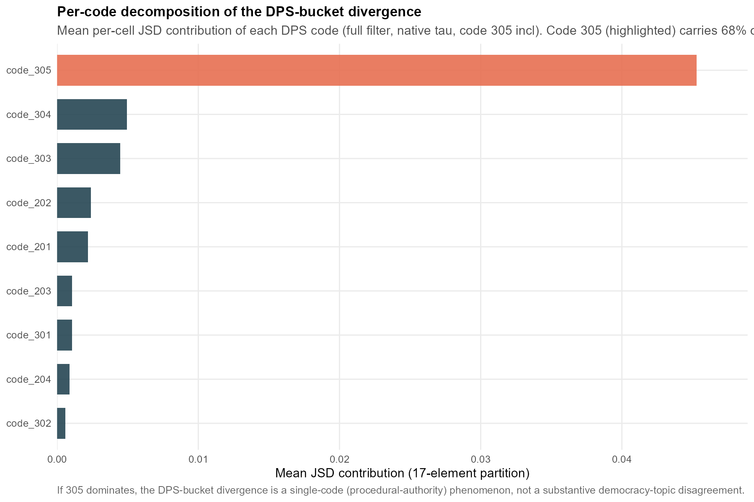
Figure F.3.1. Divergence-per-share by MARPOR code. Contribution of each code to the raw manifesto–speech divergence, ranked; code 305 is the single largest contributor on the speech side.
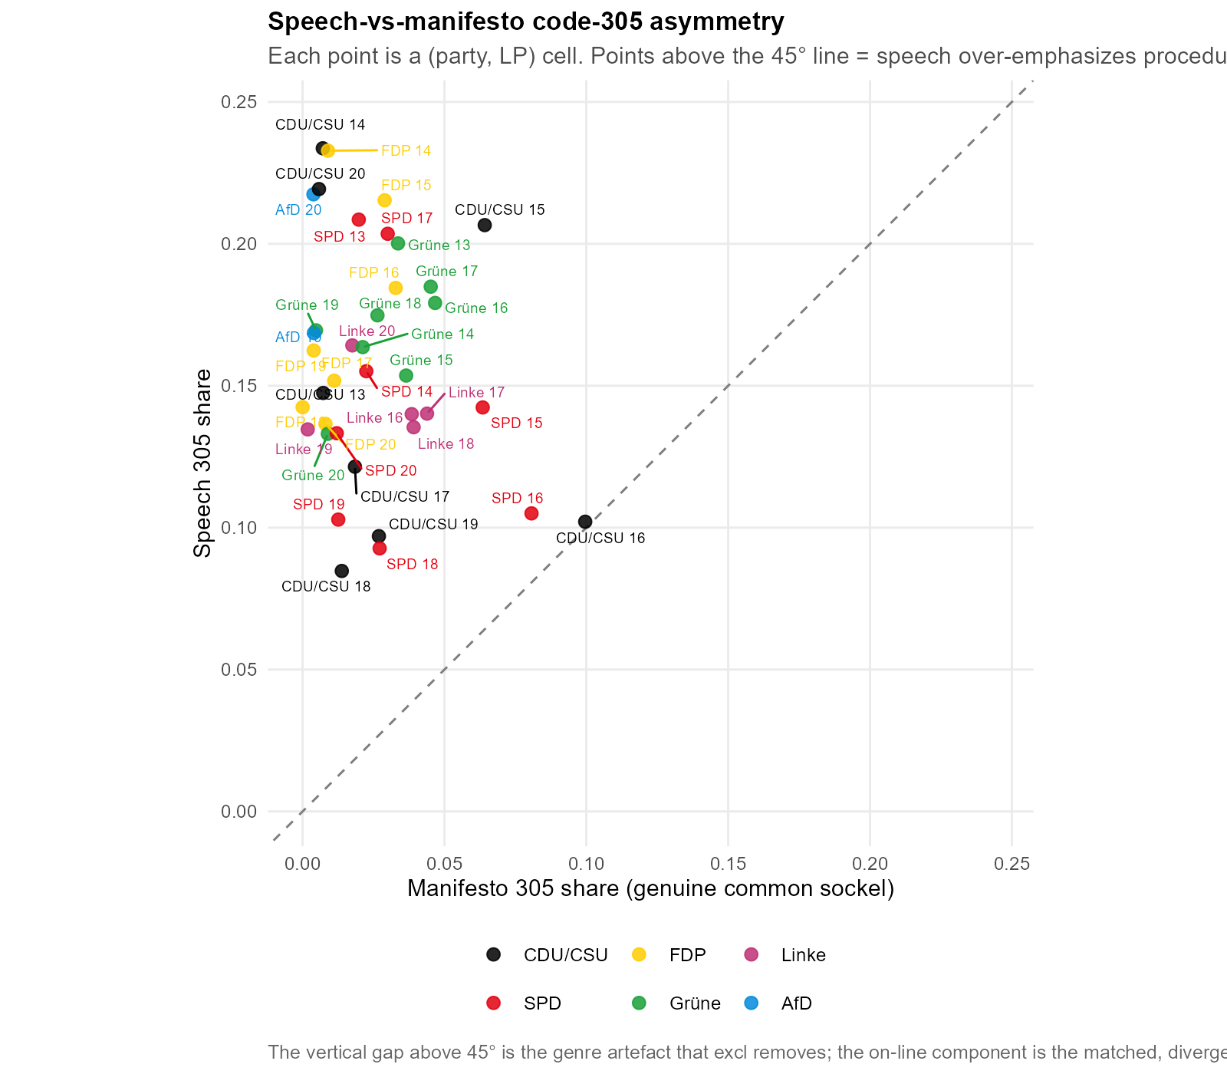
Figure F.3.2. Code-305 asymmetry between sides. Manifesto versus speech share of code 305 per cell; the systematic speech-side excess is the genre signal removed by the primary specification.
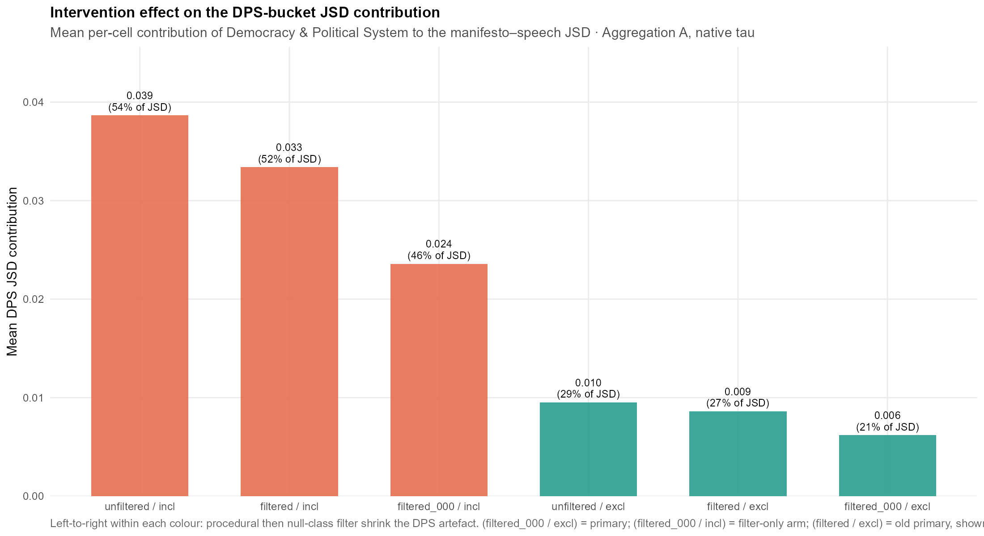
Figure F.3.3. Divergence-per-share along the intervention ladder. Effect of each successive correction (filtering, then code-305 subtraction) on the mean divergence-per-share.
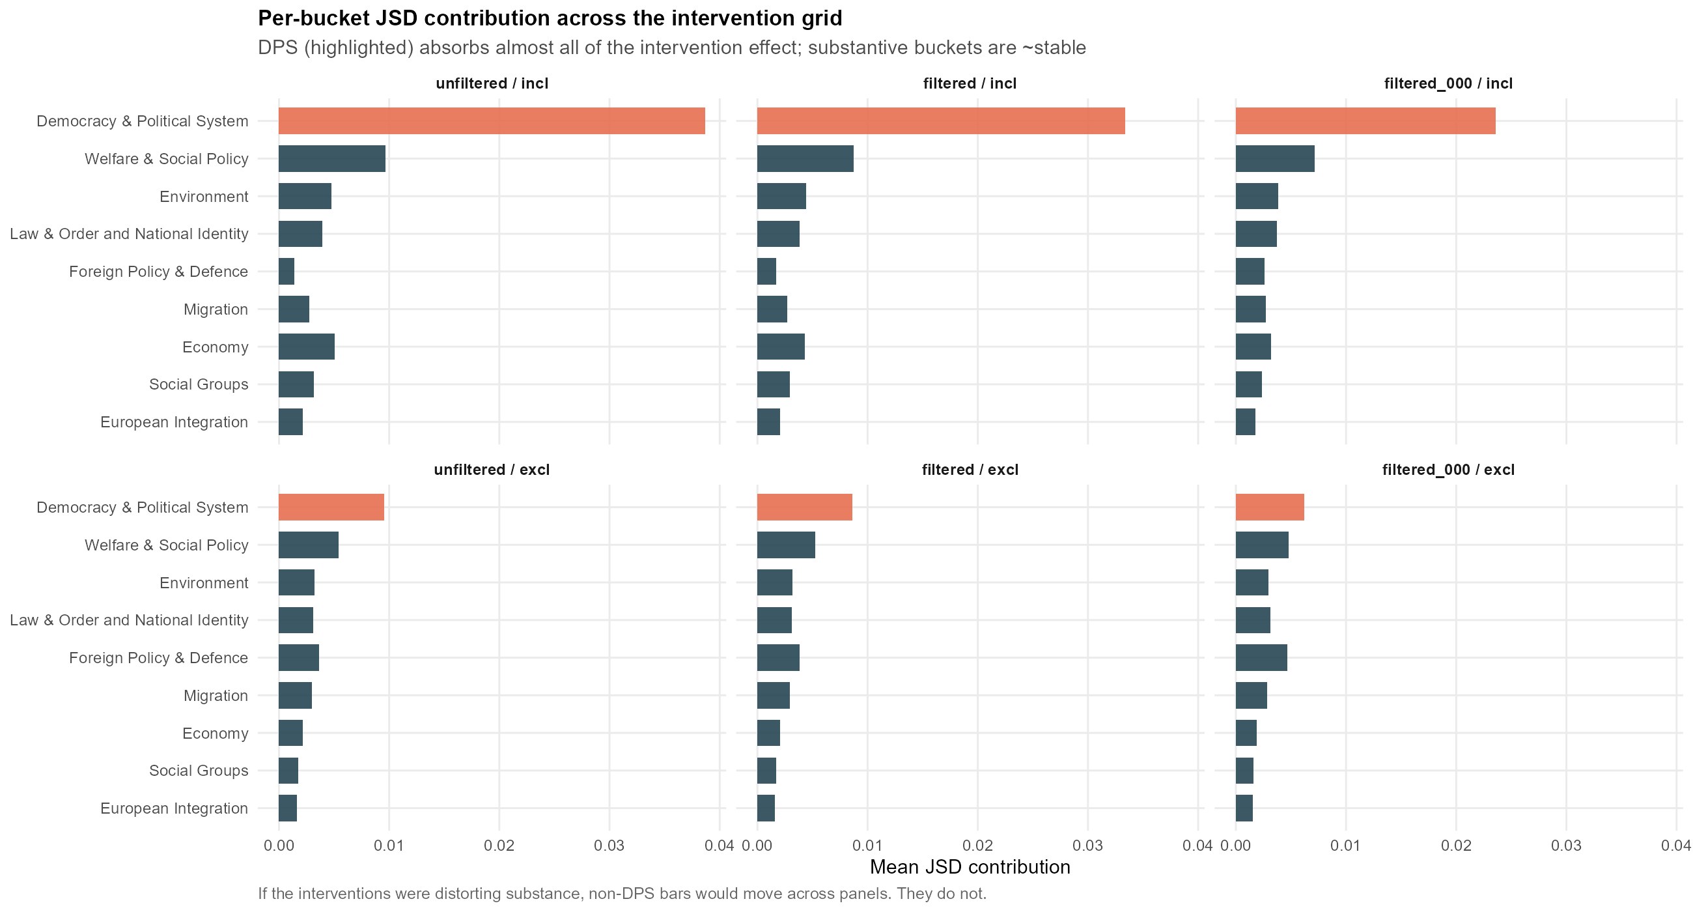
Figure F.3.4. Bucket-wise effect of the code-305 subtraction. Change in each of the nine salience buckets’ mean share under the correction; only the code-305-bearing bucket moves materially.
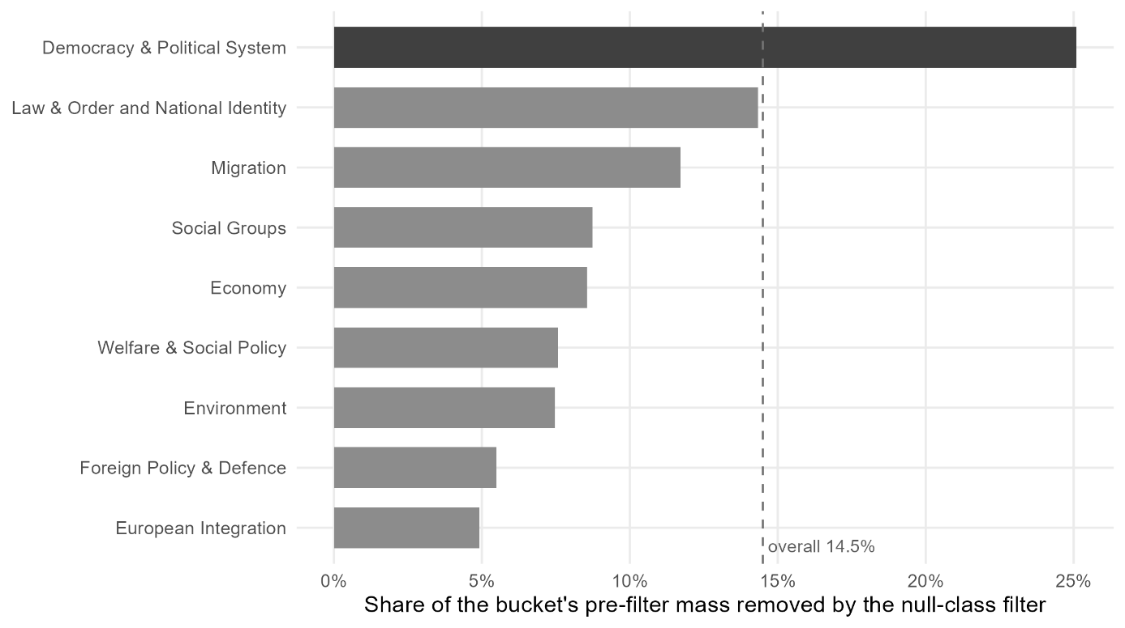
Figure F.3.5. Bucket-wise effect of the null-class filter. Share of each bucket's unnormalised mass removed when the null-class filter is added to the procedural filter, across the 38 cells of the analysis sample, against the overall removal rate of 14.5% as a reference line; code 305 is retained throughout so that the filter alone is at work. The Democracy & Political System bucket loses 25.1% of its mass, 10.6 percentage points above the overall rate and the only bucket above it. The rate is computed on the already procedurally filtered corpus, which is why it sits below the 19.34% the filter flags on the full corpus (Section 4.6.1).

F.4 Nearest-manifesto benchmark (identification of the own programme)
The nearest-manifesto benchmark asks, for each speech cell, whether the party’s own manifesto is the closest of all parties’ manifestos in the same period. Table F.4.1 reports, per party, how often the own manifesto is nearest, that hit rate, and the mean rank of the own manifesto (1 = nearest). Across all 38 cells the own manifesto is nearest in 16 (42.1 %, against a 21.1 % chance baseline, the mean of one over the field size in each cell, with fields ranging from four to six parties) and its mean rank is 1.87. The FDP and AfD identify their own programme in every period; the Linke never does, reflecting its position near the field centroid. The full per-cell test behind these aggregates is reported in Table F.4.3.
Party | Own nearest | Hit rate | Mean rank
CDU/CSU | 2 / 8 | 25.0% | 2.50
SPD | 1 / 8 | 12.5% | 2.38
FDP | 7 / 7 | 100.0% | 1.00
Grüne | 4 / 8 | 50.0% | 1.62
Linke | 0 / 5 | 0.0% | 2.00
AfD | 2 / 2 | 100.0% | 1.00
Total | 16 / 38 | 42.1% | 1.87
Table F.4.1. Nearest-manifesto identification by party. Cells in which the party’s own manifesto is the closest of all parties’ manifestos, the corresponding hit rate, and the mean rank of the own manifesto (1 = nearest). Aggregation A, primary specification. Chance baseline 21.1 %.
The complementary question, taken up as Figure 5.3 in the main text, is which single programme the chamber’s agenda sits closest to across all parties. Table F.4.2 gives the supporting quantity: the mean divergence from every one of the 38 speech cells to each party’s manifesto in the same period, both over all pairs and with each party’s distance to its own speech removed, alongside the number of cells in which that manifesto is the nearest of all. The FDP programme is the closest to the pool of parliamentary speech by a clear margin, and stays first when own-party pairs are excluded, so the result is neither self-similarity nor an effect of the FDP appearing often as a candidate. The mechanism is one of salience, not position: the chamber’s agenda is comparatively heavy on governance and economy and light on welfare and migration, which is the shape of the FDP’s programmatic agenda, while the welfare-centred Linke and the migration-centred AfD sit farthest. This is discussed in the conclusion; it is a statement about which topics are emphasised, not about the positions taken on them.
Manifesto | Mean JSD (all) | Mean JSD (excl. own) | Times nearest
FDP | 0.0257 | 0.0267 | 18
SPD | 0.0379 | 0.0400 | 6
Grüne | 0.0396 | 0.0422 | 7
CDU/CSU | 0.0463 | 0.0484 | 5
Linke | 0.0524 | 0.0564 | 0
AfD | 0.0638 | 0.0705 | 2
Table F.4.2. Agenda centre of gravity. For each party’s manifesto: the mean Jensen–Shannon divergence from each of the 38 speech cells to that manifesto in the same period (n = 38 for every party except the AfD, n = 12) (lower = the programme the chamber’s agenda most resembles), the same excluding each party’s distance to its own speech, and the number of cells in which that manifesto is the nearest of all. Manifesto candidates are restricted to parties in parliament that period. Aggregation A, primary specification. Salience, not position.
Party | LP | Candidate manifestos | Nearest manifesto | Rank of own manifesto
CDU/CSU | 13 | 4 | FDP | 4
CDU/CSU | 14 | 4 | FDP | 3
CDU/CSU | 15 | 4 | SPD | 3
CDU/CSU | 16 | 5 | FDP | 3
CDU/CSU | 17 | 5 | FDP | 2
CDU/CSU | 18 | 4 | CDU/CSU | 1
CDU/CSU | 19 | 6 | SPD | 3
CDU/CSU | 20 | 6 | CDU/CSU | 1
SPD | 13 | 4 | FDP | 2
SPD | 14 | 4 | FDP | 3
SPD | 15 | 4 | FDP | 2
SPD | 16 | 5 | Grüne | 3
SPD | 17 | 5 | FDP | 2
SPD | 18 | 4 | CDU/CSU | 2
SPD | 19 | 6 | SPD | 1
SPD | 20 | 6 | CDU/CSU | 4
FDP | 13 | 4 | FDP | 1
FDP | 14 | 4 | FDP | 1
FDP | 15 | 4 | FDP | 1
FDP | 16 | 5 | FDP | 1
FDP | 17 | 5 | FDP | 1
FDP | 19 | 6 | FDP | 1
FDP | 20 | 6 | FDP | 1
Grüne | 13 | 4 | FDP | 3
Grüne | 14 | 4 | FDP | 2
Grüne | 15 | 4 | SPD | 2
Grüne | 16 | 5 | Grüne | 1
Grüne | 17 | 5 | Grüne | 1
Grüne | 18 | 4 | Grüne | 1
Grüne | 19 | 6 | Grüne | 1
Grüne | 20 | 6 | CDU/CSU | 2
Linke | 16 | 5 | Grüne | 2
Linke | 17 | 5 | Grüne | 2
Linke | 18 | 4 | SPD | 2
Linke | 19 | 6 | SPD | 2
Linke | 20 | 6 | FDP | 2
AfD | 19 | 6 | AfD | 1
AfD | 20 | 6 | AfD | 1
Table F.4.3. Nearest-manifesto test per cell, primary specification (scheme A, full filter, code 305 excluded, native temperature).
Note: 38 valid cells (Section 4.8). Rank 1 denotes the nearest manifesto; ties take the minimum rank. The own manifesto ranks first in 16 of 38 cells (42.1%), the mean rank of the own manifesto is 1.87, and the rank distribution is 16/13/7/2 for ranks 1 to 4; the rank is never worse than 4. The derived chance baselines follow from the candidate counts: sixteen cells offer four candidates, ten cells five, and twelve cells six, which yields a random hit probability of mean(1/n) = 8/38 = 21.1% and an expected own-manifesto rank of mean((n+1)/2) = 2.95 (Section 4.8.1).

F.5 Pairwise between-party reference scale
The reference scale that calibrates H1a is built from between-party divergences on each side. Table F.5.1 reports the distribution of pairwise JSDs among speeches (the within-genre floor) and among manifestos (the cross-programme ceiling). The speech floor (mean 0.0074) and manifesto ceiling (mean 0.0520) bracket the observed H1a mean of 0.0297, which sits at 4.01 times the floor and 0.57 times the ceiling, that is, 49.9 % of the way along the floor-to-ceiling interval. The manifesto–speech divergence is therefore intermediate between the two reference regimes rather than small.
Side | Mean | Median | Q25 | Q75 | Min | Max | n
Speech (floor) | 0.0074 | 0.0063 | 0.0034 | 0.0093 | 0.0011 | 0.0303 | 74
Manifesto (ceiling) | 0.0520 | 0.0420 | 0.0281 | 0.0662 | 0.0082 | 0.1760 | 74
Table F.5.1. Between-party pairwise divergence, by side. Distribution of pairwise JSDs among all party speeches (floor) and among all party manifestos (ceiling), pooled across periods. Aggregation A, primary specification. n = number of party pairs × periods.

F.6 Decoding-temperature sweep (robustness arm 1)
The primary specification decodes the classifier at its native temperature. Table F.6.1 re-runs H1a and H1b at a sharp (τ = 0.5), native (τ = 1.0) and flat (τ = 2.0) temperature and reports the Spearman rank correlations between the three resulting cell orderings, alongside the mean divergence level at each temperature. The cross-temperature rank correlations remain high for H1a (0.579 to 0.970) and for H1b (0.706 to 0.956); the sharp-to-native correlation, the pair that brackets the native specification, is 0.970 for H1a and 0.956 for H1b. Temperature shifts the level of the divergence but preserves the ordering of cells that carries the substantive claims.
Hypothesis | sharp–native | sharp–flat | native–flat
H1a (A) | 0.970 | 0.579 | 0.729
H1b (B) | 0.956 | 0.706 | 0.843
Table F.6.1a. Rank stability across decoding temperature. Spearman ρ between cell orderings at sharp (τ = 0.5), native (τ = 1.0) and flat (τ = 2.0) temperatures, for H1a (Aggregation A) and H1b (Aggregation B).
Hypothesis | sharp (0.5) | native (1.0) | flat (2.0)
H1a (A) | 0.0283 | 0.0297 | 0.0368
H1b (B) | 0.0444 | 0.0506 | 0.0852
Table F.6.1b. Mean divergence level across decoding temperature. Mean per-cell JSD at each temperature; the native column reproduces the primary specification.
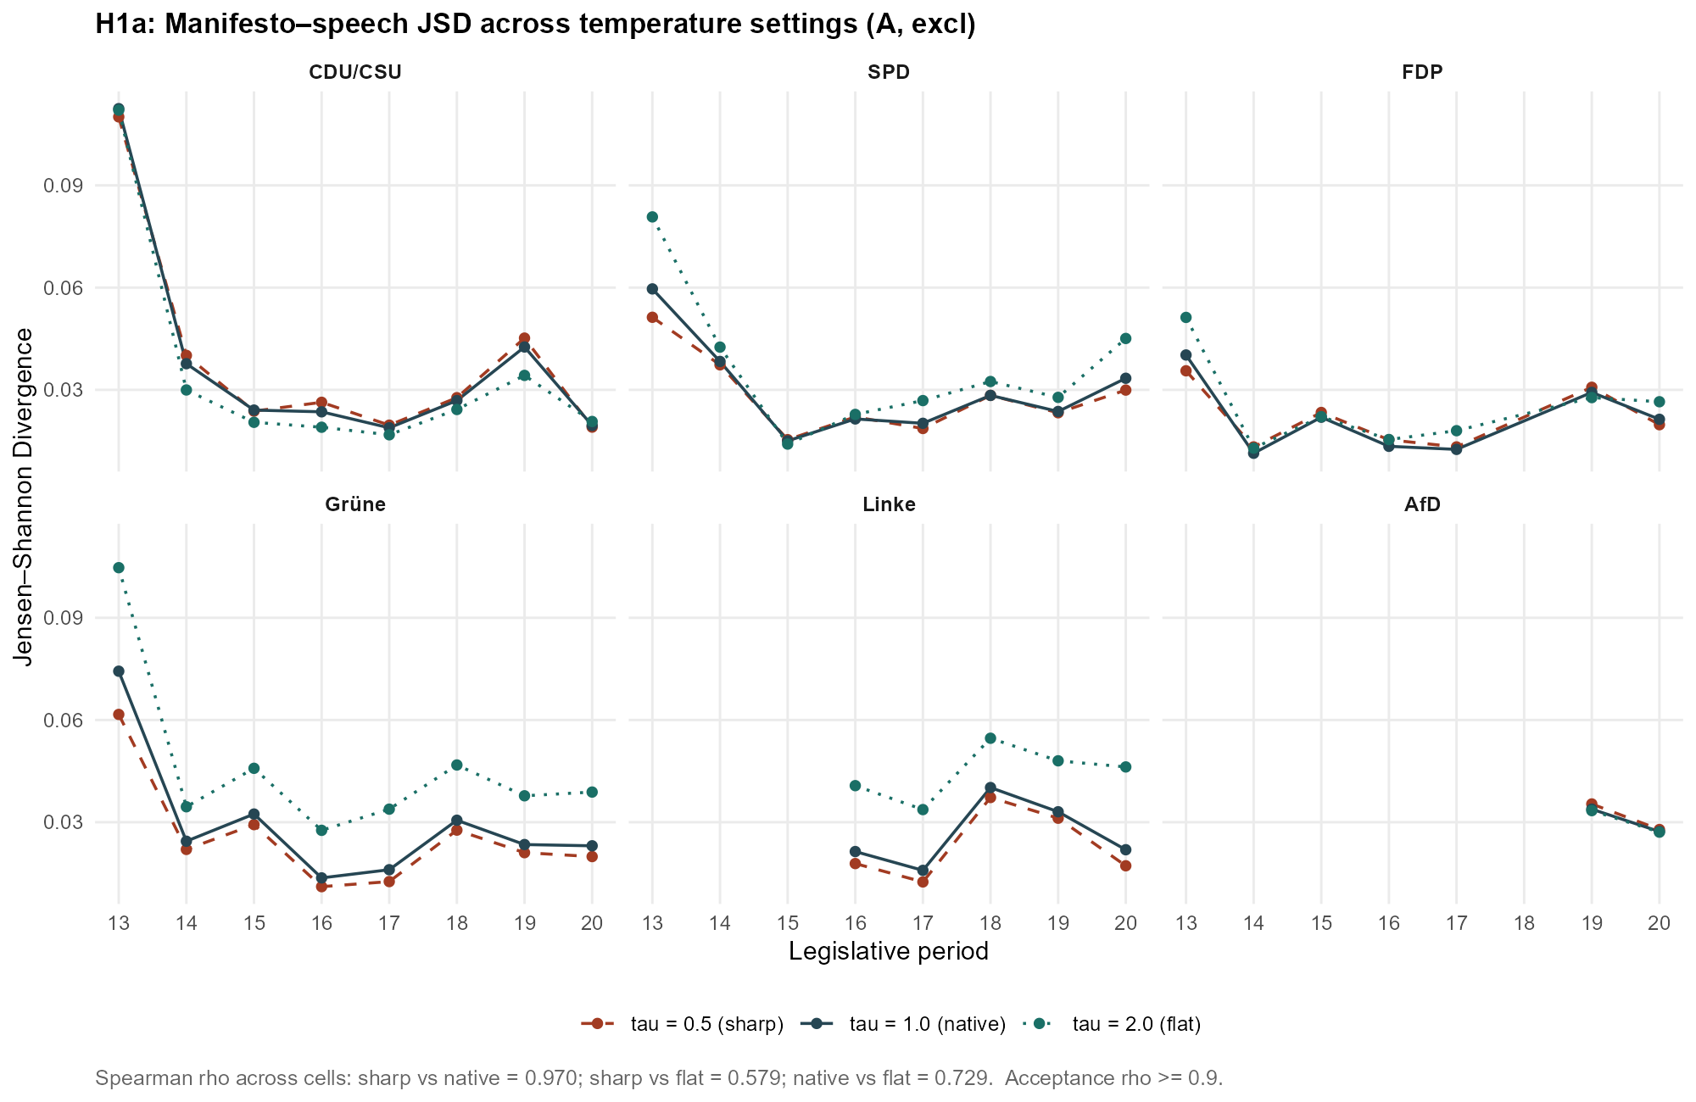
Figure F.6.1. H1a divergence across decoding temperature. Per-cell JSD at each temperature; cell orderings are preserved as the level shifts.
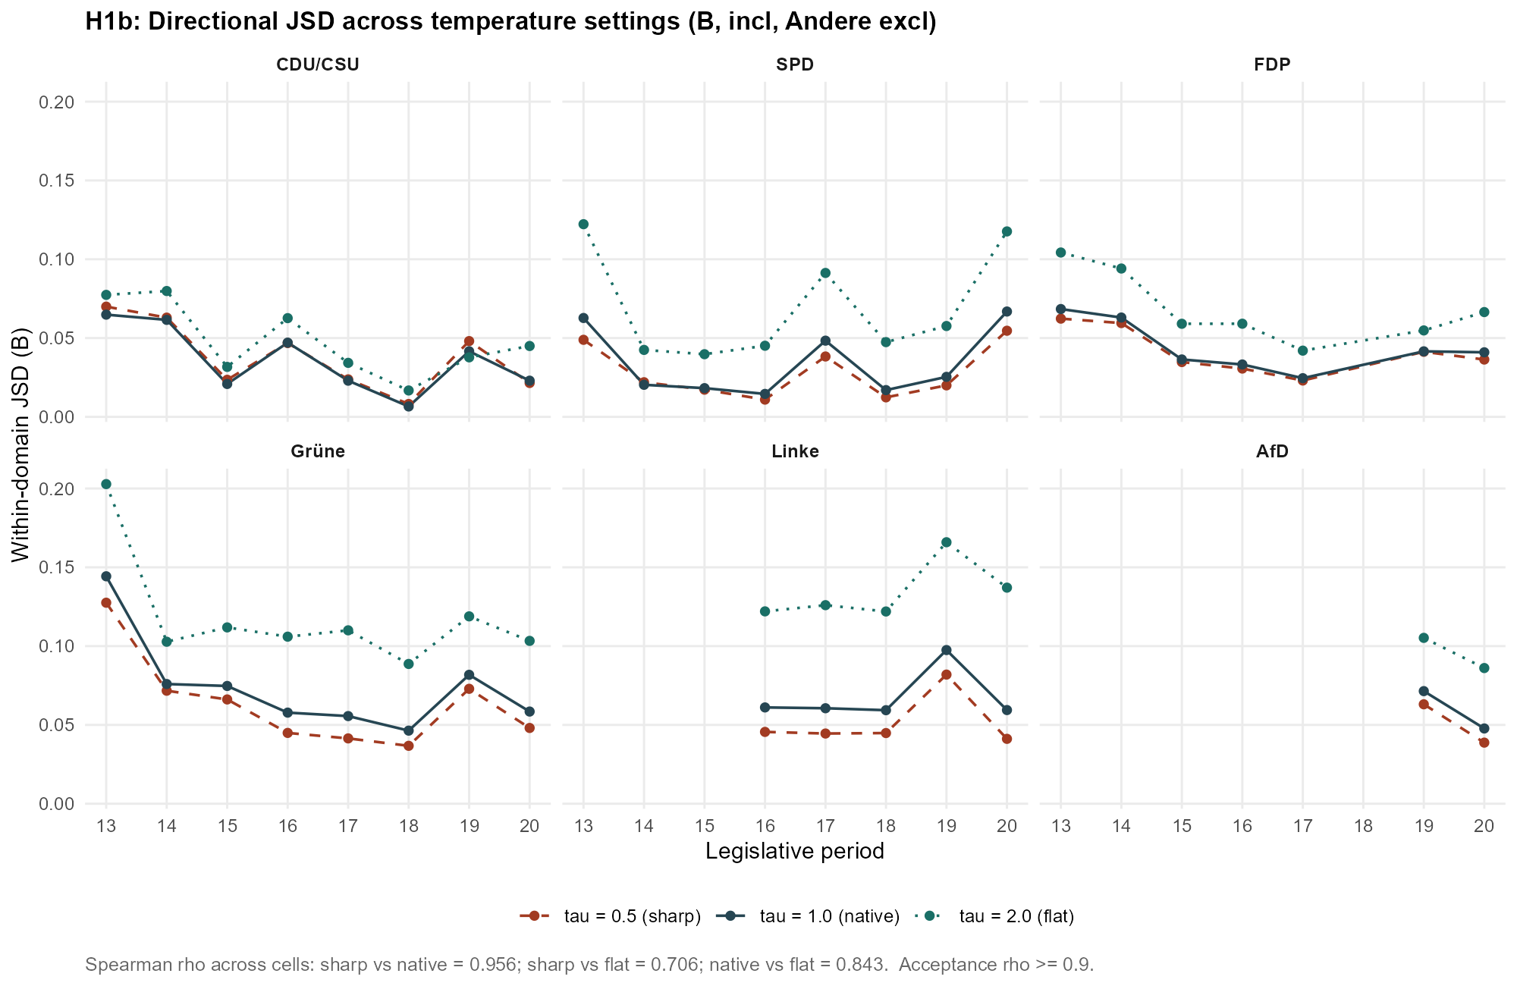
Figure F.6.2. H1b divergence across decoding temperature. As Figure F.6.1, for the directional specification (Aggregation B).

F.7 Soft-assignment versus hard-threshold classification (robustness arm 2)
The primary specification uses the classifier’s soft label distribution. Table F.7.1 compares it against two hard-threshold variants that assign each sentence to a single bucket when the top label exceeds 0.4 or 0.5. The rank correlations between the soft ordering and each hard ordering stay high (H1a 0.929 to 0.943; H1b 0.772 to 0.861), and the two hard variants agree almost perfectly with each other (0.996 for H1a, 0.964 for H1b). The mean level rises modestly under hard assignment, as expected when soft mass is collapsed onto single buckets, without reordering the cells.
Hypothesis | soft–hard0.4 | soft–hard0.5 | hard0.4–hard0.5
H1a (A) | 0.943 | 0.929 | 0.996
H1b (B) | 0.861 | 0.772 | 0.964
Table F.7.1a. Rank stability under hard-threshold assignment. Spearman ρ between the soft-assignment ordering and each hard-threshold ordering (top label > 0.4, > 0.5), and between the two hard variants. H1a and H1b.
Hypothesis | soft (τ = 1.0) | hard > 0.4 | hard > 0.5
H1a (A) | 0.0510 | 0.0577 | 0.0602
H1b (B) | 0.0506 | 0.0411 | 0.0409
Table F.7.1b. Mean divergence level under hard-threshold assignment. Mean per-cell JSD for the soft specification and each hard-threshold variant.
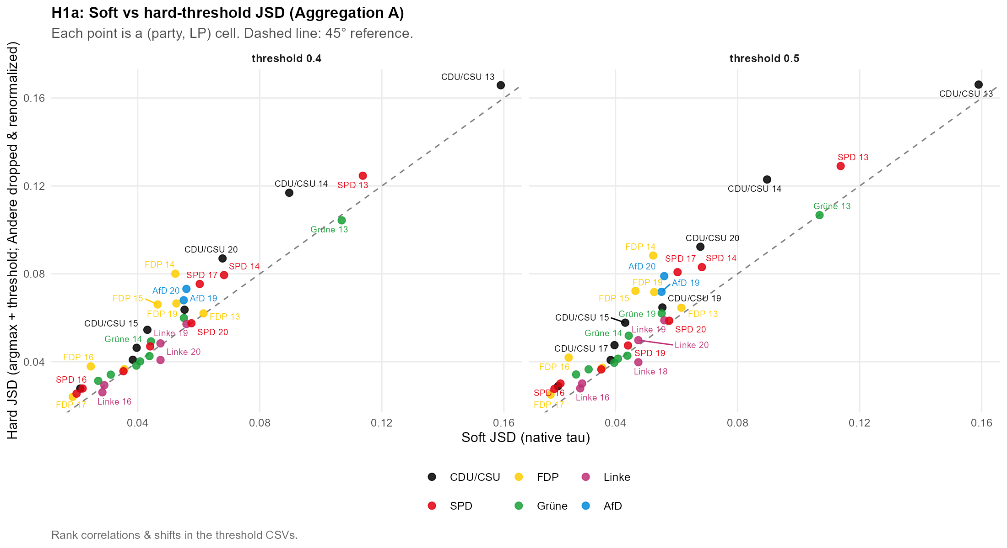
Figure F.7.1. H1a: soft versus hard-threshold divergence. Per-cell JSD under soft assignment against the hard-threshold variants; points track the identity line up to a level shift.
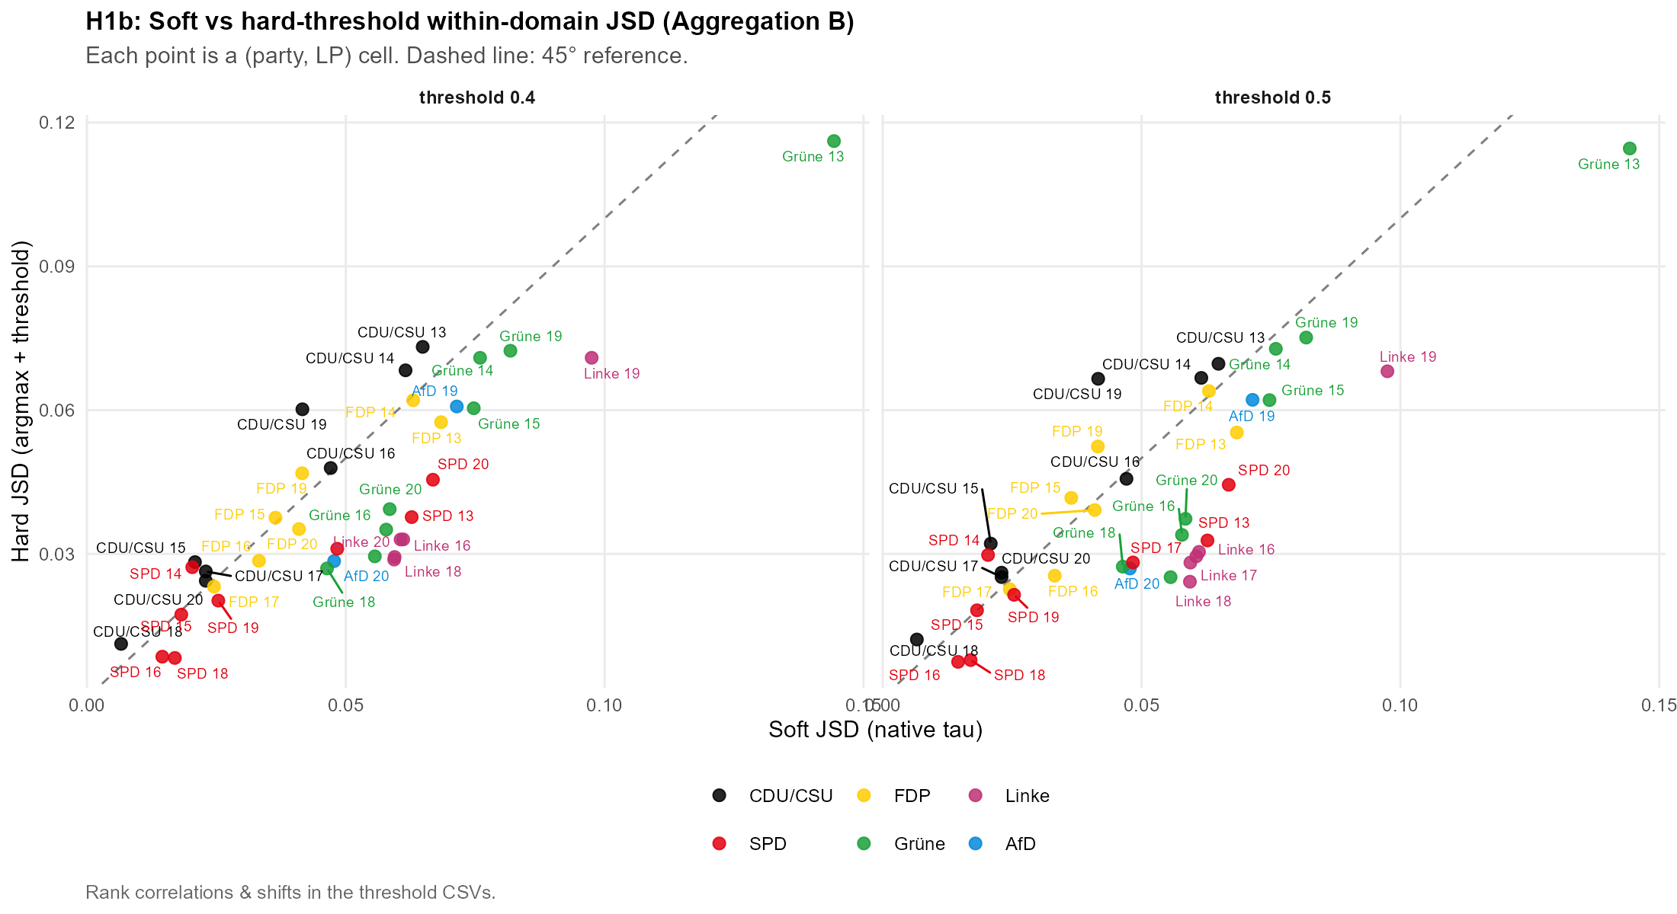
Figure F.7.2. H1b: soft versus hard-threshold divergence. As Figure F.7.1, for the directional specification.

F.8 Migration re-split (H1b, multiculturalism-only axis 608 vs 607; robustness arm 5)
The directional migration bucket pools the MARPOR national-way-of-life and multiculturalism codes. Because the split between border/immigration control and cultural integration is contested, Table F.8.1 re-runs the H1b migration cell two ways: the baseline restrictive/liberal split (601+608 restrictive, 602+607 liberal) and a narrower split that treats only multiculturalism as the axis (608 restrictive, 607 liberal). The mean divergence is essentially unchanged (0.1392 to 0.1344, a difference of −0.0062), and the restrictive share on the speech side falls from 68.4 % to 48.6 %, which localises the composition finding to the multiculturalism codes without overturning it.
Split | Cells (n) | Mean JSD | Restr. share (speech)
Baseline (601+608 / 602+607) | 37 | 0.1392 | 68.4%
Multiculturalism only (608 / 607) | 36 | 0.1344 | 48.6%
Table F.8.1. Migration re-split sensitivity (H1b). Mean migration-cell JSD and restrictive speech share under the baseline split (601+608 / 602+607) and the multiculturalism-only split (608 / 607). Δ mean JSD = −0.0062, computed as the matched mean change across the 36 cells defined under both splits; the difference of the two column means is −0.0048 because they rest on 37 and 36 cells respectively. Aggregation B, primary specification.
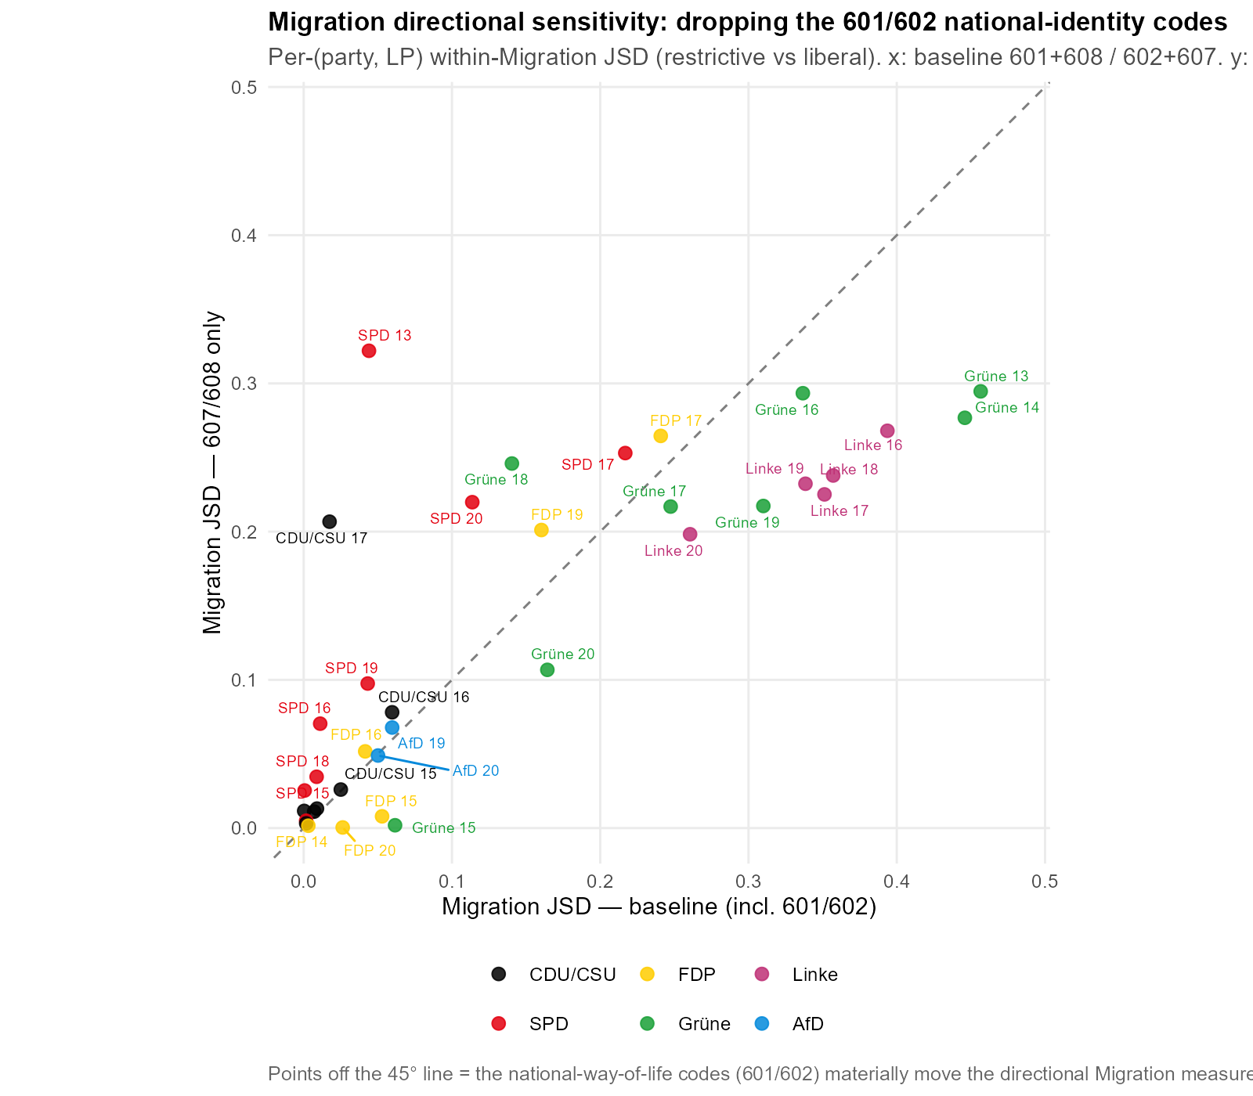
Figure F.8.1. Migration re-split sensitivity, per cell. Migration-cell JSD under the baseline and multiculturalism-only splits; the cell ordering is preserved and the level barely moves.

F.9 Supplementary directional figures
Four further figures support the directional analysis in Chapter 5. Figure F.9.1 is the H2b moderation scatter with adjusted scaling so that all dots-party pairs are readable, plotting each cell’s speech-side against its manifesto-side polarisation score so that the slope comparison of H2b can be read cell by cell: clouds flatter than the 45-degree line indicate moderation, and a cloud displaced from the line indicates a level shift of the channel. Figure F.9.2 shows the H3 mean directional positions, the manifesto and speech means on each directional sub-scale over time. Figure F.9.3 reproduces the system-level polarisation series of Figure 5.9 without the excl-AfD overlay; the underlying values are identical, and the figure is provided so the all-party series can be read uncluttered. Figure F.9.4 disaggregates the migration domain to the party level and puts the weighted mean beside the weighted dispersion, which separates a common shift of the whole chamber from a widening between the parties.
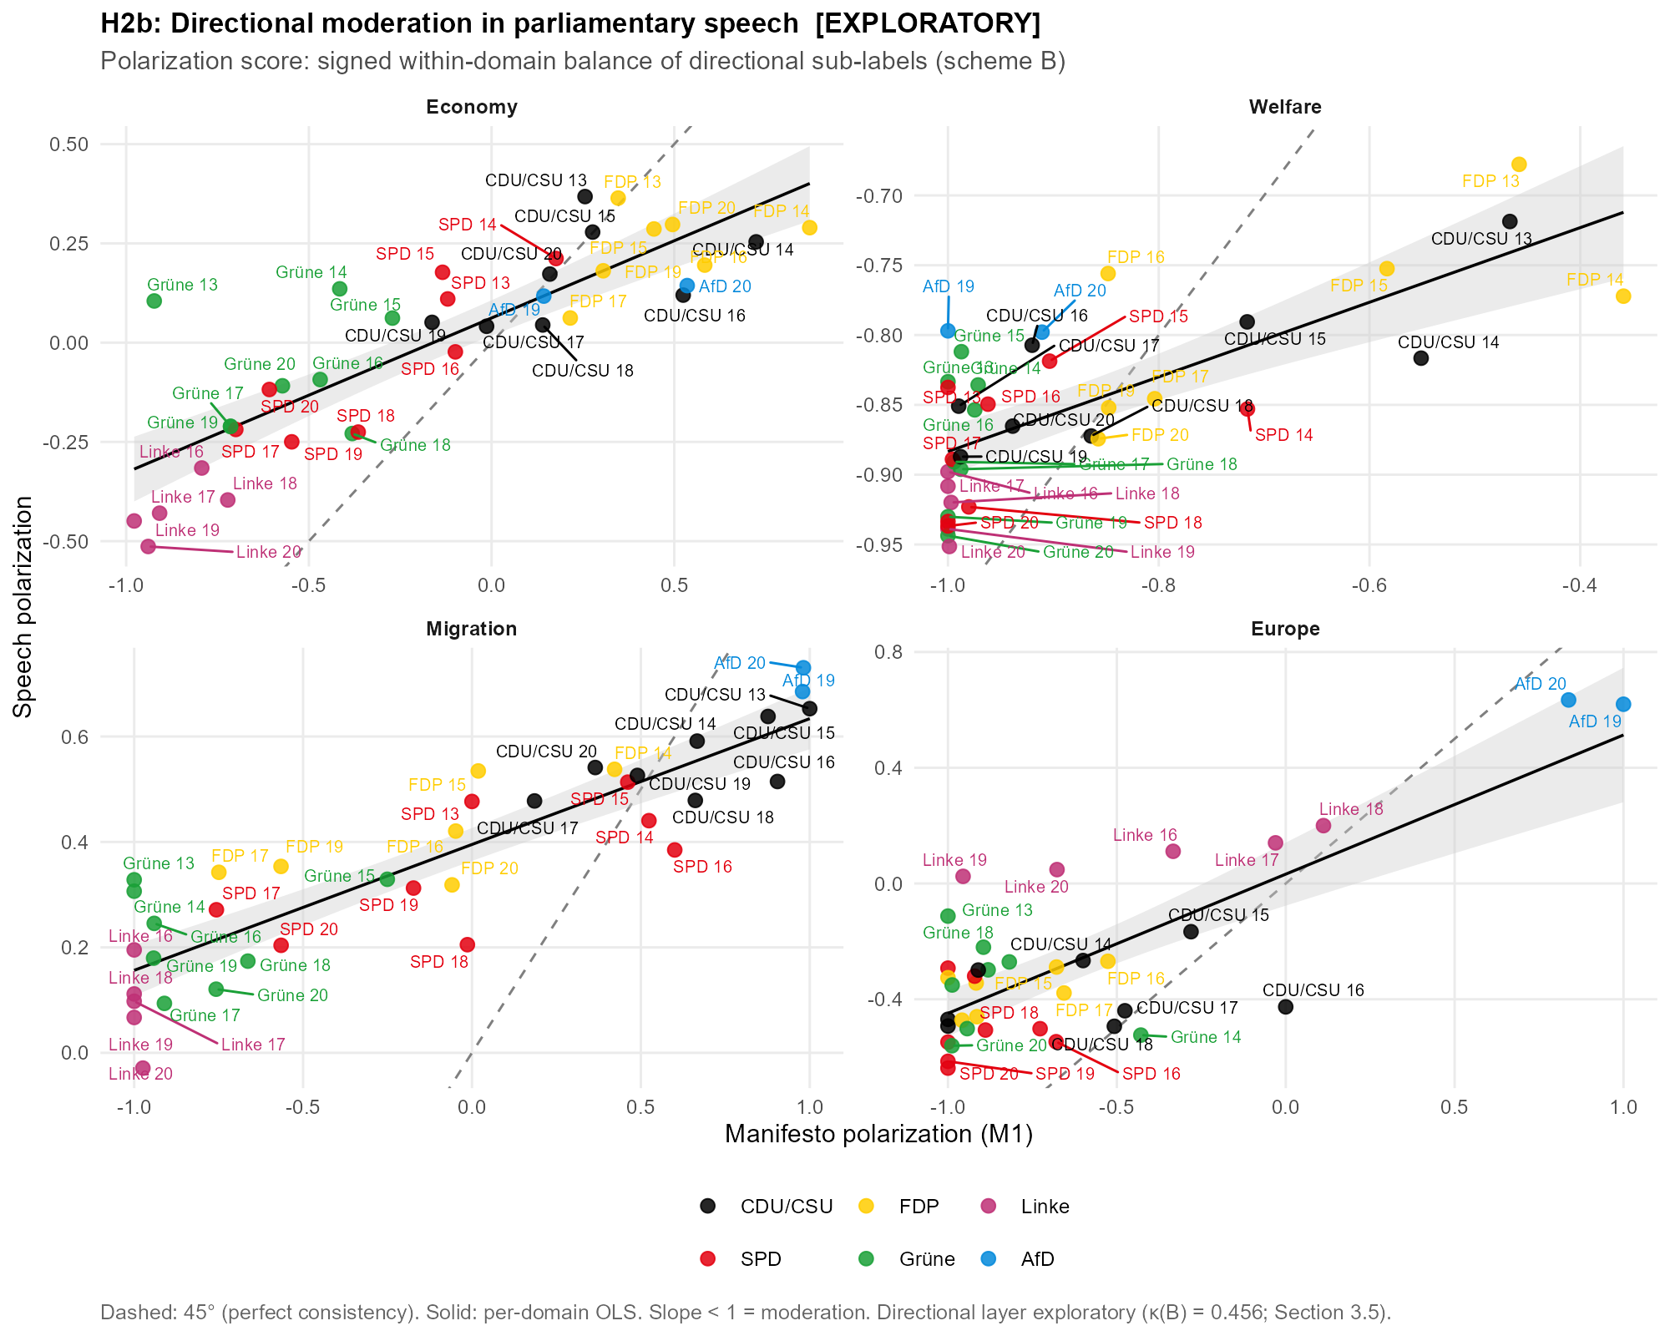
[Wecken Sie das Interesse Ihrer Leser mit einem passenden Zitat aus dem Dokument, oder verwenden Sie diesen Platz, um eine Kernaussage zu betonen. Um das Textfeld an einer beliebigen Stelle auf der Seite zu platzieren, ziehen Sie es einfach.]
Figure F.9.1. H2b: speech versus manifesto polarisation scores. Each point is a party × period cell; axes are the signed within-domain directional balance in each channel, dashed line = 45° (perfect consistency), solid line = per-domain OLS. Aggregation B, primary specification. Scales are adjusted to make the annotation of the dots readable.
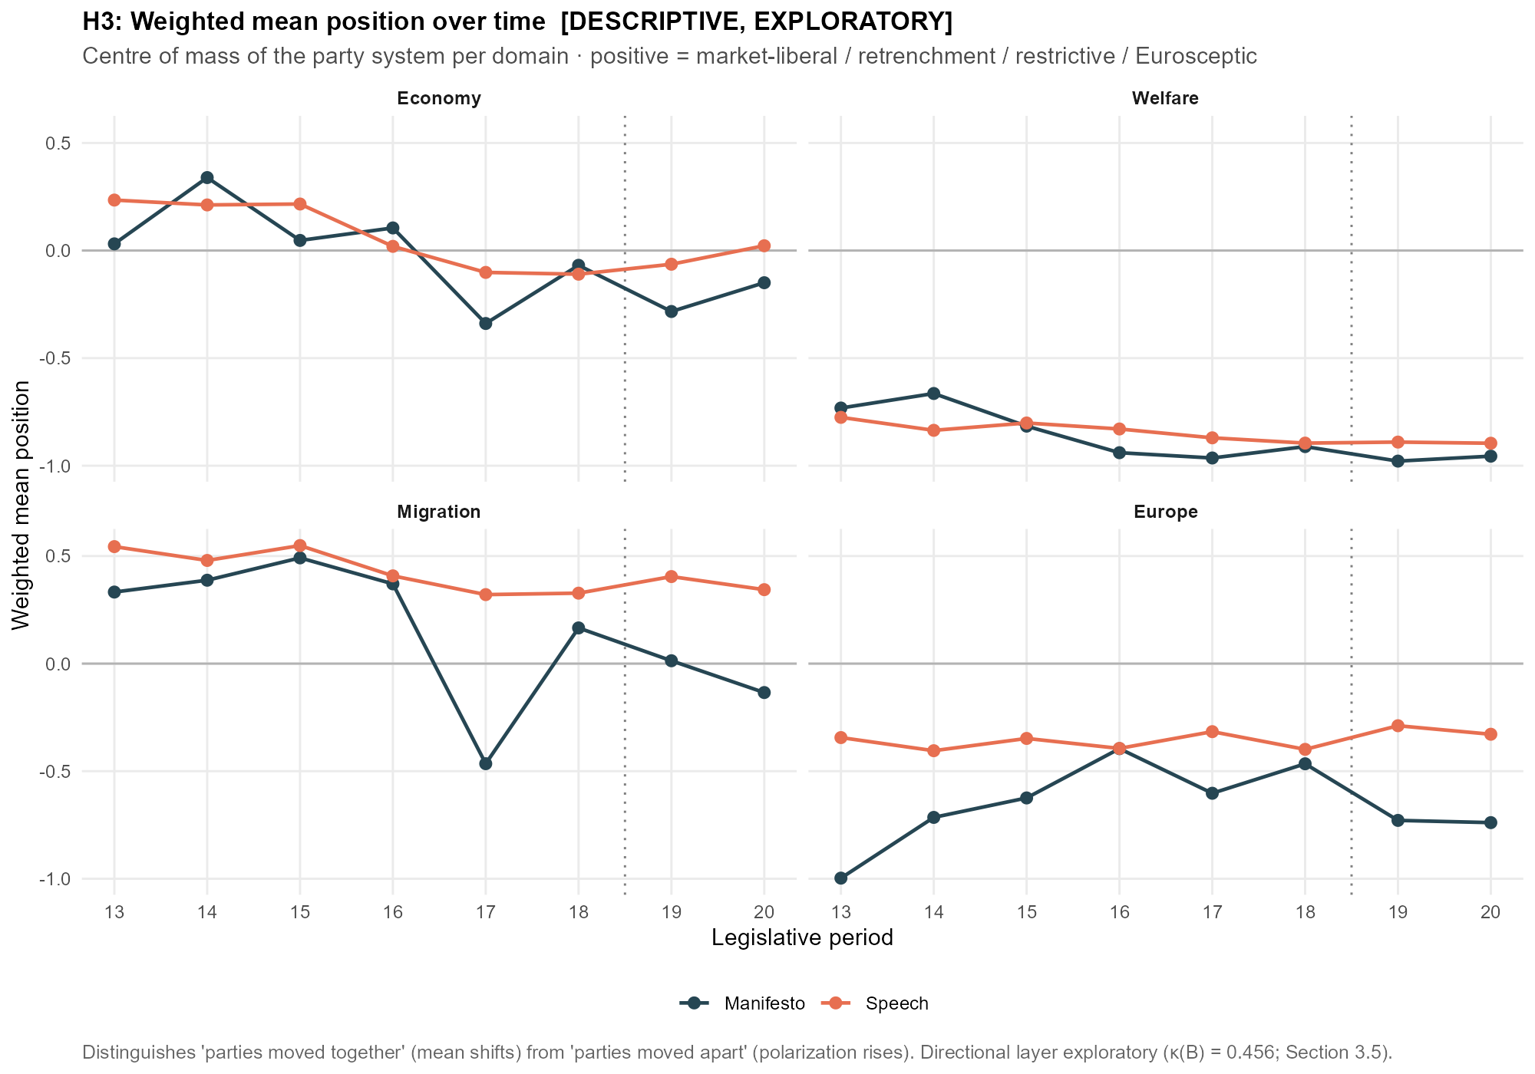
[Wecken Sie das Interesse Ihrer Leser mit einem passenden Zitat aus dem Dokument, oder verwenden Sie diesen Platz, um eine Kernaussage zu betonen. Um das Textfeld an einer beliebigen Stelle auf der Seite zu platzieren, ziehen Sie es einfach.]
Figure F.9.2. H3: mean directional positions over time. Weighted mean position per legislative period, domain and channel, manifesto weighted by vote share and speech by seat share. The mean is the centre of the dispersion reported in Section 5.4 and separates a common shift of the whole chamber from a widening between parties. Aggregation B, primary specification. Descriptive series.
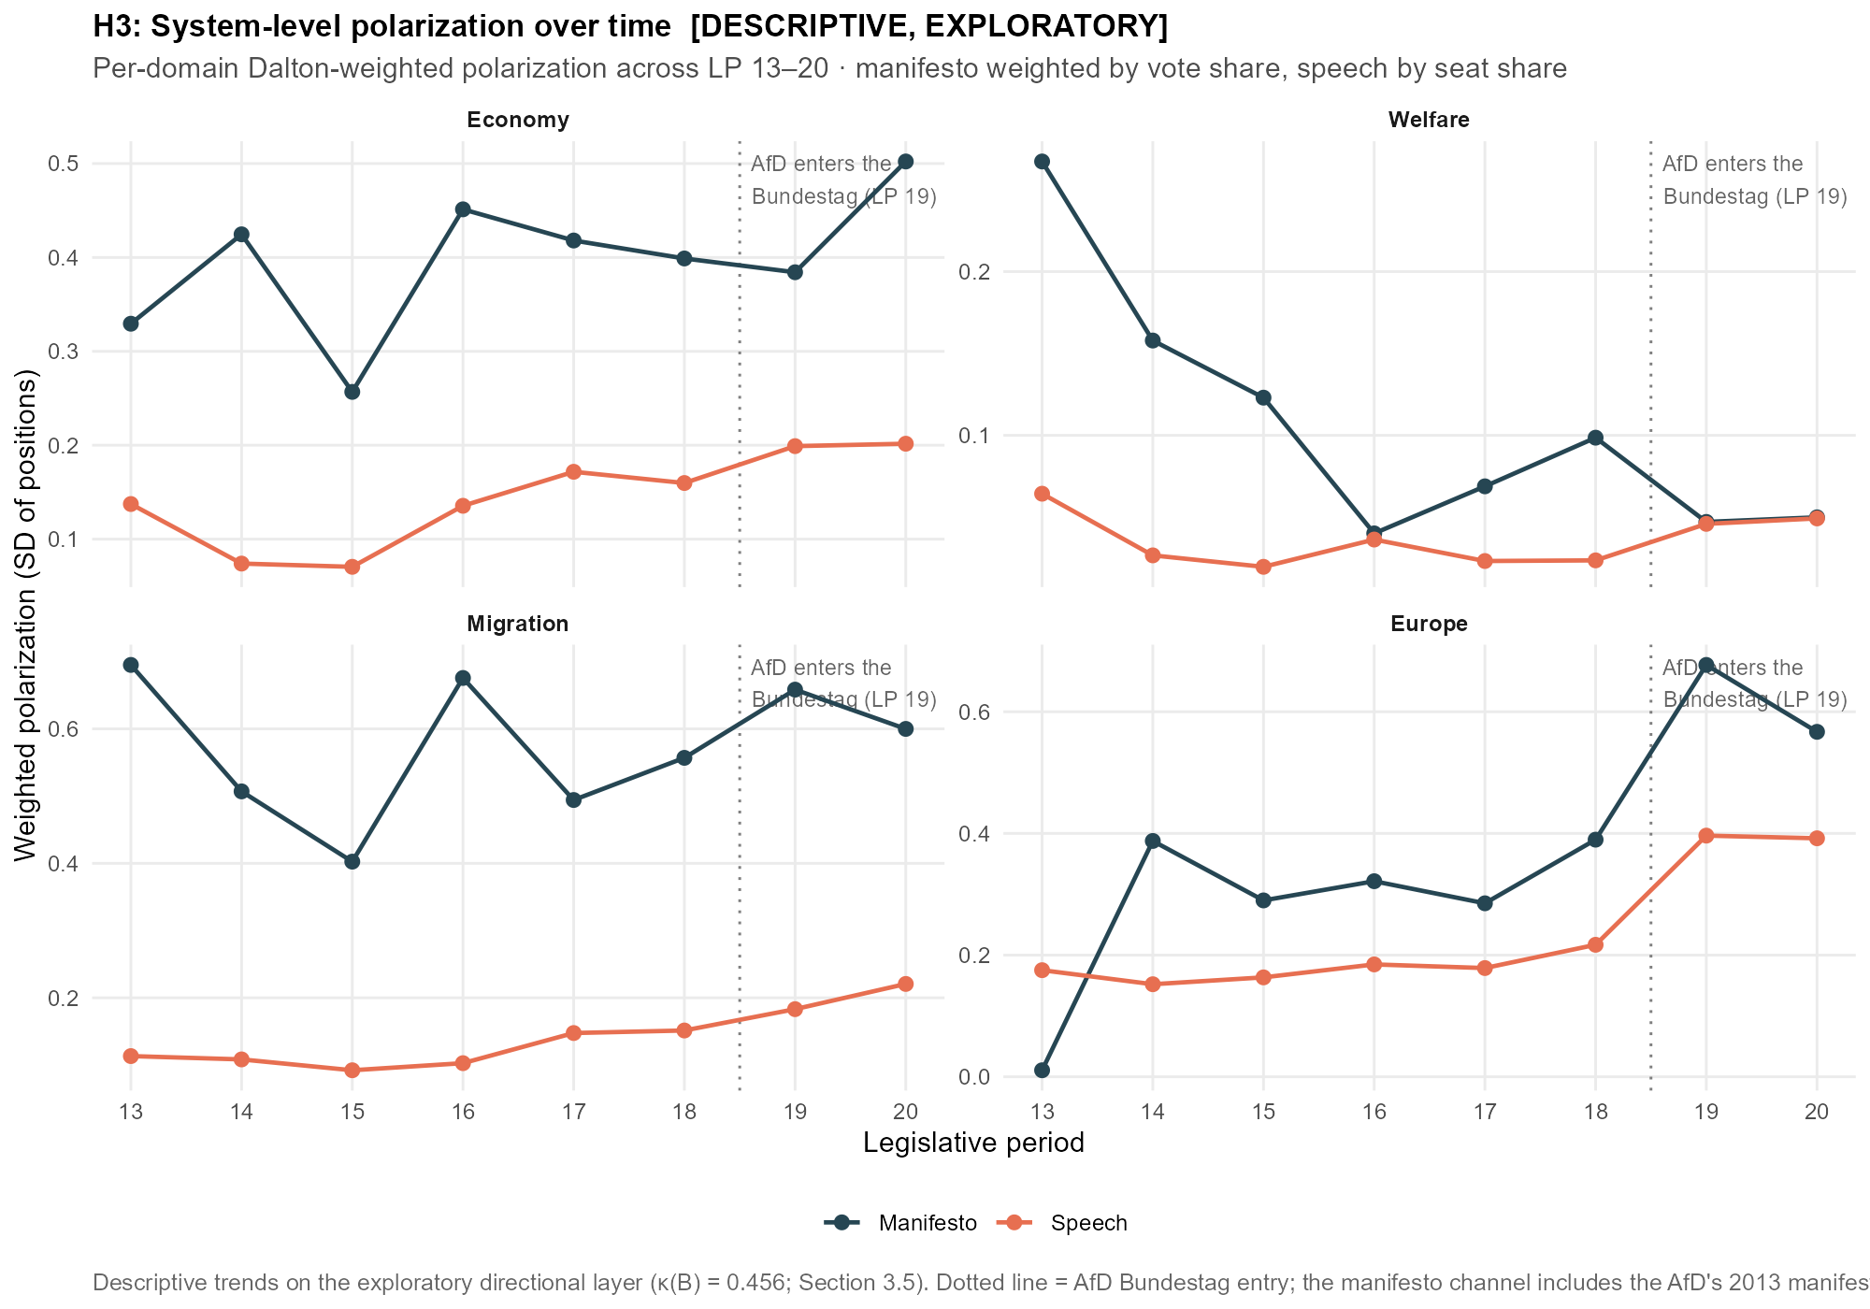
[Wecken Sie das Interesse Ihrer Leser mit einem passenden Zitat aus dem Dokument, oder verwenden Sie diesen Platz, um eine Kernaussage zu betonen. Um das Textfeld an einer beliebigen Stelle auf der Seite zu platzieren, ziehen Sie es einfach.]
Figure F.9.3. System-level polarisation over time, all parties. Dalton-weighted SD of party positions per period, domain and channel (manifesto weighted by vote share, speech by seat share); identical series to the in-text figure, shown without the excl-AfD overlay. Aggregation B, primary specification.
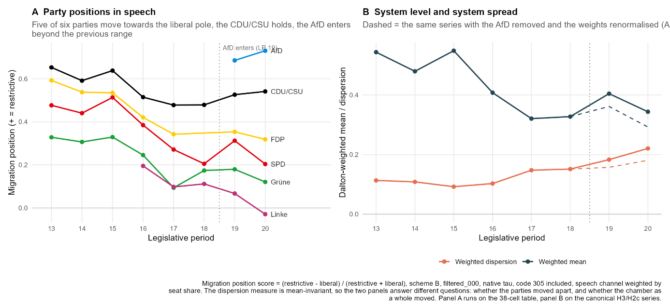
Figure F.9.4. Migration: party positions and system level over time. Panel A gives the speech-side position score of each party by legislative period, positive values denoting the restrictive pole. Panel B gives the Dalton-weighted mean and the Dalton-weighted dispersion of the same scores, the dashed lines repeating both series with the AfD removed and the remaining weights renormalised (arm 6). The FDP line breaks at LP 18, where the party held no seats, and the Linke enters the analysis sample at LP 16 (Section 4.8). Aggregation B, primary specification. Descriptive series.

F.10 The LP-13 elevation: a manifesto-side, window-boundary diagnostic
Section 5.2 reports that the manifesto–speech divergence peaks at LP 13, where all four cells (CDU/CSU, SPD, FDP, Grüne) are the maximum of their party and the CDU/CSU cell of 0.1125 is the largest value in the chapter. This subsection establishes that the elevation is a property of the manifesto input and of where the observation window opens, not an anomalous 1994 election and not a segmentation, classification, or mapping artefact. Three checks converge.
First, the divergence is localised to the manifesto side by a cross-swap. Holding the LP-13 speech distribution fixed and replacing the 1994 manifesto with the party’s typical in-window manifesto, the mean of its other 1994–2021 programmes, removes most of the divergence, whereas holding the manifesto fixed and replacing the speech leaves it unchanged (Table F.10.1). For the CDU/CSU the manifesto swap reduces the divergence from 0.1125 to 0.0150, while the speech swap leaves it at 0.1214. The speeches at LP 13 are therefore ordinary; the 1994 manifestos carry the divergence.
Cell (LP 13) | Actual JSD | Manifesto → typical | Speech → typical
CDU/CSU | 0.1125 | 0.0150 | 0.1214
SPD | 0.0596 | 0.0207 | 0.0706
FDP | 0.0402 | 0.0175 | 0.0390
Grüne | 0.0743 | 0.0171 | 0.0791
Table F.10.1. Cross-swap localisation of the LP-13 divergence. Each LP-13 cell’s JSD (Actual), recomputed with the 1994 manifesto replaced by the party’s typical in-window manifesto (Manifesto → typical) and with the LP-13 speech replaced by the party’s typical speech (Speech → typical). Aggregation A, primary specification.
Second, the 1994 manifesto is not itself an aberrant document. Across each party’s full manifesto record in the Manifesto Project main dataset, the change from the 1990 to the 1994 programme is unremarkable, and far larger shifts occurred in earlier decades (Table F.10.2, Figure F.10.1). For the CDU/CSU the 1994 change equals its long-run average and ranks sixth of twenty transitions; for the FDP it is one of the smallest on record, eighteenth of twenty. The Green record before 1994 is not captured by the party identifier used here, so the comparison is reported for the three parties with a long history; the 1994 Green change of 0.0369 is modest in absolute terms.
Party | 1994 change | Pre-1994 mean | Pre-1994 max (year) | Rank of 1994 (1 = largest)
CDU/CSU | 0.0619 | 0.0616 | 0.1579 (1957) | 6 of 20
SPD | 0.0427 | 0.0548 | 0.1015 (1976) | 8 of 20
FDP | 0.0112 | 0.0547 | 0.1079 (1972) | 18 of 20
Grüne | 0.0369 | — | — | 1 of 9
Table F.10.2. The 1994 manifesto change in historical perspective. JSD between each party’s 1994 manifesto and its immediately preceding programme (1994 change), against the mean and maximum of that party’s pre-1994 election-to-election changes and the rank of the 1994 change among all its transitions (1 = largest). Aggregation A.
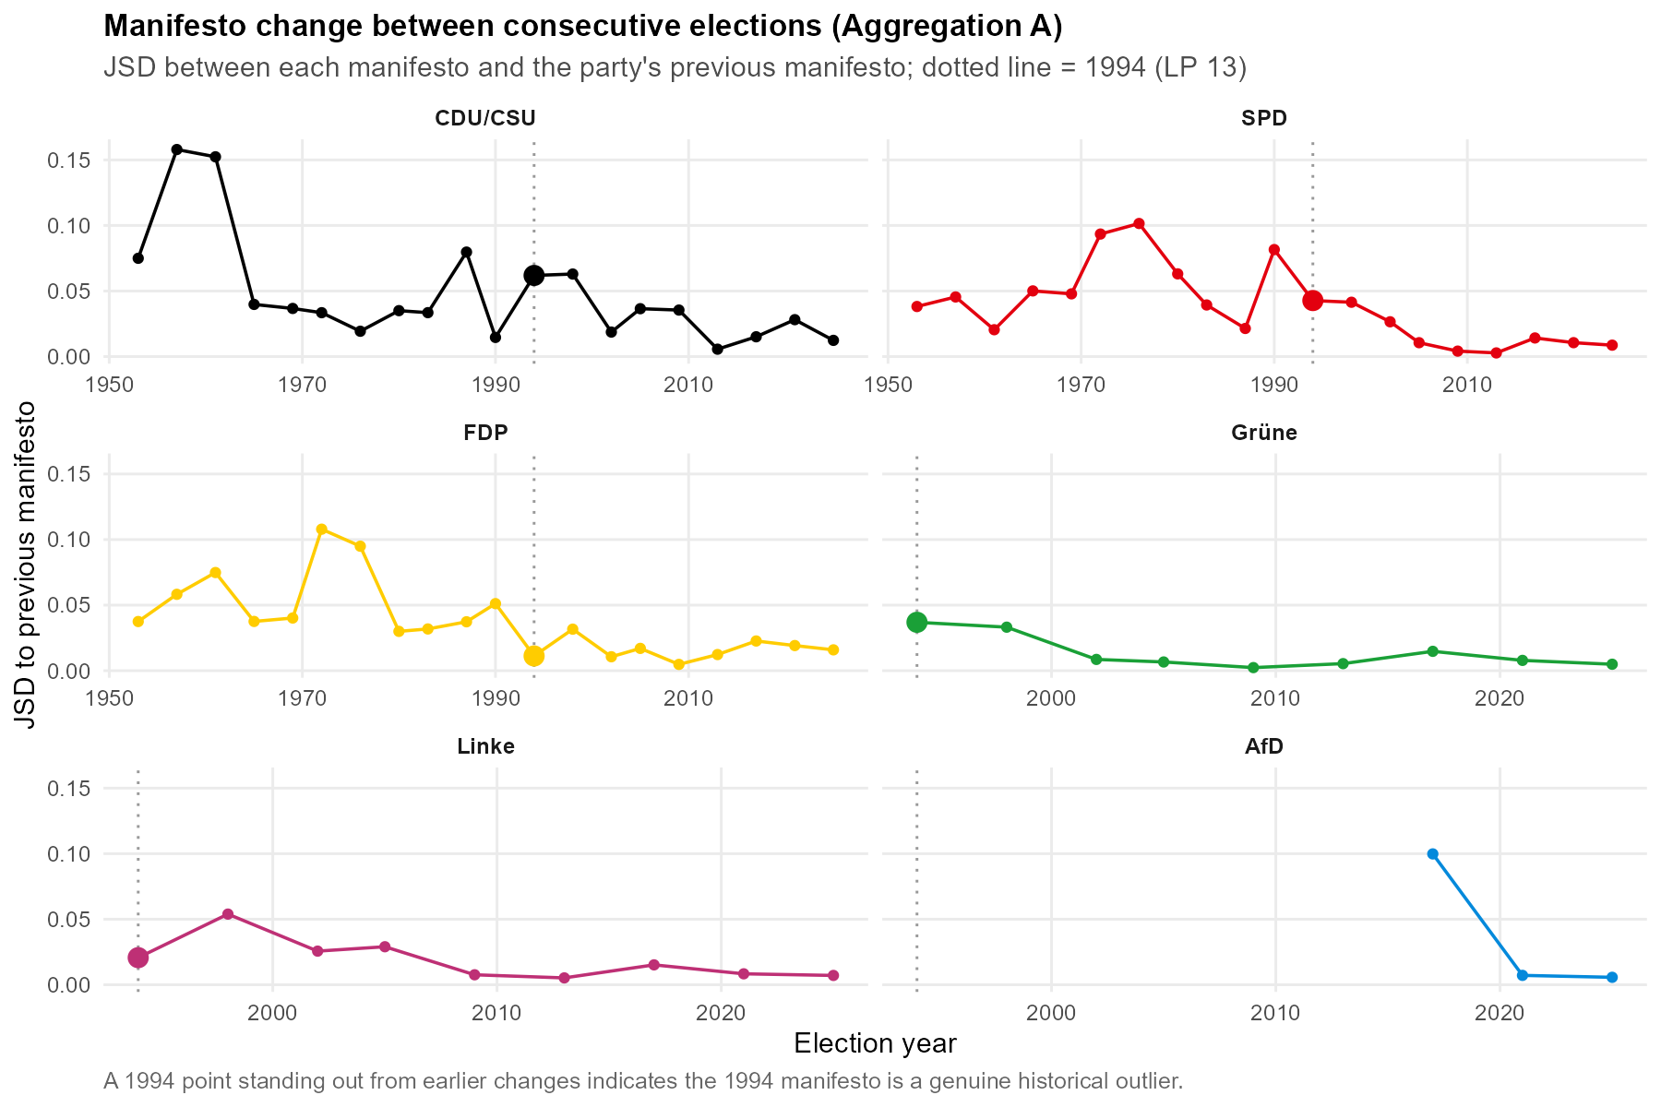
Figure F.10.1. Manifesto change between consecutive elections, by party. JSD between each manifesto and the party’s previous programme; the dotted line marks 1994. The 1994 change does not stand out from the party’s earlier transitions.
Third, the composition series explains why the 1994 programmes stand apart within the analysis window without being anomalous. Manifesto compositions drift steadily from one election to the next (Figure F.10.2), and for the three long-observed parties the election-to-election change is visibly smaller after the mid-1990s than before: the parties settle into the more similar profiles of 1998 to 2021. The 1994 manifesto is simply the earliest in the window, and therefore the most distant from that later cluster, which the genre-stable plenary speech resembles more closely than it resembles the older programme.
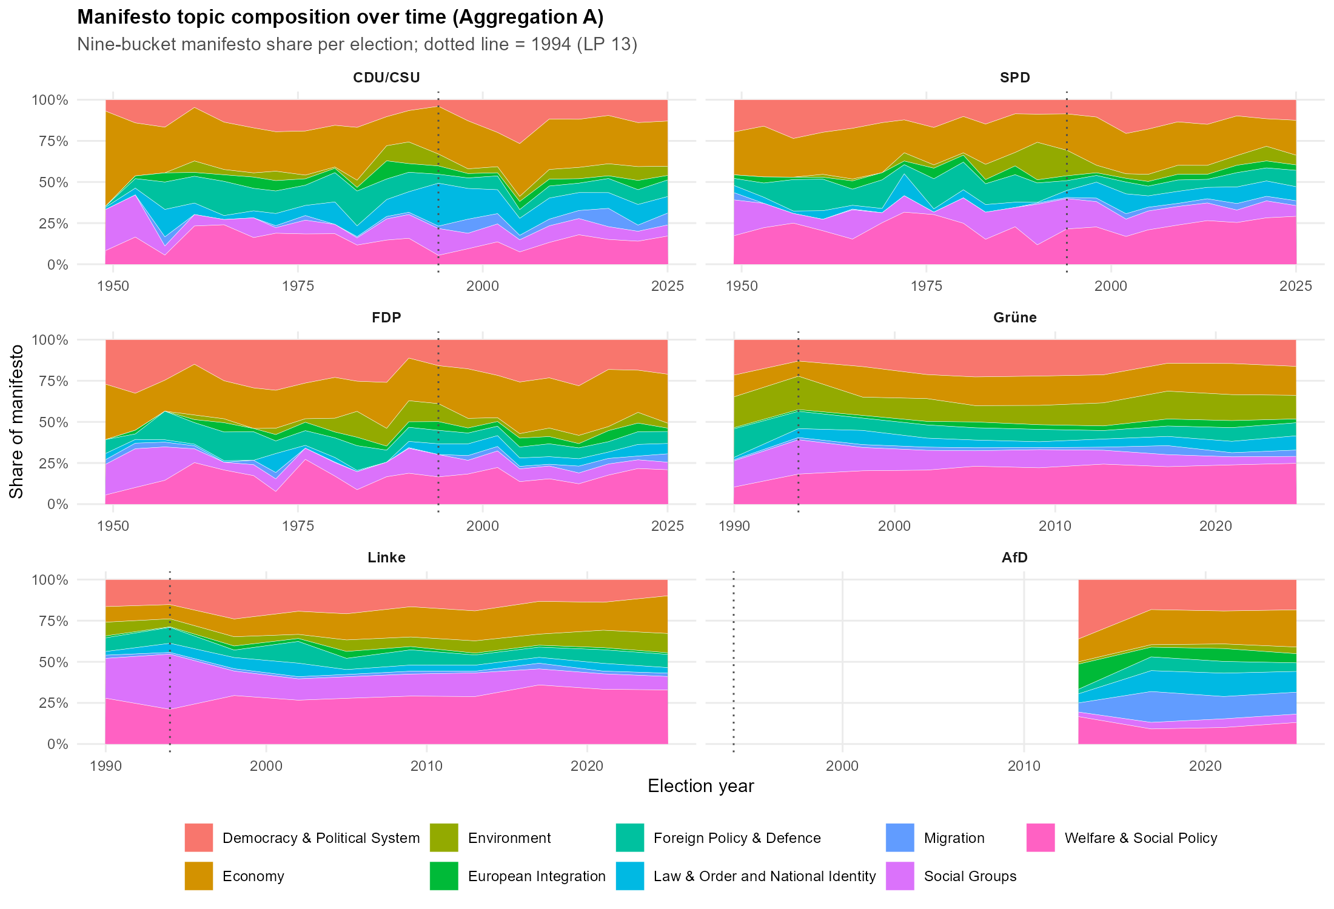
Figure F.10.2. Manifesto topic composition over time, by party. Nine-bucket manifesto share per election; the dotted line marks 1994. Compositions drift steadily, and the post-1994 profiles form a tighter cluster.
Taken together, the LP-13 elevation is a boundary effect of where the observation window opens, carried entirely by the manifesto side, and it requires no substantive account of the 1994 election. Chapter 5 reports it as such and does not read it as evidence about any single party or period.

Appendix G: Software, Runbook and Integrity Checks
This appendix documents the computational environment, the order in which the analysis scripts run, the integrity checks referenced in Section 4.7.4, and the training details of the non-codable filter of Section 4.6.1. All specification constants, including the primary specification, the temperature values, the bootstrap draws and the seeds, are declared once in the configuration script and read by every downstream script, which rules out divergent hard-coded settings by construction.
G.1 Computational Environment
Table G.1: Software, models and data versions.
Component | Version and details
Operating system | Windows 11
Hardware | NVIDIA RTX 5070 Laptop GPU (classification, filter training and inference)
R | key packages: data.table, arrow, manifestoR, polmineR, here
Python | torch (CUDA 12.8 build), transformers (>= 4.40), pandas, pyarrow, numpy
Classifier | manifesto-project/manifestoberta-xlm-roberta-56policy-topics-context-2024-1-1 (Section 4.4)
Filter model | deepset/gbert-large, fine-tuned as described in G.4
Labelling model | Claude Sonnet (claude-sonnet-4-6, accessed via the batch API; Section 4.5.2)
Corpora and data | GermaParl2 v2.3.0-rc1 (doi:10.5281/zenodo.15495748); MARPOR Main Dataset, version 2025-1 (Lehmann et al., 2025)
G.2 Pipeline Runbook
Table G.2: Analysis scripts in execution order.
Script | Purpose
00_config.R | Single source of truth: paths, the 56-code list, both aggregation schemes, specification axes, primary-specification constants, seeds, JSD and bootstrap functions. Every downstream script sources this file and never hard-codes a specification.
01 | Speech extraction from the CWB corpus: speaker roles, minimum length, sentence segmentation (Section 4.3.1).
04_classify_manifestoberta.py | GPU classification of all sentences into the 56 categories with context windows (Section 4.4); writes the chunked per-sentence posterior files.
05_pull_marpor.R | Manifesto data via manifestoR; per-manifesto code distributions.
06_gold_realign_validate.R | Gold-standard alignment and validation metrics (Section 4.5.1), including the carried triple comparison.
09 | Silver-standard agreement analysis between ManifestoBERTa and the Sonnet labels (Sections 4.5.2 and 4.5.3).
10_train_000.py | Trains the non-codable filter (G.4); writes model_000_gbert/ and the cross-validated metrics.
11_apply_000.py | Applies the filter to all chunks; adds p_000 and is_000 to every sentence, non-destructively and resumably (Section 4.6.1).
12_aggregate.R | Single streaming pass over the corpus: all 18 specifications per scheme, manifesto distributions, bootstrap intervals, cell diagnostics (Section 4.7).
13_dps_speclock.R | DPS deep dive: 305 asymmetry, redundancy test, migration re-split arm, independent recomputation of the primary JSD (Sections 4.6.2 and 4.9).
17_robustness.R | Pre-committed robustness arms and acceptance criteria (Section 4.9).
19_migration_position_trajectories.R | Party-level read-out of the migration domain: speech positions per party against the Dalton-weighted mean and dispersion (Appendix F.9).
gold_000_check.py | Post-hoc check of the filter against the gold labels (Section 4.6.1).
Note: Script names follow the repository; scripts 01 and 09 are listed by their pipeline position. Intermediate outputs are written to Data/ and cache/ under the project root.
G.3 Integrity Checks
Three layers of checks guard the aggregation. First, the code-to-bucket indicator matrices are verified at load time: every one of the 56 codes is placed in exactly one bucket of scheme A, so the row sums of the indicator matrix equal one by construction and no probability mass can be lost or duplicated. Second, every per-cell distribution of every specification is renormalised and checked to sum to one within a numerical tolerance of 10^-6, on the speech side and the manifesto side alike. Third, the primary JSD values of the aggregation script are recomputed independently in the specification-lock script from the stored per-sentence bucket masses; the two computation paths agree to within the declared numerical tolerance of 10^-6 (Section 4.7.4). In addition, the filter application of Section 4.6.1 writes atomically and resumably, so an interrupted run cannot leave partially written chunks, and the null-class probability is stored per sentence, so every threshold decision remains reversible without re-inference.
G.4 Non-Codable Filter: Training Details
Table G.3: Training and evaluation of the gBERT-000 filter.
Item | Value
Base model | deepset/gbert-large (Chan et al., 2020)
Task | Binary classification, codable versus non-codable (000)
Labels | Claude Sonnet silver labels, samples A and B combined; 19,821 usable sentences, 4,414 labelled 000 (22.3%)
Input | Sentence with surrounding context (use_context = true)
Evaluation | Stratified five-fold cross-validation, out-of-fold predictions; the production model is a final refit on all labelled data
Epochs per fold | 3
Out-of-fold metrics | PR-AUC 0.845, ROC-AUC 0.931; at threshold 0.5: precision 0.801, recall 0.716, F1 0.756
Operating point | is_000 := p_000 >= 0.5; p_000 is stored per sentence, so the threshold can be varied downstream without re-inference
Threshold justification | DPS share in the evaluation sample: 40.0% unfiltered, 32.2% at threshold 0.5, oracle 31.7% (Section 4.6.1)
Note: Metrics from model_000_text_metrics.json; see Section 4.6.1 for the gold-sample check of the filter.

Contrary to the default behaviour, split_camel_case is set to false, since abbreviations such as GroKo must not be split.
The version of SoMaJo used here is 2.4.3.
Normalisation masks named appellations to a placeholder ('Herr Kubicki' → 'herr <name>'), then lowercases, collapses whitespace, and strips leading/trailing punctuation; the identical routine builds the candidate list and matches the corpus, so a single entry (‘herzlichen dank, herr <name>') captures all name variants.
Pretrained by Facebook AI on 2.5 TB of filtered CommonCrawl data in 100 languages, with about 560M parameters (Conneau et al., 2020).
The standard classification head was modified by removing the tanh activation and the intermediate linear layer, reducing it to a direct linear projection from the sentence representation onto the 56 logits (Burst et al., 2024).
Accuracy figures as reported on the Hugging Face model card (accessed 10 July 2026).
The model is run in evaluation mode, which deactivates dropout; inference is thus deterministic in design (no stochastic components), although exact bitwise reproducibility across hardware configurations is, as usual for GPU inference, not guaranteed.
Against the prediction stored at sampling time, κ(A) over all 259 coded sentences is 0.570, against 0.562 over the 249 carried. The loss does not shift the estimate.
model identifier claude-sonnet-4-6, accessed via the batch API.
See Appendix D.
The gold sample supports the same ordering at the directional level: against the human coder, Sonnet reaches a κ(B) of 0.622 to the classifier's 0.490 (n = 111, strict direction handling, full gold basis, which is why κ(B) here differs to the κ(B) reported in Section 4.5.1).
The ROC-AUC is the probability that a randomly drawn non-codable sentence receives a higher filter score than a randomly drawn codable one. The PR-AUC summarises precision and recall across all thresholds and is the stricter measure under class imbalance, since its chance baseline equals the positive share of 0.223.
The interval is a Wilson score interval, obtained by asking which true recall values the observation would not reject rather than by placing a symmetric band around the point estimate. It is used in preference to the normal approximation, which understates the uncertainty at samples of this size because its actual coverage falls short of the nominal level.
The FDP's 1994 manifesto carries no migration-coded material, so its migration score is undefined; all migration shares are computed over the 37 cells that carry migration content on the manifesto side.
This is because the FDP's 1994 manifesto contains no migration-coded material, so its manifesto score is undefined and the cell drops from the migration regression.
For a figure with adjusted scaling for readability of dot party pairs refer to Figure F.9.1.
The dispersion series is computed on the 38-cell analysis sample, so the PDS cells of LPs 13 to 15 are outside it in both channels. The party-continuity decision of Section 4.8 applies to the assignment of manifestos to parties across the 2007 merger rather than to which parties held seats.

