

**Cruise Design Program**

**Users Guide**

**Version 2016_0505**

May 05, 2016

Washington Office

Forest Management Service Center

Fort Collins, Colorado

The U.S. Department of Agriculture (USDA) prohibits discrimination in all its programs and activities on the basis of race, color, national origin, sex, religion, age, disability, political beliefs, sexual orientation, or marital or family status. (Not all prohibited bases apply to all programs.) Persons with disabilities who require alternative means for communication of program information (Braille, large print, audiotape, etc.) should contact USDA’s TARGET Center at (202) 720-2600 (voice and TDD).

To file a complaint of discrimination, write USDA, Director, Office of Civil Rights, Room 326-W, Whitten Building, 1400 Independence Avenue, SW, Washington, DC 20250-9410 or call (202) 720-5964 (voice or TDD). USDA is an equal opportunity provider and employer.

Introduction 2

Getting Started 3

Create Design from Recon File 3

Design Strata From Historical Data 9

Setup Costs 11

Design Cruise 12

Sale Level 13

Strata Level 14

Sample Group Level 15

Designing a Cruise 17

Select Cruise Methods 17

Update any Missing Values 19

Optimize for Error 19

Modify Sample Group Information 19

Reports 20

Create Production Button 21

Help 23

Return 23

Determine Additional Samples (Future Feature) 23

Compare Design with Production Cruise (Future Feature) 23

Exit 25

# Introduction

The Cruise Design Program was developed to aid in both training and production aspects of the cruise design process. Selecting between the various cruise methods available under the National Cruise Program and determining sample sizes to meet a specific sale error can be a confusing and time consuming process. The Cruise Design Program is designed to provide an interactive approach to designing a cruise by allowing a cruiser to examine many different cruise methods across many different strata and sample groups in a relatively short period of time.

The Cruise Design Program has several features that can assist a cruiser in the cruise design process.

1. Recon data can be accessed directly from a .cruise run through the Cruise Processing program.
2. Data from historical cruises or stand exam data can be input into the system if recon data is not available.
3. Multiple strata and sample group level determinations can be made when designing a cruise. These strata and sample groups are examined simultaneously to determine sample sizes that will achieve the desired sale error.
4. Strata and sample group level errors and sample sizes can be manipulated to achieve the desired over all sale error. Optimal allocation routines provide for ‘most efficient’ sampling sizes across strata and sample groups.
5. Sale, strata, and sample group errors are determined using actual t-values based on sample size for sample sizes less than 30.
6. A one-page comparison of all cruise methods provides for quick comparisons of CVs and sample sizes between cruise methods for each stratum.
7. Sampling frequencies, BigBAF, and KZ values are computed and displayed in a report for each strata and sample group.
8. Cost analysis provides relative cost for each sampling method so comparisons can be made across sampling methods and across strata. (Available in future versions)
9. The program can create a new cruise file from the design information which can be loaded into FScruiser for data entry.
10. If a cruise fails to meet error, program can help the user determine how many additional samples are needed and where to place them.

# Getting Started

The main menu displays the name of the program in the banner at the top (Figure 1). From the main menu to the left, you will initially be given five options: File, Setup, Design, Tools, and Exit. Only File and Exit are available until a file is opened.

The program will open the File option when starting the program providing the user with the following options: *Open an Existing File*, *Create New From Recon File, Create New From Historical Data,* or *Exit.*

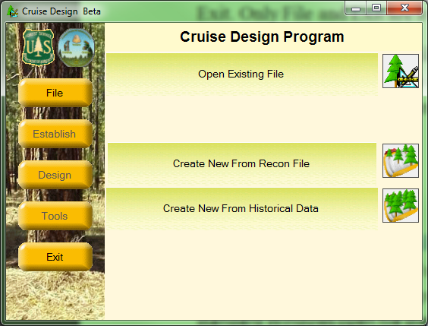

Figure 1: File Menu Screen

## Open Existing File

The Cruise Design program will save all cruise design files with a .design file extension. To open an existing design file to continue working on the file, click the Open Existing File button. This will open the standard Windows open file dialog box, prompting the user to select an existing .design file.

The user can also select a .cruise file to open with the Cruise Design program. This will allow the user to do some additional analysis on a production file like determining supplemental samples or comparing production cruise statistics to the design statistics. The .cruise file will need to be processed through the Cruise Processing program first.

Once a .design or .cruise file has been opened, the *Establish, Design* and *Tools* buttons become active.

## Create New from Recon File

Selecting this option will open the standard Windows open file dialog box, prompting you to select an existing .cruise file containing recon data. The recon .cruise file must be run through the Cruise Processing program before Cruise Design can work with the file. The Cruise Processing program adds the volume calculations to the .cruise file. No specific reports need to be requested. Once the processed recon .cruise file has been selected, the *Establish, Design* and *Tools* buttons become active.

## Create New from Historical Data

Selecting this option will open the standard Windows save file dialog box, prompting you to enter the name of a .design file. Once the file name is given and the Save button is clicked, the program will display the Select Template form prompting the user to provide a cruise Template file and enter Sale level data (Figure 2). Once the data has been entered, click on the Finish button to create the new .design file. The *Setup, Design* and *Tools* buttons will now be active.

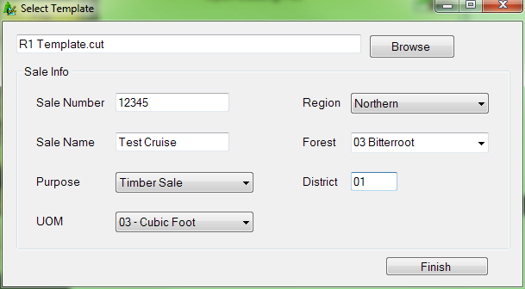

Figure 2: Select Template form.

## Establish

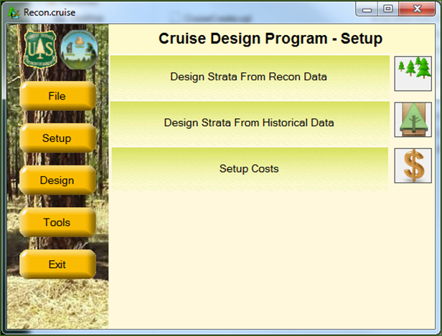Before any analysis can take place, the user will need to define the sale populations. This is done under the **Establish** menu. Click on *Establish* to begin defining the sale strata and sample group information. If the user has recon data, click on the *Design Strata From Recon Data* button to create new strata definitions. If the user is using historical data sources, click on the *Design Strata From Historical Data* button (Figure 3). If the historical data precedes the new data structure (the files are in the old .crz formats) or the users only has information from printed cruise reports, use the *Design Strata From Recon Data* button to create new strata definitions.

Figure 3: Establish Menu Options

## Design Strata from Recon Data

No strata information will be brought into a design file from an existing cruise (recon) file. Clicking on the *Design Strata From Recon Data* button will open the Strata Setup form. This will take some time initially as the Cruise Design program is creating the design file and copying information from the recon file into the design file. The design file will have the same name as the recon cruise file, but with the .design extension.

The cruise wizard forms are designed to walk the user through the strata and sample group setup process one step at a time. There are three steps required to define a stratum with one or more sample groups.

### Strata Setup Form

The Strata Setup Form (Figure 4) is where the user will define stratum codes and assign units to the individual stratum. All of the units identified in the in the recon cruise will be displayed in the unit table. If no recon file is detected, all the units will need to be added manually.

To create a Stratum, click on the *Add Stratum* button in the upper left portion of the form. Give the stratum a Code (two digits max) and, optionally, a Description. Using a detailed strata description will help you identify strata during the design phase.

Next, select one or more units from the Unit Table by clicking on the *Select* box for the associated cutting units for each stratum (Figure 4). If no units exists (or additional units need to be added), clicking the *Add Unit* button will add a blank row to the end of the Unit Table. Each unit record requires a “Code” and “Area” in acres as the minimum amount of information to be entered.

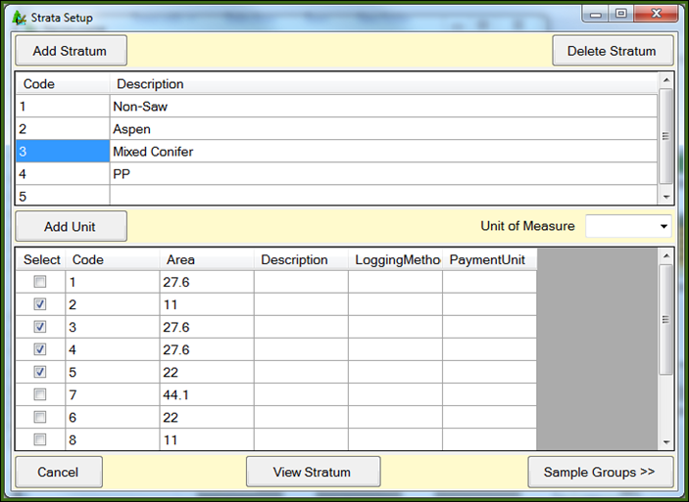

Figure 4: Strata Setup Form

Once the stratum has been created and units assigned, click the *Sample Groups* button in the bottom right corner of the form to create sample groups. This will open up a new form where sample group information can be entered. The user has the option of creating sample groups for each stratum as they are created or to create all strata first, then filling in sample groups for each stratum.

The View Stratum button will take the user to the View Strata Form. This form will allow the user to examine all stratum and sample groups defined.

### Setup Strata using Recon Populations

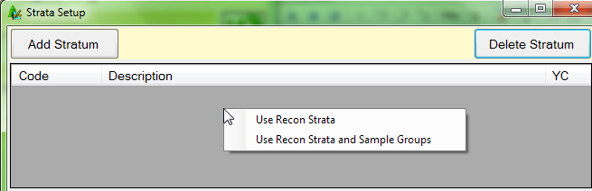Often, the populations used in the original recon cruise are the same or similar to the populations used in the production cruise. Cruise Design provides a shortcut to using those recon populations. Right click in the empty stratum table at the top. This will display a pop-up menu with two options: *Use Recon Strata* and *Use Recon Strata and Sample Groups* (see figure 5). The first option will copy the strata information from the recon cruise into the design file. The user will still have to define sample groups. The second option will copy all the strata and sample group information from the recon file.

Figure 5: Use Recon Strata Option

### Sample Group Setup Form

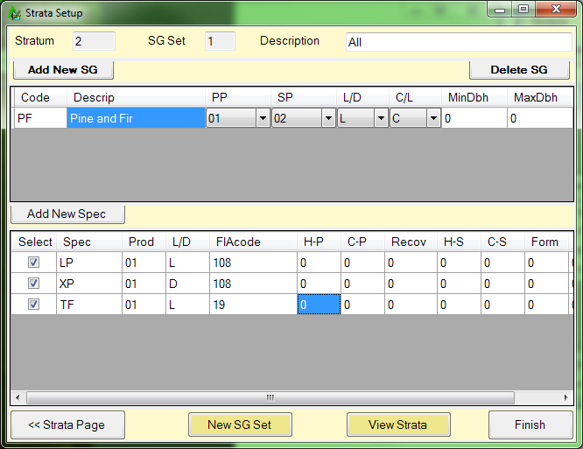The Sample Group Setup Form (Figure 6) is where the users will create sample groups for each of the defined stratum. The associated stratum number is displayed in the *Stratum* field located at the upper right have corner of the form. There are also fields for SG Set and Description, which will be discussed further down. The SG Set field is read only and will be set to the number ‘1’ initially.

Figure 6: Sample Group Setup Form

Because every stratum must have at least one sample group, the program automatically creates a blank sample group for you. To create additional sample groups, click on the Add New SG button. A new line is added to the sample group table. Enter a sample group code (up to two digits) and a description. Select the Primary Product, Secondary Product, default Live/Dead code, and Cut/Leave code for the sample group using the pull down lists.

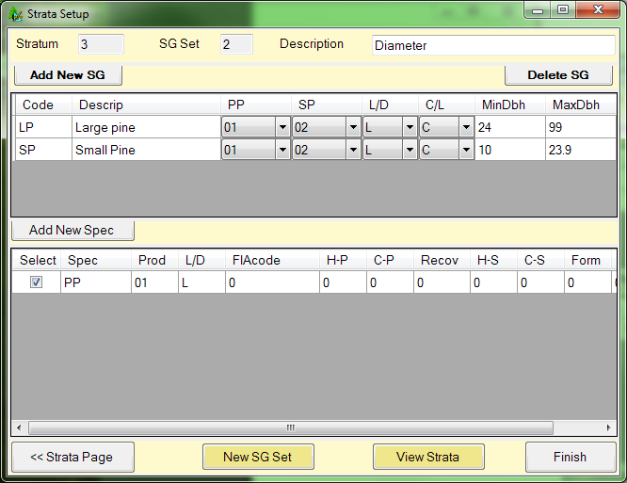If diameter ranges will be used to define populations, enter diameter limits for each sample group in the MinDbh and MaxDbh columns (Figure 7). Diameter breakpoints must be entered with a precision of 0.1 inch (e.g., 24.9) to ensure each tree is placed within a population. If stratifying by diameter class, use the same diameter range for all sample groups in the stratum. If using diameter ranges to denote sample groups, each sample group should have a separate diameter

Figure 7 - Defining Populations by Diameter Class

range. Take care not have gaps between the diameter ranges or overlapping diameter ranges. Note: when creating a diameter class with only a lower bound, it is a good idea to enter a dummy variable for the maximum diameter (e.g., 99) to ensure all large trees are included in the cruise design.

Once a sample group has been defined, it needs to be populated with species. In the bottom half of the window is where the species codes for each sample group will be selected. This list will only show species from the recon cruise attached to the selected units. The list will also be filtered to only show those rows containing the same Primary Product code selected for the sample group. To add species to the selected sample group, click one or more boxes in the Select column.

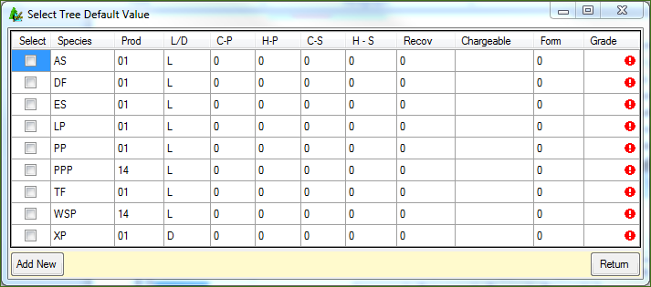If species codes are missing, click the *Add New Spec* button. A new window will pop up with a list of all default species codes that came with the recon file or template file (Figure 8). If there is a species code not available that you need to add, click the *Add New* button in the bottom left corner which will yield a blank row at the bottom of the window requiring you to enter pertinent species code information. Once all additional species codes are selected, click the Return button in the bottom right corner to close this window.

Figure 8: Select Tree Default Value Form.

#### SG Set

The SG Set is a new feature allowing the user to create more than one set of sample groups. For example, the user can lump all species together in one sample group code in the first SG Set then create a second SG Set and create separate sample groups for each species. In this way, the user can easily switch between SG Sets when designing the cruise to see how different stratification schemes affect different cruise methods. The Description field should be used to identify your SG Sets so they can be selected easily during the design phase. To create a new SG Set, click the *Add New SG Set* button to create a new sample group table. The SG Set code will be incremented by one. The user will have the ability to create several SG Sets for each created stratum.

At a minimum, the user should create two SG Sets for each stratum: one with all of the species for each product in a single sample group and one with each species in a separate sample group (or groups of like species in separate sample groups if there are a lot of species).

Once all of the sample groups for the currently selected stratum have been created, the user can select one of the following options:

Strata Page: This button takes you back to the Strata Setup window.

View Strata: This button will take you the View Strata form. This form will allow the user to examine all stratum and sample groups defined.

Finish: Once all of the sample groups for all of the strata have been created, Finish will exit the Strata Setup wizard and return the user back to the main form.

### View Strata Form

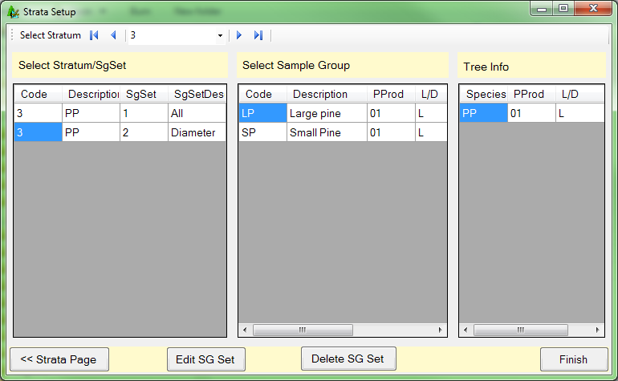The View Strata Form (Figure 9) is used to review populations and allow the user to select a specific population for editing. At the top is a navigation control allowing the user to scroll between all defined strata. Below that are three panes of information: Stratum & SG Set information, sample group information, and tree information (Figure 9). Selecting a stratum from the navigation bar will display a list of all SG Sets defined for that stratum. Selecting an SG Set will display all of the Sample Groups defined for the specific SG Set. Selecting a Sample Group will display all of the Species codes selected for that Sample Group.

Figure 9: View Strata Form

From this form, the user is able to select a specific SG Set for editing by clicking the *Edit SG Set* button. This will take the user back the Sample Group Form. To delete a specific SG Set and all corresponding Sample Groups, select the desired SG Set and click the *Delete SG Set* button. When finished reviewing the stratum information, the *Strata Page* button will take you back to the main Strata Setup form while the *Finish* button will exit the Strata Setup wizard and return the user back to the main form.

## Design Strata From Historical Data

A new feature of this version of Cruise Design allows the user to create and design strata based upon data from historical cruises that occurred in forests similar to those in your current sale area. To use this feature, click on the *Design Strata From Historical Data* button to open up the “Historical Setup” window (Figure 10). From here, there are four steps for creating strata from historical data:

**Step 1**: Click the Add button to create a new row at the bottom of the strata list and fill in the Code using two alpha-numeric characters maximum. The Description will be filled in by the program once historical data has been selected.

**Step 2**: Select the cutting unit you want this historical information to apply to by clicking on the *Select* box for the associated cutting units.

Figure 10: Historical Setup Main Form.

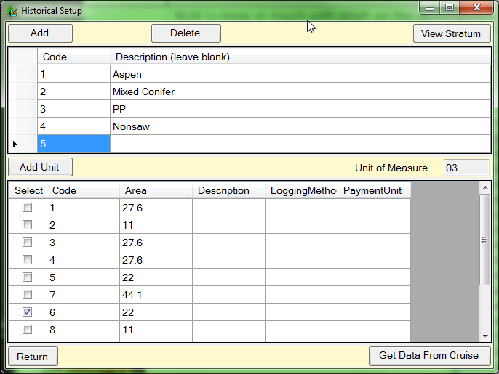**Step 3**: Click the *Get Data From Cruise* button to open up the standard Windows open file dialog box, prompting you to select the historical .cruise file. Once the historical cruise file is opened, select from the list of historical cruise strata the population to be used (Figure 11). The cruise design program will create the stratum and sample groups based on the historical data and utilize all of the calculated statistics. Once the stratum has been selected, click on *Finish* to return to the main screen. If more than one stratum need to be defined using historical data, click on the ***<<***button to return to the Historical Setup main form. The stratum description will be set to the cruise method selected followed by the cruise file name.

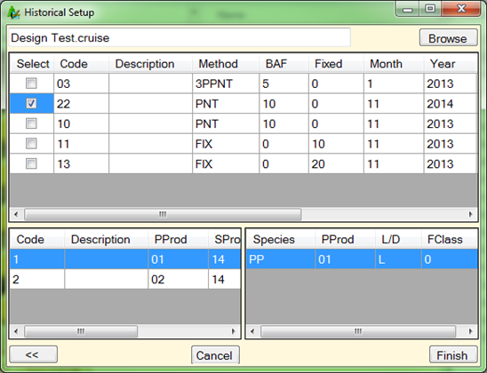

Figure 11: Select historical cruise file.

**Step 4**: Click the *Return* button in the bottom left corner to close the Historical Setup window.

## Design Strata without Using Data

Populations can be created without using either recon data or historical cruises. This can be useful if the historical data exists in paper form. In this case, the populations are created and the statistics are entered manually in the design form.

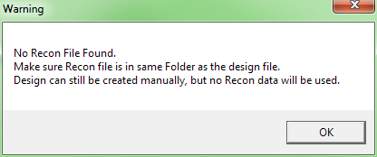Create a new file using the Create from Historical Data option, following the instructions to create the new file. From the Setup menu, selecting the *Design Strata From Recon Data* button will open the Strata Setup form. You will receive a warning message saying No Recon File Found (Figure 12). Strata and sample groups can still be created, but the user will have to manually enter in the information needed. Refer to the section titled *Design Strata from Recon Data* for more information on using the Strata Setup form.

Figure 12. No Recon File Warning Message.

## Setup Costs

In an effort to improve upon the cost determinations, a form has been created to determine relative cruising costs (Figure 13). The form makes use of hourly crew costs and the time it takes to do certain activities. The estimated values entered in this form will be used later for comparing costs between different cruise methods and sampling intensities. Enter as much information as you have available, or that you can reliably estimate.

Crew Size: Enter the number of individuals your cruising crew consists of.

Crew Cost per Hour $: Sum the hourly wages of you cruising crew and enter that number here.

Travel Time to Sale Area: Estimate the total time it will take your crew to get from the office to the timber sale area.

Cost of a Quart of Marking Paint $: If you wish to include the cost of paint to your cruise, you can enter the estimated cost of a quart of marker paint.

Number of Trees Marked per Quart: Estimate the average number of trees you can expect to mark with one quart. The number of quarts will be determined by dividing the total number of tallied trees by the estimated number of trees per quart.

Time to Measure a Single Tree: Estimate the time it takes a cruiser of average skill level to obtain the necessary tree-level measurements that will be collected for your timber cruise.

Time to Establish a Count Plot: Estimate the time it will take your crew to locate plot center, monument plot center, and determine the number of “in” trees, including measuring borderline trees, for the average plot in your sale area. Enter that number here.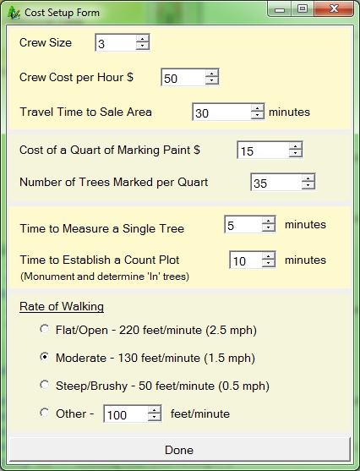

Figure 13: Cost Setup Form

Rate of Walking: This portion of the form assumes the average healthy timber cruiser walks at a pace of 3 mph in flat/open conditions as a baseline option, from which two other slower-paced options for walking rate can be selected. If you wish to specify a different walking rate, select the *Other* radio button and enter the rate by selecting the box and entering the rate, or by using the up/down arrows to arrive at your specified walking rate value.

When you have finished the form, select the *Done* button to return to the main menu.

# Design Cruise

Once all populations have been defined, click the Design button which will lead you to the Cruise Design Program-Design window (Figure 14). Select the Design Cruise button to design the cruise.

The Design Cruise option will process all of the recon and/or historical cruise data to calculate the necessary statistics for determining sample sizes. The processing stage might take a little bit of time, depending on the amount of data the program has to process. The program will attempt to calculate the CVs, trees/acre, volume/acre, and sampling errors using every sampling method available in the Cruise Processing program for each defined Stratum and Sample Group.

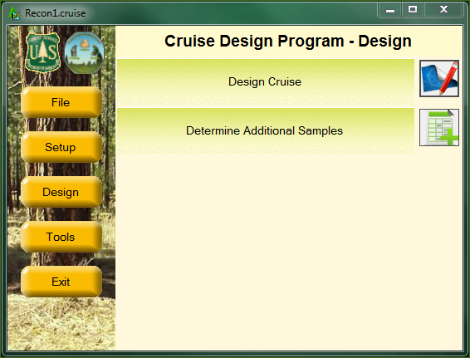

Figure 14: Cruise Design Program-Design Window

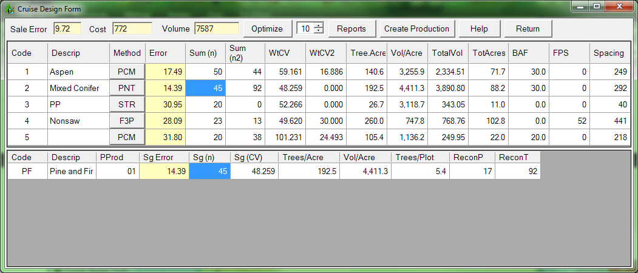If there is no tree data for any given stratum or sample group, the program will assign default values for the CVs, trees/acre, and/or volume/acre. These default values will need to be updated by the user to their appropriate values. Once the data is processed, the Cruise Design Form will be displayed (Figure 15).

Figure 15: The Cruise Design Form

There is a lot of information displayed in the Cruise Design Form. To help manage the information, the Cruise Design Form is separated into to three basic sections: Sale level section, Strata level section, and the Sample Group level section.

Sale Level

The Sale Level is shown at the top left of the form. Basically, the Sale Level consists of the Sale Error, Cost and Volume fields.

Sale Error: The Sale Error is displayed in the first blue field and is the total combined error for the sale. The error is computed using the formulas shown in the Timber Cruising Handbook (FSH 2409.12).

Cost: The Cost is the estimated relative cost for the cruise as designed. It does not represent the actual cost to do the cruise, but it provides a number to compare against other designs for this sale.

Volume: This is the total volume estimate for this sale. This number will be displayed as either CCF or MBF depending upon the Unit of Measure for the sale.

Strata Level

The Strata Level information is displayed in the upper table. There are several columns of information displayed for each stratum. All of these columns are set to Read-Only with the exception of the Description and Vol/Acre fields. If you place your mouse over these columns headings, you will see a tool tip with a description of the field appears.

Code: Stratum code.

Descrip: Stratum description. This field is editable if you wish to add or modify a stratum description.

Method: The cruise method or sampling procedure that will be used to determine the sample trees for this stratum.

Error: Stratum Error. This is the combined sample group error determined by weighting each sample group error by the amount of volume occurring in each sample group. If there is only one sample group, the stratum error will equal the sample group error.

Sum (n): The total number of first stage samples to be taken for the Cruise Method. This number is the sum of the sample group number of first stage samples (see below).

Sum (n2): The total number of second stage samples to be taken for the Cruise Method. This number is the sum of the sample group number of second stage samples (see below).

WtCV: The Weighted CV value of the first stage samples for the Stratum. This number represents the sum of the sample group first stage CVs weighted by the volume for each sample group. This value is computed using the formulas shown in the Timber Cruising Handbook (FSH 2409.12).

WtCV2: The Weighted CV value of the second stage samples for the Stratum. This number represents the sum of the sample group second stage CVs weighted by the volume for each sample group. This value is computed using the formulas shown in the Timber Cruising Handbook (FSH 2409.12).

Trees/Acre: The total estimated trees per acre. This value is the sum of the sample group trees/acre value. If only one sample group exists, the stratum trees/acre will match the sample group trees/acre.

Vol/Acre: The total estimated volume per acre displayed in either cubic foot or board foot units depending upon the Unit of Measure for the sale. This value is the sum of the sample group trees/acre value. If only one sample group exists, the stratum trees/acre will match the sample group trees/acre.

TotalVol: The volume per acre multiplied by the total acres. This number will be displayed as either CCF or MBF depending upon the Unit of Measure for the sale.

TotAcres: Total acres for the Stratum.

BAF: Basal area factor used for the stratum (if applicable).

FPS: Fixed plot size displayed as the denominator of the Fixed Plot Size fraction (i.e., a 1/50 acre plot size would display as “50”).

Spacing: For plot-based methods, this is the recommended plot spacing for the Stratum. This value is based on the total acres for the stratum and the total number of plots (Sum (n)) established. For tree-based methods, this is the average tree spacing for the Stratum. This value is based on the estimated trees/acre value assuming square spacing.

Sample Group Level

The Sample Group Level consists of the lower table. This table contains all of the sample group information for the currently selected stratum. This table is where most of the work is done. All of the values in this table are editable, except for Primary Product. You can change, for any sample group, the sample group error, the sample size, the estimated CV values, trees per acre, volume per acre, and so on.

There is quite a bit of information displayed in this table. The number of columns changes depending upon the cruise method selected. Below is the complete list of the columns that can be displayed in the sample group table.

Code: Sample group code.

Description: Sample Group Description.

PProd: Primary product code for the sample group.

Sg Error: Sample Group Error. This is the calculated sampling error for the sample group. The error will be computed using the floating Student’s T value instead of using a Student’s T value of 2.0.

Sg (n): The total number of first stage samples to be taken for the Cruise Method. For the Tree Based cruise methods 100, STR, and 3P, this number will represent the number of sample trees. For S3P, this number will represent the number of first stage samples or trees requiring a kpi estimate. For the Plot Based cruise methods PNT, FIX, F3P, P3P, PCM, and 3PPNT, this number will represent the total number of sample plots to establish. This number will include any Recon plots that might be used in the production cruise. For the 100 percent cruise method, this number will be Read-Only and will be set to the product of the trees/acre for the sample group multiplied by total stratum acres.

Sg (n2): The total number of second stage samples to be taken for the Cruise Method. This column will only be displayed for 2-stage sampling methods (S3P, P3P, F3P, PCM, 3PPNT). This number will represent the number of sample trees measured for all the 2-stage methods except 3PPNT, where the value will represent the number of sample plots to measure.

Sg (CV): The estimated CV value of the first stage samples for the sample group.

Sg (CV2): The estimated CV value of the second stage samples for the sample group. This column will only be displayed for 2-stage sampling methods (S3P, P3P, F3P, PCM, 3PPNT).

Trees/Acre: The estimated number of trees per acre for the sample group.

Vol/Acre: The estimated volume per acre for the sample group displayed in either cubic foot or board foot units depending upon the Unit of Measure for the sale.

Trees/Plot: Estimated trees per plot for the Sample Group. This number is computed from the Recon data or set to a default value of 6. This column will only be displayed for the Plot Based cruise methods (FIX, F3P, PNT, P3P, PCM, and 3PPNT).

Total Trees: The estimated number of trees per acres multiplied by stratum acres.

Total Volume: The estimated volume per acre for the sample group multiplied by stratum acres.

Freq: Frequency; the rate at which a sample is determined. A frequency of 100 equates to one sample every 100 counts. This column will only be displayed for the STR, S3P, PCM cruise methods and as a Read-Only field for the 100 percent cruise method. For the PCM method, the Frequency value can be read as measure every xth tree or measure all the trees on every xth plot where x is the actual frequency value.

Freq (ins): Insurance tree frequency; the rate at which insurance trees are determined for selection behind the scenes. For example, an insurance frequency of 10 will identify every 10th sampled tree as an insurance tree.

BigBAF: The basal area factor used to select measure trees when taking the “BigBAF” approach for the PCM cruise method.

KZ: The KZ value for a 3P sampling method. This column will only be displayed for the 3P, S3P, P3P, F3P, and 3PPNT cruise methods.

ReconP: The number of plots (if any) from the Recon data that were used to compute the statistics for this sample group.

ReconT: The number of measured trees (if any) from the Recon data used to compute the statistics for this sample group.

Designing a Cruise

To design your cruise, you need to decide upon the cruise method you wish to use for each stratum and then take enough samples across all your strata and sample groups to meet your desired sampling error. The CruiseDesign program was specifically designed to help you accomplish this task.

There are several steps you should follow when designing your cruise: select cruise methods, update any missing values, optimize for a sale error, modify the samples for each strata and sample group, and create a report with your options. You may then wish to select new cruise methods and redo the process until you determine your ‘best’ cruise design.

Select Cruise Methods

For each stratum, you should select an appropriate cruise method. To change the cruise method, click on the button located in the “Method” column for each stratum (Figure 15). A new window will appear containing all the cruise methods for the stratum by SG Set (Figure 16).

The left half of this window contains information detailing sample group variability for each SG Set and specific sampling method.

Select: use this column to select the desired cruise method.

Code: Stratum code.

Method: Cruise method under consideration.

SgSetDescrip: Description of the sample group sets.

WtCV1: The Weighted CV value of the first stage samples for the sample group set.

WtCV2: The Weighted CV value of the second stage samples for the sample group set.

Description: Stratum description.

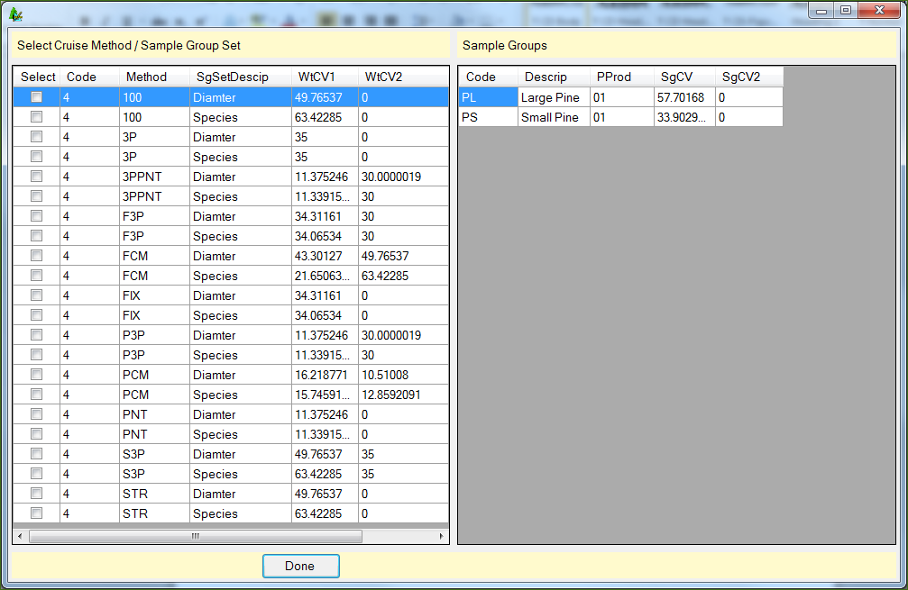

**Figure 16: Select Cruise Methods by Sample Group Set Form**

The right half of this window displays variability information for each individual sample group for the selected cruise method and SgSet.

Code: Sample group code.

Descrip: Sample group description.

SgCV: The estimated CV value of the first stage samples for the sample group.

SgCV2: The estimated CV value of the second stage samples for the sample group. This column will display as zero for one-stage sampling methods.

In the above example, there are two options for each cruise method with associated first and second stage weighted CVs for each option; the first being for the SgSetDescrip of “Diameter” and the second for the SgSetDescrip of “Species”.

From the left hand window, select the cruise method and SgSetDescrip you wish to use by checking the box in the Select column. Initially, you should start simple. Select PNT instead of PCM or STR instead of 3P. Once you have designed a cruise with these options, move to the more complicated methods to compare the benefits (and costs) of using these methods.

Update Any Values

Once the cruise method and Sg Set have been selected, look at each Sample Group. Are there any missing values? If so, you will need to enter an appropriate value. Are there any values that don’t seem right? Is so, change the values based on your own experience. If the calculated CV is lower than you would have expected, raise it. Use your experience to supplement the data. Don’t worry about meeting any specific error at this point.

Optimize for Error

The *Optimize* button located at the top of the Cruise Design Form is designed to help the user determine how many samples are required in each stratum and sample group to meet a specific sampling error. To use the option, simply type in the desired sampling error in the field to the right of the button and click the button. You may use the scroll buttons or type the number in directly. Once the desired error has been entered, click the *Optimize* button.

There are several ways to optimally allocate the samples across multiple strata and sample groups. The CruiseDesign program optimizes the samples by using the CV values weighted by the corresponding volumes. The resulting samples are then modified to account for the floating Student’s T value. The result is the minimum number of samples needed to achieve the desired sampling error consistent with the way CruiseProcesssing will determine sale errors.

The results of this optimal allocation routine should be considered as your starting point to designing an adequate cruise design and not the ending point. The CruiseDesign program does not take into account any minimum strata level or sample group errors or the relative value of each of the strata. Although you will probably meet the desired sampling error with the calculated sample sizes (providing the CVs are accurate), the samples might not provide you with the information you need to adequately appraise your sale.

The *Optimize* button should only be pushed once for the selected cruise methods. If the *Optimize* button is pushed a second time, any changes to the data made after the button was pushed the first time will be lost.

Modify Sample Group Information

Now that we have a starting point, we can modify the sample sizes to fine-tune our design. Changing values in the Sample Group table will automatically update other fields in the table as follows:

Changes to Sg (CV) or Sg (CV2): Changing the sample group CV value (Sg (CV) or Sg (CV2)) will modify the calculated sample group error (Sg Error).

Changes to Sg (n) or Sg (n2): Changing the sample group sample size (Sg (n) or Sg (n2)) will modify the calculated sample group error (Sg Error).

Changes to Sg Error: Changing the sample group error (Sg Error) will modify the calculated sample size (Sg (n) and Sg (n2)).

Changes to Freq or KZ: Changing either the frequency or the KZ value (Freq or KZ) will change the calculated sample size (Sg (n) and Sg (n2)) which will cause the sampling error (Sg Error) to be updated as well.

Changes to Trees/Acre: Changing the Trees/Acre value will update the frequency (Freq) value.

Changes to Vol/Acre: Changing the Vol/Acre value will update the KZ value.

Note: Cruise Design will use the formulas for calculating sample sizes using the Finite Population Correction for Sample Tree (STR) and 3P cruise methods.

Popup Menus

Right clicking in either Sample Group or Stratum tables will produce a popup menu with additional options (figure 17). In the Stratum table, this will allow the user to eventually save the current cruise design or load a previously saved design. The designs will be saved as separate files with a file extension of .designsave.

In the Sample Group table, the options are:

Save Trees and Volume per acre: This option will save all the current Trees/Acre and Volume/Acre values to all the cruise methods for the selected Stratum and SgSet.

Save Trees per Plot: This option will save the all the current Trees/Plot values for other like methods for the selected Stratum and SgSet. If the selected method is a fixed plot method, all the fixed plot methods will be updated with the current Trees/Plot values. The same for variable plot methods.

Recalculate For Stratum Error: This option will allow the user to optimize the sample groups for a specific Stratum Error. A form will popup asking the user for the desired stratum error. This feature is not yet complete.

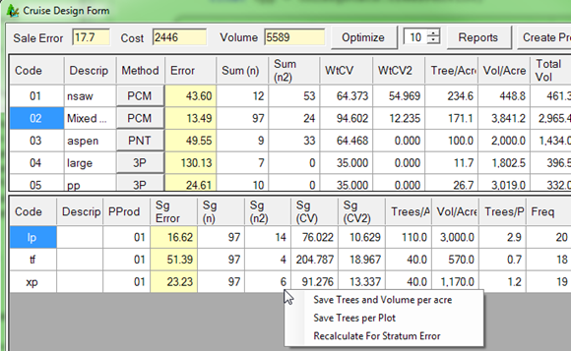

Figure 17: Popup menus for Strata and Sample Group Tables.

Reports

When your design is completed, the Cruise Design Report will compile all of your Strata and Sample Group information into one report (Figure 18). The sale level information is provided at the top of the report, including the estimated sale error, estimated sum of net CCF or MBF, and the estimated cruise cost. For each defined Stratum, all of the stratum and sample group information is provided.

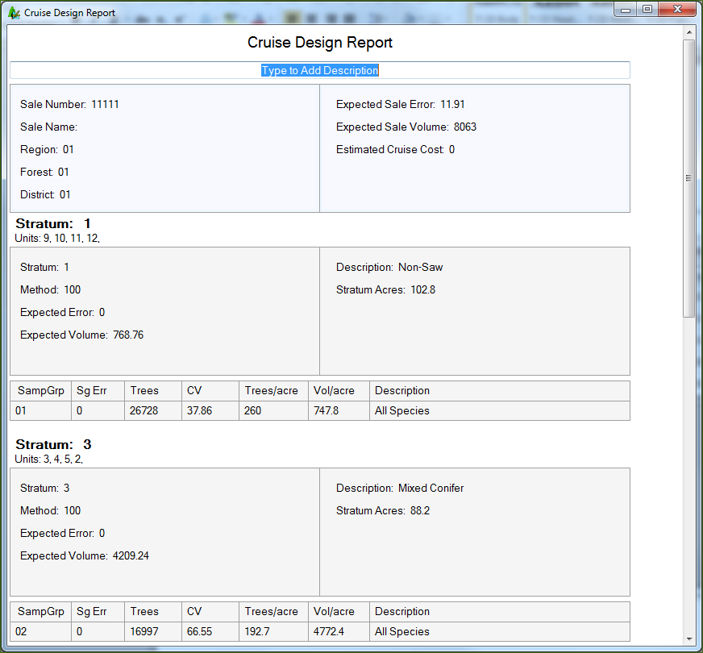

Figure 18: Cruise Design Report

The report can be printed by right-clicking anywhere within the report and selecting Print. Future versions will allow the user to save this report as a document. This report can be used to document and/or compare other cruise designs.

Create Production Button

Once the cruise has been designed, the user can create a new production cruise based on the design information. Click the Create Production button located at the top of the Cruise Design Form to create a new production level cruise file. This will open the Create Production form (see Figure 19).

Clicking the Browse button will open a standard Windows save file dialog box, prompting you to enter the name of the production cruise file. By default the program will use the following format: *SaleNumber_SaleName_TS.cruise*.

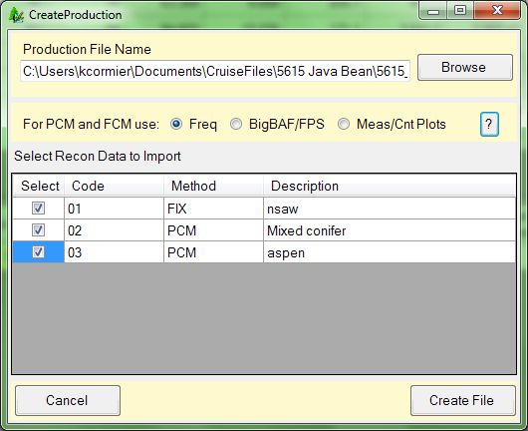If you have any FCM or PCM cruise methods, you will need to select how your measured trees will be selected. This will also affect how the recon trees are imported into the new production file. There are three options to select from:

Figure 19: Production cruise setup form

* Freq: Measured trees are determined using the calculated Frequency (1:n). When the recon plots are imported, the program will use the frequency to determine which trees will be count trees and which trees will be measure trees.
* BigBAF/FPS: A big BAF factor or small Fixed Plot Size is used to determine the measured trees. When the recon plots are imported, all trees will be entered as count trees. The user will need to revisit all recon plots to determine which trees are to be measured.
* Meas/Cnt Plots: All the trees on some plots will be measured while all the trees on the other plots will be count trees. When the recon plots are imported, all trees will be entered as measured trees.

If you collected Recon data, there are specific circumstances when you can re-use the data in a production cruise. If the Recon plots were placed using a grid, all border-line trees were checked, and compatible cruise methods were selected for use in the production cruise, the Recon plots may be re-used. If the Recon cruise contained fixed plots (FIX) and the production cruise use the FIX or FCM cruise method, or if variable plots (PNT) were used in the Recon cruise and the production cruise contains either the PNT or PCM cruise method, you are given the option of importing your Recon plots directly to your production cruise. A table with the heading “Select Recon Data to Import” will list the production cruise strata containing recon data that may be imported into the production cruise. Check the boxes in the Select column to select the data to be imported. If no recon data can be imported, the table will be empty.

Once a file name is given and recon data is selected (or not), clicking on the Create File button will create the production cruise file. Before the new cruise file can be opened with the FScruiser V2 program and used for data entry, the user will have to open the cruise file in Cruise Manager to customize the tally fields for all tree based and two stage methods. Future versions of the program will allow the user to enter this data during the Create Production Cruise process.

Help

This function is not yet available in this version. Contact Ken Cormier by email at [kcormier@fs.fed.us](mailto:kcormier@fs.fed.us) with specific questions requiring assistance.

Return

Clicking the *Return* button will close the Cruise Design form, taking you back to the previous window with all changes being saved automatically.

# Determine Additional Samples

Use the Determine Additional Samples function to calculate the number of additional samples needed in a production cruiser to meet the error requirements for Stratum Error and Sale Error (see Figure 20).

**Figure 20. Determine Additional Samples.**

The determine Additional Samples Form (see Figure 21) is very similar to the Cruise Design Form and works much the same way. The user can change either the sample group error (SgError) or the sample sizes (Sg(n) or Sg(n2)) to determine how many extra samples are needed and where to place them.

The statistics used in this report were generated from the Cruise Processing program so all the numbers in the form should match the ST1 and the ST3 reports, using primary product volumes only.

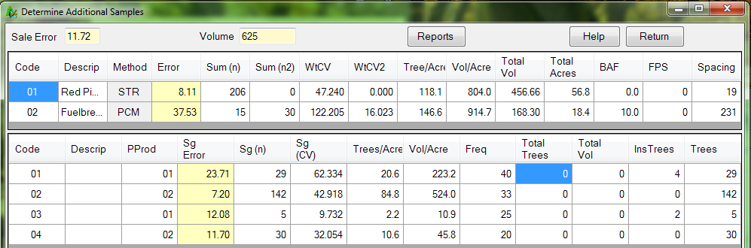The Determine Additional Samples form will not show the estimated cost field, the optimize button, or the create production button at the top. The Stratum table will display the same information but the Sample Group table has a few modifications. There are three new fields at the far right showing the number of insurance trees identified (InsTrees), the number of cruise plots (Plots), and the number of sample trees measured (Trees) for each sample group. The only editable fields are Sg Error, Sg (n), and Sg (n2). None of the information modified on this form will be saved to the production cruise.

Figure 21. Determine Additional Samples Form

As the user changes sample size or sample group error, the program will recalculate the stratum and sale errors. To include insurance trees to a sample group sample, right click and select *Add Insurance Trees to Sample Size*. This will increase the number of samples by the number of insurance trees selected. To reset the samples back to the cruise numbers, right click and select either *Reset Sample Group Sample Size* or *Reset Sample Size for Stratum*.

When changing number of plots using either PCM, FCM, P3P, or F3P, the program will use frequency or KZ values to determine the number of additional measured trees expected.

When the analysis is complete and the number of supplemental samples have been determined, clicking the Repot button will create a report describing the changes (see Figure 22). Print the report for inclusion into the sale folder.

Help

This function is not yet available in this version. Contact Ken Cormier by email at [kcormier@fs.fed.us](mailto:kcormier@fs.fed.us) with specific questions requiring assistance.

Return

Clicking the *Return* button will close the Additional Samples form, taking you back to the previous window with all changes being discarded.

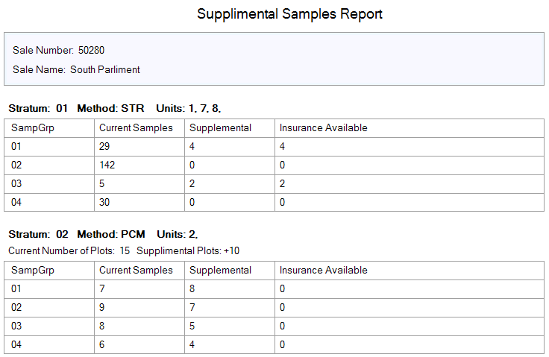

Figure 22. Supplemental Samples Report

Compare Design with Production Cruise (Future Feature)

If after completing your production cruise and adding additional samples you still have not met sale and/or strata error requirements, you have the option to use the Compare Design with Production Cruise tool for identifying what elements of your production cruise changed from the recon file.

Exit

Clicking the Exit button will close the program. All data will be saved automatically.