

**Cruise Manager User Guide**



U.S. Forest Service

Washington Office Forest Management Service Center

Fort Collins, Colorado

Updated: December 2016

This Document is currently a work in progress and may be changed frequently.

The U.S. Department of Agriculture (USDA) prohibits discrimination in all its programs and activities on the basis of race, color, national origin, sex, religion, age, disability, political beliefs, sexual orientation, or marital or family status. (Not all prohibited bases apply to all programs.) Persons with disabilities who require alternative means for communication of program information (Braille, large print, audiotape, etc.) should contact USDA’s TARGET Center at

(202) 720-2600 (voice and TDD).

To file a complaint of discrimination, write USDA, Director, Office of Civil Rights, Room 326- W, Whitten Building, 1400 Independence Avenue, SW, Washington, DC 20250-9410 or call

(202) 720-5964 (voice or TDD). USDA is an equal opportunity provider and employer.

Table of Contents

CRUISE MANAGER 1

Database 1

Template Files 1

USING CRUISE MANAGER 2

Create New Cruise 2

Sale Info 3

Cutting Unit 4

Stratum Setup 4

Sample Group Setup 5

Add New Species 6

Finish 7

Cruise File Utilities 7

Design Wizard 8

Edit Design 8

Customize 10

Field Data 13

Create Component Files 15

Combine Sale Data 17

TEMPLATE FILES 17

IMPORT FROM CRUISE 19

LEGACY DATA CONVERSION 19

APPENDIX A: CRUISE DESIGN FORMS 22

Sale Information 22

# Cruise Manager

Cruise Manager is used to establish new sales, customize data entry forms, and handle general data management issues like creating and merging component cruises, modifying cruise designs, and handling data integrity checks.

## Template Files

To reduce the amount of input required by the cruisers to establish a timber cruise file, template files are used to store commonly used data. Template files are database files with the file extension of *.cut* which is an abbreviation of Cruise User Template. All template files are stored in the following file folder:

C:\Users\<your username>\My Documents\CruiseFiles\Templates

# Using Cruise Manager

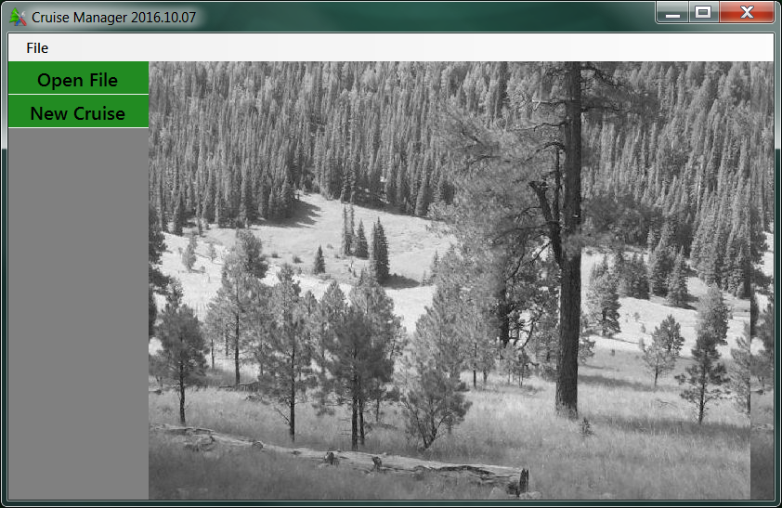The opening screen for Cruise Manager contains a single menu option, File, and two buttons: Create New Cruise and Open File (Figure 1). The File menu contains six menu options: New Cruise, Open, Recent, Save, Save As, and About.

Figure 1-Cruise Manager Opening Screen

Selecting File 🡪 New Cruise from the menu at the top will take you to the same place as clicking the Create New Cruise button.

Selecting File 🡪 Open from the menu at the top will take you the same place as clicking the Open File button.

Selecting File 🡪 Recent from the menu at the top will give you a list of recently opened .cruise files.

Selecting File 🡪 About from the menu at the top will show you the version of Cruise Manager you are running. This is also displayed at the top of the window (Figure 1).

To exit Cruise Manager, click on the ‘x’ at the upper right hand corner of the Main Form.

# Create New Cruise

The New Cruise button will launch the Cruise Wizard that will take you through the steps to establish a new timber sale cruise.

Note: If during the creation of a new cruise file you have to suspend the process and close Cruise Manager, the partially created cruise file will be saved and you will receive a prompt to resume the creating of the new cruise file if you click New Cruise again (Figure 2).

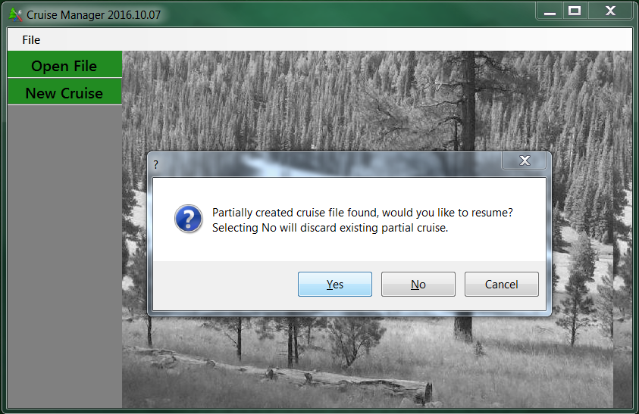Figure 2-Cruise File Creation Continuation Prompt

## Sale Info

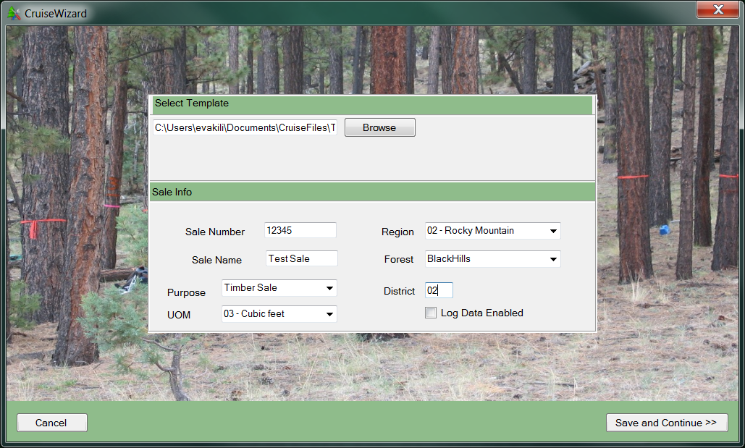The first step in establishing a new cruise is to define the sale information (Figure 3). At the top of this form, you will be asked to select a Template file from the pull down list. Although this is optional, the template file contains establishment and design information you will have to enter manually if you do not select a template file.

Figure 3-CruiseWizard Information

Once a template has been selected, enter the Sale Number (usually 5 digits) and Sale Name. Region and Forest are selected from pull down lists. The Purpose is selected from a pull down list as well and will usually be Timber Sale or Recon. District number (2 digits) will need to be entered. UOM is the default Unit of Measure for the sale. This value will be used as the default whenever UOM needs to be entered. If you are using FIXCNT method with other cruising methods, you can change the UOM to 04 for those FIXCNT populations. You also have the option of enabling log grading by checking the “Log Data Enabled” box. Once all of the information has been entered, click on the Save and Continue button to advance to the next form.

## 

## Cutting Unit

The next step is to enter all of the cutting units for the timber sale (Figure 4). Enter the cutting unit Code (up to 3 digits), Area in acres, and a brief description describing the physical piece of ground. Payment unit is optional. Use the pull down list to select a Logging Method for the unit.

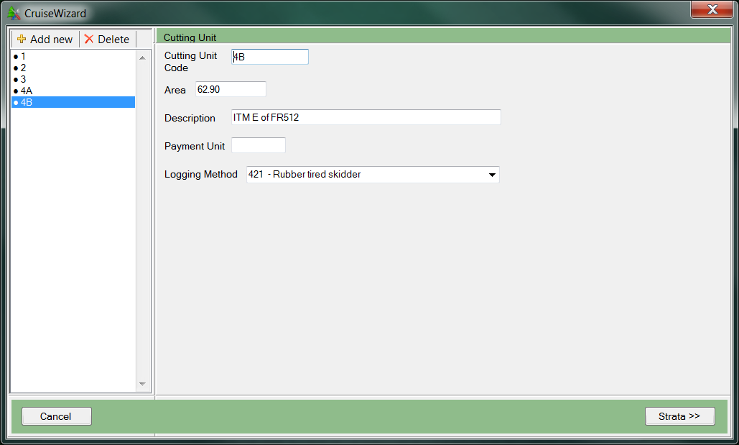The cutting unit codes will be listed in a box on the left hand side of the form. Once you add the Cutting Unit Code, the code will appear in the list to the left. To add a new cutting unit, click on the Add New button at the top of this list or click on the F1 button. To delete an existing cutting unit, select the cutting unit code from the list and click on the Delete button. If you wish to edit any information on any of the previously established cutting units, simply select the unit code in the list and all of the cutting unit information will be displayed in the Cutting Unit form. This information can be edited. The information will be saved automatically.

Figure 4-CruiseWizard Cutting Unit Information

Once all of the cutting units have been entered, click on the Strata button to move to the next form.

## Stratum Setup

The next step is to establish all of the strata for the timber sale. Enter the Stratum Code (2 digits) and select a cruise method from the Method pull down list. If a plot based method is selected, the BAF or Fixed Plot Size field will become editable. If 3PPNT method is selected, the 3PPNT KZ field will become editable. Other KZ values and sampling frequencies are selected later in the Sample Groups form. Select a Month and Year from the pull down lists and enter a brief description of the stratum.

The Cutting Unit table will show all of the Cutting Unit information entered in the previous section (Figure 5). This table is not editable. If changes need to be made to the Cutting Unit information, click on the Cutting Units button to return to the Cutting Unit form. Select the cutting units belonging to the stratum by clicking the box in the Select column.

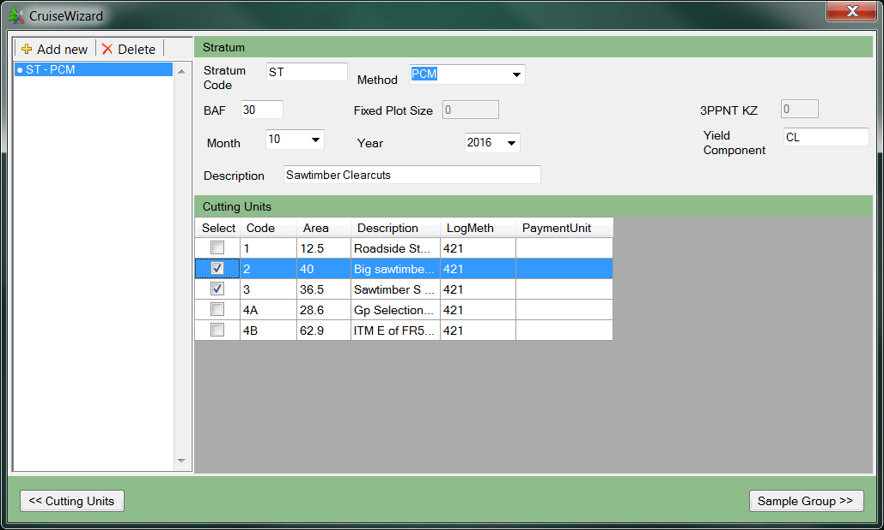

Figure 5-CruiseWizard Stratum Information

The established strata will be listed in a box on the left hand side of the form. To add a new stratum, click on the Add New button at the top of this list. To delete an existing stratum, select the stratum code from the list and click on the Delete button. If you wish to edit information on any of the previously established strata, simply select the stratum code in the list and all of the stratum information will be displayed in the Stratum form. This information can be edited and will be saved automatically.

Once all of the Strata are established, click on Sample Group to continue to the next section.

## Sample Group Setup

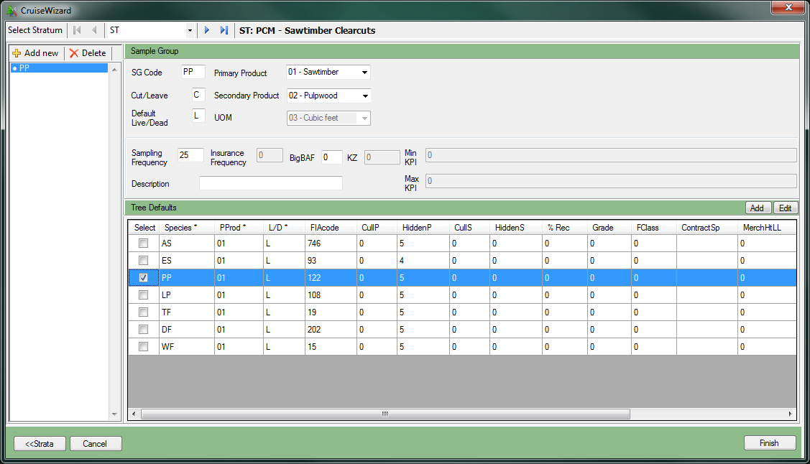The last step is to establish the sample groups for each stratum. Select each stratum by using the control at the top of the form next to the Select Stratum text (Figure 6).

Figure 6- CruiseWizard Sample Group Information

Once the Stratum has been selected, enter the sample group code (up to 2 digits) in the SG Code text box. Add the Cut/Leave code (C or L) and the Default Live/Dead code (L or D). The Default Live/Dead code can be changed on individual tree records. Select the Primary Product code and Secondary Product code using the pull down lists. The Unit of Measure (UOM) will be populated using the value from the Sale Setup form and cannot be changed from this screen.

For cruise methods that require it (everything except PNT, FIX and 100), fill in the Sampling Frequency and/or KZ values. Insurance Frequency determines the number of insurance trees you wish to identify in the cruise. The number represents the frequency of sampled trees that will be recorded as insurance trees. For example, an insurance frequency of 10 will identify 1 insurance tree for every 10 sample trees. Give a brief description of the sample group in the Description text box.

Once the sample group has been defined, select one or more species codes from the Sub- population table you wish to include with this sample group. The initial list will be populated from the Template file selected in the first step. If your sample group will contain both Live and Dead trees for the species, then select both the Live and the Dead species listing in the Sub- population table. Only tree species that match the Primary Product chosen for the sample group will be displayed.

If a Species is not listed, click on the Add button to add a new species. Click on the Edit button to edit any of the information in the Tree Defaults table. These edits will apply to all populations created using the edited species. Choosing the correct FIAcode for the species ensures that Cruise Processing..

## Add New Species

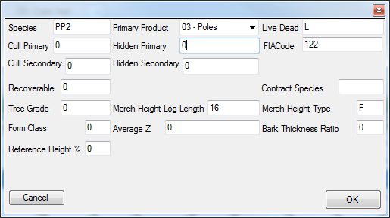When the Add button is clicked, the Add Tree Default form will be displayed (Figure 7). Each new Tree Default record must have a unique Species, Primary Product, and Live/Dead combination. Fill out the table and click OK to add the Species and return to the Sample Group setup form. The added Tree Default record will be added to the current Cruise file and will not be saved as part of the Template file (Figure 8). Still need contract species?

Figure 7-Add Tree Default Form

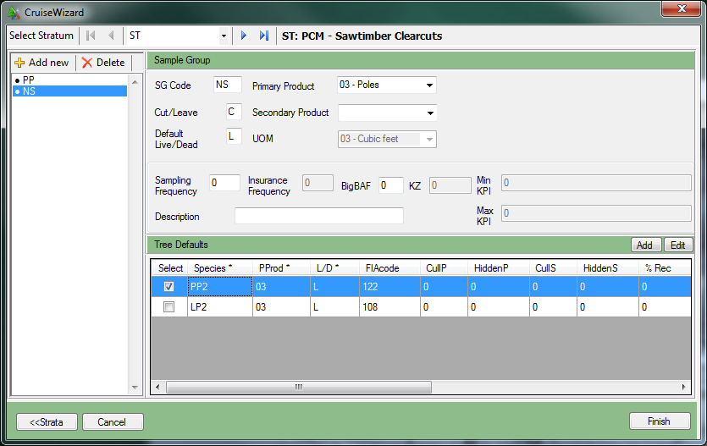Figure 8-Added Tree Default Record

## Finish

When all of the Sample Groups for each Stratum have been established, click on Finish to create the new Cruise object. The program will display a box asking whether to create a folder for the sale. Click yes or no and a save dialog will appear. Select the folder to save the file and provide the File name. The extension .cruise will be automatically added to all file names. If you chose to create a folder the name will be the Sale Number followed by the Sale Name.

# Cruise File Utilities

Once a cruise file has been created or the user opens an existing cruise file (*.cruise), the Cruise Customize form is opened and other options appear on the left of the screen (Figure 9). From here, you can customize the way the cruise file will work within FScruiser, create multiple components of a cruise file and merge the data back together, export the data, and edit cruise records. In future versions you will also be able to combine strata and units from different cruise files.

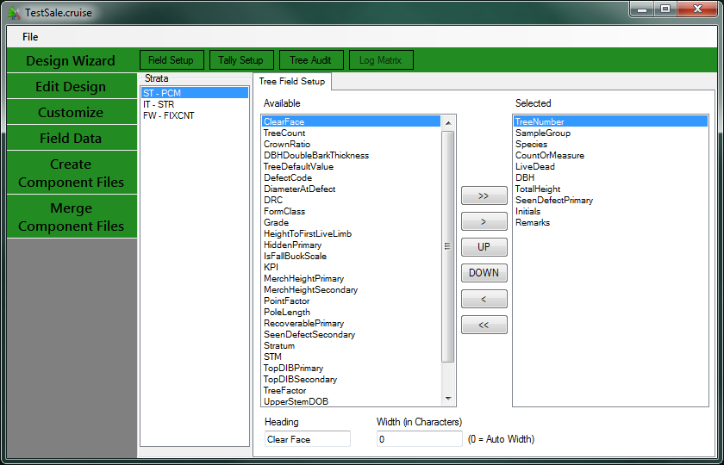Figure 9-Cruise File Utilities Form

# Design Wizard

If no data collection has taken place, and the user would rather edit the establishment data within the more user-friendly confines of the CruiseWizard, as opposed to the tabular Edit Design option (discussed next), clicking on the Design Wizard button will allow for this form of editing.

If the cruise file contains tree data, users cannot edit within the wizard!

# Edit Design

The Edit Design option provides the user with a tabular way of editing their establishment data. Changes made need to be saved by selecting *File-Save* from the menu at the top before leaving this form.

**Note**: Before making any changes to the cruise, back up the cruise file!

## Sale Info

The first tab allows the user to edit any of the Sale level information.

## Cutting Units

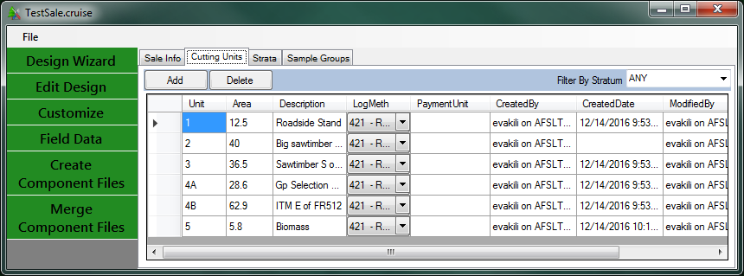The Cutting Units tab will allow the user to add, delete or modify cutting unit information. The data can be filtered by stratum via the Filter By Stratum droplist (Figure 10). The user can also create and/or remove cutting units by clicking on the Add or Delete buttons.

Figure 10-Cutting Unit Tab in the Edit Design Option

## Strata

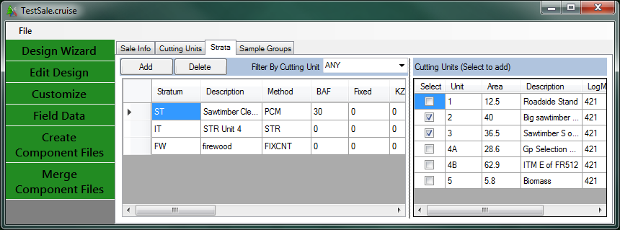The Strata tab will allow users to add, delete or modify stratum information. The data can be filtered by cutting unit via the Filter By Cutting Unit drop list (Figure 11). The user can also create and/or remove strata by clicking on the Add or Delete buttons.

Figure 11-Strata Tab in the Edit Design Option

## Sample Groups

The Sample Groups tab will allow users to edit the sample group information and also add or delete sample groups. Stratum is selected from the Strata pull down at the top (Figure 12). All of the sample groups in the selected stratum will be displayed in the table below on the left side of the window. When a sample group is selected in this table, the default species for that sample group are listed as selected rows in the Tree Defaults table right side of the window. Additional species can be selected to add them to the individual sample groups if needed. Species can also be added, edited, or deleted from this screen.

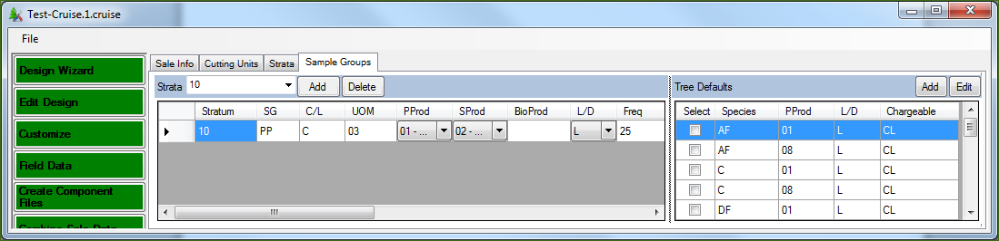

Figure 12-Sample Groups Tab in the Edit Design Option

Any sample group, stratum, cutting unit, or species associated with data that has already been collected and entered in your *.cruise file cannot be deleted. However, it is still good practice to make sure your files are backed up before using the Edit/View features.

# Customize

The Customize menu contains several tools to help customize the way the cruise file will operate within the FScruiser program when collecting cruise data. Each option is accessible from the tabs at the top of the Customization form. You can save your progress at any time by selecting File – Save from the menu at the top.

## Field Setup

The Field Setup tab allows the user to set the data fields that will appear in FScruiser during data collection and the order in which they will appear. There are three list boxes in the Field Setup form (Figure 13). The first list box contains a list of each Stratum established in the cruise file. Data setup is managed by stratum instead of by cruise method. The second list box, entitled “Available”, contains a list of all possible data collection fields that are not currently selected. The last list box, entitled “Selected”, contains the data collection fields in the order they will appear on the data collection form. The default 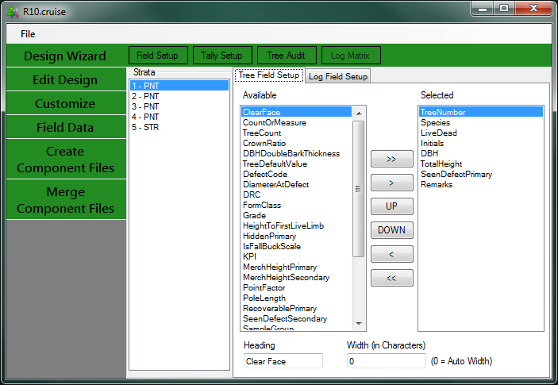fields in the Selected list are determined by the template file used.

.Figure 13-Field Setup

To change the order of the selected collection fields use the UP and DOWN buttons to the left of the “Selected” box. To move collection fields between the Available and Selected boxes use the left arrow (<) and right arrow (>) buttons. Pressing the double arrows (<< or >>) will move all fields from one box to the other.

Above the last two list boxes are two tabs defining the two data collection forms that can be customized in this form: Tree Field Setup and Log Field Setup (if log data was enabled during the Design process). Log Field Setup is navigated in the same manner as Tree Field Setup.

At the bottom of this field are two text boxes with the labels “Heading” and “Width (In Characters)”.The *Heading* field will allow the user to change the text of any selected field for the purpose of displaying it in FScruiser. For example, if you select on the *Species* field, you can change the Heading to *Sp*. When the form is displayed in FScruiser, the text *Sp* will be displayed in the form instead of the text *Species*. The *Width (In Characters)* field allows users to set the width (in characters) of the column each variable will be displayed in. Entering 0 in this box causes the program to default to a pre-programmed column width for the chosen collection field.

Save your progress by selecting *File-Save* from the menu at the top before leaving this form.

## Tally Setup

The Tally Setup page (Figure 14) allows you to create the tally form used by FScruiser to tally trees when using cruise methods where not all cruised trees are measured, such as STR, 3P, S3P, PCM, P3P, FCM, F3P, and FIXCNT. Select the Stratum from the *Stratum* pull down list and its associated Hot Key from the *Stratum Hot Key* pull down list. From the *Sample Group* pull down list, select the first sample group code.

*Note the tip listed at the bottom of the screen*: Stratum hotkeys allow you to easily switch between strata. Once a key is used for a stratum hotkey it cannot be used as a tally hotkey. Once a tally hotkey is used in a stratum it cannot be reused in the same stratum. Some users prefer using numbers for strata hotkeys and letters for tally hotkeys, or the other way around.

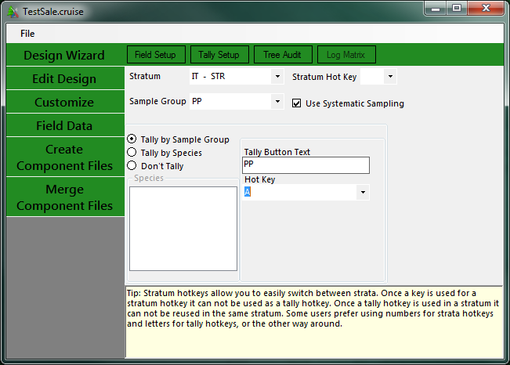If using the STR cruise method, you have the option to have the trees be selected systematically, with a random start. This is what the *Use Systematic Sampling (STR only)* checkbox is for. If using STR and this checkbox is left unchecked, blocked sampling will be used by default.

Figure 14-Tally Setup Page

By default, the *Don’t Tally* radio button will be selected. You may choose to tally by sample group or by species.

### Tally by Sample Group

When the *Tally By Sample Group* radio button is selected, the first sample group code will automatically show up in the Sample Group box. The *Tally Button Text* box will be auto populated with the Sample Group code but can be manually edited. Use the Hot Key pull down list to select a Hot Key button.

Note: Due to the way Cruise Processing uses tally trees, you may not select *Tally By Sample Group* for 3P cruise methods.

### Tally by Species

When the Tally by Species radio button is selected, the Species list box will contain a list of all of the species codes defined for the sample group. When you select a species from this list, the species and stratum codes will show up in the *Tally Button Text* box. This can be manually edited. Use the *Hot Key* pull down lists to select a Hot Key button.

Note: If two species have the same code, but have different Live/Dead codes associated with them, the species codes will appear identical in the list box. When the species code associated with the Dead trees is selected, then a D is placed after the species code in the default Tally Button Text to help you 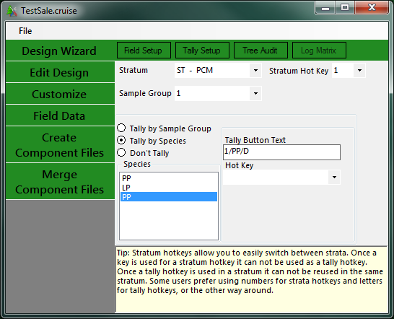tell them apart (Figure 15).

Figure 15-Tally by Species Form

Save your progress by selecting File-Save from the menu at the top before leaving this form. You will not be able to save or leave this form until all required hot keys are established.

## Tree Audit Rules

The Tree Audit Rules allow the user to create their own set of error checks to be used while data is being input. These rules will be created by Primary Product, Species, and Live/Dead codes. Initially, the Tree Audit Rules will be populated by values from the Template File.

To create Audit Rules, select the collection field from the Field drop down list (Figure 16). Currently, this list is limited to the most commonly used variables. Once the variable has been selected in the Field column, enter a range of numbers using the Min and Max fields. or a set of text values in the Value Set box. The Required field accepts True/False and will tell FScruiser if a value is always required for this variable. You will then select the Species, Primary Product, and Live/Dead codes to associate this error check with. You can create multiple checks for the same variable, such as DBH, and assign them by primary product if you wish.

If the audit checks are violated during data entry in FScruiser the cruiser will receive a warning message, but will be allowed to continue entering data.

Continue until all the Audit checks you would like to see have been created.

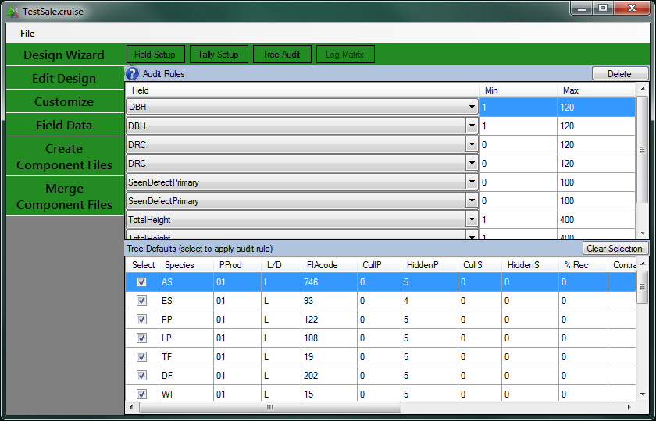Figure 16-Tree Audit Rules

Save your progress by selecting *File-Save* from the menu at the top before leaving this form

# Field Data

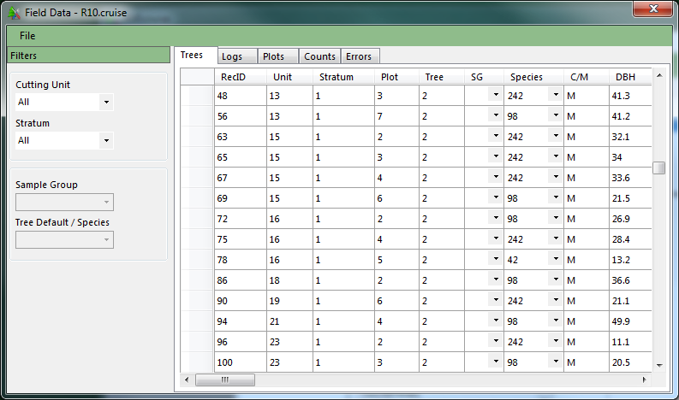The *Field Data* button will open the Field Datatool where the user can find and correct data errors (Figure 17). The data is distributed in five tabs: Trees, Logs, Plots, Counts, and Errors. To the left of the tables is a section titled Filters. The filters will allow the user to display data for individual units and/or strata. For some tabs, like the Tree tab, the user will be able to further filter on Sample Group and Species.

Figure 17-DataEditorView Tool

## 

## Trees Tab

The *Trees* tab displays all the information in the tree table. The table is editable so information can be changed. However, some information like Stratum and Unit cannot be edited in this table.

## Logs Tab

The *Logs* tab displays all log level information collected by the cruiser. The table is editable so information can be changed. However, some information like Tree Record ID cannot be edited in this table.

## Plots Tab

The *Plots* tab displays all the information stored in the plot table. Plot KPI values for 3PPNT will be stored in this table. **At this time, it is possible to change and/or delete Plots and the associated information even if data has been collected for those populations.** Because of this, it is possible to really screw up a cruise at this time. Make sure your files are backed up before using the Edit/View features.

## Count Tab

The *Count* tab displays all of the count table information. The count table contains all of the tree tallies and sum of KPIs for Sample Tree and 3P cruise methods. There will also be additional data pertaining to two stage plot methods. This data is related to the sample selection code and should not be removed. Tally counts will be zero for these cruise methods.

## Errors Tab

The *Errors* tab will display the contents of the error table. As data errors are reported, they are stored in this table. This table links to the actual data row containing the reported error.

Double clicking on any row will take the user to the reported error. If the reported error is not an issue, or was flagged in error, the user can suppress this error by checking the box in the *Suppress Error* column. CruiseProcessing will not process if there are uncorrected or unsuppressed errors in this table.

## Export

Cruise Manager allows the user to export raw data from the database into a variety of formats. To access the Export data functions, select *File – Export* from the menu at the top of the form. This will open the Data Export form (Figure 18).

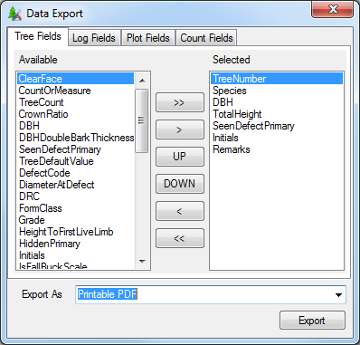

Figure 18-Data Export Form

The form will export data from the Trees, Logs, Plots, and Counts table. For each table, the user selects the data fields to be exported. Each Tab contains the list of data field names that will be exported from that table. The user selects the field name from the Available list on the left side of the form and clicks the (>) button to select that field. To add all field names, select the (>>) button. Field names can be removed from the Selected list by selecting the field name and clicking the (<) button. To remove all data fields, click on the (<<) button. The order of the fields to be exported can be changed by using the Up and Down buttons.

Once all of the data fields have been selected for each table to be exported, the user selects the format of the exported data. The current options are Printable PDF and Excel Spreadsheet. Clicking the Export button will bring up the standard Windows Save As dialog box. After providing a file name, click the Save button to export the data.

# Create Component Files

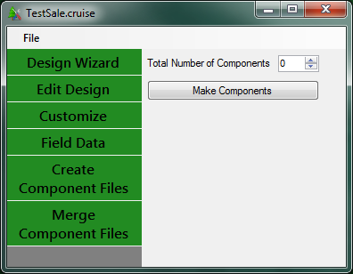Create Component Files will allow the user to create two or more component cruise files so data can be collected using multiple data recorders, then later merged together. To create component cruises, simply type in the number of components and click on the Make Components button (Figure 19).

Figure 19-Create Component Files Screen

Duplicate cruise files will be created with a numeric code in the file name using the following convention:

*filename.1.cruise*

*filename.2.cruise*

*…*

where *filename* is the name of the current cruise file. Additionally, a new Master cruise file will also be created using the following naming convention:

*filename*.M.cruise

The Master cruise file will be used to merge the data of the individual component cruises back into a single cruise file. It is important **NOT** to rename these files once components have been created. The original cruise file name will still exist. Do not use this file or the Master cruise file to collect data. Once component cruises have been created, data should only be collected using the component cruises.

## Merge Component Files

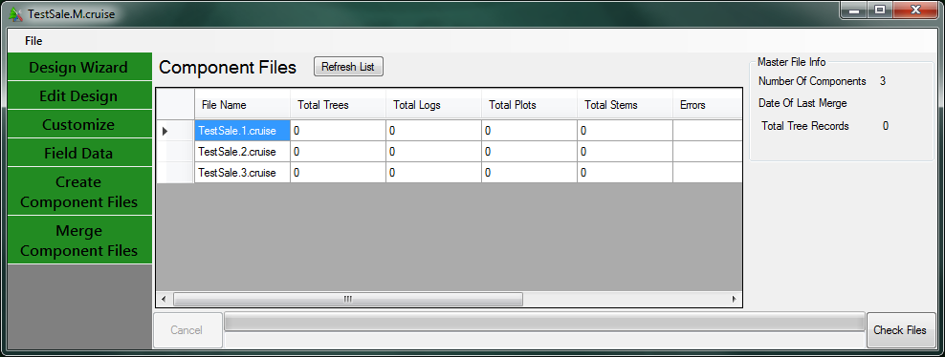The Merge Component Files button will appear below the Create Component Files button when a Master cruise file is opened (Figure 20). Currently, copies of all of the component files will need to be available in a single folder to merge data even if data has not been collected for all of the component cruises.

Figure 20-Merge Component Files Screen

Cruise Manager needs to find all component files before merging can take place. If the component files are not contained in the same folder as the Master file you will see an error message “File not found”. Move all component files to the same location as the Master file and try again.

Once the Component cruises have been located, click on the Check Files button. The Merge Preview will display information related to the Merge procedure. You will be shown a list of errors found in the Component cruises. Click Merge to complete the Merge.

You can continue to collect data in the component files and re-merge them later. Once all data has been collected and Component files have been merged, use the Master file in Cruise Processing and your project record. It is good practice to save the original cruise file and all component files as well.

# Combine Sale Data

This feature has not been implemented yet. Please check back later.

# Template Files

In the current version of the National Cruising Software Suite of programs, Template Files are stand-alone files that can be created and used to create different types of cruise files. Template files contain information that will be used to fill in default values in new cruises, including species information and field setup settings. Data from existing cruise files will have the ability to be imported into a Template File in future releases so it can be used to help establish other cruise files.

The information in Template Files can be edited directly. To edit a Template File, Click on the Open File button. In the Open File dialog box, use the pull down list at the bottom for Files of type: and select Cruise Template File (*.cut). By default, Template Files will be stored in My Documents/Cruise Files/Template Files. Select a Template File and click Open.

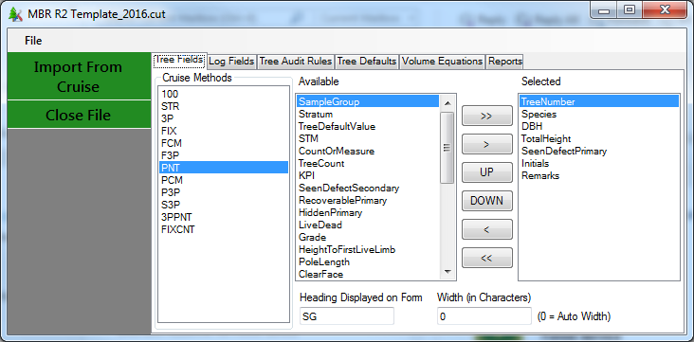The Template Editor allows the user to setup and edit Template data, and will allow the user to import data from existing cruises in the future (Figure 21).

Figure 21-Template Editor

## Tree Fields

The Tree Fields tab allows the user to set the default data collection form for recording tree level information by Cruise Method. The data setup in the Template File will be used as the default settings for any cruise created using this template. The form works the same for a template files as for a cruise file with one additional piece of information. At the bottom of this field is a text box with the label Heading. This field will allow the user to change the text of any selected field for the purpose of displaying it in FScruiser. For example, if I select on the Species field, I can change the Heading to Sp. When the form is displayed in FScruiser, the text Sp will be displayed in the form instead of the text Species. Save your progress by selecting File-Save from the menu at the top before leaving this form.

## Log Fields

The Log Fields tab is very similar to the Tree Fields tab except it works on log data collection forms instead of tree data collection forms. The Log Fields will display the same way regardless of cruise method.

## Tree Audit Rules

The Tree Audit Rules tab allows the user to set the default audit checks for data collection. The data entered in the Template File will be used as the default settings for any cruise created using this template. The form works the same for a template file as for a cruise file.

## Tree Defaults

The Tree Defaults table displays a list of all possible Species, Primary Product, and Live/Dead codes available to the cruises. The rest of the information (CullPrimary, HiddenPrimary, FormClass, etc…) is tied to those three fields. If you wish to have multiple Hidden Primary Defect percent for the same Species, Primary Product, Live/Dead combination, you will have to create a new record with a different Species code to distinguish it from the original code. This list can be edited, new records can be added, and existing records can be deleted. This table is designed to hold many of the default settings that do not change much between sales on a given Region, Forest, or District. This table allows the cruiser to check boxes when setting up sample groups instead of entering the same data over again for different cruises. This table will also be used in the Cruise Design program. Save your progress by selecting File- Save from the menu at the top before leaving this form.

## Tally Presets

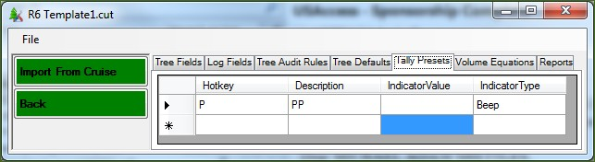Tally Presets allow the user to set some standard Hotkey – Description functions that can be used to speed up the Tally Setup in a new cruise (Figure 21).

Figure 21-Tally Presets

For example, if you always tally Ponderosa Pine species by selecting the P button with a description of PP, you can add that to this table. When setting up a tally for a cruise, you can select this default from the pull down list whenever you need to tally ponderosa pine. The field IndicatorType can hold the text *None* or *Beep* at this time. IndicatorValue is left empty at this time. In the future, this will contain a value to control the volume and/or tone of the Beep. Save your progress by selectin g *File-Save* from the menu at the top before leaving this form.

## Volume Equations

The Volume Equations tab contains a list of Volume Equations entered through the Cruise Processing Program and imported into the Template file. Storing these values here allows cruisers to skip the volume equation setup step in the CruiseProcessing program.

## Reports

The Reports table lists all reports available in the CruiseProcessing program. Reports selected here will show up in the CruiseProcessing program when a cruise is created using this template file.

Save your progress by selecting *File-Save* from the menu at the top before leaving this form.

## Import From Cruise

The Template files are designed to be expandable. As additional data is entered in cruise files, the data can be exported back into existing Template files. Currently, only Tree Defaults, Audit Rules, and Volume Equations can be imported from an existing cruise. In the future, Reports and Field Setup will be importable as well.

## Legacy Data Conversion

CSM has the ability to create a Sqlite cruise file from an existing Metakit cruise file. If the Conversion program is installed on your computer, you will have the ability to select a Metakitcruise file (*.crz) from the Open File dialog. When a .crz file is selected, the Cruise Manager will automatically run the conversion routine to move the data into the Sqlite file format.

# APPENDIX A: CRUISE DESIGN FORMS

Fill out these forms for each new cruise being established, and keep an updated copy in the presale folder.

Cruise Designer Name:

Date:

Path and Name of Template File Used:

## Sale Information

|  |  |  |  |  |  |  |  |
| --- | --- | --- | --- | --- | --- | --- | --- |
| Sale Number | Sale Name | Purpose | Default UOM | Region | Forest | District Code | Log Grading? |
|  |  |  |  |  |  |  |  |

**Cutting Units**

|  |  |  |  |  |
| --- | --- | --- | --- | --- |
| Cutting Unit Code | Area | Description | Payment Unit | Logging Method |
|  |  |  |  |  |
|  |  |  |  |  |
|  |  |  |  |  |
|  |  |  |  |  |
|  |  |  |  |  |
|  |  |  |  |  |
|  |  |  |  |  |
|  |  |  |  |  |
|  |  |  |  |  |
|  |  |  |  |  |
|  |  |  |  |  |
|  |  |  |  |  |
|  |  |  |  |  |
|  |  |  |  |  |
|  |  |  |  |  |
|  |  |  |  |  |
|  |  |  |  |  |
|  |  |  |  |  |
|  |  |  |  |  |
|  |  |  |  |  |
|  |  |  |  |  |
|  |  |  |  |  |
|  |  |  |  |  |
|  |  |  |  |  |

**Stratum**

(Fill out a copy of this page for each stratum.)

Code: _______ Cruise Method: ________ Description: ________________________________________________________

Month: _______ Year: ________ Yield Component: ______ BAF: ________ FP Size: ________ 3PPNT KZ: _______

List Cutting Units:

**Sample Groups in Stratum**

|  |  |  |  |  |  |  |  |  |  |  |  |  |  |
| --- | --- | --- | --- | --- | --- | --- | --- | --- | --- | --- | --- | --- | --- |
| **SG Code** | **Prim Prod** | **Sec Prod** | **Default LD** | **Samp Freq** | **Ins Freq** | **Big BAF\*** | **KZ** | **Min KPI** | **Max KPI** | **Descrip** | **Tally by\*\*** | **System-atic?** | **Tree Defaults (Sp/PProd/LD)** |
|  |  |  |  |  |  |  |  |  |  |  |  |  |  |
|  |  |  |  |  |  |  |  |  |  |  |  |  |  |
|  |  |  |  |  |  |  |  |  |  |  |  |  |  |
|  |  |  |  |  |  |  |  |  |  |  |  |  |  |
|  |  |  |  |  |  |  |  |  |  |  |  |  |  |
|  |  |  |  |  |  |  |  |  |  |  |  |  |  |
|  |  |  |  |  |  |  |  |  |  |  |  |  |  |
|  |  |  |  |  |  |  |  |  |  |  |  |  |  |
|  |  |  |  |  |  |  |  |  |  |  |  |  |  |
|  |  |  |  |  |  |  |  |  |  |  |  |  |  |

**Tree Field Setup Tally Setup –** Stratum Hot Key:

|  |  |  |  |  |  |  |
| --- | --- | --- | --- | --- | --- | --- |
| Field Name | Heading | Width (0 = auto width) |  | SG or Sp Code | Description | Hot Key |
|  |  |  |  |  |  |  |
|  |  |  |  |  |  |  |
|  |  |  |  |  |  |  |
|  |  |  |  |  |  |  |
|  |  |  |  |  |  |  |
|  |  |  |  |  |  |  |
|  |  |  |  |  |  |  |
|  |  |  |  |  |  |  |
|  |  |  |  |  |  |  |
|  |  |  |  |  |  |  |
|  |  |  |  |  |  |  |

* or Small FP size for FCM

** Sample Group, Species or Don’t Tally

**Tree Defaults**

|  |  |  |  |  |  |  |  |  |  |  |  |  |  |  |  |  |
| --- | --- | --- | --- | --- | --- | --- | --- | --- | --- | --- | --- | --- | --- | --- | --- | --- |
| **Sp Code** | **Primary Prod** | **LD** | **FIA Code** | **Cull P** | **Hidden P** | **Cull S** | **Hidden S** | **% Rec** | **Grade** | **Form Class** | **Contr Sp** | **Merch Ht LL** | **Merch Ht Type** | **BTR** | **AvgZ** | **RefHtPer** |
|  |  |  |  |  |  |  |  |  |  |  |  |  |  |  |  |  |
|  |  |  |  |  |  |  |  |  |  |  |  |  |  |  |  |  |
|  |  |  |  |  |  |  |  |  |  |  |  |  |  |  |  |  |
|  |  |  |  |  |  |  |  |  |  |  |  |  |  |  |  |  |
|  |  |  |  |  |  |  |  |  |  |  |  |  |  |  |  |  |
|  |  |  |  |  |  |  |  |  |  |  |  |  |  |  |  |  |
|  |  |  |  |  |  |  |  |  |  |  |  |  |  |  |  |  |
|  |  |  |  |  |  |  |  |  |  |  |  |  |  |  |  |  |
|  |  |  |  |  |  |  |  |  |  |  |  |  |  |  |  |  |
|  |  |  |  |  |  |  |  |  |  |  |  |  |  |  |  |  |
|  |  |  |  |  |  |  |  |  |  |  |  |  |  |  |  |  |
|  |  |  |  |  |  |  |  |  |  |  |  |  |  |  |  |  |
|  |  |  |  |  |  |  |  |  |  |  |  |  |  |  |  |  |
|  |  |  |  |  |  |  |  |  |  |  |  |  |  |  |  |  |
|  |  |  |  |  |  |  |  |  |  |  |  |  |  |  |  |  |
|  |  |  |  |  |  |  |  |  |  |  |  |  |  |  |  |  |
|  |  |  |  |  |  |  |  |  |  |  |  |  |  |  |  |  |
|  |  |  |  |  |  |  |  |  |  |  |  |  |  |  |  |  |
|  |  |  |  |  |  |  |  |  |  |  |  |  |  |  |  |  |
|  |  |  |  |  |  |  |  |  |  |  |  |  |  |  |  |  |
|  |  |  |  |  |  |  |  |  |  |  |  |  |  |  |  |  |
|  |  |  |  |  |  |  |  |  |  |  |  |  |  |  |  |  |
|  |  |  |  |  |  |  |  |  |  |  |  |  |  |  |  |  |
|  |  |  |  |  |  |  |  |  |  |  |  |  |  |  |  |  |
|  |  |  |  |  |  |  |  |  |  |  |  |  |  |  |  |  |
|  |  |  |  |  |  |  |  |  |  |  |  |  |  |  |  |  |
|  |  |  |  |  |  |  |  |  |  |  |  |  |  |  |  |  |
|  |  |  |  |  |  |  |  |  |  |  |  |  |  |  |  |  |
|  |  |  |  |  |  |  |  |  |  |  |  |  |  |  |  |  |

**Tree Audit Rules**

|  |  |  |  |
| --- | --- | --- | --- |
| **Field** | **Min** | **Max** | **Tree Defaults (Sp/PProd/LD)** |
|  |  |  |  |
|  |  |  |  |
|  |  |  |  |
|  |  |  |  |
|  |  |  |  |
|  |  |  |  |
|  |  |  |  |
|  |  |  |  |
|  |  |  |  |
|  |  |  |  |
|  |  |  |  |
|  |  |  |  |
|  |  |  |  |
|  |  |  |  |
|  |  |  |  |
|  |  |  |  |
|  |  |  |  |
|  |  |  |  |
|  |  |  |  |
|  |  |  |  |

**Additional Notes:**

**Additional Notes:**

**Additional Notes:**