CoFM: A Web-based System for Collaborative Feature Modeling

Li Yi, Wei Zhang, Haiyan Zhao, Zhi Jin, Hong Mei
Institute of Software, School of EECS, Peking University Beijing, China
Key Laboratory of High Confidence Software Technology, Ministry of Education of China
{yili07, zhangw, zhhy, zhijin}@sei.pku.edu.cn, meih@pku.edu.cn

ABSTRACT
Feature models provide an effective way to organize and reuse requirements in specific software domains. Many feature-oriented domain analysis approaches have been proposed to guide the construction of feature models, and in most of these approaches, collaboration among stakeholders is considered to be one of the key factors in the construction of feature models. However, few of these approaches provide effective support for collaboration among stakeholders. In this paper, we present a web-based system developed for collaborative feature modeling (CoFM) that explicitly supports stakeholders’ collaboration. The basic mechanism of supporting the collaborative work is centralized broadcasting of modeling operations – that is, each modeling operation performed by a user is sent to a central feature model, and then the operation will be broadcasted to other users to make it visible. We conduct a series of case studies in CoFM to explore its strengths and weaknesses. The observations show that CoFM improves the efficiency of feature modeling.
Categories and Subject Descriptors
D.2.1 [Software Engineering]: Requirements/Specification – methodologies, tools
General Terms
Design, Experimentation, Human Factors
Keywords
Feature Model; Domain Analysis; Requirements Elicitation; Collaboration

INTRODUCTION
In software reuse, feature models provide an effective way to organize and reuse requirements in specific software domains. The concept of feature models was first introduced in the FODA method [7]. The idea of feature models is to encapsulate requirements into a set of features and dependencies among features, and then to reuse these encapsulated requirements by selecting a subset of features from a feature model, while maintaining dependencies among features. To take full advantage of feature models in software reuse, a basic problem is how to construct high quality feature models that capture sufficient commonality and variability requirements in specific software domains.
Many feature-oriented domain analysis approaches have been proposed to guide the construction of feature models, and in most of these approaches, collaboration among stakeholders is considered to be one of the key factors in the construction of feature models. For example, in FODA [7] and FORM [9] methods, during a feature model’s construction, domain analysts (i.e. constructors of feature models) should make intensive communications with users and domain experts to gather the necessary information about the domain under consideration and resolve possible conflicts among these stakeholders, and after the feature model is constructed, the model then should be reviewed by domain experts, users, requirements analysts and other related stakeholders. In FeatuRSEB [6], domain experts are important information sources for domain analysts in the whole domain analysis cycle. The reason for collaboration is obvious: most real software domains are complex and often evolve frequently, thus it is usually impossible for only one or a few persons to obtain a comprehensive understanding of a domain without sharing knowledge with others.

However, few of these approaches provide effective support for collaboration among stakeholders. One consequence of this problem is that, in feature models’ construction, the way to collaborate among stakeholders and the effectiveness of collaboration will depend much on domain analysts’ personal experience, and thus the efficiency of collaboration and feature models’ construction is often unsatisfied. Furthermore, such domain-analyst-centric collaboration imposes considerable work load on domain analysts, thus makes feature models’ construction a time-consuming and error-prone task. We believe that this situation can be improved by integrating collaboration support into feature modeling activities through a more systematic manner.
In this paper, we present a web-based system developed for collaborative feature modeling (CoFM) that explicitly supports stakeholders’ collaboration. The mechanism of supporting the collaborative work is centralized broadcasting of modeling operations – that is, each modeling operation performed by a user is sent to a central feature model, and then the operation will be broadcasted to other users to make it visible. We provide two types of operations: creating operations (add a new element to the feature model) and voting operations (vote yes or no on any existing elements to express viewpoints on this element). We conduct a series of case studies in the CoFM system to explore its strengths and weaknesses. The observations made from the case studies show that CoFM improves the efficiency of feature modeling, and it is not only suitable for feature-oriented domain analysis, but also feature-based requirements elicitation.
The reminder of this paper is organized as follows. Section 2 gives some preliminaries on traditional feature models. Section 3 introduces the method for collaborative feature modeling. Section 4 presents the CoFM system, and the case studies are presented in Section 5. Related work is discussed in Section 6. Finally, Section 7 concludes this paper with a brief summary and future work.

PRELIMINARIES: THE FEATURE MODEL
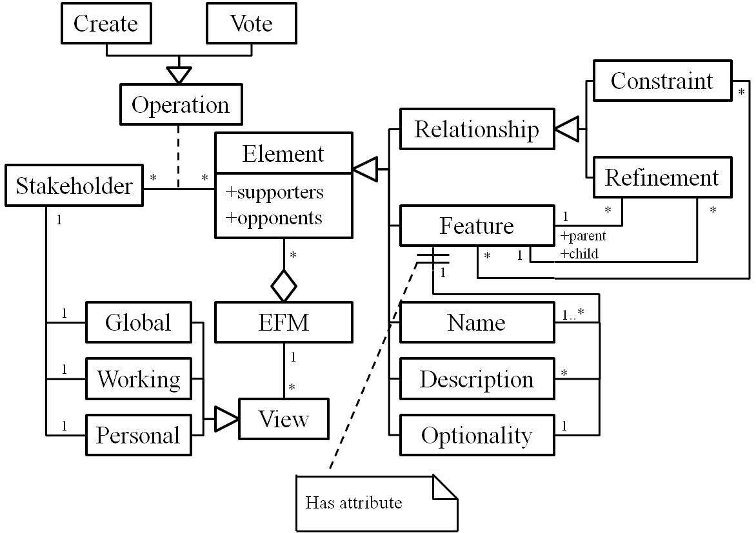
In this section, we introduce a meta-model of traditional feature models. They serve as bases of the extended feature models constructed in CoFM..
Figure 1 shows a meta-model of traditional feature models. Generally, a feature model consists of a set of features and relationships between them.
The concept of feature can be understood in two aspects: intension and extension [14]. In intension, a feature denotes a cohesive set of individual requirements. In extension, a feature describes a software characteristic having sufficient user/customer value.
Figure 1. A meta-model of feature models
There are two types of relationships, namely refinements and constraints. The refinement relationships organize features with different levels of abstraction or granularities into a hierarchical structure. In this hierarchical structure, each feature is either mandatory or optional (i.e. the optionality of a feature). If a feature is selected, its mandatory children features must be selected as well, while its optional children can either be removed or selected.
The constraint relationships describe dependencies between features. There are two basic kinds of constraints: requires and excludes [7][9]. Given two features A and B, A requires B means that if A is selected, B must be selected as well. A excludes B means that at most one of them can be selected at the same time. More types of constraints can be found in [14].

THE CoFM METHOD
The CoFM method proposes an approach to constructing a kind of extended feature models (EFMs) collaboratively. In this section, we give an overview of the CoFM method. We first introduce the meta-model of the EFMs, and then we present the process of constructing the EFMs.

Extended Feature Models (EFMs)
Figure 2 shows the meta-model of EFMs. An EFM is composed of a set of vote-able elements. The top-level elements are features and relationships. Each feature relates to a set of second-level vote-able elements, that is, a feature has one vote-able optionality attribute, and may have one or more vote-able names and descriptions. The result of vote on each element is recorded as its supporters and opponents; both are a set of stakeholders.
In CoFM, stakeholders construct EFMs with two kinds of basic modeling operations, namely the creating operation and voting operation. The function of creating operation is to add new elements to a feature model. The function of voting operation is to allow stakeholders to express their viewpoints on existing elements: a yes vote means that the voter thinks an element is valid for the EFM, while a no vote shows the opposition.
Figure 2. The meta-model of EFMs
We do not provide explicit deleting and modifying operations, in order to prevent stakeholders from editing and overwriting others’ work directly. Therefore different opinions can be expressed in a feature model equally. However, the deleting operation can be simulated through the combination of the creating and voting operations, that is, an element will be deleted if and only if it has no supporters (i.e. all votes on the element are no). In addition, the modifying operation is the combination of deleting and creating operations, therefore it can also be simulated in CoFM.
To present an EFM for stakeholders, we define three types of EFM views, namely the global view, working view and personal view. In an EFM’s construction, each stakeholder has a global view, a working view and a personal view. The global view is composed of all undeleted elements in an EFM, that is, the whole picture of the EFM. The working view is composed of elements that have not been voted no by this stakeholder, that is, elements on which the stakeholder vote yes, and elements created by others but the stakeholder has not shown any opinions on. The personal view is composed of elements supported (voted yes) by the stakeholder, that is, the stakeholder’s personal perspective of the EFM. These views are automatically generated and updated for each stakeholder during the construction of an EFM.
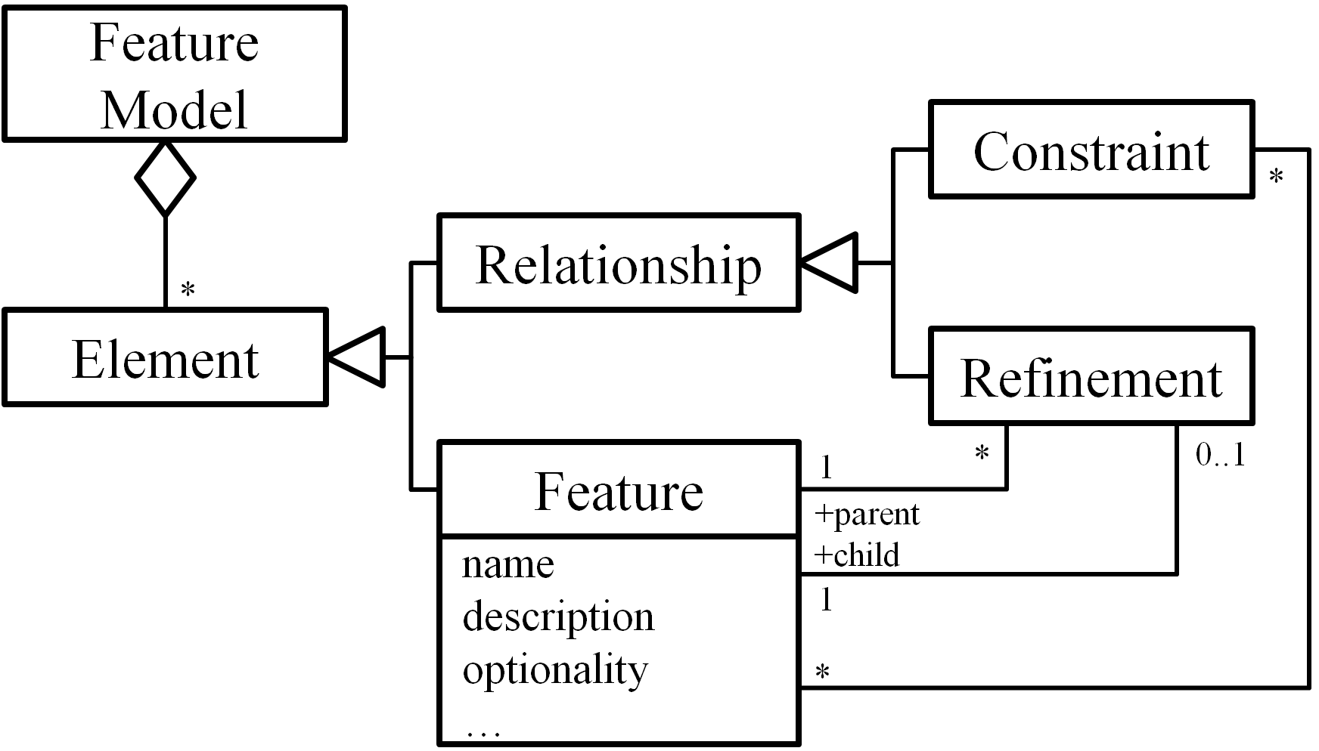

The Process
Figure 3 shows a typical process of collaborative construction of an EFM. In the beginning of a stakeholder’s work, the system will initialize the global view, working view and personal view for the stakeholder (Update Views). In a stakeholder’s work, s/he mainly engages three kinds of activities, including communicating with others, resolving conflicts and submitting modeling operations. Particularly, when s/he submits a modeling operation, the operation will be sent to the central EFM immediately. A valid operation will be applied and broadcast to all stakeholders (including the originator of the operation), which in turn, causes views of all stakeholders be updated.
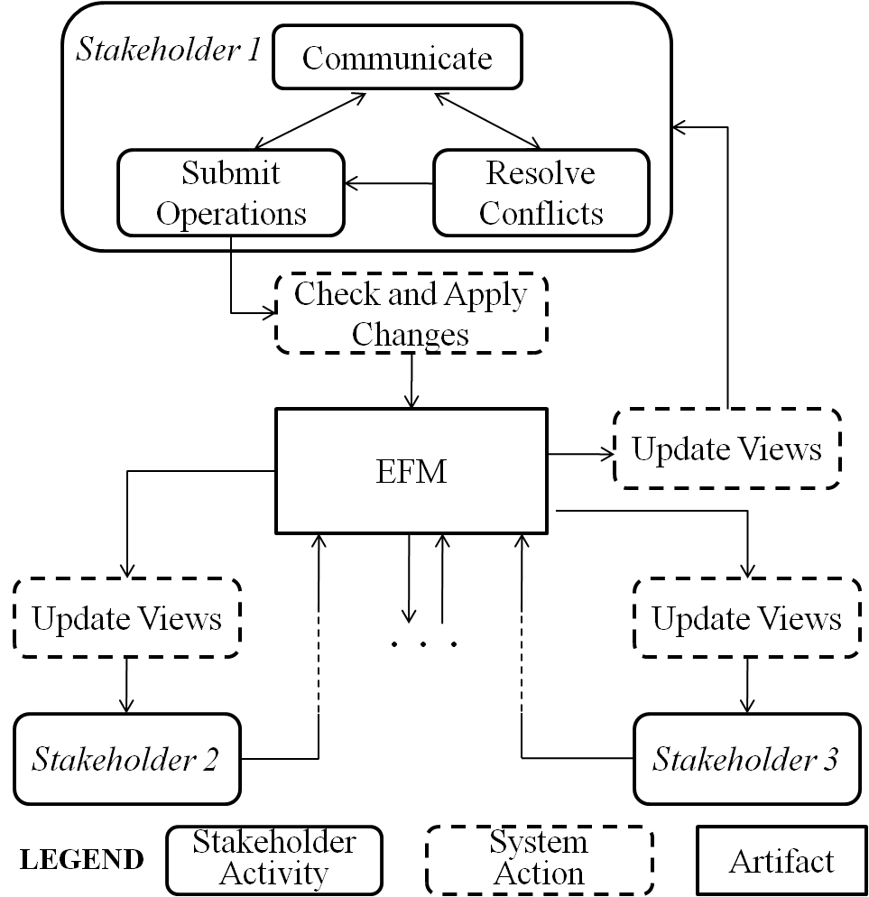
Figure 3. The process of CoFM
There is no stopping rule in the process to determine whether the construction has completed. However, there is a particular way in CoFM to determine the minimal necessary work of each stakeholder, that is, the minimal necessary work of a stakeholder is to resolve all conflicts presented to the stakeholder. (The conflicts are often caused by modeling operations from multiple stakeholders.) Therefore, if any stakeholder hasn’t finished his/her minimal necessary work, the construction must be unfinished.
Figure 4. A screenshot of CoFM’s main work page

THE CoFM SYSTEM
In this section, we present our CoFM system – the implementation of the CoFM method. We first provide an overview of key functions of the system, and then describe these functions in details.

An Overview of the System
The CoFM system is a kind of CSCW (Computer-Supported Cooperative Work) systems. Researchers have identified several central concepts of CSCW systems [4][5][12], and these concepts have shaped the design of CSCW systems over the years, despite tremendous changes of technologies. The most important concepts are production, awareness, coordination and communication, thus dividing key functions of CSCW systems into four categories.
Production refers to objects produced and shared in a CSCW system, and operations applied on these objects [12]. In CoFM, it refers to the functions for constructing, viewing and checking shared feature models. (See Section 4.2.)
Awareness means that CSCW systems should provide necessary information about activities of other people in the shared workspace, which provides the context for individual’s work [4]. For example, a collaborative writing tool should display the position of coauthors’ edit cursor, to help authors identify their work context, i.e. their editing boundaries. The support for awareness in CoFM is described in Section 4.3.
Coordination relates to mediating and meshing individual work in a shared workspace [5]. In the context of collaborative work, it is highly possible that multiple stakeholders are working on the same set of elements at the same time, thus their changes of the elements need to be coordinated. The coordination mechanism in CoFM is explained in Section 4.4.
Communication with other people is essential to collaborative work. Communication can be either synchronous (e.g. video conference) or asynchronous (e.g. emails). In CoFM, we mainly provide two kinds of asynchronous communication mechanisms, i.e. comments and discussion pages. Details are explained in Section 4.5.

Modeling Support
The key functions of modeling support in the CoFM system fall into three categories: basic modeling functions, feature attribute customizing functions, and model checking functions.

Basic modeling functions
Figure 4 is an of the main work page of the CoFM system. The shared EFM is displayed in the feature browser on the left side. The feature editor panel on the right-top shows the details of the selected feature. Other information such as the constraints list, comments for the selected feature and recent changes can be viewed in the right-bottom panels. Stakeholders submit creating and voting operations to construct the shared EFM. The function of creating operations is to add new elements to a feature model. The creating operations in our approach are more general than in other feature modeling approaches [6][7]. For example, in our approach, a stakeholder can create several names for the same feature, while in other approaches the stakeholder can only assign exactly one name to a feature.
Table 1. Restrictions on creating operations
Target | Restrictions
Feature Name | The name has not appeared in any of the features in current EFM.
Other Attributes of a Feature | The same attributes has not appeared in current feature.
Feature | A name of the feature must be created successfully.
Relationship among Features {F₁, F₂, …, F_{N}} | The features {F₁, F₂, …, F_{N}} must exist in current EFM and this relationship does not exist.
The restriction on the creating operations is that no duplicate elements can be created (Table 1). Particularly, feature names are considered as identifiers of features, therefore no duplicate names are allowed within or between features. Different names of a feature are treated as aliases of each other.
The function of voting operations is to allow stakeholders to express their viewpoints on elements in a feature model. For an element in an EFM, a yes vote means that the voter thinks this element is valid for the EFM, while a no vote shows the opposition. No explicit restrictions are imposed on the voting operations; however, we introduce a mechanism called automatic voting inference to ensure the consistency of the votes
Automatic Voting Inference
Figure 5. An example of automatic vote inference. (a) Inconsistent votes. (b)(c) Votes after inference.
Semantics of different votes from the same stakeholder may be inconsistent. An example is given in Figure 5(a), where a stakeholder tries to vote no on a feature X but votes yes on a constraint X requires Y. Based on the semantics of yes and no votes, the stakeholder supports a constraint that involves an invalid feature. In this case, these two votes from the stakeholder are inconsistent.
Our solution to such problem is automatic voting inference. That is, whenever a voting operation is submitted, inferred voting operations (if any) will be performed on related elements automatically to ensure consistency. To define which the related elements and inferred votes are, we need to take a closer look at relations between the validity of different elements in an EFM. For clarity, we first define a predicate Valid as:
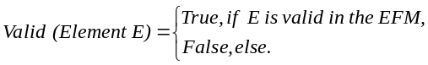
Then the relations between the validity of different elements can be defined as follows:
Valid (Relationship R involving Feature F) → Valid (F), (1)
Valid (Attribute A of Feature F) → Valid (F). (2)
According to (1) and the semantics of voting operations (yes means valid, and no means invalid), we can define the following vote inference rules (VIRs).
- VIR-1:
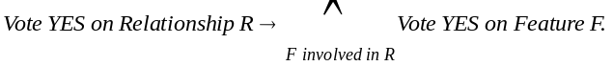
- VIR-2:
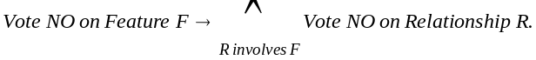
These two VIRs ensure the consistency between the votes on relationships and features. For example, in Figure 5(b), the no votes on feature X leads to an inferred no vote on the constraint X requires Y, while the feature Y will not be affected. If the user votes yes on the constraint X requires Y, then inferred yes votes will be added to both feature X and Y (Figure 5c).
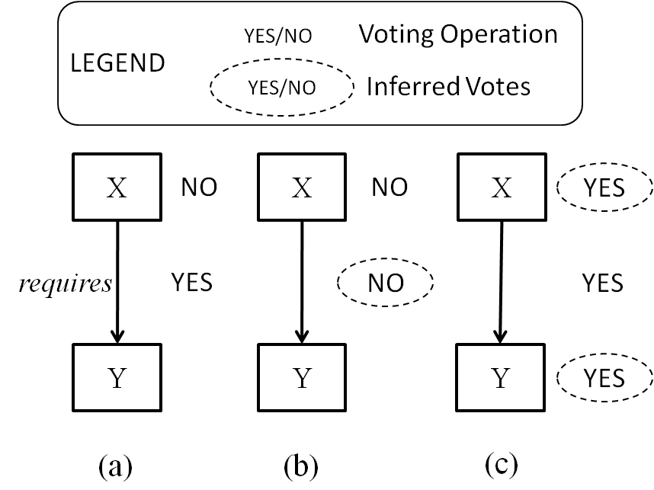
Similarly, according to (2), we can define the voting inference between features and their attributes.
- VIR-3:
Vote YES on Attribute A of Feature F → Vote YES on F,
- VIR-4:
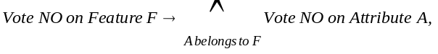
These four rules clarify the consistent relations between voting operations. However, there are also such relations between the creating and voting operations. The semantics of the creating operations is to make currently non-existing elements exist in an EFM, while the voting operations express support or opposition of the validity of existing elements. Thus we can infer that if a stakeholder creates an element, s/he must also support for its validity, as the following creating-imposed voting inference rule (VIR-C) shows.
- VIR-C:
Create Element E → Vote YES on E.
The above rules are transitive; however no actual transition happens when performing a voting operation, according to VIR-1 to VIR-4. Transitions only take effect when performing creating operations. For example, when a stakeholder creates a relationship, VIR-C will be applied, which in turn, makes VIR-1 take effect. For a voting operation, however, it is possible to apply multiple rules simultaneously. For example, VIR-2 and VIR-4 take effect when voting no on a feature.
In addition, we define an extra rule to deal with repetitive votes. Since we have not imposed any restriction on the voting operation, a stakeholder may vote on the same element for many times. Furthermore, multiple operations submitted by a stakeholder may cause several inferred votes on the same element as well. Thus it is highly possible that repetitive voting could happen. We handle this problem with the following rule.
- Repetitive Vote Rule (RVR):
If there are multiple votes on an element from the same stakeholder, no matter these votes are submitted explicitly or are inferred, only the last vote counts.
With the help of these vote inference rules, we can ensure the correctness of votes in an EFM. In addition, we can simulate other modeling operations via the combination of creating and voting operations, as described in the next sub-section.

Simulating other modeling operations
Most feature modeling approaches provide operations for creating, deleting, modifying and moving elements in feature models. In CoFM, by contrast, we purposely provide only one of these operations (the creating operation) plus the voting operation, to prevent stakeholders from editing and overwriting others’ work directly, thus different opinions can be expressed in a feature model equally.
However, we do allow stakeholders to simulate other non-provided operation, if and only if they can reach a consensus. Since modifying and moving operations are combination of creating and deleting operations, we will focus on simulating the deleting operation. The basic idea is that if a stakeholder votes no on an element, his intention is to oppose the validity of the element, which conforms to the semantics of deleting operations. However, in collaborative work, there will be multiple voters on the same element. Therefore, we define that an element cannot be deleted, until all votes on it are no, which means consensus has to be achieved, as shown below:
- Vote-Simulated Deletion:
Delete element E =_{def} All votes on E are no.
One property of the simulated deletion is that every supporter of an element has the chance to express his opinion on the deletion of this element. Specifically, VIR-3 ensures that each creator or supporter of any attribute of a feature must also be a supporter of the feature. Therefore, a contribution to any part of a feature gives the stakeholder a chance to express his/her opinion on the deletion of the feature. The benefit of the property is that it eliminates the risk of deliberate deletion (so-called vandalism).
Another property is that, the deletion of an element does not require all stakeholders vote no on the element, but only all stakeholders who have voted on it. In other words, it only needs consensus among those who are interested in the element. This property reduces unnecessary workload on stakeholders who have no interest in an element. Besides, it makes simulation of undo operations possible: if an element’s creator is the only stakeholder works on it, the creator can undo his creation by voting no on it.
As long as we simulate the deleting operations, the modifying and moving operations are trivial. To modify an element, stakeholders delete it first, and then create a new one of the same type. To move a feature, stakeholders need to modify the refinements that involve the feature as a child.

Views for EFMs
The creating and voting operations introduced in the previous sub-section allow conflicting opinions to coexist in an EFM. In this sub-section, we discuss how to represent an EFM to stakeholders with the aim of helping them understand their current context of work. The basic idea is that a stakeholder’s context of work should be built from his own viewpoints on an EFM. Besides, the whole picture of the EFM, and different stakeholders’ understanding of the EFM should be provided as supplements.
Follow this ides, we provide three types of EFM views, namely working view, global view and personal view. For each EFM, every stakeholder has a working view as the main view, as well as a global view and a personal view as supplements. All the views are generated automatically.
The Working View
Working views act as main workspaces of stakeholders. For a stakeholder, the corresponding working view is generated according to the following rule.
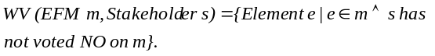 According to the rule, a working view of a stakeholder consists of elements on which the stakeholder vote yes, and elements created by others but the stakeholder has not shown any opinions on.
The Global View
A global view reveals the whole picture of an EFM. It is composed of all undeleted elements in an EFM.
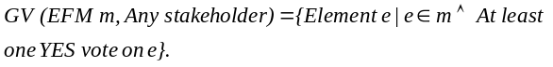
The rule VIR-C introduced in previous section attaches an initial yes vote on each elements thus ensures that a global view can be generated correctly even if no stakeholders have explicitly voted yes on any element.
Stakeholders may switch to the global view to avoid information missing. If a stakeholder has voted no on an element, the element will be invisible in his working view since then. Therefore, he might miss useful information about the element without using the global view. For example, a stakeholder may vote no on a feature in the early stage of the construction. Since then, most stakeholders have expressed opposite opinions on the feature. This possibly means that the first stakeholder needs to reconsider his/her decision. By utilizing the global view frequently, the stakeholder would not miss information like this.
The Personal View
A personal view is used to represent a specific stakeholder’s own perspective of an EFM. This view consists of all the elements supported by a stakeholder.
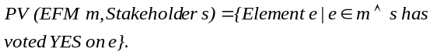
Different personal views may show different perspectives and interests in a domain. For example, end users may concern more about the service-level features, while programmers might be interested in the implementation-level features and constraints between them. Thus it is possible that the personal views of end users depict services provided by the software in a domain, and the personal views of programmers show more details about the techniques used in the domain.

Resolving conflicts in EFMs
Conflicts are common in collaborative work, because of divergence between stakeholders. In CoFM, only the divergence in the working-view-level and the personal-view-level, not the EFM-level, can lead to conflicts. In other words, we don’t force stakeholders to eliminate any divergence in an EFM; however, a stakeholder’s working view is his/her individual workspace and the personal view is his/her perspective of the feature model, therefore his work is considered unfinished if there are still conflicts in them. There are four types of conflict in a stakeholder’s working/personal view (Table 2).
Unidentifiable Feature (UF): the stakeholder denies all existing names of a feature without giving a new one, which makes the feature unidentifiable in his working/personal view.
Non-positioned Feature (NPF): the stakeholder denies all existing positions of a feature without giving a new one. (A feature must either be positioned as a root feature, or as a child of another feature.)
Conflicting Refinements (CR): multiple refinements existing in a working/personal view are considered conflicting if they involve the same feature as the child but different features as the parent.
Conflicting Constraints (CC): multiple constraints existing in a working/personal view are considered conflicting if there are two involved features A and B, where both A excludes B and A requires B can be deduced from these constraints.
Table 2. Examples of conflicts in a working/personal view
Type | The Stakeholder’s
Type | Initial View | Operations | Resulting View
UF | F  (feature)  Aliases: A₁..A_{n} | Vote no on the name F, A₁, .., A_{n} | (Unnamed)
NPF (1) | (Root)  F2  F1  R: F2 refines F1 | Vote no on R | F1  F2  (Root)
NPF (2) | F1  F2  (Root) | Vote no on F1 | F2
CR | F1  F2  F3  R1 R2  R1, R2 might be created by different stakeholders. | (None) | F2  F3  F1
CC | F1  F2  F3  excludes  R1  R3  R2  R1, R2, R3 might be created by different stakeholders.  requires | (None) | F2  F1  F3
For an unidentifiable feature, the stakeholder should either create a suitable name, or reconsider existing names.
For a non-positioned feature, the stakeholder should create a refinement involving it as a child, or make it a root feature explicitly, or reconsider existing refinements.
For conflicting refinements, the stakeholder should vote on these refinements to accept exactly one of them, or even denies all and create a new one.
For conflicting constraints, the stakeholder should vote no on some of them until the conflict has resolved, or even denies all.
The conflicts in a working view actually define the minimal amount of work that a stakeholder must do to obtain a usable feature model that conforms to traditional feature models. For example, a newly joined stakeholder only needs to resolve conflicting refinements and conflicting constraints to transform his working view into a usable feature model, which has a traditional hierarchical structure. In addition, there is a bonus for him: aliases and descriptions of features contributed by different stakeholders can help him deepen the understanding of the current domain.

Awareness Support
Awareness support is essential for improving the usability of CSCW systems [5]. It is becoming more and more apparent that being able to stay aware of others plays an important role in the fluidity and naturalness of collaboration. According to Gutwin and Greenberg’s framework of awareness [7], the CoFM system provides six kinds of awareness information, as Table 3 shows.
Table 3. An overview of awareness information in CoFM
Awareness Information | Purpose (According to [7]) | Display the information
Awareness Information | Purpose (According to [7]) | Where | How
Others’ edit location | Location (Where are they working?)  Presence (Who is participating?) | Feature Browser | Show others’ names next to being edited features.
Controversy | Artifact (What is the state of the objects?) | Feature Browser | Bold the controversial features.
Conflict | Artifact | Feature Browser | Use different colors for different type of conflicts.
My creation | Authorship (Who did that?) | Feature Browser | Underline the features created by current user.
Recently changed features | Action (What are they doing?) | Feature Browser | Use larger font for recently changed features.
Change History | Action History (What has been done?) | Change History Browser | List the details of changes made on the EFM.

Others’ edit location tells a user who is working on the feature model currently and which feature the others are editing. The information is conveyed by displaying people’s names next to the being edited features. For example, in Figure 6, the feature Job Management is being edited by the user lilong.
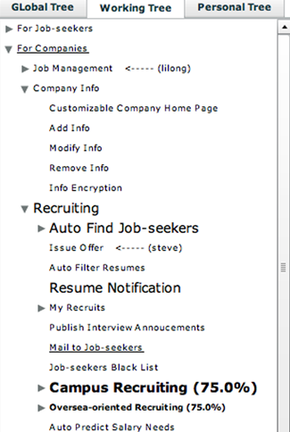
Controversy information helps users be aware of controversial features (controversy on a feature or its attributes), and if the controversy is about a feature, then the support rate of the feature’s validity is shown as a number. For example, in Figure 6, the support rate of validity of the feature Campus Recruiting is 75 percent.
Conflict information is shown by coloring, and different types of conflict (Table 2) are displayed in different colors.
My creation (features created by current user) is underlined in the feature browser. Besides, creator of each feature is shown in a feature editor panel. (Clicking a feature in feature browser will open the feature in the feature editor.)
Recently changed features have larger font size than other features, in the feature browser. We only treat features with unread recent changes for current user as recently changed ones, in other words, different users have different recently changed features. This information can help users follow the recent progress of the feature model, especially when the scale of feature model is large.
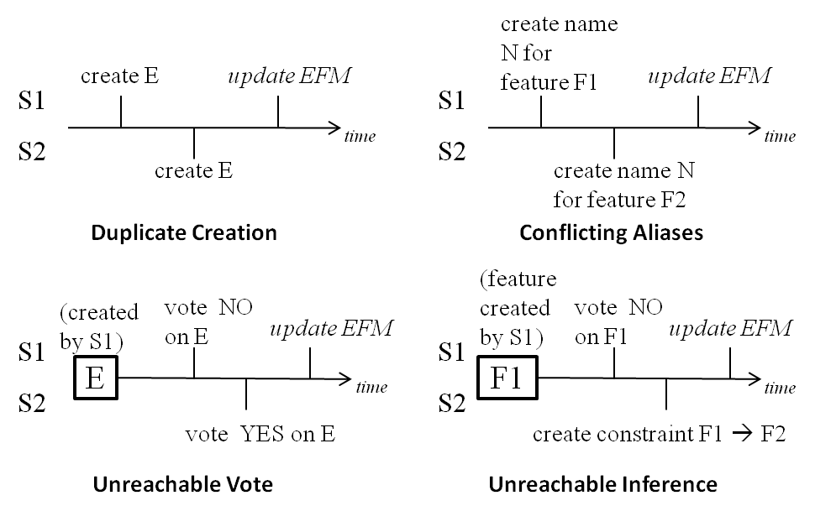
Change history is different from recently changed features. This information shows all changes that have been made on the feature model, ordered by time. By selecting a specific change, the corresponding feature will be shown in the feature editor.
In the use of our system, we find that the most frequently used UI region is the feature browser, so we display most of the awareness information in the feature browser. Furthermore, we use different UI elements for different types of information, which enables multiple awareness information of the same feature to be correctly displayed, by the combination of corresponding UI elements. For example, in Figure 6, the feature Campus Recruiting is controversial (bolded) and contains unread recent changes (large font size).
Figure 7. Situations needing coordination

Coordination Support
In the context of collaborative work, when multiple stakeholders are working on the same set of elements at the same time, their changes of the elements may need to be coordinated. In CoFM, the need for coordination is rooted in the update delay problem: update of the EFM originated by one stakeholder cannot immediately become visible to others. According to types of the update (create or vote), there are four possible situations, as illustrated in Figure 7.
Duplicate creation happens when a stakeholder (S2) creates an element E before a previous creation of the same element has became visible (i.e. update EFM) to him. Therefore the creation of the same element happens twice.
Conflicting aliases emerge when two stakeholders try to create the same alias on different features at the same time. Since different features cannot have the same name or alias, the situation needs to be coordinated.
Figure 6. An example of displaying awareness information
Unreachable vote is a vote on a nonexistent element. In Figure 7, if the no vote on E submitted by S1 leads to the deletion of E, then S2’s yes vote is an unreachable vote.
Unreachable inference is similar to unreachable votes. In Figure 7, if the no vote on F1 leads to the deletion of F1, and if S2 creates a constraint involving F1 before the deletion becomes visible to him, then the inference of yes vote on F1 (according to the rule VIR-1) is unreachable.
Coordination of these situations follows a serialized update strategy, that is, all update applies to the EFM in the same order of their submission. Furthermore, if the update being applied is no longer valid, it fails and takes no effect on the EFM, and its submitter will be informed the failure.
For duplicate creations, the first creating operation adds a new element to the EFM, and the latter is converted to a yes vote. In Figure 7, S1 will create the element E, and S2 will have a yes vote on E.
For conflicting aliases, the first alias is kept, and the latter one is neglected. In Figure 7, only F1 will be assigned the alias N, and S2 will be informed his creating operation has failed.
For unreachable votes, they are no longer valid on a nonexistent element and are neglected. In Figure 7, the element E will be deleted, and S2 will be informed that his/her voting operation has failed.
For unreachable inference, they are neglected as well as the operations which cause the inference. In Figure 7, the feature F1 will be deleted, and S2 will be informed that his/her creating operation has failed.

CASE STUDIES

Overview of the cases
The cases conducted in CoFM can be divided into two categories: domain analysis cases and requirements elicitation cases. Table 4 shows the basic information about these cases.
In the domain analysis cases, five or six participants construct a domain feature model for a familiar domain collaboratively. They first spend a couple of hours working simultaneously, and then they may work freely (often at different time) in the next few days.
In the requirements elicitation cases, CoFM is used as a platform for requesting requirements of ongoing projects. The requirements are expressed in terms of requested features, which are common in real world’s open source projects [11]. The project members create a few top-level features as feature categories. In the next few weeks, participants create new features as their requirements, and work with project members to refine these requirements.
The participants of these cases have already learned the basic concepts of feature models and requirements engineering, so their learning curves of CoFM are very short. However, some of them have little or no experience on domain analysis and requirements elicitation (they can be perceived as stakeholders like users or clients), and some of them are more experienced (they can be perceived as domain analysts or requirements analysts). We think the knowledge structure of our participants and real world projects’ stakeholders are similar.
Table 4. Basic information about the cases
Name | Description | Number of Features | Number of Participants
Domain Analysis Cases
Music Player | The domain feature model of music playing software such as iTunes. | 158 | 5 (including 1 experienced)
Job Finding Website | This domain feature model is based on the top 3 job finding websites in China. | 113 | 6 (including 2 experienced)
Requirements Elicitation Cases
CoFM | Feature request and feedback for CoFM itself. | 32 | 6 (including 1 project member)
RFTM | These are tools of other ongoing projects in our lab. | 32 | 4 (including 1 project member)
CRE | These are tools of other ongoing projects in our lab. | 40 | 8 (including 2 project members)

Observations
In this sub-section, we wish to present some observations of the uses, strengths and weaknesses of CoFM.

Efficiency of feature modeling is improved
One observation is that the efficiency of feature modeling is improved. There are three reasons for such improvement.
The first reason is the parallelism of individual work during the construction of feature models. We have observed that the participants always focus on a certain part of a feature model (i.e. a certain sub-tree in the tree view) during a period of time. With the display of others’ editing location, the participants tend to choose a different part from others. This leads to parallel creating and voting operations in different parts of a feature model. Especially, this phenomenon can be most clearly observed in the early stage of feature modeling, when participants are focusing on creating descendant features for high-level features.
The second reason is that in most situations, adjusting relationships among a group of features does not disturb the work on these features, and vice versa. For example, in the Job Finding Website Domain case, there is a period of time when three different parent features are linked to a feature Browse Company Info (i.e. three conflicting refinements). When two participants are discussing and resolving these conflicting refinements, another participant continues his work on writing description and creating child features for Browse Company Info without any trouble. This often happens in the later stage of feature modeling, when there exist a lot of earlier created features, and one or two participants (often the most experienced ones) are focusing on adjusting refinements and adding constraints, while others are trying to improve names and descriptions of existing features and find missing features.
The third reason is that participants are often inspired by others’ work. All participants have admitted that “by looking at what is being created by the others, I can always think of a related feature immediately.” For example, just a few seconds after a participant creates the feature Browse Company Info, another participant creates two features –Search Company and Publish Company Info. Furthermore, most participants agree that understanding a proper named and described feature is easier than creating a new one. They said, “Although I have to understand others’ work, it is still easier to review an existing element than to think of a new one by myself, therefore my efficiency is improved.” Therefore, individuals can work more efficiently in the collaboration.

Support for awareness is critical
We believe that support for awareness is crucial to the collaborative work. The participants have reported that the display of others’ editing location is the most useful function for their work, because they can find which part of the feature model is idle and needs attention, thus they can try their best to work in parallel.
The awareness of controversy and conflicts is also useful for participants’ work. With the highlighting of these elements, participants can quickly find and resolve divergences that might cause potential problems in further collaboration, for example, conflicting refinements of a top-level feature.
In addition, participants have positive comments for awareness information about “my creations” and “recent changes”, in terms of improving their efficiency. Highlighting their own creations helps them find if there are any controversies in these elements, and it is impossible for them to remember the creator of every element. Highlighting recently changed elements (especially features) helps them from two aspects. First, they always interest in the most recently changes in a feature model, especially when they leave the feature model for a long period of time. In the contrast, some participants also want to know the least recently changed features, which may indicate a problematic feature, such as a feature with a vague name and no descriptions thus no one can understand it.

The need of customizable attributes of features
One of the participants’ complaints about the initial version of CoFM is that the expressive power of feature models, especially when using CoFM for feature request. For example, participants want to express the priority, ease of implementation, and importance of the requested features, but they can only write them in features’ descriptions. As a result, they asked for adding such attributes to the features in the feature model. It makes us realize that we need to allow users of CoFM adding attributes to features in a certain feature model during the construction of the feature model.
We design a mechanism called customizable attributes of features. All features have default attributes, i.e. name, description and optionality. Besides, users can add attributes to all features in a certain feature model, in one of the predefined types: single-line string, multi-lines text, enumeration, and number. (We may define more types in the future.) They can create new values or vote on existing values of any attribute in a feature as before. We have observed that every feature model constructed in the new version of CoFM, no matter used for domain analysis or feature request, have a few customized attributes. This shows the ability of customization and the flexibility brought by it has very positive influence on the use of CoFM.

The need of outlining
When using CoFM for domain analysis, we have found that if an experienced domain analyst has created a few top-level features in advance, then there will be fewer conflicts in further construction, and therefore it will be more efficient. We call it the outlining of feature modeling, because top-level features can be considered as categories of features. We observe this by comparing the construction of Music Player Domain and Job Finding Website Domain feature models.
In the case of Music Player Domain, the initial 30 or 40 features are created by a participant with no experience in domain analysis. We found that the structure of these features can be almost directly mapped onto the structure of menu items of the participant’s favorite music playing software. For example, the top-level features are Play Control, Media Library, Audio Control and Lyrics, which are the same of top-level menu items. However, this kind of structure may be helpful for using the software, but is not proper for a feature model. For example, Play Control refers to the basic and most frequently used features in the software (with a play control panel on its UI), so it has child features like Play Local Files and Play from a URL. However, from a domain analyst’s perspective, these two features may be renamed to Local File and Online Audio Stream, and they should be child features of a top-level feature named Formats to Support. Such structural mismatch between the software and the feature model causes a lot of conflicts in refinement relationships when more experienced participants join the collaboration. In fact, the participants decide to stop creating new features unless they can reach a consensus on the top one or two levels of features and put the rest of initial features in right position.
With the experience of the Music Player Domain case, we decide to ask a more experienced participant to create the top one or two levels of features as a start, for the Job Finding Website Domain feature model. The participant spends about an hour on analyzing three most popular job finding websites, and then creates the top two levels of features in five minutes. The top-level feature For Job Seekers has child features like Personal Info, Search for Jobs and Resume. Another top-level feature For Companies has child features like Company Info, Job Management, Search for Job Seekers, Interview Management and Advertising. As a result, there are few conflicts of refinement relationships during the further construction, and feedback shows that the initial outline-features help participants find new features in a more systematic way.
According to the observations above, we believe that the outlining, especially performed by experienced domain analysts, can stimulate thinking and improve the efficiency of collaborative feature modeling.

A short summary
The observations made from the case studies show that feature models are suitable for being constructed in collaborative way described in this paper. With adequate awareness support, the efficiency of feature models’ construction can be increased. In addition, the flexibility of extending the feature model makes CoFM more powerful. Besides, just as in traditional domain analysis, experienced domain analysts always act as a key role in the construction of feature models.

RELATED WORK
In FODA [7], FORM [9], FeatuRSEB [6], and FOPLE [10], feature models are constructed through the commonality and variability analysis to a set of applications in a domain. The construction task is performed by domain analysts, with the assistance of other stakeholders such as users, domain experts and requirements analysts. However, despite its inherent need of intensive collaboration, none of these approaches has explicitly incorporated mechanisms or techniques to support collaboration among stakeholders in the construction of feature models.
Many generic collaboration tools allow users to express their viewpoints through a voting mechanism which is similar to ours. For example, the gIBIS tool [3] proposed a framework for people to solve complex problems in a structured way, that is, solve a problem by identifying issues (what the problem is), submitting positions (possible solutions to issues), and providing arguments (reasons to support or object to positions). However, although these tools allow different or even conflicting opinions to be expressed, they can only tolerate temporary divergences; all divergences must be eliminated in the end of work. By contrast, feature models used in CoFM can tolerate permanent divergences; the divergences are treated as indicators of domain variability. Furthermore, in these tools, conflicts between stakeholders need to be manually identified, while in feature models, conflicts are well-defined and can be automatically detected.
In the research of requirements engineering, several methods have been proposed to support collaboration among stakeholders. The EasyWinWin system [1] provides an environment for stakeholders to propose and discuss requirements. The first step in EasyWinWin is to establish categories of the requirements as an outline, and it serves as a basis for later steps, e.g. a completeness checklist for final requirements. The observations from CoFM show that the outlining is also a key step for feature modeling, and it can be seamlessly integrated into current feature modeling process – all the users have to do is to construct the top-level features first, and these features may involve with the whole feature model during the later construction.
Noor et al. [12] proposed a collaborative product line planning (CoPLP) approach, in which the desired products are discussed in terms of features and the process of collaboration is similar to EasyWinWin. However, CoPLP did not use feature models to express and organize the features, therefore there is a lack of explicit modeling of constraints between the features and verification of the products. CoFM can also be used as a platform for feature-based requirements elicitation, and constraints between the features can be explicitly expressed.
In addition, Laurent and Cleland-Huang [11] have pointed out that feature request is a common form of requirements elicitation in open source projects, and a major problem is that the requested features are often lack organization. In their research [2], data mining technologies are incorporated to help organize the request and discussion of features. In CoFM, feature models can also guide the feature request towards a clear and structured process.

CONCLUSIONS AND FUTURE WORK
This paper presents a collaborative feature modeling environment (CoFM) to improve the efficiency of feature models’ construction. In this environment, stakeholders can create new elements and vote yes or no on existing elements to express their opinions on the elements. Following this idea, we extend the meta-model of traditional feature models by introducing creating and voting operations, as well as three types of views for stakeholders. Besides, we define a process for constructing feature models in a collaborative way. We develop a tool and conduct a series of case studies to explore strengths and weaknesses of CoFM. The observations show that CoFM improves the efficiency of feature modeling, and it is not only suitable for feature-oriented domain analysis, but also feature-based requirements elicitation.
In the future, we want to conduct more case studies with larger scale and more people, and improve CoFM according to the feedback. In addition, we plan to incorporate more techniques into our feature modeling approach, such as algorithms for calculating confidence or weights of users’ operations, and mechanisms for helping users find relationships between features.

REFERENCES
- Boehm, B., Grunbacher, P., Briggs, R. O. 2001. Developing groupware for requirements negotiation: Lessons learned. IEEE Software. 18, 3, 2001, 46-55.
- Castro-Herrera, C., Cleland-Huang, J., Mobasher, B. Enhancing stakeholder profiles to improve recommendations in online requirements elicitation. In Proceedings of Intl. Conf. on Requirements Engineering. RE '09. 37-46.
- Conklin, J., Begeman, M. gIBIS: A hypertext tool for exploratory policy discussion. ACM Trans. On Information Systems (TOIS). 6, 1988, 303-331.
- Dourish, P., Bellotti, V. Awareness and coordination in shared workspaces. In Proc. of the 1992 ACM Conf. on CSCW. 107-114.
- Ellis, C. A., Gibbs, S. J. Rein, G. Groupware: Some Issues and Experiences. Communications of ACM, 34, 1991, 39-58.
- Griss, M. L., Favaro, J., d’Alessandro, M. Integrating Feature Modeling with the RSEB. In Proc. Of the Fifth Intl. Conf. on Software Reuse. ICSR '98. 76-85.
- Gutwin, C., Greenberg, S. A descriptive framework of workspace awareness for real-time groupware. Computer Supported Cooperative Work. 11, 3, 2002, 411-446.
- Kang, K. C., Cohen, C., Hess, J., Nowak, W., Peterson, S. Feature-Oriented Domain Analysis (FODA) Feasibility Study. Technical Report CMU/SEI-90-TR-21, Software Engineering Institute, Carnegie Mellon University, 1990.
- Kang, K. C., Kim, S., Lee, J., Kim, K., Kim, G. J., Shin, E. FORM: A Feature-Oriented Reuse Method with Domain-Specific Reference Architectures. Annals of Software Engineering. 5, 1998, 143-168.
- Kang, K. C., Lee, J., Donohoe, P. Feature-Oriented Product Line Engineering. IEEE Software. 19, 4, 2002, 58-65. DOI= 10.1109/MS.2002.1020288.
- Laurent, P., Cleland-Huang, J. Lessons Learned from Open Source Projects for Facilitating Online Requirements Processes. In Proc. Of Working Conf. on RE: Foundations for Software Quality. REFSQ '09.
- Laurillau, Y., Nigay, L. Clover Architecture for Groupware. In Proc. of the 2002 ACM Conf. on CSCW. 236-245.
- Noor, M. A., Rabiser, R., Grunbacher, P. Agile product line planning: A collaborative approach and a case study. J. Syst. Software. 2007. DOI=10.1016/j.jss.2007.10.028
- Zhang, W., Mei, H., Zhao, H. Y. A feature-oriented approach to modeling requirements dependencies. In Proc. of the 13th IEEE Intl. Conf. on Requirments Engineering. RE '05. 273-282

