CoFM: A Web-based Collaborative Feature Modeling System for Internetware Requirements' Gathering and Continual Evolution

Li Yi, Wei Zhang, Haiyan Zhao, Zhi Jin, Hong Mei
Institute of Software, School of EECS, Peking University Beijing, China
Key Laboratory of High Confidence Software Technology, Ministry of Education of China
{yili07, zhangw, zhhy, zhijin}@sei.pku.edu.cn, meih@pku.edu.cn

ABSTRACT
Internetware is a paradigm of open, decentralized and continually evolvable software systems running on the Internet. In the development of Internetware, the enormous amount of its stakeholders brings challenges to the gathering of common and essential requirements among these stakeholders and continual evolution of the requirements. In this paper, we present a web-based collaborative feature modeling system (CoFM) developed as a platform for gathering, organizing, evaluating, and negotiating Internetware requirements. The basic idea is to express and organize requirements in terms of user-perceivable features provided by the desired Internetware application, and to allow stakeholders to propose, evaluate and negotiate these features collaboratively, in a shared feature model of the application. During the collaboration, the application provider can discover the common and important features that need to be implemented at present, and the special but valuable features that might be provided in the future. Moreover, the provider can track the up-to-moment evolution of the features, which enables the provider to quickly respond to the changes in the Internetware requirements.
Categories and Subject Descriptors
D.2.1 [Software Engineering]: Requirements/Specification –, tools
General Terms
Design, Experimentation, Human Factors
Keywords
Feature Model, Internetware, Requirements Elicitation, Collaboration.

INTRODUCTION
Internetware is a paradigm of open, decentralized and continually evolvable software systems running on the Internet [15]. The increasing interest of Internetware is witnessed by the emergence of Web services, Service Oriented Computing (SOC), Service Oriented Architecture (SOA) and cloud computing. Particularly, the Software as a Service (SaaS) approach in cloud computing has achieved great commercial success in recent years. For example, Salesforce.com maintains a Customer Relationship Management (CRM) application on the Internet and about 70,000 subscribed clients are using this application now.
A significant characteristic of Internetware is that the amount of its potential stakeholders is usually enormous, due to the openness and global availability of the Internet. This characteristic brings challenges to the development of Internetware. Specifically, in the requirements engineering for Internetware, there needs of approaches and tools that: 1) support for gathering, organizing, evaluating, and negotiating requirements from large number of stakeholders; 2) synthesize the requirements to help Internetware provider identify the most common and essential requirements among the stakeholders, to enable the provided Internetware satisfy most stakeholders; 3) allow stakeholders to track the up-to-moment changes of the requirements, to makr the Internetware evolved continually and correctly. We believe that the emergence of such approaches and tools will have positive influence on the requirements engineering for the Internetware, and eventually, improve the dependability of the Internetware applications.
In this paper, we present a web-based collaborative feature modeling system (CoFM) developed as a platform for gathering, organizing, evaluating, and negotiating Internetware requirements. The basic idea is to express and organize requirements in terms of user-perceivable features provided by the desired Internetware application, and to allow stakeholders to propose, evaluate and negotiate these features collaboratively, in a shared feature model of the application. Specifically, the CoFM system includes the following characteristics:
- Utilize feature models to explicitly model the relationships between the gathered features. The relationships may have great influence on decisions in the later stages of the Internetware development. For example, when making the decision of whether to implement a specific feature, stakeholders should aware that all features required by this feature must be implemented before it.
- Incorporate a collaboration mechanism to allow multiple stakeholders to concurrently create new features as well as comment and vote on existing features. All the changes on the feature model immediately become visible to all stakeholders.
- Present the statistics of the features for requirements analysis. Particularly, the votes on the features help Internetware application providers identify the common features and the special ones, as a basis for feature prioritization.
Besides, we conduct a case study of gathering and negotiating the requirements of Online Job Finding applications in the CoFM system, and observations show that the CoFM provides an effective way for capturing multiple stakeholders’ requirements in a collaborative manner.
The reminder of this paper is organized as follows. Section 2 gives some preliminaries on traditional feature models. Section 3 introduces the method for collaborative feature modeling. Section 4 presents the CoFM system, and the case study is presented in Section 5. Related work is discussed in Section 6. Finally, Section 7 concludes this paper with a brief summary and future work.

PRELIMINARIES: THE FEATURE MODEL
In this section, we introduce a meta-model of traditional feature models. They serve as bases of the extended feature models constructed in CoFM..
Figure 1 shows a meta-model of traditional feature models. Generally, a feature model consists of a set of features and relationships between them.
The concept of feature can be understood in two aspects: intension and extension [14]. In intension, a feature denotes a cohesive set of individual requirements. In extension, a feature describes a software characteristic having sufficient user/customer value.
Figure 1. A meta-model of feature models
There are two types of relationships, namely refinements and constraints. The refinement relationships organize features with different levels of abstraction or granularities into a hierarchical structure. In this hierarchical structure, each feature is either mandatory or optional (i.e. the optionality of a feature). If a feature is selected, its mandatory children features must be selected as well, while its optional children can either be removed or selected.
The constraint relationships describe dependencies between features. There are two basic kinds of constraints: requires and excludes [7][9]. Given two features A and B, A requires B means that if A is selected, B must be selected as well. A excludes B means that at most one of them can be selected at the same time. More types of constraints can be found in [14].

THE CoFM METHOD
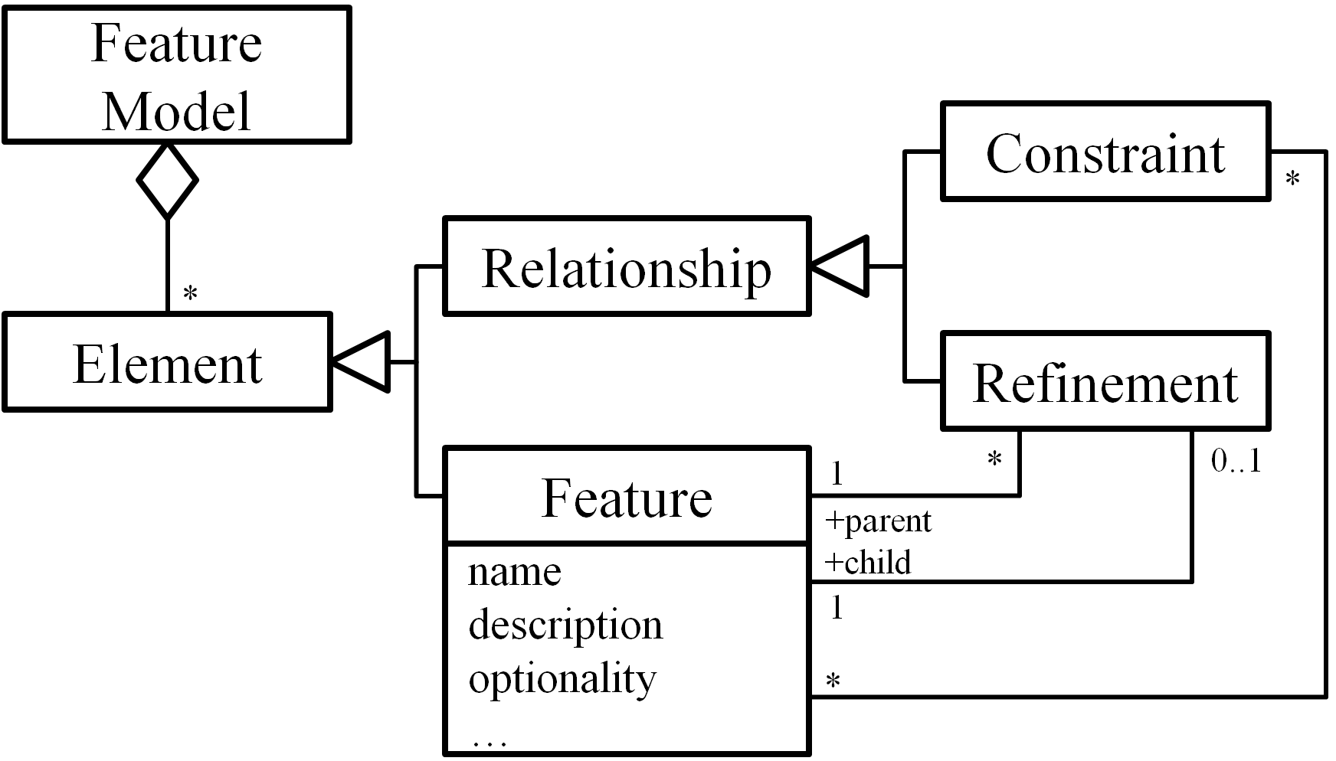
The CoFM method proposes an approach to constructing a kind of extended feature models (EFMs) collaboratively. In this section, we give an overview of the CoFM method. We first introduce the meta-model of the EFMs, and then present the process of constructing the EFMs.

Extended Feature Models (EFMs)
Figure 2 shows the meta-model of EFMs. An EFM is composed of a set of vote-able elements. The top-level elements are features and relationships. Each feature relates to a set of second-level vote-able elements, that is, a feature has one vote-able optionality attribute, and may have one or more vote-able names and descriptions. The result of vote on each element is recorded as its supporters and opponents; both are a set of stakeholders.
In CoFM, stakeholders construct EFMs with two kinds of basic modeling operations, namely the creating operation and voting operation. The function of creating operation is to add new elements to a feature model. The function of voting operation is to allow stakeholders to express their opinions on existing elements: a yes vote means that the voter thinks an element is valid for the EFM, while a no vote shows the opposition.
Figure 2. The meta-model of EFMs
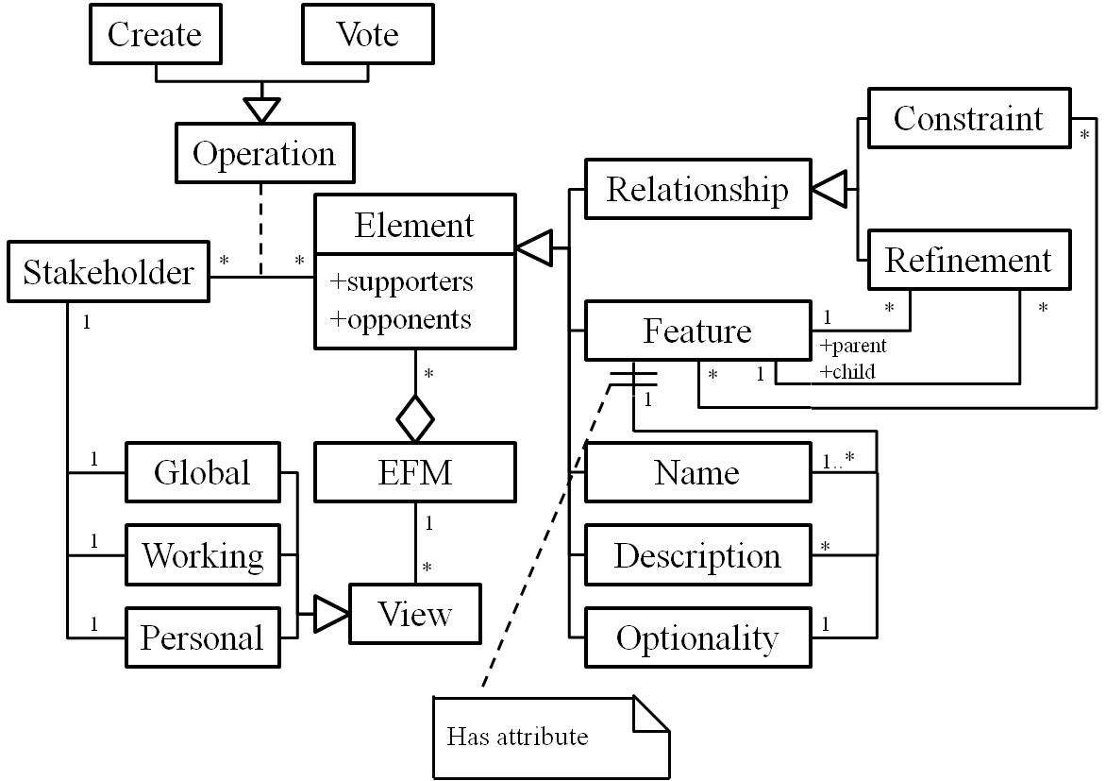
We do not provide explicit deleting and modifying operations, in order to prevent stakeholders from editing and overwriting others’ work directly. Therefore different opinions can be expressed in a feature model equally. However, the deleting operation can be simulated through the combination of the creating and voting operations, that is, an element will be deleted if and only if it has no supporters (i.e. all votes on the element are no). In addition, the modifying operation is the combination of deleting and creating operations, therefore it can also be simulated in CoFM.
To present an EFM for stakeholders, we define three types of EFM views, namely the global view, working view and personal view. In an EFM’s construction, each stakeholder has a global view, a working view and a personal view. The global view is composed of all undeleted elements in an EFM, that is, the whole picture of the EFM. The working view is composed of elements that have not been voted no by this stakeholder, that is, elements on which the stakeholder vote yes, and elements created by others but the stakeholder has not shown any opinions on. The personal view is composed of elements supported (voted yes) by the stakeholder, that is, the stakeholder’s personal perspective of the EFM. These views are automatically generated and updated for each stakeholder during the construction of an EFM.

The Process
Figure 3 shows a typical process of collaborative construction of an EFM. In the beginning of a stakeholder’s work, the system will initialize the global view, working view and personal view for the stakeholder (Update Views). In a stakeholder’s work, s/he mainly engages three kinds of activities, including communicating with others, resolving conflicts and submitting modeling operations. Particularly, when s/he submits a modeling operation, the operation will be sent to the central EFM immediately. A valid operation will be applied and broadcast to all stakeholders (including the originator of the operation), which in turn, causes views of all stakeholders be updated.
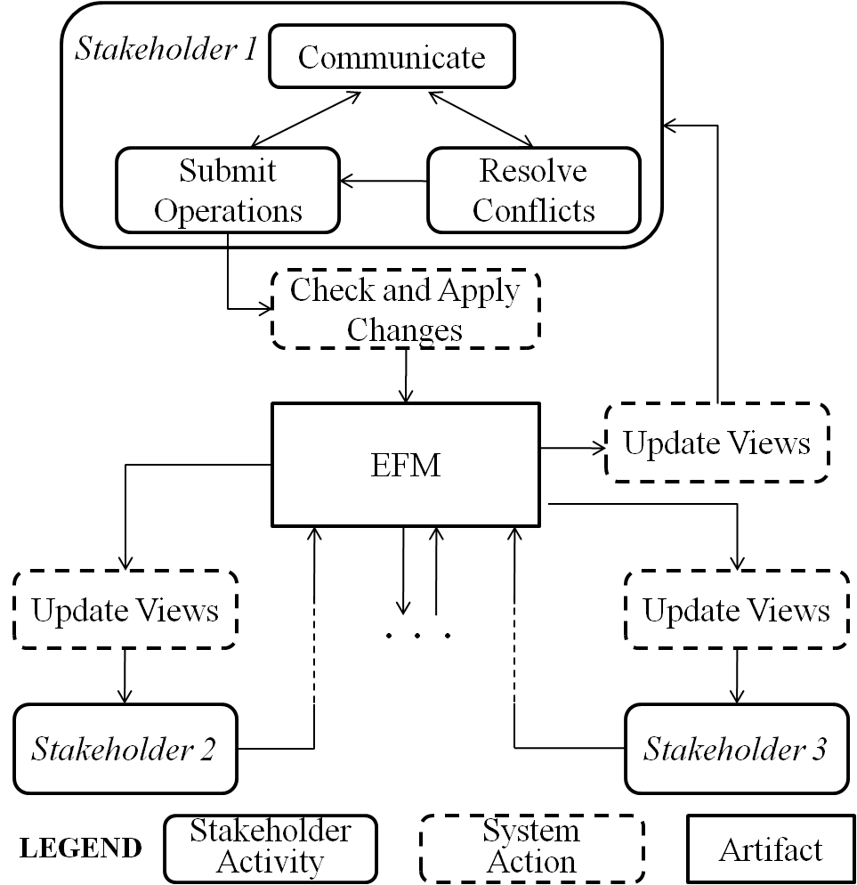
Figure 3. The process of CoFM
There is no stopping rule in the process to determine whether the construction has completed. However, there is a particular way in CoFM to determine the minimal necessary work of each stakeholder, that is, the minimal necessary work of a stakeholder is to resolve all conflicts presented to the stakeholder. (The conflicts are often caused by modeling operations from multiple stakeholders.) Therefore, if any stakeholder hasn’t finished his/her minimal necessary work, the construction must be unfinished.
Figure 4. A screenshot of CoFM’s modeling page

THE CoFM SYSTEM
In this section, we present our CoFM system – the implementation of the CoFM method. We first provide an overview of key functions of the system, and then describe these functions in details.

An Overview of the System
The CoFM system is a kind of CSCW (Computer-Supported Cooperative Work) systems. Researchers have identified several central concepts of CSCW systems [4][5][12], and these concepts have shaped the design of CSCW systems over the years, despite tremendous changes of technologies. The most important concepts are production, awareness, and coordination, thus dividing key functions of CSCW systems into three categories.
Production refers to objects produced and shared in a CSCW system, and operations applied on these objects [12]. In CoFM, it refers to the functions for constructing, viewing and checking shared feature models. (See Section 4.2.)
Awareness means that CSCW systems should provide necessary information about activities of other people in the shared workspace, which provides the context for individual’s work [4]. For example, a collaborative writing tool should display the position of coauthors’ edit cursor, to help authors identify their work context, i.e. their editing boundaries. The support for awareness in CoFM is described in Section 4.3.
Coordination relates to mediating and meshing individual work in a shared workspace [5]. In the context of collaborative work, it is highly possible that multiple stakeholders are working on the same set of elements at the same time, thus their changes of the elements need to be coordinated. The coordination mechanism in CoFM is explained in Section 4.4.

Modeling Support
The key functions of modeling support in the CoFM system fall into three categories: basic modeling functions, feature attribute customizing functions, and model checking functions.

Basic modeling functions
Figure 4 is a screenshot of the modeling page in the CoFM system. The modeling page consists of three regions: the feature browser (left), the feature editor (right-top), and additional information viewers (right-bottom). The feature browser displays the EFM as feature trees, in global view, working view and personal view, respectively. The feature editor shows details of a specific feature. Additional information such as constraints list, comments for current feature and recent changes can be viewed in the right-bottom panels.
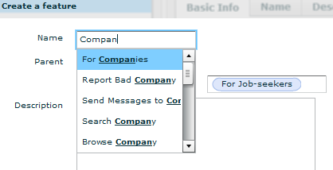
Figure 5. An example of creating a feature
Stakeholders can create new elements in the modeling page. The creation in CoFM is more general than in other feature modeling approaches such as [6] and [7]. For example, in CoFM, a stakeholder can create several names for the same feature, while in other approaches the stakeholder can only assign exactly one name to a feature. However, no duplicate feature names are allowed within or between features, because feature names are considered as identifiers of features. For the purpose of reminding stakeholders of duplicate feature names, existing feature names are shown when stakeholders are typing the name of a new feature. (See Figure 5.)
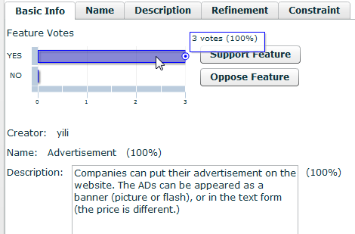
Figure 6. An example of feature editor
For each feature, in the feature editor, we generate the basic information about the feature by combining the most supported values of each attribute (Figure 6), that is, the most supported name and description of the feature. In addition, stakeholders can vote on the current feature in the basic info tab. To create, vote on, or view the details of each attribute, stakeholders can switch to the specific tabs.

Feature attribute customizing functions
In the use of the early version of CoFM, some stakeholders have complained about the expressive power of feature models. For example, they often want to express the easiness of implementation and the importance of the features; however, they cannot model these attributes explicitly but can only write them in features’ descriptions. This makes further collaboration on these attributes (e.g. vote on the importance) impractical.
Our solution to such problem is to incorporate a mechanism called feature attribute customization. In an EFM, each feature has default attributes as before, i.e. name, description and optionality. Besides, stakeholders can add new attributes to all features in the EFM, and other EFMs are not affected. The attributes must belong to one of the predefined types: single-line string, multi-lines text, enumeration, and number. (We may define more types in the future.) If the type of new attribute is enumeration, the creator must enumerate valid values. If the type is number, then the unit and the valid range of its values must be defined as well. An illustrative example can be found in Figure 7. After new attributes are created, stakeholders can add new values of the attributes or vote on existing values.
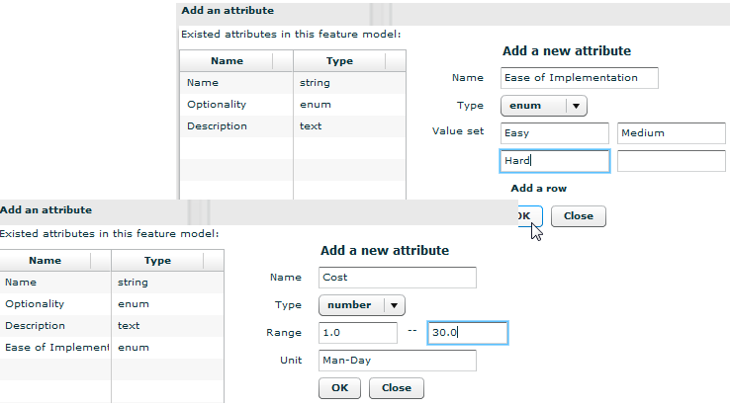
Figure 7. An example of feature attribute customization

Model checking functions
Several model checking methods have been adopted in feature modeling approaches to detect errors and defects in feature models. However, model checking in CoFM is different in two ways:
First, model checking is performed only in working views, not the whole EFM. The reason is that EFMs are designed to tolerate divergence of different stakeholders, thus conflicts in EFMs (e.g. conflicting constraints created by two stakeholders) are acceptable. By contrast, a stakeholder’s working view is his/her individual workspace, thus no errors or defects are tolerable, and the working view needs to be checked. In traditional feature modeling approaches, it is always the whole feature model that is to be checked.
Second, there are more types of errors/defects in CoFM than in traditional feature modeling approaches, as shown below.
- Unnamed Feature (UF): the stakeholder votes no on all existing names of a feature, but doesn’t create a new name. This leads to an unnamed feature in his/her working view. (According to the definition of working view, elements voted no by a stakeholder are excluded from his/her working view.)
- Non-positioned Feature (NPF): the stakeholder votes no on all existing positions of a feature without creating a new one. (A feature must either be positioned as a root feature, or as a child of another feature.)
- Conflicting Refinements (CR): multiple refinements existing in a working view are considered conflicting if they involve the same feature as the child but different features as the parent.
- Conflicting Constraints (CC): multiple constraints existing in a working/personal view are considered conflicting if there are two involved features A and B, where both A excludes B and A requires B can be deduced from these constraints.
In traditional feature models, only the last situation (conflicting constraints) is considered as errors. We incorporate existing model checking methods for the conflicting constraints. The other types (UF, NPF and CR) can be detected without much difficulty.
These errors in a working view actually define the minimal amount of work that a stakeholder must do to obtain a usable feature model that conforms to traditional feature models. For example, a newly joined stakeholder only needs to resolve conflicting refinements and conflicting constraints to transform his/her working view into a usable feature model, which has a traditional hierarchical structure. In addition, there is a bonus: aliases and descriptions of features contributed by different stakeholders can help him deepen the understanding of the current domain.

Awareness Support
Awareness support is essential for improving the usability of CSCW systems [5]. It is becoming more and more apparent that being able to stay aware of others plays an important role in the fluidity and naturalness of collaboration. According to Gutwin and Greenberg’s framework of awareness [7], the CoFM system provides six kinds of awareness information, as Table 1 shows.
Table 1. An overview of awareness information in CoFM
Awareness Information | Purpose (According to [7]) | Display the information
Awareness Information | Purpose (According to [7]) | Where | How
Others’ edit location | Location (Where are they working?)  Presence (Who is participating?) | Feature Browser | Show others’ names next to being edited features.
Controversy | Artifact (What is the state of the objects?) | Feature Browser | Bold the controversial features.
Error | Artifact | Feature Browser | Use different colors for different types of errors.
My creation | Authorship (Who did that?) | Feature Browser | Underline the features created by current user.
Recently changed features | Action (What are they doing?) | Feature Browser | Use larger font for recently changed features.
Change History | Action History (What has been done?) | Change History Browser | List the details of changes made on the EFM.

Others’ edit location tells a user who is working on the feature model currently and which feature the others are editing. The information is conveyed by displaying people’s names next to the being edited features. For example, in Figure 8, the feature Job Management is being edited by the user lilong.
Figure 8. An example of displaying awareness information
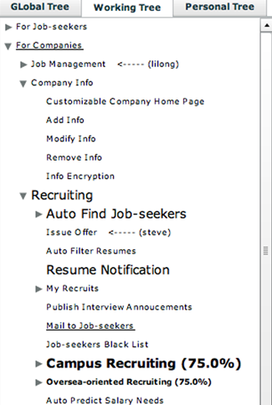
Controversy information helps users be aware of controversial features (controversy on a feature or its attributes), and if the controversy is about a feature, then the support rate of the feature’s validity is shown as a number. For example, in Figure 8, the support rate of validity of the feature Campus Recruiting is 75 percent.
Error information is shown by coloring, and different types of errors are displayed in different colors.
My creation (features created by current user) is underlined in the feature browser. Besides, creator of each feature is shown in a feature editor panel. (Clicking a feature in feature browser will open the feature in the feature editor.)
Recently changed features have larger font size than other features, in the feature browser. We only treat features with unread recent changes for current user as recently changed ones, in other words, different users have different recently changed features. This information can help users follow the recent progress of the feature model, especiallyfor the large scale feature model.
Change history is different from recently changed features. This information shows all changes that have been made on the feature model, ordered by time. By selecting a specific change, the corresponding feature will be shown in the feature editor.
Through the use of our system, we find that the most frequently used UI region is the feature browser, so we display most of the awareness information in the feature browser. Furthermore, we use different UI elements for different types of information, which enables multiple awareness information of the same feature to be correctly displayed, by the combination of corresponding UI elements. For example, in Figure 8, the feature Campus Recruiting is controversial (bolded) and contains unread recent changes (large font size).

Coordination Support
In the context of collaborative work, when multiple stakeholders are working on the same set of elements simultaneously, their changes of the elements may need to be coordinated. In CoFM, we incorporate a centralized broadcasting strategy to coordinate modeling operations submitted by multiple stakeholders. The basic idea of the strategy is that each operation performed by each stakeholder will be sent to the central server where the shared EFM is stored. The server will attempt to execute these operations on the EFM in the order of the reception of the operations. If an operation is valid at the time of its execution, it will be executed; if it is not valid and cannot be transformed into other valid operations, it fails. Executed operations will be broadcasted to all stakeholders, including its originator, and the local copy of the EFM for each stakeholder is updated by the broadcasted operations. Figure 9 gives a sketch of the strategy.
Table 3 describes how to determine the pre-condition of an operation and how to transform an invalid operation into a valid one (if possible). For example, the operation Create_Feature(X) is invalid if there is another feature F that has the name X as its alias; if it is invalid, then it will be transformed into two voting operations (vote yes on the feature F, and vote yes on X).
Table 3. Pre-condition and transformation of operations
The Client
SEND (o: Operation)
Send operation o to the server.
RECEIVE (o: Operation)
if (o.has_successfully_executed)
Update local copy of EFM by operation o.

The Server
MAIN_PROCESS (loop)
p ← The first operation in the Operation_Queue.
if (p is valid)
Execute p on the EFM.
Broadcast p.
else if (p can be transformed)
q ← transformed(p)
Execute q on the EFM.
Broadcast q.
else
Inform the invalidity of p to its originator.
RECEIVE (o: Operation)
Put o at the end of Operation_Queue.
Figure 9. The sketch of centralized broadcasting strategy
Operation | Pre-condition | How to transform an invalid operation
Create Feature X | The name X has not been used in current EFM. | If X appears in feature F, then transform it into:  Vote yes on F;  Vote yes on X.
Create Name X | The name X has not been used in current EFM. | Vote yes on X.
Create a value V for other attributes (e.g. description) | The value V has not existed in current feature. | Vote yes on V.
Create Relationship R | R has not existed in current EFM. | Vote yes on R.
Vote on element E | E must exist in current EFM. | (Cannot be transformed.)

CASE STUDY
In order to explore the use, strengths and weaknesses of CoFM, we conduct a case study with five participants. The participants have already learned the basic concepts of feature models and requirements engineering, so their learning curves of CoFM are very short. However, three of them have little or no experience on domain analysis (they can be perceived as stakeholders like users or clients), while the other two are more experienced (they can be perceived as domain analysts). We believe that the knowledge structure of our participants and real world projects’ stakeholders are similar.
The case is to construct a domain feature model for job finding websites, such as ChinaHR.com or 51job.com. Typically, these websites allow registered companies to publish job information and job-seekers to apply for the jobs.
The final domain feature model contains 113 features. During the construction, we find that the collaborative work can be roughly divided into two phases; we call them the brainstorming phase and the improving phase.
The work starts at the brainstorming phase. In the beginning, two top-level features – Feature for Job-Seekers and Feature for Companies – are created. After that, all participants are focusing on creating new features. The way they prefer is to choose an existing feature and try to refine it (create child features for it). An important observation is that because CoFM displays others’ edit location, the participants always attempt to choose a different feature from others to refine, thus leads to parallel creation at different parts of the feature model. As a result, a large number of features are identified and collected over a short period of time.
As the feature model grows larger, more and more participants start to concern about improving the quality of the feature model. In this improving phase, participants browse the whole feature model for many times, and often jump to recent changes immediately after the changes are made. Their main activities include:
- Remove redundant features. If two features have different names but with same semantics, then one of them is redundant. This occurs mainly because the terminologies used by participants are different, for example, the feature Find Jobs and the feature Search for Jobs. To remove redundant features, the participants prefer to post a topic in the discussion page, such as “Redundant features of Search for Jobs”, and ask others to vote no on redundant features to remove them from the feature model.
- Improve unclear features. Some participants are reluctant to carefully describe a feature when they create it, so others cannot understand the feature very well. The situation gets worse when the feature has an improper or vague name. As we observed, participants often post a comment on unclear features to ask for improvement, and some of them even vote no on these features until their creators improve the description and/or name.
- Find missing features. The participants try to find missing features when they are browsing the whole feature model.
- Adjust and create relationships. The participants adjust refinements and create constraints after most of the features can be well understood.
- Submit votes. The participants vote yes or no on each feature when they are browsing the feature model.
The construction lasts about three hours. Figure 10 shows the statistics of features in every 20 minutes. The features are divided into three categories: changed, unchanged, and newly created, in last 20 minutes. A feature is treated as changed feature if values of its attributes are created or deleted, or relationships involving it are created or deleted, or new comments are posted on it. Besides, the deleted features are not counted, thus by adding the numbers of the three categories, we get the total number of features at a specific point of time. Figure 10 clearly shows that in the first 80 minutes (the brainstorming phase), most of the work is to create new features. After that, there are less creations and more changes of existing features (the improving phase).
The most important observation made from this case is that the efficiency of feature modeling is improved in CoFM. The improvement is partially due to the parallelism of feature creation observed in the brainstorming phase. Besides, participants are often inspired by others’ work. One of participants said that “by looking at what is being created by the others, I can always think of a related feature immediately.” For example, just a few seconds after a participant creates the feature Browse Company Info, another participant creates two features –Search for Company and Publish Company Info. Furthermore, most participants agree that reading an existing feature is easier than creating a new one. They said, “Although I have to understand others’ work, it is still easier to review an existing element than to think of a new one by myself, therefore my efficiency is improved.” In other words, individuals can work more efficiently in the collaboration.
Another observation is that the awareness information is crucial to the collaborative work. The participants have reported that others’ editing location is the most useful information for their work, because they can find which part of the feature model is idle and needs attention, thus they can try their best to work in parallel. Besides, the awareness of recent changes is also important, because it helps participants follow others’ work and know which part of the feature model is the current interest, especially for feature models of large scale.
In summary, the case study shows that feature models are suitable for being constructed in the collaborative way described in this paper. Adequate awareness support improves the efficiency of feature models’ construction.

RELATED WORK
In FODA [7], FORM [9], FeatuRSEB [6], and FOPLE [10], feature models are constructed through the commonality and variability analysis to a set of applications in a domain. The construction task is performed by domain analysts, with the assistance of other stakeholders such as users, domain experts and requirements analysts. However, despite its inherent need of intensive collaboration, none of these approaches has explicitly incorporated mechanisms or techniques to support collaboration among stakeholders in the construction of feature models.
Many generic collaboration tools allow users to express their viewpoints through a voting mechanism which is similar to ours. For example, the IBIS (Issue Based Information System) method and the gIBIS tool [3] proposed a framework for people to solve complex problems in a structured way, that is, solve a problem by identifying issues (what the problem is), submitting positions (possible solutions to issues), and providing arguments (reasons to support or object to positions), in a shared workspace. However, as a generic collaboration tool, there is no direct support for concepts of feature models. If domain analysts use the gIBIS tool to gather information from other stakeholders, extra work must be done to translate an Issue-Position-Argument (IPA) model into a feature model. In fact, this is one problem that requirements analysts complain when they use gIBIS to elicit requirements [23]. If we map the conceptual framework of our approach into the IPA framework – constructing an EFM (the only issue), creating elements (positions), and voting on elements (arguments) –the EFM is finished when stakeholders have settled the IPAs, thus no extra work needed.
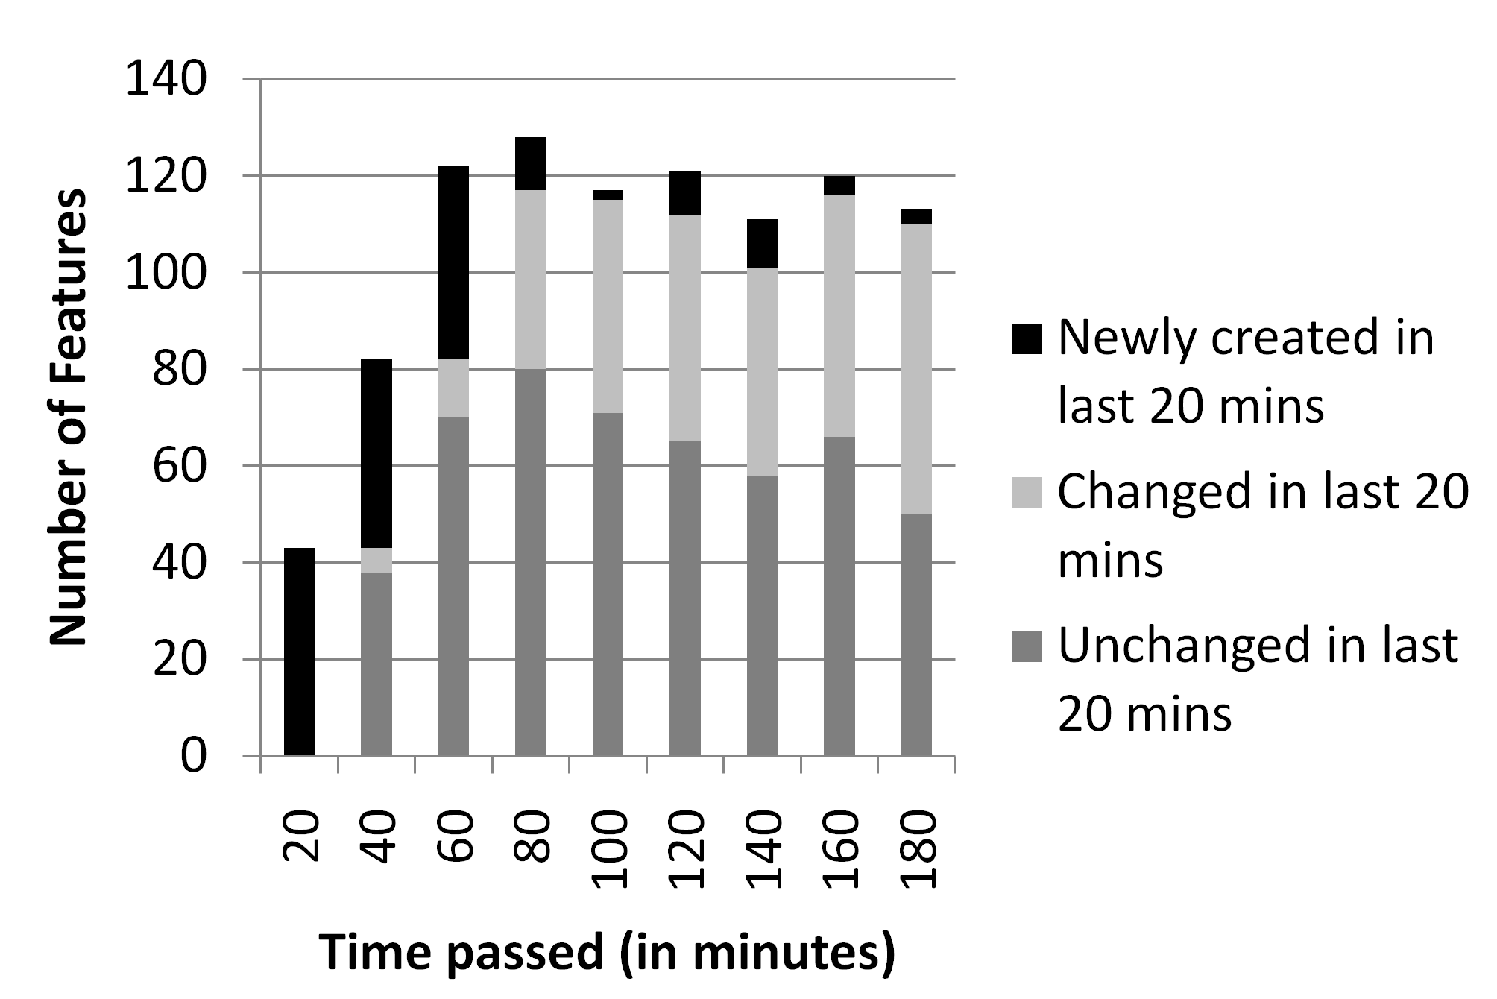
Figure 10. The statistics of features during the construction
In the research of requirements engineering, several methods have been proposed to support collaboration among stakeholders. The EasyWinWin system [1] provides an environment for stakeholders to propose requirements, and then vote and review these requirements collaboratively. Decker et al. [14] proposed a Wiki-based approach to asynchronous collaborative requirements engineering. This approach utilize collaboration mechanisms provide by the wikis to facilitate collaboration among stakeholders, and more particularly, to facilitate stakeholders’ collaborative editing on a set of use cases contained in a set of web pages. However, although these tools allow different or even conflicting opinions to be expressed, they can only tolerate temporary divergences; all divergences must be eliminated in the end of work. By contrast, feature models used in CoFM can tolerate permanent divergences; the divergences are treated as indicators of domain variability. Furthermore, in these tools, conflicts between stakeholders need to be manually identified, while in feature models, conflicts are well-defined and can be automatically detected.
Noor et al. [12] proposed a collaborative product line planning (CoPLP) approach, in which multiple stakeholders can propose and discuss features of desired products. However, CoPLP did not use feature models to express and organize the features, therefore there is a lack of explicit modeling of constraints between the features. CoFM is an extension of traditional feature modeling approaches, so not only the features of a product can be collaboratively collected and reviewed, but also the relations between these features can be explicitly expressed and explored.

CONCLUSIONS AND FUTURE WORK
This paper presents a collaborative feature modeling environment (CoFM) to improve the efficiency of feature models’ construction. In this environment, stakeholders can create new elements and vote yes or no on existing elements to express their opinions on the elements. Following this idea, we extend the meta-model of traditional feature models by introducing creating and voting operations, as well as three types of views for stakeholders. Besides, we define a process for constructing feature models in a collaborative way. We develop a tool and conduct a series of case studies to explore strengths and weaknesses of CoFM. The observations show that CoFM improves the efficiency of feature modeling, and it is not only suitable for feature-oriented domain analysis, but also feature-based requirements elicitation.
In the future, we want to conduct more case studies with larger scale and more people, and improve CoFM according to the feedback. In addition, we plan to incorporate more techniques into our feature modeling approach, such as algorithms for calculating confidence or weights of users’ operations, and mechanisms for helping users find relationships between features.

REFERENCES
- Boehm, B., Grunbacher, P., Briggs, R. O. 2001. Developing groupware for requirements negotiation: Lessons learned. IEEE Software. 18, 3, 2001, 46-55.
- Castro-Herrera, C., Cleland-Huang, J., Mobasher, B. Enhancing stakeholder profiles to improve recommendations in online requirements elicitation. In Proceedings of Intl. Conf. on Requirements Engineering. RE '09. 37-46.
- Conklin, J., Begeman, M. gIBIS: A hypertext tool for exploratory policy discussion. ACM Trans. On Information Systems (TOIS). 6, 1988, 303-331.
- Dourish, P., Bellotti, V. Awareness and coordination in shared workspaces. In Proc. of the 1992 ACM Conf. on CSCW. 107-114.
- Ellis, C. A., Gibbs, S. J. Rein, G. Groupware: Some Issues and Experiences. Communications of ACM, 34, 1991, 39-58.
- Griss, M. L., Favaro, J., d’Alessandro, M. Integrating Feature Modeling with the RSEB. In Proc. Of the Fifth Intl. Conf. on Software Reuse. ICSR '98. 76-85.
- Gutwin, C., Greenberg, S. A descriptive framework of workspace awareness for real-time groupware. Computer Supported Cooperative Work. 11, 3, 2002, 411-446.
- Kang, K. C., Cohen, C., Hess, J., Nowak, W., Peterson, S. Feature-Oriented Domain Analysis (FODA) Feasibility Study. Technical Report CMU/SEI-90-TR-21, Software Engineering Institute, Carnegie Mellon University, 1990.
- Kang, K. C., Kim, S., Lee, J., Kim, K., Kim, G. J., Shin, E. FORM: A Feature-Oriented Reuse Method with Domain-Specific Reference Architectures. Annals of Software Engineering. 5, 1998, 143-168.
- Kang, K. C., Lee, J., Donohoe, P. Feature-Oriented Product Line Engineering. IEEE Software. 19, 4, 2002, 58-65. DOI= 10.1109/MS.2002.1020288.
- Laurent, P., Cleland-Huang, J. Lessons Learned from Open Source Projects for Facilitating Online Requirements Processes. In Proc. Of Working Conf. on RE: Foundations for Software Quality. REFSQ '09.
- Laurillau, Y., Nigay, L. Clover Architecture for Groupware. In Proc. of the 2002 ACM Conf. on CSCW. 236-245.
- Noor, M. A., Rabiser, R., Grunbacher, P. Agile product line planning: A collaborative approach and a case study. J. Syst. Software. 2007. DOI=10.1016/j.jss.2007.10.028
- Zhang, W., Mei, H., Zhao, H. Y. A feature-oriented approach to modeling requirements dependencies. In Proc. of the 13th IEEE Intl. Conf. on Requirments Engineering. RE '05. 273-282

