A Collaborative Requirement Elicitation Technique for SaaS Applications

Xin Zhou
IBM Research - China
Beijing, China
zhouxin@cn.ibm.com
Li Yi, Wei Zhang
Peking University
Beijing, China
{yili07, zhangw}@sei.pku.edu.cn
Ying Liu
IBM Research - China
Beijing, China
aliceliu@cn.ibm.com

ABSTRACT
Software as a Service (SaaS) provides a web based software delivery model to serve a large number of clients with one single application instance. One of the essential problems to SaaS application development is about how to elicit the commonality and variance of multiple clients’ requirements effectively. This paper presents a collaborative requirement elicitation technique (CRETE), which keeps each potential client of a SaaS application aware of the requirements raised by other clients or the SaaS vendor and allows a client to vote on existing requirements or raise new requirements. With CRETE, individual client can create and evolve his proprietary requirements model, while the SaaS vendor can automatically get a combined requirements model that reflects all clients’ common and variant requirements. The SaaS vendor then can develop a SaaS application according to the combined requirements model, so that individual client’s requirements can be satisfied by self-serve configuration without changing the SaaS application‘s source code.
Categories and Subject Descriptors
D.3.3 [Programming Languages]: Language Contructs and Features – abstract data types
General Terms
Management
Keywords
SaaS, requirement elicitation, feature model, collaboration

INTRODUCTION
Software as a Service (SaaS) provides a web based software delivery model to serve a large number of clients with one single application instance, which has gotten rapidly growing acceptance by software vendors [5][6]. Each client might present variant requirements on the application due to their unique business and/or operational needs. To deal with such variant requirements, SaaS vendors should provide an application with all functionalities and offer clients with configuration and/or customization capabilities to tailor the whole application to a unique one as wanted Error: Reference source not found[11]. If clients’ variable requirements can be clearly identified and well dealt with at SaaS application development time, configuration can be easily done at SaaS runtime to meet each client’s unique requirements. For those unique requirements not considered at SaaS development time, configuration doesn’t work and only customization can be performed with significant complexity and cost.
There are many literatures reporting research works on SaaS application configuration and customization [11][12][14][9]. However, little work is reported on the elicitation of variant requirements for a SaaS application, which is fundamental to SaaS configuration and customization. Without well elicited and organized common and/or variant requirements from potential clients, it’s difficult to pre-define enough and appropriate configuration capability for a SaaS application at development time Error: Reference source not found[12]. As the volume of SaaS clients is usually large and the clients are separate, existing traditional requirement elicitation methods [1][3][8] are incapable of collecting large amount of diverse requirements and identifying the commonality and variability among these requirements.
In this paper, we propose a Collaborative Requirement Elicitation Technique (CRETE) for SaaS application development. The basic idea is to keep each potential client of a SaaS application aware of the requirements raised by others and allow them to raise new requirements or vote on existing requirements. With CRETE, individual client can create and evolve his proprietary requirement model, while the SaaS vendor can automatically get a combined requirement model that reflects all clients’ common and variant requirements. The remaining part of this paper is organized as follows. Section 2 presents the concept framework of CRETE. The requirement elicitation process is illustrated in Section 3. Section 4 introduces the preliminary experiment conducted to validate the feasibility of CRETE. Section 5 introduces some related works. Section 6 concludes this paper and discusses future works.

The CRETE Conceptual Framework
In this section, we discuss the concepts presented in CRETE. We first give an overview of CRETE, and then clarify the meta-model of requirements constructed in CRETE. Besides, we introduce two types of views for clients and vendors, respectively.

An Overview of CRETE
The purpose of CRETE is to facilitate the vendor and potential clients on collaboratively presenting, verifying and refining a SaaS application’s requirements via web. A SaaS vendor can raise an initial set of requirements and then inform the potential clients to verify those requirements by voting “yes” or “no” on them. Also, each client can present their personal requirements on the application by adding new requirements into the CRETE environment, which further triggers other clients to vote “yes” or “no” on these newly-added requirements. During the whole process, the SaaS vendor can review all the requirements about the application.
The conceptual framework for CRETE is shown in ‎Figure 1, which will be further illustrated in following sections.
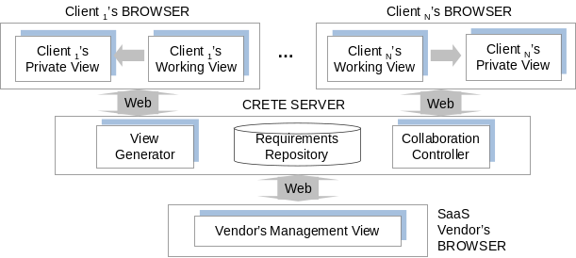
Figure 1. CRETE Conceptual Framework

CRETE Requirements Repository
In CRETE, the requirements are expressed in terms of features of an application. A feature describes a user/customer-perceivable characteristic of the software [13]. There are two kinds of relationships between the features, namely refinement, and constraint. The refinement relationships organize features with different levels of abstraction or granularities into a hierarchical structure. The constraint relationships describe dependencies between features.
The features and relationships are stored as elements in the CRETE requirements repository. (An element can be either a feature or a relationship.) In addition, collaboration-related information on elements (for example, the creation or voting actions a client performs on the elements) is also stored. Figure 2 presents the relation of elements and collaboration-related information via a meta-model of the elements.
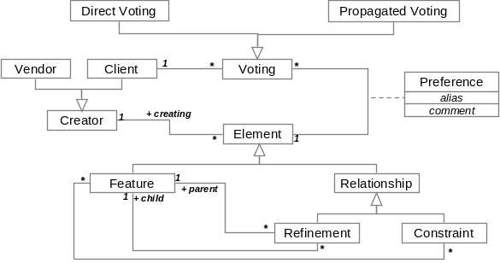
Figure 2. Meta-model of the Elements Stored in CRETE
Collaboration-related information of an element includes direct voting, propagated voting and preference. A direct vote is a “yes” or “no” directly given by a client on an existing element. The votes represent support or opposition of the element’s existence. For each direct voting on an element, there might be a propagated “yes” or “no” vote on other elements, depending on the meaning of the direct vote. Table 1 presents the situations and reasons of propagated voting. Unlike direct voting, propagated voting is performed automatically by the CRETE system. Besides the voting on an element’s existence, we also allow clients to assign preference on the element’s aliases (different clients may assign different names to the same element), descriptions (assigned by different clients), comments, etc.
Table 1. Voting propagation rules
Direct Vote | Corresponding Propagated Vote(s) | Reason
Vote “yes” on Refinement R(F1, F2), i.e. feature F2 refines feature F1 | Vote “yes” on both F1 and F2 | A refinement’s existence implies the existence of the parent feature and the child feature
Vote “no” on a feature F | Vote “no” on the refinements involved F
If there is a “F1 excludes F2” constraint, and vote “yes” on F1 or F2 | Vote “no” on the other feature | F1 and F2 cannot exist at the same time
If there is a constraint “F1 requires F2”, and vote “yes” on F1 | Vote “yes” on F2 | F2 must exist if F1 exists

Client’s Views
Each client works with two views during the process of collaborative requirement elicitation. One is client’s working view and the other is client’s private view.
Client’s working view (CWV) is a client’s main workspace to build requirement model for a SaaS application. In the CWV, a client can create requirements and review existing requirements presented by the SaaS vendor or other clients. The entities in the CWV are extracted from the CRETE requirement repository according to the view generation rule No.1, which includes all “feature” and “refinement” elements that the clients hasn’t vote “no”. According to the definition of feature model, constraint like “requires” or “excludes” is valid at product line level instead of application level so constraints will not be presented for clients. They will only be used at the backend to check the validity of a client’s voting.
View Generation Rule 1:
CWV (Application s, Client c) = {Element e |
(e.Application == s) ∧ (e.Type != “constraint” ) ∧
(! ∃v∈Voting, v.Type==“no”∧ v.Client==c ∧ v.Element == e) }
Client’s private view (CPV) is to represent a client’s proprietary perspective on the requirements on the SaaS application. The entities in the CPV are extracted from the CRETE requirement repository according to the view generation rule No.2, which includes all “feature” and “refinement” elements that the client has voted “yes” (For an element created by the client, CRETE will automatically add a “yes” voting to the element for this client).
View Generation Rule 2:
CPV (Application s, Client c) = {Element e |
(e.Application==s) ∧
(∃a ∈ Creating, a.Client==c ∧ a.Element==e) ∧
(∃a ∈ Voting, a.Type == “yes” ∧ a.Client == c ∧ a.Element == e ) }

The SaaS Vendor’s View
The SaaS vendor works with his management view (VMV) during the process of collaborative requirement elicitation. In VMV, the vendor can create some initial elements for a to-be developed application, with which clients can vote on them or be inspired to propose new elements. Also, the vendor can review all the elements about an application. Besides, the vendor is presented with each requirement’s creator, the supporters and the dissenters. Then, he can follow which elements are requested by which clients. Besides, he can attach the requirements relationships on the management view from application development perspective. For example, the “excludes” constraint can be added between two features to indicate a conflict due to development considerations.
View Generation Rule 3:
VMV (Application s) = {Element e | ( e.Application == s ) ∧
( (! ∃v∈Voting, v.Type==“yes”∧ v.Element==e)
∨ (e.Creator==this vendor))}

The Collaborative Requirements Construction Process
In this section, we introduce the collaborative requirements construction process, based on the concepts discussed before. We first give an overview of the process, and then present conflict resolution and operation coordination in detail, respectively.

Process Overview
The collaboration process for constructing a SaaS application’s requirements model is shown in Figure 3, which includes human activities performed by clients (solid lines in Figure 3) and automated activities (dashed lines).
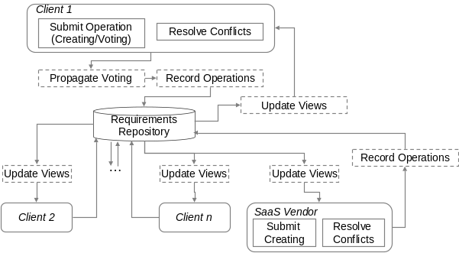
Figure 3. Requirement Construction Process
Update Views: When the information in the requirement repository changes due to operation submission or propagated voting, client and vendor’s views are automatically updated.
Resolve Conflicts: When a client’s working view is updated, he should first focus on the conflicts emerging in the view and resolve them via submission of creating and/or voting operations. Conflict resolving will be elaborated in Section 3.2.
Submitting Operations: In addition to conflict resolution, a client constructs his requirements by submitting operations. He creates a new requirement via creating operation and adds a requirement already presented by others by submitting “yes” voting operation. To remove those requirements already presented by others from his working view, a client should submit “no” voting. For the SaaS vendor, he can create initial requirements model for the clients and add relationship among the requirements through creating operations.
Propagate Votes: Propagated votes are computed according to the rules in Table 1 after an operation was submitted.
Coordinate Operations: In the context of collaborative work, changes submitted by multiple clients need to be coordinated. After the coordination, if the original changes are still valid, they are stored in the CRETE requirement repository and in turn, cause the update of views of all clients; otherwise the changes are neglected and its submitter will be informed. Operation coordination will be elaborated in Section 3.3.

Conflict Resolution
Conflicts might exist in a client’s working view as the requirement elements coming from multiple clients. Meanwhile, conflicts can also emerge in a client’s working view because of inappropriate operations of the client. There are two types of conflicts:
Non-positioned Feature (NPF): if the client has voted “no” on a refinement, then the corresponding child feature becomes a non-positioned feature. In other words, the child feature’s position in the hierarchical structure of features is unknown now. (It does not become a root feature automatically.) For example, in Table 2, a client votes “no” on a refinement, or a propagated voting on the refinement will result in a NPF.
Conflicting Refinements (CR): multiple refinements existing in a working view are considered conflicting if they involve the same feature as the child but different features as the parent. For example, in Table 2, two refinements created by different clients make the feature F2 a child of different features, so these two refinements conflict with each other.
Table 2. Example conflicts in a client’s working view
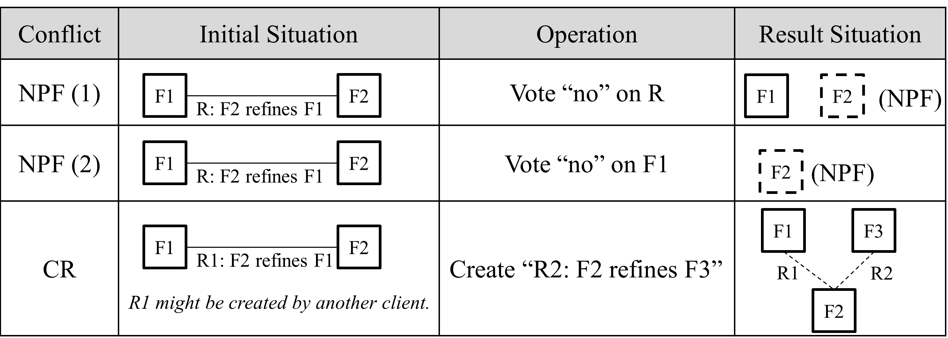
For a NPF, a client should make it a root feature explicitly, or creates a refinement involving it as a child, or reconsiders existing refinements. For CR, a client should vote on them to select only one, or even opposes all and create a new one.

Operation Coordination
As different clients might work on the same requirements set while submitting operations, it is possible that their operations need to be coordinated. According to the operation types (creating or voting) that cause the repository updates, three possible situations to be coordinated are shown in Figure 4.
Duplicate creation happens when a client (C2) creates an element (E) before a previous creation of the same element has become visible to C2 (i.e. update C2’s working view).
Unreachable vote is a vote on a nonexistent element. If client C1’s “no” vote on element E leads to the deletion of E, and if client C2 submits a “yes” vote on E before the deletion becomes visible to him, then C2’s “yes” vote becomes unreachable.
Unreachable propagation is a propagated vote on a nonexistent element. If client C1’s “no” vote on feature F1 leads to the deletion of F1, and if client C2 creates a constraint involving F1 (e.g. F1 requires F2) before the deletion becomes visible to him, then the propagation of “yes” vote on F1 (according to row 1 in Table 1) is unreachable.
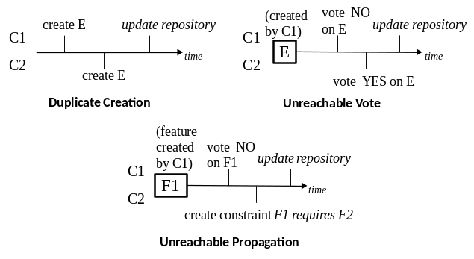
Figure 4. Example Situations to be Coordinated
Coordination of these situations follows a serialized update strategy, that is, all update applies to the elements in the same order of their submission. For duplicate creations, the first creating operation adds a new element to the repository, and the latter is converted to a “yes” vote. For unreachable votes, they are no longer valid on a nonexistent element and are neglected. For unreachable propagations, they are neglected together with the operations which cause the propagations.

The Implementation of CRETE
In this section, we give a brief introduction to a system developed for supporting the CRETE method. We first present an overview of the system, and then discuss some key features of the system in details.
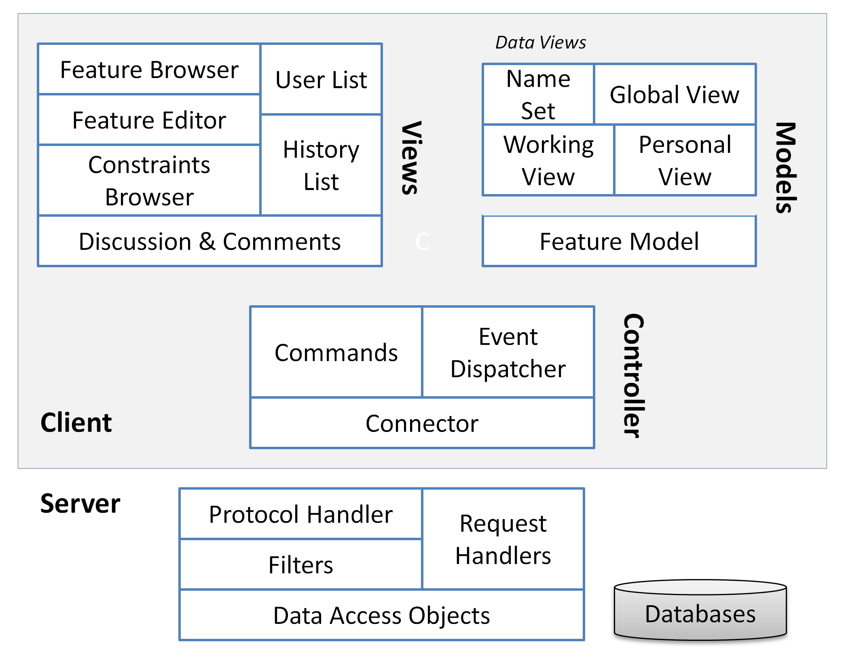
Figure 5. System Architecture (Simplified)

An Overview of the System
Figure 5 gives a simplified version of the system’s architecture. The CRETE system is designed with a typical Client/Server architecture. The client follows the Model-View-Controller design pattern. The views include feature browser, feature editor, constraints browser and other UI elements. The main model is a local work copy of the being constructed feature model; besides, there are various data-views (i.e. data subsets) for the feature model, such as the name set (a set contains existing feature names in the feature model). The controller consists of many commands (handlers of user operations), the event dispatcher and the connector (handles client-server data exchange). The server contains components for protocol handling, data filtering, request handling and database access.

Key Features of the System
The key features of CRETE system can be divided into two categories: production and awareness.
Production refers to the functionalities for constructing, viewing and checking the shared requirements. The clients and vendors can propose new requirements and vote on existing ones. The vote propagation, conflict checking and operation coordination are also implemented to help requirements construction.
Awareness means that collaborative systems should provide necessary information about activities of other people in the shared workspace, which provides the context for individual’s work. Awareness support is essential for improving the usability of collaborative systems [15]. According to Gutwin and Greenberg’s framework of awareness in [15], the CRETE system provides six kinds of awareness information, as Table 3 shows.
Table 3. Awareness information in CRETE
Awareness Information | Purpose (According to [15])
Others’ edit location | Location (Where are they working?)  Presence (Who is participating?)
Controversy | Artifact (What is the state of the objects?)
Conflict | Artifact
My creation | Authorship (Who did that?)
Recently changed features | Action (What are they doing?)
Change History | Action History (What has been done?)
Others’ edit location shows who are working in the system and which feature they are editing now.
Controversy information helps users be aware of controversial features and relationships (i.e. their supporting rate is less than 100 percent).
Conflict information helps users identify existing conflicts that need to be removed.
My creation highlights the features created by current user. When using the CRETE system, we found that the users care about whether their creations are opposed or supported by others, so we decide to highlight such information.
Recently changed features are features with unread recent changes. This information can help users follow the recent progress of the requirements elicitation, especially for the large scale repositories.
Change history shows all changes that have been made on the requirements repository, ordered by time. It helps users track the evolution of the requirements.

An Experiment
We conduct an experiment with five participants acting as four clients and one SaaS vendor, respectively. The scenario we designed for them is to collaboratively eliciting requirements for a SaaS application that supports multiple enterprises to register on it as individual tenant to perform on-line recruiting related activities like position publishing, position applying, interview arranging, etc.
The five participants spend about 3 hours working collaboratively. In the end, all clients confirm the requirements in their private views, and the vendor gets the requested features for the system in his management view. There are totally 113 features proposed for the application, including 30 variant features. Three interesting observations have emerged from this case study:
First, although there’s no rigid process for their work, we have observed that the collaborative work can be roughly divided into two phases; we call them the brainstorming phase and the evaluation phase.
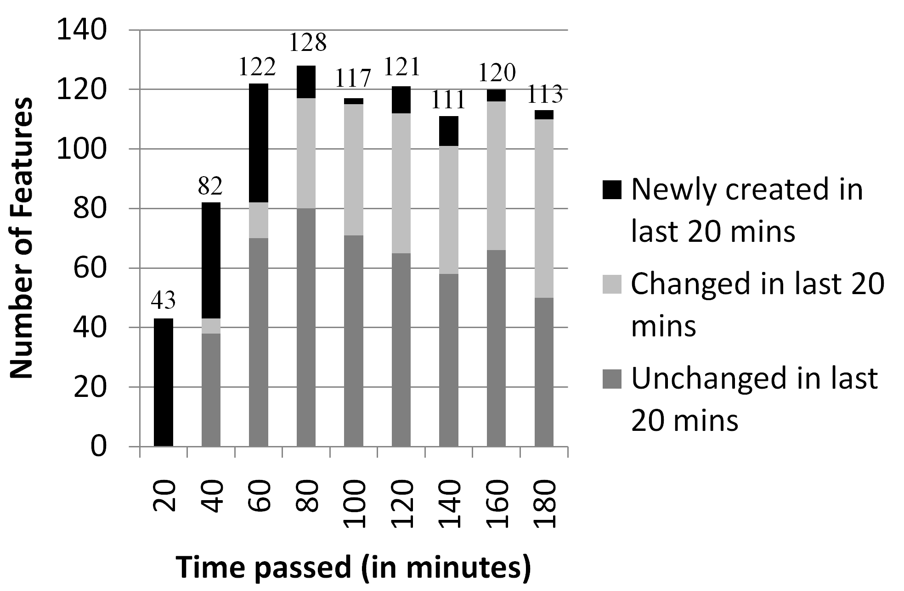
Figure 6. The Change of Features during the Collaboration
The work starts at the brainstorming phase. In this phase, the participants are focusing on proposing requirements as much as possible (i.e. creating new features). The way they prefer is to read an existing feature and try to refine it (create child features for it) or create a related feature. As shown in Figure 6, a large number of initial features are collected over a short period of time (the first hour).
As the requirements repository grows larger, the participants start to focus on evaluating the proposed features. In this evaluation phase, there are fewer creations and more changes of existing features, and the total number of features is changed very slightly. We have observed that participants browse the whole feature model for many times and perform the following activities:
- Remove redundant features. If two features have different names but the same semantics, then one of them is redundant. To remove redundant features, the participants prefer to post a topic in the discussion page, such as “Redundant features of Search for Jobs”, and ask others to vote “no” on redundant features to remove them from the repository.
- Improve unclear features. Some participants are reluctant to carefully describe a feature when they create it, so others cannot understand the feature very well. The situation gets worse when the feature has an improper or vague name. As we observed, participants often post a comment on unclear features to ask for improvement, and some of them even vote no on these features until their creators improve the description and/or name.
- Find missing features. The participants try to find missing features when they are browsing the whole feature model.
- Adjust and create relationships. The participants adjust refinements and create constraints when most of the features can be well understood.
- Confirm requirements. The clients browse each feature and vote “yes” on it if it is a desired feature, no matter whether the feature is proposed by her/him or others.
The second observation is that the efficiency of requirements elicitation is greatly improved. One reason is that the users’ edit locations displayed in CRETE help the participants choose an “idle” part of feature model to edit, which leads to parallel creation at different parts of the feature model. Another reason is that participants are often inspired by others’ work. Table 4 shows the proportion of feature creation and reuse in each client’s private view, which is another evidence for the improvement of efficiency of our requirements elicitation.
Table 4. Features in each client’s private view (CPV)
Client | Number of features in the client’s CPV
Client | Total | Created by the client | Created by others
Client 1 | 91 | 21 (23.1%) | 70 (76.9%)
Client 2 | 87 | 37 (42.5%) | 50 (57.5%)
Client 3 | 94 | 34 (36.2%) | 60 (63.8%)
Client 4 | 104 | 21 (20.2%) | 83 (79.8%)
The thrid observation is that many variants can be observed in the vendor’s management view, as shown in Table 5. It implies that our approach is capable of capturing variant requirements among the clients. The “common structure” emerges by comparing the structure of each client’s private view. We have observed that all conflicting are resolved by the participants finally, and all private views have the similar hierarchical structure except that some of the leaf features are different.
Table 5. Common and variant features in VMV
Total number of features | 113
Number of common features | 83 (73.5%)
Number of features presented in 3 CPVs | 24 (21.2%)
Number of features presented in 2 CPVs | 5 (4.4%)
Number of unique features | 1 (0.9%)
In summary, the results preliminarily demonstrate that our approach is suitable for requirements elicitation of SaaS applications, and the explicit support for collaboration between clients and vendors has very positive influence on the efficiency of elicitation.

Related Work

Feature-oriented Requirements Modeling
Our work in this paper is partly inspired by the research of feature-oriented requirements modeling [7][10][13]. One implicit assumption of these works is that there is an available set of domain experts who possess a comprehensive understanding of the current software product line and thus can discover all the important commonality and variability in the software requirements. However, this assumption is generally not hold in the SaaS circumstance, because of the rapid evolution nature of SaaS applications and the low possibility of getting a suitable set of domain experts for SaaS applications.
Our approach releases the feature-oriented requirements modeling from above assumption by integrating it with explicit collaboration mechanism and encapsulating it as a web-based application. The larger number of geographic-distributed clients can express, share requirements in a collaborative and asynchronous way, and the requirement commonality and variability can be collected via analyzing voting on requirements. Furthermore, we proposes an effective evolution mechanism, that is, clients can continuously express their updated requirements about a SaaS application and the SaaS vendor can always get the latest commonality and variability requirements of a large number of clients.

Collaborative Requirements Engineering
Another important research area related to our work is the research on collaborative requirements engineering. Potts et al. proposed an approach to carry out the requirements elicitation through the iteration of three activities: requirements documentation, discussion and evolution [4]. In CREWS project, the concept of scenario is used to facilitate the conduction of requirements engineering activities in collaborative ways [3]. Decker et al. leveraged wiki to support asynchronous collaborative requirements collecting Error: Reference source not found[2].
All these research works aim to get a suitable set of requirements for only a single customer or organization, and it is almost impossible for them to collect and analyze requirements containing variability requirements from different customers or organizations. While in our approach, a carefully designed voting mechanism is provided to collect requirements from a large number of different customers and to reflect the commonality and variability of those collected requirements, which makes our approach suitable for SaaS applications’ requirements elicitation.

Conclusions
This paper presents a Collaborative Requirement Elicitation Technique (CRETE) to facilitate SaaS vendors on eliciting the commonality and variance of multiple clients’ requirements effectively. In this approach, a center repository is used to record all requirements about the to-be developed SaaS application and all collaboration related information. Based on the information in repository, client’s working view is presented as a client’s workspace while client’s private view is presented for a client to review his proprietary requirement model. SaaS vendor raises initial application requirements and reviews the combined requirements model through management view. A process with relevant conflict resolving and coordination rules is also proposed to guide the collaboration. An experiment is conducted to show the feasibility of CRETE.
In the future, we are going to focus on improving the usability of the CRETE. Especially, how to represent a large number of requirement elements in client’s working view in a well organized way so that clients will not get lost in it.

REFERENCES
- A. Van Lamsweerde, "Requirements Engineering in the Year 00: A Research Perspective," International Conference on Software Engineering, Los Alamitos, California: IEEE Computer Society Press, 2000, pp. 5-19.
- B. Decker, E. Ras, J. Rech, P. Jaubert, and M. Rieth. Wiki-Based Stakeholder Participation in Requirements Engineering. IEEE Software, 2007, 24(2):28-35.
- CREWS Homepage. http://sunsite.informati k.rwth-aachen.de/CREWS/.
- C. Potts, K. Takahashi, A.I. Anton. Inquiry-Based Requirements Analysis. IEEE Software, 1994, 11(2):21-32
- D. Ma, The Business Model of "Software-As-A-Service”. In 2007 IEEE International Conference on Services Computing (SCC 2007), pages: 701–702, July 2007.
- L. Herbert, E. G. Brown, and S. Galvin, “Competing in the fast-growing SaaS market”, Forrester Report, No. 0,5110,44254,00, 2008.
- K. C. Kang, S. Kim, J. Lee, K. Kim, E. Shin, and M. Huh, “FORM: A Feature-Oriented Reuse Method with Domain-Speciﬁc Architecture”, Annals of Software Engineering, vol. 5, pp. 143-168, Sept. 1998
- K. E. Wiegers, Software Requirements, Microsoft Press, 1999.
- K. Zhang, X. Zhang, W. Sun, H.Q. Liang, Y. Huang, L. Zeng and X. Z. Liu, “A Policy-Driven Approach for Software-as-Services Customization”, IEEE Computer Society, CEC-EEE, 2007, pp.1-8.
- P. Clements, and L. Northrop, “Software Product Lines: Practices and Patterns”, Addison-Wesley Professional, 2001
- R. Mietzner, A. Metzger, F. Leymann, K. Pohl, “Variability modeling to support customization and deployment of multi-tenant-aware Software as a Service applications”, 2009 ICSE Workshop on Principles of Engineering Service Oriented Systems, pages: 18-25.
- W. Sun, X. Zhang, C. Guo, P. Sun, and H. Su, “Software as a Service: Configuration and Customization Perspectives”. SERVICES-2. IEEE, 2008, pages: 18–25.
- W. Zhang, H. Mei, H. Zhao, “A feature-oriented approach to modeling requirements dependencies,” in Proc. of the 13th IEEE Intl. Conf. on Requirements Engineering (RE 05), 2005, pp. 273–282
- Y. Shi, S. Luan, Q. Li, H. Wang, “A Multi-tenant Oriented Business Process Customization System”, 2009 International Conference on New Trends in Information and Service Science, Beijing, China, 2009.
- C. Gutwin, S. Greenberg A descriptive framework of workspace awareness for real-time groupware. Computer Supported Cooperative Work. 11, 3, 2002, 411-446.

