A Collaborative Requirement Elicitation Technique for SaaS Applications
Xin Zhou¹, Li Yi2, Wei Zhang2, Haiyan Zhao2, Ying Liu1
1 IBM Research - China
Diamond Building,Zhong Guan Cun Software Park,#8, Western Dong-Bei-Wang Road,Beijing 100193, P.R.China
{zhouxin, aliceliu}@cn.ibm.com

2 Institute of Software School of EECS, Peking University, Beijing, China
100193, P.R.China
{yili07, zhangw, zhaohy}@sei.pku.edu.cn
Abstract. Software as a Service (SaaS) provides a web based software delivery model to serve a large number of clients with one single application instance . One of the essential problems to SaaS application development is about how to elicit the commonality and variance of multiple clients’ requirements effectively. This paper presents a collaborative requirement elicitation technique (CRETE), which keeps each potential client of a SaaS application aware of the requirements raised by others clients or the SaaS vendor and allows a client to vote on existing requirements or raise new requirements. With CRETE, individual client can create and evolve his personal requirements model, while the SaaS vendor can automatically get a combined requirements model that reflects all clients’ common and variant requirements. The SaaS vendor then can develop a SaaS application according to the combined requirements model, so that individual client’s requirements can be satisfied by self serve configuration without changing the source code of the SaaS application.
Keywords: SaaS, requirement elicitation, feature model, collaboration
1 Introduction
Software as a Service (SaaS) provides a web based software delivery model to serve a large number of clients with one single application instance, which has gotten rapidly growing acceptance by software vendors [2]‎. IDC estimates that the worldwide revenue associated with SaaS reached $3.98 billion in 2006 and is expected to reach $14.5 billion in 2011, representing a compound annual growth rate of 30% ‎[3]. Unlike clients of traditional software application, SaaS application clients need neither deploy a software application nor maintain it. They subscribe to a SaaS application and access the application functions at any time and from anywhere with a web browser ‎[4]. For example, Salesforce.com builds and maintains the Customer Relationship Management (CRM) application on its own infrastructure and more than 69,000 subscribed clients are using this application over web.
In contrast to the benefits brought to SaaS clients, challenges are encountered by SaaS vendors as they have to serve all clients simultaneously with one application instance. On one hand, SaaS vendors wish to attract significant number of clients for a SaaS application to exploit the economies of scale. On the other hand, they have to deal with the variant requirements raised by clients. Offering an application with standardized functionalities to all clients is an idealized state. In reality, each client might present variant requirements on the application due to their unique business and/or operational needs. As all clients are served by one application instance, to deal with variant requirements, SaaS vendors should provide an application with all functionalities and offer clients with configuration and/or customization capabilities to tailor the whole application to a unique one as wanted ‎[5]. Configuration allows to changing application functionalities within pre-defined scope without changing the source code. Customization involves changing the application source code for a specific client to meet his unique requirements and the customization code should always being maintained client by client. If clients’ variable requirements can be clearly identified and well dealt with at SaaS application development time, configuration can be easily done at SaaS runtime to meet each client’s unique requirements. For those unique requirements not considered at SaaS development time, configuration doesn’t work and only customization can be performed with significant complexity and cost.
There are many literatures reporting research works on SaaS application configuration and customization. Reference ‎[5] describes how variability modeling techniques from software product line engineering can support SaaS vendors in managing the variability of SaaS application requirements. It also demonstrates how variability models could be used to guide the deployment of a SaaS application for new clients based on systematical analysis on the deployment information for existing clients. Reference ‎[6] introduces a competency model that divides SaaS configuration and customization competency into 5 levels: Entry, Aware, Capable, Mature, and World Class. It also presents a methodology framework to facilitate SaaS vendors on planning and executing configuration strategy. Reference [7] proposes a flexible multi-tenant oriented business process customization system, to resolve the problem caused by implying SaaS model base on BPEL. Reference [8] proposes a SaaS-oriented service customization approach. The approach allows service vendors to publish customization policies along with services. If tenant’s customization requirement is in agreement with policy after being verified, vendors will update service accordingly.
However, little work is reported on the elicitation of variant requirements for a SaaS application, which is fundamental to SaaS configuration and customization. Without well elicited and organized common and/or variant requirements from potential clients, it’s difficult to pre-define enough and appropriate configuration capability for a SaaS application at development time ‎[6]. As a result, a client’s unique requirements might not be satisfied as it is beyond the pre-defined configuration capability and customization is not affordable. Existing traditional requirement elicitation methods, like [219][10][11], are incapable of dealing with at least one of the new challenges in SaaS era. The SaaS clients are separate, and its volume is usually larger than ever before. It’s hard to collect their requirements and even harder to identify the commonality and variability among their requirements.
In this paper, we propose a Collaborative Requirement Elicitation Technique (CRETE) for SaaS application development. The basic idea is to keep each potential client of a SaaS application aware of the requirements raised by others and allow them to raise new requirements or vote on existing requirements. To facilitate the collaboration among different clients, CRETE employs features as the basic units of requirements, and use feature models to organize a set of features. The concepts of features and feature models are widely used in software product lines to encapsulate and organize a large set of common and variant requirements [12]. A feature is a characteristic of software with sufficient client value and it essentially denotes a cohesive set of individual requirements. A feature model organizes a set of related features into hierarchical structures and thereby provides a way to understand each feature and its context. With CRETE, individual client can create and evolve his personal feature model, while the SaaS vendor can automatically get a combined feature model that reflects all clients’ common and variant requirements.
The remaining part of this paper is organized as follows. Section 2 presents the concept framework of CRETE. The requirement elicitation process is illustrated in Section 3. Section 4 introduces the experiment conducted to validate the feasibility of CRETE. Section 5 introduces some related works. Section 6 concludes the paper and discusses future works.
2 CRETE Conceptual Framework
2.1 Overview
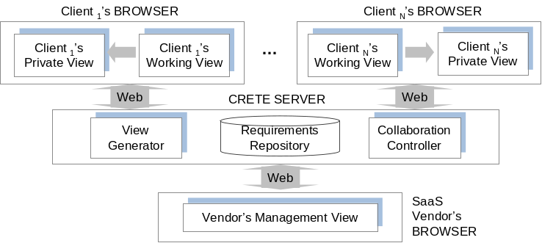
Fig. 1. CRETE Usage Scenario
The purpose of CRETE is to facilitate the vendor and potential clients on collaboratively presenting, verifying and refining a SaaS application’s requirements via web. In collaboration, the SaaS vendor can raise an initial set of features and then inform the potential clients to verify those features by voting “yes” or “no” on them. Also, each client can present their personal requirements on the application by creating new features into the CRETE environment, which further triggers other clients to vote “yes” or “no” on these newly-added features. A typical usage scenario for CRETE is shown in ‎Fig.1.

In this typical usage scenario, clients log on to CRETE server with browser individually. Physically, a client might be a single person or an enterprise consisting of multiple persons. To make the scenario focus on illustrating how clients collaboratively present requirements, we assume there is a representative person from each enterprise client who can present requirements on behalf of all stakeholders from this client. So, we won’t further differentiate roles within an enterprise client and the collaboration among the roles within a client will be excluded from this usage scenario. Similarly, we regard SaaS vendor logging on the CRETE server as a single person for reasonable simplification.
After logging on to the CRETE server, a client reviews existing requirements on the to-be developed SaaS application in his working view. For the purpose of privacy protection, the client will see the content of existing requirements but won’t know exactly who else ever presented the requirements. We suggest a client reviewing and voting on existing requirements before presenting new requirements. A client can reuse some of those existing requirements by voting “yes” on relevant elements. Or, the client can vote “no” on relevant elements if it doesn’t align with his requirements. With this approach, the commonality and variability among multiple clients’ requirements are identified gradually and implicitly, which significantly saves SaaS vendor’s effort. Besides reviewing and voting on existing requirements, a client can also input new requirements in the format of feature model.‎ The client might input a feature that describes a valuable software characteristic, input refinement and/or constraint relationships among features. In the private view, a client can review all requirements he regarded as necessary for the to-be developed SaaS application. The requirements might either be reused from others or be presented by himself. He also needs to resolve the conflict existing in the private view promptly to make it always be consistent.
In this scenario, A SaaS vendor can use his management view to propose some initial requirements for a to-be developed application. With these initial requirements, clients can vote on them and be inspired to propose new requirements. Meanwhile, the SaaS vendor can review all requirements about the application. In this view, he is presented with the creator, the supports, and the dissenters of each requirement. He can understand which requirements are required by all or most of the clients while which requirements are required by a minority of clients. Also, he can attach the requirement relationships on the management view from application development perspective. Finally, the vendor can make requirement prioritization based on the information in his management view.
2.2 CRETE Requirement Repository
CRETE requirement repository stores not only all requirements presented by every clients, but also collaboration-related information (for example, the creation or voting actions a client performs on a requirement). As mentioned in 2.1, we leverage feature model to represent requirements. The collaboration related information is attached based on the feature model. Fig.2 shows the repository’s major structure.
Data in the repository that represents a SaaS application’s requirements includes “feature”, “refinement”, and “constraint”. Also, the creator of those requirement elements is recorded in the repository. We consider two kinds of inter-feature relationships. The refinement relationships organize features with different levels of abstraction or granularities into a hierarchical structure. A refinement relationship between two features represents that the child feature is refinement of the parent feature. If a feature is selected, its mandatory children features must be selected as well, while its optional children can either be removed or selected. The constraint relationships describe dependencies between features. For the sake of simplicity, we consider only two basic kinds of constraints in this paper: requires and excludes. Given two features A and B, A requires B means that if A is selected, B must be selected as well. A excludes B means that at most one of them can be selected at the same time. These two kinds of constraints are created by SaaS vendor when proposing the initial requirements for the application. While a client is picking some elements from the initial requirements by voting “yes”, above constraints will be checked to make sure the client’s selection is complete and consistent. For example, suppose SaaS vendor creates a constraint “feature A requires feature B”, if a client votes “yes” to A, he should also vote “yes” to feature B. Similarly, suppose SaaS vendor creates a constraint “feature A excludes feature B”, if a client votes “yes” to A, he should not also vote “yes” to feature B.
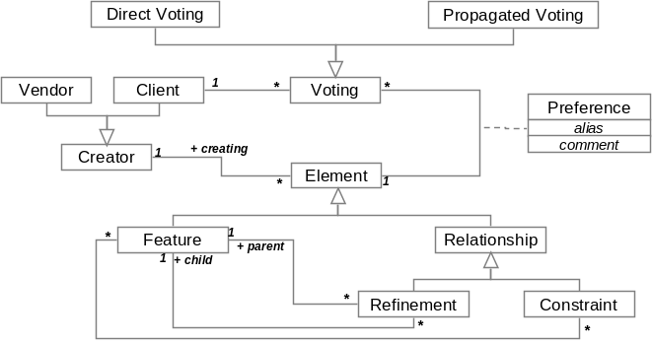
Fig. 2. Major Structure of CRETE Requirement Repository
Data in the repository that represents the collaborative requirement modeling information includes “direct voting”, “propagated voting” and “preference”. A client can apply two basic actions to a requirement element (feature or relationship). That is, a client can either create a new element or directly vote on an existing one. The voting types include: “yes”, “no”. If a client votes “yes” on an existing element, it implies that he wish to include this element in his requirement model. We allow the client to set his preference on this element, include the element’s alias, comment to this element’s original name or description, etc. If a client votes “no” on an existing element, it implies that he wish to exclude this element from his requirement model. Besides, propagated voting can be automatically applied on an element as a consequence of a directly voting initiated by a client. For example, if there is a direct voting “yes” applied to a refinement relationship, there will be a corresponding propagated voting “yes” to the two features involved in this relationship.
2.3 Client’s Views
Each client works with two views during the process of collaborative requirement elicitation. One is client’s working view and the other is client’s private view.
Client’s working view (CWV) is a client’s main workspace to build requirement model for a SaaS application. In the CWV, a client can create requirements and echo existing requirements presented by the SaaS vendor or other clients. The entities in the CWV are extracted from the CRETE requirement repository according to the view generation rule1, which includes all “feature” and “refinement” elements that the clients hasn’t vote “no”. According to the definition of feature model, constraint like “requires” or “excludes” is valid at product line level instead of application level. So it’s appropriate to have SaaS vendor instead of individual SaaS client review and operate on “constraint” elements. In CWV, elements with type of “constraint” will not be presented for clients to voting. They will only be used at the backend to check the validity of a client’s voting.
View generation rule1:
CWV (Application s, Client c) =
{Element e | ( e.Application == s ) ∧
( e.Type != “constraint” ) ∧
(! ∃v∈Voting, v.Type==“no”∧ v.Client==c ∧ v.Element == e) }
Client’s private view (CPV) is to represent a client’s proprietary perspective on the requirements on the SaaS application. The entities in the CPV are extracted from the CRETE requirement repository according to the view generation rule2, which includes all “feature” and “refinement” elements that the client has voted “yes” (For an element created by the client, CRETE will automatically add a “yes” voting to the element for this client).
View generation rule2:
CPV (Application s, Client c) =
{Element e | ( e.Application == s ) ∧
( ∃a ∈ Creating, a.Client == c ∧ a.Element == e ) ∧
(∃a ∈ Voting, a.Type == “yes” ∧ a.Client == c ∧ a.Element == e ) }
2.4 SaaS Vendor’s Views
The SaaS vendor works with his management view (VMV) during the process of collaborative requirement elicitation. In VMV, the vendor can create some initial requirements for a to-be developed application, with which clients can vote on them or be inspired to propose new requirement. Also, the vendor can review all the requirements about an application. The entities in the VMV are extracted from the CRETE requirement repository according to the view generation rule3. If an element is voted “no” by all clients, it will be excluded from VMV.
View generation rule3:
VMV (Application s) =
{Element e | ( e.Application == s )
( (! ∃v∈Voting, v.Type==“yes”∧ v.Element == e)∨(e.Creator == this vendor))}
Besides the entities, the vendor is presented with the creator, the supports, and the dissenters of each entity. Then, he can understand which requirements are required by which clients. Also, he can attach the requirement relationships on the management view from application development perspective. For example, the “excludes” constraint can be added between two features to indicate their conflict due to development considerations. With the information in VMV, the vendor can make requirement prioritization finally.
2.5 Requirements Construction Operations
CRETE provides two basic operations for a client to construct his requirements. One is creating and the other is voting.
Creating is to add new elements to the requirements model. The restrictions on creation fall into three categories. The first category of restrictions is to avoid duplicate requirement elements in the CRETE repository. Name is used as the unique identity for a feature element, and the unique identity for a relationship is the features at its both ends. The second category of restrictions is to avoid the conflict between the created relationship and the ones already in this client’s private view. For example, if there has been a relationship “feature A refines feature B” in the client’s private view, it’s forbidden to create a relationship like “feature A refines feature C”. The third category of restrictions is to avoid conflict between the created relationship and the ones created by SaaS vendor.

Voting is to allow a client expressing their viewpoints on requirements presented by SaaS vendor or other clients. He gives a “yes” voting to a requirement element means that he feels it is also his requirement. Meanwhile, he can attach his preference about this element to the voting, such as the element’s alias and the comment to the element. He gives a “no” voting to a requirement element means that he feels it is not his requirement. Then it will be excluded from his private view.
Having a client vote to all requirement elements created by others takes too many efforts. CRETE will automatically generate voting to some requirement elements according to his direct voting on other related requirement elements. Table 1 lists the propagation rules that CRETE follows to automatically propagate voting:
Table 1. Voting propagation rules
ID |  | Rules
PR-1 |  | Vote “yes” on Refinement r -> Vote “yes” on Feature f, f is involved in r
PR-2 |  | Vote “no” on Feature f -> Vote “no” on Refinement r, f is involved in r
PR-3 |  | If there is a “f1 excludes f2” constraint, Vote “yes” on f1 -> Vote “no” on Refinement f2, Vote “yes” on f2 -> Vote “no” on Refinement f1
PR-4 |  | If there is a “f1 requires f2” constraint, Vote “yes” on f1 -> Vote “yes” on Refinement f2
For SaaS vendor, only creating operation is provided for him to propose initial requirements for clients’ reference. The restrictions on a vendor’s creating operation also fall into two categories. The first category of restrictions is to avoid duplicate requirement elements in the CRETE repository, which is the same as that for client. The second category of restrictions is to avoid the conflict between the created elements and the relationships already in the repository. For example, if there has been a constraint “feature A excludes feature B” and a constraint “feature A requires feature C” in the repository, it’s forbidden to create a relationship like “feature C requires feature B”.
3. Collaborative Requirement Construction Process
3.1 Process Overview
There are two kinds of activities during the collaborative requirement construction, namely human activities that performed by clients and system activities that performed automatically by the system according to predefined rules.
Table 3. Requirement construction activities
Activity | Description
Human Activities
Submit Operation | Submit creating and voting operations.
Resolve Conflicts | Resolve conflicts in the working view.
System Activities
Propagate Votes | Propagate votes after operations are submitted.
Coordinate Operations | Coordinate the operations submitted by clients, then store the actor and content of each valid operation.
Update Views | Update private views and working views for clients and update global view for SaaS vendor.
Fig.3 shows the collaboration process for constructing a SaaS application’s requirements model. Following steps are gone through iteratively:

Update Views: When the information in the requirement repository changes due to operation submission or propagated voting, client and vendor’s views can be automatically updated. Particularly, updating the client’s working view involves conflict detection. Sometimes, views are not updated immediately to avoid that clients and the vendor are bothered by too frequent refreshing.
Resolve Conflicts: When a client’s working view is updated or he submits an operation, he should first focus on the conflicts brought to the view and resolve them using creating and/or voting operations. Conflict resolving will be elaborated in Section 3.2.
Submitting Operations: In addition to conflict resolution, a client constructs his requirements by submitting operations. He creates a requirement totally new by submitting creating operation and adds a requirement already presented by others by submitting “yes” voting operation. To remove those requirements already presented by others from his working view, a client should submit “no” voting. For SaaS vendor, he can create initial requirements model for clients’ reference or add relationship to his management view by submitting creating operations.

Propagate Votes: Propagated votes are computed according to rule PR-1, PR-2 , PR-3 and PR-4 after an operation was submitted.
Coordinate Operations: In the context of collaborative work, changes submitted by multiple clients need to be coordinated. After the coordination, if the original changes are still valid, they are stored in the CRETE requirement repository and in turn, cause the update of views of all clients; otherwise the changes are neglected and its submitter will be informed. Operation coordination will be elaborated in Section 3.3.
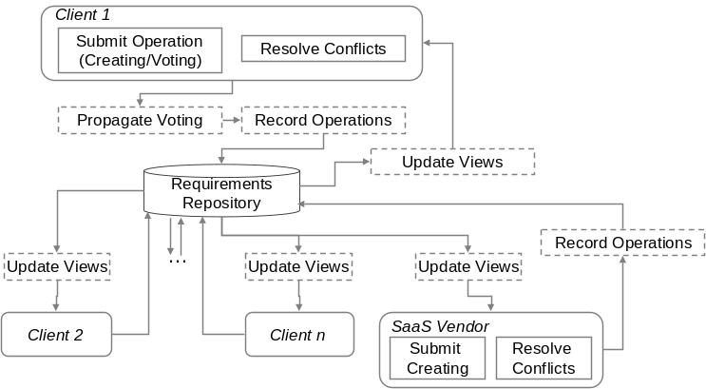
Fig. 3. Requirement Construction Process
3.2 Conflict Resolution
Conflicts might exist in a client’s working view as the requirement elements presented in it are from multiple clients. Meanwhile, a client’s operations also bring conflicts to his working view. To generate a consistent private requirement model, a client should start from resolving the conflict via voting. Fig.4 illustrates the potential conflicts in a client’s working view.
Non-positioned Feature (NPF): the client has denied all existing positions of a feature without giving a new one. (A feature must either be positioned as a root feature, or as a child of another feature.)
Conflicting Refinements (CR): multiple refinements existing in a working view are considered conflicting if they involve the same feature as the child but different features as the parent.

For a non-positioned feature, a client should create a refinement involving it as a child, or make it a root feature explicitly, or reconsider existing refinements. For conflicting refinements, a client should vote on them to select only one, or even denies all and create a new one. For conflicting constraints, a client should vote “no” on some of them until the conflict has resolved, or even denies all.
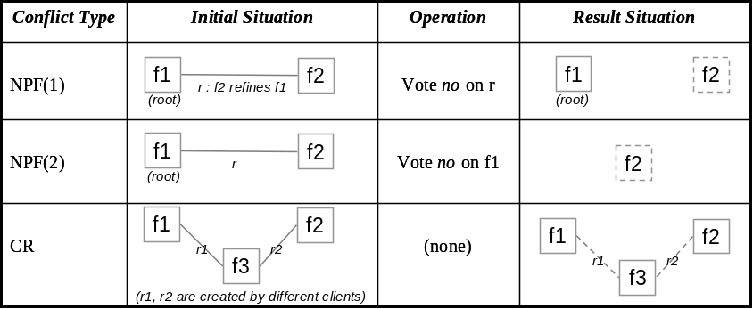
Fig. 4. Conflicts to be resolved

The conflicts in a working view actually define the minimal amount of work that a client must do to obtain a usable feature model that conforms to traditional feature models. For example, a newly joined client only needs to resolve conflicting refinements to transform his working view into a proprietary consistent requirement model. In addition, there is a bonus for him: aliases and comments of features contributed by different clients can help him deepen the understanding of the requirement he wants to include in his requirement model.
3.3 Operation Coordination
As different clients might work on the same requirements set while submitting operations, it is possible that their operations need to be coordinated. The need for coordination is rooted in the working view update delay problem: updates in the requirement repository caused by one client’s operation cannot immediately be visible to others. According to the operation types (creating or voting) that cause the repository updates, there are three possible situations to be coordinated, as illustrated in Fig.5 .
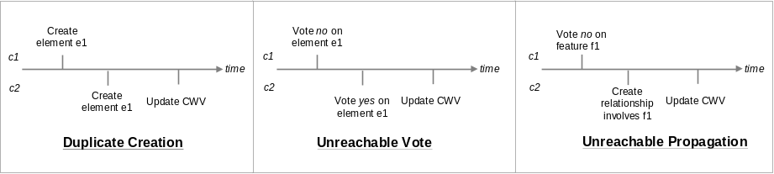
Fig. 5. Situations to be coordinated
Duplicate creation happens when a client (c2) creates an element e1 before a previous creation of the same element has became visible (i.e. update c2’s working view) to him. Therefore the creation of the same element happens twice.
Unreachable vote is a vote on a nonexistent element. As shown in Fig.5, if c1’s “no” vote on element e1 leads to the deletion of e1, and if c2 submits a “yes” vote on e1 before the deletion becomes visible to him, then c2’s “yes” vote is unreachable.
Unreachable propagation is similar to unreachable votes. In Fig.5, if c1’s “no” vote on feature f1 leads to the deletion of f1, and if c2 creates a constraint involving f1 before the deletion becomes visible to him, then the propagation of “yes” vote on f1 (according to the rule PR-1) is unreachable.
Coordination of these situations follows a serialized update strategy, that is, all update applies to the elements in the same order of their submission. Furthermore, if the update being applied is no longer valid, it fails and takes no effect, and its submitter will be informed the failure. For duplicate creations, the first creating operation adds a new element to the repository, and the latter is converted to a “yes” vote. In Fig.5, c1 will create the element e1, and c2 will be prompted to give a “yes” vote on e1. For unreachable votes, they are no longer valid on a nonexistent element and are neglected. In Fig.5, the element e1 will be deleted, and c2 will be notified that his “yes” voting on e1 is invalid. For unreachable propagations, they are neglected together with the operations which cause the propagations. In Fig.5, the feature f1 will be deleted, and c2 will be notified that his operation for creating constraint that involves f1 is invalid.

4. An Experiment
In order to investigate CRETE’s feasibility, we conduct an experiment with five participants acting as clients (four) and SaaS vendor (one). The scenario we designed for them is to collaboratively eliciting requirements for an on-line recruiting management system. This web-delivered system is a SaaS application that supports multiple enterprises to register on it as individual tenant to perform the on-line recruiting related activities like position publishing, position applying, interview arranging, offer issuing, etc.
To facilitate the experiment, we develop a tool that implements all essential aspects of CRETE, including automatic generation of client and vendor views, support of creating and voting on features, and organizing features with refinement relationships. The five participants spend several hours working simultaneously in the first day, and spend a couple of hours working freely (at any time they like, and often at different time) in the next two days. In the end, all clients confirm the requirements in their private views, and the vendor gets the requested features for the system in his management view. There are totally 113 features proposed for the application, including 30 variant features. Two interesting observations have emerged from this case study:
One observation is that the efficiency of requirements elicitation is greatly improved. The reason is that participants are often inspired by others’ work. All participants have said that “by looking at what is being created by the others, I can find those requirements I also want to raise or be inspired to think of a related requirement immediately.” For example, just a few seconds after a client proposing Browse Company Info, two features – Search Company and Publish Company Info – are created by another client. Furthermore, some participants have said that “although I have to understand others’ work, it is somehow easier to review an existing element than to consider and create a new one, therefore my efficiency is improved.” Table 3 shows the proportion of feature creation and reuse in each client’s private view, which is another evidence for the improvement of efficiency of our requirements elicitation.
Table 3. Features in each client’s private view (CPV)
Client | Total number of features in CPV | Number of features in CPV that are created by the client | Number of features in CPV that are created by others (voted “yes” by the client)
Client 1 | 91 | 21 (23.1%) | 70 (76.9%)
Client 2 | 87 | 37 (42.5%) | 50 (57.5%)
Client 3 | 94 | 34 (36.2%) | 60 (63.8%)
Client 4 | 104 | 21 (20.2%) | 83 (79.8%)

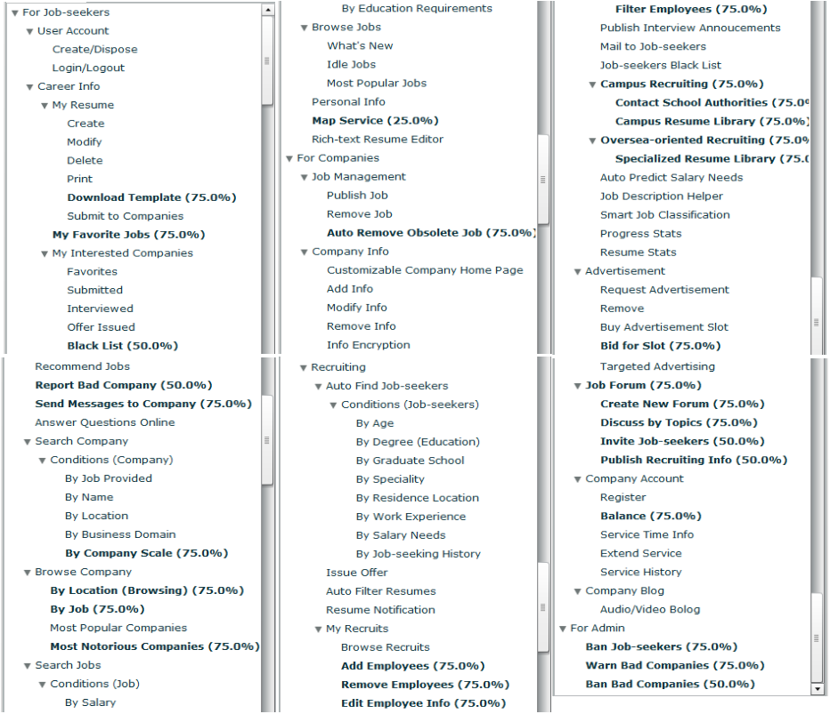
Fig. 5. The result of vendor’s management view (variant features are bolded)
The other observation is that the result of elicitation matches the characteristic of SaaS applications very well, i.e. many variants in a common structure. The “many variants” can be observed in the vendor’s management view (Figure 5 and Table 4), which shows that our approach is capable of capturing variant requirements among the clients. The “common structure” emerges by comparing the structure of each client’s private view. We have observed that at the end of elicitation, all conflicting refinement relationships are resolved by the participants, therefore all private views have the same hierarchical structure – the only difference is some of the leaf features.
Table 4. Common and variant features in the vendor’s management view (VMV)
Total number of features | Number of common features (presented in all 4 CPVs) | Number of features presented in 3 CPVs | Number of features presented in 2 CPVs | Number of unique features (presented in only 1 CPV)
113 | 83 (73.5%) | 24 (21.2%) | 5 (4.4%) | 1 (0.9%)
The results show that our approach, especially the use of feature models for expressing and organizing requirements, is suitable for requirements elicitation of SaaS applications, and the explicit support for collaboration between clients and vendors has very positive influence on the efficiency of elicitation.
5. Related Works
5.1 feature-oriented requirements modeling
Our work in this paper is partly inspired by the research of feature-oriented requirements modeling [13][114][2515][16], which is an important technique to capture the commonality and variability of software requirements in software product lines. The basic idea of feature-oriented requirements modeling is to partition software requirements into a set of features and explicitly identify the constraints among features (such a modeling artifact is call a feature model), thereby to increase the customizability and improve the reusability of software requirements. One implicit assumption of feature-oriented requirements modeling is that there is an available set of domain experts who possess a comprehensive understanding of the current software product line and thus can discover all the important commonality and variability in the software requirements. However, this assumption is generally not hold in the SaaS circumstance, because of the rapid evolution nature of SaaS applications and the low possibility of getting a suitable set of domain experts for SaaS applications, and thus it is impractical to apply the feature-oriented requirements modeling technique to SaaS applications’ requirements elicitation directly.
One improvement of our work in this paper is that it releases the feature-oriented requirements modeling technique from the above assumption, by integrating it with explicit collaboration mechanism and encapsulating it as a web-based application, so that the larger number of geographic-distributed uses/clients can express and share their requirements with each others in a collaborative and asynchronous way, and the SaaS vendor can collect adequate commonality and variability of a SaaS application’s requirements. Furthermore, our work in this paper also enhances the traditional feature-oriented requirements modeling technique with an effective evolution mechanism, that is, users/clients can continuously express their updated requirements about a SaaS application and the SaaS vendor can always get the latest commonality and variability requirements of a large number of users/clients.
5.2 collaborative requirements engineering
Another important research area related to our work is the research on collaborative requirements engineering. The idea of collaborative requirements elicitation can be traced to the Inquiry Cycle Model (ICM) 2727[2717] proposed by Potts et al. in 1994, in which, the requirements elicitation is carried out through the iteration of three activities: requirements documentation, discussion and evolution. In this method, the collaboration among stakeholders uses the traditional meeting-based synchronous mechanism, and no tool support is provided to facilitate or manage the collaboration among stakeholders. After that, a notable research work in this area is the CREWS 21[9] project, which collects a set of researchers from several European countries, and focuses on the problem of how to use the concept of scenario to facilitate the conduction of requirements engineering activities in collaborative ways. As the ICM method, the collaboration technique used in CREWS is still the traditional meeting-based mechanism. More recently, Decker et al. [18] proposed a Wiki-based approach to asynchronous collaborative requirements engineering. This approach utilize collaboration mechanisms provide by the Wiki platform to facilitate collaboration among stakeholders, and more particularly, to facilitate stakeholders’ collaborative editing on a set of use cases contained in a set of web pages. Comparing to the above research work, our work in this paper possess a distinguish characteristic. That is, all the above research work aims to get a suitable set of requirements for only a single customer or organization, and it is almost impossible for them to collect and analyze requirements containing variability requirements from different customers or organizations, while in our approach, a carefully designed collaboration mechanism is provided to collect requirements from a large number of different customers and to reflect the commonality and variability of those collected requirements. Such a characteristic makes our approach and tool more suitable for SaaS applications’ requirements elicitation.
6. Conclusions
This paper presents a Collaborative Requirement Elicitation Technique (CRETE) to facilitate SaaS vendors on eliciting the commonality and variance of multiple clients’ requirements effectively. In this approach, a center repository is used to record all requirements about the to-be developed SaaS application and all collaboration related information, namely the clients and vendor’s operations. Based on the information in repository, client’s working view is presented as a client’s workspace while client’s private view is presented for a client to review his prioritary requirement model. SaaS vendor raises initial application requirements and review the combined requirements model through management view. A process with relevant conflict resolving and coordination rules is also proposed to guide the collaboration. An experiment is conducted to show the feasibility of CRETE.
In the future, we are going to focus on improving the usability of the CRETE. For example, how to present a large number of requirement elements in client’s working view in a well organized way so that clients will not get lost in it.
References
- blank
- L. Herbert, E. G. Brown, and S. Galvin, “Competing in the fast-growing SaaS market”, Forrester Report, No. 0,5110,44254,00, 2008.
- E. TenWolde, “Worldwide software on demand 2007-2011 forecast: A preliminary look at delivery model performance”, IDC Report, No. 206240, 2007.
- Ma, D, The Business Model of "Software-As-A-Service”. In 2007 IEEE International Conference on Services Computing (SCC 2007), pages: 701–702, July 2007.
- Ralph Mietzner, Andreas Metzger, Frank Leymann, Klaus Pohl, “Variability modeling to support customization and deployment of multi-tenant-aware Software as a Service applications”, in Proceedings of the 2009 ICSE Workshop on Principles of Engineering Service Oriented Systems, pages: 18-25.
- Sun, W., Zhang, X., Guo, C., Sun, P., and Su, H. “Software as a Service: Configuration and Customization Perspectives”. SERVICES-2. IEEE, 2008, pages: 18–25.
- Yuliang Shi, Shuai Luan, Qingzhong Li, Haiyang Wang, “A Multi-tenant Oriented Business Process Customization System”, 2009 International Conference on New Trends in Information and Service Science, Beijing, China, 2009.
- Z. Kuo, “A Policy-Driven Approach for Software-as-Services Customization”, IEEE Computer Society, CEC-EEE, 2007, pp.1-8.
- CREWS Homepage. http://sunsite.informati k.rwth-aachen.de/CREWS/.
- to be added
- to be added
- Hong Mei, Wei Zhang, and Fang Gu, “A Feature Oriented Approach to Modeling and Reusing Requirements of Software Product Lines”, 27th International Computer Software and Applications Conference (COMPSAC’03), Dallas, TX, USA, pp.250-256, 2003.
- Kyo C. Kang, Sajoong Kim, Jaejoon Lee, Kijoo Kim, Euiseob Shin, and Moonhang Huh, “FORM: A Feature-Oriented Reuse Method with Domain-Speciﬁc Architecture”, Annals of Software Engineering, vol. 5, pp. 143-168, Sept. 1998
- W. Zhang, H. Mei, H. Zhao, “A feature-oriented approach to modeling requirements dependencies,” in Proc. of the 13th IEEE Intl. Conf. on Requirments Engineering (RE 05), 2005, pp. 273–282
- P. Clements, and L. Northrop, “Software Product Lines: Practices and Patterns”, Addison-Wesley Professional, 2001
- Kyo C. Kang, Sholom G. Cohen, James A. Hess, William E. Novak, and A. Spencer Peterson, Feature-Oriented Domain Analysis Feasibility Study, Technical Report(SEI-90-TR-21), Software Engineering Institute, Carnegie Mellon University, Nov. 1990.
- C. Potts, K. Takahashi, A.I. Anton. Inquiry-Based Requirements Analysis. IEEE Software, 1994, 11(2):21-32
- B. Decker, E. Ras, J. Rech, P. Jaubert, and M. Rieth. Wiki-Based Stakeholder Participation in Requirements Engineering. IEEE Software, 2007, 24(2):28-35
- .

