**Táblák létrehozása:**

create table tulajdonos (tkod int(3) primary key, nev varchar(20) not null, varos varchar(20));

create table auto (rendszam char(7) primary key, tipus varchar(25) not null, szin varchar(15), kor int(2), ar int(8), tulaj int(3), foreign key (tulaj) references tulajdonos (tkod));

DESCRIBE tulajdonos;

+-------+-------------+------+-----+---------+-------+

| Field | Type | Null | Key | Default | Extra |

+-------+-------------+------+-----+---------+-------+

| tkod | int(11) | NO | PRI | NULL | |

| nev | varchar(20) | NO | | NULL | |

| varos | varchar(20) | YES | | NULL | |

+-------+-------------+------+-----+---------+-------+

DESCRIBE auto;

+----------+-------------+------+-----+---------+-------+

| Field | Type | Null | Key | Default | Extra |

+----------+-------------+------+-----+---------+-------+

| rendszam | char(7) | NO | PRI | NULL | |

| tipus | varchar(25) | NO | | NULL | |

| szin | varchar(15) | YES | | NULL | |

| kor | int(2) | YES | | NULL | |

| ar | int(8) | YES | | NULL | |

| tulaj | int(3) | YES | MUL | NULL | |

+----------+-------------+------+-----+---------+-------+

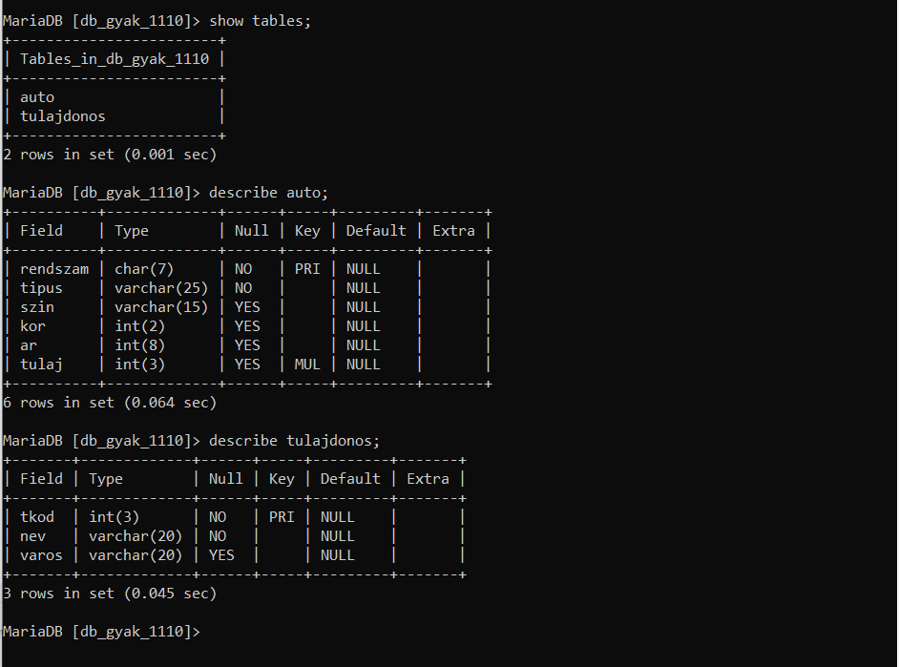

**Táblák feltöltése:**

insert into tulajdonos values (101, 'Kis János', 'Miskolc');

insert into tulajdonos values (102, 'Kis Éva', 'Szerencs');

insert into tulajdonos values (103, 'Retek Ödön', 'Miskolc');

insert into tulajdonos values (104, 'Virág Zoltán', 'Nyék');

insert into tulajdonos values (105, 'Nagy Eszter', 'Nyék');

insert into tulajdonos values (106, 'Kovács Magor', 'Szerencs');

insert into tulajdonos values (107, 'Asztal Antal', 'Miskolc');

Insert INTO Auto values('FER-831', 'Opel Corsa', 'Piros', 18, 390, 101);

Insert INTO auto values('IXJ-239', 'Suzuki Swift', 'Zöld', 15, 450, 105);

Insert INTO auto values('JAH-425', 'Skoda Fabia', 'Piros', 13, 620, 102);

Insert INTO auto values('MLM-211', 'Toyota Yaris', 'Fehér', 3, 1850, 105);

Insert INTO auto values('KFT-204', 'Opel Astra', 'Szürke', 7, 1250, 106);

Insert INTO auto values('JCD-443', 'Opel Astra', 'Fehér', 12, 990, 107);

Insert INTO auto values('KAP-290', 'BMW 316', 'Fekete', 6, 3250, 102);

Insert INTO auto values('GDF-525', 'Renault Twingo', 'Fekete', 16, 280, NULL);

Insert INTO auto values('HUB-936', 'Suzuki Swift', 'Fekete', 16, 500, NULL);

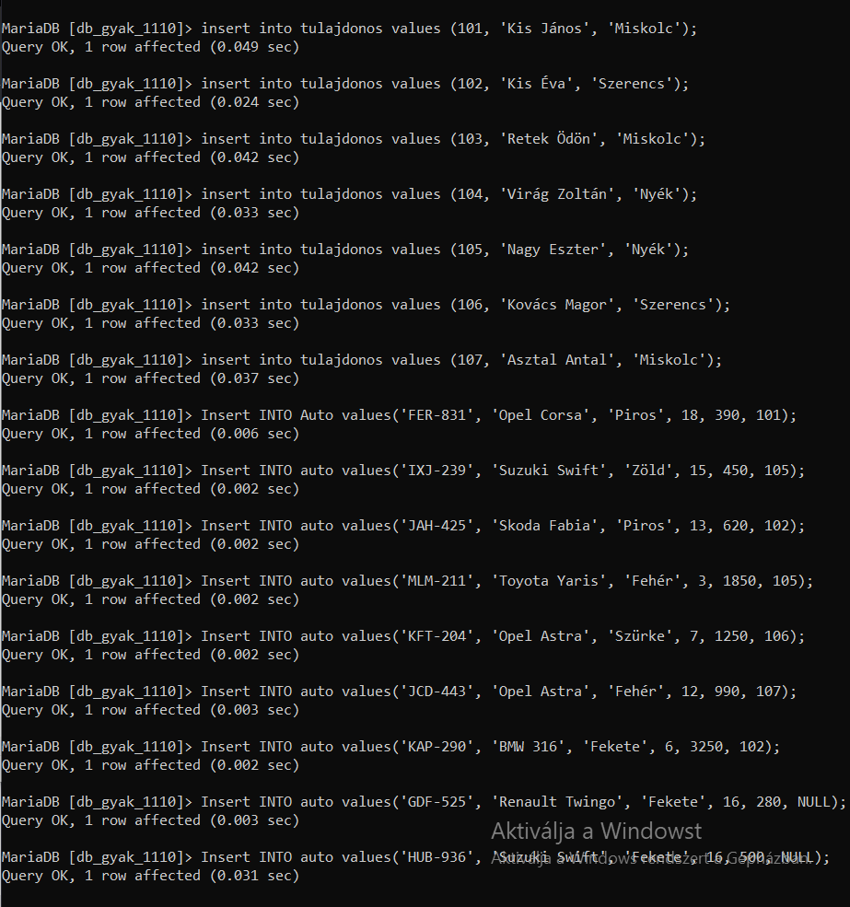

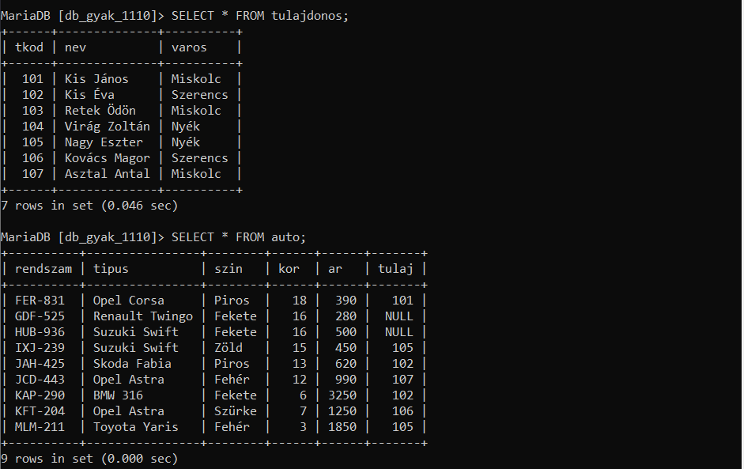

**Lekérdezések:**

1, SELECT rendszam, nev FROM auto INNER JOIN tulajdonos ON tulaj = tkod;

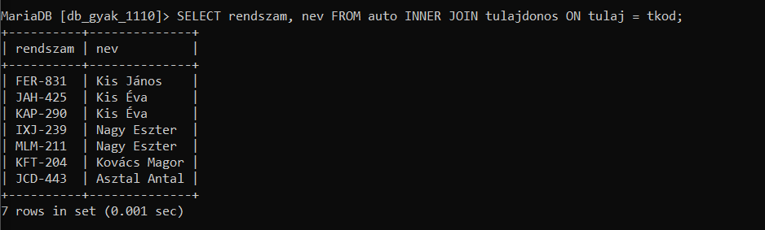

2, SELECT * FROM auto INNER JOIN tulajdonos ON tulaj = tkod WHERE varos = 'Miskolc';

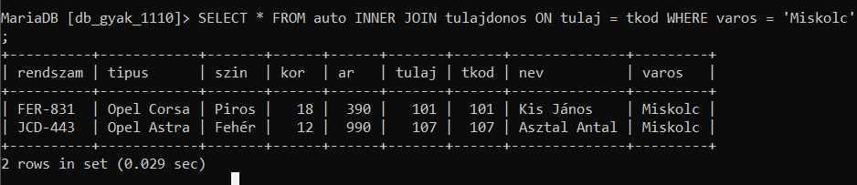

3, SELECT tipus, ar FROM auto;

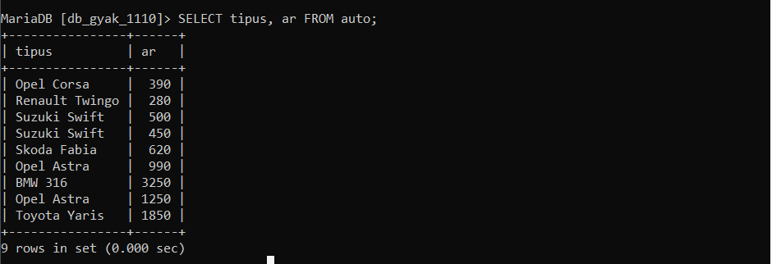

4, SELECT tulajdonos.*, auto.rendszam FROM tulajdonos LEFT JOIN auto ON tulajdonos.tkod = auto.tulaj;

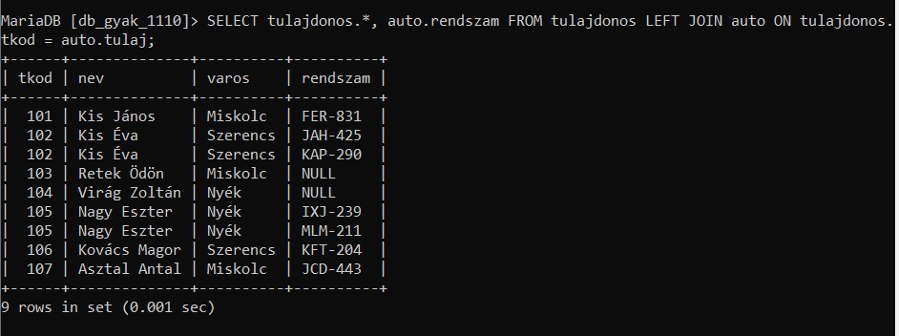

5, SELECT rendszam, nev FROM auto LEFT JOIN tulajdonos ON tkod = tulaj;

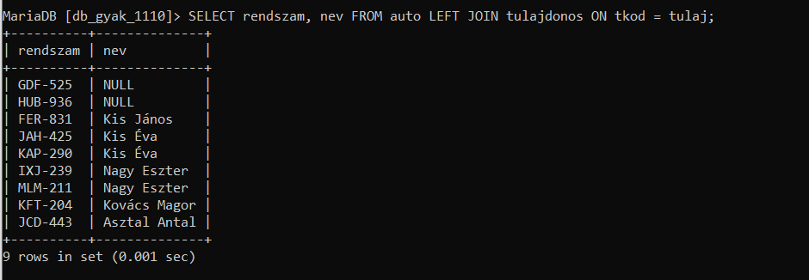

6, SELECT rendszam FROM auto INNER JOIN tulajdonos ON tkod = tulaj WHERE ar > (SELECT AVG(ar) FROM auto INNER JOIN tulajdonos ON tkod = tulaj WHERE varos = 'Miskolc') AND varos != 'Miskolc';

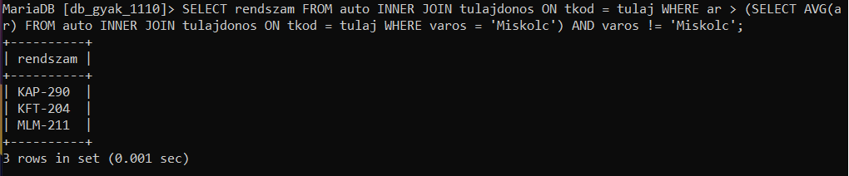

7, SELECT nev, COUNT(tulaj) FROM tulajdonos INNER JOIN auto ON tkod = tulaj GROUP BY tulaj HAVING COUNT(tulaj) > 1;

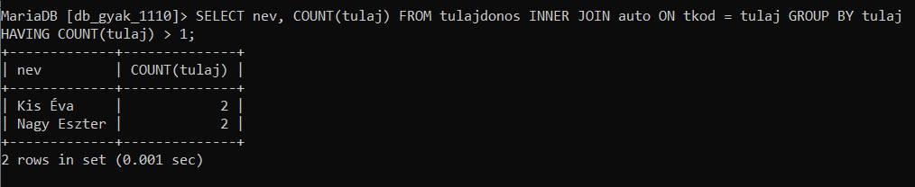

8, SELECT A.rendszam AS rendszam1, A.tipus, A.kor, A.ar FROM auto A, auto B WHERE A.rendszam <> B.rendszam AND A.tipus = B.tipus AND A.kor > B.kor AND A.ar > B.ar ORDER BY A.tipus;

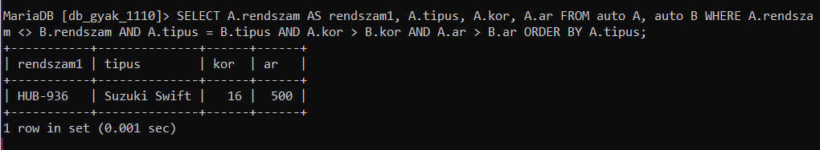

9, SELECT * FROM auto WHERE (SELECT ar FROM auto WHERE szin = 'Piros' ORDER BY ar DESC LIMIT 1) > ar;

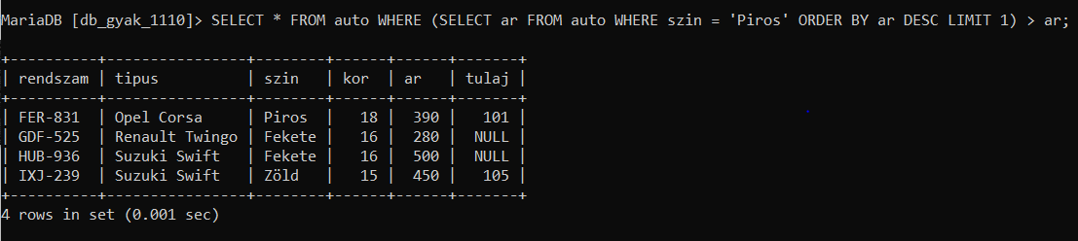

10, SELECT * FROM auto WHERE (SELECT ar FROM auto WHERE szin = 'Piros' ORDER BY ar ASC LIMIT 1) > ar;

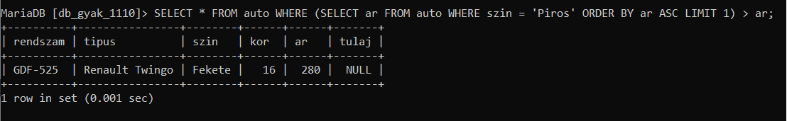

11, SELECT DISTINCT nev FROM tulajdonos INNER JOIN auto ON tkod = tulaj WHERE tulaj IS NOT NULL;

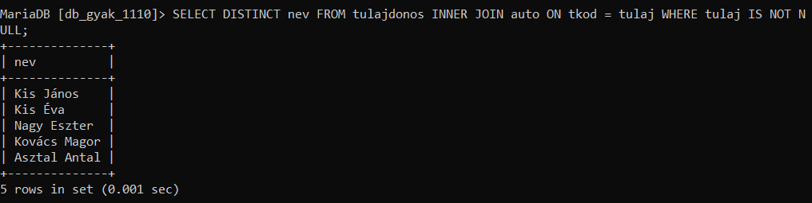

12, SELECT nev FROM tulajdonos WHERE NOT EXISTS (SELECT 1 FROM auto WHERE auto.tulaj = tulajdonos.tkod);

