Domain: E-commerce Analytics
Source: Kaggle — Brazilian E-Commerce Public Dataset by Olist
Business problem: Olist management needs visibility into sales performance, delivery efficiency, customer satisfaction, and product category trends across Brazil (2016–2018) to make data-driven decisions on logistics investment, product strategy, and regional market expansion.
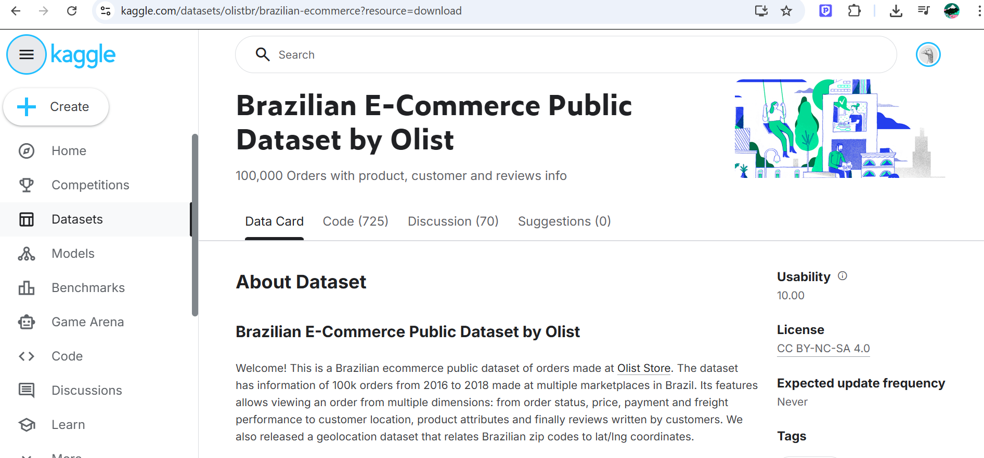
URL: kaggle.com/datasets/olistbr/brazilian-ecommerce
License: CC BY-NC-SA 4.0

The Olist dataset satisfies all advanced analysis requirements: it contains 6 related tables linked by shared keys (order_id, customer_id, product_id) enabling a proper star schema; the main orders table has 99,441 rows exceeding the 9,000 minimum; it contains both categorical variables (order_status, payment_type, customer_state, product_category) and numerical variables (price, freight_value, review_score, payment_installments); and the order_purchase_timestamp field spans September 2016 to October 2018 enabling full time-intelligence analysis including year-over-year comparisons, YTD calculations, and monthly trend analysis.

