AstroCard Software requirements specification
- System characteristics
- The application should be a Telegram Bot (see details DS-1.6:)
- The application should be developed using Java (see details DS-1.1:)
- The application should use Spring framework (see details DS-1.2:)
- The application should use Swiss Ephemeris Library (see details DS-1.5:)
- The application should use PostgreSQL
- User requirements
- Starting and using application
  - The user should be able to start interaction with the application by sending the “/start” command to the telegram Bot.
  - After receiving the “start/” command, the application should send message “Выберите действие. Если карта была создана в прежней версии, введите данные заново” with the menu, which should contain following option “Создать натальную карту”.
  - From any FSM state, /start shall clear the draft and show the saved natal chart when user had already given the place, date and time of birth.
- Generating natal chart
- For details see Menus and messages, Conversation transitions.
- From CHOOSE_ACTION, NATAL_RESULT or FORECAST_CARD the NATAL_BUTTON action should request country, city, local birth date and local birth time in that order. An accepted field shall advance exactly one corresponding input step.
- After choosing the “Создать натальную карту” application should request country of birth.
- After receiving the country of birth application should request city of birth.
- After receiving city of birth application should request date of birth.
- After receiving date of birth application should request time of birth.
- The application should calculate natal chart and then send it to the user with menu to explore descriptions of given combinations.
- Natal chart results
- For details see Menus and messages, Conversation transitions.
- The natal chart reply shall be HTML text headed “Натальная карта”. Each of the 11 body rows shall show the object name, sign, integers degrees in sign, integer minutes and house number.
- The result menu should contain “Планеты в знаках”, “Планеты в домах”, “Прогноз” options.
- After pressing either of “Планеты в знаках”, “Планеты в домах” application should send list of planets to choose from. The signs and houses menus shall each offer 11 planets via inline buttons and “Моя карта” inline button which shall restore NATAL_RESULT.
- After receiving list of planets, user should be able to choose any of given options. A missing description shall return “Описание пока отсутствует”
- After selecting planet user should receive description.
- Description should be followed by inline buttons “Назад к планетам” which shall return to originating signs or houses list and “Моя карта” shall restore NATAL_RESULT from either list.
- Generating forecast
    - For details see Menus and messages, Conversation transitions.
    - The application should be able to calculate natal chart for current date and time. It shall calculate current positions at the saved birth coordinates using one Clock instant truncated to a UTC minute. The heading should include the calculation instant.” Моя карта” shall restore the natal chart.
- Business rules
- Processing user data.
- After users’ country city birth date and time had been collected, the application should store that data in database.
- Data persistence.
    - Geographical data should be stored in database.
    - Descriptions of planets in signs, houses should be stored in database
- Natal chart calculation.
    - By default, the application use Placidius House system
- Navigation.
    - All interactions with user besides gathering place of birth, date and time should be done using Telegram inline Buttons.
- Quality attributes
- Performance
- The bot should maintain the current interactions state for each active user. And store that state in database.
- Resilience to input data
- Application should inform user if input data is incorrect
- Limitations
- Application supports only Russian-language user interaction
- The application requires access to the PostgreSQL database containing geographical and descriptive data.
- Detailed specification
- Application environment
  - The application should run on Java 21
  - The application should use Spring framework (Spring Boot 3.4.4, Spring Statemachine, Spring Data JPA)
  - The application should use Maven
  - The application should use Caffeine 3.2.1 (https://github.com/ben-manes/caffeine)
  - The application should use Swiss Ephemeris (http://www.th-mack.de/international/download/)
  - The application should use Telegram Bots(https://rubenlagus.github.io/TelegramBotsDocumentation/telegram-bots.html)
- Telegram Bot.
- The bot should provide inline keyboard buttons for selecting available operations.
- The chart cache shall load atomically on a miss using UTC instant and coordinates as key, with default maximum size 2000 and expiry six hours after access. Description cache shall use object and position, default maximum size 5000 and expiry one hour after write
- Birth place data.
- The application should validate supplied country and city
- Date and time.
- Supplied date format “dd.mm.yyyy”.
- Supplied time format “hh:mm”.
- Astronomical calculations.
- The application should use Placidus house system to calculate houses.
- Natal chart data.
- Natal chart should contain following objects: Sun, Moon, Mercury, Venus, Mars, Jupiter, Saturn, Uranus, Neptune, Pluto, Chiron.
- Each celestial object is determined to be in one particular sign and one particular house. When natal chart is generated, the list should have such format: “Celestial object: Sign [numerical degrees in that sign] [numerical minutes in that sign] House: [number of house]”

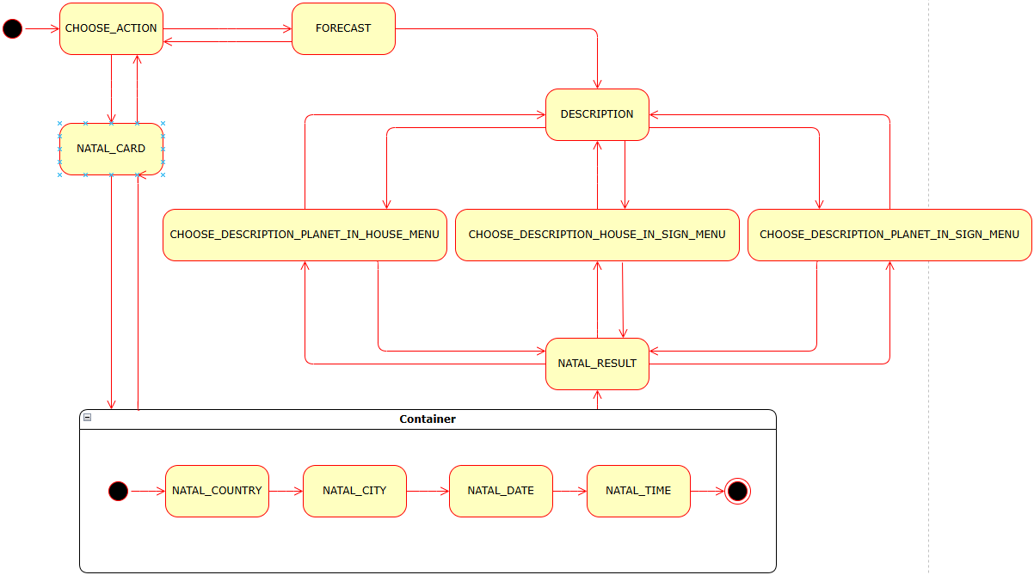

Menus and messages
Context | Text and available actions
Initial menu | “Моя карта  “Создать натальную карту”
Country | “Введите страну рождения:”
City | “Введите город рождения:”
Date | “Введите дату рождения (ДД.ММ.ГГГГ):”
Time | “Введите местное время рождения (ЧЧ:ММ):”
Input navigation | “Отменить ввод”
Chart | “Натальная карта”  “Планеты в знаках”, “Планеты в домах”, “Прогноз”, “Ввести данные заново”
Signs and houses | “Выберите планету в знаке:” / “Выберите планету в доме:”  11 body buttons; “Моя карта”
Description | Plain description; “Назад к планетам”, “Моя карта”
Current positions | “Положения планет на” followed by ISO UTC instant; “Моя карта”
Stale callback | “Эта кнопка сейчас недоступна. Используйте последнее меню или /start.”
Generic failure | “Не удалось выполнить действие. Повторите ввод или используйте /start.”
Missing description | “Описание пока отсутствует.”

Conversation transitions
Source state | Action | Target state
Any state | /start with no usable profile; /cancel | CHOOSE_ACTION
Any state | /start with usable profile; SAVED_CHART with usable profile | NATAL_RESULT
CHOOSE_ACTION, NATAL_RESULT, FORECAST_CARD | NATAL_BUTTON | NATAL_COUNTRY
NATAL_COUNTRY | Accepted country | NATAL_CITY
NATAL_CITY | Accepted city | NATAL_DATE
NATAL_DATE | Accepted date | NATAL_TIME
NATAL_TIME | Accepted time and successful calculation | NATAL_RESULT
NATAL_RESULT | PLANETS_IN_SIGNS_BUTTON | Signs list
NATAL_RESULT | PLANETS_IN_HOUSES_BUTTON | Houses list
Signs list / houses list | Configured body callback | SHOW_PLANET_IN_SIGN / SHOW_PLANET_IN_HOUSE
Sign / house description | Back to planets | Originating list
CHOOSE_ACTION or NATAL_RESULT | PREDICT_BUTTON with usable profile | FORECAST_CARD
Forecast, either list or description | Back to natal chart | NATAL_RESULT

