Interoception Study – Workflow for the operator
- Prior participant comming to the experiemental room
What to do | Notes
1.1 Go the experiment room | The experimental room is located in the basement of the PER-21 building. The room number is G0195. There is a locker where you can find the key for the door.  The actual code is 7775.  WARNING: Don’t lose the key or leave the room without it (otherwise you will not able to come back). Always put back the key in the locker before to leave.  When you enter , the light switch are on the left (expect for the control room where you have to go across the room.
1.1 Setup computers | - Turn on the power and wait 15s. Then turn on the computer  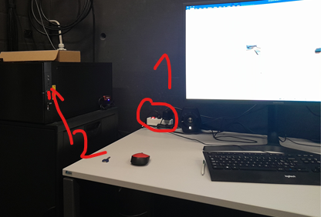  - Login the Experimental computer  - User: “Michael Mouthon”  - PW: Biosemi2011  - Open the program Unity   - Select the FBI_MotionCapture2025  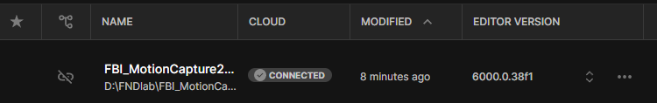  - Open the program Motive 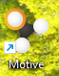  - Check the character is in the center of the screen like that:  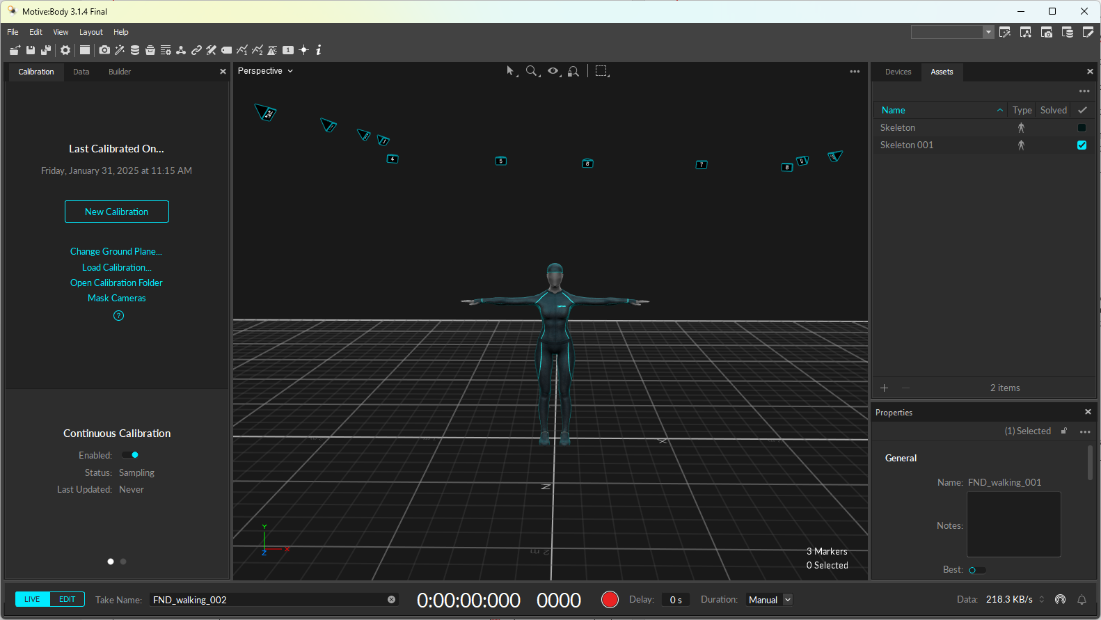  If it is not the case, you have to go to the calibration procedure (see next point).  - Calibration procedure if needed:  - Take the calibration device (which is on the operator table) and place it on the floor or the Motion tracking exactly on the yellow marker as showed in this picture:  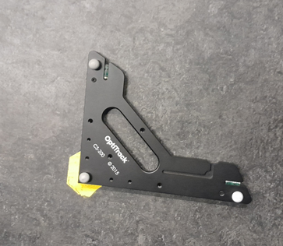  - In the Motive windows, select the three markers on the ground with a mouse drag. Then press on the option “Change ground Plane…” as showed in this picture:  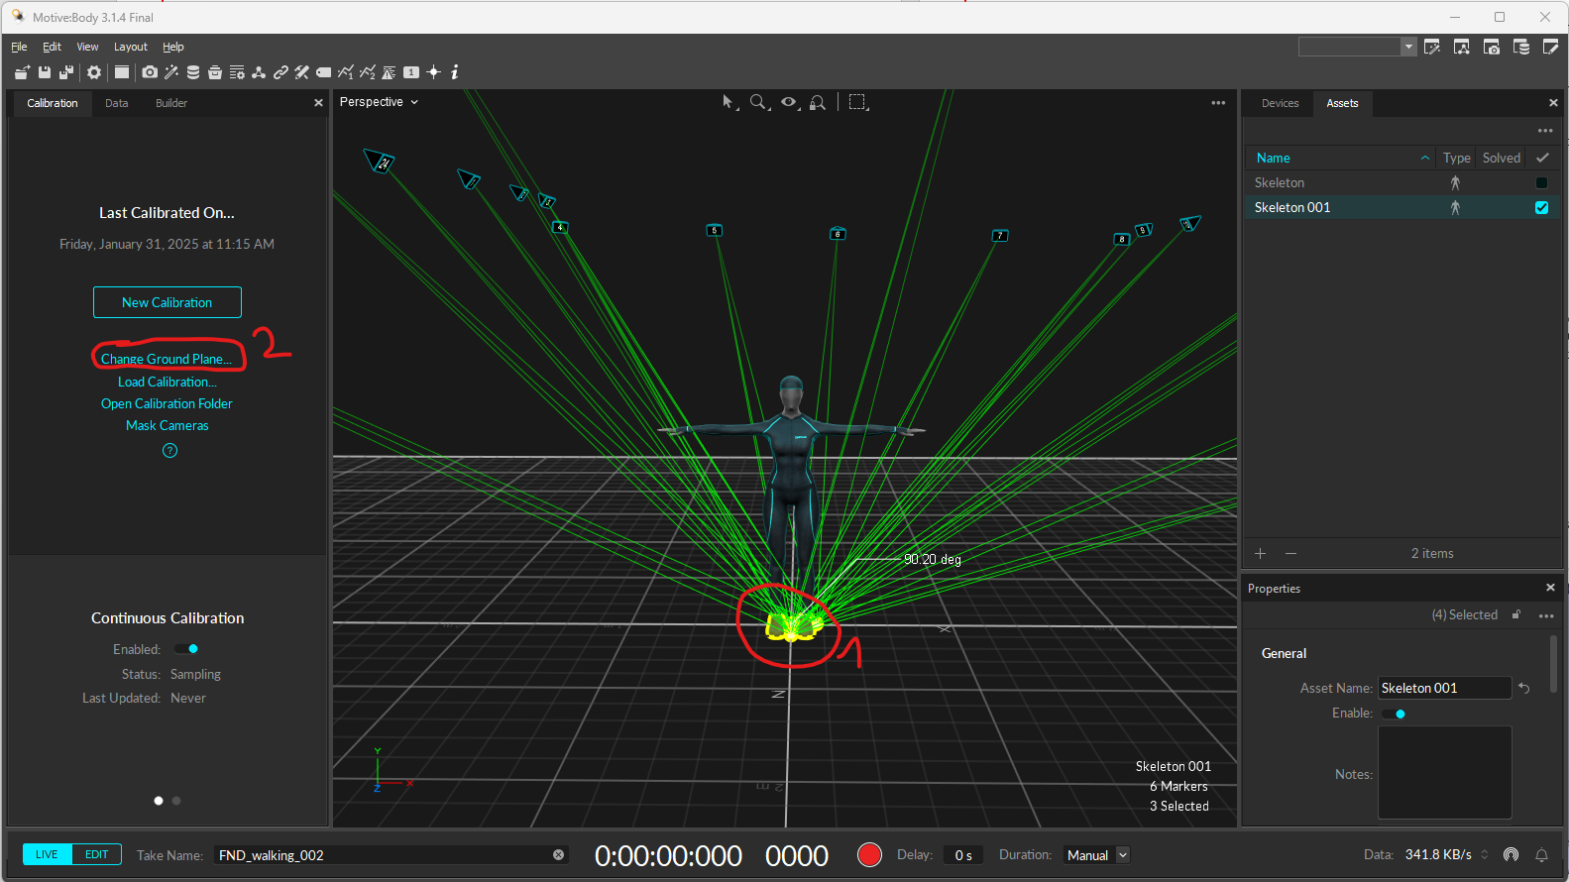  - Press again on the Change ground plane button and you are done  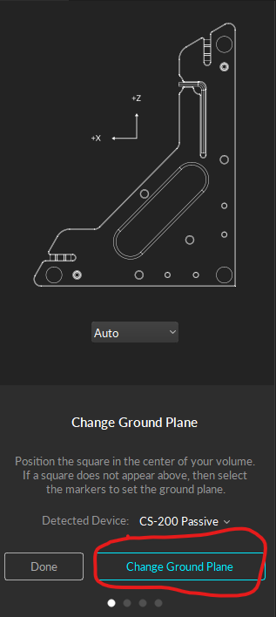  - Check the sampling frequency of the optiTrack system in the right panel of Motive window. It must be at 200Hz for this protocole:  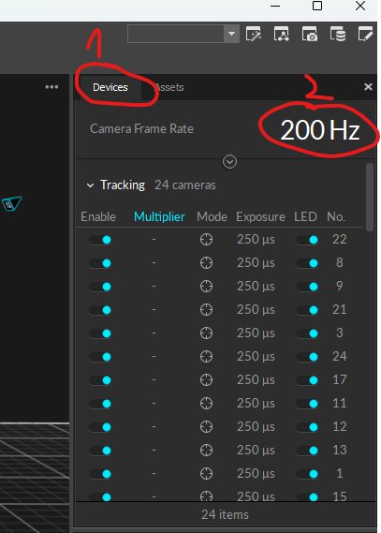
1.2 Enter participants infos | - Open the Excel sheet FBA_Participant_randomisation to know if you start by the walking task or the delay task  - In unity, in the project tab (buttom left of the screen), double click on the right scene to open it  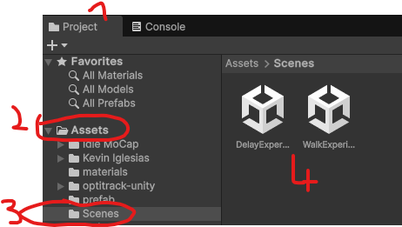  - In the hierarchy tab (up left of the screen), select the object sceneManager  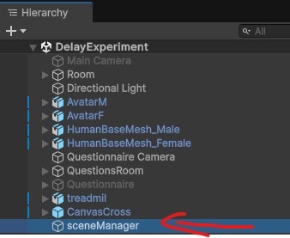  - In the Inspector tab (right part of Unity screen), you will introduce the specific data for the participant :  - Participant code: P###  - Language (Fr, De, En)  - Gender of the participant (Male or Female)  - Skeleton name (identifier for Motive): SkeletonP###  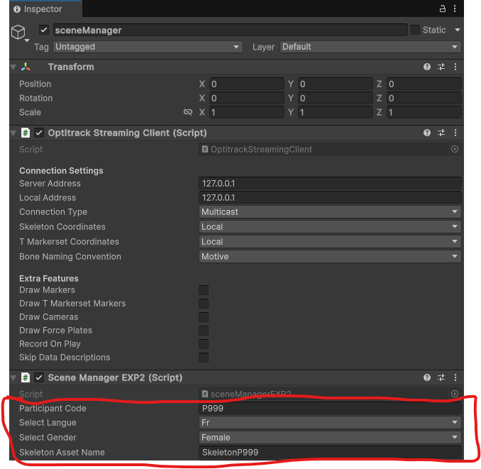  Don’t touch the other parameters of the inspector !

- Clinical examination and blood intake
What to do | Notes
- Neurological testing | Wait the experimenter do the questionnaires in the other room.
- Go to the lab facility of the HFR | Go with the Experimenter and the participant. At the secretariat of the lab, Report at secretariat and register at Visit book for “study of the neurology Prof Aybek”.  After the blood intake, Freeze blood sample right away (according to protocol) in freezer 20, drawer 8. Fill the hole of the box in the correct order and fill it in the storage sheet. In the meanwhile, the Experimenter go back to the recording room with the participant.

- RRST task
What to do | Notes
- Change Screen display | - Check that the Display hub is in position 1  - Go to the “Display setting” of the experimental computer. You can access it with a right mouse click on the desktop of the computer  - In “Multiple displays” section, switch to “Extended these Display”  - Use the mouse to move the command windows of Matlab on the operator screen
- Plug the RRST device | It is important to respect this order (otherwise it could damage the device!)  - Plug the power of the USB fan above the electric circuit. Turn it on  - Plug the power of the device Power supply  - Connect the USB of the device to the black USB prolongator  WARNING: with the RRST device, never plug the USB before the power!
- Run the task | - Execute the script “experimentLauncher.m”  - Wait that the device has completed its calibration before to start (until the screw make a click on the detector)  - Turn on and give the wireless mouse to the participant in order they can respond to the task (if not done already)  - Be aware: whenever they go too much to the left, they will appear with their mouse on the Operator computer (and might click something in matlab) : observe and if the mouse does appear, do lead it back
- Generate and save the result graph for RRST task | - Execute the script “execute_simple_plot.m” already open in MATLAB  - Select the data file in “D:\Experimental_scripts\projet_interoception_2023\task1_RRST\task\RRS-3-0\data” folder. If the script finished correctly, the file would start by ‘RRS_*.mat’ and if not, it will start by ‘Error_*.mat’ (but contain still all the data).  - Drag the results figure on the screen of the participant in order the experimenter can comment it.  - In the meanwhile, on the first screen, eject the device from the computer. Go to the menu “Bluetooth or other device” and remove the device “USB Serial Device (COM4)”  - Disconnect the USB of the device  - Switch off alimentation rack (where the fan and device is plug)  WARNING: with the RRST device, always unplug the USB in first!  - When experimenter speech over, Go to the “Display setting” of the experimental computer. You can access it with a right mouse click on the desktop of the computer  - In “Multiple displays” section, switch to “Duplicate these Display”  In the MATLAB result plot window,  - go to ‘File->Save As’  - go in the data directory of the participant or create it (exact path: D:\Experimental_scripts\projet_interoception_2023\data\PXXX)  - change the destination file format for .jpg  - Name your file RRST_results_PXXX.jpg  - Close the MATLAB result plot window
- Display pictures to participant | - Open the folder “Pretty Picture” located on the desktop of the experimental computer  - Double click on a picture to open it  - In the menu bar above the picture, find the button ‘…’ and select the option ‘Diaporama’ or press F5 on keyboard
NOTE | If you must quit the RRST task when it’s still running: Wait a respiration period/period of the main screen and press on the ‘Esc’ task of the keyboard. It is not possible to abort the task during questions, break period or during the training. If you absolutely need to abort during these periods (which I don’t advise), you have no choice to use the task manager (CTRL+ALT+DEL) and force quit MATLAB. Normally restart MATLAB should be enough to re-execute the RRST script. However, if Matlab failed to reconnect to the device you have to close MATLAB, follow the disconnection procedure of the RRST device. Reconnect it and restart MATLAB. If it still doesn’t work, disconnect the device and restart the computer.

- Setup EEG and signal check
What to do | Notes
- Setup | Install the ECG, Respiration belt, EEG with the Experimenter according to the document SOP_EEG.docx  Reminder:  - ECG electrode positions : 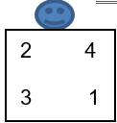 (when you face the participant)  - When filling the gel, respect order of the number; look at the document that is shared with the experimenter.
- Quality check of the EEG setup | - Open “Offset” tab in Actiview and check that the values are in the interval [-30,30]  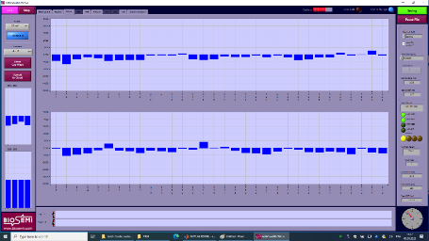  - To improved a bad channel :  - Unplug the electrode  - Try to move away the hair with the syringe  - Add a little bit of gel  Sometimes, you will be not able to improve the signal (especially A15 and B20 which are above the ears). Don’t panic. We can interpolate them in the post-processing.  - Open the “Monopolar” tab and look at the signal of each electrode to check if there is an abnormal behavior from one electrode (like huge amplitude of very high frequency oscillation) when participant is at rest (don’t move or speak). In this example, try to improve the highlighted one:  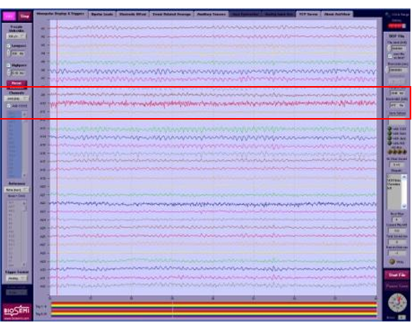
- Check ECG | Open “Bipolar” tab, check that both ECG channels (EXG1-EXG2 and EXG3-EXG4) are positive (R-peak above the baseline). If it is not the case, invert the position of the connector of corresponding EXG electrode. In the following example, the connector between EXG3 and EXG4 must be switch on the EEG box.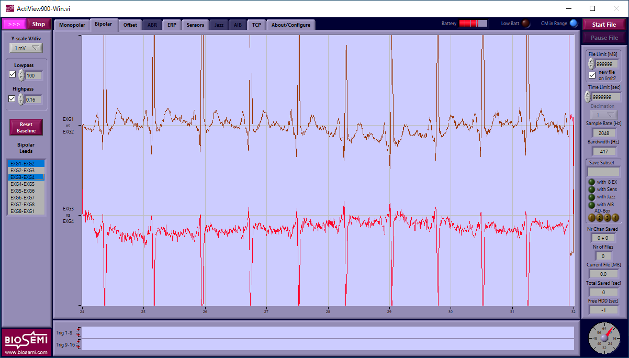
- Show the EEG to participant and let experimenter explain | Go back to the “Monopolar” tab and showed the screen to the participant.  On the Display Hub (located below the experimental computer screen), select the position 2 with the remote (to display the EEG computer screen).  After demonstration, select again the position 1 On the Display Hub to show the experimental computer screen.

- Experiment recording GENERAL
Procedure to create a new EEG recording file
- Click on the upper right button
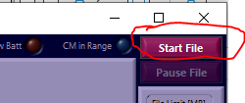
- Check if the correct options are selected (which should be the case if you had correctly load the config file):
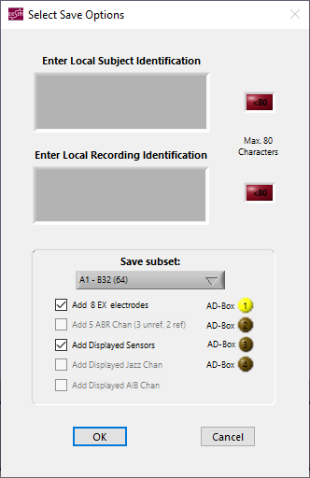
- Create a .bdf file in the folder of the participant. Respect the convention:
“Interoception_TaskInitial_Pcode_date.bdf" with date format ddmmyyyy
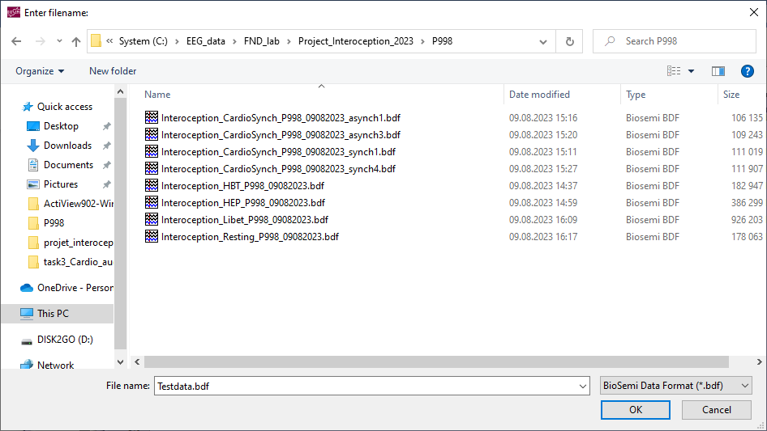
- !!!!!!WARNING!!!!! The recording doesn’t start automatically.
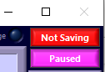
You must first press on the pink button “paused“ to start the recording
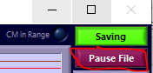 The upper button “saving” must be green: this indicates RECORDING

What to do | Notes
- HBT task | - Display Instruction for HBT task from Experimental Computer (E Run Script File) in “Task 2_HBT\task2_HBT.ebs3” of “Project_interoception_2023”  - Create the EEG file “Interoception_HBT_Pcode_date.bdf" during instruction on the EEG computer.  - Start the recording when participant is ready to start.  - BE AWARE: when the experimenter completed the test round, the next button they press will start the task (by then the recording must be going) : double check with the experimenter that both are ready to start the task  Note: Don’t pause the EEG recording during the Instruction of the cond2 (generate problem with the postprocessing Matlab script).  - Stop the recording when experiment is finished.
- HEP task | - put up the instruction for the HEP on the from Experimental Computer (E Run Script File) in “Task 3_HEP\task3_HEP_TRAINING.ebs3” of “Project_interoception_2023”  - Connect the earplug and sound prolongation cable in the right hole of the front panel of the experimental computer  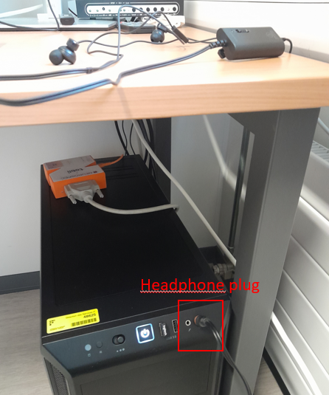  Take caution because the cable will pass under the operator chair.  - Remove the chair  - let the participant install  - Put back you chair over the cable and don’t movie it  - Turn on the noise cancellation of the earphone  - Create the EEG file “Interoception_HEP_Pcode_date.bdf" during instruction on the EEG computer.  - After the training, execute the Eprime script “Task 3_HEP\task3_HEP.ebs3”. Start the EEG recording immediately after execution of the Eprime script.  - Stop the recording when experiment is finished.

- Experiment recording for CAS task
STEP | What do I need for this
- Transfer HEP data on Experimental computer | - Use the USB key to copy the “Interoception_HEP_Pcode_date.bdf" and “Interoception_HBT_Pcode_date.bdf" from the EEG computer (in the folder EEGdata) to the experimental computer (at location “D:\Experimental_scripts\projet_interoception_2023\data”).
- Open the Eprime of CAS instruction | - On the EEG computer, execute the script “task4_CAS.ebs” at the location “C:\Experimental_scripts\task4_CAS”  - Change the Display Hub on the table for position 2 (show the EEG computer screen to the participant)
- Plug the EEG on the experimental computer | - Unplug the EEG cable from the EEG computer’s docking station.  - Plug-in the EEG cable in the front panel of the Experimental computer (caution not to pull the cable with your feet)
- Execute the MATLAB script in order to compute the ECG R-peak detection threshold on Experimental computer | - Restore the Matlab windows and execute the script “ECG_R_peak_detection_Compute_Variance_LABVIEW_version.m” on the Experimental computer:  - On the first Dialog box of Matlab, chose “Change Directory”  - Select the EEG recording file of the participant for the HEP experiment (Interoception_HEP_*.bdf)  - Enter the Pcode of the participant (e.g. P998)  - 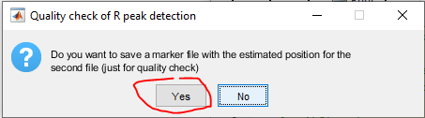  - Wait until the message busy disappear at the bottom-left of the Maltab command windows  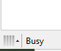  - In the same folder as the EEG recording file of the HEP, open the file logfile_P*.txt  - Give a look which are the best ECG channels (as shown in the picture). It could be 1 (it means that R-peak are clearer on the EXG1-EXG2 electrodes) or 2 (it means that R-peak are clearer on the EXG3-EXG4 electrodes  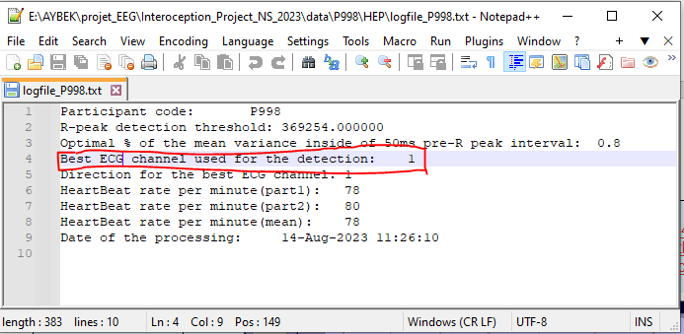  - Info: the script creates a “CardioSynchExperimental_P*.txt” containing the experimental randomization and Asynch timing for the participant at the same location
- Setup the best ECG channel | The best ECG channel must be connected physically to the channels EXG1/EXG2! According to the best ECG detected in 6.4 c):  - If best channel = 1: Do NOT change anything  - If best channel = 2: Swap EXG1<->EXG3 and EXG2<->EXG4 connectors on the EEG box.
- Open ActiView_Interoception_CAS.exe | - Open the “ActiView_Interoception_CAS.exe” on the Experimental computer with the shortcut on the Desktop (exact path: “D:\Experimental_scripts\projet_interoception_2023\task4_CAS\Experimental_script_LABVIEW”).  - Select the “CardioSynchExperimental_P*.txt” you have created in step 6.4 (located in the same folder as the EEG recording for the HEP task).  - Select the “logfile_P*.txt” you have created in step 6.4 (located in the same folder as the EEG recording for the HEP task).
- TEST the R-peak threshold | QUALITY CONTROL: You must check if the R-peak threshold is correct for this participant. During the talk between the experimenter and the participant about the task:  - Disconnect the headphone prolongator from the computer  - Turn the speaker volume down to a minimal value  - press on the Start button (figure, position 7) then on the task OFF/ON button (figure, position 3).  Check if a sound or a trigger in set on each R-peak.  If yes:  - Press on the stop button (figure, position 7)  - Plug back the headphone prolongator in the computer  - Put back the volume to ¾ on the speakers (for the resting task)  If No:  - First ask the participant whether they can remain calm without moving.  - If the detection is still inaccurate, adjust the R-peak Threshold thanks to the corresponding field ((figure, position 5). To decrease the threshold (case missing detection) put a value between 0-1 (for example 0.9), to increase the threshold (too much detection) put a value above 1 (for example 1.1).  Tips: adjust from with +/- 0.1 steps until the detection is accurate  - When detection is accurate, press on the stop button (figure, position 7) and go to the next point  Note: The change of the threshold is stored in memory of the application. So, change need to be done only once (if you don’t close completely the app).  Final Tips: If you were not able to complete the steps 6.4 (due to a bug) you can load a “logfile_P*.txt” from a previous participant and adjust manually the threshold with this procedure (but could take time)
- Recording | Check whether the fixation cross is on the participants screen and they are ready to start  - Specify which is the bloc of the task (1,2,3 or 4) using menu on (figure, position 1)  - Specify if it is a Synch or Asynch condition previously define (4x5min block in pseudorandomized order: EVEN Pcodes are syn-async-async-sync and  ODD Pcodes are a-s-s-a). Use the menu on (figure, position 2).  - Press on the button “Start File” (figure, position 6), create the EEG file “Interoception_CAS_Pcode_date_condition#bloc.bdf” (e.g. Interoception_CAS_P997_14082023_synch2.bdf).  START DIRECTELY THE RECORDING by pressing on Pause button in order that you get the green button “saving”.  - When the participant is ready, press on the “Task OFF/ON” switch to start the experimental bloc (figure, position 3)  - You can check the number of remaining stimulations in figure, position 4.  When it got to 0, the switch automatically turns off.  - Press on “Stop” button (figure, position 7)  - Let the experimenter know the round was completed.  - Once the participant is ready for the next block; let them know your starting and  Repeat these steps a-f for the four experimental bloc.
Figure 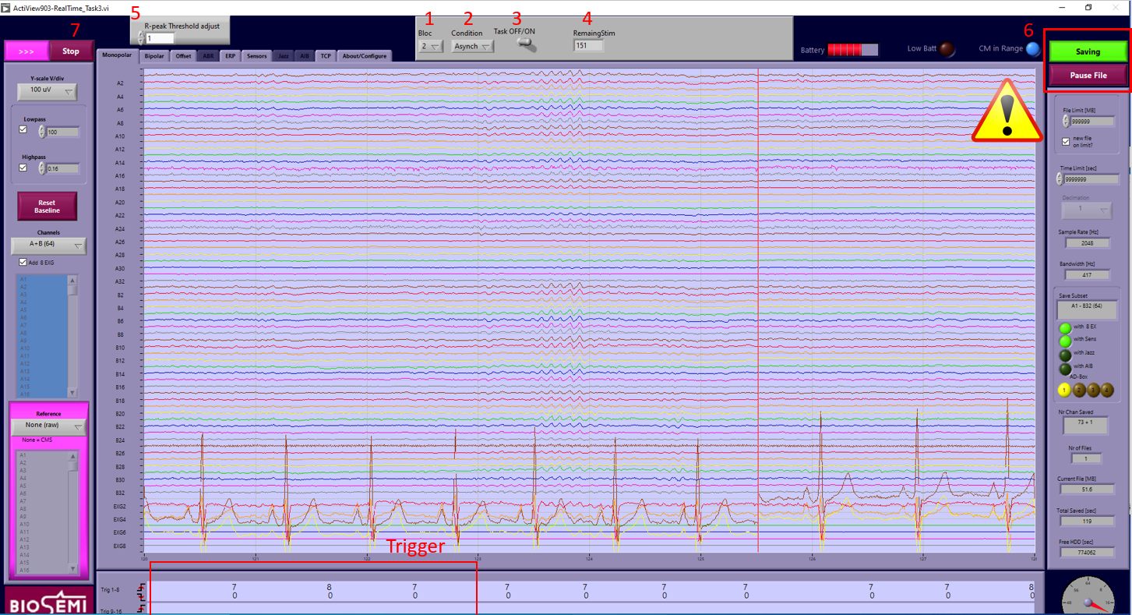
- After recording | - Close the “ActiView_Interoception_CAS.exe” on the experimental computer  - Close the Eprime script by pressing on ENTER on the EEG computer  - On the Display Hub, select the position 1 with the remote (to display the Experimental computer screen again).  - Unplug the usb of the EEG from the Experimental computer and plug it back to the docking station of the EEG computer  - Open instruction for the resting state from the Experimental Computer

- Experiment recording for Resting task
What to do | Notes
- Preparation | Play instructions from experimenter computer (execute file “D:\Experimental_scripts\*\task5_RestingState\task5_resting.ebs3” on the experimental computer
- Preparation EEG computer | - Normally, ActiView is still open on the EEG computer. If it is not the case, repeat these steps  Open the software “official” ActiView902 (direct path: “C:\software\Actiview\ActiView902-Win\ ActiView902-Win.exe” again  - Load the config file by  - Go to the “About/Configure” tab  - Press on the button “Load Config”  Select the file “Config_FNDlab_Interoception_2023.cfg”
- Resting task | - Create the EEG file “Interoception_Resting_Pcode_date.bdf" during instruction.  - Close the light and the store to 75%  - Make sure the fixation cross is on the participant’s screen  - Start the recording when participant is ready to start.  - Stop the recording when experiment is finished.

8. Cleaning and data saving
What to do | Notes
- Preparation | Clean the equipment as explain in the document “SOP_EEG.docx”
- Generate the result file for HBT task | - Restore the Matlab windows and execute the script “HBT_automatic_processing.m” on the Experimental computer:  - On the first Dialog box of Matlab, chose “Change Directory”  - Select the EEG recording file of the participant for the HBT experiment (Interoception_HBT_*.bdf)  - Enter the Pcode of the participant (e.g. P998)  - Wait until the message busy disappear at the bottom-left of the Maltab command windows  Open the result file “HBT_Results_P*.txt”in the same folder as the eeg data and show it to the experimenter in order he can fill the REDCAP  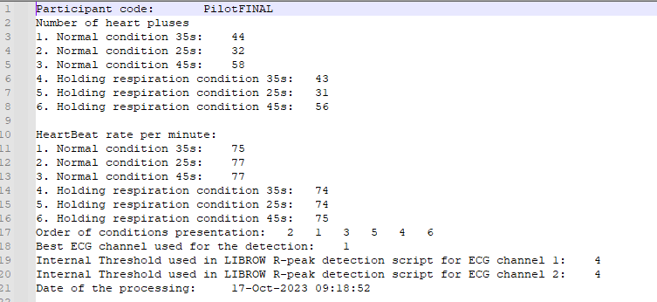
- Backup the data | - Connect an USB memory on the EEG computer and copy the participant’s folder created in “C:\EEG_data\FND_lab\Project_Interoception_2023”  - Connect the USB memory on the Experimental computer and copy the data into the folder “D:\Experimental_scripts\projet_interoception_2023\data”  - Reorganize this data folder to have one folder for each task  - On the Experimental computer, you are going to move the E-prime results file in the data folder.  - Folder “Task1_RRST”, go to the subfolder “task/RRS_3-0/data”, find the results file which contain the Pcode and move it in the main data folder.  - Folder “Task2_HBT”, move the files which contain the Pcode in their name to the main data folder  - Folder “Task3_HEP”, move the files which contain the Pcode in their name to the main data folder  - Folder “Task4_CAS”, move the files which contain the Pcode in their name to the main data folder  - Folder “Task5_Resting”, move the files which contain the Pcode in their name to the main data folder  - Connect yourself on the FND server (\\bigdata\Science\Med\NMS_Aybek). You will need to enter your unifr login in this way:  User: unifr\username  Password: Your UNIFR password.  - Copy the data participant’s folder on the server at the location “*\Experiments\Original Results\27 - Interoception\” on the server

