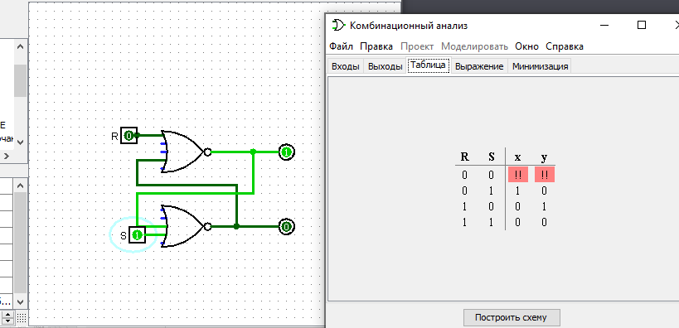

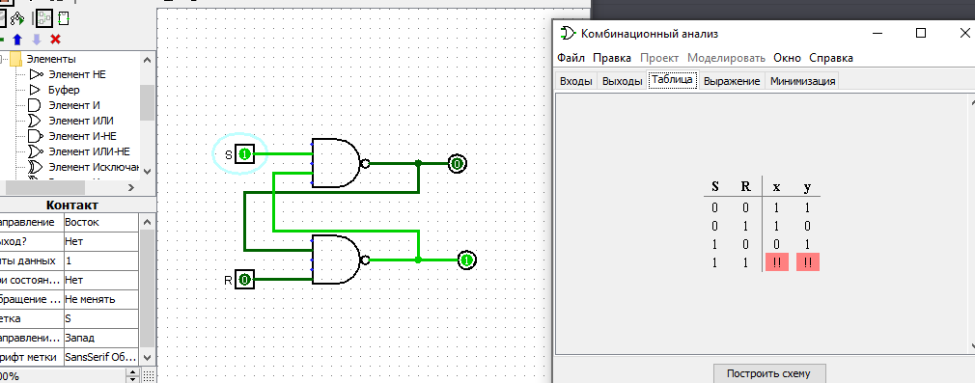

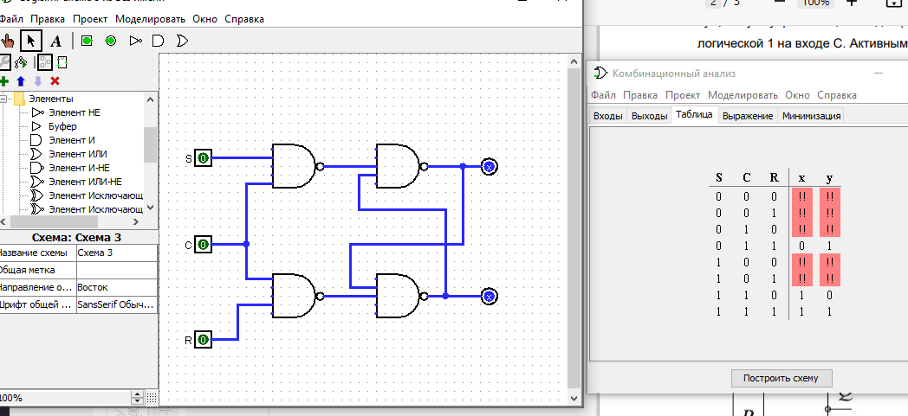

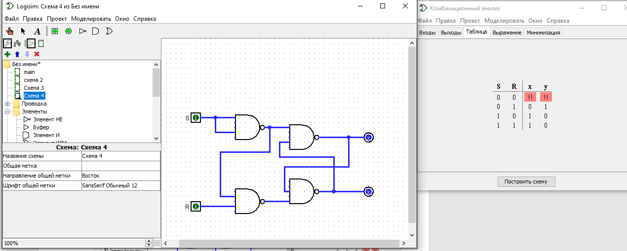

|  |  |  |  |  |
| --- | --- | --- | --- | --- |
| время | S | R | Q | !Q |
| T0 | 0 | 0 | 0 | 1 |
| T1 | 1 | 0 | 1 | 0 |
| T2 | 0 | 0 | 1 | 0 |
| T3 | 0 | 1 | 0 | 1 |
| T4 | 0 | 0 | 0 | 1 |
| T5 | 1 | 1 | НЕСТ | НЕСТ |

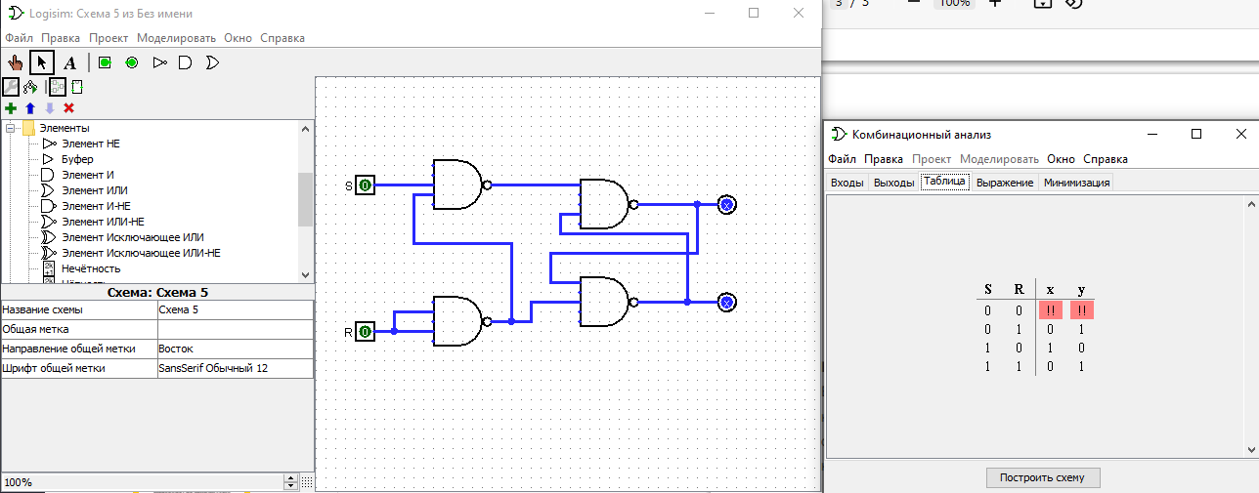

|  |  |  |  |  |
| --- | --- | --- | --- | --- |
| время | S | R | Q | !Q |
| T0 | 0 | 0 | 0 | 1 |
| T1 | 1 | 0 | 1 | 0 |
| T2 | 0 | 0 | 1 | 0 |
| T3 | 0 | 1 | 0 | 1 |
| T4 | 1 | 1 | 0 | 1 |
| T5 | 0 | 0 | 0 | 1 |

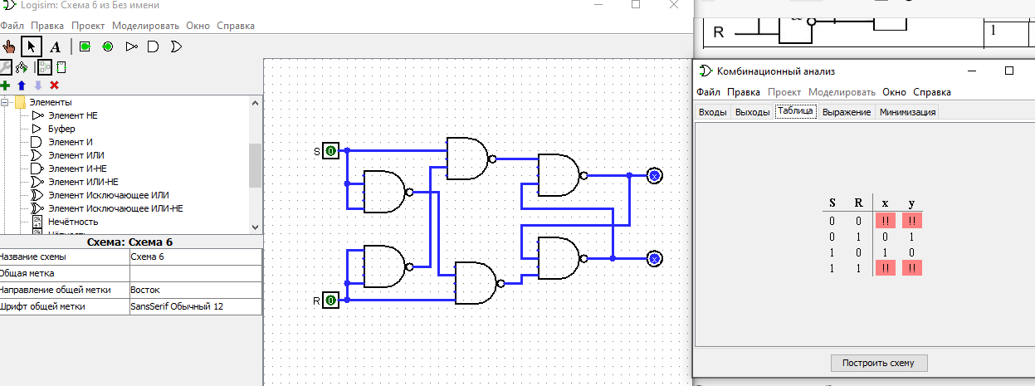

|  |  |  |  |  |
| --- | --- | --- | --- | --- |
| время | S | R | Q | !Q |
| T0 | 0 | 0 | 0 | 1 |
| T1 | 1 | 0 | 1 | 0 |
| T2 | 0 | 0 | 1 | 0 |
| T3 | 0 | 1 | 0 | 1 |
| T4 | 1 | 1 | 0 | 1 |
| T5 | 0 | 0 | 0 | 1 |
| Т7 | 1 | 1 | 0 | 1 |
| Т8 | 1 | 0 | 1 | 0 |