Быков Сергей

Лаб 1   
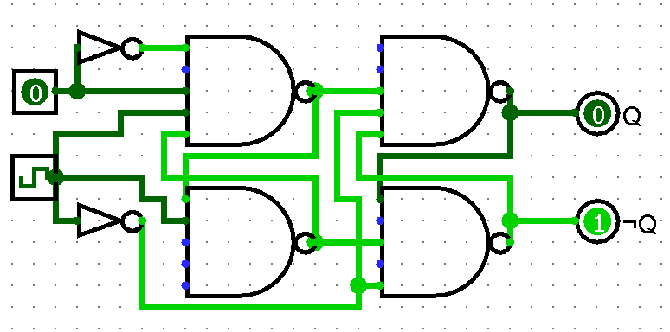

|  |  |  |
| --- | --- | --- |
| D | Q | Q2 |
| 0 | 1 | 0 |
| 1 | 1 | 1 |

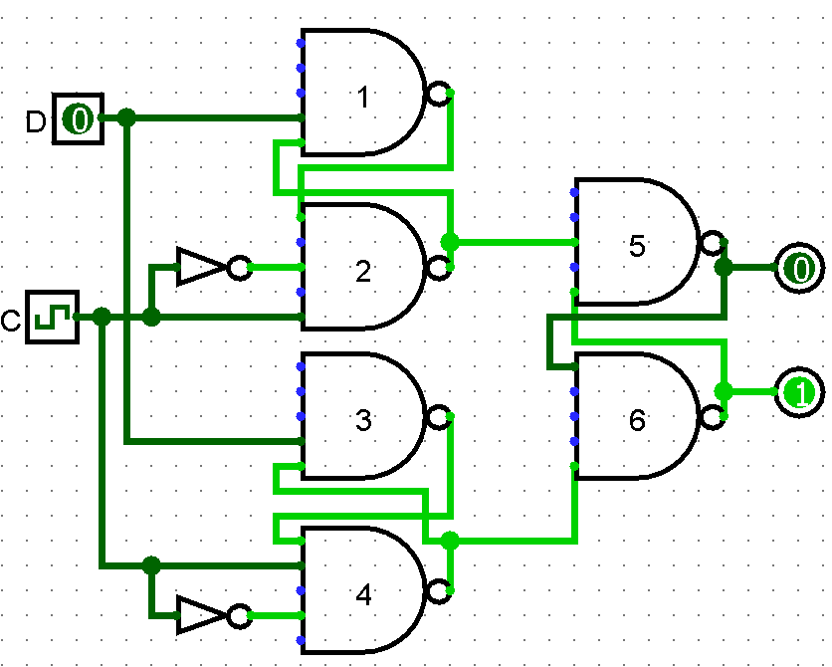

|  |  |  |
| --- | --- | --- |
| D | X | Y |
| 0 | 1 | 1 |
| 1 | 1 | 0 |

Временная диаграмма:

|  |  |  |  |  |  |
| --- | --- | --- | --- | --- | --- |
| T | 0 | 1 | 2 | 3 | 4 |
| C | 0 | 1 | 0 | 1 | 0 |
| D | 1 | 1 | 0 | 0 | 1 |
| Q | 0 | 1 | 1 | 0 | 0 |

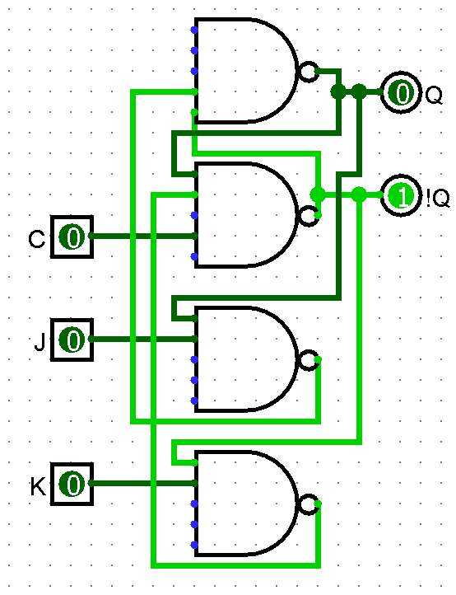

|  |  |  |
| --- | --- | --- |
| J | K | Q |
| 0 | 0 | Q |
| 0 | 1 | 0 |
| 1 | 0 | 1 |
| 1 | 1 | !Q |