Virtual Museum

**Uploading Files Manually:**

First we will need to create a database entry for our object.

1. Go to the Firebase Console and click Database in the left pane
2. Select ‘Cloud Firestore’ from our database list

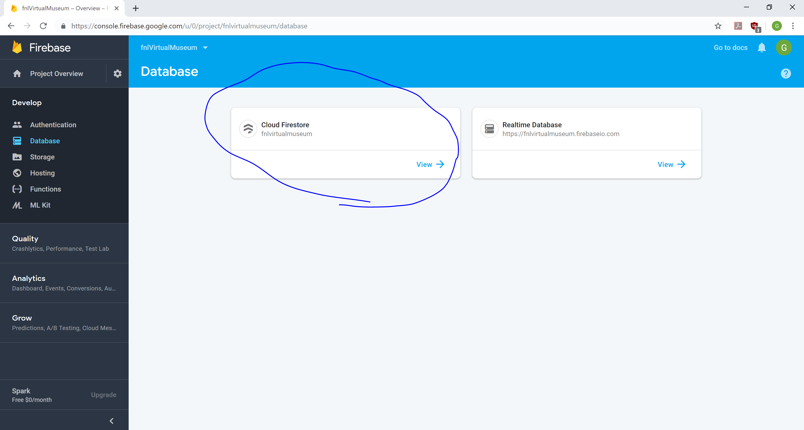

1. Click ‘Add document’ in the ‘3dObjects’ collection

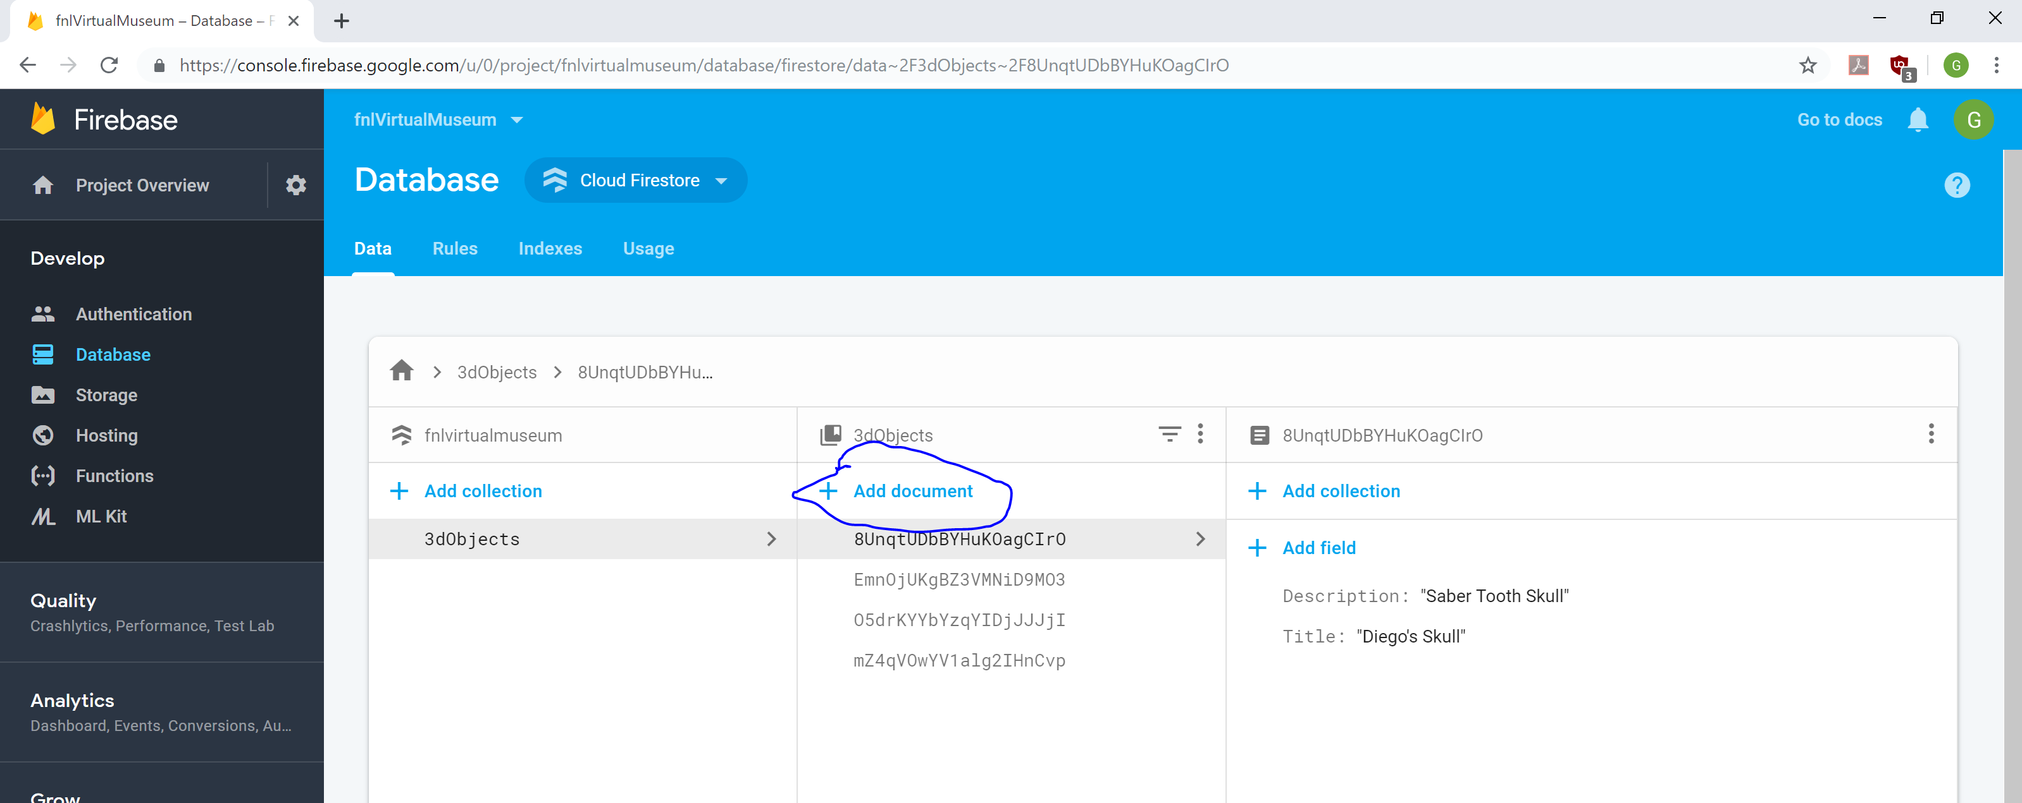

1. Give the document an ‘Auto-ID’ and create two fields: Title and Description (case sensitive)

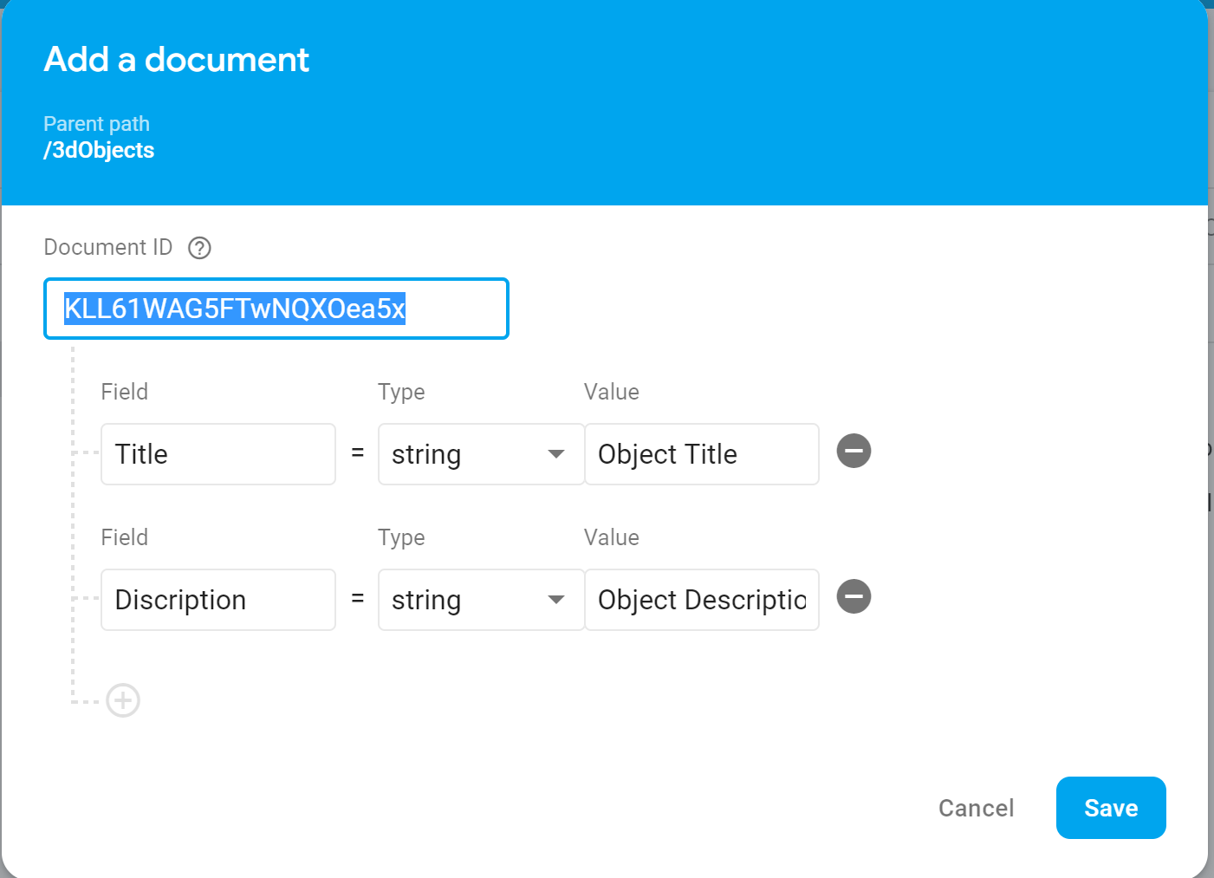

1. Copy the Document ID
2. Select ‘Storage’ on the left pane
3. Open the ‘3dObjects’ folder
4. Create a new folder with the Document ID you copied in step 5
5. Before uploading your 3dObject, rename the files to the following format

OBJ file -> High_Res.obj

MTL file -> properties.mtl

Material Image -> material.jpg

(Case Sensitive)

