# csy1018-assign1

Assignment

By following the checklist, and assignment brief provided, to complete this assignment. I ensured that I followed everything gradually. I have correctly implemented, using HTML5 and CSS as these are the only two programming languages which we have covered. I have been able to add my full name and student identification as a comment on all code files, as well as adding additional comments. I have saved my work as a single zip file, named ‘csy1018-assign1 which contains all the relevant subfolders listed within the assignment brief. I ensured that all images, where copyright free as they were my own images – primary research. Also, added a header, and footer.

Using HTML5 and CSS I created four personal web pages, which are all linked together through CSS, and stylesheet link – cv.html, bio.html, contact.html and index.html have all been implemented correctly. I’ve ensured that I have checked that all my HTML and CSS files pass the specification validator online. Before submitting my work, I ensured that I looked at the marking breakdown, and the penalties, to ensure I did not make any minor mistakes. Identify anyone with whom you have collaborated or discussed the assignment.

Although, I have completed these instructions, I have not correctly implemented, optimizing my images, as much although my images, where primary images, and where already changed. I found it difficult to create a form, so I used a website which taught me how to do this, and to put it into practise. I ensured I did this – this allowed me to successfully create a contact form, for my contact page. Also, used a website to help me find the hex colour codes for CSS stylesheet. Lastly, my code layout was not perfect although, I used Atom beautifier to help enhance this.

As I was nearly finished with my assignment, earlier, I wanted to improve it, to ensure I received the best possible grade. To achieve this I asked, Michael Omogbai, to give me brief feedback on what I had produced to ensure I was on the right track. He then ensured that if I wanted to achieve a better grade, that I should work on my layout, and adding more features. He reminded me to use the resources set by out lecturer. The first two images below, show how my website was before, I had focused on the layout and the design, as well as my wireframe I created beforehand. The next image, shows the after design after focusing more on the CSS file.

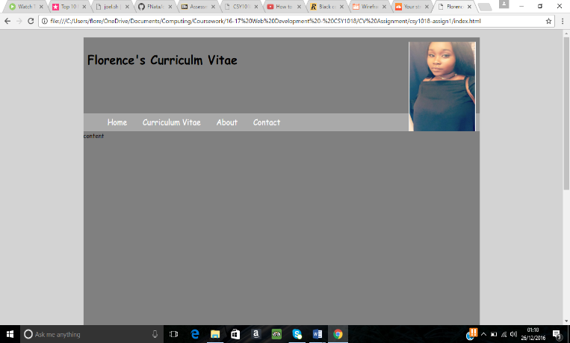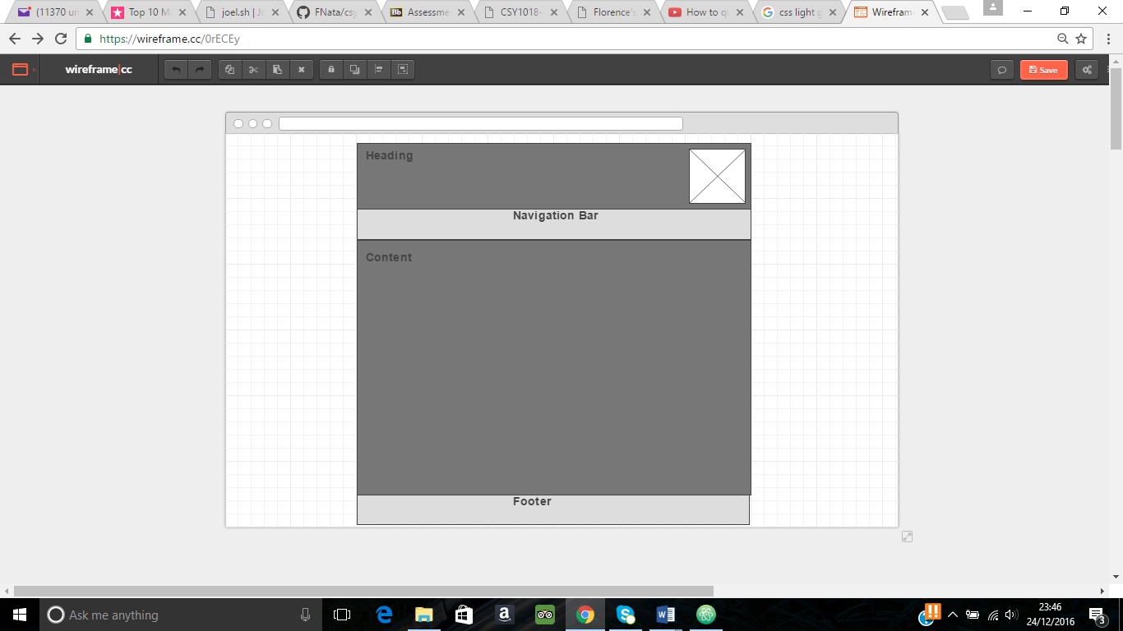

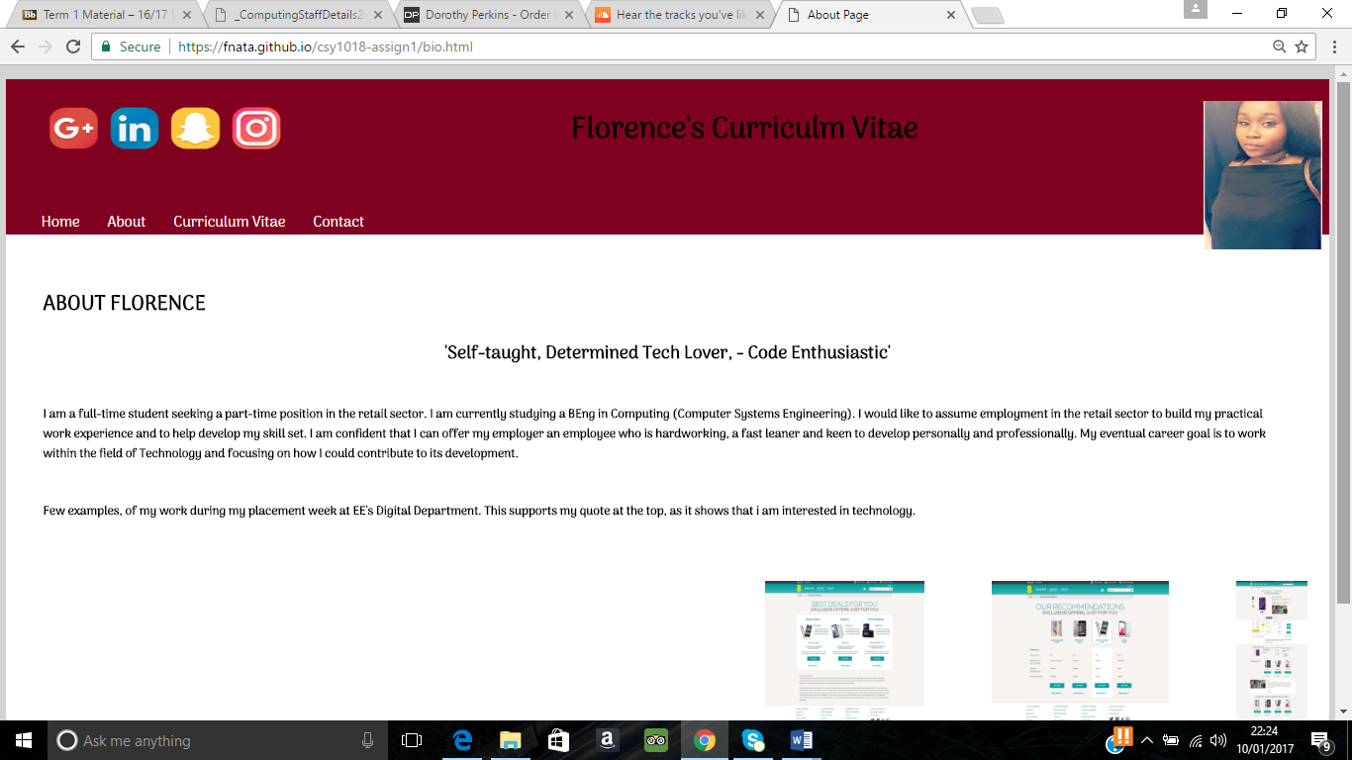

Overall, in completing this assignment I spent approximately, 40-45 hours. This is because I had started and deleted my work twice, which meant I had to then restart and put more effort in to my final piece – allowing me to add more skills into my work ethic.

Florence Twumasi Ankrah 16424857