Cagayan de Oro College | College of Information Technology Education 

GeoRoute: Travel Discovery and Planning System in Misamis Oriental

RESEARCHER SOMOGOY, MARK AGUSTIN S. MOLINA, KENT JOVERSON M.
OLINAN, NATHANIEL G.
JAMAR, JOHN KENNETH A.
HERNAN, MARK JUDE U.

March 2026

CHAPTER 1
THE PROBLEM

1.1 Introduction
Tourism is one of the growing industries that contributes to the economic and cultural development of many regions. In the Philippines, provinces continue to promote their tourist destinations to attract visitors and support local businesses. Misamis Oriental, located in Northern Mindanao, offers several natural attractions, historical landmarks, and recreational destinations that attract travelers from different areas. However, tourists and local travelers often experience difficulty in discovering destinations and planning their travel routes due to scattered information sources and the lack of centralized travel planning tools.
With the advancement of information technology, digital platforms and tourism information systems have become useful tools in improving how travel information is organized and accessed. According to Zhide Luo (2022), tourism information systems help manage tourism data and provide better services to travelers by organizing information and supporting route planning. These systems allow users to easily explore destinations, access travel information, and make informed decisions when planning trips.
Previous studies also highlight the importance of route planning and geographic information systems in tourism development. Dominic S. Lutero et al. (2021) emphasized that optimal route planning can help tourists efficiently visit multiple destinations within a limited time. Similarly, tourism recommendation systems can provide personalized travel suggestions and improve the travel experience of users by analyzing destination data and traveler preferences (Esper et al., 2025).
Despite the availability of tourism platforms and travel applications, many systems focus mainly on general tourism information rather than localized travel discovery and route planning. In many cases, travel information about specific provinces is distributed across multiple websites and social media platforms, making it difficult for travelers to organize their trips efficiently. Because of this, there is a need for a system that integrates travel discovery and route planning within a single platform.
To address this concern, the researchers propose the development of GeoRoute: Travel Discovery and Planning System in Misamis Oriental. The system aims to help users discover tourist destinations, visualize their locations through a map interface, and identify travel routes between locations. By providing an organized digital platform for travel discovery and route planning, the system aims to support tourists and local travelers in planning trips more efficiently while promoting tourism in Misamis Oriental.

1.2 Statement of the Problem
Travelers visiting Misamis Oriental often encounter difficulties in identifying tourist destinations and planning efficient travel routes due to scattered travel information and the lack of a centralized travel planning system. Without an organized platform that integrates destination discovery and route planning, travelers may experience inconvenience when searching for locations, estimating travel distances, and organizing their travel itinerary.
This study aims to develop GeoRoute: Travel Discovery and Planning System in
Misamis Oriental.
Specifically, it seeks to answer the following questions:
- How can a travel discovery system be developed to help users easily identify tourist destinations in Misamis Oriental?
- How can a route planning feature be implemented to assist users in determining travel routes, distance, and estimated travel time?
- How can the system present destination and route information through a user-friendly mapbased interface?
- How can the developed system improve convenience in travel discovery and planning for users?

1.3 Conceptual Framework
The conceptual framework of the study follows the Input–Process–Output (IPO) model, which describes how the system gathers information, processes the data, and produces results for the users.
The input of the system includes data related to tourist destinations in Misamis Oriental such as destination names, geographic locations, and basic travel information. These data are gathered from tourism sources, mapping services, and available travel information. In addition, users provide their current location and preferred destination as part of the system input.
The process involves analyzing the collected data and user inputs to determine possible travel routes between locations. The system identifies nearby tourist destinations, calculates travel distance, and estimates travel time using location-based mapping technology. Through these processes, the system organizes travel information and generates route suggestions for the users.
The output of the system includes a visual map displaying tourist destinations and suggested travel routes. The system also provides travel details such as distance and estimated travel time to help users plan their trips effectively within Misamis Oriental.

Input Process Output
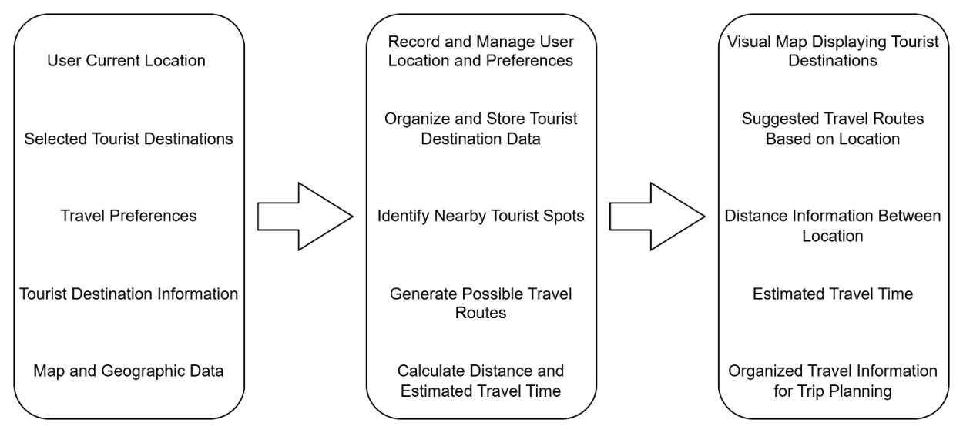

Figure 1.1 Input-Process-Output of GeoRoute: Travel Discovery and Planning System in Misamis Oriental

(INPUT PROCESS) User / Guest Inputs
- Destination search keywords (place name)
- Selected destination category (e.g., Beach, Mountain, Falls)
- Selected travel mode (Walking or Driving)
- User registration details
  - Name
  - Email address
  - Password
- Login credentials (email and password)
- Selected chatbot question (from predefined options)

- Route selection and save action
- Logout request

Admin Inputs
- Admin login credentials
- Destination information
  - Name
  - Description
  - Category
- Category management inputs
- User management actions
- Report generation request

System Processes
- Validate user login credentials
- Process user registration
- Retrieve destination data from the system database
- Integrate Google Maps API for:
o Map display
o Distance calculation
o Estimated travel time
- Filter destinations by category
- Display suggested nearby destinations
- Save user travel routes and destination history
- Display chatbot responses based on selected predefined questions Manage admin dashboard operations (CRUD functions)

(OUTPUT PROCESS) User / Guest Outputs
- Account successfully created
- Login success or error messages
- Displayed list of tourist destinations
- Interactive map showing selected destination
- Distance and estimated travel time
- Suggested nearby tourist spots
- Destination details (description and category)
- Chatbot responses to selected questions
- Saved travel routes (for registered users)

Admin Outputs
- Admin dashboard interface
- List of users
- User account status (Active/Inactive)
- Updated destination and categories
- System Statistics (system reports)
- Confirmation messages

1.4 Objectives of the Study

1.4.1 General Objectives
The study aims to develop GeoRoute: Travel Discovery and Planning System in Misamis Oriental that assists users in discovering tourist destinations and planning travel routes efficiently.

1.4.2 Specific Objectives
- To design a system that provides organized information about tourist destinations in
Misamis Oriental.
- To develop a route planning feature that identifies travel routes, distance, and estimated travel time between locations.
- To implement a map-based interface that visually presents destinations and travel routes for users.
- To evaluate the system in terms of functionality and usability.

1.5 Significance of the Study
The development of GeoRoute: Travel Discovery and Planning System in Misamis
Oriental will benefit several stakeholders.
Travelers and tourists will benefit from the system because it provides an organized platform for discovering tourist destinations and planning travel routes within the province. The system allows users to easily view destination locations, identify nearby attractions, and determine travel distance and estimated travel time, making trip planning more convenient and efficient.
Local tourism organizations and tourism offices may also benefit from the system as it helps promote tourist destinations in Misamis Oriental. By providing accessible digital information about destinations and routes, the system can help increase visibility and encourage more visitors to explore the province.
Information Technology students and future researchers may benefit from the study as a reference for developing tourism-related information systems. The study can contribute to the knowledge and application of travel planning systems, geographic information systems, and route optimization technologies in future research and system development.

1.6 Scope and Limitations
This study focuses on the development of GeoRoute: Travel Discovery and Planning System in Misamis Oriental, a travel discovery and planning platform designed to assist users in identifying tourist destinations and determining travel routes within the province. The system provides destination information, map visualization, and route suggestions based on the user’s selected location and preferred destination.
The system is intended for travelers, tourists, and local users who want to explore tourist attractions in Misamis Oriental. It operates through a digital interface that displays tourist destinations and travel routes using mapping technology. The system is developed and evaluated during the academic year 2025–2026 as part of the researchers’ system development study.
However, the system has several limitations. The coverage of the system is limited to selected tourist destinations within Misamis Oriental only. The accuracy of travel distance and estimated travel time depends on the available mapping data and internet connectivity. In addition, the system focuses only on travel discovery and route planning and does not include features such as hotel booking, transportation reservations, or real-time traffic monitoring.

1.7 Definition of Terms
For better comprehension of the study, the proponents gave a several terms that were defined conceptually as used in the study.
Destination Discovery – The process of finding tourist destinations in Misamis Oriental using the system.
Estimated Travel Time – The approximate time needed to travel between locations as shown by the system.
GeoRoute – A travel discovery and planning system designed for Misamis Oriental.
Geographic Data – Location-related information used by the system, including distance and routes.
Map-Based Interface – A digital map display used to show tourist destinations and travel routes.
Route Planning – The process of identifying travel routes between locations within the system.
Tourist Destination – A place of interest in Misamis Oriental that users can view in the system.
User – A tourist or local traveler who uses the GeoRoute system for travel planning.

CHAPTER 2
REVIEW OF RELATED LITERATURE AND STUDIES
This chapter contains the different related literature and studies of researchers. This also serves as the structure of reference to the proponents for further understanding for the development of the study.

2.1 Foreign Related Studies
Tourism information systems have become an important tool in improving travel planning and tourism management. According to Zhide Luo (2022), tourism information systems help organize and manage tourism data while assisting travelers in identifying destinations and planning their travel routes. The study proposed a tourism management system that uses an improved genetic algorithm to determine optimal travel routes while considering factors such as travel time, cost, and destination popularity. The study highlights how technology can help tourists plan trips more efficiently.
Another study by Phuong Minh Binh Nguyen et al. (2023) discussed the role of usergenerated video and content in travel planning. The study reviewed different research works related to travel planning and found that travelers often rely on digital platforms when selecting destinations and planning trips. The study emphasized that online information sources and digital travel content significantly influence how tourists make travel decisions.
Personalized travel recommendation systems are also becoming more common in tourism technology. In a study conducted by João Paulo Esper et al. (2025), a system called +Tour was developed to recommend personalized travel itineraries based on user preferences and destination popularity. The study showed that recommendation algorithms can improve tourist experience by suggesting travel routes and destinations that match user interests.
In addition, tourism recommender systems are also being studied to promote sustainable travel practices. According to Ashmi Banerjee et al. (2024), user interface design plays an important role in influencing travel decisions. Their study showed that providing information such as sustainability indicators, crowd levels, and popularity ratings can guide tourists in choosing destinations more responsibly.
Furthermore, travel data analysis has become useful in understanding tourist movement and behavior. Guangchen Zhao et al. (2025) explained that combining travel survey data with mobile device location data can help researchers analyze travel patterns more accurately. Their study shows how travel data can help improve transportation planning and tourism management systems.
These studies show that modern tourism systems rely on digital platforms, location-based data, and intelligent algorithms to improve travel planning and tourism experiences.

2.2 Local Related Studies
In the Philippine context, tourism planning systems are also being explored to improve travel accessibility and destination management. A study conducted by Dominic S. Lutero et al. (2021) developed an optimal route planning model for day tours in Marinduque, Philippines. The study used spatial data analysis to identify the most efficient routes between tourist destinations. The results showed that route optimization techniques can help tourists visit multiple destinations within a limited time.
Another local study discussed the importance of tourism information systems in promoting tourist destinations in the Philippines. The researchers explained that web-based tourism platforms can help organize travel information, making it easier for tourists to discover attractions and plan their trips. By using digital systems, tourism offices can also promote destinations more effectively.
Similarly, other researchers explored the use of Geographic Information Systems (GIS) in tourism mapping and destination management. GIS technology allows users to view destination locations through interactive maps and analyze spatial relationships between tourist sites. This approach helps travelers identify nearby attractions and determine travel routes more easily.
Another study emphasized the importance of digital platforms in improving tourism accessibility in different regions of the Philippines. The researchers found that providing online travel information and digital maps can help tourists plan trips more efficiently while supporting local tourism promotion.
Furthermore, recent studies highlight the growing use of information systems in tourism planning and management. These systems provide destination information, travel routes, and location-based services that support travelers in organizing their trips more conveniently.
These local studies show that tourism information systems and route planning technologies are useful tools in improving travel accessibility and promoting tourist destinations in the Philippines.

2.3 Synthesis
Based on the reviewed foreign and local studies, tourism information systems play an important role in improving travel planning and tourism management. Many studies focused on developing systems that help travelers identify destinations, plan travel routes, and access tourism information through digital platforms. These systems aim to improve convenience, accessibility, and efficiency for tourists when organizing their trips.
Several studies also used technologies such as geographic information systems, recommendation algorithms, and route optimization models to support tourism planning. These technologies allow users to visualize destinations, calculate travel routes, and receive personalized travel suggestions. Both foreign and local studies show that digital tourism systems can significantly improve travel experience and destination accessibility.
However, most of the existing studies focus on general tourism management systems or travel recommendation platforms designed for larger tourism areas. There are limited studies that focus specifically on localized travel discovery and route planning systems for particular provinces or regions.
The proposed study, GeoRoute: Travel Discovery and Planning System in Misamis Oriental, is similar to previous studies in terms of using digital technology to improve travel planning. However, the proposed system focuses specifically on providing a localized platform that allows users to discover tourist destinations and determine travel routes within Misamis Oriental.

2.4 Research Gap
The reviewed foreign and local studies show that tourism information systems, route optimization models, and travel recommendation platforms are widely used in improving tourism services and travel planning. Many studies focus on developing systems that provide travel recommendations, analyze tourist behavior, and optimize travel routes using different algorithms and technologies.
However, most of these systems are designed for large-scale tourism management or general travel recommendation platforms rather than localized tourism planning systems. In the Philippine context, although some studies explore route planning and tourism mapping, there are still limited systems that specifically focus on integrating travel discovery and route planning for a particular province.
In addition, many tourism systems mainly focus on tourism promotion and information dissemination rather than providing a combined platform that allows users to both discover destinations and plan travel routes efficiently. Because of this, travelers may still rely on multiple applications and websites to gather travel information.
This research gap highlights the need to develop a system that integrates travel discovery and route planning in a single platform. Therefore, the proposed study aims to develop GeoRoute: Travel Discovery and Planning System in Misamis Oriental, which focuses on providing an organized digital platform that helps users discover tourist destinations and determine travel routes within the province.

REFERENCES
Banerjee, A., Mahmudov, T., & Wörndl, W. (2024). A user interface study on sustainable city trip recommendations. arXiv. https://arxiv.org/abs/2405.11869
Esper, J. P., Fraga, L. S., Viana, A. C., Cardoso, K. V., & Correa, S. L. (2025). +Tour: Recommending personalized itineraries for smart tourism. Computer Networks.
https://doi.org/10.1016/j.comnet.2025.111118
Luo, Z. (2022). Construction of tourism management information system based on genetic algorithm. In 2022 International Conference on Artificial Intelligence and Autonomous Robot Systems (AIARS). IEEE. https://doi.org/10.1109/AIARS55618.2022
Nguyen, P. M. B., Pham, L. X., & Truong, G. N. T. (2023). A systematic literature review on travel planning through user-generated video. Tourism and Hospitality Research, 30(3). https://doi.org/10.1177/13567667231152935
Zhao, G., Al-Khasawneh, M. B., Tuoto, T., & Cirillo, C. (2025). Data fusion for travel analysis: Linking travel survey and mobile device location data. Transportation. https://doi.org/10.1007/s11116-025-10312-5
Lutero, D. S., Cerilo, G. E. A., Eustaquio, A. M., Buhat, C. H., Nazareno, A. O., Nazareno,
A. L., & Salvacion, A. R. (2021). Optimal route planning for day tours in Marinduque, Philippines. Spatial Information Research, 30(2), 205–214. https://doi.org/10.1007/s41324-021-00424-3
Benitez, J. M., Santos, R. L., & Cruz, P. D. (2022). Development of a web-based tourism information system for promoting local destinations in the Philippines. Philippine Journal of
Information Technology, 15(1), 45–55.
Reyes, M. J., & Gonzales, A. R. (2021). Geographic information system for tourism mapping and destination management in the Philippines. Journal of Philippine Tourism Research, 8(2), 21–30.
Dela Cruz, R. P., & Ramos, K. L. (2022). Development of a digital tourism information platform for local travel planning. Philippine E-Journals, 17(1), 33–41. https://www.ejournals.ph
Gagula, M. C., Abad, R. C., & Lopez, D. S. (2025). GIS-based network analysis for tourism accessibility in Siargao Island, Philippines. IOP Conference Series: Earth and Environmental Science, 1489(1). https://iopscience.iop.org

CHAPTER 3

SYSTEM DESIGN AND METHODOLOGY
This chapter presents the System Development Life Cycle (SDLC) model used in developing the GeoRoute: Travel Discovery & Planning System in Misamis Oriental. The SDLC provides a structured process that guides the development of an information system from initial planning up to deployment. It ensures that each stage of development is properly analyzed, designed, implemented, and tested before moving to the next phase. Using a systematic model helps minimize errors, improve documentation, and ensure that the final system meets the intended requirements of users.
For this study, the Waterfall Model was used as the development framework. This model follows a sequential process where each phase must be completed before proceeding to the next. It is suitable for this project because the requirements were identified early through interviews, research, and system planning activities. The structured approach of the Waterfall Model also helps maintain clarity in documentation, which is important for academic system development projects
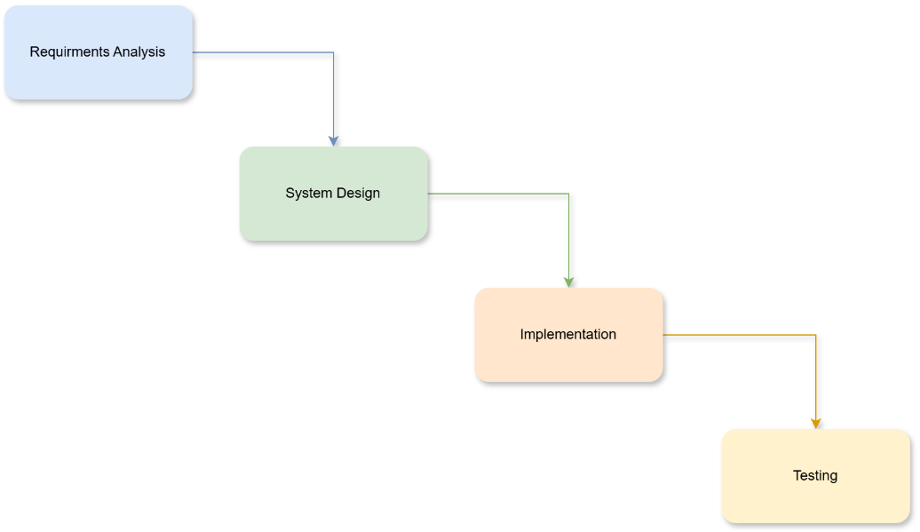

Figure 3.1 Waterfall Model of SDLC

3.1 Requirements Gathering / Analysis
This chapter presents the System Development Life Cycle (SDLC) model used in developing the GeoRoute: Travel Discovery & Planning System in Misamis Oriental. The SDLC provides a structured process that guides the development of an information system from initial planning up to deployment. It ensures that each stage of development is properly analyzed, designed, implemented, and tested before moving to the next phase. Using a systematic model helps minimize errors, improve documentation, and ensure that the final system meets the intended requirements of users.

For this study, the Waterfall Model was used as the development framework. This model follows a sequential process where each phase must be completed before proceeding to the next. It is suitable for this project because the requirements were identified early through interviews, research, and system planning activities. The structured approach of the Waterfall Model also helps maintain clarity in documentation, which is important for academic system development projects

3.1.1 Research Ethics
Ethical considerations were observed during the requirements gathering process. Information collected from respondents was treated with confidentiality and used strictly for academic and system development purposes only. Participation in interviews and data collection was voluntary, and respondents were informed about the purpose of the study.

Respect for data privacy, honesty in documentation, and responsible handling of gathered information were strictly observed. This ensures that the research process maintains integrity while protecting the rights and information of all involved participants.

3.2 Design Phase
The design phase focused on planning how the GeoRoute system will function based on the identified requirements. This includes designing system processes, database structure, user interface layouts, and overall system workflow. Diagrams such as data flow diagrams and entity relationship diagrams were prepared to visualize how information moves within the system and how data will be stored and managed.
This phase also emphasized user experience and accessibility since the system is intended for tourists and travelers. The interface design ensures that users can easily browse destinations, view travel information, plan trips, and access their travel history. Proper system design helps prevent confusion during development and ensures that all components work together effectively.

3.3 Development Phase
During the development phase, the system design was translated into actual implementation through coding and integration of system components. Features such as user accounts, destination browsing, travel planning, and history tracking were developed according to the approved design specifications. This phase focuses on turning design plans into a working system while ensuring consistency with the project objectives. (Architectural Design)

3.4 Testing and Evaluation Phase
The testing and evaluation phase ensured that the system functions correctly and meets the identified requirements. Various tests were conducted to check system functionality, usability, accuracy of information, and overall performance. Errors and issues identified during testing were addressed to improve system reliability.
Evaluation also focused on ensuring that the system provides accurate travel information, smooth navigation, and a user-friendly interface. Proper testing helps ensure that the system is ready for deployment and can effectively support users in discovering destinations and planning their travel within Misamis Oriental.

Functional Requirements

- Role-Based Access Control (RBAC): The system must identify the user’s role
(Guest/Unregistered User, Tourist/Registered User, or Admin) at access and redirect them to the appropriate interface.

- One-to-One Account Validation: The system must check if a tourist account exists and prevent the creation of duplicate accounts.

- Mandatory Security Link: For the "First Entry Login," the system must force users to link a primary email address for password recovery.

- Password Recovery Workflow: If a login fails, the system must provide a Forgot Password path that includes email verification and Admin contact.

- Destination Management: Admins must be able to add, edit, delete destinations, set categories, upload images, and assign status (active/inactive).

- Tourist Destination Portal: Tourists must be able to view and search destinations by category, location, or name, and pin them to plans.

- Travel Tracking: Tourists must be able to track visited destinations in a history/journal with dates, categories, and notes; registered users can also save travel routes for future access.

- User Account Management: Admins must be able to view user accounts

- Statistics Dashboard : The system must provide statistical data on user activity and destination usage in the admin dashboard.

Non-Functional Requirements

- Security: The system must stay idle on the access page if credentials are not validated, protecting the internal interfaces from "intruders/hackers."

- Reliability: The system must maintain high Network Reliability to ensure that active travel plans are not interrupted and data is not lost.

- Usability: Each role must have a distinct UI (e.g., Admin views All Logs while a Tourist only views "Home, Map, Planner, History") to minimize user confusion.

- Availability: The system must be accessible for tourists to search destinations and for admins to manage content at any time.

- Data Accuracy: The system must provide accurate travel information; the Analytics Module must provide regular updates to Admins regarding tourist activity and destination popularity.

Manual Process Flow (BPMN)

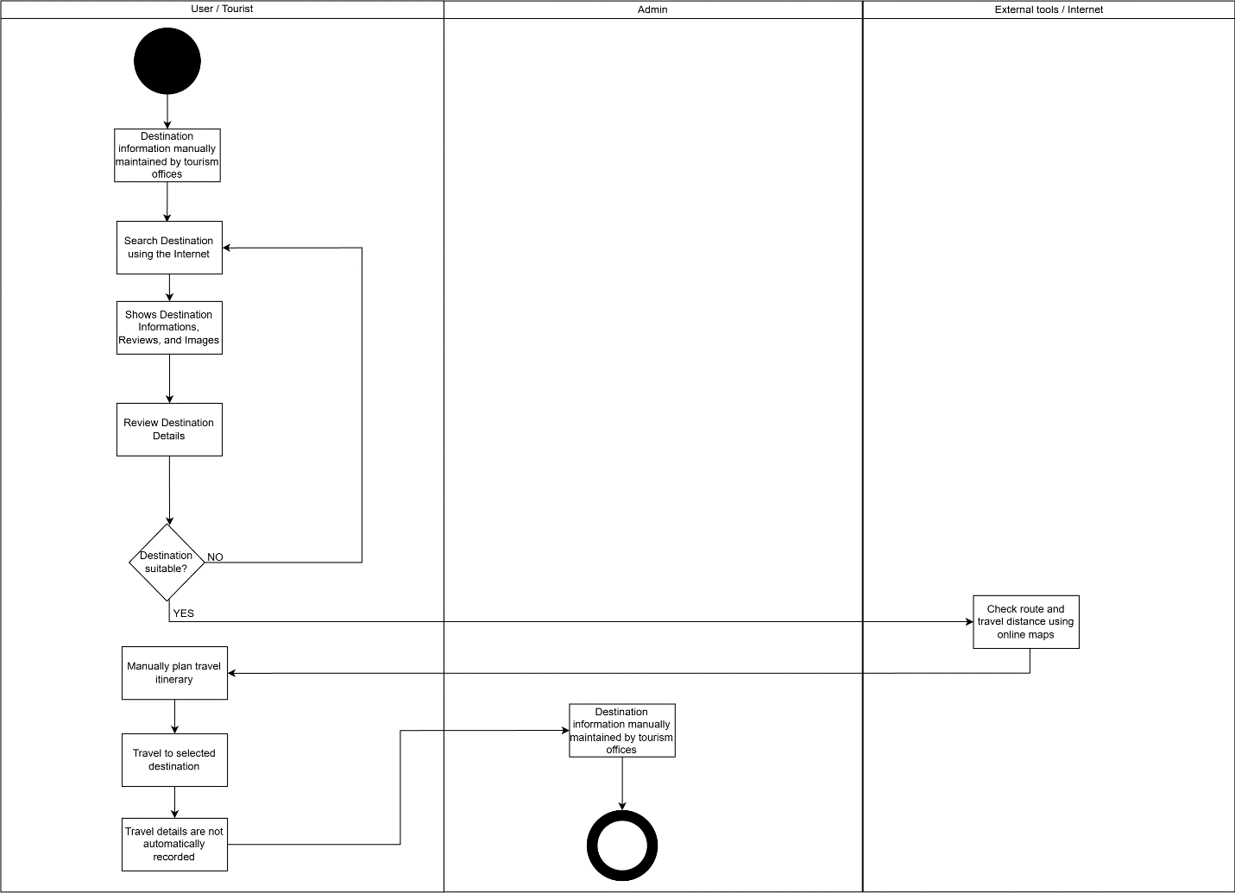

Proposed System Flow (Activity Diagram)

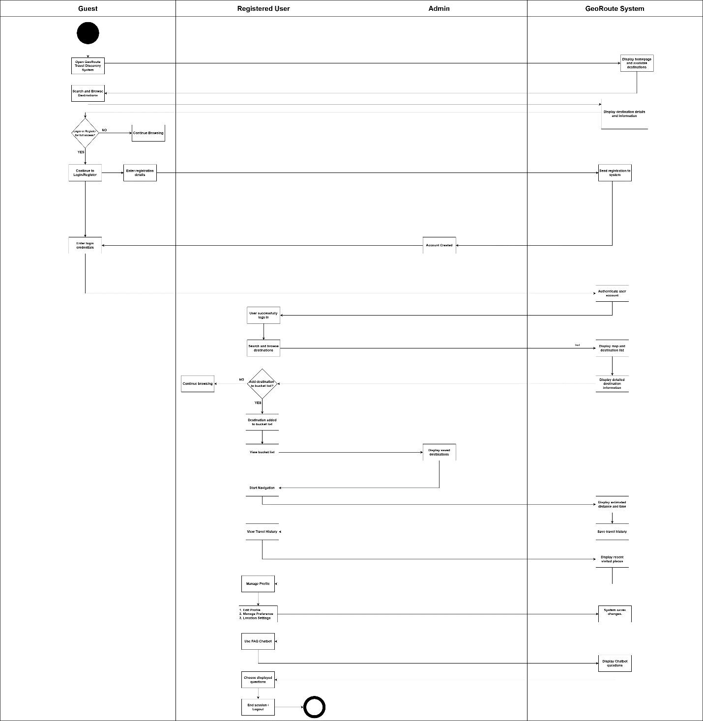

Use Case Diagram

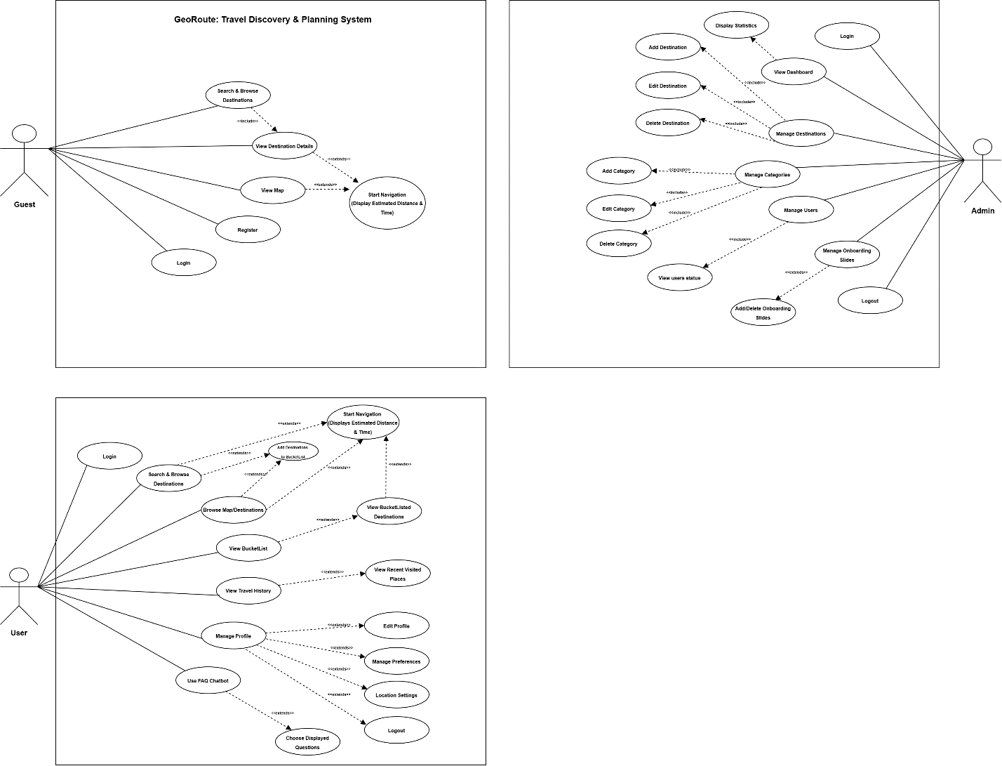

Entity Relationship Diagram (ERD)
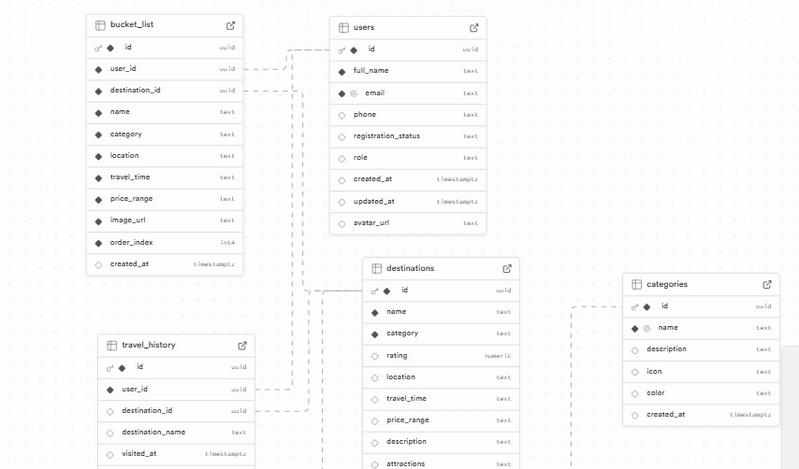
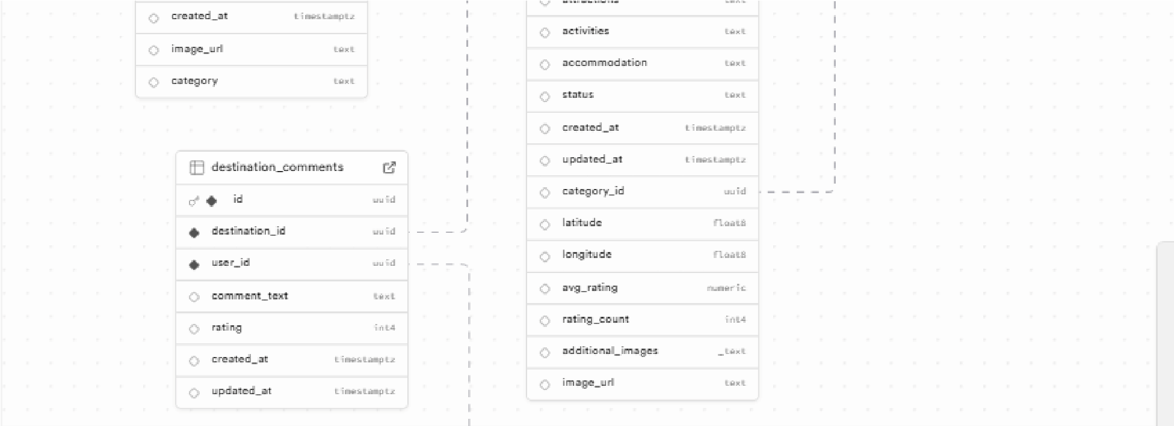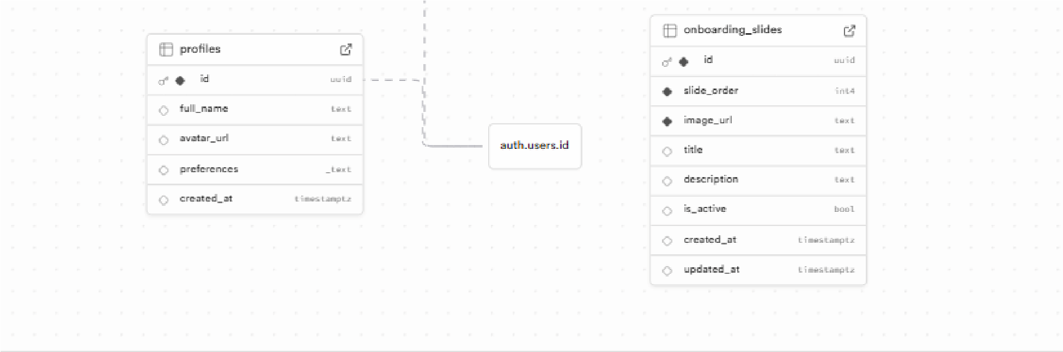
Flowchart
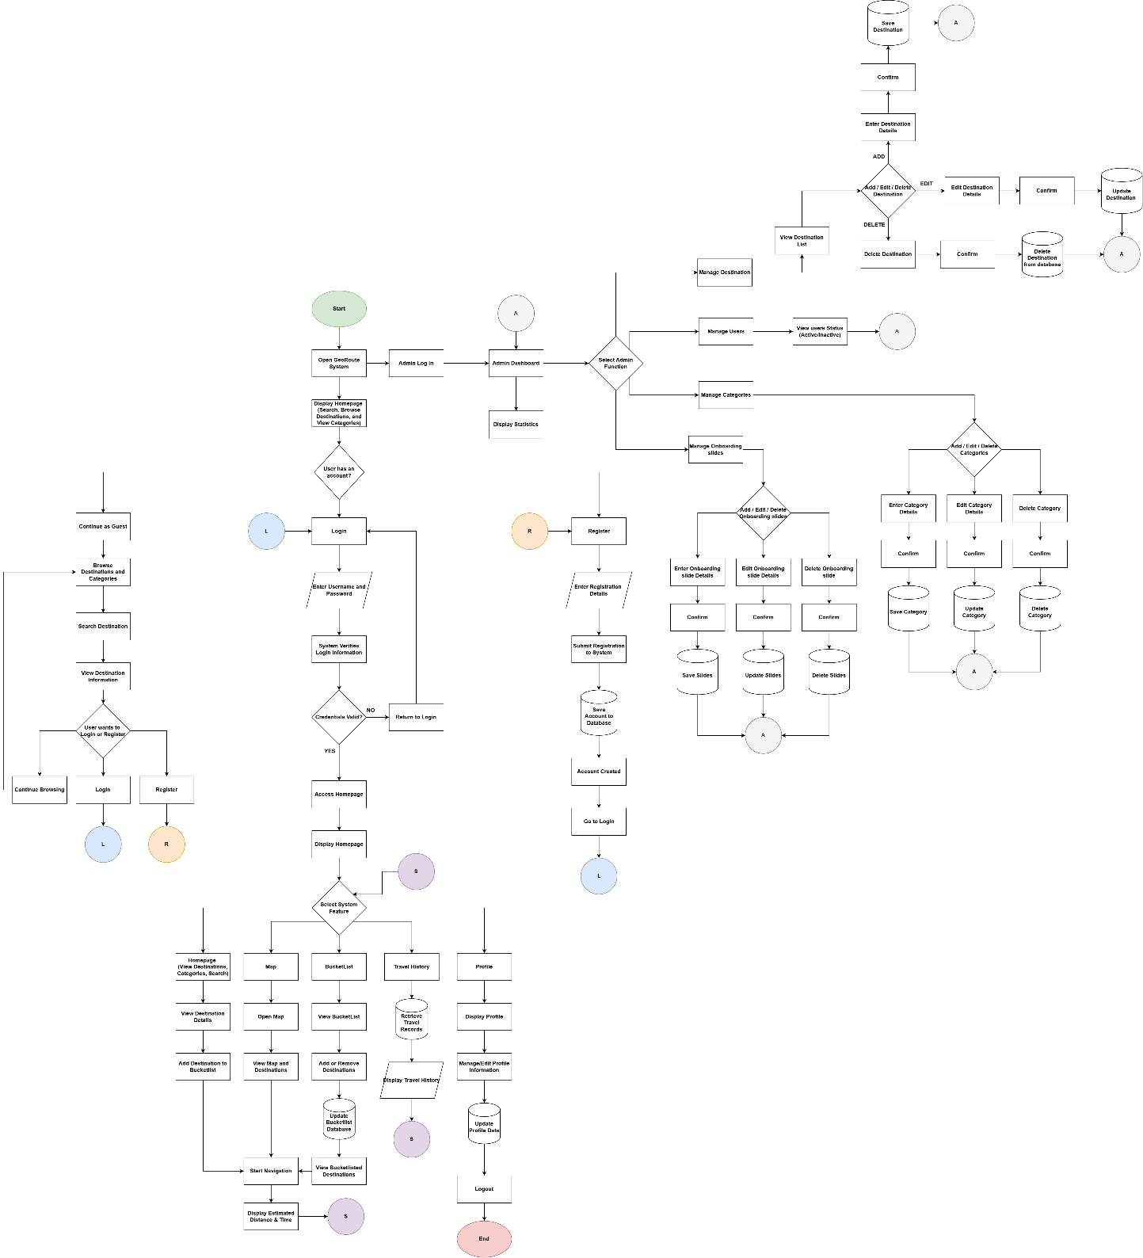

Functionality Testing Results
Login Test Case
Test Case ID | Test Case Description | Remarks
TC1 | Validate user login with correct email and password | Passed
TC2 | Validate user login with incorrect email | Passed
TC3 | Validate user login with incorrect password | Passed
TC4 | Validate login with empty input fields | Passed

Registration Test Case
Test Case ID | Test Case Description | Remarks
TC5 | Register account with valid inputs | Passed
TC6 | Register account with missing required fields | Passed
TC7 | Register account with missing required fields | Passed
TC8 | Register account with already existing email | Passed

Destination & Search
Test Case ID | Test Case Description | Remarks
TC9 | Search destination with valid keyword | Passed
TC10 | Search destination with no matching result | Passed
TC11 | View destination details | Passed
TC12 | Filter destinations by category | Passed

Map Feature
Test Case ID | Test Case Description | Remarks
TC13 | View map with displayed destinations | Passed
TC14 | Select destination on map | Passed
TC15 | Display distance and estimated travel time | Passed

Bucket List
Test Case ID | Test Case Description | Remarks
TC16 | Add destination to bucket list | Passed
TC17 | Add duplicate destination to bucket list | Passed
TC18 | Remove destination from bucket list | Passed
TC19 | View saved bucket list | Passed

Travel History
Test Case ID | Test Case Description | Remarks
TC20 | Save visited destination to travel history | Passed
TC21 | View Travel history | Passed
TC22 | Access travel history with no records | Passed

Profile Management
Test Case ID | Test Case Description | Remarks
TC23 | View user profile | Passed
TC24 | Update profile information with valid data | Passed
TC25 | Update profile with invalid input | Passed
TC26 | Logout account and set status to inactive | Passed

Admin Functions
Test Case ID | Test Case Description | Remarks
TC27 | Admin login with correct credentials | Passed
TC28 | Admin login with incorrect credentials | Passed
TC29 | Add new destination | Passed
TC30 | Edit existing destination | Passed
TC31 | Delete destination | Passed
TC32 | Manage Categories (Add/Edit/Delete) | Passed
TC33 | View list of users | Passed
TC34 | View Statistics dashboard | Passed

FAQ Chatbot
Test Case ID | Test Case Description | Remarks
TC23 | Select predefined FAQ question | Passed
TC24 | Display correct chatbot response | Passed
TC25 | Update profile with invalid input | Passed
TC26 | Select invalid or unrelated question | Passed

