Capstone Companion
A methodology-aware design coach for engineering capstone students
Architecture Design Document — v0.1 (Draft for review)
Companion to “Engineering Capstones — a recipe book” (Sadek & Newland)
Prepared for
Franz Newland
May 2026

Document control
This is a working architecture document. It captures the design of a software tool — provisionally called the Capstone Companion — that would support engineering capstone students through every phase of their project, calibrated to whichever design methodology their team has chosen. It is intended to be read alongside the book Engineering Capstones — a recipe book, from which it draws all of its pedagogical content.

Revision history
Version | Date | Author | Summary of change
v0.1 | 2026-05-14 | Drafted with Claude | Initial architecture for review by Franz and Hossam.

Document conventions
- Requirement IDs use the form FR-NN (functional), NFR-NN (non-functional), and ER-NN (ethical / equity). All are traceable to a book chapter section.
- Architectural decisions use the form AD-NN with rationale and alternatives considered.
- Diagrams follow the in-conversation diagram standard from the systems-engineering skill: context, functional block, phase / swim-lane, decision tree, N². Each is also available as a PNG in the source folder.
- Where the document references concepts the authors have not yet locked down, these are flagged as “open authorial decision” for resolution by Franz and Hossam.

Reading order
Readers short on time should read Section 1 (intent and scope), Section 4 (operating model), and Section 11 (roadmap). Readers needing the build-ready detail should also read Sections 5–8.

Executive summary
Engineering Capstones — a recipe book argues that there is no single right way to run a capstone, and no single right way for a student team to navigate one. The book offers seven design methodologies (System-V, Waterfall, Mechanical Systems Design, CDIO, Design Thinking, UML/OO, Agile) and a course design that organises the experience into four phases — Phase 0 course creation, Phase 1 start-up, Phase 2 running, Phase 3 assessment and closeout — wrapped in three learning philosophies (Mezirow, Freire, Knowles). It is, in the authors’ own framing, a recipe book: a set of patterns for capstone designers and student teams to draw on intentionally, not a single workflow to be applied mechanically.
This document specifies the Capstone Companion, a tool that turns those recipes into structured, on-demand support for the student team while keeping the team in charge of its own design journey. It is a single document specifying a system; nothing is built yet.

The core architectural moves
- 1. Methodology Picker upfront. At project kickoff, the student team profiles its project across four axes (nature of deliverable, partner involvement, openness of brief, novelty of solution) and the tool recommends a primary design methodology and an optional hybrid. The picker is re-runnable at every phase gate.
- 2. Phase Guide as a shared spine. All seven methodologies are decomposed onto a common set of student-facing phases (kickoff → need definition → concept → preliminary design → detailed design → build → V&V → handover). The chosen methodology only changes the emphasis, the vocabulary, and the artefacts surfaced inside each phase — not the phase model itself.
- 3. Course-context as a read-only layer. Students see what their course director and supervisor agreed in Phase 0 / Phase 1 — assessment rubrics, project sourcing, expectations — without being given the levers. This makes the hidden curriculum legible and keeps decision authority where the book places it.
- 4. Reflection on the gates, not as an extra. Every phase exit prompts a structured reflection drawing on Mezirow (transformative learning), Freire (power and voice) and Knowles (adult learner agency). The book treats reflection as constitutive of capstone learning; the tool follows that lead.
- 5. Assessment-evidence builder. What students produce inside the tool becomes evidence against the course's assessment scheme — including the graduate-attribute mappings — rather than a parallel set of artefacts to be re-packaged. This solves the “double work” problem capstone students routinely report.

What this document is not
It is not a build specification, nor a UI design, nor a research protocol. It is the layer between the book and any of those — the architecture a developer, a research student, or a course-design team could each use to do their part. Open authorial decisions for Franz and Hossam are flagged throughout and gathered in Section 10.

1. Introduction

1.1 Purpose
To specify, at architecture level, a software tool that supports an undergraduate engineering capstone student team through every phase of its project, regardless of which of the seven canonical design methodologies in the book the team adopts; that surfaces the relevant course-level context so the student team can act with full visibility of expectations; and that integrates with the assessment framework so its outputs serve as evidence of learning rather than parallel busywork.

1.2 Background — the gap a tool would fill
The book is a recipe book. It explains what good capstone design looks like, gives course directors and student teams a vocabulary, and surfaces options. It does not, and cannot, sit alongside a student team week-by-week as they make decisions, when their faculty supervisor is not present and their TA's office hours are at an awkward time. Yet the most consequential capstone moments — choosing what to design, scoping the work, negotiating with a partner, deciding when a prototype is good enough — happen in exactly those gaps.
A second gap: the book covers seven methodologies because no single one fits every capstone. But a student team that has chosen Agile will not automatically know which book sections apply to their week-3 problem, nor which to skip. The Companion is in part a navigation layer over the book itself — a way for a team to read just what they need just when they need it.
A third gap: the assessment framework in Chapter 9–10 cares about process at least as much as product. Process is hard to evidence after the fact. The tool can quietly capture the process artefacts — decisions, trade studies, reflections, stakeholder interactions — as they happen, so the team's grade reflects what they actually did.

1.3 Scope and boundaries

In scope
- Student-facing support across the full project lifecycle, from kickoff to capstone day.
- Methodology-specific coaching for the seven design frameworks listed in Chapter 3 (System-V, Waterfall, Mechanical Systems Design, CDIO, Design Thinking, UML/OO, Agile), plus a documented hybrid recommendation.
- A read-only course-context awareness layer that exposes the Phase 0 / Phase 1 decisions made by the course-design team (rubrics, deliverable definitions, supervisor agreements, partner-engagement policies).
- Reflection scaffolding and an assessment-evidence builder.

Out of scope (for now)
- Course-director and supervisor-facing tooling for designing the course, sourcing projects, or managing supervisor agreements. These are tracked in Section 11 as candidate future increments.
- Partner / industry-facing tooling for project proposers.
- Institutional integrations beyond hooks into the LMS, library / shop booking, and assessment systems. Implementation of those integrations is downstream of this document.
- Replacing the supervisor or TA relationship. The tool augments — it does not substitute.

1.4 Terminology and abbreviations
Term | Meaning in this document
Capstone team | The 4–8 students assigned to a single capstone project.
Teaching team | Course director(s), faculty supervisors, TAs, and any admin support.
Project partner | The external party (industry, community, research lab) that proposes or sponsors the project.
Phase Guide | The phase-aware coaching spine inside the tool (Module M2).
Methodology profile | The output of the Methodology Picker: chosen primary framework + optional hybrid + per-phase emphasis.
Course-context | The set of decisions made by the teaching team in Phase 0 / Phase 1 (book) that constrain or shape what the student team is expected to do.
GA | Graduate Attribute — Engineers Canada / CEAB framework or equivalent.
FPIC | Free, Prior and Informed Consent. Used here in the sense of treating project partners and any community stakeholders as decision authorities, not consultees.
TRL | Technology Readiness Level — used in this document to describe the tool's own maturity (TRL 1–9), not the maturity of the student-team's project.

2. Stakeholders and users

2.1 System-in-context
The Capstone Companion sits inside a dense stakeholder network. The figure below shows who the tool interacts with and on whose behalf the student team is operating. The student is the primary user; everyone else is a stakeholder whose voice the tool helps the student hear, navigate, or document.
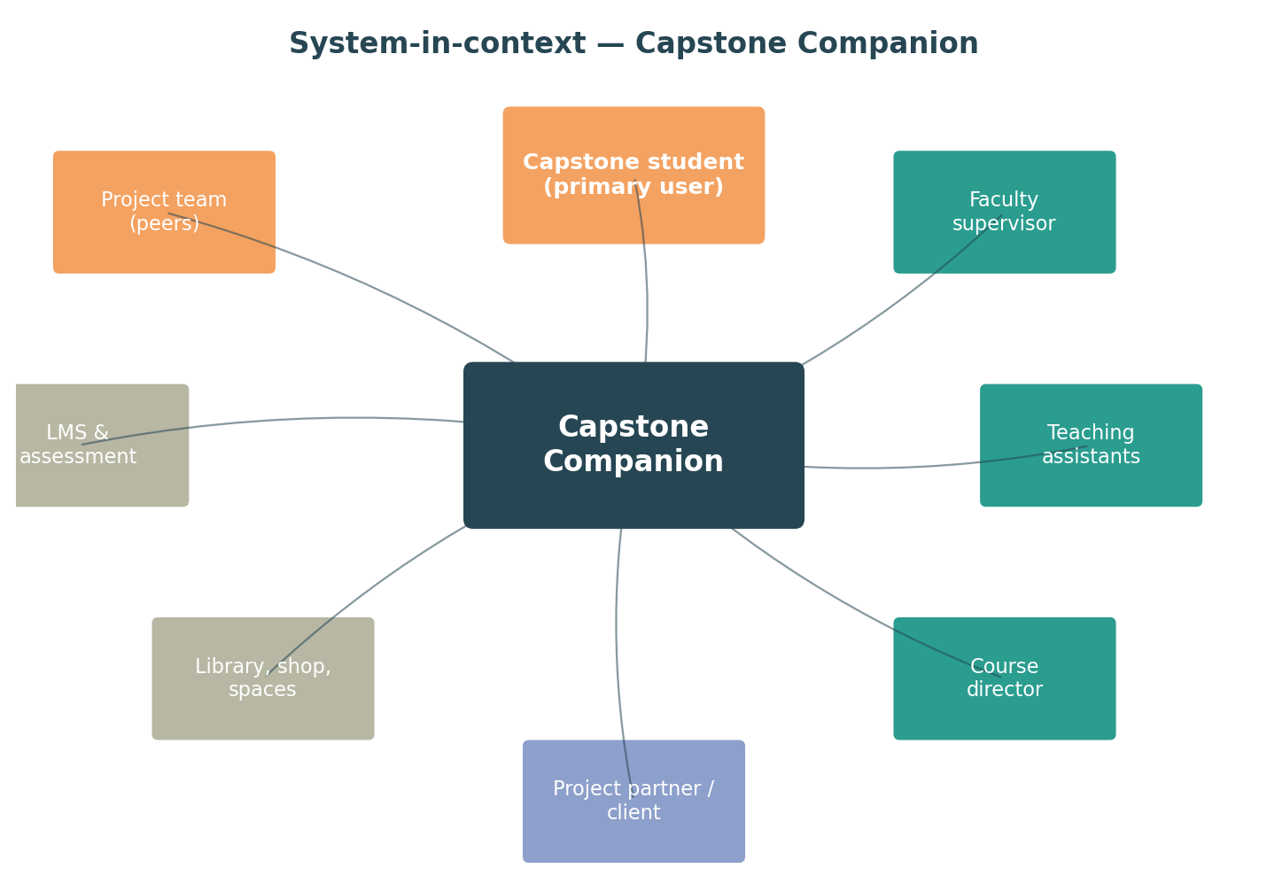
Figure 1. System-in-context — the Capstone Companion within the capstone stakeholder network.

2.2 Primary user — the capstone student
Two student personas are useful for grounding design choices:
Persona A — Priya, the first-year-of-team-lead
Priya is in her final year of mechanical engineering. She has chosen, with her team, a partner-sponsored hardware project. She is comfortable with CAD and the machine shop but has not previously been responsible for negotiating scope with a client, and is anxious about being assessed as much on process as on the artefact. She wants clear waypoints and templates, and a way to know that what she is delivering is what is expected.
Persona B — Sam, the agile software team-member
Sam is on a four-person software capstone with a research-lab sponsor. The brief is open-ended; the team has decided to use Agile. Sam is comfortable with stand-ups and ticket boards but worries that an Agile project will not generate the kind of evidence the course wants for assessment. They need help making their iterative process legible, and they want the reflection prompts to actually help them learn — not just feel like another deliverable.

2.3 Other stakeholders (secondary, but design-shaping)
Stakeholder | What they need from the tool | Tool obligation
Faculty supervisor | Visibility of team progress; a way to give targeted feedback at gates; not to be drowned in notifications. | Surfaces gate artefacts and reflections; supervisor can comment but does not grade through the tool.
Teaching assistant | A way to coach without re-reading every team's full history every week. | Provides a curated week-by-week digest; preserves student authorship.
Course director | Confidence that what the tool prompts students to do aligns with the syllabus, rubrics, and the book chapters chosen for this offering. | Read-only context layer; explicit traceability between tool content and the book chapter set in use.
Project partner | Predictable cadence of contact; clear expectations. | Stakeholder coach (M4) prepares the student for partner interactions; does not communicate with the partner directly.
Examiner / external judge | At capstone day, evidence that grading is consistent and that the team's process is documented. | Assessment-evidence builder (M7) produces a clean evidence pack.
Institution | Compliance with academic integrity policy, accessibility standards, and any FPIC obligations on Indigenous / community partnership projects. | M6 risk / ethics / IP overlay; accessibility baked in to NFR-04.

2.4 Decision authority
The book is clear that capstone power dynamics are messy. The tool deliberately does not concentrate authority: it does not grade, it does not approve partner deals, it does not override supervisor judgement. It does surface where authority sits, and helps the student team operate inside it.
Decision | Authority | Tool role
Course rubrics, syllabus, deliverable definitions | Course director | Display (read-only) in M8 context layer.
Project sourcing and approval | Course director with input from supervisor & partner | Display only.
Methodology choice for this team's project | Student team, advised by supervisor | Recommend via Picker; team decides.
Scope changes mid-project | Student team with partner & supervisor | Document; flag risk implications.
Grading | Teaching team | Produce evidence pack; never grade.
Use of partner's IP / data | Partner (FPIC-style consent) | Prompt student to confirm consent; document.

3. Tool requirements
Requirements are framed against the learning intent of the book and the ISO/IEC/IEEE 15288 Stakeholder Needs and Requirements process. They are intentionally outcome-oriented; constraints on implementation are kept light to preserve future build flexibility.

3.1 Functional requirements
ID | Requirement | Source
FR-01 | The tool shall recommend a primary design methodology (and optional hybrid) based on a project profile supplied by the student team at kickoff. | Ch 3 frameworks; Ch 1 design Qs
FR-02 | The tool shall allow the student team to re-profile their project and re-pick the methodology at any phase gate. | Ch 3 hybrids; Appendix tips
FR-03 | The tool shall present phase-aware guidance, deliverable templates, and rubrics that adapt to the chosen methodology. | Ch 3, Ch 6, Ch 9
FR-04 | The tool shall prompt the student team to identify and engage stakeholders at the cadence appropriate to the chosen methodology. | Ch 4 interactions; Ch 1 voices
FR-05 | The tool shall scaffold a phase-exit reflection drawing on Mezirow, Freire, and Knowles, retain it privately to the student, and offer the student the option to share with the teaching team. | Ch 2 learning philosophies
FR-06 | The tool shall apply risk, safety, ethics, and IP overlays appropriate to the project type, with mandatory checkpoints before any prototype build or partner data use. | Appendix; Ch 8 ethics
FR-07 | The tool shall package student-produced artefacts into an assessment evidence pack mapped to the course's rubric and GA framework. | Ch 9, Ch 10
FR-08 | The tool shall provide a read-only Course-context view summarising the Phase 0 / Phase 1 decisions made by the teaching team for this offering. | Ch 1, Ch 2 lessons learned
FR-09 | The tool shall not initiate communication with project partners on behalf of the student team; partner-facing actions remain student-driven. | Ch 4 partner relations
FR-10 | The tool shall integrate with the institutional LMS for submission of deliverables, where such an LMS is available. | Ch 9 deliverables
FR-11 | The tool shall record an audit trail of methodology changes, scope changes, and gate decisions sufficient for the teaching team to reconstruct the team's journey. | Ch 9, Ch 10
FR-12 | The tool shall, on request, generate a Capstone Day evidence package (poster outline, presentation video brief, individual reflection prompts) per the book Chapter 8 pattern. | Ch 8 capstone day

3.2 Non-functional requirements
ID | Requirement
NFR-01 | The tool shall be usable by a student team without prior systems-engineering training. The Methodology Picker shall complete in under 10 minutes.
NFR-02 | The tool shall function on standard student hardware (laptop, smartphone) and meet WCAG 2.2 AA accessibility guidelines.
NFR-03 | All student-authored content shall remain the IP of the student / team unless the team explicitly grants the institution wider use.
NFR-04 | Reflective content shall be private to the author by default; sharing is opt-in and revocable.
NFR-05 | The tool shall be authored in a content model that is editable by the book authors (or a delegate) without code changes, so a new edition of the book propagates into the tool by content update.
NFR-06 | The tool shall be deployable in three modes: institution-hosted, vendor-hosted, and self-hosted, to accommodate institutional data-residency policies.
NFR-07 | The tool shall not require always-on connectivity for core student workflows; offline drafting with later synchronisation shall be supported.
NFR-08 | The tool shall be internationalisable; the initial release supports English, with French (Canadian) as the next priority.

3.3 Ethical and equity requirements
ID | Requirement
ER-01 | The tool shall not generate content that purports to be a student's reflection or written analysis. AI-assisted drafting may be offered but is clearly labelled and shall be opt-in per institutional academic-integrity policy.
ER-02 | Where a project involves Indigenous or community partners, the tool shall surface FPIC-style consent prompts before data is collected or recorded about people, lands, or knowledge systems. (See systems-engineering skill: UNDRIP / TRC #92 for Canadian-jurisdiction projects.)
ER-03 | Stakeholder coaching shall not encourage extractive partner relationships. The Stakeholder & Interaction Coach (M4) shall prompt the team to consider what the partner is getting in return.
ER-04 | Risk overlays shall include team welfare risks (workload, conflict, mental health) alongside project risks, per Appendix patterns.
ER-05 | The Methodology Picker shall not present non-Western design traditions as supplementary to Western frameworks if the team adds them through the “other” option. They are treated as co-equal methodological alternatives.
ER-06 | Accessibility is a first-class requirement; not an afterthought. Reflection prompts shall be available in spoken / audio mode for students for whom written reflection is a barrier.

3.4 Constraints
- The tool's content model must remain faithful to the book. Where the tool needs to express something the book does not yet cover (for example a hybrid not explicitly discussed), that gap is flagged for authorial review.
- Single-institution pilot before multi-institution release.
- Open licence consistent with the book's CC-BY 4.0 licensing for any content republished from the book.

4. Conceptual operating model
The operating principle of the tool is captured in one sentence: it is a phase-aware, methodology-aware design coach for the student team. Every interaction is conditioned on two things — where the team is in the project lifecycle, and which methodology the team is using. Everything else flows from those two pieces of context.

4.1 The recipe → cooking metaphor
Sadek and Newland call the book a recipe book. The Companion is, by extension, a kitchen. The book contains the recipes. The Companion gives the student team:
- A way to choose which recipe (or hybrid of recipes) to cook this evening (the Methodology Picker).
- A way to follow the recipe at the right pace, with the right tools to hand at the right step (the Phase Guide and Templates).
- A way to taste as they go and decide whether to adjust seasoning (Reflection and gate decisions).
- A way to plate the dish and serve it (Assessment-evidence builder and Capstone Day pack).
- A way to know whose kitchen they're cooking in — what the head chef has said is on the menu (Course-context Awareness Layer).
The metaphor is deliberate. It places the student team in charge of cooking, and the book authors and course director in the role of writing recipes and setting kitchen rules. The tool is the kitchen — well-lit, well-stocked, and not in the way.

4.2 The four design moves, restated
Move 1 — Single phase model, many methodologies
Rather than building seven different workflows, the tool runs on one student-facing phase model (kickoff → need → concept → preliminary design → detailed design → build → V&V → handover). The methodology controls what each phase emphasises, what artefacts are generated, and what vocabulary is used — but never the phase structure itself. This keeps the tool tractable and lets methodology choice be made without restarting the journey.
Move 2 — Course-context as a transparent layer
The book devotes significant space to Phase 0 / Phase 1 decisions by the teaching team. These shape what students experience but are usually invisible. The tool exposes them. Students see why their assessment looks the way it does, why their projects came from particular sources, and what their supervisor agreed to do. This is a deliberate equity move.
Move 3 — Reflection on the gates, not on the side
The book treats reflection as constitutive of capstone learning, drawing on Mezirow (transformative learning), Freire (power and voice), and Knowles (the adult learner). The tool puts reflection at every phase exit, not as an end-of-course exercise. Each prompt names which philosophical framing it draws on, so reflection becomes part of the learning, not separate from it.
Move 4 — Process artefacts as assessment evidence
Process is hard to grade after the fact. The tool captures process while it happens — decisions, trade studies, partner conversations, conflicts and resolutions, scope changes — and produces a clean evidence pack at the end. Done right, this means the team's grade reflects what they did rather than what they remembered to write up.

4.3 Default user journey
A typical first-time user journey through the tool, end to end:
- Team kickoff. The team opens the tool, sees the course-context view, profiles its project, and runs the Methodology Picker. Output: methodology profile and a per-phase emphasis map.
- Need definition. The Phase Guide surfaces methodology-specific templates for stakeholder needs analysis. The team uses them. Reflection at gate exit.
- Concept. Trade study with M3 templates. Picker re-prompts: have the conditions changed? If yes, the team can re-pick.
- Preliminary and detailed design. Phase Guide and Templates dominate. M6 risk / ethics / IP overlay activates as the team approaches first build.
- Build. The tool moves into a lighter-touch coaching mode. Reflection and stakeholder coaching continue.
- V&V. Methodology-specific verification practices surface (TADI for V-model teams, sprint demos and acceptance for Agile, etc.).
- Capstone Day and handover. M7 produces the evidence pack; M5 produces the individual reflection prompts.

5. Methodology Picker

5.1 Why a picker, not a single canonical method
Chapter 3 of the book is explicit: there is no one right design methodology. It presents seven, with the strong claim that capstones routinely benefit from mixing and matching. A tool that imposed a single method would betray the book's argument. A tool that presented seven without help choosing would overwhelm the student team. The Methodology Picker resolves this by being a recommender, not a gatekeeper — it suggests, the team decides, and either party can revisit at any phase gate.

5.2 What the Picker takes as input
The Picker profiles the project across four axes. These were chosen because they are the variables that, between them, predict which design methodology will best fit. The axes are:
Axis | Question to the team | Discrete levels
Nature of deliverable | What kind of thing are you producing? | Hardware / product • Software / data • Process / wicked
Partner involvement | How present is the project partner? | Client (frequent) • SME (occasional) • Informal advisor • None
Openness of brief | How open is the problem statement? | Prescribed • Constrained • Open • Open-ended / problem-finding
Novelty / TRL of solution | Has anyone done this before? | Known solution • Established with adaptation • Novel • Research-grade

5.3 Picker logic
The Picker uses the input profile to recommend a primary methodology and an optional hybrid, with rationale. The decision logic is structured as a primary axis (nature of deliverable) followed by adjustments on the three secondary axes.
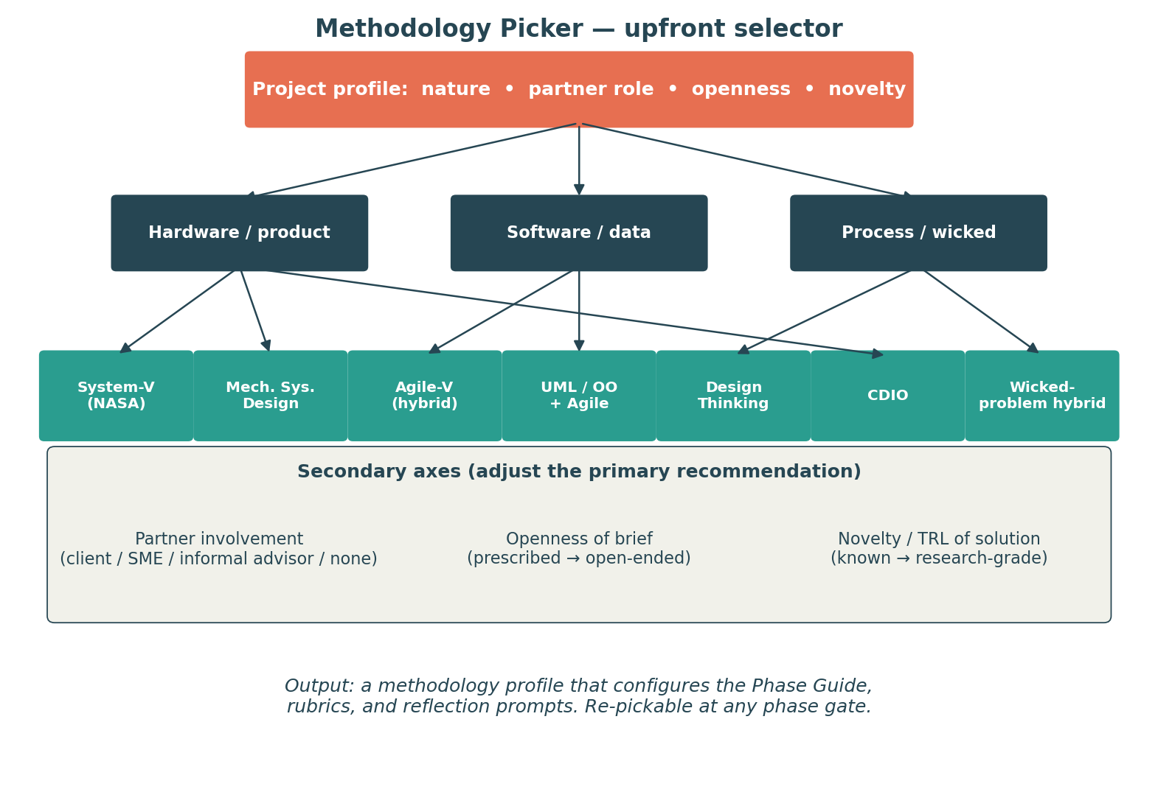
Figure 2. Methodology Picker decision logic — primary axis filters, secondary axes adjust.

5.4 Recommendation rules
The recommendation rules below are the v0.1 starting point. They will be refined by the authorial team based on pilot data.
Profile | Primary recommendation | Optional hybrid layer | Rationale
Hardware product • Client partner • Constrained • Established | System-V | — | Classic structured engineering; verification benefits from gated structure.
Hardware product • Client • Open-ended | Mechanical Systems Design | Design Thinking at need-definition | Need-finding matters; design proceeds through structured product development.
Software / data • Any partner • Open-ended | Agile | UML / OO at architecture | Iteration in face of evolving need; OO architecture keeps coherence.
Process or wicked • Community partner • Open | Design Thinking | Doughnut-Economics / SDG check (M6 overlay) | Need-finding and stakeholder voice are the project, not preliminaries.
Multi-disciplinary system • Mixed novelty | Agile-V hybrid | — | V-model rigour where interfaces must hold; Agile cadence inside subsystems.
Research-grade novelty • Any partner | Hybrid (System-V backbone + Agile build loops) | TRL / MRL gate check (M2) | Novelty demands learning loops; verification needs structure.
Educational design project • Internal partner | CDIO | — | Conceive-Design-Implement-Operate aligns with end-to-end learning intent.

5.5 Picker output — the methodology profile
The Picker emits a methodology profile object containing: primary methodology, optional hybrid layer(s), per-phase emphasis map, recommended deliverable set, and recommended vocabulary. This object is the configuration input to the Phase Guide (M2), Templates (M3), and Assessment-evidence builder (M7).

5.6 Re-picking
The Picker is callable at any phase gate. If the team's context has changed — partner became a client, scope opened up, prototype revealed a wicked dimension — the team re-profiles. The tool diff-checks against the previous profile and shows what would change in the methodology configuration; the team decides whether to commit. Re-picks are logged and surface in the assessment evidence pack as moments of intentional course-correction (a positive process signal).

5.7 Open authorial decisions
- Whether the Picker should also surface non-Western design traditions (Ubuntu, Two-Eyed Seeing, Jugaad, Buen Vivir) as first-class options. Recommendation: yes, treating them as co-equal alternatives per the systems-engineering skill's framework selection guide. Requires authorial work in the book.
- Calibration of the recommendation rules. Suggest doing this against the corpus of past Lassonde capstone projects.
- Whether to offer a “team mood” axis (confidence, prior experience, conflict) — useful but invasive.

6. Phase model and student journey

6.1 One phase model, three lenses
The tool needs to be legible to students, faithful to the book's course-design model, and translatable into standard systems-engineering vocabulary so the team can speak to industry partners on industry terms. The diagram below overlays all three.
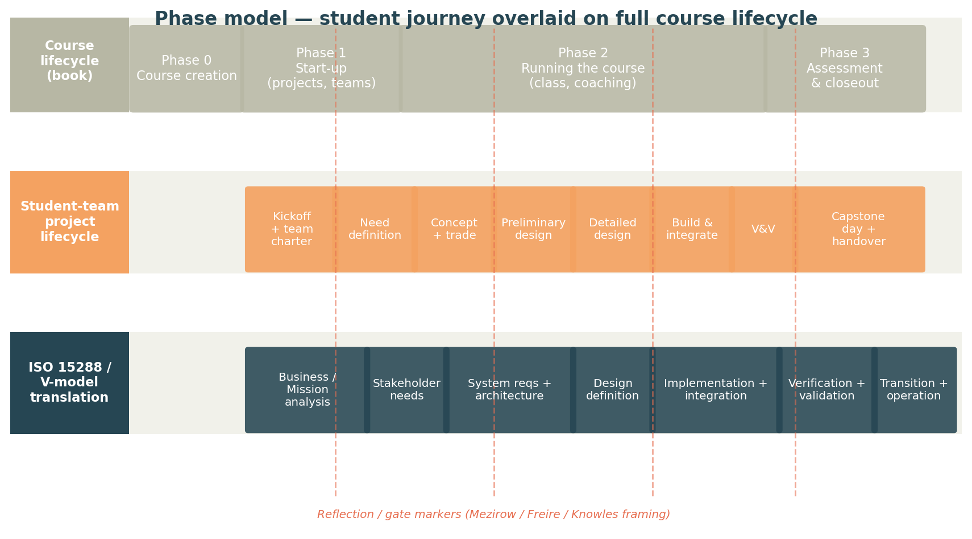
Figure 3. Phase model — the student-team project lifecycle overlaid on the full course lifecycle (book) and on the ISO 15288 / V-model translation that supervisors and industry partners will recognise.

6.2 Student-facing phases
Phase | Student-facing question | Methodology-agnostic exit gate
Kickoff | Who are we, what is the project, and how will we work together? | Team charter signed; methodology profile committed.
Need definition | What is the real need behind the brief? | Stakeholder needs document; partner agreement on the problem statement.
Concept | What might we do? What will we not do? | Trade study with at least three concepts and a documented selection.
Preliminary design | What is our architecture, at a level we can defend? | Preliminary design review (whatever the team calls it); risk register updated.
Detailed design | How exactly will we build it? | Detailed design review; build plan; safety / ethics / IP overlay complete.
Build | Have we made the thing? | Working prototype or working software; integration plan executed.
V&V | Does it do what we said it would? | Verification report; validation against the original need.
Handover | What is the legacy of the project? | Capstone Day artefacts; handover or disposal plan; individual reflections.

6.3 Phase × Methodology — what changes inside each phase
Phases are constant; what the tool surfaces inside them adapts to the chosen methodology. The matrix below shows the default emphasis pattern.
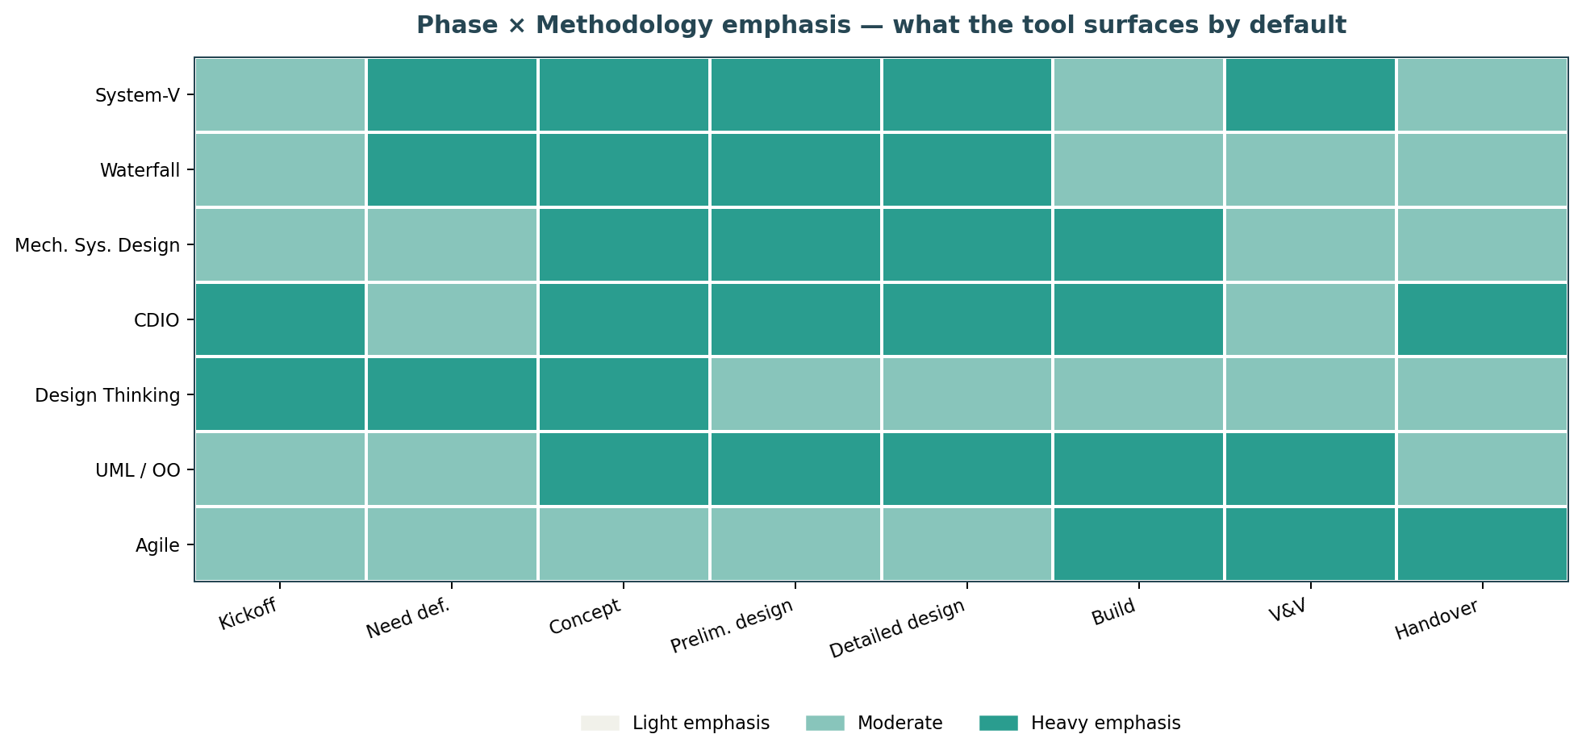
Figure 4. Phase × Methodology emphasis matrix. Cells indicate the relative weight of guidance, templates and assessment cues the tool surfaces by default. The team can override any cell.

6.4 Mapping to course lifecycle
The book's Phase 0 / Phase 1 sit outside the student-team project timeline — they happen before the team arrives. The tool exposes them via M8 (Course-context Awareness Layer) so students know what was decided on their behalf. Phase 2 and Phase 3 of the course overlap with the student team's whole project lifecycle and capstone-day closeout respectively.

6.5 Reflection gates
The tool inserts a reflection prompt at each phase exit. Prompts cycle through three framings:
- Mezirow (transformative). What disorienting moment did you encounter in this phase? What assumption did it surface? What might you do differently next time?
- Freire (power and voice). Whose voice was loudest in this phase? Whose was quietest? What did the team do about it, and what could it do next phase?
- Knowles (adult learner). What did you need to know in this phase that you didn't know coming in? Where did you find it? What does that tell you about how you learn?
Reflections are private by default. The team can choose to share with the supervisor or include selectively in the assessment pack.

7. Component architecture

7.1 Functional decomposition
The tool decomposes into eight functional modules organised in four logical layers: configuration (M1), spine (M2), services (M3–M7), and context (M8).
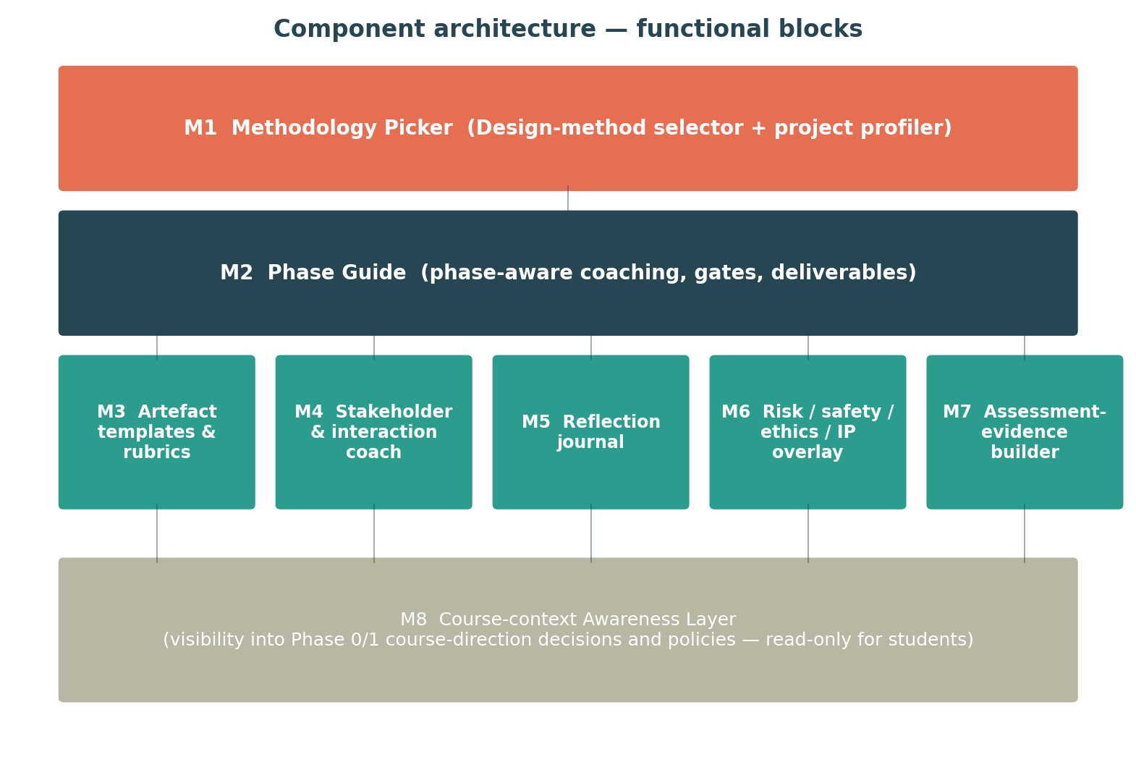
Figure 5. Component architecture — M1 configures M2, which orchestrates the M3–M7 services; M8 supplies course-context to all of them.

7.2 Module responsibilities
Module | Responsibility | Primary book chapters
M1 Methodology Picker | Profile the project; recommend methodology; emit the methodology profile. | Ch 3 frameworks; Ch 1 design questions
M2 Phase Guide | Drive phase-by-phase coaching; manage gate criteria; orchestrate the service modules. | Ch 3, Ch 4, Ch 6
M3 Templates & rubrics | Provide methodology-appropriate templates for deliverables and the rubric scaffolds for self-assessment. | Ch 9, Ch 10
M4 Stakeholder coach | Identify, prioritise, and prepare for stakeholder interactions; surface the nine mentoring functions (Pembridge & Paretti) as a checklist for supervisor conversations. | Ch 4 interactions; Ch 5 stakeholder map
M5 Reflection journal | Hold private reflections; cycle through Mezirow / Freire / Knowles framings; allow opt-in sharing. | Ch 2 learning philosophies; Ch 9 assessing reflection
M6 Risk / safety / ethics / IP overlay | Inject context-sensitive prompts and required checks for safety, ethics, partner consent, IP, and team welfare. | Appendix; Ch 6 ethics
M7 Assessment-evidence builder | Aggregate artefacts and reflections into a rubric-aligned evidence pack; produce Capstone Day deliverables. | Ch 8, Ch 9, Ch 10
M8 Course-context Awareness | Surface (read-only) the Phase 0 / Phase 1 decisions made by the teaching team for this offering. | Ch 1, Ch 2

7.3 Internal interfaces (N² matrix)
The matrix shows how the eight modules talk to each other. Rows are source; columns are destination. Configuration flows are infrequent and propagate methodology / context decisions; data flows are continuous; events are notifications (e.g. "phase exit reached", "risk overlay triggered").
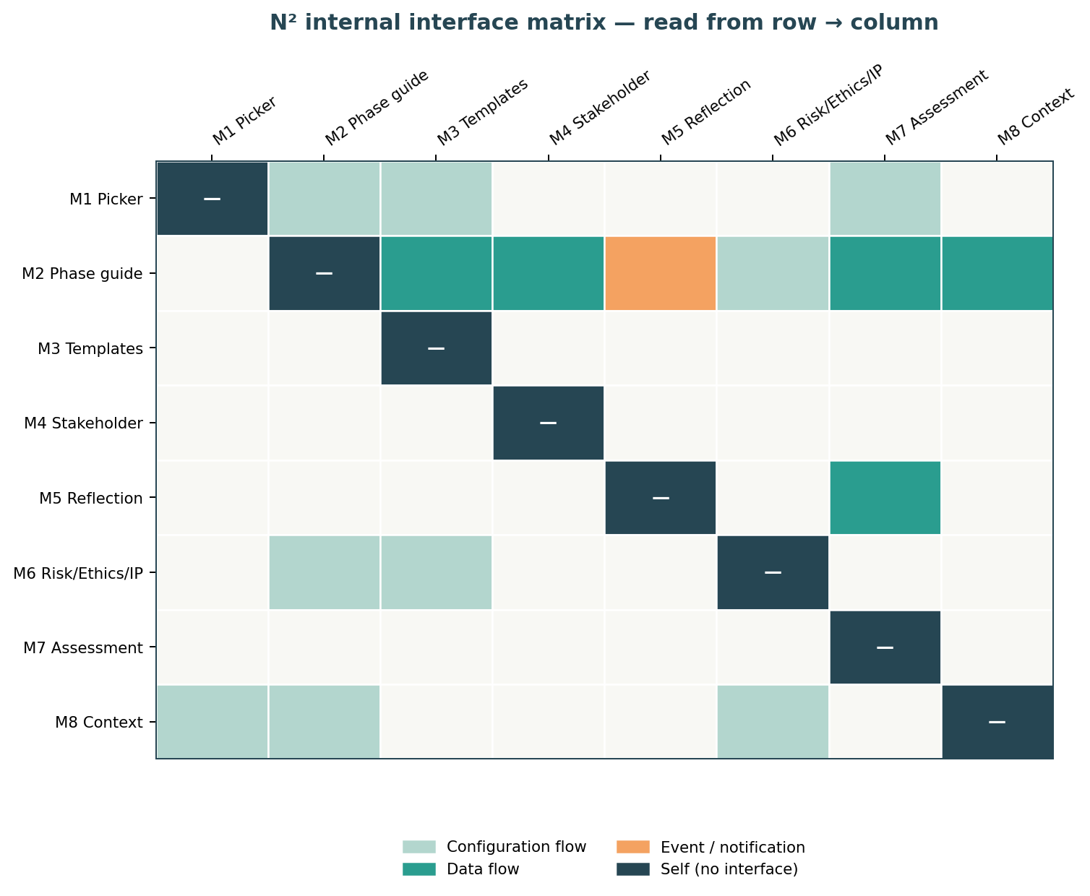
Figure 6. N² internal interface matrix. Read row → column.

7.4 External interfaces
External system | Direction | Purpose | Failure mode tolerance
Institutional LMS (Brightspace, Canvas, Moodle) | Bidirectional | Submit deliverables; pull rubrics / due dates. | Tool functions if LMS offline; submission can be manual.
Library catalogue / databases | Outbound (link) | Surface curated background resources at need-definition. | Tool functions if outage; links degrade gracefully.
Machine shop / workshop booking | Outbound | Surface booking links at build phase. | Tool functions if outage.
Supervisor / partner agreement system | Read-only | Display agreed supervisor / partner commitments. | Defaults to text view.
Identity provider (SSO) | Inbound | Authenticate students. | Required for institution-hosted deployment.
AI assistance (optional) | Outbound | Optional drafting / summarisation assistance, clearly labelled. | Tool functions without it; behind a feature flag.

7.5 Data model (high level)
The tool persists six principal entity types: Team, Project, MethodologyProfile, PhaseState, Artefact, Reflection. All other state derives from these.
Entity | Key fields | Lifetime
Team | members, kickoff date, charter, supervisor link, partner link | Course offering
Project | title, brief, partner, novelty / TRL flag, IP terms | Course offering
MethodologyProfile | primary, hybrid, axis values, version, timestamp | Versioned; latest active
PhaseState | current phase, gate status, gate decisions, gate evidence pointers | Continuous, per project
Artefact | type, methodology tags, phase, author(s), submission status, IP terms | Permanent (until disposal)
Reflection | author, phase, framing (Mezirow / Freire / Knowles), text or audio, share state | Permanent; private by default

8. Content model

8.1 Content schema
All in-tool guidance is structured around a simple schema: every content item is tagged with one or more (phase, methodology, module) triples. This is what makes methodology-aware coaching possible without seven parallel sets of content.
Field | Purpose
id | Stable identifier.
phase | Which phase(s) the item applies to.
methodology | Which methodology profile(s) the item is relevant to (or 'all').
module | Which module surfaces the item (M2 phase guide, M3 templates, M5 reflection, M6 overlay, etc.).
book_ref | Pointer to the book section(s) the content derives from. Required for traceability and CC-BY 4.0 attribution.
author | Person or role who authored the item (book author / course director / community contributor).
version | Versioning for content updates without code release.
lang | Locale code (en, fr-CA, …).
body | The content itself — Markdown with constrained extensions for templates and prompts.

8.2 Authoring responsibilities
Author role | What they produce | Where it lives in the tool
Book authors (Sadek & Newland) | Canonical content for each phase × methodology cell; the seven framework descriptions; reflection prompt library. | Core content packs
Course director (per offering) | Course-context content (rubrics, syllabus extracts, supervisor agreement template, project sourcing notes). | M8 context layer
Supervisors / TAs | Optional notes attached to specific gate criteria for their teams. | Comments on PhaseState
Claude / AI assistant (optional) | Draft suggestions only, clearly labelled, opt-in. | Side-panel; never primary
Student team | All authored artefacts, reflections, decisions. | Artefact, Reflection
Community / Indigenous partners (where relevant) | Co-authored guidance for projects in their domain. | Tagged content with co-attribution

8.3 Traceability to book chapters
Every guidance item must trace to a book section. This is not just attribution housekeeping; it is what allows the tool to be edited by content update when a new edition of the book is released. The mapping below is a starter set — full traceability is appendix material.
Module | Primary book chapter(s)
M1 Methodology Picker | Ch 1 design questions; Ch 3 frameworks
M2 Phase Guide | Ch 3 frameworks; Ch 4 pedagogical interactions; Ch 6 assessment
M3 Templates & rubrics | Ch 9, Ch 10 (assessment)
M4 Stakeholder coach | Ch 4 interactions; Ch 5 stakeholder map; Pembridge & Paretti mentoring functions
M5 Reflection journal | Ch 2 (Mezirow / Freire / Knowles); Ch 9 (assessing reflection)
M6 Risk / Ethics / IP | Appendix tips & tricks; Ch 6 ethics
M7 Assessment evidence | Ch 8 capstone day; Ch 9–10 assessment
M8 Course-context | Ch 1, Ch 2 lessons learned, Ch 11 closeout

8.4 Versioning
Content is versioned independently of code. A content release is signed by the authorial team and propagates to deployments without a new build. This keeps the tool aligned with the book without making book revisions a software release event.

9. Validation & verification (of the tool itself)
A pedagogical tool that has not been validated against learning outcomes is a hypothesis, not a tool. This section specifies how Capstone Companion would be verified (does it do what we said it would?) and validated (does what it does actually improve the student learning experience?).

9.1 Verification approach
Requirement category | Verification method
Functional (FR-01 – FR-12) | Inspection of UI, automated test against documented behaviours, scenario-based walkthroughs.
Non-functional (NFR-01 – NFR-08) | Performance benchmarks, accessibility audit (WCAG 2.2 AA), security and privacy review.
Ethical / equity (ER-01 – ER-06) | Independent review by an ethics-and-equity panel including a student rep, an Indigenous education advisor, and a disability-services representative.
Content fidelity to the book | Sampling audit: 10% of content items checked against the cited book section; full audit on major content releases.

9.2 Validation approach
Three pilot cohorts. Each builds the evidence base for the next.
- Single-team alpha. One real capstone team uses an MVP of the tool for one full project cycle. Daily journaling by the team; weekly debrief with the research lead. Aim: surface usability and conceptual gaps.
- Multi-team beta. 4–6 teams in one cohort use the tool alongside a control cohort of similar projects without it. Mixed-methods evaluation: assessment outcomes, time-to-deliverable, partner satisfaction, student wellbeing measures. Aim: surface comparative value.
- Multi-institution release. Three institutions, with explicit attention to differences in course design (small / large cohorts; mandatory / elective; multi-disciplinary / single-discipline). Aim: surface contextual fragility before wider release.

9.3 Success criteria for validation
- Students complete the Methodology Picker in under 10 minutes and report (≥80%) that the chosen methodology matched what their supervisor or partner would have advised independently.
- Phase Guide use correlates with on-time deliverable submission (no causal claim, but correlation absent would be a red flag).
- Reflection completion rate ≥ 70% at each phase gate, with reflections rated as substantive (not superficial) by independent coders ≥ 60%.
- Assessment-evidence pack reduces marking time for the teaching team by ≥ 25% without reducing inter-rater agreement.
- No widening of the achievement gap by gender, mode of entry, language background, or disability status. (Equity is a stop-the-line criterion.)

9.4 Re-validation cadence
Validation is not a one-time gate. Each new edition of the book, each new institutional deployment, and each major content release triggers a re-validation appropriate to its scope (sampling audit, content-fidelity check, or full validation sub-study).

10. Risks and open questions

10.1 Risk register (development and deployment)
ID | Risk | Likelihood | Impact | Mitigation
R-01 | Scope creep: the tool tries to serve supervisors / course directors / partners too soon and dilutes the student focus. | High | High | Lock primary user as student in v1; ringfence supervisor / course-director work as v2 increments per Section 11.
R-02 | Methodology Picker recommendations are wrong often enough that teams stop trusting it. | Medium | High | Calibrate against past projects in alpha; expose rationale so teams can override; track override rate.
R-03 | Reflection prompts feel like busywork and are completed superficially. | Medium | High | Design with students; vary framing; allow audio reflection; make reflection visibly count in assessment evidence.
R-04 | Tool becomes a venue for academic-integrity issues (AI-generated reflections, plagiarised artefacts). | Medium | High | ER-01 policy; clear labelling of AI assistance; institution-specific opt-in for AI features.
R-05 | Course directors resent the tool as a constraint on their pedagogical freedom. | Medium | Medium | M8 is read-only consumer of their decisions, not authority over them; co-design the M8 schema with a course-director advisory group.
R-06 | Tool entrenches a hidden curriculum: methodology recommendations privilege Western frameworks. | Medium | High | ER-05; authorial work to include non-Western methodologies as first-class; community co-authorship for relevant content.
R-07 | Privacy concerns about reflection content used in assessment. | Medium | High | FR-05; NFR-04; institutional review.
R-08 | Tool requires institutional integration work that becomes the rate-limiting step. | High | Medium | Offer all three deployment modes (NFR-06); ship with mock LMS integration so pilot is unblocked.
R-09 | Book is updated and tool content lags, eroding fidelity. | Medium | Medium | NFR-05; content versioning; authorial sign-off process.
R-10 | Tool is built but never used: teams discover it in week 3 and have already started their own systems. | High | High | First-week onboarding by course director; methodology picker doubles as kickoff activity in syllabus.

10.2 Open authorial decisions
- Whether to surface non-Western design traditions as first-class options in the Picker (recommendation: yes; requires book content).
- How to handle hybrid methodologies that are not fully discussed in the book yet (e.g. Agile-V; System-V + Design Thinking front-end). Recommendation: document them as v0.1 hybrids; promote to first-class in next edition.
- Whether the tool should include a “team mood” / interpersonal layer (overlap with M4 stakeholder coach; risk of invasiveness).
- How the tool relates to graduate-attribute mapping (CEAB / Engineers Canada). Recommendation: M7 produces a GA evidence map per offering; the mapping itself is course-director-owned.
- Whether to translate the seven core methodologies into ISO 15288 / NASA SE / ECSS vocabulary for industry-partner-facing artefacts (Recommendation: yes, via a transparent translation table in M3 templates).
- Licensing of generated artefacts: default to team IP; default to CC-BY 4.0 for any aggregated, anonymised analytics. Confirm with institutional policy.

11. Roadmap — staged delivery
The tool is described here at the level of ambition needed to express its full architecture. It would not, and should not, be built all at once. The staged delivery below uses a TRL-style framing for the tool itself — TRL 1–3 is concept; TRL 4–6 is single-institution pilot; TRL 7–9 is multi-institution operational. Each stage has a minimum viable shape; each is independently valuable.

11.1 TRL 1–3 — Concept and breadboard (3–6 months)
What's built | What's demonstrated | Decision at exit
Paper / Figma prototype of M1 (Picker) and M2 (Phase Guide). Content sourced directly from book chapters with permission. No persistence; no integrations. Tested with 2–3 student teams in conversational walk-throughs. | Conceptual viability; methodology picker logic plausible; content model survives contact with student teams. | Go / no-go to single-institution pilot.

11.2 TRL 4–6 — Single-institution pilot (12 months)
What's built | What's demonstrated | Decision at exit
MVP build of M1, M2, M3 (templates), M5 (reflection), M7 (evidence builder) — minimal versions of each. M4, M6, M8 represented as static content. Used by 4–6 capstone teams alongside a control cohort. Equity-aware evaluation per Section 9.3. | Validation against learning outcomes; no widening of the achievement gap; teaching-team time-saving on grading. | Go / no-go to multi-institution release.

11.3 TRL 7–9 — Multi-institution operational (24+ months)
What's built | What's demonstrated | Decision at exit
Full module set; production-grade integrations; community-author contributions; full content authoring tools for the book authors; French (Canadian) localisation. Three institutions running concurrently. | Robustness across course-design variants; sustained content / institutional fit; book authors maintain content without developer involvement. | Sustainability decision: institutional, vendor, or community-stewardship model.

11.4 Build options at each TRL stage
- At TRL 1–3: paper / Figma prototype, no engineering investment. Authoring effort dominates.
- At TRL 4–6: lightweight web application (e.g. Next.js, Supabase) for one institution. Single team can build.
- At TRL 7–9: vendor-built or community-stewarded codebase with an open-content licence. Likely requires a small product team.

12. Architectural decisions log
Architectural decisions captured at this iteration. Each entry records the decision, the alternatives considered, and the rationale. They are explicit invitations for review; any of them can be revisited.

AD-01 Student is the sole primary user in v1
Alternatives: include supervisors as co-primary; include course directors. Decision: defer both to v2 increments. Rationale: clarity of design focus, avoids feature creep, aligns with the user answer to the initial scoping question. Trade-off: tool will not solve all capstone problems in v1.

AD-02 One phase model, methodology variations
Alternatives: a separate workflow per methodology; no fixed phases (pure Agile-style emergent flow). Decision: single phase model with methodology-aware emphasis. Rationale: book argues for hybrids and re-picking, which is impossible if methodology equals workflow; assessment frameworks generally assume gated structure.

AD-03 Methodology Picker upfront with re-picking allowed
Alternatives: methodology agnostic from start; one mandatory methodology per course offering. Decision: upfront picker with re-picking. Rationale: per user choice (Section 0); honours book's argument that real capstone projects shift methodology over time.

AD-04 Course-context as a read-only layer
Alternatives: include course-director authoring inside the tool; ignore Phase 0 / 1 content. Decision: read-only view. Rationale: makes hidden curriculum visible without diluting student focus; keeps decision authority with the course director.

AD-05 Reflection on the gates, not on the side
Alternatives: end-of-course reflection; weekly journal. Decision: per-phase-gate reflection with Mezirow / Freire / Knowles framings. Rationale: book treats reflection as constitutive; gate timing makes reflection actionable for the next phase.

AD-06 Content versioned independently of code
Alternatives: bundle content with code releases. Decision: independent content versioning. Rationale: NFR-05 — book revisions should not require software releases; authorial team must be able to update content.

AD-07 Three deployment modes from day one of operational release
Alternatives: single hosted model. Decision: institution-hosted, vendor-hosted, self-hosted (NFR-06). Rationale: institutional data-residency varies; multi-institution adoption requires flexibility.

AD-08 No partner-facing communication on student's behalf
Alternatives: tool sends emails, books meetings with partner. Decision: no. Rationale: partner relationships are pedagogical territory; the tool prepares the student to communicate, it does not communicate for them.

13. References and traceability

13.1 Primary book content
Sadek, H., & Newland, F. (2026). Engineering Capstones — a recipe book. CC-BY 4.0. Chapters drawn on: Ch 1 (capstone design questions), Ch 2 (preparing for capstone; learning philosophies), Ch 3 (frameworks part 1 — System-V, Waterfall, MSD, CDIO, Design Thinking, UML/OO, Agile), Ch 4 (pedagogical and class interactions), Ch 5 (resources and spaces), Ch 6 (deliverables and assessment), Ch 8 (Capstone Day and wrap-up), Appendices (tips, tricks, troubleshooting).

13.2 Systems-engineering standards
- ISO/IEC/IEEE 15288:2023 — Systems and software engineering — System life cycle processes.
- INCOSE Systems Engineering Handbook v5.0.
- NASA Systems Engineering Handbook (NPR 7123.1D).
- ECSS-E-ST-10C — Space engineering: System engineering general requirements.
- Trade studies and N² interface analysis as described in the systems-engineering skill methods files.

13.3 Pedagogical references
- Mezirow, J. (1991). Transformative Dimensions of Adult Learning.
- Freire, P. (1970). Pedagogy of the Oppressed.
- Knowles, M. (1980). The Modern Practice of Adult Education.
- Pembridge, J. & Paretti, M. (2011, 2019). Mentoring functions in the capstone course.
- Angel et al. (2022); Rasul et al. (2016) on capstone assessment design.

13.4 Traceability matrix (starter)
Every requirement should trace to (a) a book chapter section and (b) the validation activity that would confirm it. The matrix below is a starter; full traceability is to be completed by the authorial / development team.
Requirement | Book source | Validation activity
FR-01 Picker recommendation | Ch 3 frameworks | Picker calibration study (Section 9.2 alpha)
FR-05 Reflection scaffolding | Ch 2 philosophies; Ch 9 reflection | Reflection-quality coder study (Section 9.3)
FR-07 Evidence pack | Ch 9, Ch 10 | Marking time / inter-rater study (Section 9.3)
ER-02 FPIC prompts | Appendix; systems-engineering skill UNDRIP guidance | Ethics panel review (Section 9.1)
NFR-02 WCAG 2.2 AA | — | Accessibility audit

Appendix A — Sample Picker interaction
A sample first run through the Methodology Picker for the team described in Persona B (Sam's software team).
Q1 — Nature of deliverable
“Mostly software, with a small data-engineering component.” Selected: Software / data.
Q2 — Partner involvement
“Research lab; we'll have monthly check-ins.” Selected: SME (occasional).
Q3 — Openness of brief
“They've told us the problem domain. We choose the approach.” Selected: Open.
Q4 — Novelty
“There are papers but no working tools we can find.” Selected: Novel.
Recommendation
Primary: Agile. Optional hybrid: UML / OO at architecture (to preserve interface coherence given the data-engineering component). Rationale: open brief with an SME partner and novel solution favours iterative discovery; the data-engineering component benefits from explicit interface design. Re-pick suggested at end of concept phase.

Appendix B — Phase × Framework excerpt
A short worked excerpt from the content schema for the Concept phase. The full content set is appendix material to be authored by Sadek & Newland.
Methodology | What the Phase Guide surfaces in Concept | Required artefacts
System-V | Functional decomposition; concept-of-operations sketches; preliminary requirements. | Concept-of-operations; trade study with ≥3 concepts.
Waterfall | Concept document with full intended scope; first-cut requirements. | Concept document; assumptions log.
Mech. Sys. Design | Customer / user needs translation into engineering characteristics (QFD-style). | House-of-quality; concept sketches.
CDIO | Conceive-stage outputs: stakeholder needs, system context, top-level architecture. | Conceive-stage portfolio entry.
Design Thinking | Empathy synthesis → How Might We → ideation → low-fidelity prototype. | Empathy map; HMW board; ≥10 ideas; one prototype.
UML / OO | Use-case identification; domain model first cut; component sketches. | Use-case diagram; domain model.
Agile | Initial product backlog; one or two user stories elaborated; sprint cadence agreed. | Product backlog; sprint 0 plan.

Appendix C — Sample reflection prompts
Three prompts per framing, illustrative only.

Mezirow (transformative)
- This phase, what was the moment when something you took for granted stopped working?
- What assumption did your team carry into this phase that you would now phrase differently?
- What is something you would tell your week-1 self about this phase?

Freire (power and voice)
- Whose voice shaped the decisions in this phase — and whose was missing?
- How did your team handle disagreement? What does that tell you about how you decide?
- If your project partner could change one thing about how this phase went, what would they choose?

Knowles (adult learner)
- What did you need to learn for this phase that no course had taught you? Where did you find it?
- How did your prior experience help or hinder you here?
- What kind of learning environment did your team create this phase — and is it the one you wanted?

Appendix D — Graduate Attribute mapping (placeholder)
Open authorial decision. The full mapping between Capstone Companion artefacts and the Engineers Canada / CEAB Graduate Attributes is to be authored by Franz and Hossam in consultation with the relevant programme committees, and embedded in M7 as the offering's GA evidence map. The structure below is a placeholder.
GA # | GA name (Engineers Canada) | Likely tool evidence source
GA1 | A knowledge base for engineering | M3 templates; trade studies
GA2 | Problem analysis | Need definition artefacts; concept phase
GA3 | Investigation | Concept and detailed-design phase artefacts
GA4 | Design | Phase Guide outputs throughout
GA5 | Use of engineering tools | Build phase artefacts
GA6 | Individual and team work | M4 stakeholder coach; charter; team-conflict log
GA7 | Communication | M7 evidence pack; reports; presentations
GA8 | Professionalism | M6 risk / ethics overlay outputs
GA9 | Impact of engineering on society and the environment | M6 overlay; reflection prompts
GA10 | Ethics and equity | M6 overlay; ER-02 / ER-05 outputs
GA11 | Economics and project management | Phase gates; risk register; resource decisions
GA12 | Lifelong learning | Reflection journal across the whole project

Appendix E — Glossary
Term | Definition
FPIC | Free, Prior and Informed Consent. The principle, established in UNDRIP and adopted in Canadian law via Bill C-15 (2021), that Indigenous peoples are decision authorities for projects affecting their lands, resources, or knowledge. The Companion uses the term more broadly to mean: consent is the criterion, not satisfaction, for any partner / community.
GA | Graduate Attribute. The Engineers Canada / CEAB framework's 12 attributes that an accredited engineering programme must demonstrate its graduates possess.
ISO 15288 | The international standard for systems and software engineering lifecycle processes. Used in this document as the cross-walk standard for translating between methodologies and industry vocabulary.
LMS | Learning Management System — Brightspace, Canvas, Moodle, etc.
MBSE | Model-Based Systems Engineering. Out of scope for v1 of the Companion, but a candidate addition for advanced students.
N² matrix | An interface analysis matrix used in systems engineering to map data, configuration and event flows between components. Used in Section 7.3.
TADI | Test, Analyse, Demonstrate, Inspect — the four verification methods used in V-model and ECSS verification.
TRL | Technology Readiness Level (1–9). Used in this document only to describe the maturity of the Companion itself.
V-model | A representation of the systems-engineering lifecycle as a V-shape with design phases on the left, build at the bottom, and verification/validation phases ascending on the right.
— end of architecture document —

