Engineering Capstones
Programme Plan
Book • Tool • Community of Practice
An integrated programme to take the recipe book to first full draft, build the companion tool, and design both to serve capstone learning across multiple audiences

v0.1 (Draft for review)
Prepared for Franz Newland
May 2026

Document control
This is a working programme plan for the Engineering Capstones programme. It covers two deliverables — a book (first full draft and beyond) and a companion tool (architecture defined separately) — and frames them inside a wider programme that includes audience expansion (multidisciplinary, graduate, continuing education, community learning), a unified content engine that keeps book and tool in sync, and the governance / contributor network that would sustain both over time.
It builds on the Capstone Companion Architecture Design Document (v0.1) and assumes that document is read in conjunction with this one. Where the two diverge, the architecture document is treated as the technical spec for the tool, and this plan extends its scope to cover the full programme.

Revision history
Version | Date | Author | Summary
v0.1 | 2026-05-14 | Drafted with Claude | Initial integrated programme plan for review by Franz and Hossam.

How to read this document
It is structured for two different reading paths.
Short read (≈ 20 minutes)
Read the Executive Summary (Section 1), the Programme vision figure (Section 2), the Audience map figure (Section 3), the Programme phases figure (Section 7), the candid answer to “is this too much?” (Section 11), and the first-90-days backlog (Section 14).
Full read (≈ 2 hours)
Read end to end. Sections 4–9 are the granular workstream-by-workstream plan; Section 10 is the critical-path analysis; Sections 11–14 are the decision-shaping content. Appendices give chapter-by-chapter book status, the content schema in full, and the research-student thesis outline.

Companion artefact
This document is accompanied by an interactive Programme Dashboard (HTML) that renders the same phase model and workstream backlog as a live, filterable view. The dashboard is intended to evolve into the tool's own programme-awareness layer once the tool is built. Both artefacts are versioned together; the dashboard reads its data from the same content engine the book and tool will.

1. Executive summary
Franz, you asked for two things and a strategic question. The two things: get the book to a first full draft, and build the companion tool. The strategic question: could the tool also serve C4-style multidisciplinary capstones, graduate-level integrative projects, continuing education, and community learning — and would that be too much?
Short answer to the strategic question, before the long answer: no, the wider scope is not too much, on three conditions. First, the programme has to be unconstrained in time as you've set it. Second, the work has to be planned as a platform — book, tool, and community of practice as three faces of one content engine — rather than as three independent projects. Third, the multi-audience expansion has to be paced behind the engineering-capstone foundation, not run alongside it. Sections 2, 3, and 11 unpack each of these.

The programme in one paragraph
Over four to five years, the authoring team (Franz, Hossam, a research student, and a growing contributor network) builds a single content engine that produces three faces: the book (CC-BY 4.0, multiple output formats), the companion tool (web application supporting students, teaching teams, admins, and partners across the engineering-capstone, multidisciplinary, graduate, continuing-education, and community-learning audiences), and a community of practice (advisory board, contributors, FPIC relationships with community partners). A research student's PhD or MASc thesis is embedded in the tool-build and validation work. The programme proceeds through five phases gated by four explicit go/no-go decisions; the critical path runs through the book's first full draft, the content engine's set-up, and the tool's TRL-5 alpha pilot.

What is in this plan
- A vision figure (book / tool / community as three faces of one engine).
- An audience map showing how the book core extends into four expansion rings, with four personas at every ring.
- A content sync architecture showing how authoring once propagates to all three faces.
- Seven workstreams (book, tool, content engineering, audience expansion, research, engagement, governance) each with its own work breakdown.
- A five-phase programme model with four explicit gates.
- A critical-path analysis identifying content engineering as the choke point shared by book and tool.
- A RAID register (risks, assumptions, issues, dependencies) with mitigations.
- A candid answer to “is the wider scope too much?” with the conditions under which it is, and is not.
- A first-90-days backlog that can be started before the research student arrives.

What this plan is not
It is not a detailed schedule with hard dates — you asked for plan-to-quality without a time gate, and binding the work to dates this early would be false precision. It is not a budget — funding model is discussed in Section 12 but not costed. It is not a research protocol for the embedded thesis — the research student will need to author that themselves under their supervisor's direction. And it does not specify how to author the tool's user interface — the architecture document does, at the level appropriate to that document.

2. Vision — three outputs, one engine
The single most consequential design move in this programme is treating the book, the tool, and the community of practice as three outputs of one content engine — not as three projects to coordinate. The figure below shows the architecture of that move.
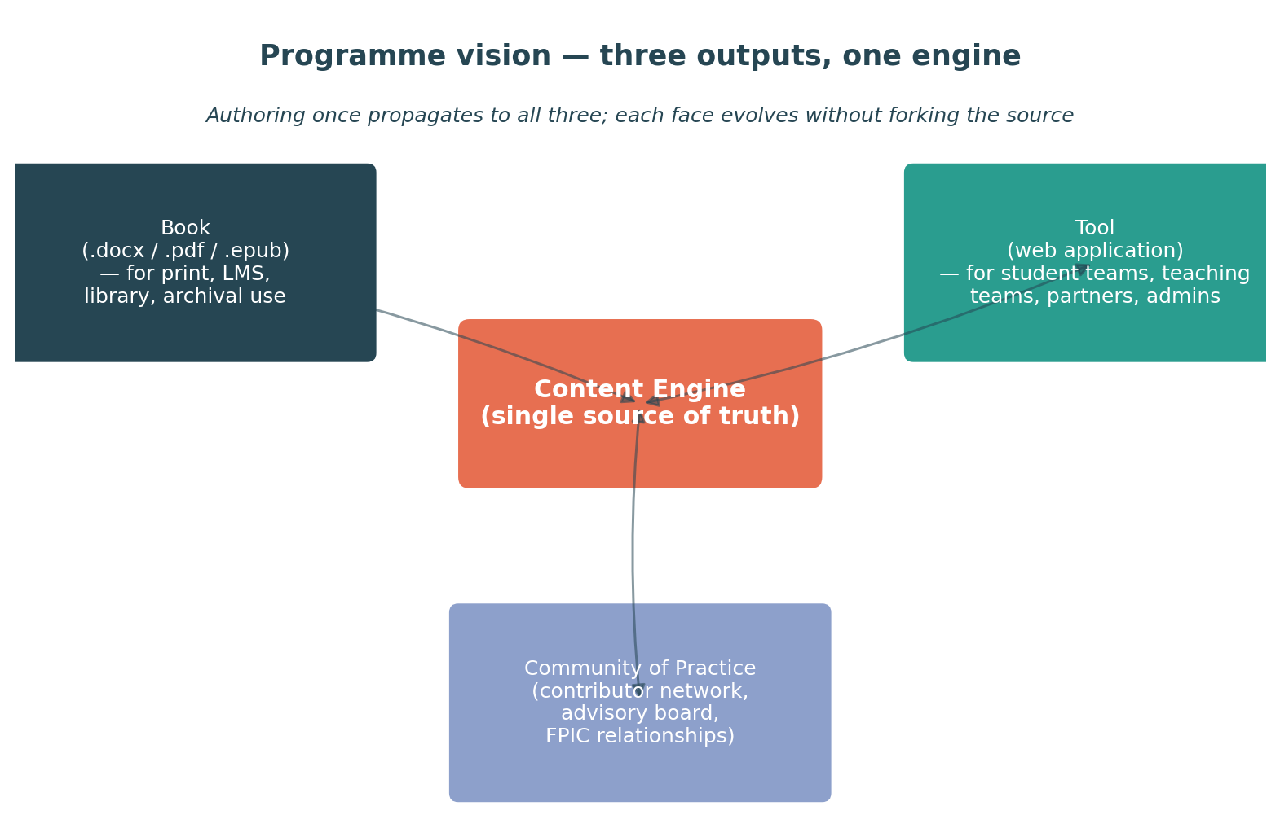
Figure 1. Programme vision — the book, the tool, and the community of practice each draw from a shared Content Engine. Authoring once propagates to all three.

2.1 Why this matters
If the book and tool are run as parallel projects, each chapter edit is a synchronisation event: someone has to remember to update the tool's content; someone has to remember to bump the version; someone has to remember to translate to French. In practice that someone never does, and the two outputs diverge until one becomes the canonical version and the other becomes a stale shadow of it. We have all watched this happen.
If, on the other hand, the book and tool are two outputs of a single content engine, every change to the engine flows to both. The book becomes a build artefact: a compile of the content engine against a specific subset and a specific output template. The tool becomes a runtime: queries the engine at the right tuple at the right moment. The community of practice becomes a contribution and governance layer: contributors add to the engine, the editorial board curates, and both outputs refresh.
This is not novel architecture — it is how technical documentation works at scale (Antora, Docusaurus, GitBook, every open-source project) and how multi-format publishing works in trade publishing. What is novel here is applying it to a textbook in a way that also makes the textbook a live, queryable resource.

2.2 The three faces

The book
A traditional textbook delivered in multiple output formats — .docx for institutions that prefer Word-native editing, .pdf for print and LMS upload, .epub for ebook readers, and selected chapters delivered as LMS-importable modules. CC-BY 4.0 licensed, peer-reviewed, citable. The book is the long-form, narrative output.

The tool
The Capstone Companion as specified in the architecture document, extended to serve four persona types (student, teaching team, admin team, partner) across five audience contexts (engineering-capstone, multidisciplinary, graduate, continuing-education, community-learning). The tool is the short-form, just-in-time, methodology-aware output.

The community of practice
A contributor network — capstone coordinators at other institutions, partner organisations, community educators, FPIC-honoured Indigenous education partners, and former students. They contribute to the content engine; they review each other's contributions; they pilot the tool with their own teams; they hold each other to the quality bar. The community of practice is the human face of the platform and its long-term sustainability strategy.

3. Audience expansion
The current book targets engineering-capstone course directors and student teams. The programme extends that core through four expansion rings — multidisciplinary, graduate, continuing education, community learning — and across four personas at every ring: students (learners), teaching team (coaches), admin team (operators), and partners or community sponsors. The figure below shows the structure.
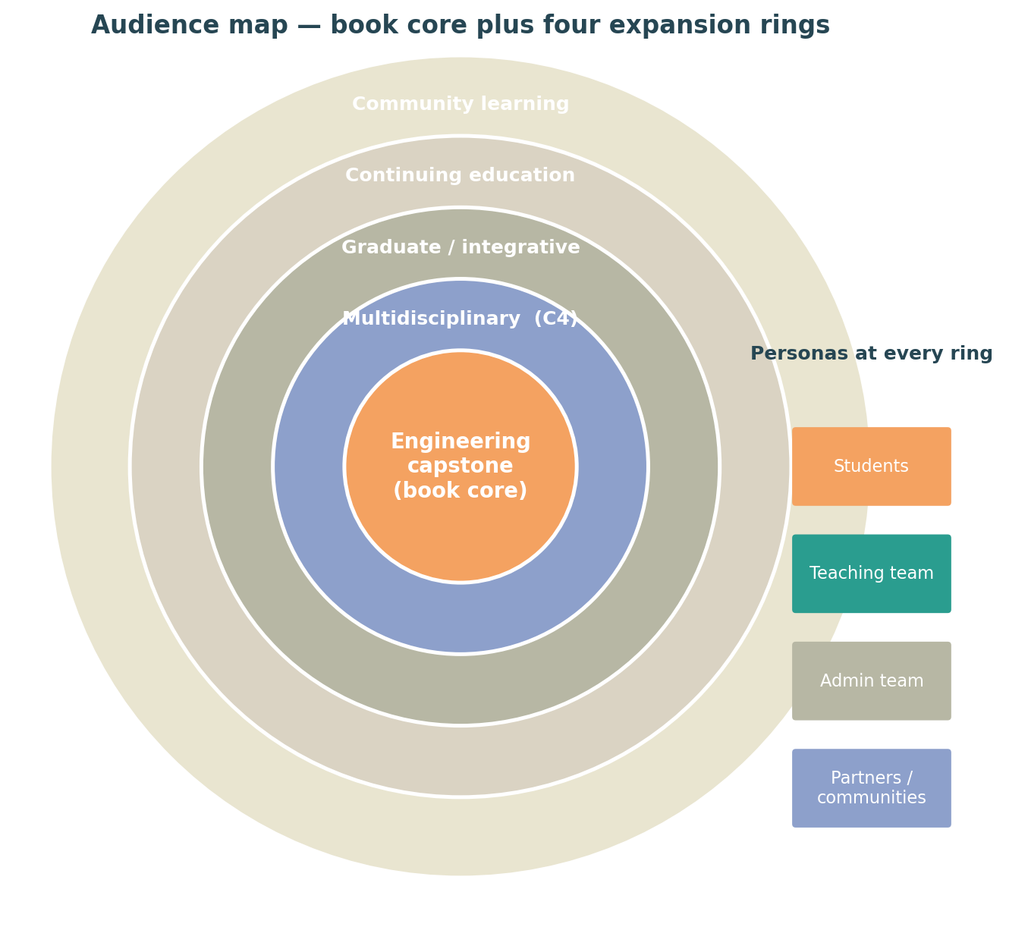
Figure 2. Audience map — the engineering-capstone core (current book) plus four expansion rings. Four personas operate at every ring.

3.1 Reading the map
The map is not concentric in the sense that an outer ring is bigger than an inner one — community learning is not larger than continuing education. It is concentric in the sense that each outer ring adds methodological and pedagogical considerations that the inner rings can borrow from but do not strictly need. Multidisciplinary work brings cross-faculty stakeholder navigation; graduate work brings supervisor-relationship complexity; continuing education brings adult-learner agency considerations; community learning brings community governance and FPIC.
In other words, the outer rings are not “more advanced” than the inner — they are different, with their own design moves that the engineering-capstone core can also benefit from. A first-year undergraduate engineering capstone that ignores FPIC when working with an Indigenous community partner is failing in exactly the same way a community-learning programme would. The expansion rings make explicit what is already latent in the book core.

3.2 The four expansion rings

3.2.1 Multidisciplinary capstones (C4-style)
C4 in this context refers to the cross-college / cross-campus collaborative capstone model used at institutions such as Lassonde, Northeastern, MIT, and others, where students from two or more faculties (engineering plus design, or engineering plus business, or all three) form a single team. The book's existing frameworks need three additions for this audience:
- A method overlay that handles non-engineering design vocabularies (design as in industrial design, service design, communication design — each with its own canonical phase model).
- Stakeholder coaching that accounts for differences in disciplinary norms (engineering students are often blunt about technical constraints; design students are often more comfortable with ambiguity; business students often want a market-fit lens).
- Assessment frameworks that work across faculty grading conventions — typically rubric reconciliation rather than rubric harmonisation.

3.2.2 Graduate-level integrative projects
MASc / MEng / MSc capstones, applied research projects, and graduate practica. Different from undergraduate capstones in three significant ways: the supervisor relationship is more like a junior-PI relationship (one student, deeper technical relationship, longer time horizon); the project is often a small piece of a larger research programme; and the assessment scheme is typically more individual and more reliant on peer-reviewable artefacts. The book's existing material on supervisor relationships needs an extension for this audience, and the tool's assessment-evidence builder needs a variant for peer-reviewable outputs (papers, conference contributions).

3.2.3 Continuing education and adult learners
Capstones inside continuing-education and professional-development programmes — typically part-time, fee-paying adults working on projects that connect to their workplace. The Knowles framing in book Chapter 2 is essential here, and the tool needs to handle a different cadence (evenings, weekends, asynchronous work) and a different stakeholder set (the workplace becomes the partner).

3.2.4 Community learning
Capstone-style design and learning programmes outside the formal academy — community education organisations, technical schools, partner organisations, Indigenous-led learning programmes. The most consequential design move here is the shift in authority: there is no course director in the traditional sense, and the community itself holds decision authority on what gets built and how. The systems-engineering skill's framework selection guide is explicit about this — community governance is treated as decision-making authority, not as a stakeholder to consult.
Of all four expansion rings, this is the one that most demands authorial humility. The book authors do not have the standing to write content for community learning audiences on their own. Section 9 (Governance, IP, sustainability) explains how the programme accommodates community-author contributions on equitable terms.

3.3 Four personas at every ring
Within each audience ring, four persona types use the tool differently. The architecture document treats students as the single primary user; the programme expansion adds three more as first-class personas. The table below summarises what each persona needs at each ring.
Persona | What they primarily do | Audience-ring sensitivity
Student / learner | Navigates project phases; produces artefacts; reflects. | Vocabulary, scope, partner relationships shift by ring.
Teaching team / coach | Coaches, gates, gives feedback, grades. | Authority and grading vary sharply (peer-led in community; supervisor-PI in grad).
Admin team | Sources projects; manages partner agreements; runs capstone day. | Partner intake forms, IP policies, deliverables logistics differ by ring.
Partner / community sponsor | Proposes a project; commits resources; receives outcomes. | Relationship norms differ widely — client (eng), co-design (multi), supervisor (grad), workplace (CE), community body (community learning).

3.4 Audience-by-feature map
Most of the tool's content is shared across audiences. Some content is audience-specific. The matrix below summarises which features (architecture document modules M1–M8) need audience-specific variants versus a single shared implementation.
Module | Engineering capstone | Multidisciplinary | Graduate | Continuing ed | Community
M1 Picker | Shared core | Add disciplinary axis | Add supervisor-role axis | Add workplace-fit axis | Add governance-mode axis
M2 Phase guide | Shared | Shared | Shared | Shared | Shared
M3 Templates | Shared | Add inter-disciplinary template | Add paper / conference template | Add workplace-deliverable template | Add community-acceptance template
M4 Stakeholder coach | Shared | Variant: cross-faculty norms | Variant: PI-student | Variant: workplace | Variant: community governance + FPIC
M5 Reflection | Shared (Mezirow/Freire/Knowles) | Shared | Shared | Knowles-heavy variant | Shared, with community-voice variant
M6 Risk/ethics/IP | Shared core | Add IP-across-discipline overlay | Add research-ethics overlay | Add workplace-IP overlay | Add FPIC + OCAP overlay
M7 Evidence pack | Rubric-aligned | Multi-rubric reconciliation | Peer-reviewable variant | Workplace-deliverable variant | Community-acceptance variant
M8 Course-context | Course director | Programme committee | Supervisor agreement | Programme manager | Community governance body

3.5 The strategic implication of the audience map
The audience expansion is mostly an authoring problem, not an engineering problem. Once the content schema (Section 4) handles audience tags as first-class, adding an audience is a matter of adding tagged content — most of which can be co-authored with practitioners in that audience. The engineering work is concentrated in M4 (stakeholder coach), M7 (evidence pack), and M8 (course-context), and even there the change is configuration and content, not fundamentally new architecture.
This is why we can answer “the wider scope is not too much” with some confidence — provided the content engineering is done right in Phase 1.

4. Content sync architecture
This section is the technical foundation of the whole programme. If we get this right, every other downstream task gets easier; if we get it wrong, every other downstream task gets harder. It is also the section that has the highest authoring throughput leverage.

4.1 The model
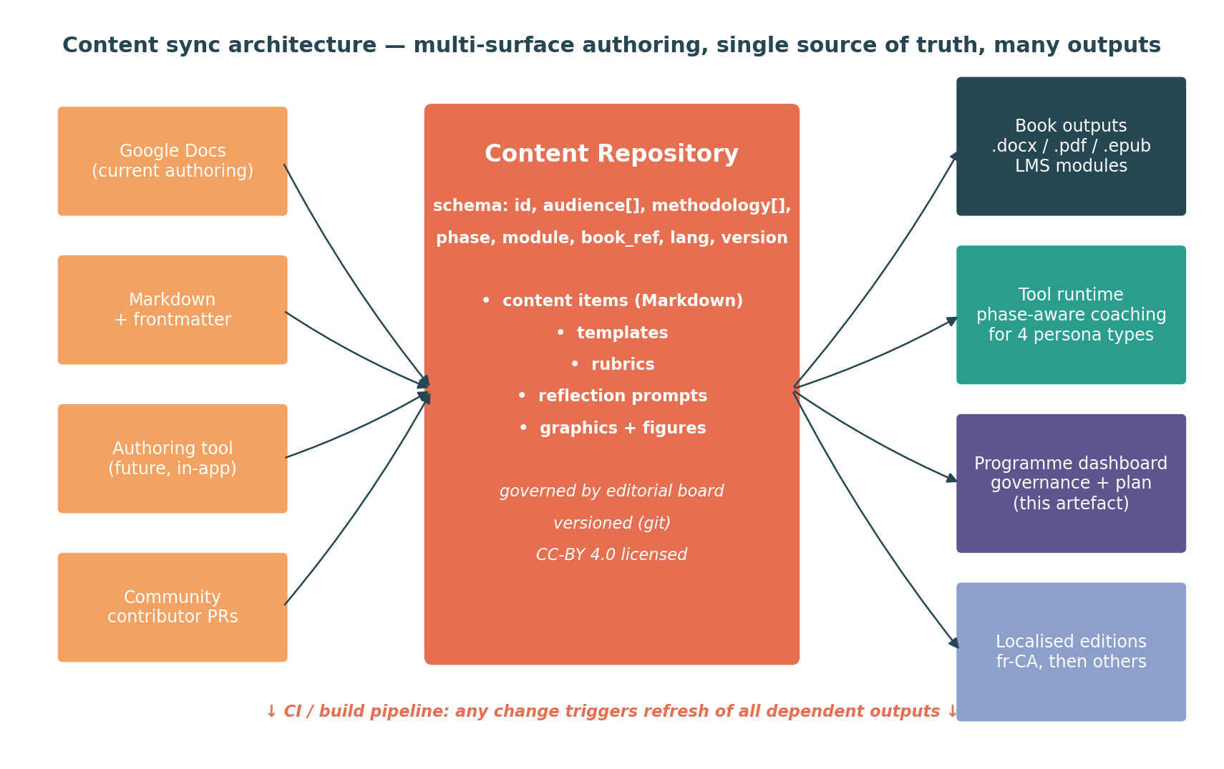
Figure 3. Content sync architecture — multi-surface authoring, single source of truth, many outputs.

4.2 How it works
- Authoring surfaces. Authors edit content in whichever surface suits them — Google Docs (current; lowest friction), Markdown with frontmatter (preferred long-term; lowest tooling overhead), an in-tool authoring view (for power users), or community pull requests via a git repository. All surfaces are bridged to the content repository.
- Content repository. The single source of truth. A git repository (or equivalent) holds content items as Markdown files with YAML frontmatter capturing the metadata needed to address them: id, audience tag, methodology tag, phase, module, book section reference, language, version, status.
- CI / build pipeline. A change in the repository triggers refresh of all dependent outputs. The book builds — pandoc compiles the chapter subset into .docx, .pdf, .epub. The tool refreshes — its content packs update, and the live runtime picks up the new content on its next refresh. The programme dashboard refreshes — its data layer rebuilds from the same repository.
- Outputs. Each output consumes the content engine but presents it differently. The book is a static long-form artefact. The tool is a runtime that queries the engine by (audience × methodology × phase × module). The programme dashboard is a planning view of the same engine.

4.3 Content item schema
The content schema is the load-bearing artefact of this whole programme. Every other piece of work either produces content items or consumes them. The schema below is the v0.1 starting point.
Field | Type | Purpose | Required
id | string (stable) | Unique identifier for cross-references and citations. | yes
title | string | Short human-readable title. | yes
audience | array<enum> | engineering-capstone, multidisciplinary, graduate, continuing-ed, community-learning. Use 'all' as shorthand. | yes
persona | array<enum> | student, teaching-team, admin, partner. Default: all. | no
methodology | array<enum> | system-v, waterfall, mech-sys-design, cdio, design-thinking, uml-oo, agile, ubuntu, two-eyed-seeing, jugaad, buen-vivir. 'all' allowed. | yes
phase | array<enum> | kickoff, need, concept, prelim-design, detailed-design, build, vv, handover, course-context (M8). 'all' allowed. | yes
module | enum | M1 picker, M2 phase-guide, M3 templates, M4 stakeholder, M5 reflection, M6 risk-ethics-ip, M7 assessment, M8 course-context. | yes
book_ref | string | Citation pointer into the book — chapter and section anchor. Required for traceability and CC-BY 4.0 attribution. | yes
author | array<person> | Authors of this item (book authors / course director / community contributor). | yes
lang | string | RFC 5646 locale code. en, fr-CA, etc. | yes
version | string (semver) | Item version. Bumped on substantive content change. | yes
status | enum | draft, in-review, published, deprecated. | yes
body | Markdown | The content itself. Constrained Markdown — see authoring guide. | yes
body_audio | URL | Optional audio narration / reflection-prompt recording. ER-06. | no
assets | array<URL> | Images, figures, sample artefacts. Stored in repo or CDN. | no
related | array<id> | Cross-references to other content items. | no
consent | object | FPIC consent metadata for community-authored content. See Section 9.5. | no

4.4 Sample content item
Example — a single content item in the engine
id: ref/concept/agile/picker-output • audience: [engineering-capstone, multidisciplinary] • methodology: [agile] • phase: [concept] • module: M1 • book_ref: ch5-s3-agile-concept • author: [sadek, newland] • lang: en • version: 0.3.1 • status: draft • body: “For an Agile project entering Concept, the picker's output should...”

4.5 Migration strategy from the current Google Docs
The current book lives in Google Docs (one main manuscript, eight chapter / appendix docs). Migration is a one-time activity that should happen early in Phase 1, before too much new content is added in the legacy format. The recommended approach is incremental and reversible:
- Run a script that exports each Google Doc as Markdown (pandoc handles the .docx export; light cleanup follows).
- Section-by-section, attach frontmatter to each Markdown file using the schema above. This is editorial work, not just mechanical — it forces explicit decisions about audience, methodology, and phase tags for every existing piece of content.
- Stand up the repo, the build pipeline, and a first round of outputs. The first .docx and .pdf outputs from the engine should be auditable against the legacy Google Docs.
- Switch authoring to the engine. Google Docs becomes optionally a parallel surface; the engine is canonical. New chapters are authored directly into the engine.

4.6 Editorial governance over the engine
Single source of truth requires single editorial authority. The recommendation is a three-tier model:
- Editor-in-chief tier. Franz and Hossam jointly. They approve schema changes, accept first contributions from new authors, and make final calls on contested content.
- Section editor tier. One editor per audience ring once that ring is active (multidisciplinary editor, graduate editor, CE editor, community-learning editor). They review contributions within their ring.
- Contributor tier. Anyone with FPIC-honoured standing on the relevant content can contribute. Contributions go through normal review.
Editorial governance is reviewed annually at the advisory-board meeting (Section 9).

5. Programme workstreams
The programme is organised into seven workstreams. Each stream has its own deliverable, its own pace, and its own dependencies. The streams interlock through the content engine — most cross-stream work happens through it.
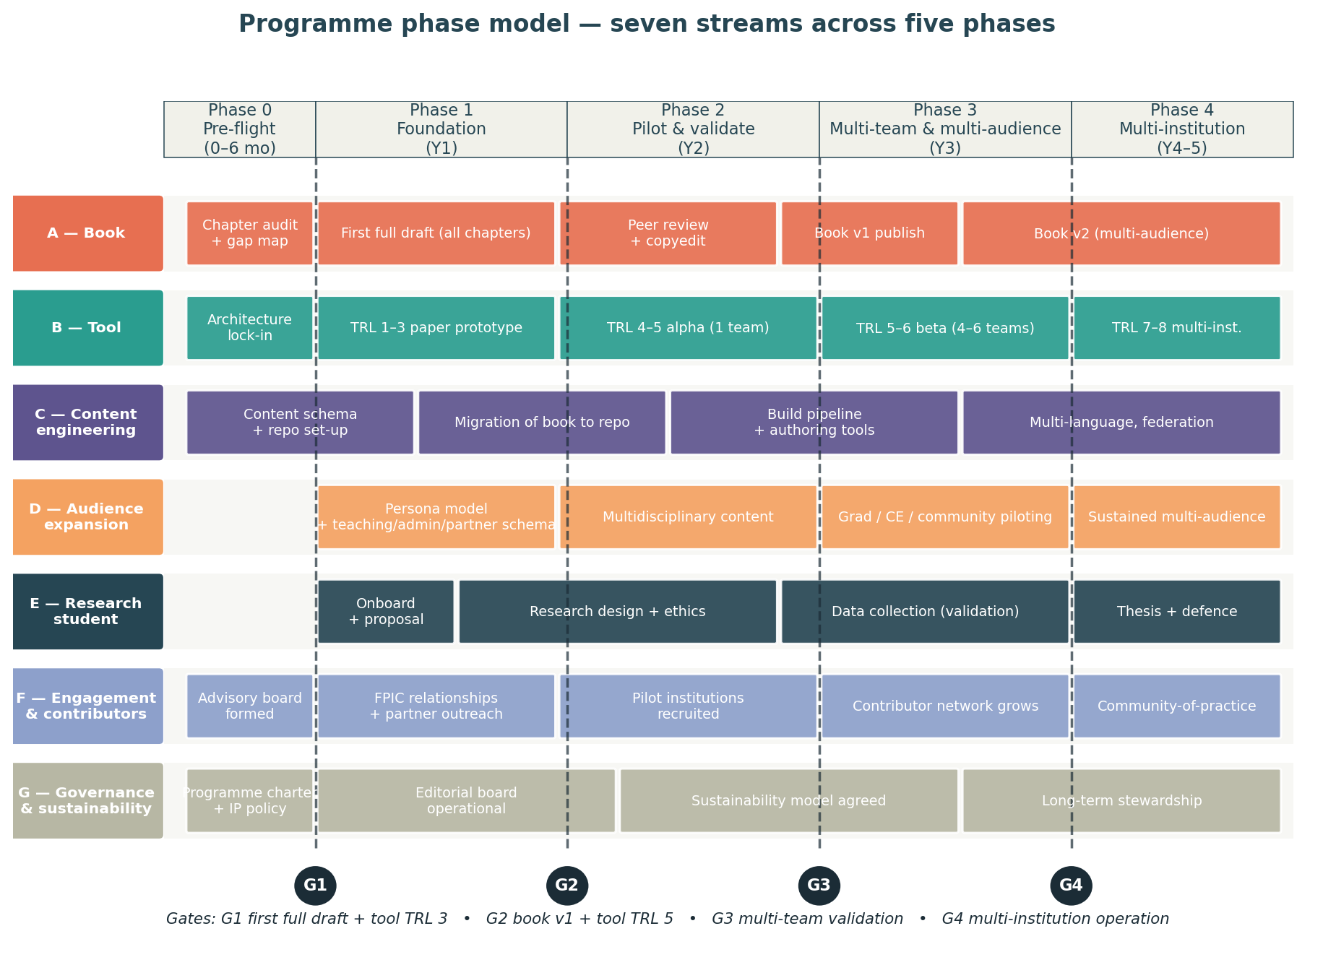
Figure 4. Programme phase model — seven streams across five phases, with four gates.

5.1 Stream summary
Stream | Owner | Primary deliverable | On critical path?
A — Book | Franz + Hossam | First full draft → v1 → v2 multi-audience | yes (Phase 1)
B — Tool | Research student + dev help | TRL 3 → 5 → 6 → 8 | yes (Phase 2 onward)
C — Content engineering | Research student + Franz | Schema, repo, build pipeline, authoring tools | yes (Phase 1)
D — Audience expansion | Section editors | Per-ring content + tool variants | no (Phase 3 onward)
E — Research student PhD/MASc | The student | Thesis embedded in tool build + validation | co-dependent with B
F — Engagement & contributors | Franz + advisory board | Contributor network, partner relationships, pilot institutions | no
G — Governance & sustainability | Franz + institutional advisor | IP policy, editorial board, sustainability model | yes (Phase 0–1)

5.2 Stream A — Book to first full draft (and beyond)
The book has eight Google Docs at the time of writing — the main compiled manuscript plus chapter / appendix drafts. Most drafts have not been substantively edited since 2023 or 2024, while the main manuscript was last touched in late 2025. The first piece of Stream A work is therefore an audit: chapter by chapter, what is canonical and what is stale, what gaps exist against the full ToC, and what is missing entirely.

Stream A work breakdown
WP | Work package | Output | Owner | Phase
A-1 | Chapter audit and gap map | Per-chapter status report; gap list | Franz | Phase 0
A-2 | Author Chapter 7 (project management) | Chapter 7 first draft | Franz | Phase 1
A-3 | Complete Chapter 6 (assessment) | Chapter 6 first draft | Hossam | Phase 1
A-4 | Complete Chapter 8 (capstone day) | Chapter 8 first draft | Hossam | Phase 1
A-5 | Resolve “TBW / DIAGRAM OF / GOES IN” marks | Editorial pass across all chapters | Both | Phase 1
A-6 | Template library expansion | ≥40 templates across phases | Both + students | Phase 1
A-7 | Diagrams pass — produce all named figures | All ToC-referenced figures and tables | Both | Phase 1
A-8 | Migrate book to content engine (Stream C) | Engine-canonical book content | Research student | Phase 1
A-9 | Internal peer review | Reviewer comments + revision pass | Advisory board | Phase 2
A-10 | External peer review (3 reviewers) | Reviewer reports + response document | Editors | Phase 2
A-11 | Copyedit + indexing | Copy-edited manuscript | Hired copyeditor | Phase 2
A-12 | Book v1 publish (CC-BY 4.0) | .docx, .pdf, .epub, web edition | Both | Phase 2 end
A-13 | Author Ring D content (multidisciplinary) | Multidisciplinary chapter / supplements | Section editors | Phase 3
A-14 | Author Ring E–G content (grad, CE, community) | Per-ring chapter supplements | Section editors + community contributors | Phase 3–4
A-15 | Book v2 (multi-audience edition) | Updated book, all rings included | Both + editors | Phase 4

Stream A authoring throughput assumption
First-draft authoring throughput for two academic authors working alongside teaching and research duties is realistically 500–1000 words per author per week on average, with peaks and troughs. The book is currently 250-something pages of compiled manuscript, much of it draft. To get to a first full draft (estimated ~80,000 words for the engineering-capstone core), roughly 30,000 net new words plus heavy editorial restructuring is plausible in 10–12 months. This is the constraint that anchors Phase 1's length.

5.3 Stream B — Tool to operational maturity
Tool work is anchored in the architecture document (separate v0.1). Stream B implements that architecture, extended for the wider audience scope. Note that Stream B has to wait for Stream C content schema before non-trivial implementation can begin.

Stream B work breakdown
WP | Work package | Output | Phase
B-1 | Architecture v1 lock — extended for multi-persona, multi-audience | Updated architecture doc; ADRs for personas & rings | Phase 0
B-2 | TRL 1–3 paper prototype of M1 Picker + M2 Phase guide | Figma prototype; 2–3 walk-throughs with student teams | Phase 1
B-3 | Build minimal alpha — M1, M2, M3, M5, M7 in skeleton | Web app running with 1 capstone team | Phase 2
B-4 | Add M4, M6, M8 — full module set in beta form | Web app running with 4–6 capstone teams | Phase 3
B-5 | Multi-persona views — teaching team, admin, partner views | Persona-specific UIs | Phase 3
B-6 | Audience-ring configuration — multidisciplinary, grad, CE, community | Per-audience tool variants | Phase 3–4
B-7 | Three deployment modes operational | Institution-hosted, vendor-hosted, self-hosted | Phase 4
B-8 | Localisation — fr-CA | Bilingual tool | Phase 4
B-9 | Accessibility audit + WCAG 2.2 AA certification | Audit report; remediation | Phase 3 + Phase 4
B-10 | Security review + privacy compliance | Pen test; data-handling sign-off | Phase 3

5.4 Stream C — Content engineering
This is the choke point of the programme. The content engine has to be designed, built, and validated before Stream A's Phase-1 work can migrate into it, and before Stream B's alpha can run against meaningful content.

Stream C work breakdown
WP | Work package | Output | Phase
C-1 | Content schema v1.0 | Schema document + sample items | Phase 0–1
C-2 | Repository set-up + access controls | Git repo; CI/CD; SSO | Phase 1
C-3 | Build pipeline for book outputs | pandoc-based .docx/.pdf/.epub build | Phase 1
C-4 | Build pipeline for tool content packs | JSON/YAML content packs per persona / audience | Phase 1–2
C-5 | Migration of Google Docs to engine | Engine-canonical book content | Phase 1
C-6 | In-tool authoring surface (Markdown editor) | Authoring UI for non-technical authors | Phase 2–3
C-7 | Content review workflow (pull-request style) | Review and merge workflow for contributors | Phase 2
C-8 | Versioning policy + release notes auto-generation | Semver in metadata; CHANGELOG generation | Phase 1
C-9 | Schema v2 — handles localisation + community-author consent metadata | Schema v2 | Phase 3
C-10 | Federated content packs (institution-specific) | Per-institution overlays | Phase 4

5.5 Stream D — Audience expansion

Stream D work breakdown
WP | Work package | Output | Phase
D-1 | Persona model — extend tool's user model to four personas | Persona spec; UX implications | Phase 1
D-2 | Multidisciplinary ring authoring (C4) | Ring-D content; tool variants | Phase 2–3
D-3 | Graduate ring authoring | Ring-E content; tool variants | Phase 3
D-4 | Continuing-education ring authoring | Ring-F content; tool variants | Phase 3
D-5 | Community-learning ring authoring (with community partners) | Ring-G content; tool variants | Phase 3–4
D-6 | Cross-ring pilots — 1 capstone per ring | Per-ring validation evidence | Phase 3–4

5.6 Stream E — Research student (PhD or MASc)
The research student is the build lead for the tool and the principal data-collector for tool validation. Their thesis is embedded in this work. The choice between PhD (4–5 years) and MASc (2–2.5 years) materially shapes the programme's pace beyond Phase 2.

Stream E work breakdown
WP | Work package | Output | Phase
E-1 | Recruitment + supervisor agreement | Funded student; supervisor agreement | Phase 0
E-2 | Literature review + research question lock | Comprehensive exam (PhD) / proposal (MASc) | Phase 1
E-3 | Research ethics submission (REB) | REB approval | Phase 1
E-4 | Tool build (alpha through beta) | MVP through Phase-3 tool | Phase 2–3
E-5 | Validation study (alpha, beta cohorts) | Quantitative + qualitative data | Phase 2–3
E-6 | Thesis writing | Thesis draft | Phase 3–4
E-7 | Defence and publication | Defended thesis; ≥1 journal paper | Phase 4

Open question on Stream E
Whether the student is positioned as a PhD candidate or a MASc candidate is a programme-level decision. PhD allows deeper research and a longer build runway, at the cost of longer time-to-publication for the validation studies. MASc completes faster but compresses the research design and may limit the validation depth. Recommendation: PhD if institutional funding is secure for 4 years; MASc plus a second postdoc / research engineer otherwise.

5.7 Stream F — Engagement and contributor network

Stream F work breakdown
WP | Work package | Output | Phase
F-1 | Advisory board recruitment | Advisory board (5–7 members) | Phase 0
F-2 | FPIC-honoured relationships with Indigenous education partners | MOUs; co-author agreements | Phase 1–2
F-3 | Pilot-institution recruitment | 3 pilot institutions for Phase 3 | Phase 2
F-4 | Conference / workshop dissemination | Annual presence at CEEA-ACÉG, ASEE | Phase 1 onward
F-5 | Contributor network growth | Active contributors at scale | Phase 3 onward
F-6 | Community-of-practice convening | Annual programme retreat | Phase 3 onward

5.8 Stream G — Governance, IP, sustainability

Stream G work breakdown
WP | Work package | Output | Phase
G-1 | Programme charter — vision, scope, decision rights | Signed charter | Phase 0
G-2 | IP and licensing policy | IP policy doc; CC-BY 4.0 confirmation | Phase 0
G-3 | Editorial board constitution | Editor terms; review process | Phase 1
G-4 | Risk register + RAID maintenance cadence | Quarterly RAID review | Phase 1 onward
G-5 | Funding strategy + grant applications | NSERC, SSHRC, Mitacs, foundation applications | Phase 1–2
G-6 | Sustainability model — institutional, vendor, community-stewarded | Sustainability decision | Phase 3
G-7 | Long-term stewardship handover | Sustainable governance structure | Phase 4

6. Phase model and gates
The programme has five phases. Each phase has a stated intent, a set of work packages drawn from the streams above, and an exit gate. The gates are decision points — at each one, the programme leadership can elect to proceed, replan, or stop.

6.1 Phase 0 — Pre-flight (0–6 months from start)
Intent: do the foundational decisions before the research student arrives. Lock the programme charter, lock the IP policy, finalise the architecture extension for the multi-persona / multi-audience scope, start the chapter audit, and stand up the advisory board.
Phase 0 must-haves
(1) Programme charter signed by Franz + Hossam + institutional sponsor. (2) IP / licensing policy locked. (3) Architecture document updated for multi-persona / multi-audience scope. (4) Advisory board formed (≥5 members) and convened once. (5) Chapter audit (Stream A-1) complete with explicit gap map. (6) Research student recruitment underway.

6.2 Phase 1 — Foundation (year 1)
Intent: get the book to a first full draft and stand up the content engine. The two activities are tightly coupled — the book is migrated into the engine as it is completed, which forces good content schema decisions while there is still time to iterate. Research student begins, takes ownership of Stream B (tool) and Stream C (content engineering).
Phase 1 must-haves
(1) Book first full draft complete across all chapters, with templates and figures. (2) Content schema v1.0, repo, build pipeline, all in place. (3) Book migrated to the engine; engine outputs auditable against original Google Docs. (4) Tool TRL 3 — paper prototype walked through with 2–3 student teams. (5) Research student proposal accepted; REB submission underway.
Gate G1 — End of Phase 1. Go / no-go decision: is the book first draft good enough to enter peer review? Is the engine stable enough to support beta tool work?

6.3 Phase 2 — Pilot and validate (year 2)
Intent: publish the book, get the tool to alpha-with-real-team, begin the research student's data collection. Phase 2 is when the programme starts producing evidence — book peer review, alpha pilot evaluation, research student's early findings.
Phase 2 must-haves
(1) Book through peer review, revisions, copyedit, and v1 publication (CC-BY 4.0). (2) Tool TRL 4–5 alpha — running with one real capstone team end-to-end. (3) Research student validation study (alpha) under way. (4) FPIC-honoured relationships with at least two community / Indigenous education partners established. (5) Pilot institutions recruited for Phase-3 multi-team beta.
Gate G2 — End of Phase 2. Decision: book v1 is published; does the tool alpha justify scaling to a multi-team beta?

6.4 Phase 3 — Multi-team and multi-audience (year 3)
Intent: scale the tool to a 4–6-team beta; author the audience-expansion content; begin piloting with non-engineering-capstone audiences. The audience expansion content has been authored in parallel through Phase 2 and now goes through pilot validation.
Phase 3 must-haves
(1) Tool TRL 5–6 beta — running with 4–6 capstone teams; equity-aware evaluation per arch doc Section 9.3. (2) Multidisciplinary ring content authored and piloted. (3) Graduate / CE / community-learning ring content drafted; ≥1 pilot per ring. (4) Research student data collection complete; thesis writing under way. (5) Sustainability model decision (institutional / vendor / community-stewarded).
Gate G3 — End of Phase 3. Decision: which audience rings continue to fund / staff, and which are deferred or descoped?

6.5 Phase 4 — Multi-institution and sustainable operation (years 4–5)
Intent: take the tool from one-institution beta to a multi-institution operational footing; publish book v2 with all rings included; complete the research thesis; transition to long-term stewardship.
Phase 4 must-haves
(1) Tool TRL 7–8 — operational at three institutions concurrently. (2) Book v2 (multi-audience) published. (3) Research student defended; ≥1 peer-reviewed publication. (4) Long-term stewardship model operational. (5) Community of practice convening annually; contributor network self-sustaining.
Gate G4 — End of Phase 4. Decision: programme transitions to steady-state stewardship.

7. Critical path and dependencies
The critical path runs through three streams in sequence: Stream C content engineering up to repo + pipeline, then Stream A book first full draft through migration, then Stream B tool through alpha and validation. Everything else either feeds into the critical path or runs in parallel without gating it.
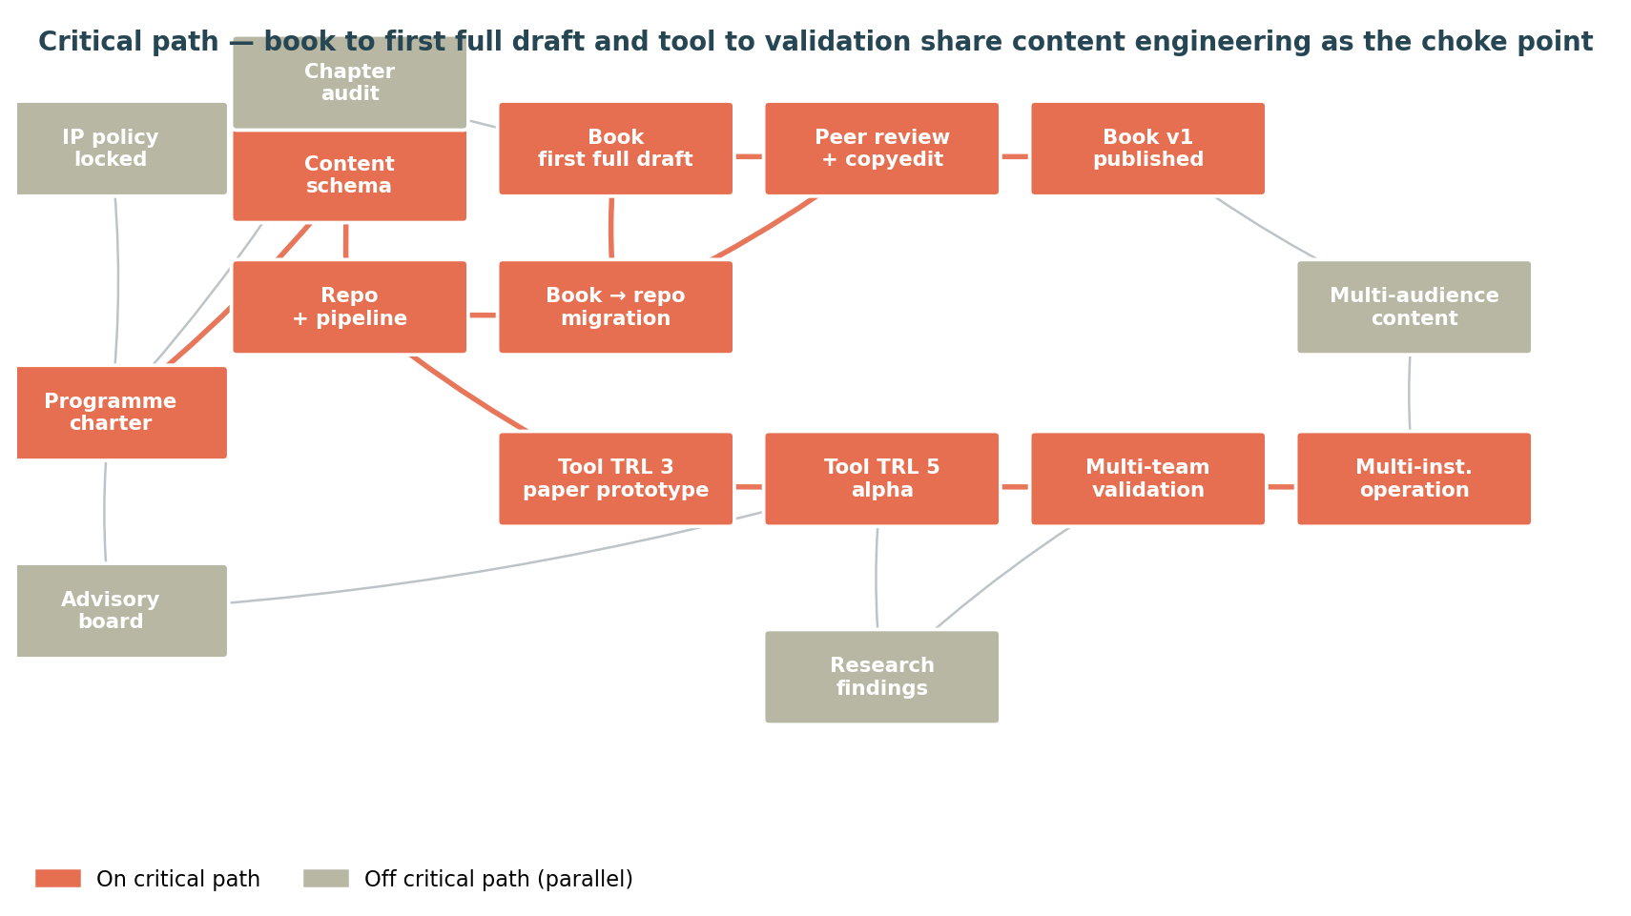
Figure 5. Critical path — content engineering is the choke point that both book and tool depend on.

7.1 The choke point
The content schema and repo / pipeline (Stream C, WP C-1 through C-4) are on the critical path because both the book's first full draft and the tool's alpha pilot need to be authored against them. If the schema is wrong, both downstream activities suffer; if the repo / pipeline is late, both downstream activities are blocked.
This means content engineering deserves disproportionate attention in Phase 0 / early Phase 1. It is also where the research student's early work matters most — getting them onto Stream C as soon as they arrive (rather than letting them disappear into Stream B prematurely) protects the critical path.

7.2 Where slack lives
Stream F (engagement) and Stream G (governance) operate alongside the critical path with significant slack. Audience expansion (Stream D) does not start in earnest until Phase 2 and so does not constrain Phase 1. The research student's thesis writing (Stream E-6) can compress or expand to fit the available time at end of programme.

7.3 Slip risks
Where slippage hurts | Why | Mitigation
Content schema decisions early in Phase 1 | Schema changes are expensive once content has been authored against it. | Spend a deliberate sprint of Phase 0 / early Phase 1 on schema design; review with the research student before lock-in.
Book chapters in the critical-path bracket (Ch 6, 7, 8) | These three are most incomplete and have to be drafted before the engine can be canonical. | Allocate explicit authoring time on the calendar; do not let teaching duties consume the bracket.
Research student arrival timing | Stream B and Stream C both depend on them. | Recruit in Phase 0; secure funding before they arrive.
External peer review | Reviewer availability is unpredictable. | Recruit reviewers in Phase 1 (not Phase 2); offer reasonable timeline; have a backup reviewer pool.

8. Resource and capacity plan

8.1 Authoring throughput
This is the hardest constraint in the programme. Academic authors with teaching and research duties realistically sustain 500–1000 net words per author per week over a multi-year horizon. With two authors, 1,000–2,000 net words per week is the throughput envelope. The book's first full draft (engineering-capstone core, estimated 80,000 words) is feasible in a year at this throughput, leaving margin for editorial restructuring and template authoring.
The multi-audience expansion in Phase 3–4 cannot be authored by Franz and Hossam alone within the same throughput envelope. Either the contributor network has to provide audience-ring authoring, or the timeline stretches further. The plan assumes the former.

8.2 Research student capacity
A funded PhD student spends roughly 35 hours per week on their thesis on average. Of this, perhaps 60% is technical work (build, data collection, analysis), 25% is writing, and 15% is meetings, coursework, supervision. This means the tool build itself absorbs roughly 20–22 hours per week, sustained for 3–4 years. That is sufficient for a TRL 3 → TRL 6 build with reasonable engineering quality. It is not sufficient for TRL 7–8 multi-institution-grade engineering — Phase 4 will likely require an additional research engineer or institutional dev support.

8.3 When to bring in additional help
Help type | When | Why
Designer / UX researcher | Phase 2 (alpha pilot) | Persona-specific interface design beyond what the research student can do alone.
Copyeditor + indexer | Phase 2 (between peer review and v1) | Book publication-quality work that is a one-time activity.
Research engineer | Phase 3–4 | Tool TRL 6 → 8 is software engineering, not research. Different skill set.
Community liaison / FPIC-honoured collaborator | Phase 1 (Stream F) | Authorial humility — community-learning content cannot be authored without legitimate community standing.
Translator (en → fr-CA) | Phase 4 | Localisation needs professional translation, not machine translation, for a textbook of this quality bar.

8.4 Funding envelope
The programme can be staged so that significant work happens before any external funding is secured — Phase 0 and most of Phase 1 are well within the authors' professional time, plus the research student's funded position. From Phase 2 onward, the funding envelope grows: copyediting, design work, pilot-institution incentives, advisory-board honoraria, dissemination travel, eventual research-engineer or vendor support.
Plausible funding sources, in approximate order of fit:
- NSERC CREATE or similar capacity-building grant — multi-institution training programme framing fits.
- Mitacs Accelerate / Elevate — research student plus partner organisation; works if a pilot institution becomes a Mitacs partner.
- SSHRC Insight Grant — for the pedagogical research, framed as design-based research in engineering education.
- Foundation grants — Lassonde Foundation / similar institutional sources for the multi-audience expansion.
- Industry partner contributions — modest, targeted at specific pilot offerings.
Section 9.4 discusses the sustainability model that follows once the seed funding has done its work.

9. Governance, IP, and sustainability

9.1 IP and licensing
Recommendation: maintain CC-BY 4.0 on the book (consistent with current draft); apply CC-BY 4.0 to all content in the engine; apply an open-source licence to the tool's source code (recommendation: AGPL-3.0 to ensure derivatives remain open). Confirm with institutional legal counsel and any partner organisations before locking. Tool data — student-authored content, reflections, evidence packs — remains team / student IP under FR-NFR-03 (architecture doc); institution data-handling policy applies.

9.2 Editorial board
Co-edited by Franz and Hossam as Editors-in-Chief. Section editors recruited one per audience ring as that ring activates. Editorial board reviews engine schema changes annually, contested content as needed. Decision-by-consensus among editors; Editor-in-Chief casts deciding vote in tie.

9.3 Advisory board
Five to seven members representing: a capstone coordinator from another Canadian university (one); a US engineering-education researcher (one); a community-learning practitioner (one); an Indigenous education representative or advisor (one, FPIC-honoured relationship); a project partner from industry (one); and one or two student / former student representatives. Meets annually; reviews programme progress, advises on strategic decisions.

9.4 Sustainability model
The sustainability decision in Phase 3 picks between three models. Section 12 covers the trade-offs in detail; the candidates are:
- Institutional-stewarded. A single institution (likely Lassonde) hosts the engine, the tool, and the editorial board. Lowest external coordination overhead; highest dependency on that institution's continued investment.
- Vendor-stewarded. A commercial vendor (or social enterprise) takes the tool's operational hosting; institutions license access; book stays CC-BY 4.0; engine governed jointly. Sustainable financially; some risk of mission drift.
- Community-stewarded. The community of practice itself governs (similar to Apache Software Foundation model). Sustainable in principle; demands serious community-of-practice maturity.
The recommendation is to make the call in Phase 3 based on observed adoption, funding posture, and community-of-practice maturity. Do not lock the decision in Phase 0.

9.5 FPIC, Indigenous content stewardship, and OCAP
Where content addresses, derives from, or is co-authored by Indigenous educational practitioners, the content engine has to honour:
- OCAP® (Ownership, Control, Access, Possession — First Nations Information Governance Centre). Data and knowledge originating from First Nations communities remains under their control.
- UNDRIP Article 31 (rights to maintain, control, protect, and develop traditional knowledge, traditional cultural expressions, and intellectual property).
- Bill C-15 (Canada) and TRC Call to Action #92 — FPIC is not consultation, it is consent as authority.
Operationally, this means the content schema's optional `consent` object (Section 4.3) is mandatory for community-authored or community-derived content. It records who the community author / authority is, what they have consented to, what conditions they have placed, and how to revoke or modify consent. Editorial governance treats this metadata as binding.

10. RAID register — risks, assumptions, issues, dependencies

10.1 Top risks
ID | Risk | Lik. | Imp. | Mitigation
R-01 | Authoring throughput is below the 1,000–2,000 net words / week assumption, slipping Phase 1. | High | High | Build in protected authoring time on the calendar; renegotiate teaching loads; bring in section editors earlier than Phase 2.
R-02 | Content schema requires breaking changes after content has been authored against it. | Medium | High | Spend a deliberate sprint on schema design in Phase 0; pilot with 5–10 sample items before locking; version explicitly.
R-03 | Research student onboarding is delayed (funding, recruitment, supervisor availability). | Medium | High | Begin Phase 0 work without them; have a fallback plan for tool build (research engineer, vendor support, longer Phase 1).
R-04 | FPIC relationships are not in place when community-learning content authoring begins. | Medium | High | Start the relationships in Phase 1 (Stream F-2); do not author community content without legitimate standing.
R-05 | Audience expansion content is authored without genuine practitioner standing. | Medium | High | Hard rule: every audience ring needs a section editor with practitioner standing; no exceptions.
R-06 | Tool TRL 5 alpha reveals fundamental architecture flaws. | Low | High | Paper prototype walk-throughs in Phase 1 surface problems early; alpha pilot allows for replan if needed at G2.
R-07 | Sustainability model not viable at G3. | Medium | High | Begin sustainability conversations in Phase 1 (with advisory board); do not defer to Phase 3 surprise.
R-08 | Validation evidence does not support continued expansion (no signal of learning benefit). | Low | High | Equity-aware evaluation per architecture doc; honest reporting; willingness to descope or pivot at G3.
R-09 | Book v1 peer reviewers reject the manuscript. | Low | Medium | Internal peer review (advisory board) precedes external; revise on internal review before submitting.
R-10 | Institutional politics interfere with multi-audience expansion (e.g. another faculty objects). | Medium | Medium | Advisory board includes cross-faculty representation; involve institutional sponsor early.
R-11 | Tool privacy / data-protection issue surfaces during pilot. | Low | High | Privacy-by-design in architecture doc; institutional ethics review; FR-NFR-04 enforcement; pen test in Phase 3.
R-12 | Programme outlasts the authors' active careers without a stewardship plan. | Low (now), High (later) | High | Stewardship plan locked at G3; long-term stewardship transitioned at G4.

10.2 Key assumptions
- Franz and Hossam continue to be the primary book authors throughout Phase 1, with renegotiated teaching loads or comparable support.
- A funded research student arrives within 6 months of programme charter signing.
- At least one pilot institution (Lassonde) will host the alpha cohort in Phase 2.
- Institutional CC-BY 4.0 / open-licence policy is compatible with the programme; no IP barriers to releasing the book or the tool.
- REB ethics approval for tool validation is achievable on a normal timeline.

10.3 Active issues to resolve in Phase 0
- Programme name — “Capstone Companion” for the tool, but the platform / programme name is open. Suggestions in the appendix.
- Research student framing — PhD vs MASc — see Section 5.6.
- Editorial board representation — who is the multidisciplinary editor? Who is the Indigenous education advisor?
- Funding strategy lead — who in the team writes the first grant application, and on what timeline?

10.4 Dependencies on external parties
- Institutional sponsor — needs to sign the programme charter and provide research-student funding pathway.
- Advisory board members — need to commit time and standing.
- Pilot institutions — need to commit to running the tool with a capstone cohort.
- Community partners (for community-learning ring) — need to enter FPIC-honoured relationships.

11. “Is the wider scope too much?” — the candid answer
You asked, directly. Here is the candid answer.

11.1 What “too much” means here
Three readings of “too much” are in play. The first is about scope creep: are we adding things that do not belong? The second is about feasibility: can two academic authors, one research student, and an unknown contributor network actually produce all of this to quality? The third is about focus: even if it is feasible, will the breadth dilute the depth of any single piece?

11.2 Reading 1 — scope creep
No. The audience expansion (multidisciplinary, graduate, CE, community) is not scope creep — it is the latent argument of the book itself. The book is already a recipe book that explicitly resists a single recipe for engineering capstones. Saying out loud that the recipes generalise to other audiences, and architecting the engine accordingly, is honesty rather than ambition.
The persona expansion (teaching team, admin team, partners) is more debatable. The architecture document originally treated the student as the sole primary user; this plan elevates the others to first-class. The argument for doing so is that the book already covers all four personas in its course-design content (Chapters 1, 2, 4, 5 most explicitly), and the tool's M8 layer is meaningless without populating it with course-director and admin decisions. The argument against is the usual one — every additional persona makes the tool more complex to build and harder to keep coherent. The recommendation is to keep all four personas in scope but pace their tool support: students get full v1; teaching teams get a read-only / commenting v1 and a richer v2; admin and partner views are pushed to Phase 3.

11.3 Reading 2 — feasibility
Feasible on these conditions:
- The programme runs over four to five years, not one to two. The unconstrained-time choice protects this. If pressure to compress emerges, defer the audience expansion before defending the book or the tool.
- The research student is a real PhD student with real funding, on the critical path of tool and content engineering, not an after-hours volunteer.
- Authoring throughput on the book is protected on the calendar — i.e. Franz and Hossam negotiate explicit time, not just intent. Without this, R-01 is the dominant slip risk.
- The content schema is locked early. Without this, all downstream authoring throughput is unstable.
- Contributor network does the audience-expansion authoring. Without it, Phase 3 stretches into Phase 4 and Phase 5.
If any of those five conditions fail, the wider scope is infeasible and the programme should descope to engineering-capstone-only with the four-persona expansion deferred to a hypothetical v3.

11.4 Reading 3 — focus
This is the most legitimate concern. Anyone who has watched a strong academic project lose its centre to scope expansion will recognise the worry. The mitigation here is not procedural — it is structural. By treating the engineering-capstone core as the foundational ring of an audience map, the work on other rings strengthens the core rather than diluting it. A method that has been put through community-learning, continuing-education, and graduate contexts before it returns to the engineering-capstone classroom is a methodologically more robust method.
That said, focus needs guarding. The recommendation is to hold three discipline lines:
- Discipline line 1: the engineering capstone core stays the primary text of the book. Other rings are extensions, supplements, and chapter additions — not replacements.
- Discipline line 2: the tool's v1 is engineering-capstone-only. Multi-audience views come after the tool has proven itself with engineering capstones. This protects the validation evidence.
- Discipline line 3: editorial governance is the gatekeeper. Section editors with practitioner standing are the only path to authoring content for an audience ring. No content gets in without that standing.

11.5 The bottom line
Direct answer
The wider scope is not too much, conditional on (1) plan-to-quality time horizon, (2) a funded PhD-level research student on the critical path, (3) protected authoring time on the calendar, (4) early content-schema lock-in, (5) a contributor network for the audience-expansion authoring. Hold the three discipline lines, gate hard at G1 / G2 / G3, and the programme is feasible and coherent. Lose any of the five conditions, or any of the three discipline lines, and descope to engineering-capstone-only — that is a perfectly worthy outcome and not a failure.

12. Decision points (gates)
Four gates. Each is a structured decision moment with specific criteria. The advisory board chairs the gate review; the editors-in-chief make the call. Slipping a gate by a quarter is normal; missing the criteria altogether is the signal to replan.

12.1 Gate G1 — End of Phase 1
Criterion | Pass / Fail / Replan | Evidence
Book first full draft complete across all chapters | — | Manuscript in engine; chapter audit reports green
Content schema locked at v1.0 | — | Schema document; >= 100 content items authored against it
Engine outputs auditable against original Google Docs | — | Audit comparison report
Tool TRL 3 paper prototype with student walk-throughs done | — | Walk-through reports; lessons learned log
Research student proposal accepted | — | Supervisor sign-off
Decision question: is the foundation sound enough to support Phase 2's pilot and validation work?

12.2 Gate G2 — End of Phase 2
Criterion | Pass / Fail / Replan | Evidence
Book v1 published (CC-BY 4.0) | — | Published artefact; DOI; copyright deposit
Tool alpha completed with one team end-to-end | — | Alpha team artefacts; tool-usage data
Alpha-team learning outcomes not worse than control | — | Equity-aware evaluation report
Pilot institutions recruited for Phase 3 beta | — | Signed MOUs
Sustainability conversation under way | — | Advisory-board minutes
Decision question: do we scale to a 4–6-team beta, and do we begin the audience expansion?

12.3 Gate G3 — End of Phase 3
Criterion | Pass / Fail / Replan | Evidence
Tool beta delivers validation evidence per arch doc 9.3 | — | Beta evaluation report
Multidisciplinary ring content piloted | — | Per-ring pilot report
Other rings drafted with ≥ 1 pilot each | — | Per-ring pilot reports
Research student thesis writing under way | — | Thesis chapter drafts
Sustainability model decision made | — | Sustainability decision document
Decision question: which audience rings continue to invest in, and what is the path to multi-institution operational footing?

12.4 Gate G4 — End of Phase 4
Criterion | Pass / Fail / Replan | Evidence
Tool operational at three institutions | — | Per-institution operational reports
Book v2 (multi-audience) published | — | Published artefact
Research thesis defended and published | — | Defended thesis; journal paper
Long-term stewardship operational | — | Stewardship structure operational ≥ 6 months
Community of practice convening annually | — | Convening reports
Decision question: programme transitions to long-term stewardship. End of the active programme; beginning of sustained operation.

13. Open authorial decisions
Decisions that Franz and Hossam should make explicitly, in Phase 0 or early Phase 1, before they get made by default.
- Programme name. “Capstone Companion” for the tool, but the platform name is open. Working candidates: “Capstone Atelier”, “Capstone Studio”, “Engineering Capstones (the platform)”.
- Research student framing — PhD or MASc. Section 5.6 discusses; recommendation depends on funding security.
- Whether non-Western design traditions (Ubuntu, Two-Eyed Seeing, Jugaad, Buen Vivir, Doughnut Economics) are first-class methodologies in the picker or recognised through audience-ring overlays. The systems-engineering skill argues for first-class; this is also the authorial-humility-honest position.
- Book v1 publication venue. Self-publish (CC-BY 4.0, deposited with institutional library), open publisher (e.g. UBC Press OpenBook, Open Book Publishers), or commercial publisher with negotiated open-licence terms.
- Pilot institutions — Lassonde plus which two others? Recommendation in Phase 0 / 1: target institutions with multi-disciplinary capstones already, so multi-audience piloting in Phase 3 has natural homes.
- Whether the programme dashboard (this artefact) should be promoted into the tool's M8 layer as a first-class component, or kept as a separate programme-management artefact.
- Indigenous education advisor — who, and how is the relationship structured? This is the most consequential single recruiting decision in the programme.
- Funding strategy lead. Who writes the first grant; on what timeline; for which funder.

14. First 90 days
Concrete actions for the first 90 days, starting from the day this plan is approved. Most can be done without external funding; all can be done by Franz and Hossam plus existing institutional networks. The 90-day budget is roughly half-day-a-week per author across most weeks, with two single-day intensives.

14.1 Days 1–30
- Day 1–7: Read this plan and the architecture document end-to-end with Hossam. Sign off on (or amend) the programme charter.
- Day 1–14: Run the Chapter Audit (Stream A-1). Per chapter: what is canonical, what is stale, what is missing, who owns the next draft. Aim for a 1-page status per chapter.
- Day 7–21: Draft IP and licensing policy (Stream G-2). Confirm CC-BY 4.0 for the book with institutional legal counsel.
- Day 14–30: Recruit advisory board. 5 conversations; 2–3 commitments by day 30.
- Day 14–30: Initiate FPIC relationship-building with one community / Indigenous educational partner. This is a relational, not transactional, activity — start now.
- Day 21–30: First content-schema sprint. Take 5 existing content items from across the book; write each as a content-item with full frontmatter. Iterate the schema.

14.2 Days 30–60
- Day 30–45: Research student recruitment underway. Job description posted; conversations with shortlist; funding pathway confirmed.
- Day 30–45: First advisory-board convening (virtual, 90 minutes). Read this plan; provide feedback; commit to first-year cadence.
- Day 30–60: Architecture extension authored — multi-persona, multi-audience scope. This is the technical update to the architecture document we wrote together.
- Day 45–60: Pilot institution conversations. Initiate with Lassonde first; then 1–2 candidate second institutions for Phase 3.
- Day 45–60: Content schema v0.9. Reviewed by advisory board; ready to lock at v1.0 in days 60–90.

14.3 Days 60–90
- Day 60–75: Lock content schema at v1.0. Stand up the repo (Stream C-2). Migrate two sample chapters as a proof-of-concept (Stream C-5 pilot).
- Day 60–90: Begin Chapter 7 (project management) drafting — currently missing from the eight Google Docs. Begin Chapter 6 / 8 completion work.
- Day 75–90: First grant application drafted (NSERC CREATE or Mitacs Accelerate, depending on the partner story).
- Day 75–90: Programme dashboard (this artefact) opened with Hossam. Decide whether it lives as a separate artefact or becomes part of the tool's M8 layer (decision #6 in Section 13).
- Day 90: Phase 0 retrospective. Have we cleared Phase 0 entry criteria for Phase 1? If yes, formal entry to Phase 1. If not, identify the blocker and re-plan.

14.4 What success looks like at day 90
Day-90 success
(1) Programme charter signed. (2) Chapter audit complete; gap map agreed. (3) Advisory board convened once; committed to cadence. (4) Content schema at v1.0; repo stood up; 1–2 sample chapters migrated. (5) Research student recruited (or final-stage candidates identified). (6) First FPIC relationship initiated. (7) First grant application drafted. (8) Phase 1 work plan agreed.

Appendix A — Chapter-by-chapter book status
Starter status report against the current eight Google Docs. To be confirmed and updated as Stream A-1 (Chapter audit) is run in days 1–14 of Phase 0.
Chapter | Current state (from Drive metadata) | Likely gap | Phase 1 priority
Introduction | Compiled into main manuscript; not in separate doc | Forward, dedication, acknowledgements | Low
Ch 1 — Key questions / design | Draft, last modified Aug 2024 | Possibly stale vs main manuscript | Medium
Ch 2 — Preparing / learning philosophies | Long doc, last modified Jun 2023 | Stale; check vs main manuscript | Medium
Ch 3 — Frameworks (System-V, Waterfall, MSD, CDIO, DT, UML, Agile) | Draft, May 2023 | Likely needs expansion of hybrids; non-Western frameworks | High
Ch 4 — Pedagogical / class interactions | Draft, May 2023 | Stale; integrate Pembridge & Paretti mentoring functions explicitly | Medium
Ch 5 — Resources and spaces | Draft, Aug 2025; note: 'SPLIT INTO CHAPTER 0 AND 1' | Authorial note suggests restructure | Medium
Ch 6 — Deliverables / assessment | Draft, May 2023; marked 'FEBRUARY - HOSSAM' | Incomplete; central to tool's M7 | High
Ch 7 — Project management (Waterfall / Agile / tools) | MISSING as separate doc; in main manuscript ToC | Author from scratch | High
Ch 8 — Capstone day / celebration / wrap-up | Draft, Aug 2025; marked 'APRIL - HOSSAM' | Incomplete | High
Ch 9 — Deliverables / assessment WHAT | In main manuscript | Editorial pass; templates | Medium
Ch 10 — Deliverables / assessment WHO | In main manuscript | Editorial pass; templates | Medium
Ch 11 — Celebration / wrap-up (course) | In main manuscript | Likely consolidates with Ch 8 | Low
Appendices — tips and tricks | Draft, Aug 2024 | Expand troubleshooting; add risk-overlay content for tool M6 | Medium

Appendix B — Content schema v1.0 (full)
The full content-item schema from Section 4.3, repeated here for ease of reference and for use as the contract between authors, the engine, and downstream outputs.
Field | Type | Allowed values / format | Required
id | string | lowercase-with-hyphens; namespaced (e.g., 'ref/concept/agile/picker-output') | yes
title | string | human-readable, < 80 chars | yes
audience | array | ['engineering-capstone', 'multidisciplinary', 'graduate', 'continuing-ed', 'community-learning']; 'all' allowed | yes
persona | array | ['student', 'teaching-team', 'admin', 'partner']; default all | no
methodology | array | ['system-v', 'waterfall', 'mech-sys-design', 'cdio', 'design-thinking', 'uml-oo', 'agile', 'ubuntu', 'two-eyed-seeing', 'jugaad', 'buen-vivir']; 'all' allowed | yes
phase | array | ['kickoff', 'need', 'concept', 'prelim-design', 'detailed-design', 'build', 'vv', 'handover', 'course-context']; 'all' allowed | yes
module | enum | ['M1', 'M2', 'M3', 'M4', 'M5', 'M6', 'M7', 'M8'] | yes
book_ref | string | chapter-section anchor (e.g., 'ch3-s2-agile') | yes
author | array | list of contributors with role and affiliation | yes
lang | string | RFC 5646 locale code | yes
version | string | semver (e.g., '1.0.0') | yes
status | enum | ['draft', 'in-review', 'published', 'deprecated'] | yes
body | Markdown | constrained Markdown — see authoring guide | yes
body_audio | URL | optional audio narration | no
assets | array | URLs to images, figures, sample artefacts | no
related | array | ids of related content items | no
consent | object | FPIC consent metadata for community-authored content | no — but mandatory where applicable

Appendix C — Research student thesis outline
Indicative outline for the PhD or MASc thesis embedded in this programme. To be authored by the student under their supervisor; provided here as a starting structure to inform recruitment.

Working title
“Methodology-aware learning support for engineering capstone teams: design, build, and validation of a multi-audience companion tool.”

Chapter structure
- Introduction and research questions — what is a capstone, what is the methodology question, what are we validating?
- Literature review — capstone pedagogy; design methodology choice; learning analytics; equity in engineering education.
- Theoretical framework — Mezirow, Freire, Knowles; methodology-as-recipe; design-based research.
- Research design — design-based research with alpha → beta → multi-institution cohorts.
- Tool design — implementation of the architecture document, with ADRs.
- Alpha pilot — single team, qualitative data, conceptual learning.
- Beta pilot — multi-team, mixed methods, equity analysis.
- Cross-institution validation — robustness across course-design variants.
- Discussion — methodological choice support as a learning intervention; what works, what doesn't.
- Conclusion and future work.

Appendix D — Programme name suggestions
Working candidates for the platform / programme name (the tool stays “Capstone Companion” unless changed). To be decided in Phase 0.
- Capstone Atelier — “workshop” connotation; cooking-metaphor adjacent.
- Capstone Studio — clean; design-school adjacent.
- Engineering Capstones (the platform) — descriptive; closely tied to the book title.
- The Capstone Recipe — playful; ties to the book's recipe-book framing.
- Capstone Commons — emphasises the community of practice; the open-content positioning.

Appendix E — Glossary
Term | Meaning
Audience ring | One of the four expansion rings around the engineering-capstone book core: multidisciplinary, graduate, continuing-education, community-learning.
C4 | Cross-college / cross-campus collaborative capstone — a multidisciplinary capstone model used at several universities including Lassonde.
Content engine | The single source of truth — a git repository plus build pipeline — that produces the book, the tool's content packs, and the programme dashboard from one set of authored content items.
Content item | An individually addressable unit of content in the engine, tagged with audience / methodology / phase / module.
FPIC | Free, Prior and Informed Consent. Used in the strict UNDRIP / Bill C-15 sense for Indigenous education content; used in a generalised sense for any community-author content.
OCAP® | Ownership, Control, Access, Possession — First Nations Information Governance Centre's principles for data sovereignty.
Persona | One of the four user types: student, teaching team, admin, partner. Different from audience — every audience has all four personas.
Programme | The integrated five-phase work plan covering book, tool, content engineering, audience expansion, research, engagement, and governance.
TRL | Technology Readiness Level (1–9). Applied here to the tool's maturity; not to be confused with the maturity of student-team projects (where TRL is also used as a separate concept).
— end of Programme Plan —

